4.1. Modify the mutex version of the $π$ calculation program so that the critical section is in the for loop. Compare the performance of your version with the serial version.

4.2. Modify the mutex version of the $π$ calculation program so that it uses a semaphore instead of a mutex. Compare the performance of your version with the serial version.

4.3.

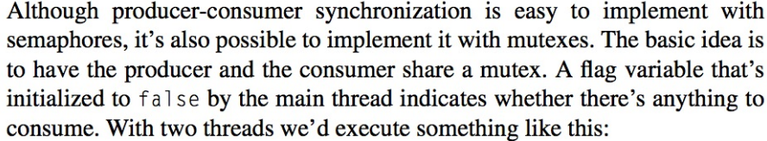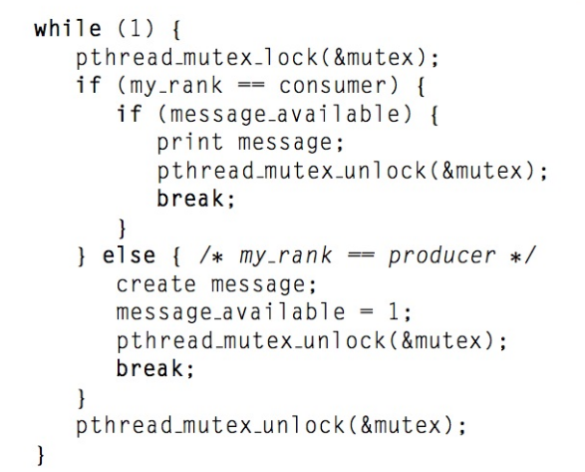

a. Write a Pthreads program that implements this version of producer-consumer synchronization with two threads.

b. Generalize this so that it works with 2*k* threads – odd-ranked threads are consumers and even-ranked threads are producers.

c. Generalize this so that each thread is both a producer and a consumer. For example, suppose that thread q “sends” a message to thread (*q* + 1) mod *t* and “receives” a message from thread (*q* − 1 + *t*) mod *t*, where *t* is the total number of threads.

Templates for 4.1 and 4.2 are provided, they both use timer.h to obtain the system time, and this head file is also provided.

**Note: All programs have to be presented to the instructor on the class of due date.**