A PROJECT REPORT ON
NORTHSTAR
AI TRAVEL GUIDE
An Intelligent Full-Stack Trip Planning and Journey Management Platform
Submitted by
Nijanshi Lara (A014)
Navyata Bhatt (A029)
Siona Karmokar (A009)
Under the guidance of
Mr. Tirup Parmar
NMIMS Nilkamal School of Mathematics,
Applied Statistics & Analytics
October 2026

TABLE OF CONTENTS
1. Introduction 1
1.1 Overview of the Project 1
1.2 Background and Motivation 2
1.3 Problem Statement 2
1.4 Objectives 2
1.5 Scope of the Project 3
1.6 Methodology 4
1.7 Organisation of the Report 6
2. Literature Survey and Existing Systems 7
2.1 Introduction 7
2.2 Study of Existing Systems 7
2.3 Related Techniques 8
2.4 Comparative Analysis 9
2.5 Limitations of Existing Systems 10
2.6 Proposed System 10
3. System Analysis and Requirements 11
3.1 Requirement Gathering 11
3.2 Feasibility Study 11
3.3 User Classes and Characteristics 12
3.4 Functional Requirements 12
3.5 Non-Functional Requirements 15
3.6 Hardware and Software Requirements 15
3.7 Constraints and Assumptions 16
4. System Design 17
4.1 Design Goals 17
4.2 System Architecture 17
4.3 Use Case Design 20
4.4 Data Flow Diagrams 23
4.5 Database Design 27
4.6 Class Design 29
4.7 Sequence Diagrams 30
4.8 State Diagrams 34
4.9 Deployment Design 36
5. Backend Design 38
5.1 Technology Stack 38
5.2 Project Structure 38
5.3 Configuration Management 39
5.4 Database Design and Data Dictionary 40
5.5 API Design 45
5.6 Security Design 48
5.7 Algorithm Design 49
5.8 Two-Stage Itinerary Planning Service 55
5.9 External Integrations 56
5.10 Email Delivery Design (Mailjet) 56
5.11 Error Handling and Logging 58
6. Frontend Design 59
6.1 Technology Stack 59
6.2 Project Structure 59
6.3 Routing and Navigation 60
6.4 Component Architecture 62
6.5 State Management 64
6.6 Service Layer 65
6.7 Design System and Theming 66
6.8 Frontend Utility Modules 67
6.9 User Interface Design 68
6.10 Usability and Accessibility Considerations 84
7. Implementation 85
7.1 Implementation Overview 85
7.2 Application Bootstrap 85
7.3 Data Model Implementation 87
7.4 Authentication Implementation 88
7.5 Itinerary Engine Implementation 90
7.6 Splitwise Implementation 93
7.7 Memory Capsule Media Handling 95
7.8 AI Provider Implementation 97
7.9 Frontend Implementation 98
7.10 Email Delivery Implementation 99
7.11 Currency Conversion Implementation 100
7.12 Coding Standards Followed 101
8. Testing 102
8.1 Introduction 102
8.2 Testing Strategy 102
8.3 Testing Tools and Environment 103
8.4 Automated Test Suites 104
8.5 Sample Test Cases 105
8.6 Test Results Summary 106
8.7 Defects Found 107
8.8 Performance Observations 108
9. Deployment and Maintenance 109
9.1 Local Installation 109
9.2 Environment Configuration 109
9.3 Configuring Email Delivery (Mailjet) 110
9.4 Production Deployment 110
9.5 Backup and Restore 111
9.6 Maintenance 111
9.7 Troubleshooting 111
10. Conclusion and Future Enhancements 113
10.1 Conclusion 113
10.2 Limitations 114
10.3 Future Enhancements 114
References 116
Appendix A – User Manual 118
A.1 Creating an Account 118
A.2 Planning a Trip 118
A.3 Tracking the Budget 118
A.4 Splitting Expenses 118
A.5 Weather, Currency and AI 119
A.6 Memory Capsules 119
A.7 Choosing Your Currency 119
A.8 Resetting a Forgotten Password 119
A.9 Account and Settings 120
Appendix B – Complete Route and Endpoint Index 121
Appendix C – Glossary 123

LIST OF FIGURES
Figure 1.1: Project development schedule (phase-wise Gantt chart) 5
Figure 4.1: Three-tier system architecture of Northstar 18
Figure 4.2: Layered architecture of the FastAPI backend 19
Figure 4.3: Use case diagram 21
Figure 4.4: DFD Level 0 – context diagram 24
Figure 4.5: DFD Level 1 – major processes and data stores 25
Figure 4.6: DFD Level 2 – itinerary planning 26
Figure 4.7: Entity relationship diagram 28
Figure 4.8: Class diagram – domain model 29
Figure 4.9: Class diagram – algorithm data structures 30
Figure 4.10: Sequence diagram – login 31
Figure 4.11: Sequence diagram – password reset via Mailjet 31
Figure 4.12: Sequence diagram – itinerary generation 32
Figure 4.13: Sequence diagram – expense and settlement 32
Figure 4.14: Sequence diagram – media upload and secure streaming 33
Figure 4.15: Sequence diagram – currency preference and inline conversion 33
Figure 4.16: Sequence diagram – AI chat with fallback 34
Figure 4.17: State diagram – trip status 35
Figure 4.18: State diagram – user account and session 36
Figure 4.19: Deployment diagram 37
Figure 5.1: Flowchart of the schedule builder 51
Figure 5.2: Flowchart of the Plan-B replanning engine 53
Figure 5.3: Flowchart of greedy debt simplification 54
Figure 5.4: AI provider fallback chain 56
Figure 5.5: Password-reset email template (rendered from the application code with a sample token) 57
Figure 6.1: Route map of the single-page application 61
Figure 6.2: Frontend component hierarchy 63
Figure 6.3: Login screen 68
Figure 6.4: Registration screen 69
Figure 6.5: Forgot password screen 69
Figure 6.6: Overview dashboard 70
Figure 6.7: My Trips page 71
Figure 6.8: Itinerary page – coverage and budget summary 72
Figure 6.9: Itinerary page – day-by-day timeline 72
Figure 6.10: Budget and Savings page 73
Figure 6.11: Splitwise – group expenses 74
Figure 6.12: Splitwise – balances and suggested settlements 74
Figure 6.13: Weather page (search state) 75
Figure 6.14: AI Travel Assistant page 76
Figure 6.15: Flight search and route planner 77
Figure 6.16: Find accommodation 77
Figure 6.17: Ground transport and transit hub 78
Figure 6.18: Explore destinations 79
Figure 6.19: Travel safety and emergency directory 79
Figure 6.20: Memory Capsules (empty state) 80
Figure 6.21: History page 80
Figure 6.22: Account and profile page 81
Figure 6.23: Settings and integration status 81
Figure 6.24: Account – currency and price preferences 82
Figure 6.25: Budget page with preferred currency USD: original INR amounts with ≈ USD equivalents and the rate popover 82

LIST OF TABLES
Table 1.1: Functional scope of Northstar 3
Table 1.2: Development phases and deliverables 5
Table 2.1: Comparison of Northstar with existing systems 9
Table 3.1: User classes 12
Table 3.2: Functional requirements 12
Table 3.3: Non-functional requirements 15
Table 3.4: Hardware requirements 15
Table 3.5: Software requirements 16
Table 4.1: Backend package responsibilities 19
Table 4.2: Use case specification – UC-04 Generate Itinerary 22
Table 4.3: Use case specification – UC-09 Settle Group Expenses 22
Table 4.4: Use case specification – UC-16 Upload Memory Media 22
Table 5.1: Backend technology stack 38
Table 5.2: Principal configuration settings 39
Table 5.3: Enumerated types 40
Table 5.4: Data dictionary – users 41
Table 5.5: Data dictionary – trips 41
Table 5.6: Data dictionary – activities 42
Table 5.7: Data dictionary – expense_groups and group_members 42
Table 5.8: Data dictionary – expenses and expense_shares 43
Table 5.9: Data dictionary – capsules and memories 43
Table 5.10: Data dictionary – search_history and token tables 44
Table 5.11: Authentication endpoints 45
Table 5.12: Trip, activity and itinerary endpoints 45
Table 5.13: Expense and settlement endpoints 46
Table 5.14: Memory Capsule endpoints (all require authentication) 47
Table 5.15: Weather, currency, AI, history and platform endpoints 47
Table 5.16: Threats and mitigations 49
Table 5.17: Scheduling constants and parameters 50
Table 5.18: Worked example – settlement of the Goa Squad group (real API output) 55
Table 5.19: Places providers 55
Table 5.20: External integration adapters 56
Table 5.21: Email delivery behaviour 56
Table 6.1: Frontend technology stack 59
Table 6.2: Route table 61
Table 6.3: Shared components 63
Table 6.4: Themes and palettes 66
Table 6.5: Utility modules 67
Table 7.1: Size of the main source modules 85
Table 8.1: Levels of testing 102
Table 8.2: Testing tools 103
Table 8.3: Test execution environment 103
Table 8.4: Backend test modules and results 104
Table 8.5: Frontend test files and results 105
Table 8.6: Representative test cases 105
Table 8.7: Module-wise summary of documented test cases 106
Table 8.8: Defect log 107
Table 9.1: Operating modes 109
Table 9.2: Maintenance activities 111
Table 9.3: Common problems and solutions 111
Table 10.1: Planned future enhancements 114
Table B.1: Endpoint to frontend service mapping 121
Table C.1: Glossary of terms 123

LIST OF ABBREVIATIONS
Abbreviation | Full Form
AI | Artificial Intelligence
API | Application Programming Interface
ASGI | Asynchronous Server Gateway Interface
CORS | Cross-Origin Resource Sharing
CRUD | Create, Read, Update, Delete
CSS | Cascading Style Sheets
DFD | Data Flow Diagram
DXA | Twentieth of a point (Word layout unit)
ECB | European Central Bank
ER | Entity Relationship
FK | Foreign Key
HTTP(S) | HyperText Transfer Protocol (Secure)
IATA | International Air Transport Association
JSON | JavaScript Object Notation
JWT | JSON Web Token
LLM | Large Language Model
MIME | Multipurpose Internet Mail Extensions
ORM | Object Relational Mapper
OSM | OpenStreetMap
PK | Primary Key
REST | Representational State Transfer
SDLC | Software Development Life Cycle
SMTP | Simple Mail Transfer Protocol
SPA | Single Page Application
SQL | Structured Query Language
TTL | Time To Live
UI / UX | User Interface / User Experience
UK | Unique Key
URL | Uniform Resource Locator
UUID | Universally Unique Identifier
WAL | Write-Ahead Logging
WMO | World Meteorological Organization

CHAPTER 1

INTRODUCTION

1.1 Overview of the Project
Travel has become one of the most common leisure and business activities in the world. A single journey, however, involves a long chain of decisions: choosing a destination, finding transport, booking accommodation, deciding what to do on each day, checking the weather, staying within a budget, sharing costs with companions, keeping track of emergency numbers, and finally preserving the memories of the trip. Each of these steps is usually handled in a different application or website, and the traveller is left to stitch the pieces together manually.
Northstar – AI Travel Guide, with the tagline “Your compass to everywhere”, is a full-stack web platform that brings all of these activities into a single, consistent experience. A user can create a trip with an origin, destination, dates, number of travellers, budget, currency and travel preferences, and Northstar generates a realistic day-by-day itinerary with start and end times, estimated costs and a category-wise budget breakdown. The itinerary adapts to the live weather forecast, keeps any activity that the user has locked, and can be repaired automatically when a disruption such as a delay or closure occurs.
Around the itinerary, Northstar provides a budget and savings tracker, a global preferred-currency setting that shows the converted equivalent beneath every price, a Splitwise-style group expense manager that calculates who owes whom, a currency converter based on official reference rates, worldwide weather forecasts, an AI travel assistant, private Memory Capsules for photos and videos, a safety and emergency directory, flight, hotel and transport search through trusted providers, and a searchable history of the user’s activity. The application is responsive, supports light, dark and colourful themes, and is designed to remain fully usable even when no paid API keys are configured.
The project is engineered as a clean three-tier system. The presentation tier is a React 18 single-page application written in TypeScript and styled with Tailwind CSS. The application tier is a Python FastAPI service that exposes a REST API under /api, validates every request with Pydantic, and keeps all business logic in services and pure-Python algorithms. The data tier uses SQLAlchemy 2.0 over SQLite in WAL mode, with a clear migration path to PostgreSQL, and stores uploaded media on the local file system. External services – Open-Meteo, OpenStreetMap Nominatim and Overpass, the Frankfurter (ECB) exchange-rate API, Google Gemini and OpenAI – are reached through adapter modules that cache responses and fall back gracefully when a provider is unavailable.

1.2 Background and Motivation
Several observations motivated the development of Northstar:
- Fragmentation of tools. A typical traveller uses five to ten different applications for a single trip. Data must be re-entered repeatedly, and there is no single place that shows the plan, the budget and the actual spending together.
- Static itineraries. Most itinerary planners produce a fixed list of attractions. Real trips change constantly – a museum is closed, a train is late, it rains – and the plan is rarely updated to reflect this.
- Unreliable money arithmetic. Splitting expenses with friends using spreadsheets or floating-point calculations leads to rounding errors where the shares do not add up to the bill, causing confusion and disputes.
- Over-trust in AI output. Generative AI can write attractive travel plans, but it can also invent places, prices and opening hours. A responsible travel product must clearly separate verified data from generated text and must keep working when the AI is unavailable.
- Cost of APIs. Many travel APIs are paid or require commercial agreements. A student or small team needs a design that delivers real value using free and open data sources while remaining ready for premium providers later.

Northstar was therefore designed around three principles that appear throughout this report: one integrated workspace for the whole journey, algorithms first, AI second – deterministic Python algorithms guarantee a correct plan while AI enriches it when available – and honest data – every value shown to the user is labelled as live, cached, estimated, curated or demo data.

1.3 Problem Statement
To design and develop a secure, responsive, full-stack web application that enables a traveller to plan, budget, manage and remember a trip from a single platform. The system must automatically generate a feasible, weather-aware, budget-constrained day-by-day itinerary from user preferences; re-plan the itinerary when disruptions occur without disturbing activities the user has locked; track planned and actual spending; split group expenses exactly and compute a minimal settlement plan; provide live weather, currency and AI travel assistance with transparent fallbacks; and allow users to store private multimedia memories – all while protecting user accounts and data.

1.4 Objectives
The specific objectives of the project are:
- To build a responsive single-page web application with a consistent navigation structure covering all phases of a trip.
- To implement secure user registration, login, email verification, password reset, profile management and account deletion using hashed passwords and httpOnly JWT cookies.
- To design a constraint-aware scheduling algorithm that converts travel styles, pace, budget and an avoid-list into a non-overlapping multi-day itinerary within daily time windows.
- To implement a two-stage, destination-aware itinerary pipeline that combines real candidate places and live weather with optional AI planning and a deterministic fallback.
- To implement a Plan-B engine that handles delays, closures and cancellations, preserves locked activities, and explains every change in plain language.
- To build a group expense module supporting equal, exact, percentage and share-based splits with exact integer arithmetic, and a greedy algorithm that minimises the number of settlement transfers.
- To integrate free worldwide weather, geocoding, places and currency services with caching, validation and graceful degradation.
- To provide an AI travel assistant with a model fallback chain, bounded continuation of truncated answers, and an honestly labelled offline mode.
- To provide private Memory Capsules with validated photo and video uploads, ownership checks and protection against path traversal.
- To deliver real verification and password-reset emails through a transactional email provider (Mailjet) without ever exposing tokens or credentials, and to let every user view all prices in a preferred currency without altering the original amounts.
- To verify the system with automated unit, integration and end-to-end tests and with a documented manual test-case suite.

1.5 Scope of the Project
The scope of Northstar covers the following functional areas:
Table 1.1: Functional scope of Northstar
Module | Scope
Authentication & Profile | Register, login, logout, session refresh, email verification and password-reset emails sent through Mailjet SMTP, profile, theme and currency preferences, change password, delete account.
Global currency | Preferred currency (31 currencies) stored on the profile, converted equivalents shown beneath prices across the app, rate details popover, toggle to hide equivalents.
Trips | Create, list, view, update and delete trips with dates, travellers, budget, currency, travel styles, pace, walking tolerance, must-visit and avoid lists.
Itinerary | Generate and regenerate day-by-day plans, lock/unlock and delete activities, view budget breakdown, re-plan after disruptions.
Budget & Savings | Compare budget cap, planned estimates and actual recorded expenses; category-wise spending; remaining balance.
Splitwise | Expense groups, members, four split methods, edit/delete expenses, balances, settlement plan, record settlements, leave/delete group safely.
Weather | Worldwide geocoding autocomplete, current conditions, 24-hour trend and 7-day forecast in destination local time.
Currency | 31 supported currencies, conversion, rate tables, AED peg handling, ECB attribution.
AI Assistant | Chat with context, floating chatbot, itinerary enrichment, provider status, offline curated guide.
Memory Capsules | Private capsules with photos/videos, notes, dates and locations; reorder memories; secure media streaming.
Discovery & Booking links | Explore destinations; flight, hotel and ground transport search through external aggregators (no fake bookings).
Safety | Country-wise emergency numbers, official travel advisories and a pre-departure checklist.
History & Settings | Activity history with filters and saved items; theme and palette settings; integration status.

The following are outside the scope of the current version: real payment processing and confirmed bookings (which require airline/GDS merchant agreements), native mobile applications, offline service-worker caching, and multi-user real-time collaboration on the same trip. These are discussed as future enhancements in Chapter 10.

1.6 Methodology
The project followed an iterative and incremental development model. Work was organised into eleven phases, each ending with a working, tested and committed version of the application. Every phase added a vertical slice of functionality – database model, API, algorithm and user interface together – so that the product was always demonstrable. Dedicated audit phases (Phase 6 and 7) were used to revisit existing modules, close correctness gaps found during testing, and strengthen validation. Figure 1.1 shows the phase schedule.
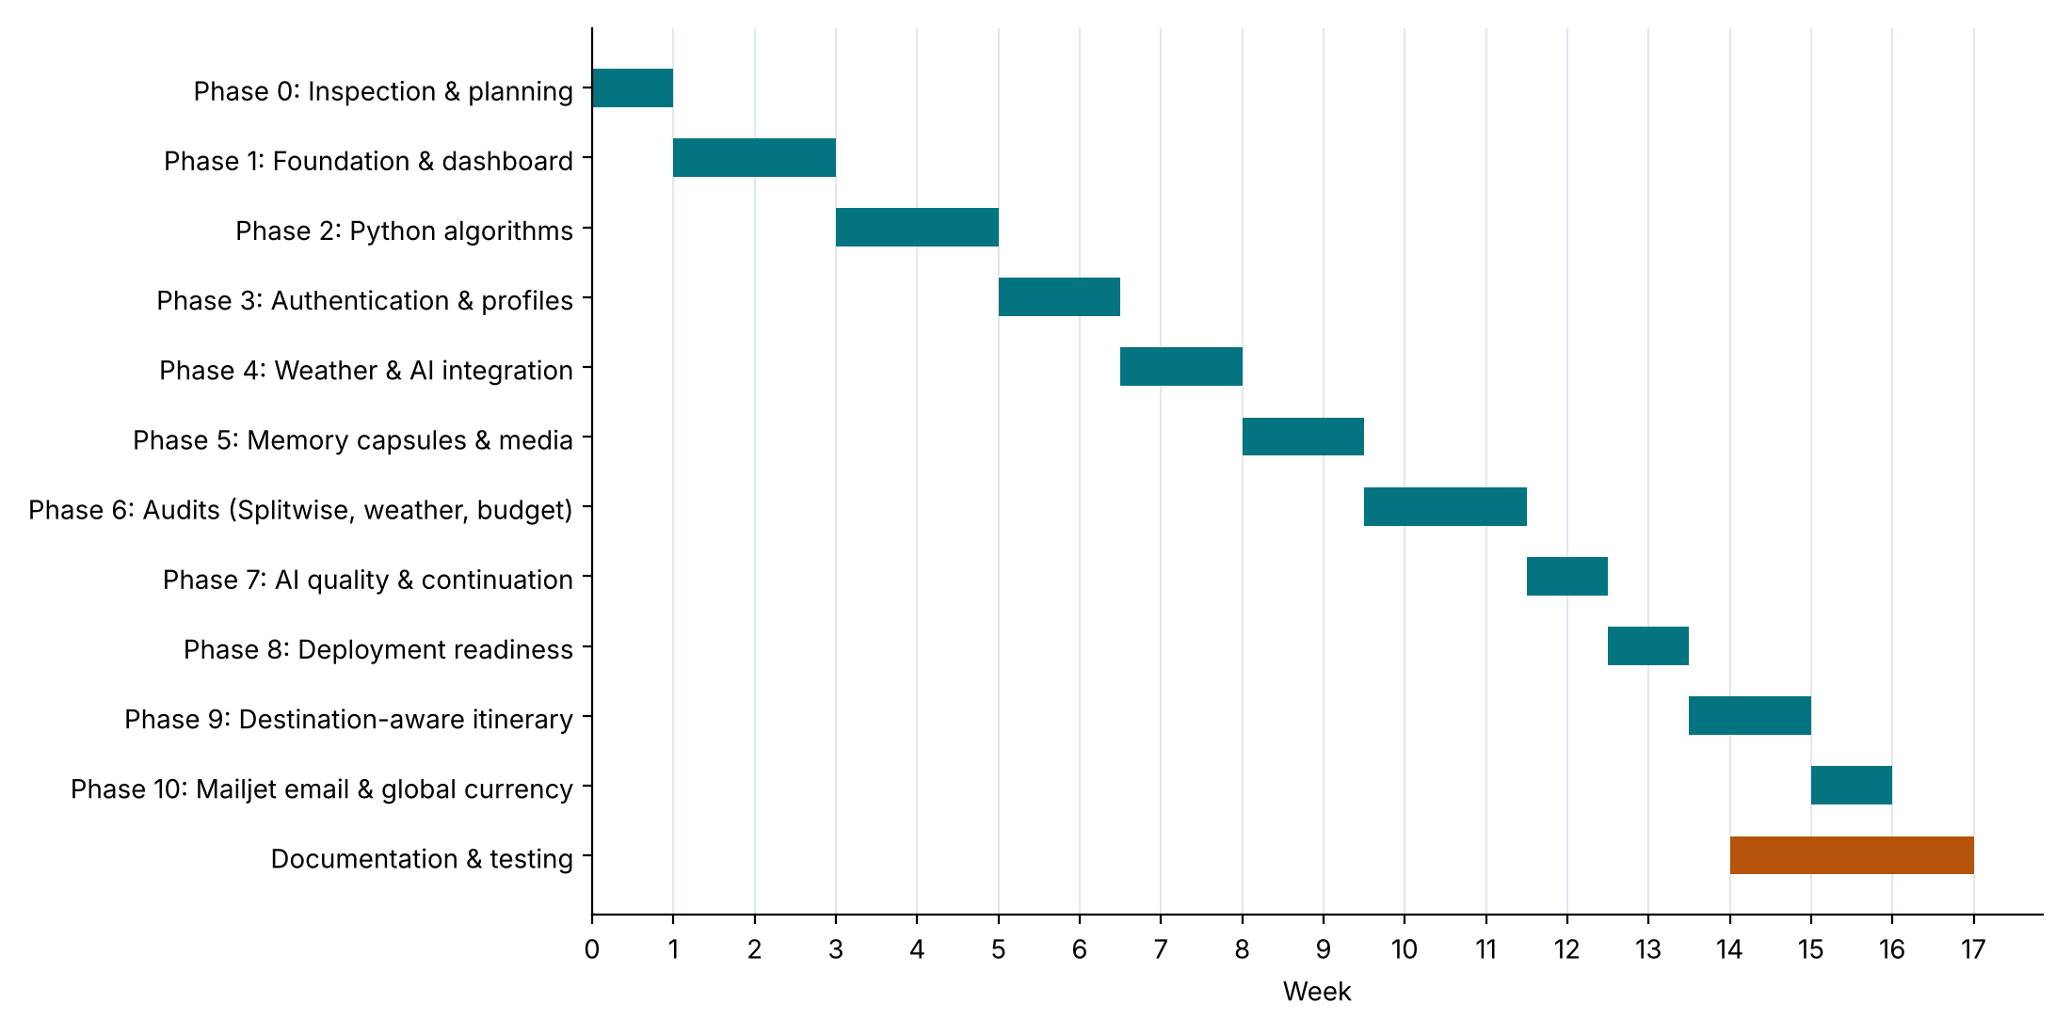
Figure 1.1: Project development schedule (phase-wise Gantt chart)
Table 1.2: Development phases and deliverables
Phase | Title | Key deliverables
0 | Inspect, plan, initialise | Repository, AGENTS.md coding rules, implementation plan, environment checks
1 | Foundation and dashboard | FastAPI skeleton, ORM models, trips/activities/expenses APIs, React layout with sidebar, Overview and My Trips pages, demo seeding
2 | Python algorithms | Schedule builder, schedule validator, Plan-B engine, settlement algorithm, itinerary endpoints
3 | Authentication and profiles | Users, tokens, cookies, verification, password reset, history, protected routes
4 | Weather and AI integrations | Open-Meteo weather and geocoding, Gemini/OpenAI provider, AI chat and enrichment
5 | Memory Capsules | Capsule and memory models, media upload and secure streaming, integrations status
6 | Audits | Splitwise, Memory Capsules, budget, weather and security audits with regression tests
7 | AI quality | Continuation of truncated answers, model fallback chain, truthful attribution
8 | Deployment readiness | Launch scripts, backup/restore, environment hardening, deployment guide
9 | Smart itinerary | Two-stage destination-aware pipeline, places providers, weather-aware planning
10 | Email delivery and global currency | Mailjet SMTP with branded HTML/plain-text emails, preferred currency with inline conversion, schema migration, regression fixes

1.7 Organisation of the Report
The remainder of this report is organised as follows. Chapter 2 reviews existing travel-planning systems and related techniques and positions Northstar against them. Chapter 3 presents the requirement analysis, including feasibility, functional and non-functional requirements and hardware/software requirements. Chapter 4 describes the overall system design using architecture, use-case, data-flow, entity-relationship, class, sequence, state, activity and deployment diagrams. Chapter 5 details the backend design – database, API, security, algorithms and integrations. Chapter 6 details the frontend design – routing, components, state management, theming and the screen-by-screen user interface. Chapter 7 discusses implementation with key code listings. Chapter 8 covers the testing strategy, representative test cases, results and defects. Chapter 9 covers deployment and maintenance, and Chapter 10 concludes the report with limitations and future enhancements. References and appendices follow.

CHAPTER 2

LITERATURE SURVEY AND EXISTING SYSTEMS

2.1 Introduction
Before designing Northstar, existing travel-planning products and the techniques behind them were studied. The goal of this survey was to understand what travellers already use, where those tools fall short, and which algorithmic and architectural approaches could be adopted. The survey is divided into three parts: commercial and popular systems, relevant techniques from research and engineering practice, and a comparative analysis that leads to the proposed system.

2.2 Study of Existing Systems

2.2.1 Online Travel Agencies and Aggregators
Platforms such as MakeMyTrip, Booking.com, Expedia, Skyscanner and Google Flights specialise in searching and booking flights, hotels and packages. They provide excellent inventory, pricing and booking flows, but their focus ends at the transaction. They do not build a day-by-day plan of what to do at the destination, they do not track the traveller’s overall budget against actual spending, and they do not help a group share costs. Northstar does not attempt to replace these services; instead, its Flights, Hotels and Transport pages construct correctly pre-filled deep links to them, preserving one-way versus round-trip mode, dates, passenger breakdown and cabin class.

2.2.2 Itinerary Planners
Tools such as TripIt, Wanderlog, Roadtrippers and Google Travel help users organise reservations and lists of places. TripIt parses booking confirmation emails into a timeline; Wanderlog lets users drag places onto days and shows them on a map. These tools are valuable for organisation, but most of the planning effort – choosing activities, fitting them into time windows, checking the budget – remains manual. When the plan breaks, the user has to rearrange it by hand.

2.2.3 Expense-Sharing Applications
Splitwise and Tricount are widely used to share costs among friends. They support several split methods and compute simplified debts. However, they are separate from the trip plan, so the planned budget of the trip and the money actually spent by the group are never compared in one place. Northstar includes a comparable expense engine and links expense groups to trips so that the Budget page can show planned versus actual spending together.

2.2.4 Generative AI Travel Assistants
General-purpose chat assistants built on large language models (LLMs) can answer travel questions and draft itineraries in seconds. Their limitations are well documented: they may describe places that do not exist, quote out-of-date prices or opening hours, ignore the user’s budget, and produce plans with impossible timings. They also depend on a paid, rate-limited API. Northstar therefore treats the LLM as an optional planning stage whose output is validated, de-duplicated and checked for time overlaps, and which is replaced by a deterministic engine whenever it fails.

2.2.5 Weather and Currency Applications
Dedicated weather apps and currency converters provide accurate data but are disconnected from the trip. A common source of error in travel apps is displaying forecast times in the browser’s time zone instead of the destination’s, or presenting historical climate averages as if they were a forecast. Northstar requests forecasts in the destination’s local time zone, labels cached and stale data, and never fabricates a forecast beyond the 7-day horizon.

2.3 Related Techniques

2.3.1 Itinerary Scheduling as a Constraint Problem
Planning a sightseeing itinerary is closely related to the Orienteering Problem and the Tourist Trip Design Problem studied in operations research: given a set of points of interest, each with a value (score), a duration and possibly a time window, select and order a subset that maximises total value without exceeding a time or cost budget. Exact solutions are NP-hard, so practical systems use heuristics. Northstar uses a greedy weighted-scoring heuristic: each candidate receives a score combining match with the traveller’s styles, affordability against the remaining budget and a duration penalty for slow-paced travellers; the highest-scoring candidate that fits the current day-part window and the remaining budget is placed next. This produces good plans in milliseconds and is easy to explain to the user.

2.3.2 Debt Simplification
Given the net balance of every member of a group (amount paid minus amount owed), the balances always sum to zero. The minimum number of transfers needed to settle all debts is at most n − 1 for n members with non-zero balances. Finding the absolute minimum is NP-hard in general (it reduces to partitioning), but the greedy creditor–debtor matching algorithm – repeatedly matching the largest creditor with the largest debtor and transferring the smaller of the two amounts – always settles all balances with at most n − 1 transfers and is the approach used by Northstar.

2.3.3 Exact Money Arithmetic
Binary floating-point numbers cannot represent most decimal fractions exactly (for example 0.1 + 0.2 ≠ 0.3). Financial software therefore stores money as integers in the smallest currency unit (paise, cents) or uses decimal arithmetic. Northstar stores every amount as an integer in minor units (budget_minor, amount_minor, share_minor) and distributes rounding remainders explicitly so that the shares of an expense always sum exactly to the total.

2.3.4 Token-Based Authentication
JSON Web Tokens (JWT, RFC 7519) are signed, self-contained tokens that carry a user identity and expiry. Storing JWTs in JavaScript-accessible storage (such as localStorage) exposes them to cross-site scripting attacks. The recommended practice adopted by Northstar is to deliver a short-lived access token and a longer-lived refresh token in httpOnly cookies with the SameSite attribute, so that client-side scripts can never read them.

2.3.5 Graceful Degradation and Provider Abstraction
Software that depends on external services should continue to provide core value when those services are slow or unavailable. The adapter (or provider) pattern hides each external service behind a common interface, making it possible to cache responses, switch providers and fall back to local data. Northstar applies this pattern to places (curated, OpenStreetMap, Google), weather, geocoding, currency and AI.

2.4 Comparative Analysis
Table 2.1: Comparison of Northstar with existing systems
Feature | OTA / Aggregator | Itinerary planner | Splitwise-type | AI chatbot | Northstar
Automatic day-by-day itinerary | No | Partial | No | Yes (unverified) | Yes (validated)
Budget-constrained planning | No | No | No | Rarely | Yes
Weather-aware plan | No | No | No | No | Yes
Re-planning after disruption | No | Manual | No | Manual prompt | Yes (Plan-B engine)
Locked activities preserved | N/A | Partial | N/A | No | Yes
Group expense splitting | No | Partial | Yes | No | Yes
Planned vs. actual budget | No | No | No | No | Yes
Works without paid API keys | N/A | Partial | Yes | No | Yes
Honest data labelling | Yes | Partial | N/A | No | Yes
Private memory storage | No | No | No | No | Yes
Flight / hotel booking | Yes | Links | No | No | Links only

2.5 Limitations of Existing Systems
- No single system covers planning, budgeting, expense sharing, weather and memories together.
- Itineraries are static and are not repaired when plans change.
- Budgets are not enforced while planning, and planned estimates are not compared with actual spending.
- AI-generated plans may contain fictitious places or impossible timings, and are presented without attribution.
- Many tools depend on paid APIs and stop working when keys or quotas are missing.

2.6 Proposed System
The proposed system, Northstar, overcomes these limitations by combining a deterministic scheduling core with optional AI enrichment and free live data, inside one secure web application. Its distinguishing characteristics are:
- Integrated workspace – trips, itinerary, budget, expenses, weather, currency, AI help, safety information and memories share one data model and one interface.
- Algorithmic guarantees – the schedule builder guarantees valid days, no overlaps, daily time windows, a budget cap and preservation of locked activities; these properties are covered by automated tests.
- Two-stage smart planning – real candidate places and live weather feed either an AI planner or the deterministic engine, with automatic fallback and atomic persistence.
- Exact money handling – integer minor units, remainder distribution and validated split methods ensure that shares and balances always reconcile.
- Honesty by design – every response carries flags such as is_ai, is_demo, is_verified, cached/stale indicators and provider names, and the interface shows them as badges.
- Security – bcrypt password hashing, httpOnly JWT cookies, ownership checks on every private resource, timing-safe login and validated, user-bound media storage.

CHAPTER 3

SYSTEM ANALYSIS AND REQUIREMENTS

3.1 Requirement Gathering
Requirements were gathered by analysing how travellers plan trips today (Chapter 2), by listing the pain points of fragmented tools, and by walking through complete journeys – for example, a five-day group trip from Mumbai to Goa with a fixed budget – from first idea to final settlement of expenses. Each step of these journeys was converted into user stories, which were then grouped into modules and refined into functional and non-functional requirements. The coding rules recorded in the project’s AGENTS.md (for example, “never claim a booking is confirmed unless a real payment provider confirms it” and “use integer minor-currency units for all money”) were treated as binding requirements as well.

3.2 Feasibility Study

3.2.1 Technical Feasibility
All technologies selected for Northstar are mature, open-source and well documented. FastAPI provides high-performance asynchronous request handling with automatic OpenAPI documentation; SQLAlchemy offers a portable ORM so that the SQLite development database can be replaced by PostgreSQL by changing only DATABASE_URL; React with TypeScript provides a robust component model with static typing; Tailwind CSS enables a consistent responsive design. Free public services (Open-Meteo, OpenStreetMap, Frankfurter) supply real data without keys. The required skills – Python, TypeScript, REST and SQL – are part of a standard computer-science curriculum. The project is therefore technically feasible.

3.2.2 Economic Feasibility
Northstar can be developed and run at zero licence cost. All frameworks are free; the weather, geocoding, places and currency services are free; the AI features work in an honest offline mode without any key and can use the free tier of Google Gemini when a key is provided. Development requires only a standard laptop. Hosting a demonstration can use free tiers of static hosting for the frontend and a small application server with a persistent volume for the backend. The project is economically feasible.

3.2.3 Operational Feasibility
The application runs in any modern web browser and requires no installation by end users. The interface follows familiar patterns – a sidebar for navigation, cards, forms with inline validation and clear empty, loading and error states. A one-click launcher (start_local_demo.bat) starts both servers for demonstrations, and demo data can be seeded with a single call. Users with no technical background can therefore operate the system, which makes it operationally feasible.

3.2.4 Schedule Feasibility
The work was divided into eleven incremental phases (Figure 1.1) of one to two weeks each, with every phase producing a working build. This plan fits comfortably within an academic semester, leaving time for documentation and testing.

3.3 User Classes and Characteristics
Table 3.1: User classes
User class | Description and permissions
Guest (unauthenticated) | Can browse public pages, view demo trips, explore destinations, check weather, convert currency, use the AI assistant, search flights/hotels/transport and view safety information. Cannot access History, Profile or private Memory Capsules.
Registered user | All guest capabilities plus owning trips, itineraries and expense groups, Memory Capsules with media uploads, history and saved items, profile and theme preferences synchronised to the server, password change and account deletion.
Group member (non-user) | A person listed in an expense group by name (and optional email). Members do not need an account; the group owner records what they paid and owe.
Administrator / Operator | Configures environment variables, API keys and SMTP, runs backups and restores, and monitors the integration status page. There is no separate admin UI in this version.

3.4 Functional Requirements
Table 3.2 lists the functional requirements. Each requirement has an identifier, which the test cases in Chapter 8 refer to for traceability.
Table 3.2: Functional requirements
ID | Module | Requirement
FR-01 | Auth | The system shall allow a user to register with name, email and a password of at least 8 characters containing an uppercase letter and a digit.
FR-02 | Auth | The system shall reject registration with an email that already exists (HTTP 409).
FR-03 | Auth | The system shall authenticate users with email and password and issue httpOnly access (30 min) and refresh (7 days) cookies.
FR-04 | Auth | The system shall return the same error for an unknown email and a wrong password, using a timing-safe path.
FR-05 | Auth | The system shall email a single-use verification link valid for 24 hours through the configured SMTP provider (Mailjet), or return the token in development mode when SMTP is not configured.
FR-06 | Auth | The system shall email a single-use password-reset link valid for 1 hour, without revealing whether an email is registered and without returning the token to the browser when SMTP is enabled.
FR-07 | Auth | The system shall allow an authenticated user to update name and theme preferences, change password and delete the account with all data.
FR-08 | Trips | The system shall allow creating a trip with name, origin, destination, dates, travellers (1–50), budget, currency and preferences, and shall compute the number of days.
FR-09 | Trips | The system shall reject a trip whose return date is before the departure date.
FR-10 | Trips | The system shall show authenticated users only their own trips plus clearly labelled demo trips, and forbid access to other users’ trips.
FR-11 | Itinerary | The system shall generate a day-by-day itinerary for a trip using candidate places, weather and preferences.
FR-12 | Itinerary | Generated activities shall lie on valid days, inside 09:00–22:00, without overlaps, with end = start + duration.
FR-13 | Itinerary | The total estimated cost shall not exceed the trip budget cap; skipped activities shall produce a de-duplicated warning.
FR-14 | Itinerary | Locked activities shall never be removed, moved or duplicated by regeneration or re-planning.
FR-15 | Itinerary | On rainy forecast days the system shall prefer indoor activities and add a weather advisory.
FR-16 | Itinerary | If AI planning fails, times out or returns malformed or partial JSON, the system shall fall back to the deterministic engine without an HTTP 500 and without losing existing data.
FR-17 | Itinerary | The system shall re-plan a day after a delay, closure or cancellation, leave other days unchanged and list every change.
FR-18 | Budget | The system shall show the budget cap, planned estimates, actual recorded expenses, remaining amounts and category breakdown for a trip.
FR-19 | Splitwise | The system shall allow creating expense groups with members, optionally linked to a trip.
FR-20 | Splitwise | The system shall record expenses with equal, exact, percentage or share-based splits among all or selected active members.
FR-21 | Splitwise | Shares of every expense shall sum exactly to the expense amount in minor units.
FR-22 | Splitwise | The system shall compute member balances (which sum to zero) and a minimal settlement plan, and allow recording a settlement.
FR-23 | Splitwise | A member with a non-zero balance shall not be able to leave a group, and a group with unsettled balances shall not be deleted unless forced.
FR-24 | Weather | The system shall provide worldwide destination autocomplete and current, hourly and 7-day forecasts in destination local time.
FR-25 | Weather | The system shall validate coordinates and return a clear error for unknown or blank locations and network failures.
FR-26 | Currency | The system shall convert between supported currencies using ECB reference rates, handle same-currency and AED-peg cases, and reject invalid amounts.
FR-27 | AI | The system shall answer travel questions using a configured AI provider, fall back across models and providers, and label offline answers as non-AI.
FR-28 | AI | The system shall continue truncated AI answers once and label any still-incomplete answer.
FR-29 | Capsules | An authenticated user shall be able to create, edit and delete capsules and memories and reorder memories.
FR-30 | Capsules | The system shall accept JPEG/PNG/WEBP/GIF images up to 10 MB and MP4/WEBM/MOV videos up to 50 MB and reject empty or other files.
FR-31 | Capsules | Media shall be served only to the owner, and path-traversal attempts shall be rejected.
FR-32 | History | The system shall record, list, filter, save, delete and clear (with confirmation) the user’s history items.
FR-33 | Flights | The system shall validate flight searches and build correct Google Flights, Skyscanner and MakeMyTrip links for one-way and round trips.
FR-34 | Safety | The system shall show country-wise emergency numbers, official advisories and a pre-departure checklist.
FR-35 | Settings | The system shall support light, dark and colourful themes with six palettes and a custom accent, persisted in the browser, with matching fields stored on the user profile.
FR-36 | Platform | The system shall show an integration status (live, hybrid or demo) and label demo data in the interface.
FR-37 | Currency | The system shall let each user choose a preferred currency (default INR) and a toggle for showing converted prices, persisted to the profile for signed-in users and to the browser for guests.
FR-38 | Currency | Wherever a price is shown in a currency different from the preferred one, the system shall show the original amount and the approximate converted equivalent, with rate details on demand, without changing stored amounts.
FR-39 | Currency | Missing exchange-rate data, corrupted cached rates or a failing rates API shall never prevent any page from rendering.

3.5 Non-Functional Requirements
Table 3.3: Non-functional requirements
ID | Category | Requirement
NFR-01 | Performance | Standard CRUD API calls shall respond within 300 ms on a local deployment; deterministic itinerary generation shall complete within 2 s excluding external calls.
NFR-02 | Performance | External responses shall be cached: weather 10 min, currency 1 h, geocoding and places 24 h.
NFR-03 | Security | Passwords shall be stored only as bcrypt hashes; tokens shall be signed with HS256 using a secret of at least 32 characters in production; SMTP credentials shall exist only in backend/.env and never be logged.
NFR-04 | Security | Auth tokens shall be stored only in httpOnly, SameSite=Lax cookies, never in localStorage.
NFR-05 | Security | Every private resource shall enforce ownership on the server; no secrets shall appear in frontend code.
NFR-06 | Reliability | Failure of any external provider shall not cause an HTTP 500; the system shall fall back to cached, curated or deterministic data.
NFR-07 | Reliability | Itinerary regeneration shall be atomic: existing activities are replaced only after a new plan is ready.
NFR-08 | Accuracy | All monetary values shall be stored as integers in minor units; displayed values shall use the correct currency symbol and grouping.
NFR-09 | Usability | Every page shall handle loading, empty and error states; every button shall perform an action or show “Coming soon”.
NFR-10 | Usability | The layout shall be responsive from 360 px mobile width to large desktops, with sufficient colour contrast in all themes.
NFR-11 | Honesty | Demo, curated, cached, estimated and AI-generated data shall be labelled distinctly.
NFR-12 | Maintainability | Business logic shall live in services and algorithms, not route handlers; code shall use type hints and docstrings.
NFR-13 | Portability | The backend shall run on Windows, macOS and Linux with Python 3.12+; the database shall be switchable via DATABASE_URL.
NFR-14 | Testability | Algorithms shall be pure functions without database access so they can be unit-tested in isolation.

3.6 Hardware and Software Requirements

3.6.1 Hardware Requirements
Table 3.4: Hardware requirements
Component | Development / Server (minimum) | Client (minimum)
Processor | Dual-core 2.0 GHz (Intel i3 / Ryzen 3) or better | Any modern smartphone or PC
RAM | 8 GB (4 GB minimum) | 2 GB
Storage | 2 GB free (plus space for uploaded media) | –
Network | Broadband internet for live weather, currency and AI | Internet connection
Display | 1366 × 768 or higher | 360 px width or higher

3.6.2 Software Requirements
Table 3.5: Software requirements
Item | Specification
Operating system | Windows 10/11, macOS or Linux
Backend runtime | Python 3.12 or higher, pip, virtual environment
Backend libraries | FastAPI 0.115, Uvicorn 0.32, Pydantic 2.10, pydantic-settings 2.7, SQLAlchemy 2.0, Alembic 1.14, HTTPX 0.28, bcrypt 4.2, python-jose 3.3, email-validator 2.2, google-genai, openai, pytest 8.3
Frontend runtime | Node.js 18+ and npm 9+
Frontend libraries | React 18.3, React Router 6.28, TypeScript 5.6, Vite 6, Tailwind CSS 3.4, Axios 1.7, Framer Motion 11, Lucide React
Database | SQLite 3 (development); PostgreSQL recommended for production
Browser | Latest Chrome, Edge, Firefox or Safari
Email service | Mailjet account with a verified sender address (SMTP in-v3.mailjet.com, port 587, STARTTLS)
Tools | Git, VS Code, Swagger UI (/docs), Postman (optional)

3.7 Constraints and Assumptions
- Free public APIs have rate limits (for example, Nominatim allows about one request per second), so responses must be cached and requests throttled.
- Weather forecasts are available only for the next 7 days; plans further ahead use neutral assumptions rather than invented forecasts.
- Real bookings require commercial credentials, so flights and hotels are handled via deep links to external providers.
- SQLite is suitable for development and single-server deployments; serverless hosts with ephemeral storage require an external database and object storage.
- Users are assumed to have a modern browser with cookies enabled.

CHAPTER 4

SYSTEM DESIGN

4.1 Design Goals
System design translates the requirements of Chapter 3 into an architecture and a set of models that guide implementation. The design of Northstar was driven by the following goals:
- Separation of concerns – presentation, application logic, algorithms, integrations and persistence are separate layers with one-directional dependencies.
- Thin client – the React frontend never runs planning or settlement algorithms itself; it always calls the backend, which is the single source of truth.
- Pure algorithms – scheduling and replanning functions receive plain data and return plain results, with no database or network access, which makes them deterministic and easy to test.
- Replaceable providers – each external service is behind an adapter with caching and fallback, so that providers can be swapped or added without touching business logic.
- Secure by default – authentication, ownership checks and input validation are applied at the API boundary for every request.

4.2 System Architecture
Northstar follows a three-tier client–server architecture (Figure 4.1). The browser loads the compiled React single-page application from static hosting. All dynamic data is exchanged with the FastAPI backend as JSON over HTTP(S) under the /api prefix; the browser automatically attaches the httpOnly authentication cookies. The backend validates the request, applies business rules in its service layer, calls pure algorithms and integration adapters as required, and persists data through SQLAlchemy to SQLite. Media files for Memory Capsules are stored on the server’s file system and streamed back only to their owners.
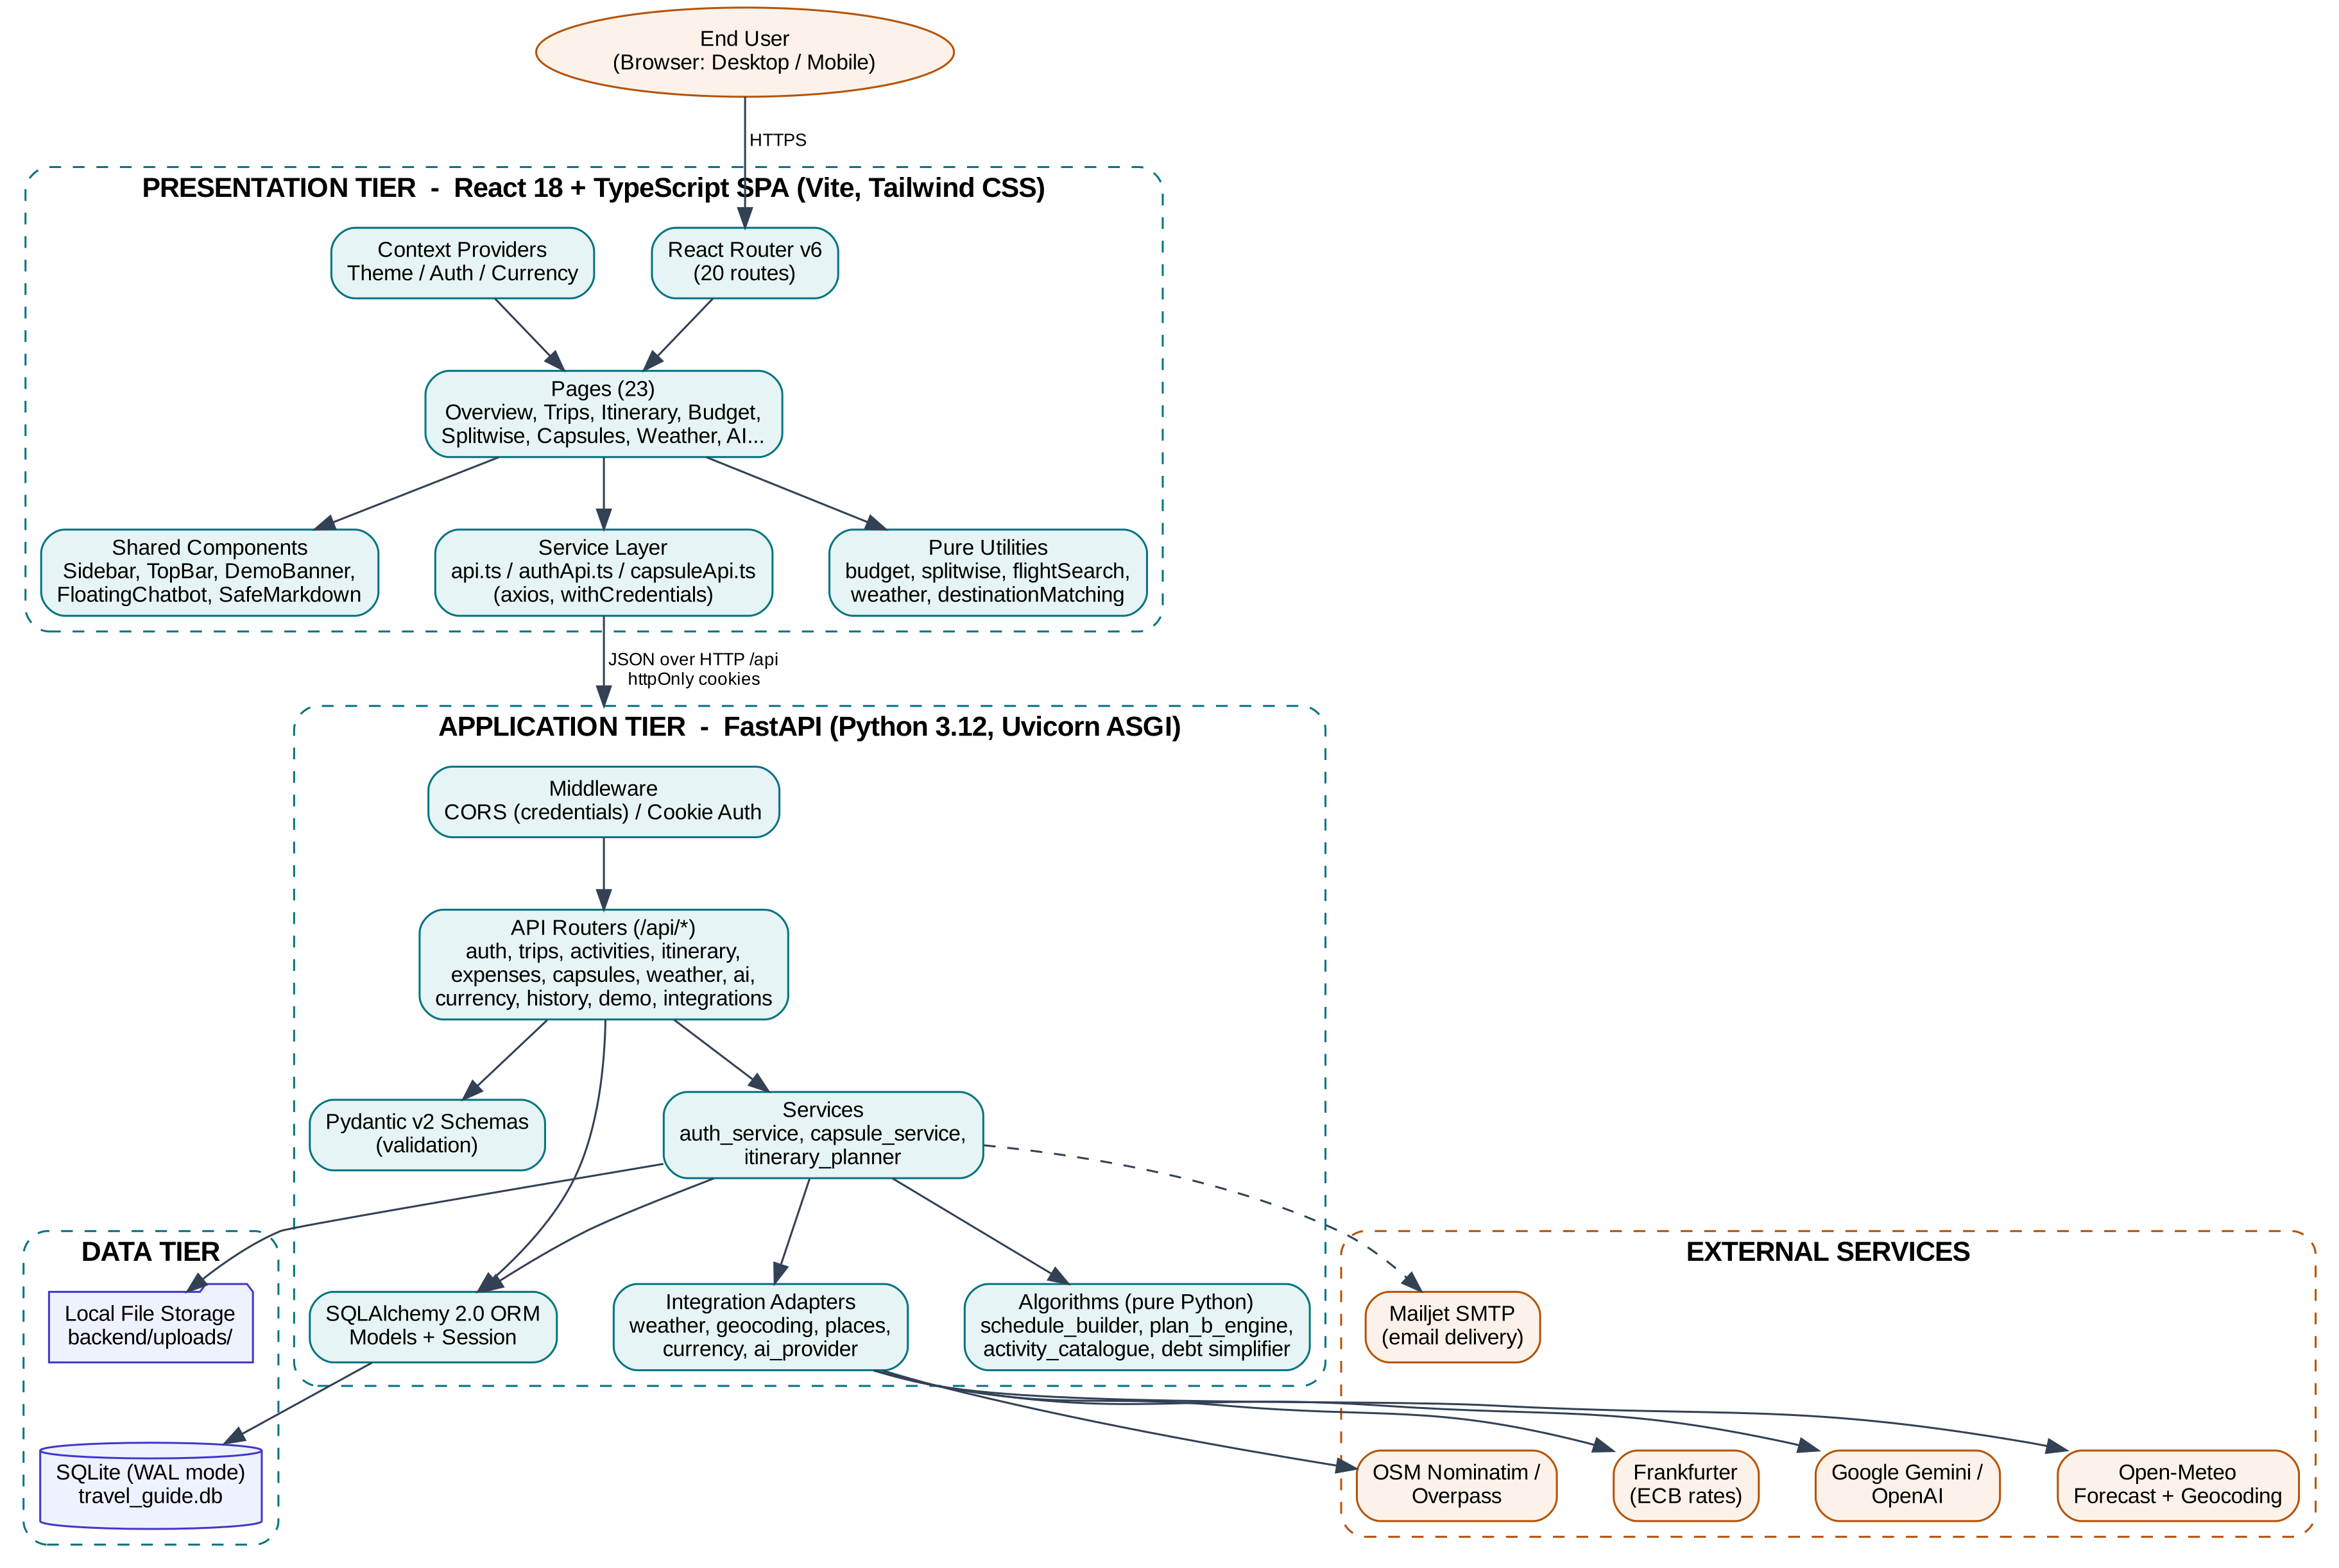
Figure 4.1: Three-tier system architecture of Northstar
In development, the Vite dev server runs on port 5173 and proxies every /api request to the backend on port 8000, so the browser sees a single origin and cookies work without additional configuration. In production, the frontend can be served from a CDN with VITE_API_BASE_URL pointing at the API domain, in which case CORS is configured with allow_credentials=True for the allowed frontend origin.

4.2.1 Backend Layered Architecture
Inside the application tier, code is organised into layers as shown in Figure 4.2. Route handlers in app/api are deliberately thin: they declare the URL, the request/response schemas and dependencies (database session, current user), and delegate work to services and algorithms. This rule, recorded in the project’s coding guidelines, keeps the HTTP layer independent of the planning logic.
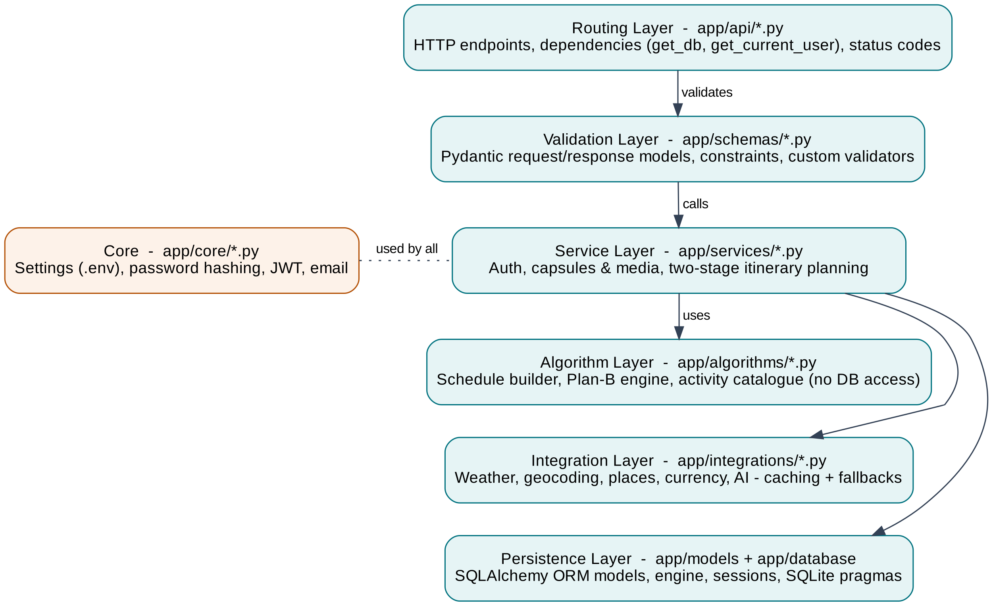
Figure 4.2: Layered architecture of the FastAPI backend
Table 4.1: Backend package responsibilities
Package | Responsibility
app/main.py | Creates the FastAPI application, registers CORS middleware and all routers, creates tables on start-up and applies a small in-place migration for group_members.is_active.
app/core | config.py (typed settings from .env), security.py (bcrypt hashing, JWT creation/decoding), email.py (Mailjet SMTP delivery or development mode).
app/database | Engine creation, SQLite pragmas (WAL, busy timeout, synchronous NORMAL), backward-compatible schema upgrade (ensure_sqlite_schema), SessionLocal factory and the get_db dependency.
app/models | SQLAlchemy ORM models: Trip, Activity, ExpenseGroup, GroupMember, Expense, ExpenseShare, User, tokens, SearchHistory, Capsule, Memory.
app/schemas | Pydantic request and response models with constraints and custom validators.
app/api | Routers: health, auth, trips, activities, itinerary, expenses, capsules, weather, ai, currency, history, demo, integrations.
app/services | auth_service, capsule_service and itinerary_planner – business workflows that coordinate models, algorithms and integrations.
app/algorithms | activity_catalogue, schedule_builder (build and validate schedules) and plan_b_engine (replanning).
app/integrations | Adapters for weather, geocoding, places, currency and the AI provider, each with caching and fallback.

4.3 Use Case Design
Figure 4.3 shows the use-case diagram. Two primary actors interact with the system: the Guest, who can use the public tools, and the Registered User, who additionally owns private data. External services (weather, AI, exchange rates, email) act as secondary actors.
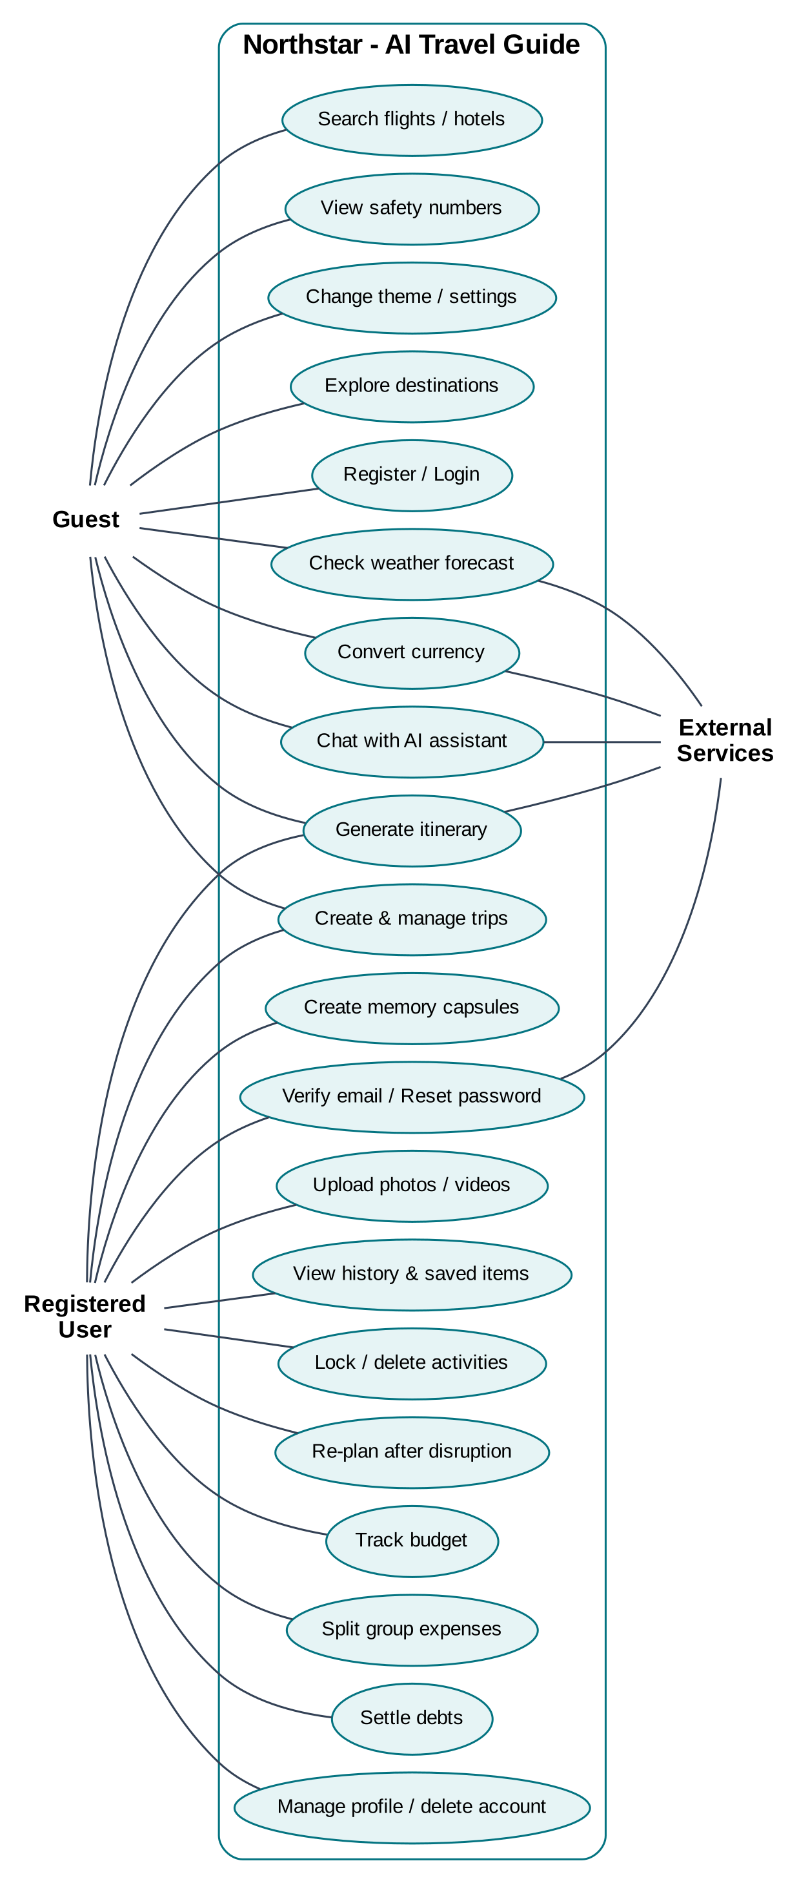
Figure 4.3: Use case diagram

4.3.1 Use Case Specifications
Table 4.2: Use case specification – UC-04 Generate Itinerary
Field | Description
Use case | UC-04 Generate itinerary
Actors | Registered user (owner) or guest (demo trip); Places, Weather and AI providers
Pre-conditions | The trip exists and has a non-empty destination; the caller owns the trip or the trip is a demo/unowned trip.
Main flow | 1. User selects a trip on the Itinerary page and clicks Generate.  2. Frontend sends POST /api/itinerary/{id}/generate.  3. System loads the trip and locked activities.  4. System gathers candidate places and the weather forecast.  5. System asks the AI provider for a plan (if configured) or runs the deterministic scheduler.  6. System validates the plan and atomically replaces unlocked activities.  7. System returns activities, day themes, budget breakdown and warnings; the page renders a day-by-day timeline.
Alternate flows | 5a. AI times out, is rate-limited or returns malformed/partial JSON – deterministic scheduler fills the plan.  4a. Weather unavailable – plan generated without weather adaptation and labelled.
Exceptions | Trip not found (404); not owner (403); empty destination (400); unexpected failure (500, existing activities preserved).
Post-conditions | Activities stored for every day of the trip; locked activities unchanged; history entry recorded for authenticated users.

Table 4.3: Use case specification – UC-09 Settle Group Expenses
Field | Description
Use case | UC-09 Settle debts
Actors | Registered user (group owner)
Pre-conditions | An expense group exists with at least two members and one or more expenses.
Main flow | 1. User opens the Balances tab of a group.  2. System computes paid, owed and net balance per member.  3. System runs greedy debt simplification and displays transfers (who pays whom, how much).  4. User clicks Settle on a transfer.  5. System records a settlement entry and recalculates balances.
Exceptions | Self-settlement or non-positive amount rejected (400); group not found (404).
Post-conditions | Settled transfers reduce the corresponding balances; balances always sum to zero.

Table 4.4: Use case specification – UC-16 Upload Memory Media
Field | Description
Use case | UC-16 Upload photo or video to a Memory Capsule
Actors | Registered user
Pre-conditions | User is logged in and owns the capsule.
Main flow | 1. User selects a file in a capsule.  2. Frontend validates type and size.  3. Backend validates extension, MIME type, non-empty content and size limit.  4. File is saved as u{user_id}_{uuid}.ext and a memory is created.  5. Media is displayed via the authenticated media endpoint.
Exceptions | Unsupported format, empty file or oversize file (400); capsule of another user (404); unauthenticated (401).
Post-conditions | Media is stored privately and listed in the capsule in display order.

4.4 Data Flow Diagrams
Data Flow Diagrams (DFDs) describe how data moves between external entities, processes and data stores, without showing control logic. Northstar is described at three levels.

4.4.1 Level 0 (Context Diagram)
At level 0 (Figure 4.4) the whole system is a single process. The traveller supplies credentials, trip details, preferences, questions and media, and receives itineraries, budgets, forecasts, settlements and AI answers. Group members contribute expense information. Weather/geocoding services, AI providers, the exchange-rate service and an SMTP server exchange data with the system.
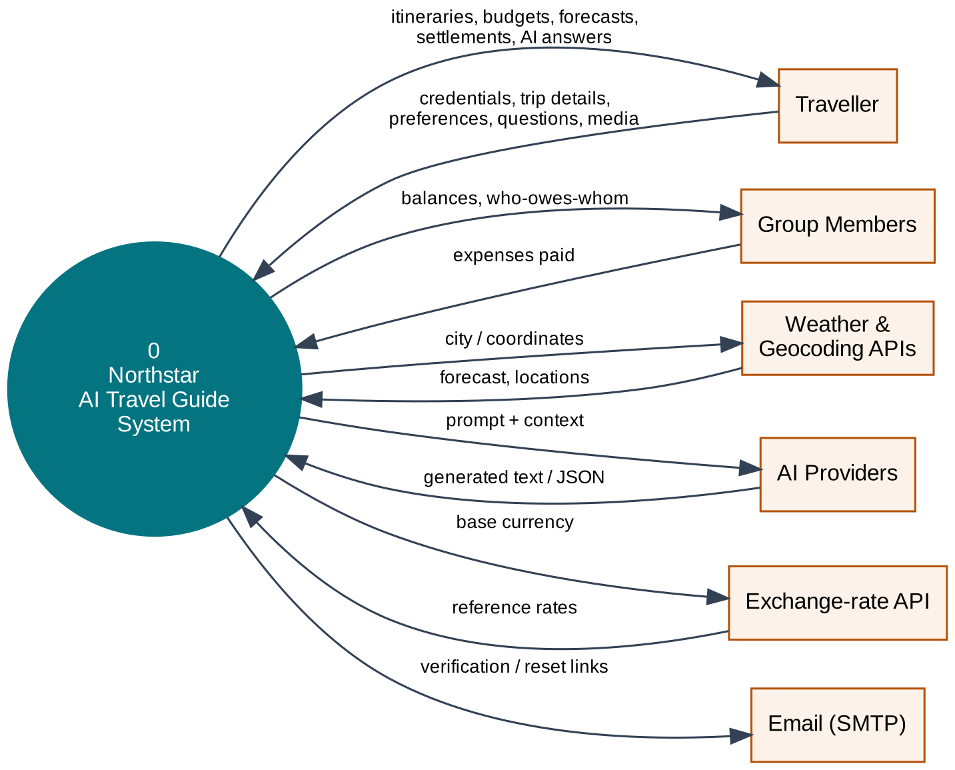
Figure 4.4: DFD Level 0 – context diagram

4.4.2 Level 1
Level 1 (Figure 4.5) decomposes the system into seven major processes – authenticate user, manage trips, plan itinerary, manage expenses, manage capsules, provide travel information and AI assistant – and seven data stores that correspond to groups of database tables and the uploads folder.
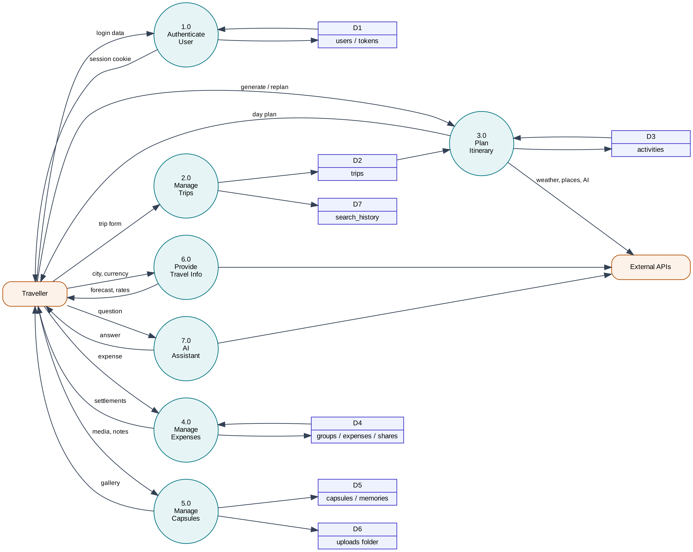
Figure 4.5: DFD Level 1 – major processes and data stores

4.4.3 Level 2 – Plan Itinerary (Process 3.0)
Process 3.0 is the most complex process and is expanded in Figure 4.6. The trip is loaded and ownership verified (3.1); the destination string is resolved to coordinates (3.2); candidate places (3.3) and the forecast (3.4) are gathered; the AI planner (3.5) produces JSON, or the deterministic scheduler (3.6) produces slots using locked activities from D3; the result is validated and de-duplicated (3.7) and persisted atomically (3.8).
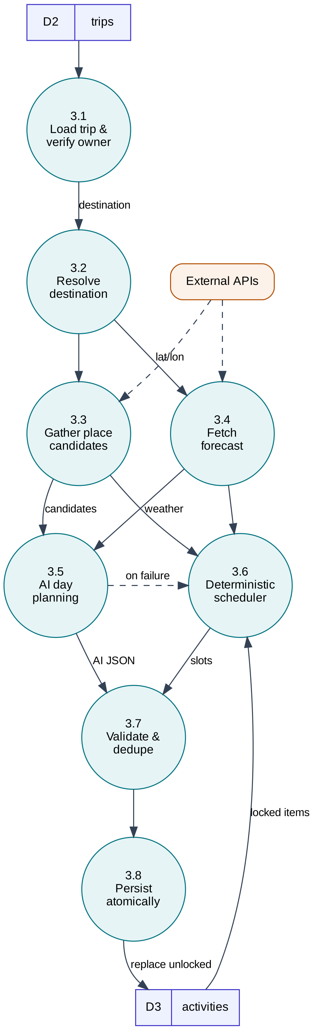
Figure 4.6: DFD Level 2 – itinerary planning

4.5 Database Design
The relational schema contains twelve tables. Figure 4.7 shows the entity-relationship diagram with primary keys (PK), foreign keys (FK), unique keys (UK) and cardinalities. The key relationships are:
- A user owns many trips, capsules, history entries and verification/reset tokens. Deleting a user cascades to capsules, tokens and history; trips use ON DELETE SET NULL.
- A trip contains many activities and may be linked to several expense groups.
- An expense group has members and expenses; each expense is paid by one member and split into expense shares, one per participating member.
- A capsule contains many memories, ordered by display_order.

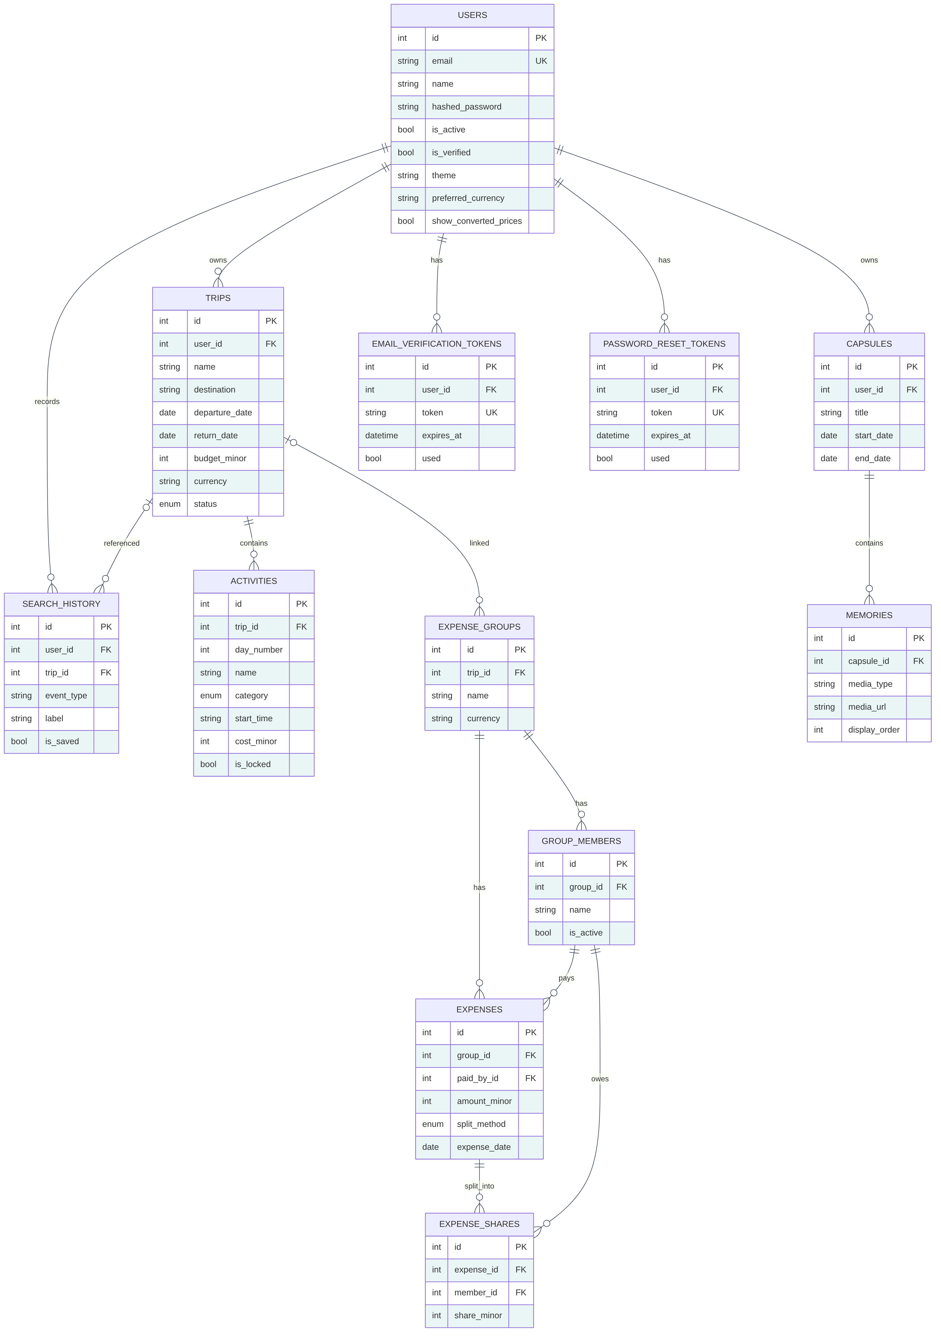
Figure 4.7: Entity relationship diagram
The schema is in third normal form: each non-key attribute depends only on its table’s key. Two deliberate denormalisations exist for simplicity on SQLite: travel_styles is stored as a comma-separated list of enum values, and the trip’s num_days is stored although it can be derived from the dates. The complete data dictionary is given in Chapter 5.

4.6 Class Design
Figure 4.8 shows the domain classes (ORM models) with their main attributes, derived properties and associations; composition (filled diamond) indicates that children are deleted with their parent. Figure 4.9 shows the data classes used by the planning algorithms. These are Python dataclasses independent of the database: TripPreferences is built from a Trip, build_schedule() returns a ScheduleResult containing ActivitySlot, DayPlan and BudgetBreakdown objects, and replan() takes a Disruption and returns a ReplannedResult.
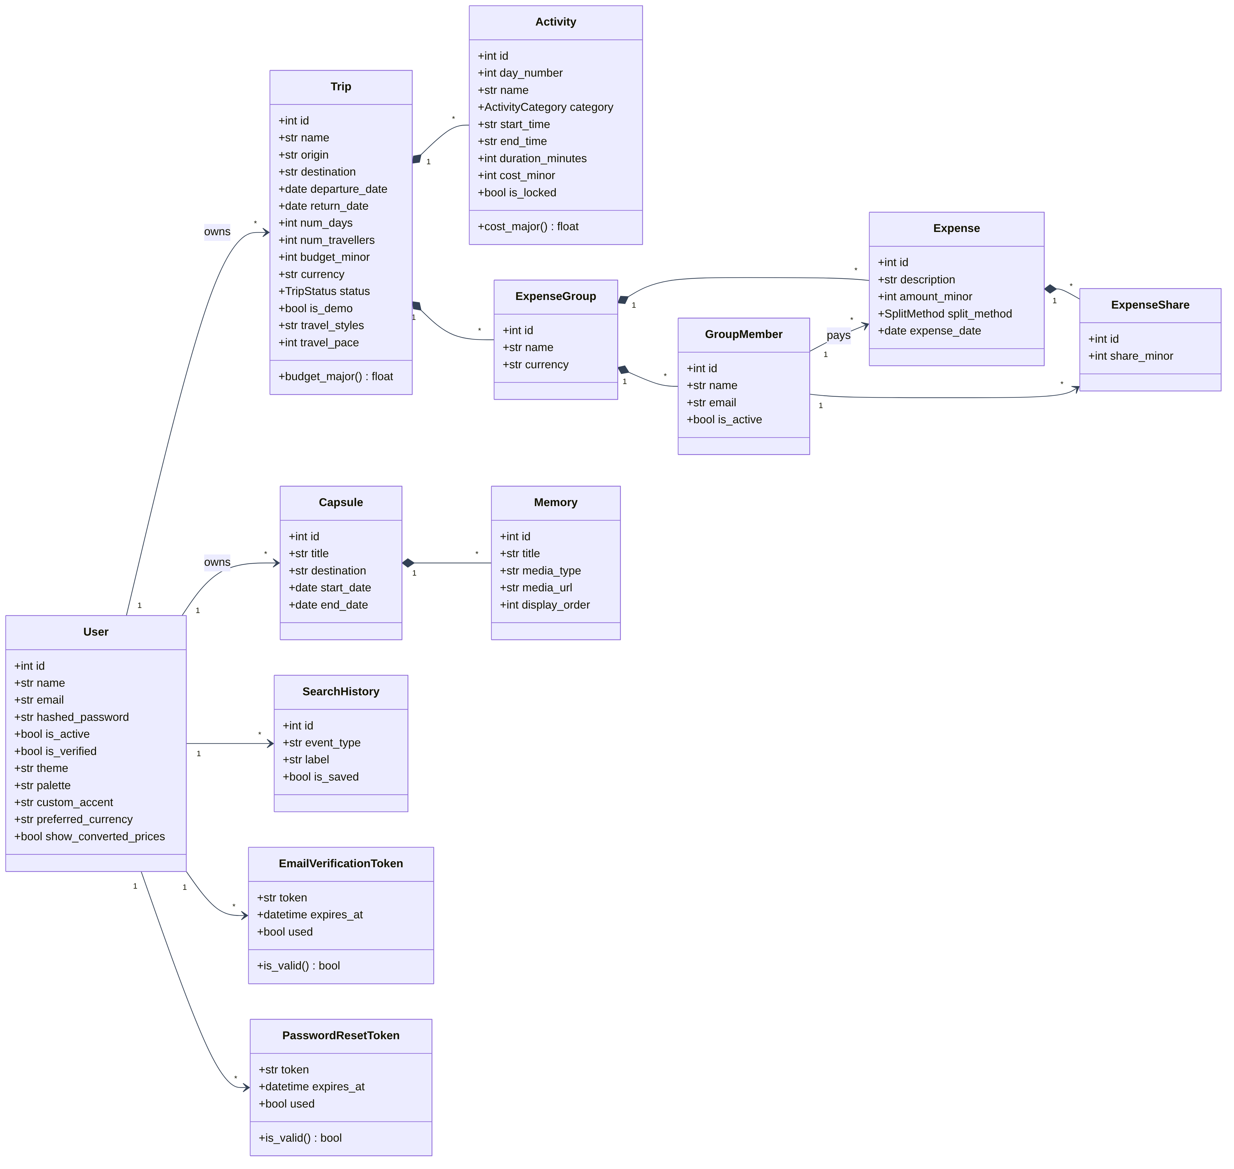
Figure 4.8: Class diagram – domain model
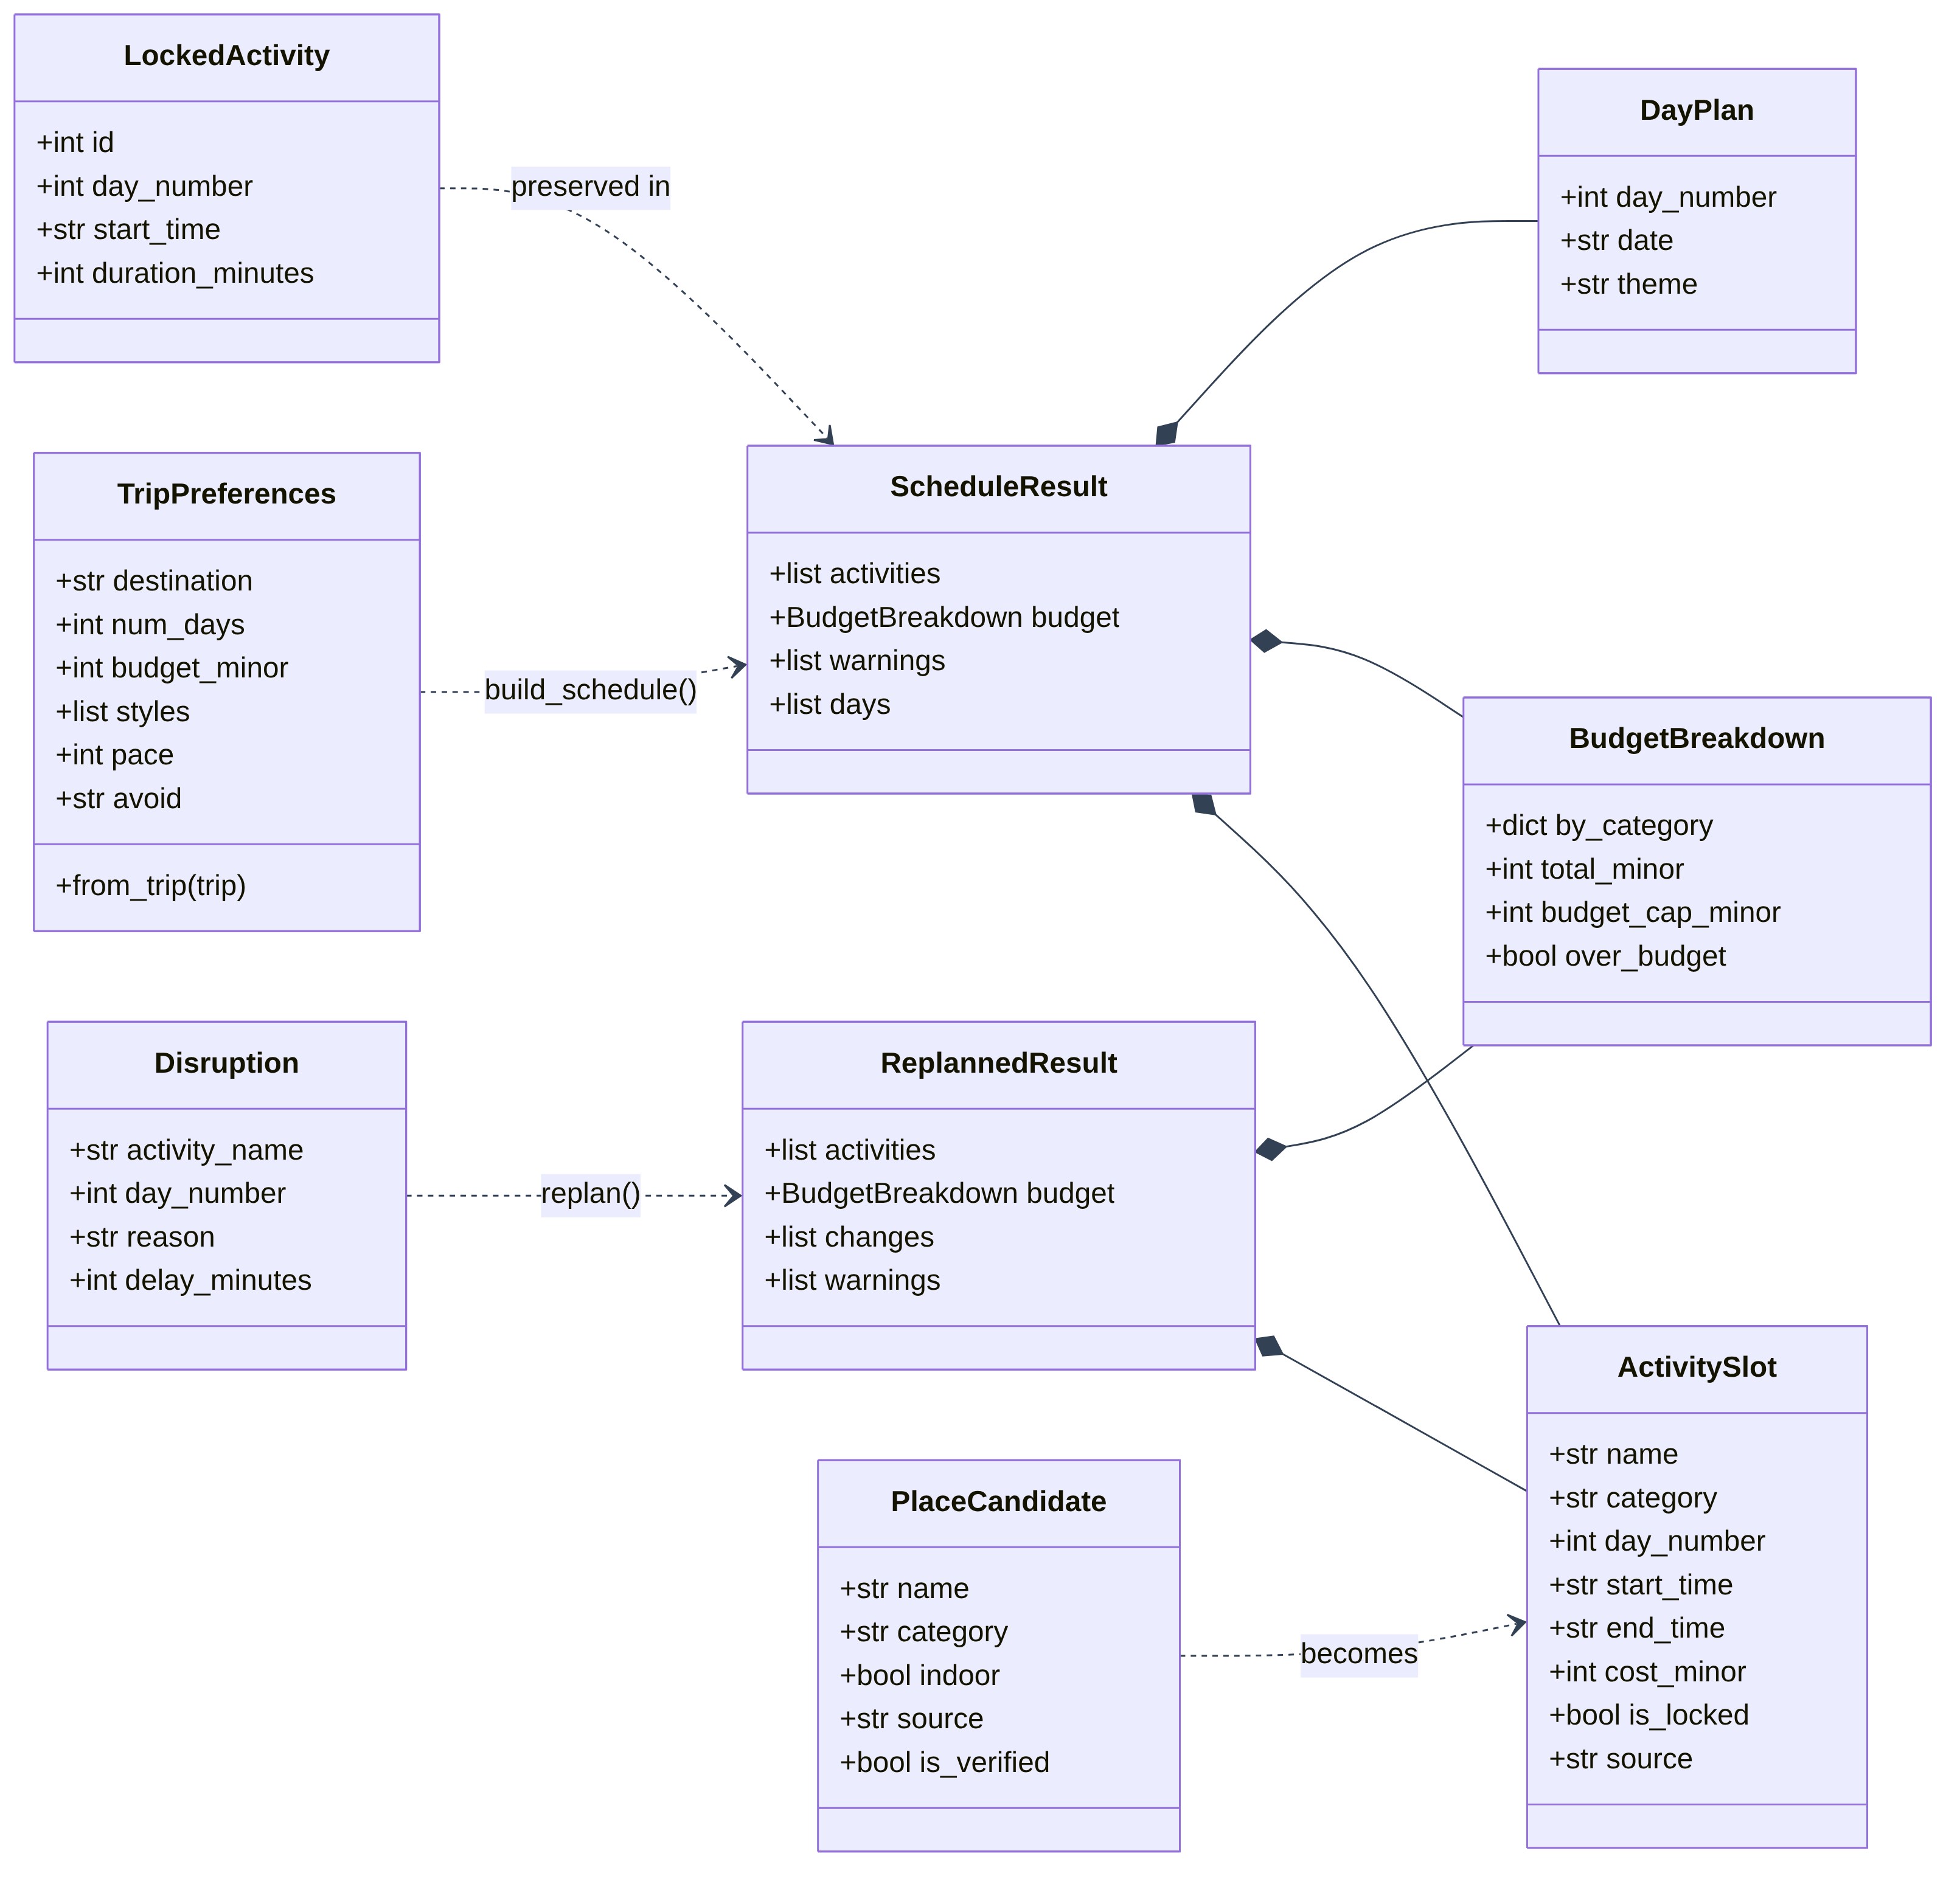
Figure 4.9: Class diagram – algorithm data structures

4.7 Sequence Diagrams
Sequence diagrams show how objects collaborate over time for the most important scenarios.

4.7.1 User Login
Figure 4.10 shows login. The authentication service always performs a bcrypt comparison – against a dummy hash if the email is unknown – so that response time does not reveal whether an account exists. On success, two httpOnly cookies are set and the React AuthContext updates its state.
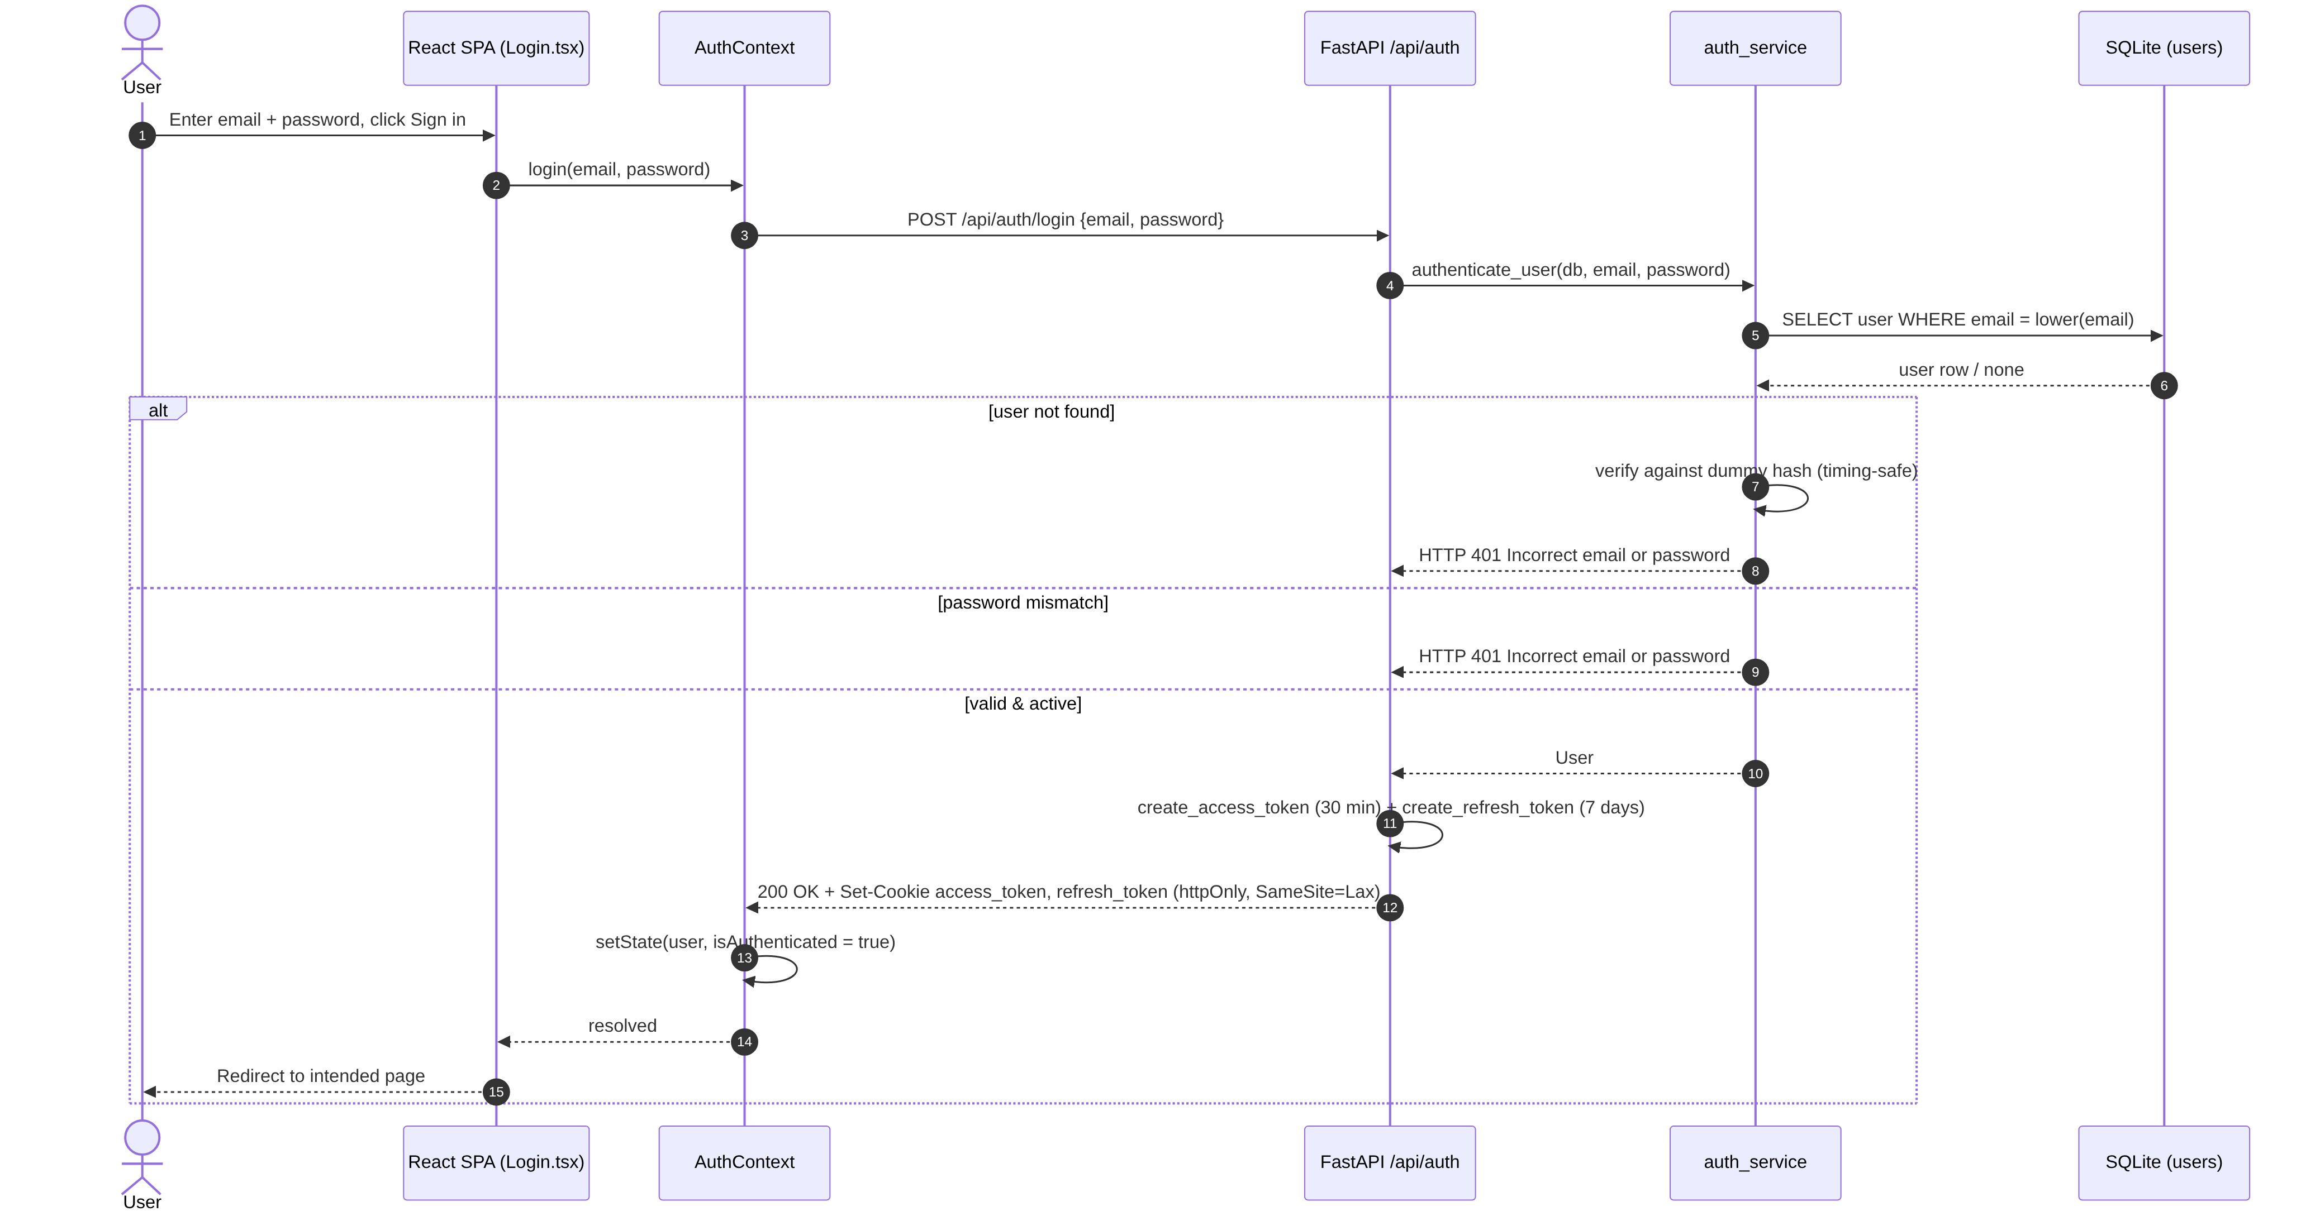
Figure 4.10: Sequence diagram – login

4.7.2 Password Reset with Mailjet Email
Figure 4.11 shows the password-reset flow after the Mailjet integration. A random single-use token valid for one hour is stored, and the email module sends a branded multipart message (plain text and HTML) over STARTTLS. The browser always receives the same generic message, whether or not the address is registered and whether or not sending succeeded; the token is returned in the response only in development mode, when SMTP is not configured.
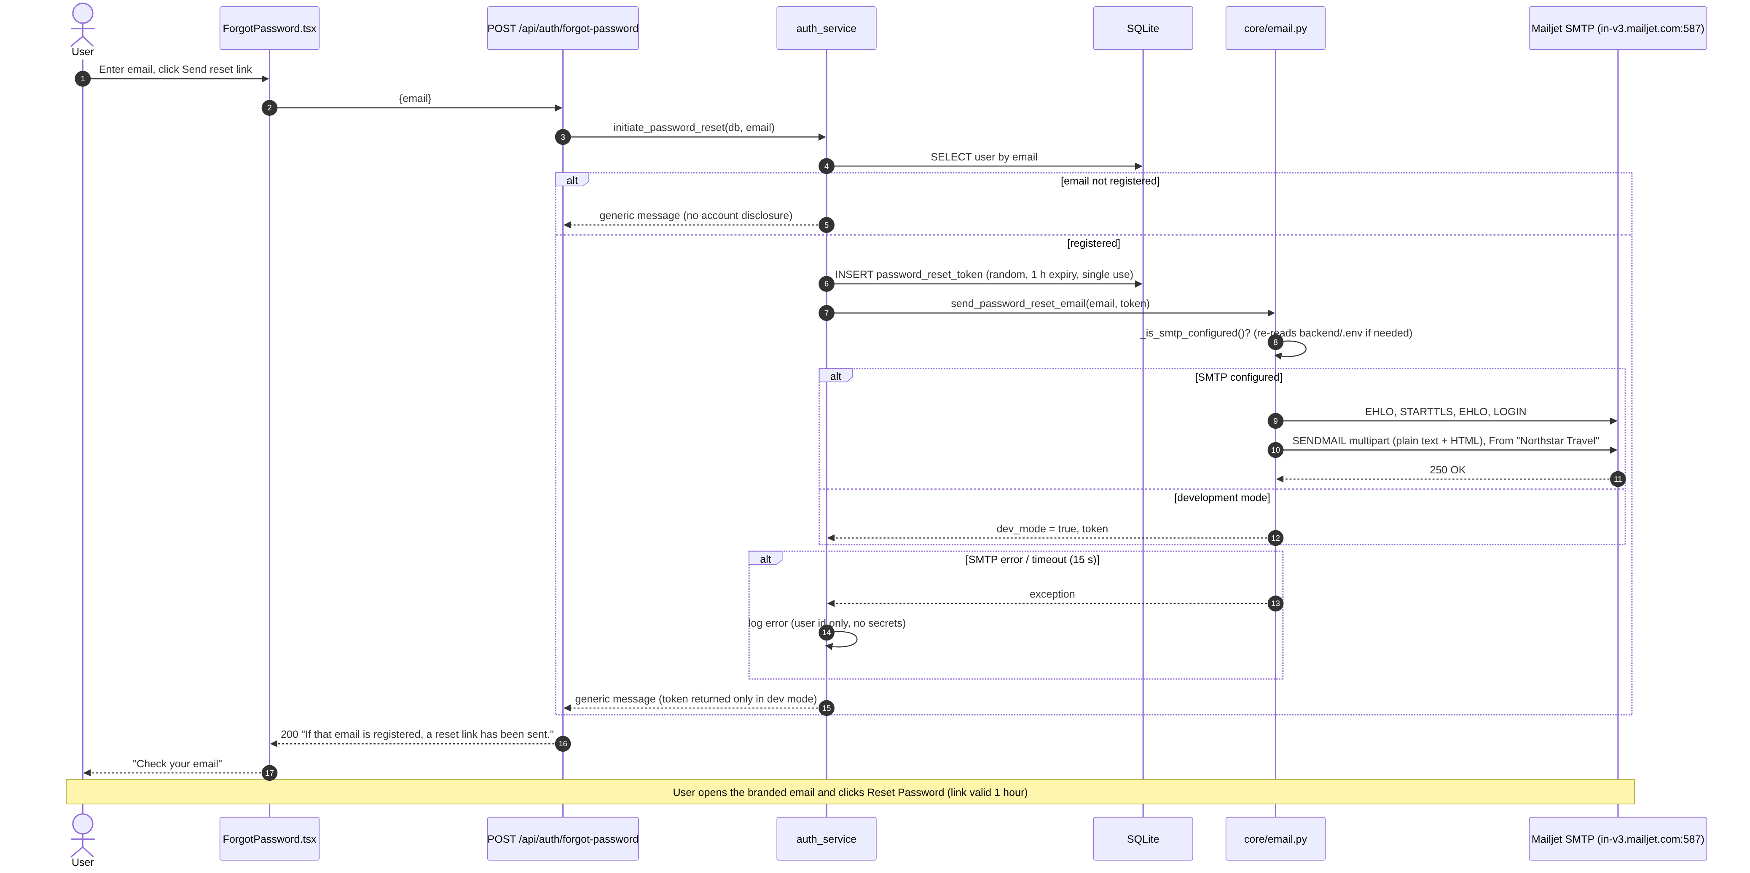
Figure 4.11: Sequence diagram – password reset via Mailjet

4.7.3 Itinerary Generation
Figure 4.12 shows the two-stage pipeline. Places and weather are gathered in parallel, the AI planner is tried when configured, and the deterministic scheduler is used on any failure. Unlocked activities are replaced in a single transaction only after a valid plan exists.
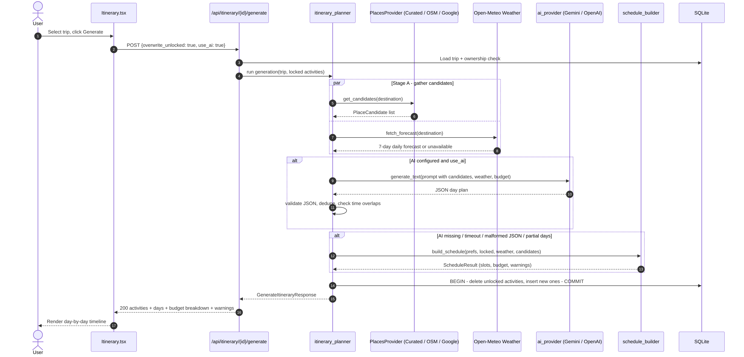
Figure 4.12: Sequence diagram – itinerary generation

4.7.4 Adding an Expense and Computing Settlements
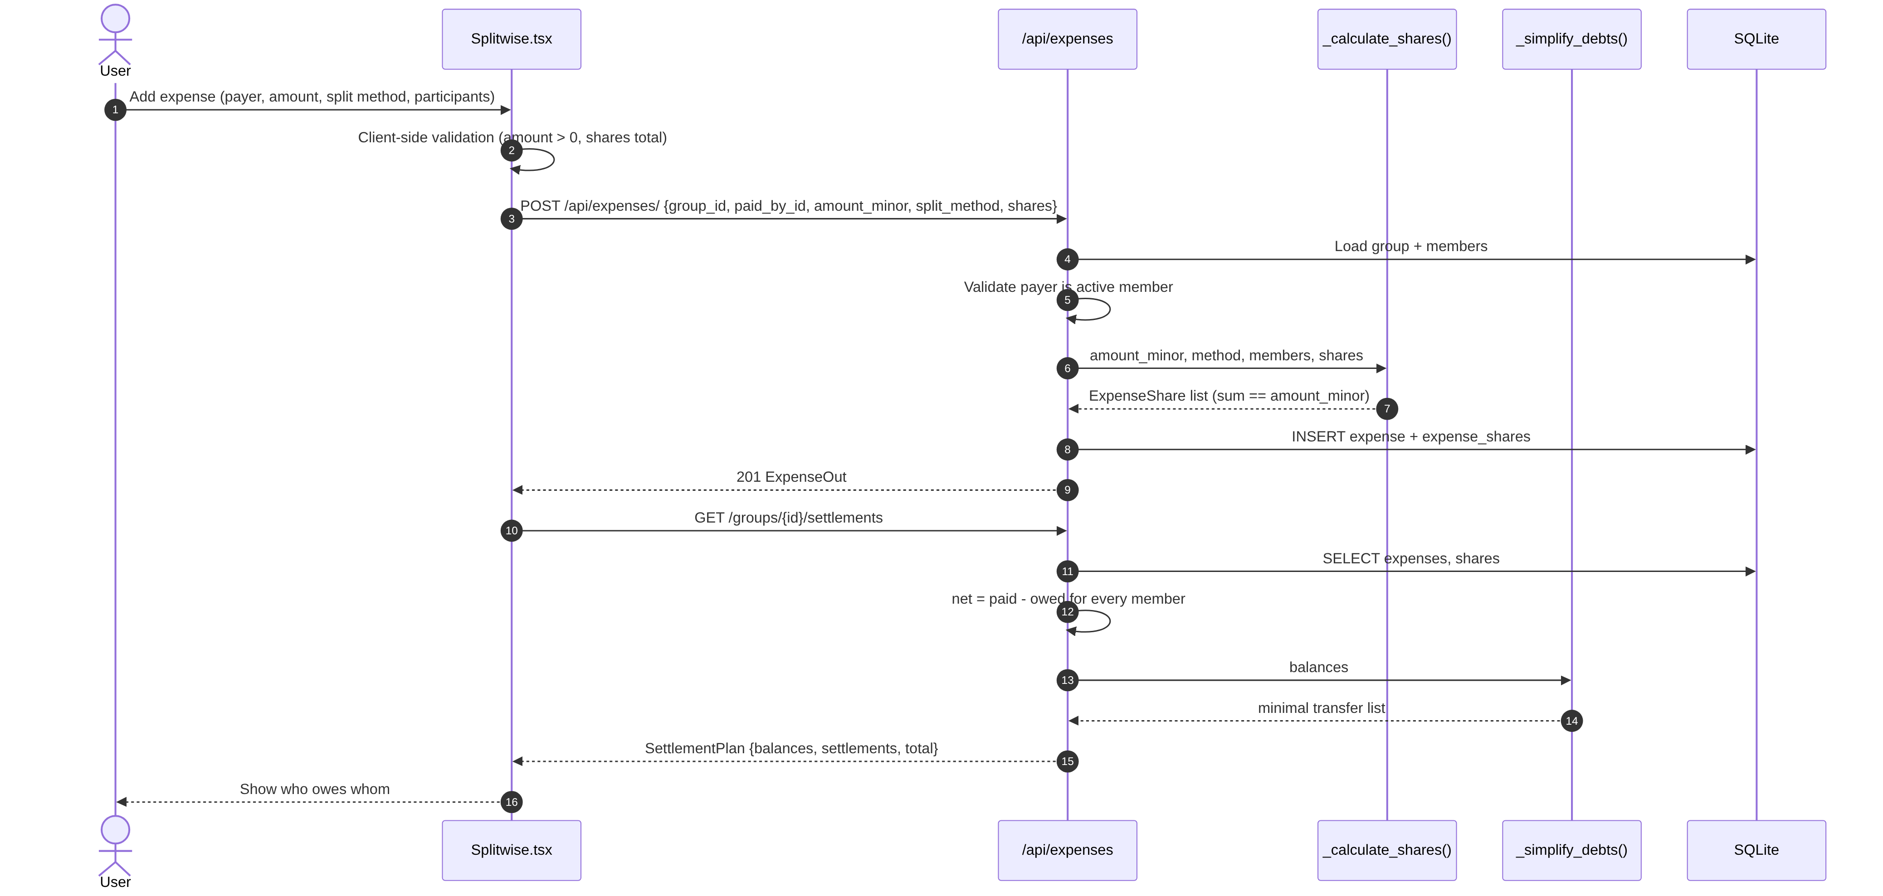
Figure 4.13: Sequence diagram – expense and settlement

4.7.5 Memory Capsule Media Upload
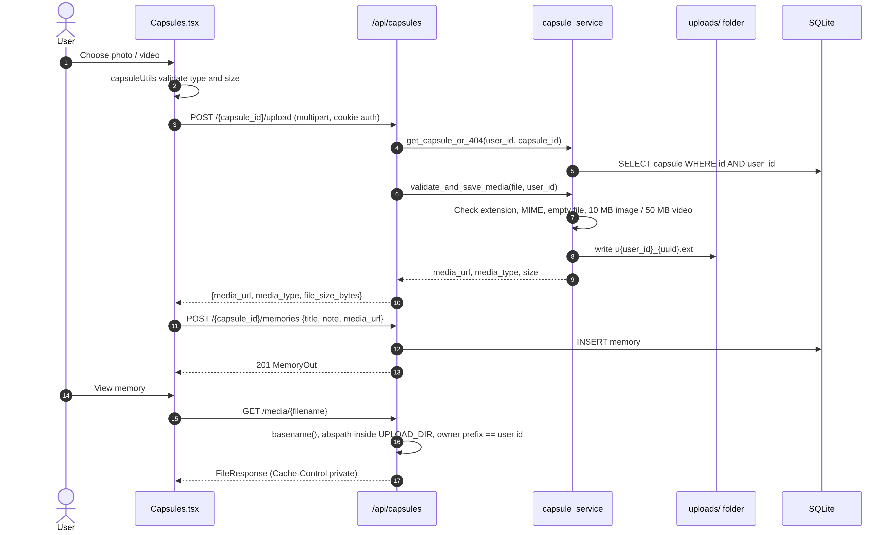
Figure 4.14: Sequence diagram – media upload and secure streaming

4.7.6 Global Currency Conversion
Figure 4.15 shows how the CurrencyProvider initialises. It reads the preference from the signed-in user or the browser, loads cached rates inside a try/catch, and fetches fresh reference rates in the background every hour. A failed request only marks the rates as stale; the page keeps rendering. Every CurrencyAmount then converts synchronously from the in-memory rate table.
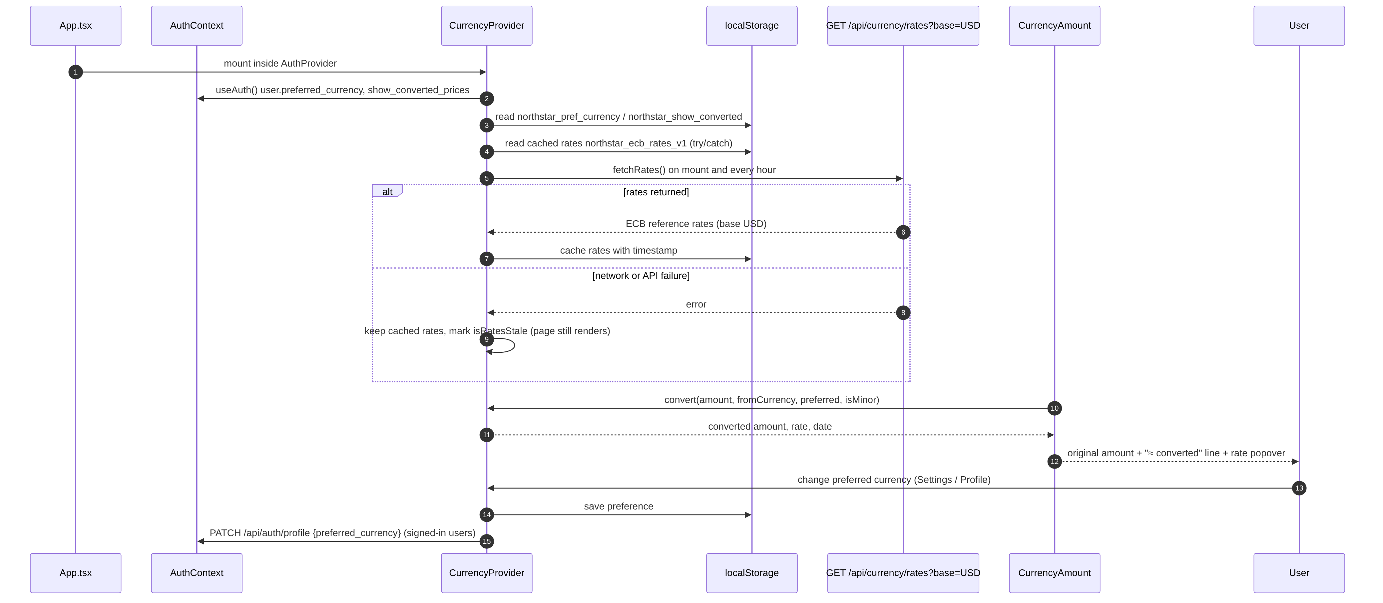
Figure 4.15: Sequence diagram – currency preference and inline conversion

4.7.7 AI Assistant Chat
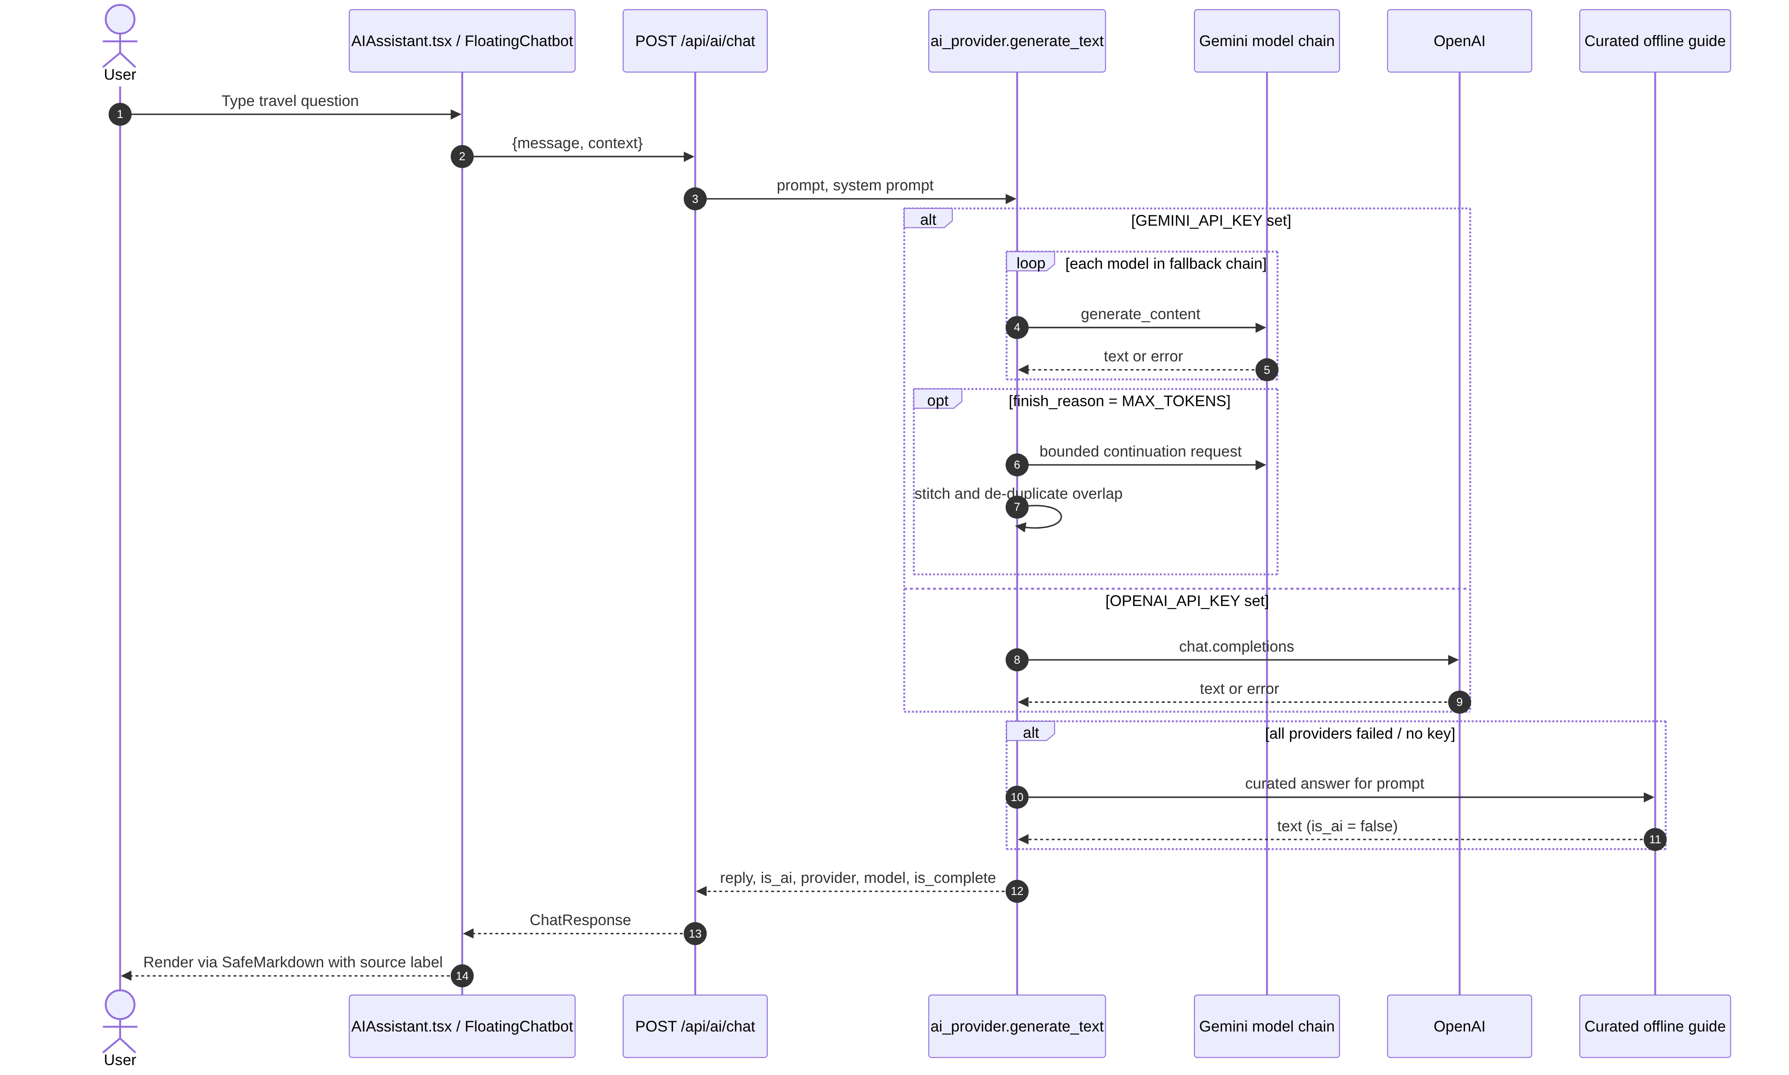
Figure 4.16: Sequence diagram – AI chat with fallback

4.8 State Diagrams
A trip moves through the states defined by the TripStatus enumeration (Figure 4.17). A user account moves through guest, unverified, verified and authenticated states, with time-limited tokens governing each transition (Figure 4.18).
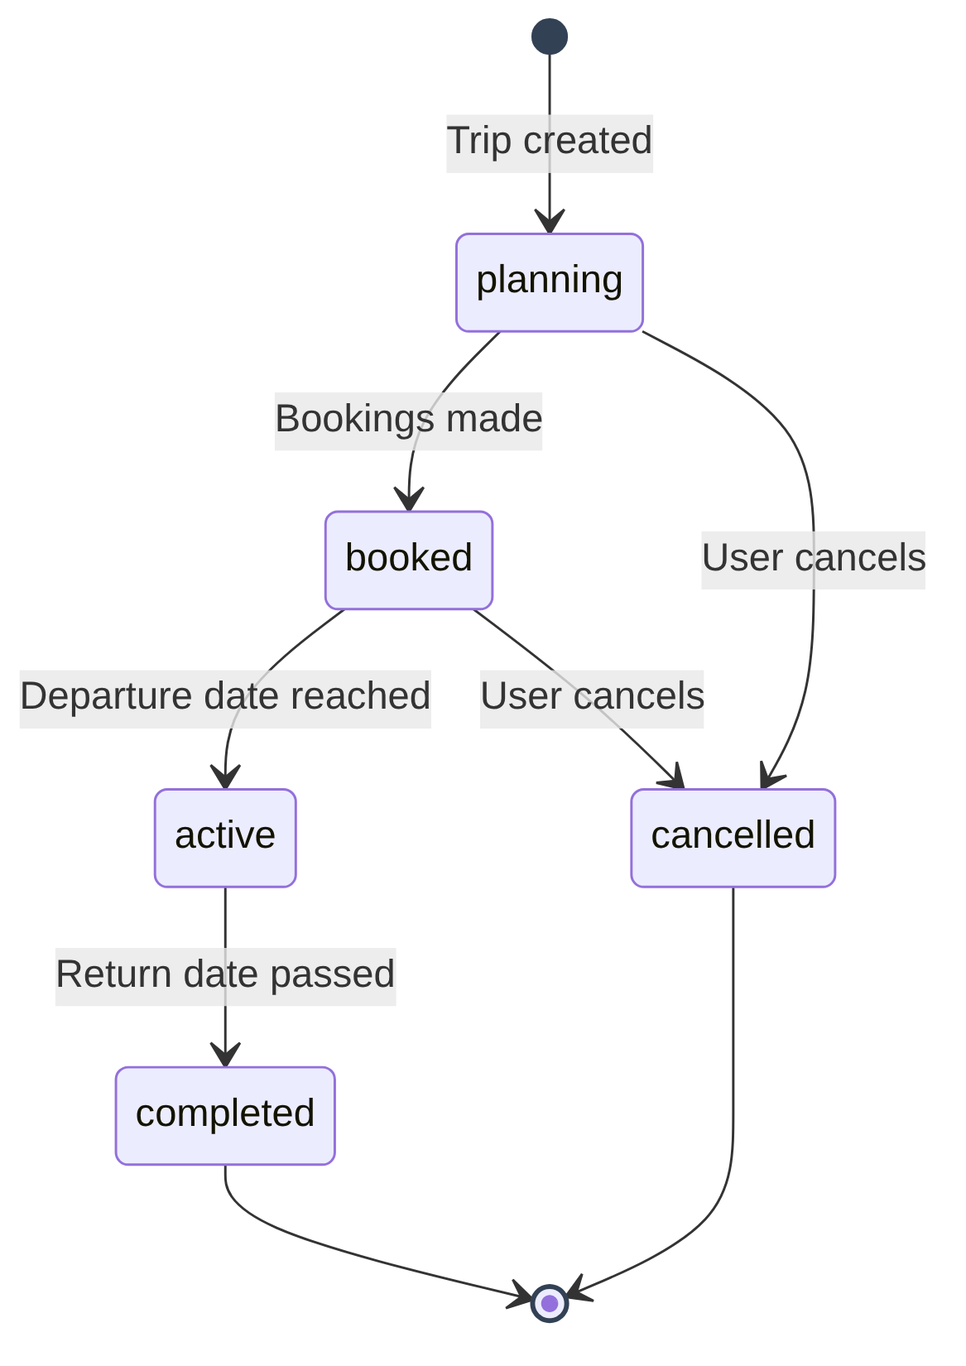
Figure 4.17: State diagram – trip status
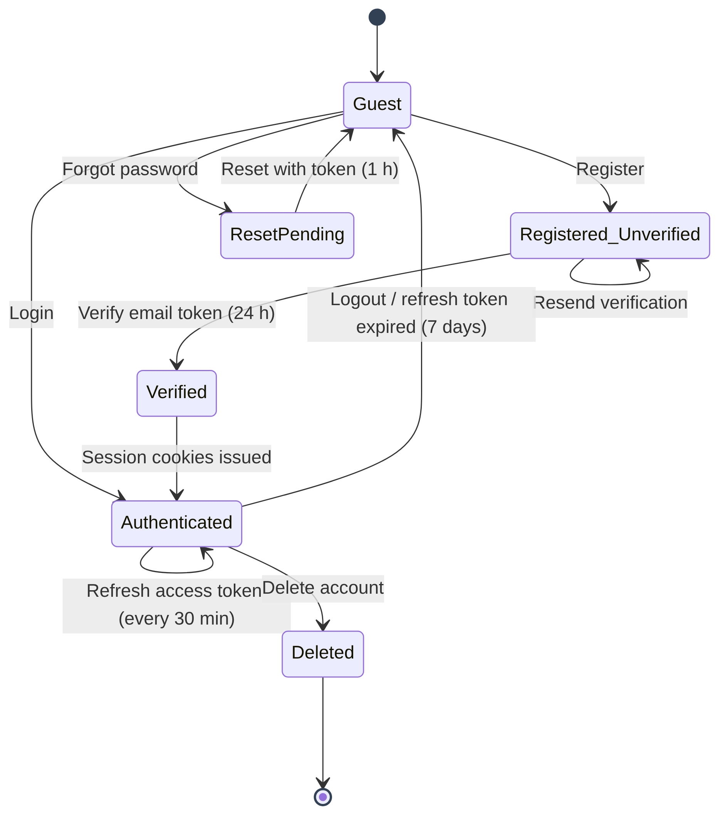
Figure 4.18: State diagram – user account and session

4.9 Deployment Design
Figure 4.19 shows the deployment view. For local demonstrations, start_local_demo.bat starts Uvicorn with auto-reload on port 8000 and the Vite dev server on port 5173. For production, the compiled frontend (frontend/dist) is served by static hosting with a rewrite rule that sends every path to index.html (configured in vercel.json), and the backend runs under Uvicorn with multiple workers on an application server with a persistent volume holding the database and uploads.
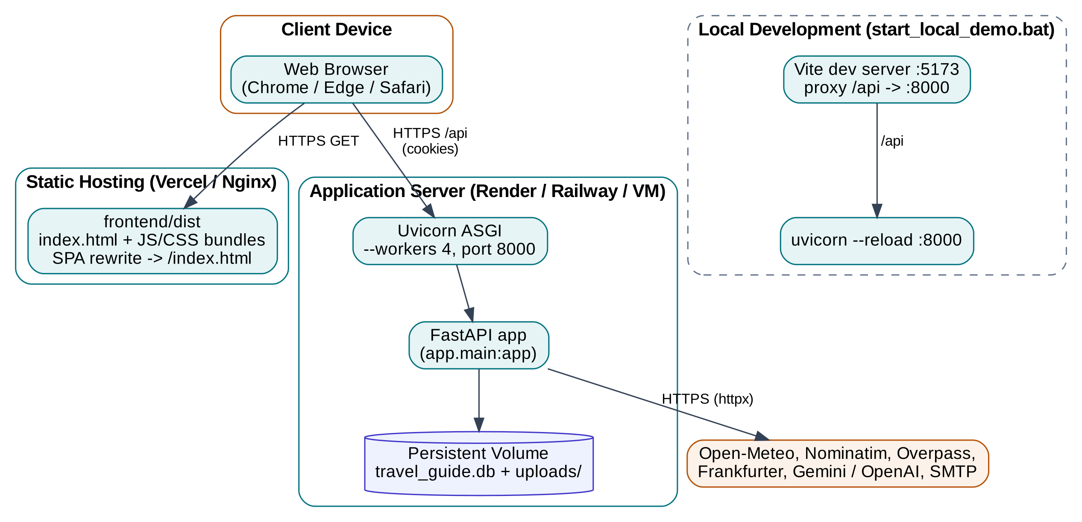
Figure 4.19: Deployment diagram

CHAPTER 5

BACKEND DESIGN

5.1 Technology Stack
The backend is written in Python 3.12 using FastAPI, an ASGI web framework built on Starlette and Pydantic. FastAPI was chosen for four reasons: it validates requests and serialises responses automatically from type-annotated Pydantic models; it supports both synchronous and async route handlers, which suits a service that waits on several external APIs; it generates interactive OpenAPI documentation at /docs; and its dependency-injection system makes cross-cutting concerns such as database sessions and the current user explicit in every handler signature.
Table 5.1: Backend technology stack
Library | Version | Purpose in Northstar
FastAPI | 0.115.6 | REST API framework, routing, dependency injection, OpenAPI docs
Uvicorn [standard] | 0.32.1 | ASGI server (auto-reload in development, multiple workers in production)
Pydantic / pydantic-settings | 2.10.4 / 2.7.0 | Request/response validation; typed settings loaded from .env
SQLAlchemy | 2.0.36 | ORM with typed Mapped[] columns, relationships and cascades
Alembic | 1.14.0 | Schema migration tooling (prepared for PostgreSQL migration)
HTTPX | 0.28.1 | Async HTTP client for Open-Meteo, Nominatim, Overpass and Frankfurter
bcrypt | 4.2.1 | Password hashing with per-password salt
python-jose[cryptography] | 3.3.0 | Signing and verifying HS256 JSON Web Tokens
email-validator | 2.2.0 | RFC-compliant email validation for EmailStr fields
python-multipart | 0.0.20 | Multipart form parsing for media uploads
google-genai / openai | ≥0.8 / ≥1.50 | LLM provider SDKs for Gemini and OpenAI
pytest / pytest-asyncio | 8.3.4 / 0.25.0 | Automated backend testing

5.2 Project Structure
The backend source tree is shown below. Each folder corresponds to one layer of Figure 4.2.
backend/
├── app/
│ ├── main.py # FastAPI app, CORS, router registration, lifespan
│ ├── core/
│ │ ├── config.py # Settings (pydantic-settings, .env)
│ │ ├── security.py # bcrypt + JWT helpers
│ │ └── email.py # SMTP / development-mode email
│ ├── database/session.py # engine, SQLite pragmas, SessionLocal, get_db
│ ├── models/ # base.py, user.py, capsule.py (ORM)
│ ├── schemas/ # schemas.py, auth_schemas.py, capsule_schemas.py
│ ├── api/ # 14 routers (auth, trips, itinerary, expenses, ...)
│ ├── services/ # auth_service, capsule_service, itinerary_planner
│ ├── algorithms/ # activity_catalogue, schedule_builder, plan_b_engine
│ └── integrations/ # weather, geocoding, places, currency, ai_provider
├── tests/ # 18 pytest modules, 210 tests
├── uploads/ # private Memory Capsule media (git-ignored)
├── requirements.txt
└── .env.example

5.3 Configuration Management
All configuration is centralised in the Settings class (app/core/config.py), which extends Pydantic’s BaseSettings. Values are read from environment variables or from a .env file searched in .env, backend/.env and ../.env, so the server behaves the same whether it is started from the project root or the backend folder. Derived properties such as is_ai_live, is_amadeus_live and demo_mode let the rest of the code ask what is available rather than inspecting keys directly. Secrets are never committed: .env is git-ignored and .env.example documents every key with an empty value.
Table 5.2: Principal configuration settings
Variable | Default | Meaning
DATABASE_URL | sqlite:///./travel_guide.db | SQLAlchemy connection URL; switch to PostgreSQL in production
SECRET_KEY | dev-secret-key-... | HS256 signing key for JWTs (32+ random characters in production)
DEBUG | True | Enables SQL echo logging
ACCESS_TOKEN_EXPIRE_MINUTES | 30 | Lifetime of the access token cookie
REFRESH_TOKEN_EXPIRE_DAYS | 7 | Lifetime of the refresh token cookie
FRONTEND_ORIGIN | http://localhost:5173 | Allowed CORS origin and base for email links
GEMINI_API_KEY / GEMINI_MODEL | – / gemini-3.8-flash | Primary AI provider and model
OPENAI_API_KEY / OPENAI_MODEL | – / gpt-4o-mini | Secondary AI provider
OPEN_METEO_BASE_URL | https://api.open-meteo.com/v1 | Weather API base (no key required)
GOOGLE_MAPS_API_KEY | – | Optional Google Places provider
AMADEUS_CLIENT_ID / SECRET | – | Optional flight API (developer notice only in this version)
SMTP_HOST, PORT, USER, PASSWORD, FROM | –, 587, –, –, – | Email delivery (Mailjet: in-v3.mailjet.com, 587, API key, secret key, verified sender); blank means development mode (tokens returned in API)
SMTP_FROM_NAME | Northstar Travel | Display name in the From header of every email

5.4 Database Design and Data Dictionary
The database layer (app/database/session.py) creates a single SQLAlchemy engine. For SQLite, a connect event listener enables Write-Ahead Logging (PRAGMA journal_mode=WAL) so that readers do not block the writer, sets a 30-second busy timeout, and uses synchronous=NORMAL for good durability with lower latency. check_same_thread=False allows the connection to be used by FastAPI’s worker threads. Every request receives its own session from the get_db dependency, which is always closed in a finally block.
Tables are created at start-up by Base.metadata.create_all(), which is idempotent. Older databases are upgraded in place without data loss by ensure_sqlite_schema() and the start-up handler: they add group_members.is_active and the new users.preferred_currency (default INR) and users.show_converted_prices (default true) columns when missing, and back-fill existing users with the defaults. Money is always stored as an integer number of minor units (paise for INR), and convenience properties such as budget_major and amount_major divide by 100 only for display.

5.4.1 Enumerations
Table 5.3: Enumerated types
Enum | Values
TravelStyle | outgoing, leisurely, adventure, luxury, budget, solo, romantic, family, group, cultural, food_nightlife, nature_wellness
TripStatus | planning, booked, active, completed, cancelled
ActivityCategory | sightseeing, food, nightlife, adventure, wellness, culture, nature, shopping, transport, accommodation, rest, other
SplitMethod | equal, exact, percentage, shares

5.4.2 Table Definitions
Table 5.4: Data dictionary – users
Column | Type | Constraints | Description
id | INTEGER | PK, index | Surrogate key
name | VARCHAR(150) | NOT NULL | Display name (HTML characters rejected)
email | VARCHAR(254) | UNIQUE, NOT NULL, index | Login email, stored in lower case
hashed_password | VARCHAR(255) | NOT NULL | bcrypt hash; plain password never stored
is_active | BOOLEAN | default TRUE | Deactivated users cannot log in
is_verified | BOOLEAN | default FALSE | Set after email verification
theme | VARCHAR(20) | nullable | light | dark | colourful
palette | VARCHAR(20) | nullable | ocean | sunset | tropical | lavender | rose | forest | custom
custom_accent | VARCHAR(7) | nullable | Hex colour #rrggbb
preferred_currency | VARCHAR(3) | default INR | ISO 4217 code used for converted equivalents
show_converted_prices | BOOLEAN | default TRUE | Show “≈ converted” lines beneath prices
created_at / updated_at | DATETIME | server default now() | Audit timestamps

Table 5.5: Data dictionary – trips
Column | Type | Constraints | Description
id | INTEGER | PK | Surrogate key
user_id | INTEGER | FK users.id, SET NULL, index | Owner; NULL for demo/unowned trips
name / origin / destination | VARCHAR(200) | NOT NULL | Trip title and route
departure_date / return_date | DATE | NOT NULL | Return must not precede departure
num_days | INTEGER | NOT NULL | (return − departure) + 1, minimum 1
num_travellers | INTEGER | default 1 (1–50) | Group size
budget_minor | INTEGER | NOT NULL, ≥ 0 | Budget cap in minor units; 0 = uncapped
currency | VARCHAR(3) | default INR | ISO 4217 code
status | ENUM TripStatus | default planning | Life-cycle state
is_demo | BOOLEAN | default FALSE | Clearly labelled sample data
travel_styles | TEXT | nullable | Comma-separated TravelStyle values
accommodation_pref / transport_pref / food_pref | VARCHAR | nullable | Free-text preferences
must_visit / avoid | TEXT | nullable | Comma-separated keywords used by the scheduler
walking_tolerance / travel_pace | INTEGER | default 5 (1–10) | Pace controls activities per day
notes | TEXT | nullable | Free notes
created_at / updated_at | DATETIME | server default | Audit timestamps

Table 5.6: Data dictionary – activities
Column | Type | Constraints | Description
id | INTEGER | PK | Surrogate key
trip_id | INTEGER | FK trips.id, NOT NULL | Parent trip (cascade delete)
day_number | INTEGER | NOT NULL, ≥ 1 | 1-indexed day of the trip
name | VARCHAR(300) | NOT NULL | Activity or place name
category | ENUM ActivityCategory | default sightseeing | Used for budget breakdown
location / latitude / longitude | VARCHAR / FLOAT | nullable | Place details
start_time / end_time | VARCHAR(5) | nullable | "HH:MM" in destination local time
duration_minutes | INTEGER | default 60 | Planned duration
cost_minor / currency | INTEGER / VARCHAR(3) | default 0 / INR | Estimated cost
is_locked | BOOLEAN | default FALSE | Locked activities are preserved
is_confirmed / booking_required | BOOLEAN | default FALSE | Booking flags (never auto-confirmed)
notes / recommendation_reason / opening_hours | TEXT / VARCHAR | nullable | Explanations shown to the user

Table 5.7: Data dictionary – expense_groups and group_members
Column | Type | Constraints | Description
expense_groups.id | INTEGER | PK | Group key
expense_groups.trip_id | INTEGER | FK trips.id, nullable | Optional link to a trip
expense_groups.name / currency | VARCHAR(200) / (3) | NOT NULL / INR | Group title and currency
group_members.id | INTEGER | PK | Member key
group_members.group_id | INTEGER | FK expense_groups.id | Parent group
group_members.name / email | VARCHAR(100) / (200) | NOT NULL / nullable | Member identity
group_members.is_active | BOOLEAN | default TRUE | FALSE after the member leaves

Table 5.8: Data dictionary – expenses and expense_shares
Column | Type | Constraints | Description
expenses.id | INTEGER | PK | Expense key
expenses.group_id | INTEGER | FK expense_groups.id | Parent group
expenses.paid_by_id | INTEGER | FK group_members.id | Member who paid
expenses.description | VARCHAR(300) | NOT NULL | What the money was for
expenses.amount_minor | INTEGER | NOT NULL, ≥ 1 | Total amount in minor units
expenses.category / split_method | VARCHAR(50) / ENUM | other / equal | Category and split rule
expenses.expense_date / notes | DATE / TEXT | NOT NULL / nullable | When and notes
expense_shares.id | INTEGER | PK | Share key
expense_shares.expense_id / member_id | INTEGER | FK | Which expense, which member
expense_shares.share_minor | INTEGER | NOT NULL, ≥ 0 | Member’s share; shares sum to amount_minor

Table 5.9: Data dictionary – capsules and memories
Column | Type | Constraints | Description
capsules.id | INTEGER | PK | Capsule key
capsules.user_id | INTEGER | FK users.id, CASCADE, index | Owner
capsules.title / description / destination | VARCHAR(200) / TEXT | title NOT NULL | Capsule details
capsules.start_date / end_date | DATE | nullable, end ≥ start | Occasion dates
capsules.cover_image_url | VARCHAR(500) | nullable | Cover media URL
memories.id | INTEGER | PK | Memory key
memories.capsule_id | INTEGER | FK capsules.id, CASCADE | Parent capsule
memories.title / note / memory_date / location | VARCHAR / TEXT / DATE | nullable | Memory details
memories.media_type | VARCHAR(20) | default image | image | video
memories.media_url / thumbnail_url | VARCHAR(500) | media_url NOT NULL | /api/capsules/media/{file}
memories.file_size_bytes / display_order | INTEGER | default order 0 | Size and ordering

Table 5.10: Data dictionary – search_history and token tables
Column | Type | Constraints | Description
search_history.id / user_id | INTEGER | PK / FK users.id | Entry and owner
search_history.event_type | VARCHAR(50) | NOT NULL | search | itinerary_generated | trip_created | trip_viewed | favourite
search_history.label / payload | VARCHAR(300) / TEXT | label NOT NULL | Readable label and JSON payload
search_history.is_saved / trip_id | BOOLEAN / INTEGER | FK trips.id SET NULL | Bookmark flag and link
(index) ix_search_history_user_id_created | – | composite | Fast per-user chronological listing
email_verification_tokens.token | VARCHAR(128) | UNIQUE, index | 64-char URL-safe random token, 24 h expiry, single use
password_reset_tokens.token | VARCHAR(128) | UNIQUE, index | Random token, 1 h expiry, single use
*.expires_at / used | DATETIME / BOOLEAN | NOT NULL | is_valid() = not used and now < expires_at

5.5 API Design
The API follows REST conventions. Resources are nouns under /api, HTTP methods express the action, and responses use standard status codes: 200 OK, 201 Created, 204 No Content, 400 Bad Request (business-rule violation), 401 Unauthorized (not logged in), 403 Forbidden (not the owner), 404 Not Found, 409 Conflict (duplicate email), 422 Unprocessable Entity (Pydantic validation failure), 500 Internal Server Error and 503 Service Unavailable (external provider down). Errors are returned as JSON with a human-readable detail field, which the frontend’s getErrorMessage() helper extracts for display. Fourteen routers expose more than 70 endpoints; they are summarised below, and the interactive specification is available at /docs.

5.5.1 Authentication API (/api/auth)
Table 5.11: Authentication endpoints
Method | Path | Auth | Description
POST | /register | No | Create account, set cookies, send verification email (201)
POST | /login | No | Verify credentials and set access/refresh cookies
POST | /logout | No | Clear auth cookies
GET | /me | Yes | Return the current user
POST | /refresh | Refresh cookie | Issue a new access token
POST | /verify-email | No | Consume a verification token
POST | /resend-verify | Yes | Re-send the verification email
POST | /forgot-password | No | Start password reset (same response for unknown emails)
POST | /reset-password | No | Set a new password using a reset token
PATCH | /profile | Yes | Update name, theme, palette, custom accent, preferred currency and converted-price toggle
POST | /change-password | Yes | Change password after verifying the current one
DELETE | /account | Yes | Delete account and all owned data

5.5.2 Trips, Activities and Itinerary APIs
Table 5.12: Trip, activity and itinerary endpoints
Method | Path | Auth | Description
GET | /api/trips/ | Optional | List own trips plus demo trips
POST | /api/trips/ | Optional | Create a trip (owned if logged in)
GET | /api/trips/{id} | Optional | Get one trip (403 if another user’s)
PATCH / PUT | /api/trips/{id} | Owner | Update trip fields; recompute days
DELETE | /api/trips/{id} | Owner | Delete trip and its activities (204)
GET | /api/activities/trip/{trip_id} | No | List activities of a trip
POST | /api/activities/ | No | Add a manual activity
GET | /api/activities/{id} | No | Get one activity
PATCH | /api/activities/{id}/lock | No | Toggle the locked flag
DELETE | /api/activities/{id} | No | Delete an activity
POST | /api/itinerary/{trip_id}/generate | Owner / demo | Generate or regenerate the itinerary
GET | /api/itinerary/{trip_id} | Owner / demo | Full day-by-day itinerary with completeness flags
POST | /api/itinerary/{trip_id}/replan | Owner / demo | Apply a disruption and return the changes
GET | /api/itinerary/{trip_id}/budget | Owner / demo | Planned vs actual budget breakdown

The generate endpoint returns the complete itinerary. An abbreviated real response for the seeded Goa demo trip is shown below; note the integer minor units, the explicit completeness flags and the ai_enhanced attribution.
{
"trip_id": 1,
"activities": [ {
"day_number": 1, "name": "Basilica of Bom Jesus", "category": "culture",
"location": "Old Goa", "start_time": "09:00", "end_time": "10:30",
"duration_minutes": 90, "cost_minor": 0, "currency": "INR", "is_locked": false,
"recommendation_reason": "UNESCO World Heritage Site completed in 1605 ...",
"opening_hours": "09:00-18:30" }, ... ],
"days": [ { "day_number": 1, "date": "2026-11-22",
"theme": "Historic Heritage & Cultural Beginnings", "status": "scheduled" }, ... ],
"budget": { "by_category": { "culture": 35000, "food": 115000, "sightseeing": 55000,
"nature": 50000, "shopping": 0 },
"total_minor": 255000, "budget_cap_minor": 5000000, "over_budget": false,
"actual_spent_minor": 0, "remaining_minor": 4745000 },
"warnings": [], "is_demo": true, "calendar_complete": true,
"schedule_complete": true, "ai_enhanced": false
}

5.5.3 Expenses (Splitwise) API (/api/expenses)
Table 5.13: Expense and settlement endpoints
Method | Path | Description
GET | /groups | List expense groups
POST | /groups | Create a group with members, optionally linked to a trip (group currency aligned to trip)
GET | /groups/{id} | Get group with members
POST | /groups/{id}/members | Add a member
DELETE | /groups/{id}?force= | Delete group; refused while balances are unsettled unless force=true
POST | /groups/{id}/leave | Member leaves; refused while the member has a non-zero balance
GET | /groups/{id}/expenses | List expenses with shares
POST | / | Create expense with split method, participants and shares
GET / PUT / DELETE | /{expense_id} | Read, update (re-split) or delete an expense
POST | /groups/{id}/settle | Record a settlement payment between two members
GET | /groups/{id}/settlements | Balances and minimal settlement plan

5.5.4 Memory Capsules API (/api/capsules)
Table 5.14: Memory Capsule endpoints (all require authentication)
Method | Path | Description
GET | / | List the user’s capsules (optional search text)
POST | / | Create a capsule (201)
GET / PUT / DELETE | /{capsule_id} | Read, update or delete a capsule (and its files)
POST | /{capsule_id}/upload | Upload a photo/video (multipart)
POST | /{capsule_id}/memories | Create a memory
PUT / DELETE | /{capsule_id}/memories/{memory_id} | Update or delete a memory
PUT | /{capsule_id}/reorder | Set the display order of memories
GET | /media/{filename} | Stream a media file to its owner only

5.5.5 Information, AI and Utility APIs
Table 5.15: Weather, currency, AI, history and platform endpoints
Method | Path | Description
GET | /api/weather?city= | lat=&lon= | Current conditions, 24-hour trend and 7-day forecast
GET | /api/weather/geocoding?q= | Worldwide destination suggestions
GET | /api/currency/currencies | Supported currencies with names
GET | /api/currency/convert?from=&to=&amount= | Convert an amount with rate, inverse rate and date
GET | /api/currency/rates?base= | Reference rate table for a base currency
GET | /api/ai/status | Whether live AI is configured; active model
POST | /api/ai/chat | Chat message (1–4000 chars) with optional context
POST | /api/ai/enrich-itinerary | AI suggestions for an existing trip (budget, food, culture, adventure, general)
GET / POST | /api/history/ | List (filter by event type) or add history items
PATCH | /api/history/{id}/save | Toggle saved flag
DELETE | /api/history/{id} | /?confirm=true | Delete one item or clear all (confirmation required)
GET | /api/health | Health check with demo-mode flag
GET | /api/health/smtp-status | Whether email delivery is configured: host, port, sender, and presence (not values) of credentials
GET / POST | /api/demo/status | /seed | /destinations | Demo status, idempotent seeding, curated destinations
GET | /api/integrations/status | Status of every integration and overall live/hybrid/demo mode

5.6 Security Design

5.6.1 Password Storage
Passwords are hashed with bcrypt using a fresh random salt for every password (bcrypt.gensalt()). bcrypt is deliberately slow, which makes brute-force attacks on a stolen database expensive. Because bcrypt only considers the first 72 bytes, input is truncated to 72 bytes consistently during both hashing and verification. Password strength is enforced by Pydantic validators: 8–128 characters with at least one uppercase letter and one digit.

5.6.2 Token-Based Sessions
On login or registration the server issues two HS256-signed JWTs. The access token contains sub (user id), email, type: "access" and a 30-minute expiry; the refresh token contains sub, type: "refresh" and a 7-day expiry. Both are set as cookies with httponly=True, samesite="lax" and path="/", with secure=True required in production over HTTPS. Because the cookies are httpOnly, JavaScript running in the page – including any injected script – cannot read them. The type claim prevents a refresh token from being used as an access token.
The get_current_user dependency reads the access_token cookie (or, for API clients, an Authorization: Bearer header), decodes it, checks the type, and loads an active user, raising 401 otherwise. A variant, get_current_user_optional, returns None instead, which lets public endpoints such as trip listing behave differently for guests and owners.

5.6.3 Authorisation and Ownership
Every private resource is checked on the server: trips with a non-null user_id that are not demo trips can be read or modified only by their owner (403 otherwise); capsules are always queried with both id and user_id, so another user’s capsule returns 404 without revealing its existence; history entries are filtered by user; expense groups linked to a trip inherit the trip’s ownership. These rules are covered by dedicated cross-user isolation tests.

5.6.4 Protection Against Common Attacks
Table 5.16: Threats and mitigations
Threat | Mitigation in Northstar
User enumeration | Identical error for unknown email and wrong password; dummy bcrypt comparison keeps timing equal; forgot-password always returns the same message.
Cross-site scripting (XSS) | Tokens in httpOnly cookies; React escapes output; AI answers rendered by SafeMarkdown, which only produces safe elements and refuses javascript: and other unsafe link schemes; names with HTML characters rejected.
Cross-site request forgery | SameSite=Lax cookies; CORS restricted to configured origins with credentials.
Path traversal | Media filenames passed through os.path.basename; absolute path must remain inside UPLOAD_DIR; otherwise 404.
Malicious uploads | Extension and MIME allow-lists, empty-file rejection, 10 MB/50 MB limits, server-generated UUID filenames.
Token replay | Verification and reset tokens are single-use with expiry; JWTs expire; refresh tokens checked for type.
SQL injection | All queries built with the SQLAlchemy ORM using bound parameters.
Secrets leakage | Keys only in backend .env (git-ignored); frontend contains no secrets; AI calls proxied through the backend.
Token leakage by email flow | With SMTP enabled, verification and reset tokens are sent only by email and never returned in API responses; send failures are logged with the user id only, never credentials.
Accidental mass deletion | Clearing history requires confirm=true; deleting groups with balances requires force=true.

5.7 Algorithm Design

5.7.1 Schedule Builder
The schedule builder (app/algorithms/schedule_builder.py) is the deterministic heart of itinerary planning. It is a pure function build_schedule(prefs, locked, weather_days, candidate_places) → ScheduleResult. Its constants and parameters are listed in Table 5.15 and its control flow in Figure 5.1.
Table 5.17: Scheduling constants and parameters
Name | Value | Meaning
DAY_START_MINUTES | 540 (09:00) | Earliest start of any activity
DAY_END_MINUTES | 1320 (22:00) | Latest end of any activity
USABLE_MINUTES | 780 | Usable minutes per day
TRAVEL_BUFFER | 20 min | Gap inserted after each activity for transit
Morning window | 09:00–13:00 | For activities tagged morning
Afternoon window | 12:00–18:00 | For activities tagged afternoon
Evening window | 17:00–22:00 | For activities tagged evening
Activities per day | pace ≤3: 2; ≤6: 3; ≤8: 4; else 5 | Derived from travel_pace (1–10)

Each candidate activity a is scored against the trip’s travel styles S, the remaining budget R and the pace p:
style(a) = |S ∩ styles(a)| / |S| (0.5 if no styles chosen)
budget(a) = max(0, 1 − cost(a) / R) (1 if free; 0 if R ≤ 0 and cost > 0)
penalty(a) = max(0, (duration(a) − 360) / 360) if p < 5, else 0
score(a) = 0.55 · style(a) + 0.30 · budget(a) + 0.15 · (1 − penalty(a))

The weights express the design priority: matching what the traveller enjoys matters most, affordability second, and avoiding very long activities for slow-paced travellers third. The algorithm first places locked activities on their days, filters out candidates matching the avoid-list, then fills each day greedily with the highest-scoring candidate that fits both the day-part window and the remaining budget. A cursor tracks the end of the last activity plus the 20-minute buffer. On rainy forecast days (precipitation above 1.5 mm or rain/snow WMO codes) indoor candidates are boosted and an advisory is added. Finally the category-wise BudgetBreakdown is computed and validate_schedule() reports any overlap between activities on the same day.
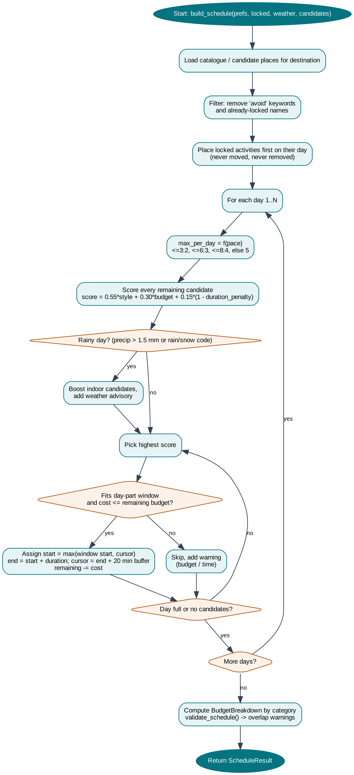
Figure 5.1: Flowchart of the schedule builder
The complexity is O(D · k · n) for D days, at most k activities per day and n candidates, because each placement scans the remaining candidates once. With n typically below 200, generation completes in milliseconds.

5.7.2 Schedule Validator
validate_schedule(slots) groups slots by day, sorts them by start time and compares each slot with the next. An overlap exists when the next start is earlier than the current end. Adjacent activities (end equals next start) and activities on different days are not flagged. The function returns a list of human-readable warnings and is used both after generation and in tests.

5.7.3 Plan-B Replanning Engine
The Plan-B engine (plan_b_engine.replan) repairs a schedule when the user reports a Disruption – an activity name, a day and a reason (closure, cancellation or delay with minutes). Its rules are: locked activities are never removed (a warning is returned instead); only the affected day is changed; a delay shifts the activity and cascades later activities on the same day, but a delay pushing beyond 22:00 is treated as a closure; a removed activity leaves a gap that is filled with the best alternative that fits, is not avoided and is not already in the plan; and every change is recorded as a plain-English sentence for the user (Figure 5.2).
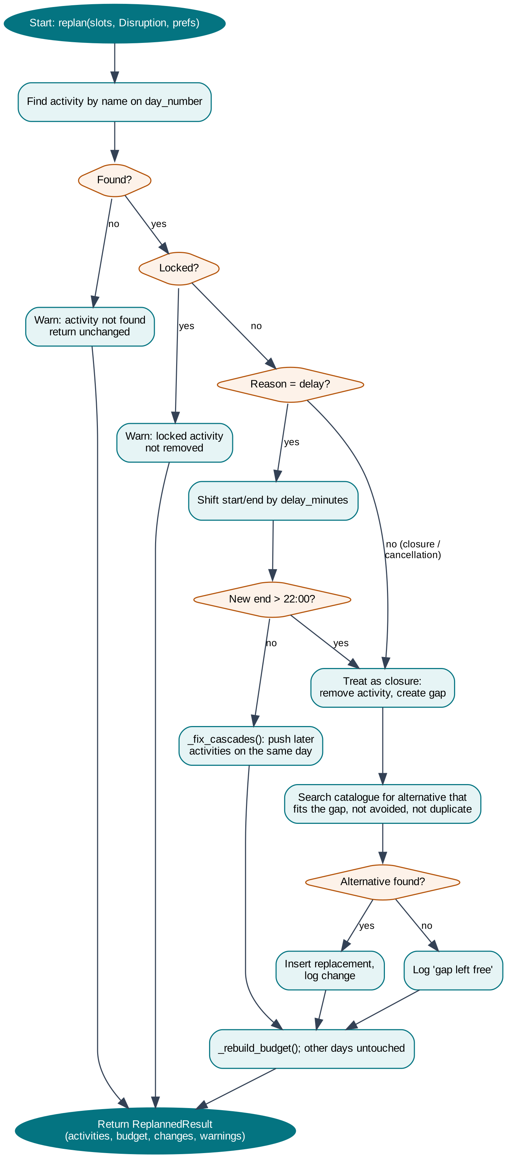
Figure 5.2: Flowchart of the Plan-B replanning engine

5.7.4 Expense Share Calculation
_calculate_shares() converts an expense into per-member shares and guarantees that the shares sum exactly to the amount in minor units. For equal splits it computes base = amount // n and gives one extra unit to the first amount − base·n participants. For example, ₹100.00 (10000 paise) among three people gives 3334, 3333 and 3333 paise. Exact splits must sum to the amount, otherwise the request is rejected with a message stating both totals. Percentage splits accept whole percentages summing to 100 or basis points summing to 10000; every share except the last is rounded and the last receives the remainder. Shares-based splits divide proportionally by integer weights, again assigning the remainder to the last participant. Participants must be active members of the group, must not be duplicated, and at least one must be selected.

5.7.5 Debt Simplification
Balances are computed as net = paid − owed for every member; by construction they sum to zero. _simplify_debts() sorts creditors (positive net) and debtors (negative net) in descending order of magnitude and repeatedly transfers min(credit, debt) from the current debtor to the current creditor, advancing whichever side reaches zero (Figure 5.3). The result has at most n − 1 transfers.
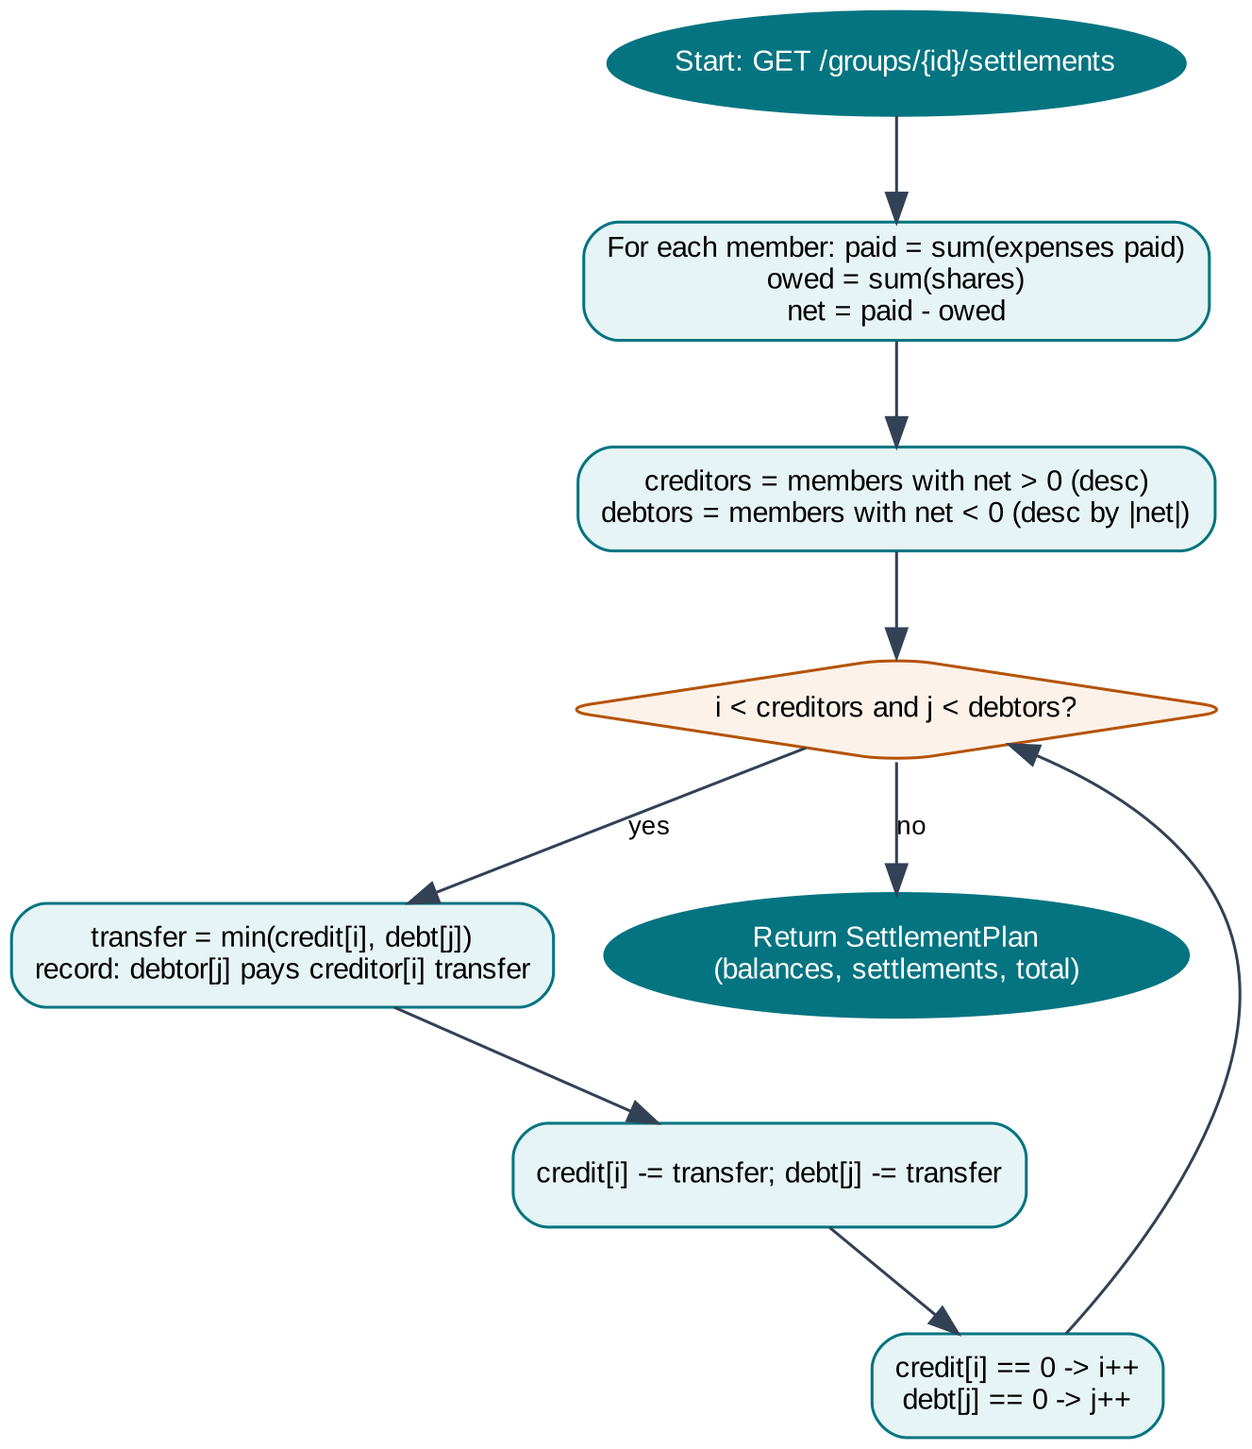
Figure 5.3: Flowchart of greedy debt simplification
Table 5.17 shows a real run on the demo group “Goa Squad” with four members and four equally split expenses totalling ₹30,000. Each member owes ₹7,500. Only Kabir is a creditor, so three transfers settle the group.
Table 5.18: Worked example – settlement of the Goa Squad group (real API output)
Member | Paid (₹) | Owes (₹) | Net (₹) | Settlement
Aarav | 6,400 | 7,500 | −1,100 | Pays Kabir ₹1,100
Diya | 2,400 | 7,500 | −5,100 | Pays Kabir ₹5,100
Kabir | 18,000 | 7,500 | +10,500 | Receives ₹10,500
Meera | 3,200 | 7,500 | −4,300 | Pays Kabir ₹4,300
Total | 30,000 | 30,000 | 0 | 3 transfers

5.8 Two-Stage Itinerary Planning Service
itinerary_planner.py orchestrates the smart pipeline. Stage A resolves the destination and gathers candidate places from a PlacesProvider and the forecast from Open-Meteo. Stage B sends the candidates, weather, budget and preferences to the AI provider with a strict JSON schema; the response is extracted from code fences, parsed and validated. Validation removes duplicate attractions across days, enforces chronological, non-overlapping times with buffers, keeps locked activities, applies the budget cap, and synthesises any days that the AI omitted using the deterministic engine. Attribution is honest: ai_enhanced is true only when live AI actually produced the plan; otherwise ai_unavailable_reason explains why. Persistence is atomic – unlocked activities are deleted and new ones inserted in one transaction only after planning succeeds, so a failure never leaves a trip with an empty or half-written itinerary. Concurrent duplicate requests for the same trip join the active generation task instead of running twice.
Table 5.19: Places providers
Provider | Behaviour
CuratedPlacesProvider | Verified, hand-curated entries for Paris, Tokyo, London, Agra, Goa, Jaipur, Dubai, New York and Kyoto across six categories: heritage, museums/culture, neighbourhoods/viewpoints, markets/shopping, parks/nature and food. Includes disambiguation (e.g. Paris, Texas is not Paris, France).
OpenStreetMapPlacesProvider | Queries Overpass around the geocoded coordinates for real named places; 24-hour cache; tolerant of timeouts.
CompositePlacesProvider | Combines curated and OSM results, preferring verified entries and de-duplicating by name.
GooglePlacesProvider | Adapter for Google Places; reports a truthful credentials-missing state when GOOGLE_MAPS_API_KEY is unset.
Generic adaptation | For unlisted towns, destination-qualified generic activities (e.g. “Historic District Walking Tour in Florence”) are labelled as such, never as verified venues.

5.9 External Integrations
Table 5.20: External integration adapters
Adapter | Provider | Cache | Fallback / notes
weather.py | Open-Meteo forecast and geocoding (no key) | 10 min | Serves stale cached data with a stale flag; validates lat ∈ [−90, 90], lon ∈ [−180, 180]; times in destination time zone.
geocoding.py | OSM Nominatim, then Open-Meteo geocoding | 24 h | Respects ≥1 s between Nominatim calls with a descriptive User-Agent; disambiguates by country/region.
places.py | Curated, Overpass, Google Places | 24 h | Composite provider; generic adaptation for unknown towns.
currency.py | Frankfurter (ECB) primary and mirror | 1 h | Last-known cache; 1:1 same-currency shortcut; AED pegged at 3.6725 per USD; 31 currencies.
ai_provider.py | Google Gemini, OpenAI | – | Five-model Gemini chain, then OpenAI, then curated offline guide (is_ai=false); one bounded continuation for truncated answers.
email.py | Mailjet SMTP (STARTTLS, port 587) | – | Branded HTML + plain-text emails; 15 s timeout; development mode returns the token only when SMTP is not configured.

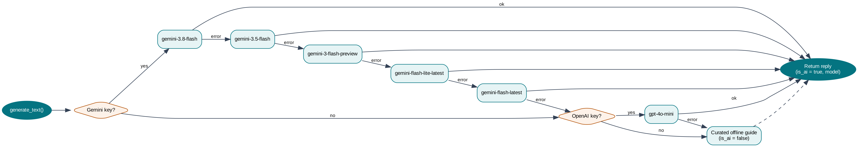
Figure 5.4: AI provider fallback chain

5.10 Email Delivery Design (Mailjet)
Northstar delivers verification and password-reset emails through Mailjet, a transactional email service, using its SMTP relay. The module app/core/email.py builds each message as a multipart email with a plain-text part and a branded, responsive HTML part (dark card layout, the Northstar compass header, a call-to-action button, the raw link as a fallback, and an expiry and security notice). The sender is formatted as “Northstar Travel <verified-sender>” using email.utils.formataddr.
Table 5.21: Email delivery behaviour
Aspect | Design
Transport | SMTP to in-v3.mailjet.com:587; EHLO, STARTTLS with a default SSL context, EHLO again, LOGIN with the Mailjet API key and secret, SENDMAIL; 15-second connection timeout.
Configuration detection | _is_smtp_configured() requires host, user and password. If the server was started before .env was edited, it re-reads backend/.env so a restart is not needed. It always reports “not configured” while unit tests run (unless FORCE_TEST_SMTP is set), so tests never send real email.
Messages | Verification email (24-hour, single-use link to /verify-email) and password-reset email (1-hour, single-use link to /reset-password), each in HTML and plain text.
Privacy | Forgot-password always returns “If that email is registered, a reset link has been sent.” Tokens are included in API responses only in development mode.
Failure handling | Registration re-raises a delivery failure; forgot-password catches it, logs the user id and error, and still returns the generic message.
Diagnostics | GET /api/health/smtp-status reports whether SMTP is configured, the host, port, sender address and display name, and only the presence of the user and password.

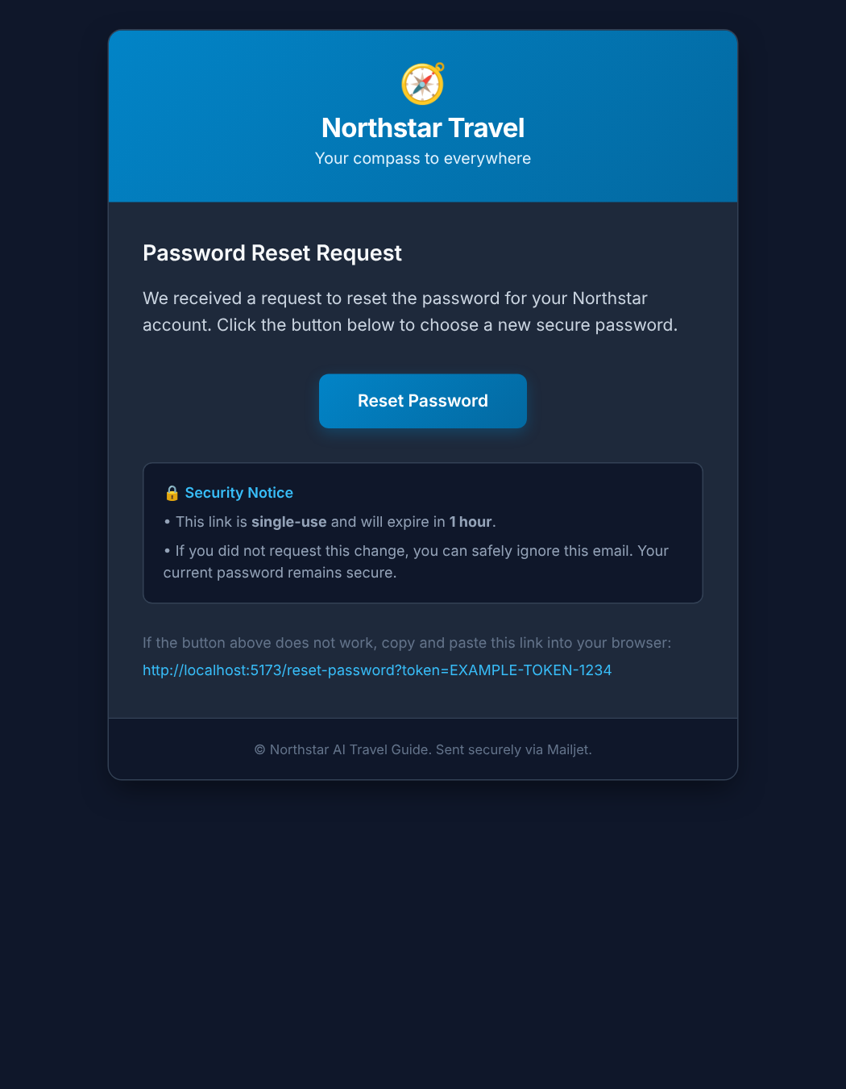
Figure 5.5: Password-reset email template (rendered from the application code with a sample token)
The diagnostics endpoint never returns the API key or secret, but it is public and reveals the SMTP host and sender address. In a production deployment it should be restricted to administrators or removed (see Chapter 10).

5.11 Error Handling and Logging
Expected business errors are raised as HTTPException with an appropriate status and a clear detail message that can be shown directly to the user (for example, “Exact shares sum to 9000 (90.00), which does not match the expense amount 10000 (100.00).”). Validation errors from Pydantic produce 422 responses listing each invalid field. Calls to external providers are wrapped so that timeouts, rate limits and malformed payloads are logged with the standard logging module and converted into fallbacks rather than server errors. The itinerary endpoint catches unexpected exceptions, logs the stack trace with logger.exception, and returns a 500 response while the transaction guarantees that existing activities are untouched.

CHAPTER 6

FRONTEND DESIGN

6.1 Technology Stack
The frontend is a single-page application (SPA). The browser downloads one HTML page and a compiled JavaScript bundle; afterwards, navigation between pages happens on the client without full page reloads, and only JSON data is exchanged with the backend. This gives a fast, app-like experience and keeps the server focused on data and logic.
Table 6.1: Frontend technology stack
Technology | Version | Purpose
React | 18.3 | Component-based UI with hooks (useState, useEffect, useMemo, useCallback, useRef, useContext)
TypeScript | 5.6 | Static typing of props, state and every API response shape
Vite | 6.0 | Development server with hot module replacement, /api proxy and production bundling
React Router DOM | 6.28 | Client-side routing with nested layouts and protected routes
Tailwind CSS | 3.4 | Utility-first styling, custom accent/surface palettes, class-based dark mode
Axios | 1.7 | HTTP client with base URL, JSON headers, 10-second timeout and credentials
Framer Motion | 11 | Animations and transitions
Lucide React | 0.469 | Consistent line icon set
Node test runner | Node 22 | Unit tests for utilities and UI invariants (134 tests)
ESLint / oxlint | 9 | Static analysis and code style

6.2 Project Structure
frontend/
├── index.html # SPA entry document
├── vite.config.ts # dev server :5173, /api proxy -> :8000
├── tailwind.config.js # accent + surface palettes, animations, shadows
├── vercel.json # rewrite every path to /index.html
└── src/
├── main.tsx # ReactDOM root
├── App.tsx # providers + route table
├── index.css # design tokens, theme classes, components
├── context/ # AuthContext.tsx, ThemeContext.tsx
├── layouts/AppLayout.tsx # sidebar + top bar + banner + outlet + chatbot
├── components/ # Sidebar, TopBar, DemoBanner, FloatingChatbot,
│ # DestinationInput, SafeMarkdown, ProtectedRoute
├── pages/ # 23 page components
├── services/ # api.ts, authApi.ts, capsuleApi.ts
├── types/ # index.ts, capsule.ts (API interfaces)
├── utils/ # budget, splitwise, flightSearch, weather, format,
│ # markdown, destinationMatching, capsule utilities
└── tests/ # 11 test files

6.3 Routing and Navigation
Routing is declared in App.tsx (Figure 6.1). Five authentication pages are rendered without the application shell. All other pages are nested under the AppLayout route, which renders the sidebar, top bar, status banner and floating chatbot around an <Outlet />. Most pages are public but authentication-aware: a guest sees demo data and prompts to sign in, while a signed-in user sees their own data. The Profile and History pages are wrapped in ProtectedRoute, which waits for the initial session check and then redirects unauthenticated visitors to /login, remembering the requested path in location.state.from so the user returns there after signing in.
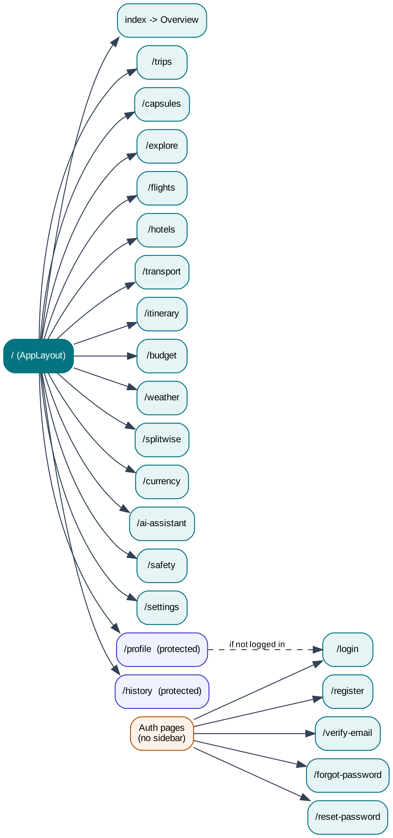
Figure 6.1: Route map of the single-page application
Table 6.2: Route table
Path | Page component | Access | Purpose
/login, /register | Login, Register | Public | Sign in and create account with inline validation
/verify-email, /forgot-password, /reset-password | VerifyEmail, ForgotPassword, ResetPassword | Public | Token-based email and password flows
/ | Overview | Public | Dashboard: stats, next expedition, quick navigation, recent trips
/trips | MyTrips | Public* | List, create, edit and delete trips
/itinerary | Itinerary | Public* | Generate, view, lock and re-plan day-by-day plans
/budget | Budget | Public* | Budget cap vs planned vs actual, categories
/splitwise | Splitwise | Public* | Groups, expenses, balances and settlements
/capsules | Capsules | Guest overview / auth content | Private photo and video memories
/weather, /currency | Weather, CurrencyConverter | Public | Live forecasts and conversion
/ai-assistant | AIAssistant | Public | Full-page AI chat
/flights, /hotels, /transport | Flights, Hotels, Transport | Public | Search via trusted providers
/explore, /safety | Explore, Safety | Public | Destination guides and emergency information
/settings | Settings | Public | Theme, palette and integration status
/profile, /history | Profile, History | Protected | Account management and activity history

* Public pages show demo data to guests and the user’s own data after sign-in; ownership is enforced by the backend.

6.4 Component Architecture
Figure 6.2 shows the component hierarchy. ThemeProvider, AuthProvider and CurrencyProvider wrap the entire application, in that order, so that any component can read the current theme, the signed-in user and the currency preference through the useTheme(), useAuth() and useCurrency() hooks. CurrencyProvider sits inside AuthProvider because it reads the user’s saved preference. Reusable components are kept small and focused:
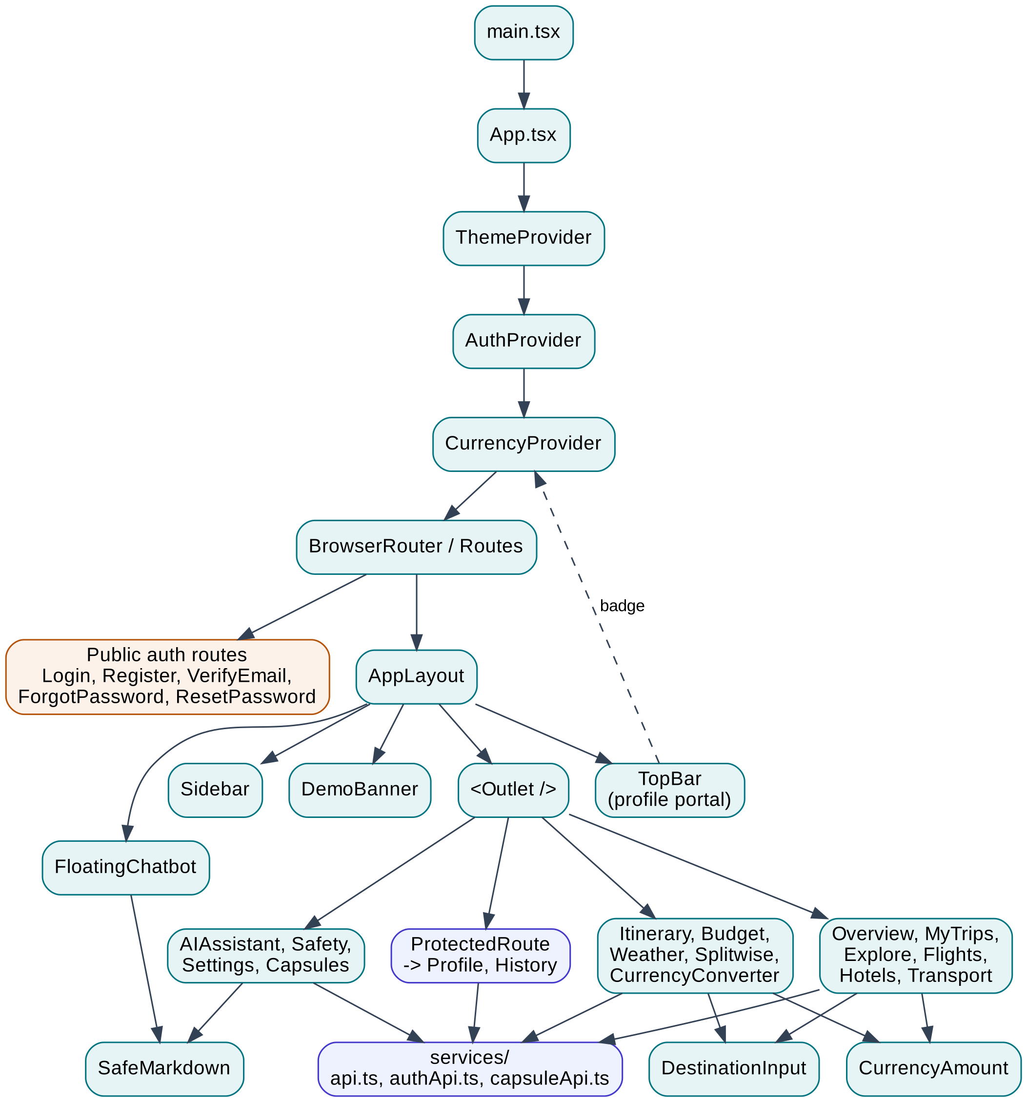
Figure 6.2: Frontend component hierarchy
Table 6.3: Shared components
Component | Responsibility
AppLayout | Page shell; fetches /api/integrations/status once and passes the overall mode (live / hybrid / demo) to the top bar and banner.
Sidebar | Collapsible navigation with 16 sections, icons, an AI badge, active-route highlighting and the signed-in user card; History is shown only to signed-in users.
TopBar | Menu toggle, mode badge and profile dropdown rendered through a React portal with a very high z-index, Escape-key and outside-click dismissal.
DemoBanner | Explains the current integration mode and links to the status page; can be dismissed.
FloatingChatbot | Always-available “Ask AI” button that opens a compact chat panel on every page.
DestinationInput | Autocomplete input combining a curated destination list (ranked prefix/word matching) with worldwide geocoding suggestions.
SafeMarkdown | Renders AI answers as headings, lists, bold, inline code and links without using dangerouslySetInnerHTML; unsafe URL schemes become plain text.
ProtectedRoute | Guards private routes and preserves the intended destination.
CurrencyAmount | Shows an amount in its original currency and, when it differs from the preferred currency, a “≈ converted” line beneath it; a click or hover opens an accessible popover with the rate, rate date and a link to the converter (Escape and outside-click close it).

6.5 State Management
Northstar uses React’s built-in state tools instead of an external store, because most state is local to a page and the shared state is small.
- Global authentication state – AuthContext holds { user, loading, isAuthenticated } and exposes login, register, logout, refreshUser and updateUser. On mount it calls GET /api/auth/me; because tokens are httpOnly cookies, the client never stores or sees them.
- Global theme state – ThemeContext holds the theme (light, dark, colourful), palette and custom accent, applies CSS custom properties to :root, toggles the dark class for Tailwind, persists choices in localStorage keys ai-travel-theme, ai-travel-palette and ai-travel-custom-accent. The backend also stores theme, palette and accent columns on the user and accepts them through PATCH /api/auth/profile, ready for cross-device synchronisation.
- Global currency state – CurrencyContext holds the preferred currency and the show-converted toggle, a USD-based table of reference rates (fetched from /api/currency/rates on load and hourly, cached in localStorage), and synchronous convert() and formatCurrency() helpers. Preferences are saved to the profile for signed-in users and to localStorage for guests. Rate failures only mark data as stale; they never throw during rendering.
- Page state – each page manages its own form inputs, selected trip, modals, loading and error flags with useState, derives computed values with useMemo (for example, Splitwise balances and filters), and loads data with useEffect.
- Server state – the backend is the single source of truth; after any mutation the page re-fetches the affected resource rather than patching local copies, which avoids inconsistencies between pages such as Overview and Budget.

Listing 6.1 – AuthContext provider (excerpt from src/context/AuthContext.tsx)
export function AuthProvider({ children }: { children: React.ReactNode }) {
const [state, setState] = useState<AuthState>({
user: null,
loading: true,
isAuthenticated: false,
})

/** Fetch the current user from the backend (reads access_token cookie). */
const refreshUser = useCallback(async () => {
try {
const user = await authApi.me()
setState({ user, loading: false, isAuthenticated: true })
} catch {
setState({ user: null, loading: false, isAuthenticated: false })
}
}, [])

// On mount, check if we already have a valid session
useEffect(() => {
refreshUser()
}, [refreshUser])

const login = async (email: string, password: string) => {
const { user } = await authApi.login(email, password)
setState({ user, loading: false, isAuthenticated: true })
}

const register = async (name: string, email: string, password: string) => {
const data = await authApi.register(name, email, password)
setState({ user: data.user, loading: false, isAuthenticated: true })
return { devToken: data.dev_verification_token }
}

const logout = async () => {
await authApi.logout()
setState({ user: null, loading: false, isAuthenticated: false })
}

const updateUser = (user: User) => {

6.6 Service Layer
All HTTP calls are made through three service modules, which act as a typed client for the REST API. api.ts is the single source of truth for trips, activities, itinerary, expenses, demo, integrations and currency calls; authApi.ts covers authentication and history; capsuleApi.ts covers Memory Capsules and uploads. Each module creates an Axios instance whose base URL is VITE_API_BASE_URL or /api, with JSON headers and a 10-second timeout; the authentication and capsule clients set withCredentials: true so that cookies are sent on cross-origin deployments. Helper functions getErrorMessage() and getAuthError() turn FastAPI error payloads – including lists of Pydantic validation errors – into readable messages.
Listing 6.2 – API client set-up and trip functions (src/services/api.ts)
export const API_BASE = (import.meta.env.VITE_API_BASE_URL || '/api').replace(/\/+$/, '')

const api = axios.create({
baseURL: API_BASE,
headers: { 'Content-Type': 'application/json' },
timeout: 10_000,
})

// ── Health ─────────────────────────────────────────────────────────────────

export const getHealth = () =>
api.get<{ status: string; demo_mode: boolean; version: string }>('/health')

// ── Trips ──────────────────────────────────────────────────────────────────

export const listTrips = () => api.get<Trip[]>('/trips/')
export const getTrip = (id: number) => api.get<Trip>(`/trips/${id}`)
export const createTrip = (data: TripCreate) => api.post<Trip>('/trips/', data)
export const updateTrip = (id: number, data: Partial<TripCreate>) =>
api.patch<Trip>(`/trips/${id}`, data)
export const deleteTrip = (id: number) => api.delete(`/trips/${id}`)

// ── Activities ─────────────────────────────────────────────────────────────

export const listActivities = (tripId: number) =>
api.get<Activity[]>(`/activities/trip/${tripId}`)
export const createActivity = (data: Partial<Activity>) =>
api.post<Activity>('/activities/', data)
export const toggleLock = (id: number) => api.patch(`/activities/${id}/lock`)
export const deleteActivity = (id: number) => api.delete(`/activities/${id}`)

6.7 Design System and Theming
The visual language is clean and card-based, using the Inter typeface, rounded cards with soft shadows, a refined teal accent and slate neutrals. Tailwind’s configuration defines two custom scales – accent (50–900, centred on #047481) and surface (50–900) – together with fade-in, slide-in and pulse-soft animations and card shadows. Three themes are provided:
Table 6.4: Themes and palettes
Theme / palette | Description
Light (default) | Light surfaces with dark text; teal accent.
Dark | Dark slate surfaces with light text using Tailwind’s class-based dark mode.
Colourful – Ocean | Teal, turquoise and blue gradients.
Colourful – Sunset | Coral, orange, warm pink and purple.
Colourful – Tropical | Emerald, aqua, lime and ocean blue.
Colourful – Lavender | Lavender, violet and soft purple.
Colourful – Rose | Rose, berry and blush.
Colourful – Forest | Deep green, sage and earthy neutrals.
Colourful – Custom | Any user-chosen accent colour (#rrggbb).

Each palette is a set of tokens (accent gradient, sidebar gradient, body gradient, card border, title gradient, navigation text, focus ring and badge colours) injected as CSS custom properties, so a single set of component classes renders correctly in every palette. Automated tests check contrast-critical rules, such as readable navigation text in light and colourful modes and opaque styling of the profile dropdown in all themes.

6.8 Frontend Utility Modules
Calculations that the user interface needs before calling the server – validation, formatting and URL building – live in pure TypeScript utility modules. They have no React dependencies and are covered by unit tests.
Table 6.5: Utility modules
Module | Functions
format.ts | Currency formatting with the right symbol and grouping (₹ with Indian grouping, $, €, £, ¥ without decimals), dates and durations; safe handling of zero, negative and NaN.
budgetUtils.ts | Parse budget input to minor units, reject negative, empty, non-numeric and oversized values; separate planned estimates from actual spend; utilisation percentages without division by zero.
splitwiseUtils.ts | Equal shares with remainder distribution, exact and percentage validation, participant filtering, settlement validation (no self-settlement, positive amounts).
flightSearch.ts | Validate one-way/round trips, dates (no past dates, return ≥ departure), passengers (1–9 adults, ≤9 total, infants ≤ adults), origin ≠ destination; build Google Flights, Skyscanner and MakeMyTrip URLs with cabin class and passenger breakdown.
weatherUtils.ts | Format destination local time, hours and dates without browser time-zone drift; validate coordinates; UV index categories.
destinationMatching.ts | Rank curated destinations by exact, prefix, word-prefix and substring matches across city, region and country (139-line curated list).
markdownUtils.ts | Tokenise AI answers into blocks and inline tokens; un-escape stray markdown; detect truncated answers.
capsuleUtils.ts | Date-range validation, supported image/video types, 10 MB/50 MB limits, empty-file rejection, human-readable file sizes.

6.9 User Interface Design
This section presents the main screens of Northstar. The screenshots were captured from the production build of the application running against the FastAPI backend with seeded demo data (a five-day “Goa Beach Getaway” for two travellers with a ₹50,000 budget and a four-member expense group). The orange banner at the top of each screen reports Hybrid Mode: live weather and local storage are active, while the AI assistant is in its labelled offline mode because no AI key was configured for the capture.

6.9.1 Authentication Screens
The login page (Figure 6.3) uses a centred card with email and password fields, a show/hide password toggle, a “Forgot password?” link and a link to registration. Registration (Figure 6.4) asks for full name, email, password and confirmation and validates the password rules before submitting. The reset-password request page (Figure 6.5) always shows the same confirmation message, whether or not the email exists.
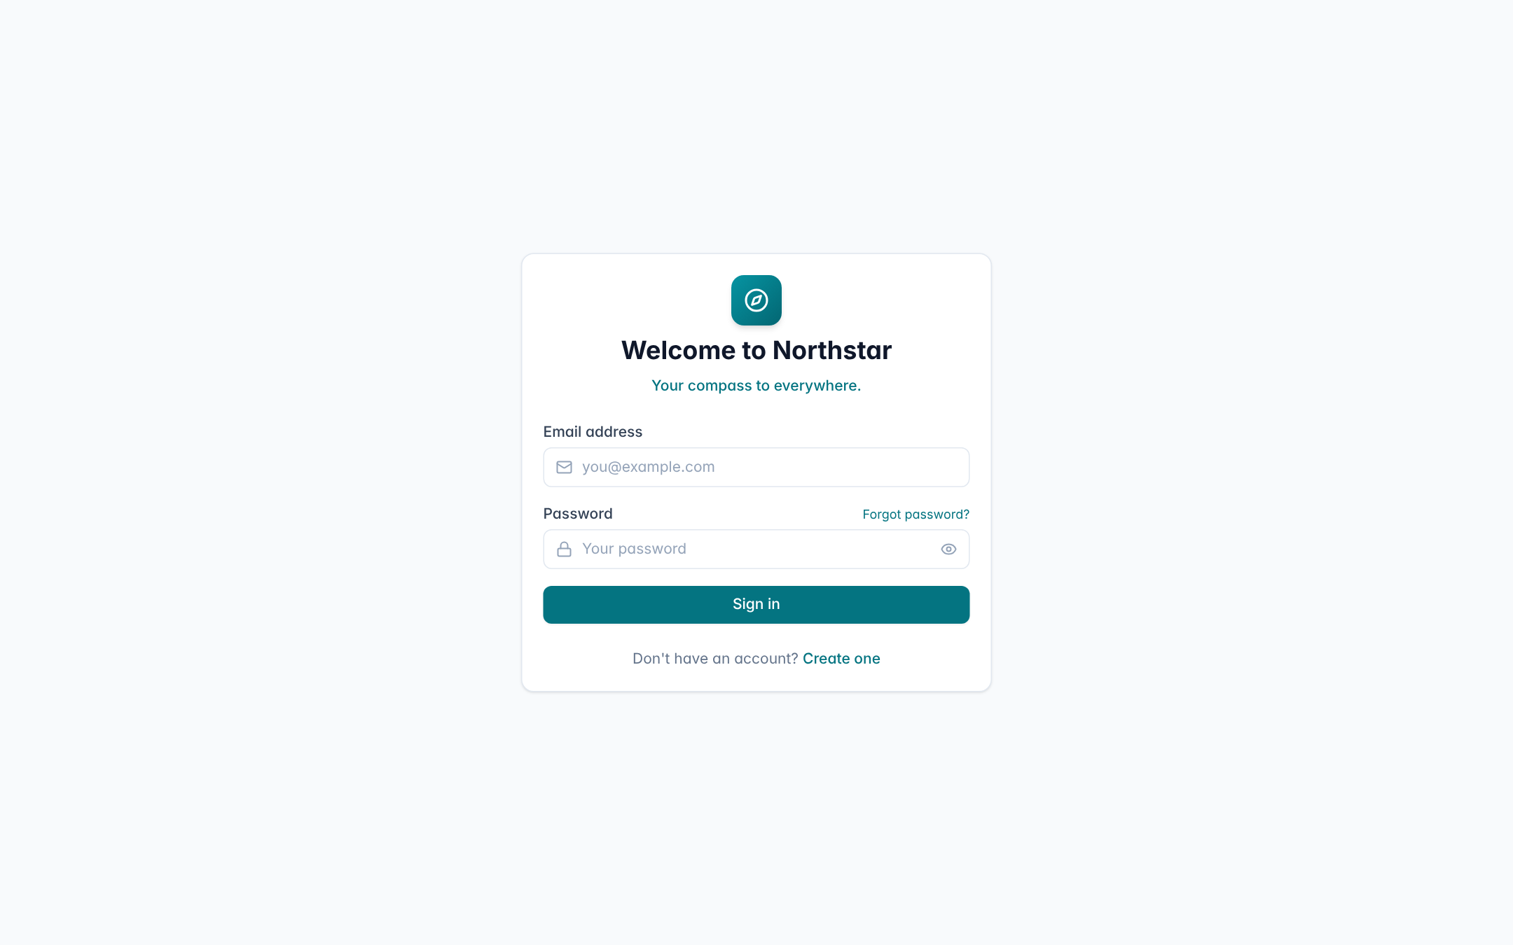
Figure 6.3: Login screen
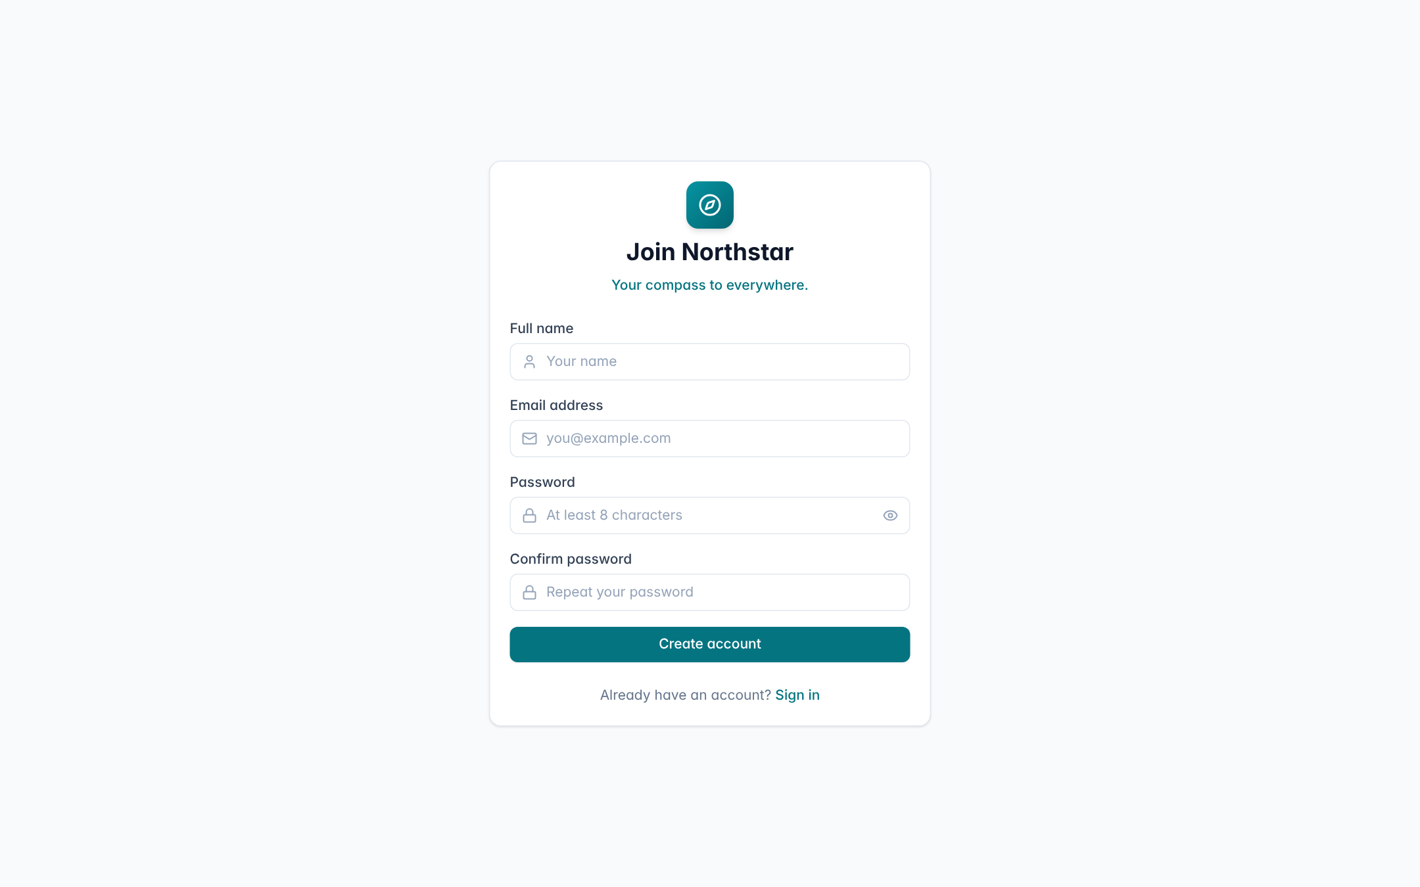
Figure 6.4: Registration screen
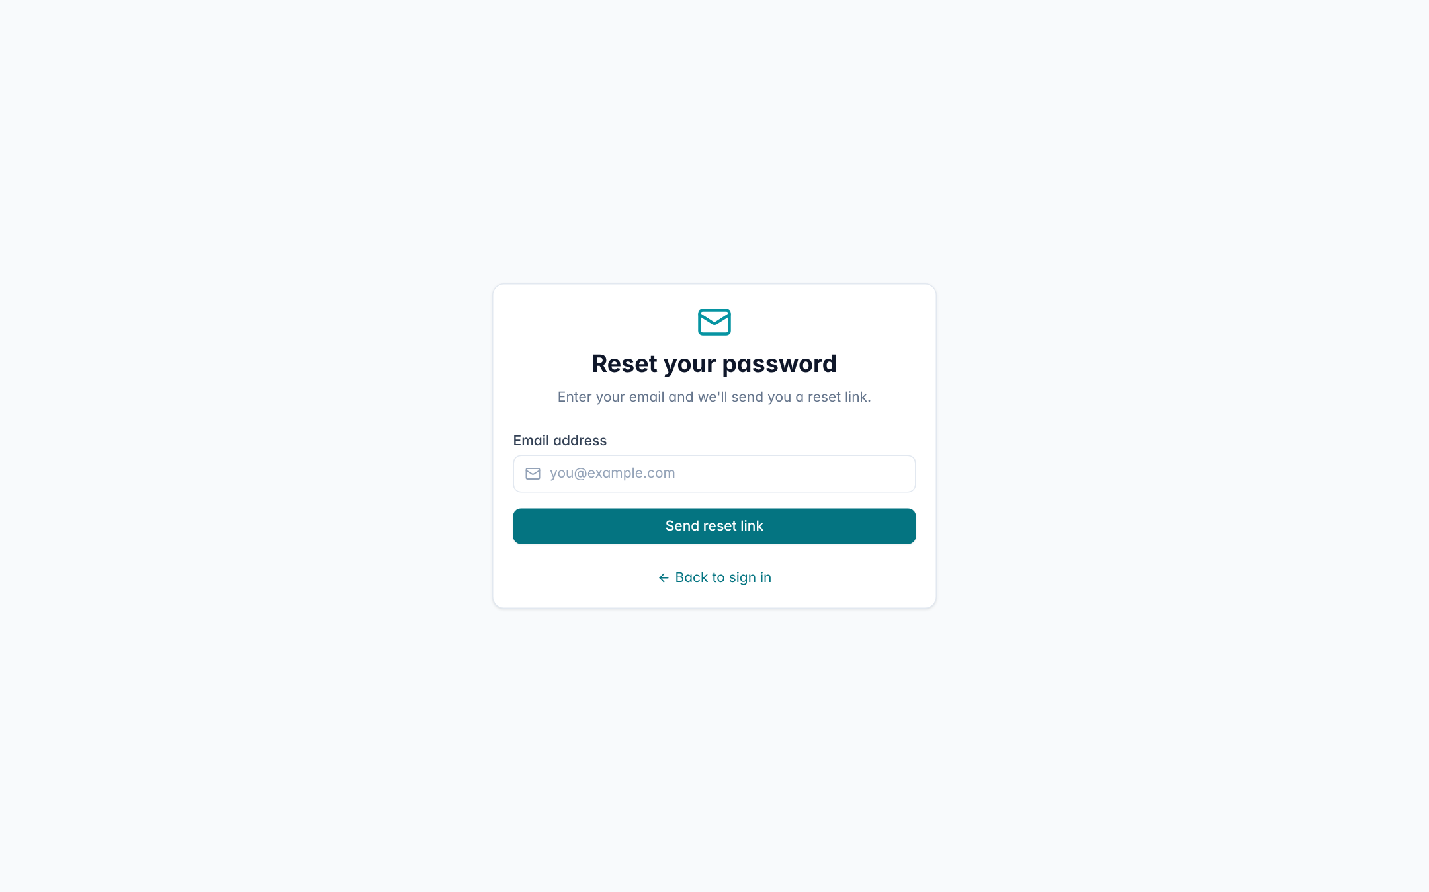
Figure 6.5: Forgot password screen

6.9.2 Overview Dashboard
The Overview page (Figure 6.6) is the landing page after sign-in. Four stat cards summarise total trips, upcoming trips, the trip budget and destination ideas. The “Next Expedition” card shows the nearest trip with its route, dates, duration, budget and remaining budget, along with DEMO DATA and status badges and shortcuts to the Budget and Itinerary pages. Quick-navigation chips and a recent-trips list complete the page. The persistent left sidebar lists every module, and an “Ask AI” button floats at the bottom right.
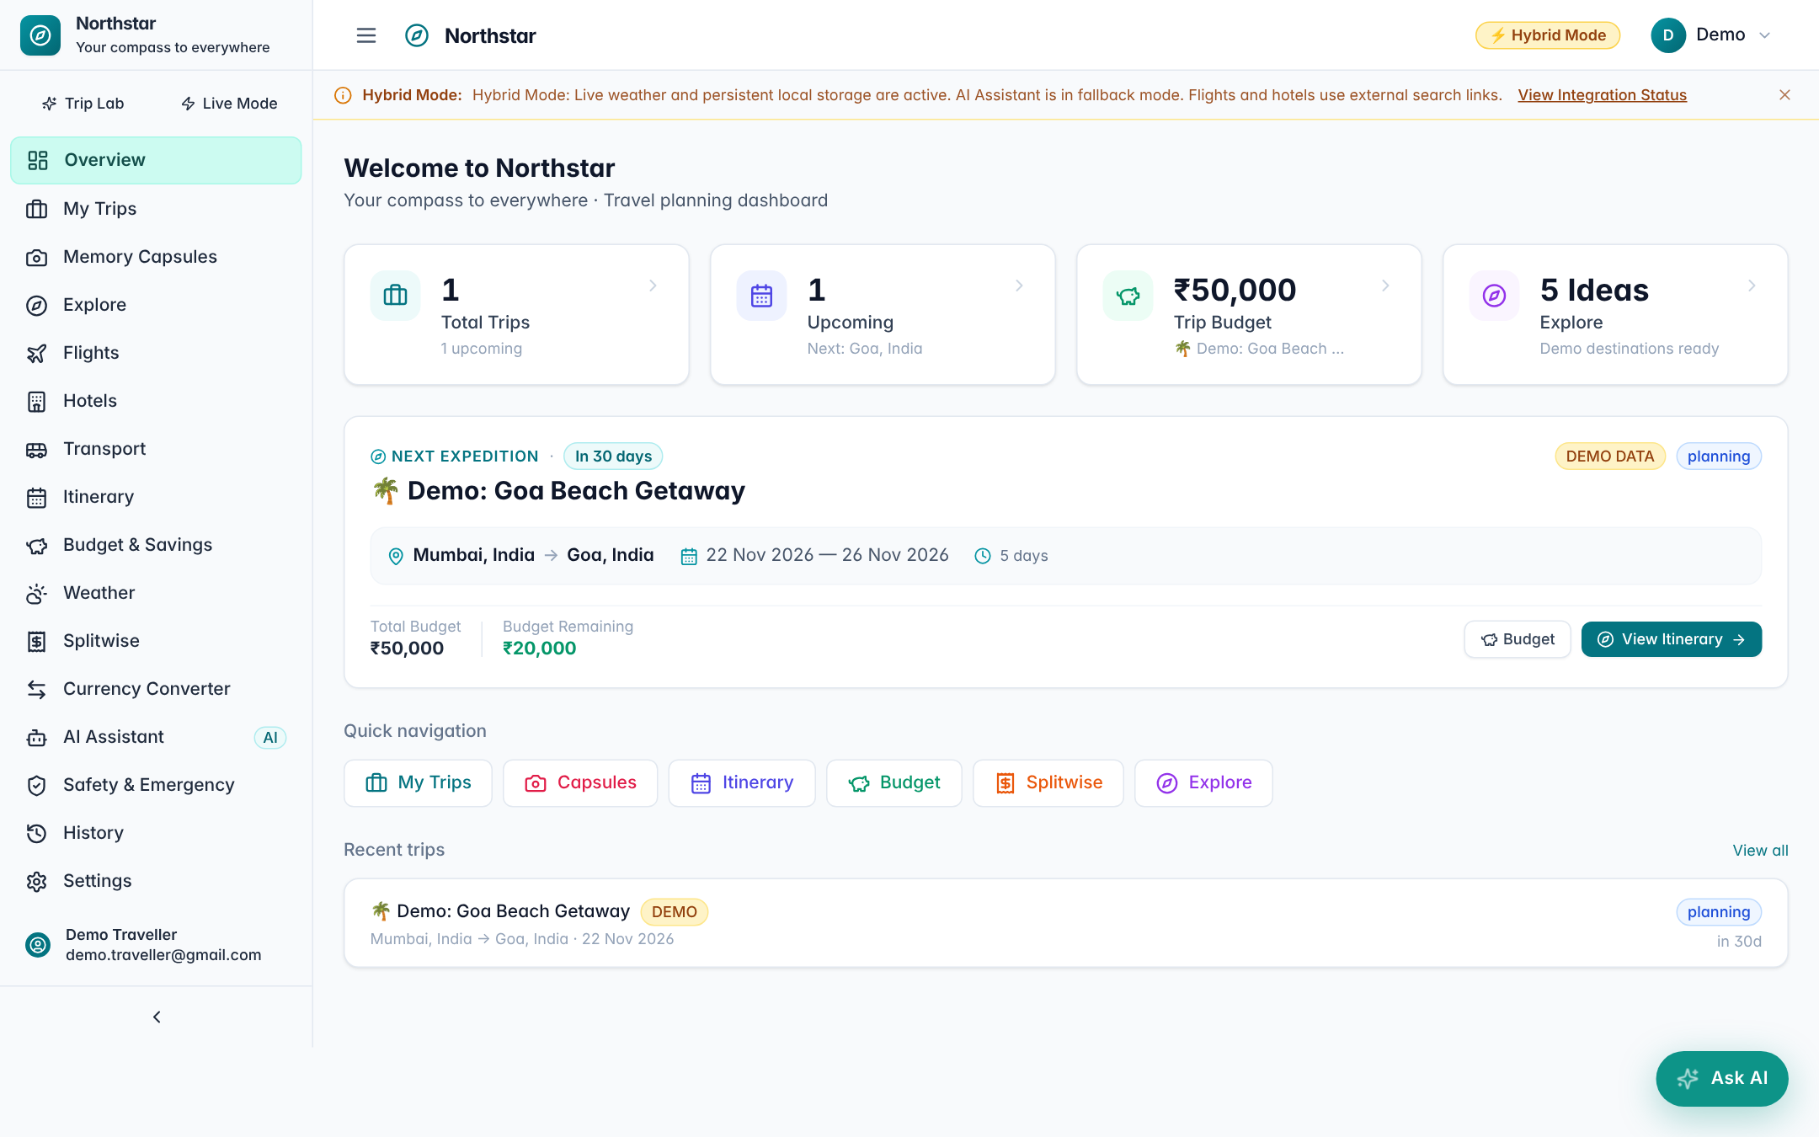
Figure 6.6: Overview dashboard

6.9.3 My Trips
The My Trips page (Figure 6.7) lists trips as cards showing the destination, dates, budget, number of travellers, travel-style tags and a countdown. The “New Trip” button opens a form with destination autocomplete, date pickers, traveller count, budget with currency, travel styles, pace and walking-tolerance sliders, and must-visit and avoid lists.
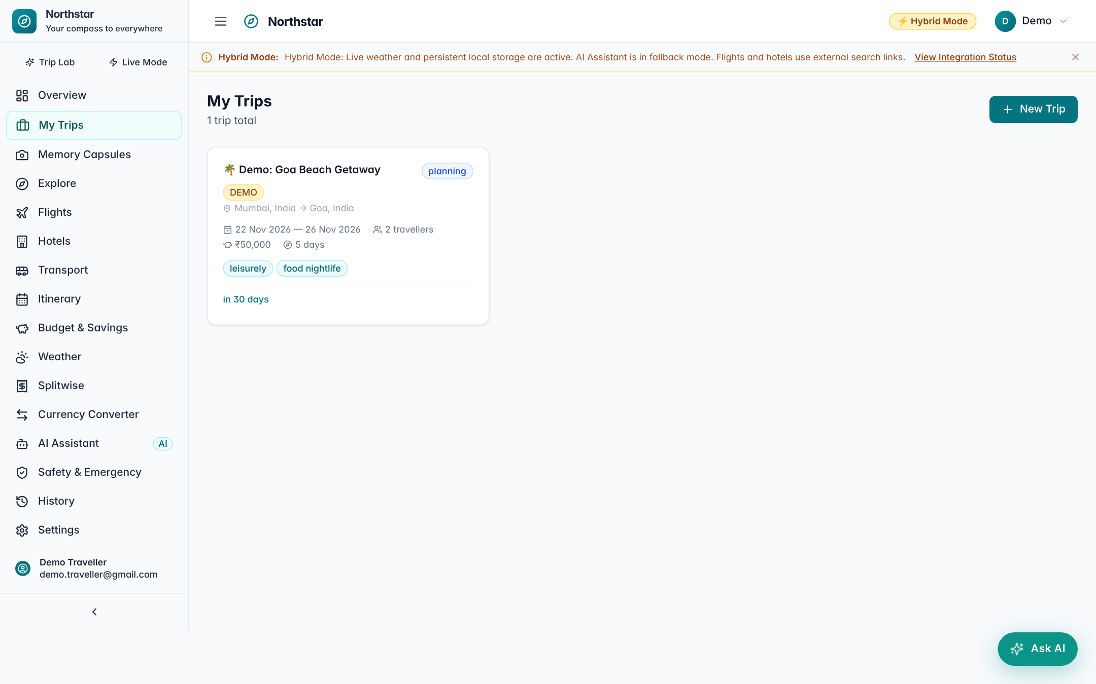
Figure 6.7: My Trips page

6.9.4 Itinerary
The Itinerary page (Figures 6.8 and 6.9) is the centre of planning. A trip selector and coverage badges (“Calendar Complete (5/5 Days)”, “Activity Schedule Complete”, “Deterministic Destination Baseline (AI Offline)”) state exactly what was produced and by which engine. A budget card compares the trip budget, estimated spend and remaining balance with a category breakdown. Each day is a collapsible card with a theme (for example, “Historic Heritage & Cultural Beginnings”) and a timeline of activities showing time, category tag, location, duration, cost, opening hours, the recommendation reason and a “Booking required” flag where relevant. Every activity has lock and delete controls, and a Re-plan dialog reports a delay, closure or cancellation.
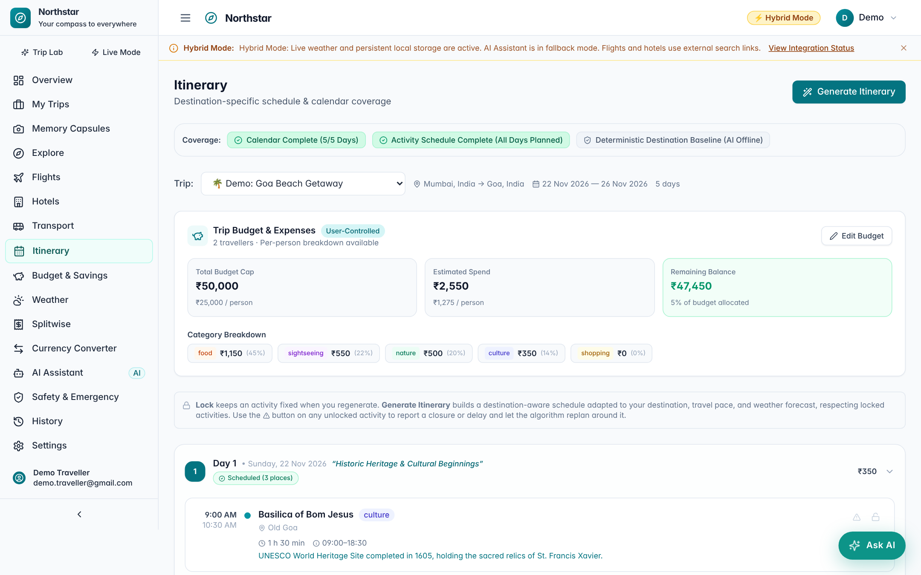
Figure 6.8: Itinerary page – coverage and budget summary
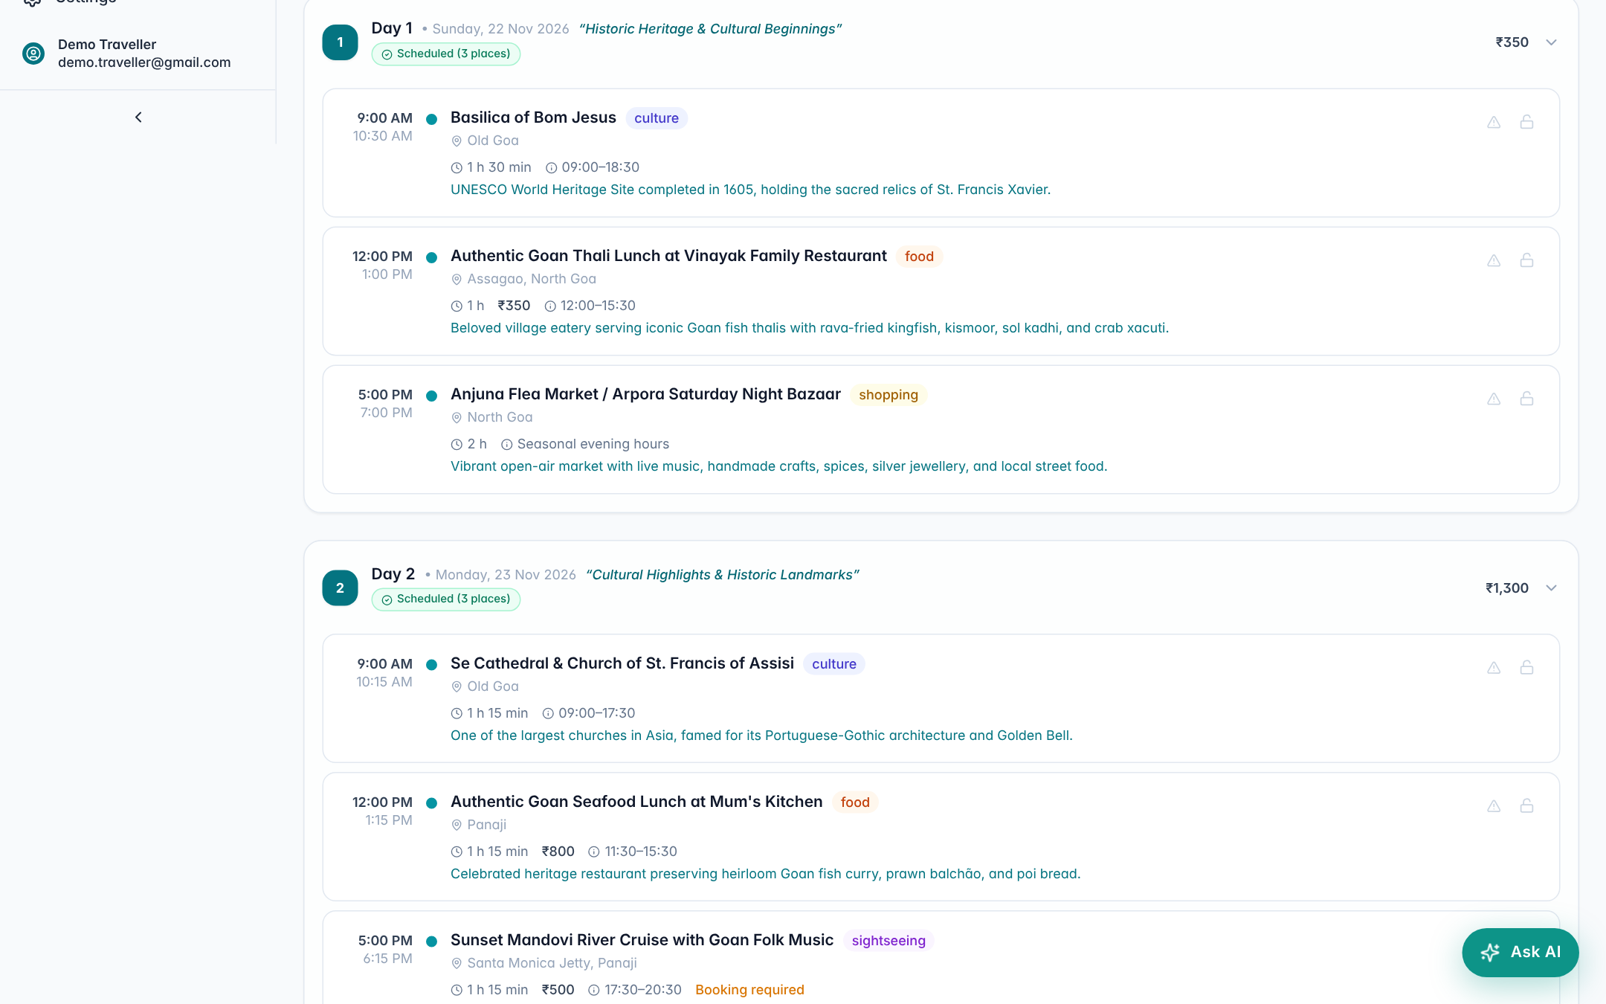
Figure 6.9: Itinerary page – day-by-day timeline

6.9.5 Budget and Savings
The Budget page (Figure 6.10) gives one trip-specific source of truth for money. Stat tiles show the total budget cap, estimated costs from the itinerary, actual spent from linked expense groups, remaining actual and remaining projected balances. Progress bars compare actual spending and planned estimates against the cap separately, so planned estimates are never presented as money already spent. A category chart shows spending by culture, food, shopping, sightseeing and nature.
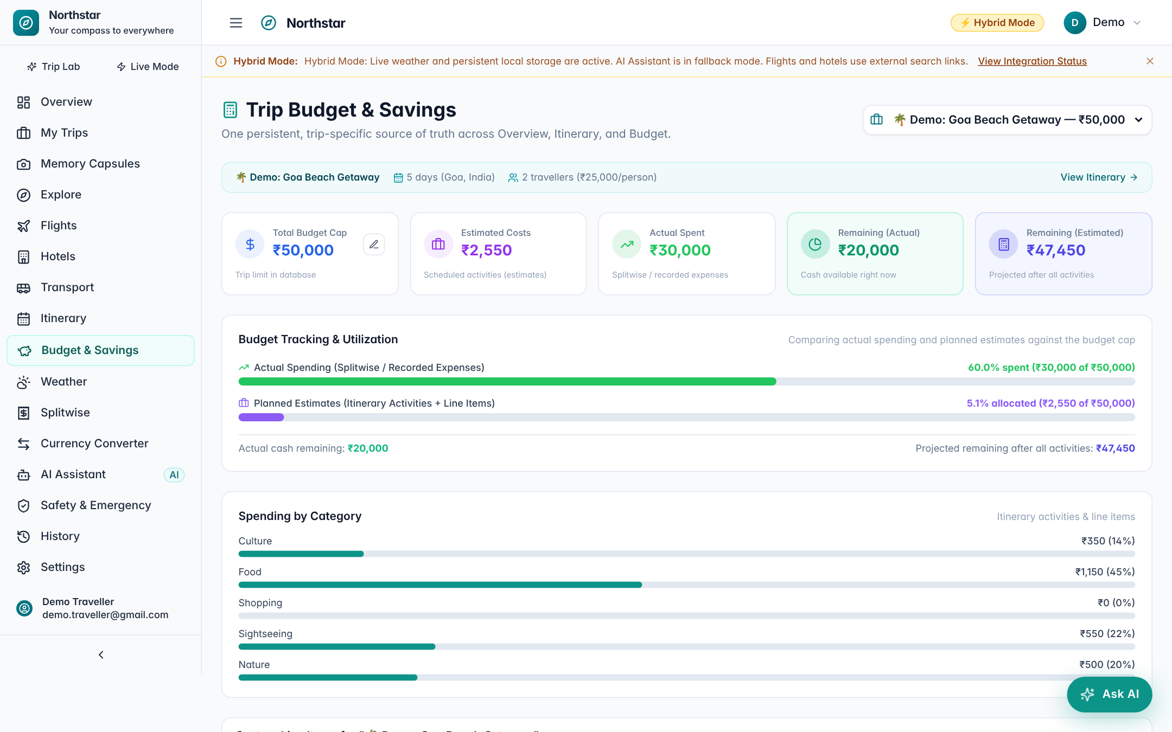
Figure 6.10: Budget and Savings page

6.9.6 Splitwise
The Splitwise page (Figures 6.11 and 6.12) lists groups on the left; a “Trip Linked” badge marks groups attached to a trip. The selected group shows members, total spending and average per person, with actions to add members, add expenses and settle debts. The Expenses tab lists each expense with payer, date, category and amount per person. The Balances tab shows each member’s paid and owed amounts and net balance in green or red, followed by suggested debt settlements (for example, “Diya pays Kabir ₹5,100”) with a one-click “Settle Up” button.
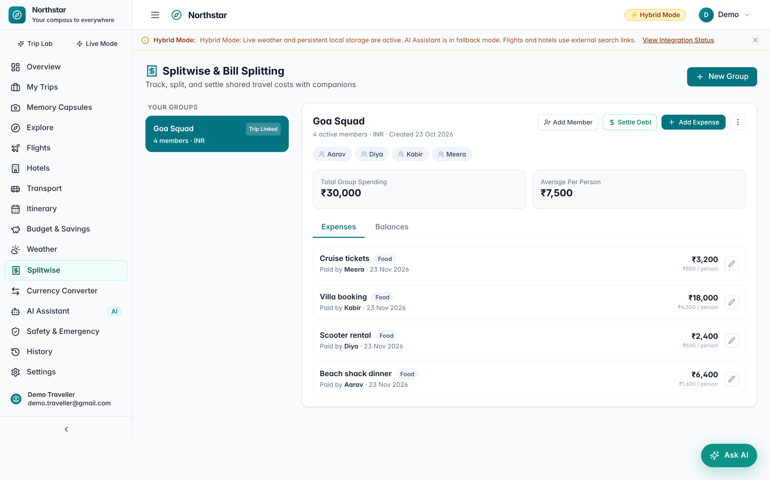
Figure 6.11: Splitwise – group expenses
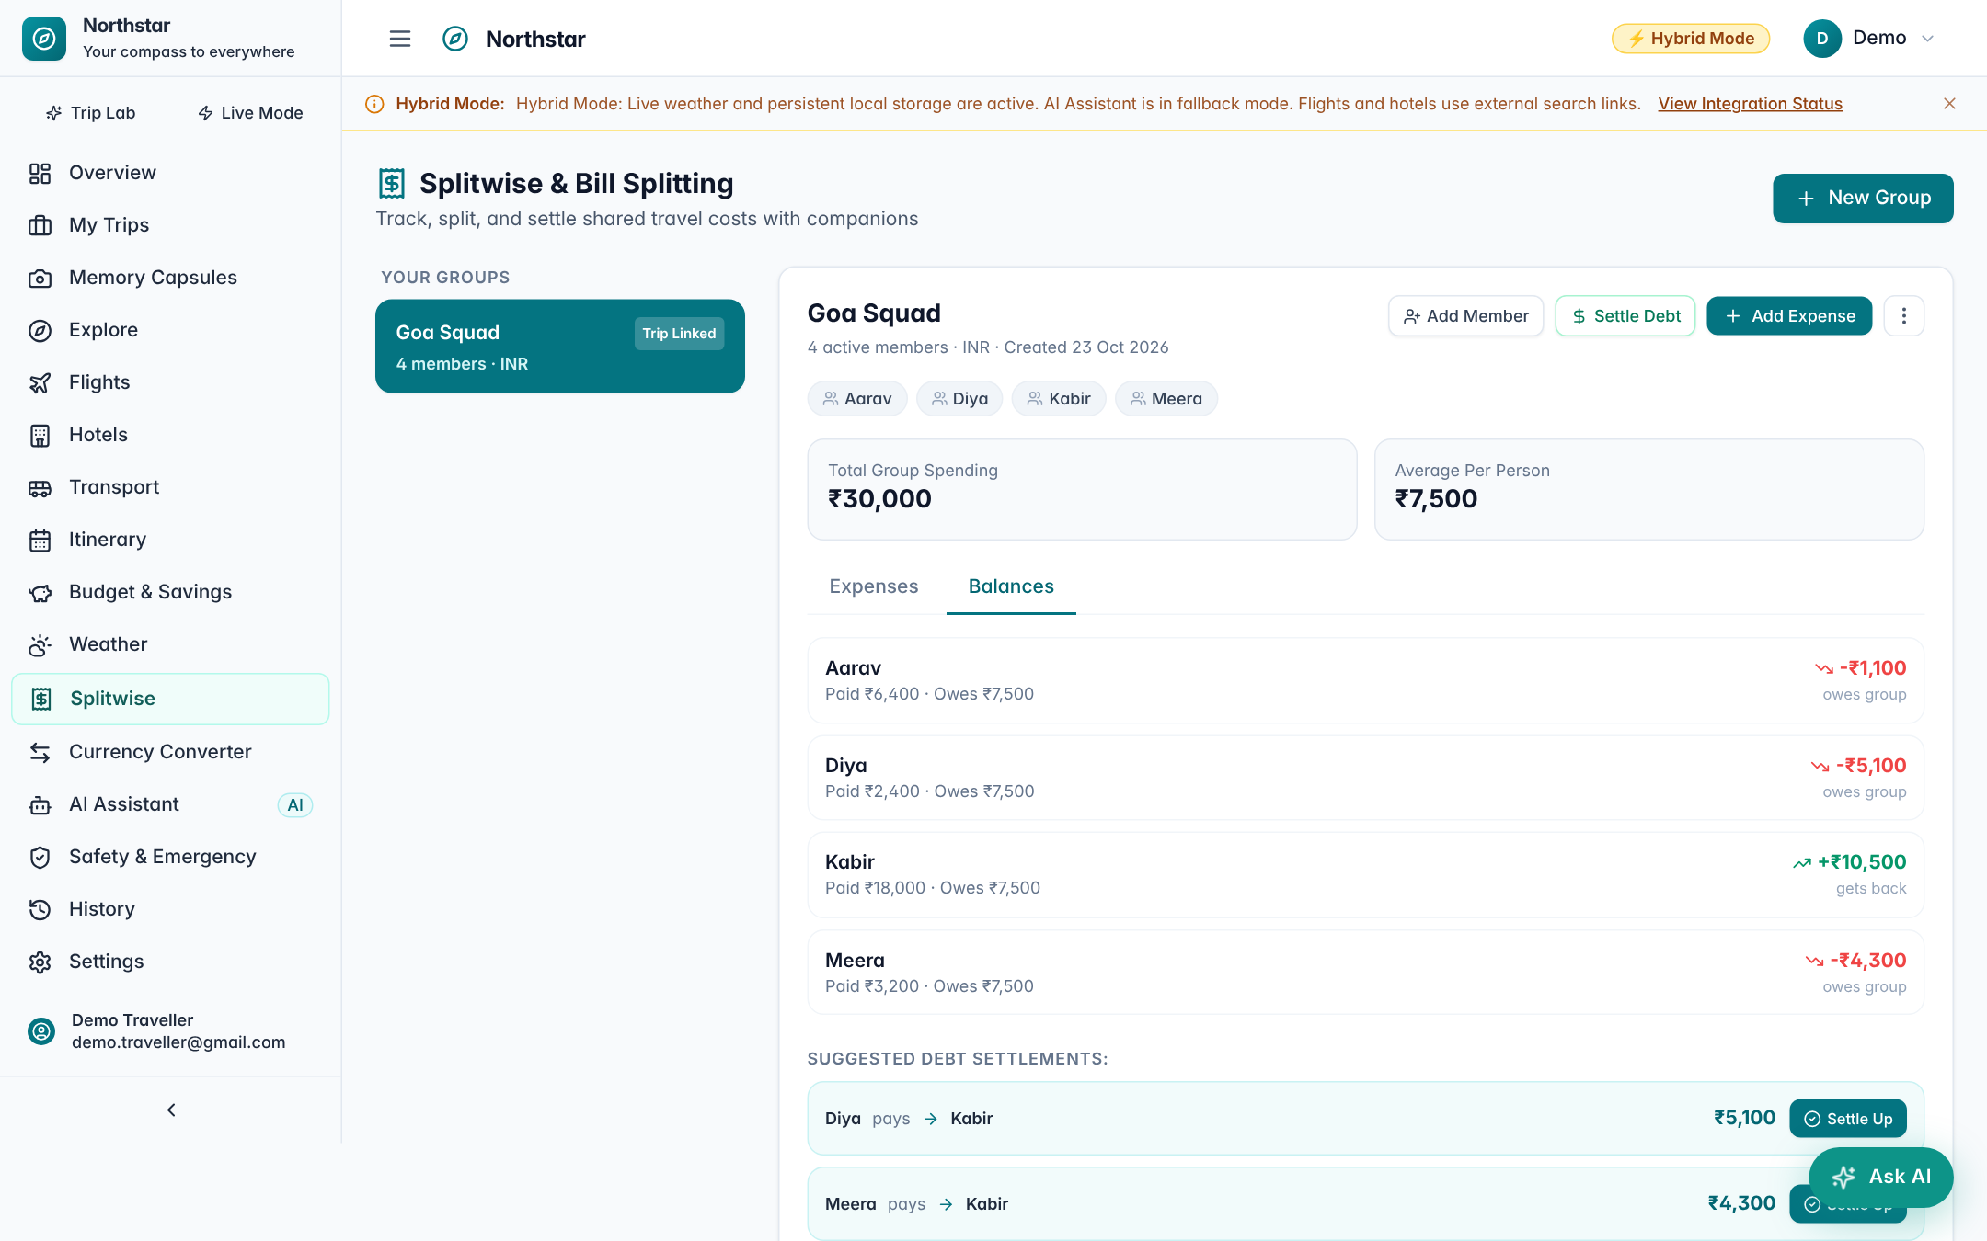
Figure 6.12: Splitwise – balances and suggested settlements

6.9.7 Weather
The Weather page (Figure 6.13) offers a worldwide search box with popular destination chips. After a search it displays current conditions, the destination’s local time, a 24-hour trend and a 7-day forecast with temperature range, precipitation probability, wind and UV category. Cached and stale data are marked, and failures show a “Weather Lookup Issue” card instead of an empty page.
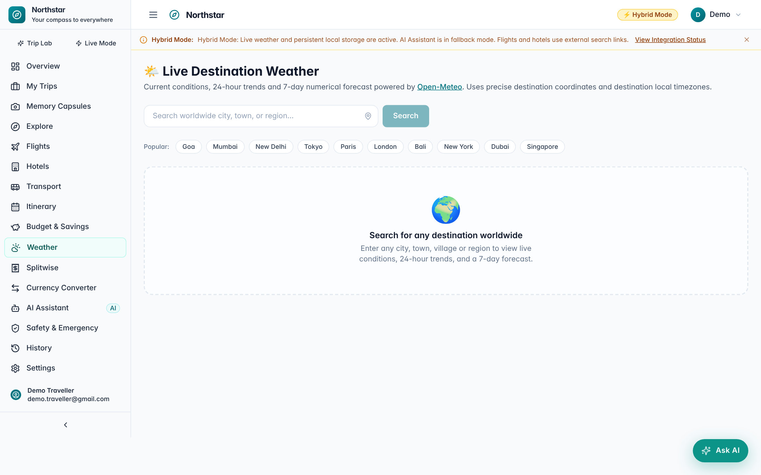
Figure 6.13: Weather page (search state)

6.9.8 AI Travel Assistant
The AI Assistant page (Figure 6.14) shows the provider status – here “Offline Travel Guide Mode” with a link to obtain a free Gemini key – and suggested starter questions. Answers are rendered with SafeMarkdown and labelled with their source. A disclaimer reminds users to verify prices, availability and safety information independently.
Figure 6.14: AI Travel Assistant page

6.9.9 Flights, Hotels and Transport
The Flights page (Figure 6.15) collects trip type, origin, destination, dates, passengers and cabin class, validates them, and opens the chosen provider – Google Flights, Skyscanner or MakeMyTrip – with all fields pre-filled; every provider card is labelled “External Search Link (Redirect)”, and the Amadeus card is marked as a developer notice. Hotels (Figure 6.16) and Transport (Figure 6.17) follow the same honest pattern with Booking.com, Airbnb, Agoda, IRCTC, Trainline, Amtrak, redBus and Google Maps transit directions.
Figure 6.15: Flight search and route planner
Figure 6.16: Find accommodation
Figure 6.17: Ground transport and transit hub

6.9.10 Explore and Safety
Explore (Figure 6.18) presents curated destination guides with filters (beach, culture, food, adventure, history, nature, romance, nightlife, shopping), the best time to visit, a daily budget range, highlights and a Wikipedia link. The Safety page (Figure 6.19) shows national emergency numbers for a selected country (for India: 112, 100/112, 102/108, 101 and the 1363 tourist helpline), official travel advisories, and a pre-departure checklist with progress.
Figure 6.18: Explore destinations
Figure 6.19: Travel safety and emergency directory

6.9.11 Memory Capsules, History, Profile and Settings
Memory Capsules (Figure 6.20) shows the empty state with a call to action for a new user; capsules then appear as cards with cover images and open into a gallery of photos and videos with notes, dates and locations. History (Figure 6.21) lists searches, generated itineraries, created and viewed trips and favourites with filter chips. The Account page (Figure 6.22) has Profile, Password and Danger-zone tabs and shows a banner when the email is not yet verified. Settings (Figure 6.23) shows the live status of every integration and the theme and palette selectors.
Figure 6.20: Memory Capsules (empty state)
Figure 6.21: History page
Figure 6.22: Account and profile page
Figure 6.23: Settings and integration status

6.9.12 Global Currency Preference
The Preferences tab of the Account page (Figure 6.24) and a matching card in Settings let the user choose a preferred currency from 31 supported currencies and decide whether converted equivalents are shown, with a live preview. The choice appears as a badge in the top bar. When the preferred currency differs from the currency of a price, every amount on Overview, My Trips, Itinerary, Budget, Splitwise and Explore shows its original value with an approximate converted value beneath it. Clicking an amount opens a popover with the rate, the rate date and a disclaimer that it is a reference rate (Figure 6.25). The original amounts and currencies stored in the database are never changed.
Figure 6.24: Account – currency and price preferences
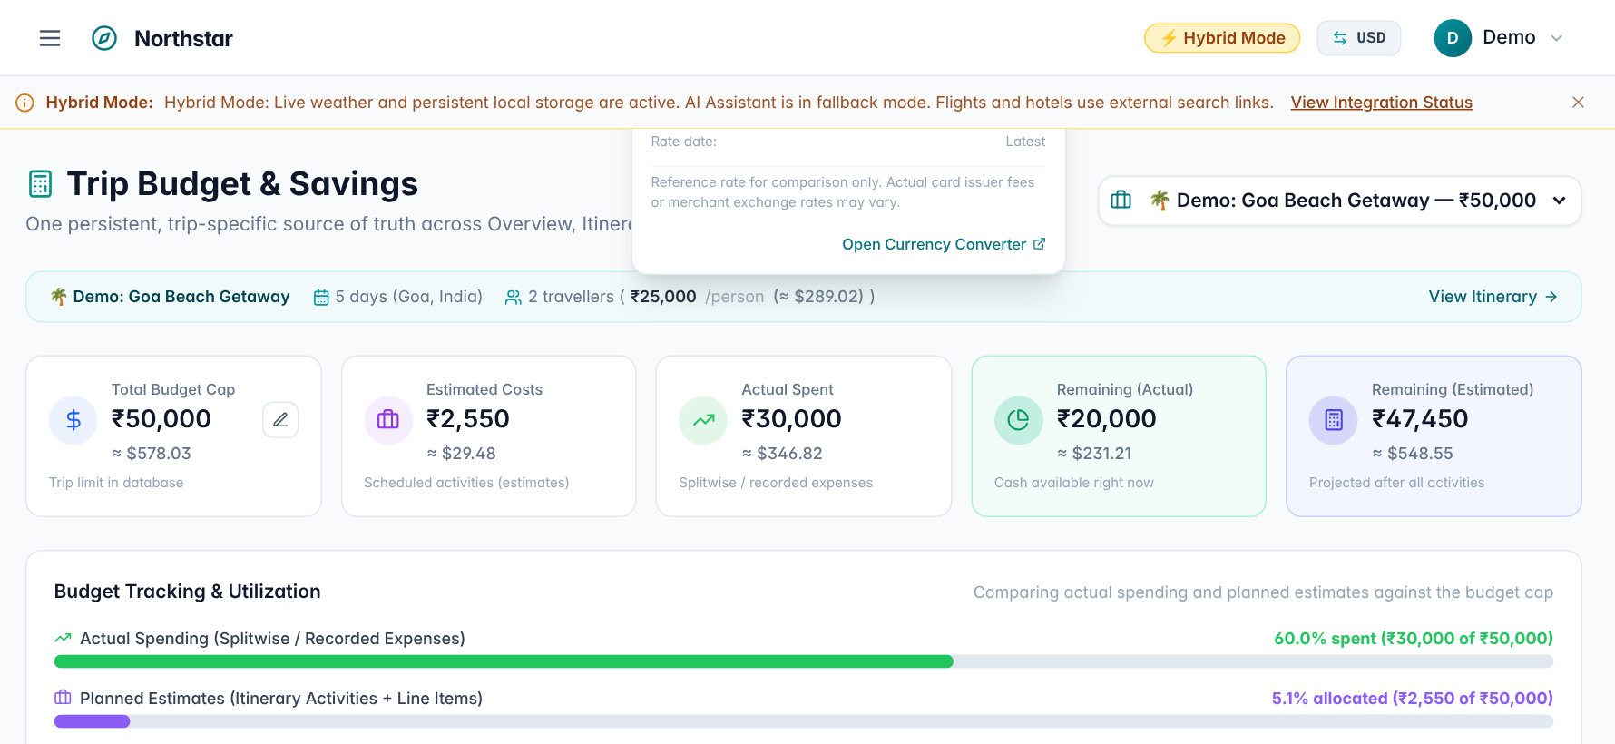
Figure 6.25: Budget page with preferred currency USD: original INR amounts with ≈ USD equivalents and the rate popover
Note on the figures: these screenshots were captured without internet access to the exchange-rate service, so the converted values use the application’s built-in approximate fallback rates (for example, ₹50,000 ≈ $578.03 at 86.5 INR per USD), not live ECB rates. This behaviour is discussed in Section 8.7.
Listing 6.3 – CurrencyProvider initialisation (src/context/CurrencyContext.tsx)
export function CurrencyProvider({ children }: { children: React.ReactNode }) {
const { user, updateUser } = useAuth()

// 1. Preferred Currency State (default INR)
const [preferredCurrency, setPreferredCurrencyState] = useState<string>(() => {
return user?.preferred_currency || localStorage.getItem(PREF_CURRENCY_KEY) || 'INR'
})

// 2. Show Converted Prices Toggle (default true)
const [showConvertedPrices, setShowConvertedPricesState] = useState<boolean>(() => {
if (user && typeof user.show_converted_prices === 'boolean') {
return user.show_converted_prices
}
const stored = localStorage.getItem(SHOW_CONVERTED_KEY)
return stored !== 'false'
})

// Synchronize with user profile when user logs in or profile changes
useEffect(() => {
if (user?.preferred_currency) {
setPreferredCurrencyState(user.preferred_currency)
localStorage.setItem(PREF_CURRENCY_KEY, user.preferred_currency)
}
if (user && typeof user.show_converted_prices === 'boolean') {
setShowConvertedPricesState(user.show_converted_prices)
localStorage.setItem(SHOW_CONVERTED_KEY, String(user.show_converted_prices))
}
}, [user?.preferred_currency, user?.show_converted_prices])

// 3. Exchange Rates Table (keyed by common reference base USD with all ECB rates)
const [ratesTable, setRatesTable] = useState<Record<string, number>>({})
const [ratesDate, setRatesDate] = useState<string>('')
const [isRatesStale, setIsRatesStale] = useState<boolean>(false)
const [isLoadingRates, setIsLoadingRates] = useState<boolean>(false)

// Load cached rates from localStorage on initial render
useEffect(() => {
try {
const cached = localStorage.getItem(RATES_STORAGE_KEY)
if (cached) {
const parsed: CachedRatesPayload = JSON.parse(cached)
if (parsed && parsed.rates) {
setRatesTable(parsed.rates)
setRatesDate(parsed.date || '')
}
}
} catch {
// Ignore parse failure
}
}, [])

6.10 Usability and Accessibility Considerations
- Every data-driven page has explicit loading, empty and error states with a next action (for example, “Create Your First Capsule”).
- Forms validate inline before submission and show the server’s detail message when the backend rejects a request.
- Badges distinguish DEMO DATA, live, cached, curated, AI and offline content.
- Interactive elements use semantic buttons and links with visible focus rings; the profile menu supports Escape and outside-click dismissal.
- Colour contrast is maintained in all themes and checked by automated tests.
- Layouts use responsive grids that reflow from four columns to one; the sidebar can be collapsed to icons.

CHAPTER 7

IMPLEMENTATION

7.1 Implementation Overview
Northstar was implemented in approximately 19,000 lines of Python (application code and tests) and 18,400 lines of TypeScript, TSX and CSS. This chapter explains how the most important parts of the design were realised, using short listings taken directly from the source code. Listings are excerpts; unrelated lines are omitted for brevity.
Table 7.1: Size of the main source modules
File | Lines | Role
backend/app/integrations/places.py | 2,812 | Curated places data and places providers
backend/app/api/expenses.py | 780 | Splitwise API, share calculation, settlements
backend/app/algorithms/schedule_builder.py | 754 | Deterministic scheduling engine
backend/app/integrations/ai_provider.py | 639 | Gemini/OpenAI provider with fallbacks
backend/app/api/itinerary.py | 584 | Itinerary generation, replan and budget APIs
backend/app/algorithms/activity_catalogue.py | 546 | Activity catalogue for the scheduler
backend/app/integrations/weather.py | 480 | Open-Meteo weather and geocoding
backend/app/services/capsule_service.py | 407 | Capsules, memories and media storage
frontend/src/pages/Splitwise.tsx | 1,848 | Splitwise user interface
frontend/src/pages/Capsules.tsx | 1,808 | Memory Capsules user interface
frontend/src/pages/Itinerary.tsx | 1,088 | Itinerary user interface
frontend/src/pages/Budget.tsx | 861 | Budget and Savings user interface

7.2 Application Bootstrap
The FastAPI application is created in main.py. A lifespan handler creates database tables at start-up, CORS is configured to allow credentials from the frontend origin, and each router is mounted under its own prefix and documentation tag.
Listing 7.1 – Application set-up (backend/app/main.py)
async def lifespan(app: FastAPI):
"""Create database tables on startup (safe: create_all is idempotent)."""
Base.metadata.create_all(bind=engine)
try:
with engine.connect() as conn:
res = conn.execute(text("PRAGMA table_info(group_members)")).fetchall()
cols = [r[1] for r in res]
if cols and "is_active" not in cols:
conn.execute(text("ALTER TABLE group_members ADD COLUMN is_active BOOLEAN DEFAULT 1"))

# Migrate users table for global currency preferences
user_cols_res = conn.execute(text("PRAGMA table_info(users)")).fetchall()
user_cols = [r[1] for r in user_cols_res]
if user_cols and "preferred_currency" not in user_cols:
conn.execute(text("ALTER TABLE users ADD COLUMN preferred_currency VARCHAR(3) DEFAULT 'INR'"))
if user_cols and "show_converted_prices" not in user_cols:
conn.execute(text("ALTER TABLE users ADD COLUMN show_converted_prices BOOLEAN DEFAULT 1"))
# Ensure any existing users with null preferred_currency default to 'INR'
if user_cols:
conn.execute(text("UPDATE users SET preferred_currency = 'INR' WHERE preferred_currency IS NULL"))
conn.execute(text("UPDATE users SET show_converted_prices = 1 WHERE show_converted_prices IS NULL"))
conn.commit()
except Exception:
pass
yield

app = FastAPI(
title="Northstar API",
description="Northstar — Your compass to everywhere. Backend API",
version="0.2.0",
lifespan=lifespan,
)

# ---------------------------------------------------------------------------
# CORS — allow_credentials=True is required for httpOnly cookie auth
# ---------------------------------------------------------------------------
app.add_middleware(
CORSMiddleware,
allow_origins=[settings.FRONTEND_ORIGIN, "http://localhost:5173", "http://127.0.0.1:5173"],
allow_credentials=True,
allow_methods=["*"],
allow_headers=["*"],
)

# ---------------------------------------------------------------------------
# Routers — Phase 1 & 2 (unchanged)
# ---------------------------------------------------------------------------
app.include_router(health.router, prefix="/api", tags=["health"])
app.include_router(trips.router, prefix="/api/trips", tags=["trips"])
app.include_router(activities.router, prefix="/api/activities", tags=["activities"])
app.include_router(expenses.router, prefix="/api/expenses", tags=["expenses"])
app.include_router(groups.router, prefix="/api/groups", tags=["groups"])
app.include_router(demo.router, prefix="/api/demo", tags=["demo"])
app.include_router(itinerary.router, prefix="/api/itinerary", tags=["itinerary"])

7.3 Data Model Implementation
Models use SQLAlchemy 2.0’s typed declarative style with Mapped[...] annotations, so the Python types of columns are checked by editors and type checkers. Relationships declare cascades explicitly; for example, deleting a trip deletes its activities and expense groups.
Listing 7.2 – Trip model (backend/app/models/base.py)
class Trip(Base):
__tablename__ = "trips"

id: Mapped[int] = mapped_column(Integer, primary_key=True, index=True)
name: Mapped[str] = mapped_column(String(200), nullable=False)
origin: Mapped[str] = mapped_column(String(200), nullable=False)
destination: Mapped[str] = mapped_column(String(200), nullable=False)
departure_date: Mapped[date] = mapped_column(Date, nullable=False)
return_date: Mapped[date] = mapped_column(Date, nullable=False)
num_days: Mapped[int] = mapped_column(Integer, nullable=False)
num_travellers: Mapped[int] = mapped_column(Integer, default=1)

# Budget (stored as integer minor-currency units, e.g. paise)
budget_minor: Mapped[int] = mapped_column(Integer, nullable=False, default=0)
currency: Mapped[str] = mapped_column(String(3), default="INR")

status: Mapped[TripStatus] = mapped_column(
SAEnum(TripStatus), default=TripStatus.PLANNING
)
is_demo: Mapped[bool] = mapped_column(Boolean, default=False)

# Optional owner — NULL means unowned / demo trip
user_id: Mapped[Optional[int]] = mapped_column(
Integer, ForeignKey("users.id", ondelete="SET NULL"), nullable=True, index=True
)

# Preferences (JSON-serializable fields stored as strings for SQLite compat)
travel_styles: Mapped[Optional[str]] = mapped_column(Text, nullable=True) # comma-sep enum values
accommodation_pref: Mapped[Optional[str]] = mapped_column(String(100), nullable=True)
transport_pref: Mapped[Optional[str]] = mapped_column(String(100), nullable=True)
food_pref: Mapped[Optional[str]] = mapped_column(String(200), nullable=True)
must_visit: Mapped[Optional[str]] = mapped_column(Text, nullable=True)
avoid: Mapped[Optional[str]] = mapped_column(Text, nullable=True)
walking_tolerance: Mapped[int] = mapped_column(Integer, default=5) # 1–10
travel_pace: Mapped[int] = mapped_column(Integer, default=5) # 1–10 (slow–fast)

notes: Mapped[Optional[str]] = mapped_column(Text, nullable=True)

created_at: Mapped[datetime] = mapped_column(DateTime, server_default=func.now())
updated_at: Mapped[datetime] = mapped_column(
DateTime, server_default=func.now(), onupdate=func.now()
)

# Relationships
activities: Mapped[List["Activity"]] = relationship(
"Activity", back_populates="trip", cascade="all, delete-orphan"
)
expense_groups: Mapped[List["ExpenseGroup"]] = relationship(
"ExpenseGroup", back_populates="trip", cascade="all, delete-orphan"
)

@property
def budget_major(self) -> float:
"""Budget in major currency units (e.g. rupees)."""
return self.budget_minor / 100

def __repr__(self) -> str:
return f"<Trip id={self.id} name={self.name!r} destination={self.destination!r}>"

7.4 Authentication Implementation
Password hashing and token creation are isolated in core/security.py. Note the 72-byte truncation required by bcrypt and the type claim that distinguishes access and refresh tokens.
Listing 7.3 – Password hashing and JWT creation (backend/app/core/security.py)
# ── Password hashing ──────────────────────────────────────────────────────────

def hash_password(plain: str) -> str:
"""Return a bcrypt hash of *plain*."""
# bcrypt requires bytes; truncate to 72 bytes per bcrypt specification
plain_bytes = plain.encode("utf-8")[:72]
salt = bcrypt.gensalt()
return bcrypt.hashpw(plain_bytes, salt).decode("utf-8")

get_password_hash = hash_password

def verify_password(plain: str, hashed: str) -> bool:
"""Return True if *plain* matches the stored *hashed* password."""
try:
plain_bytes = plain.encode("utf-8")[:72]
hashed_bytes = hashed.encode("utf-8")
return bcrypt.checkpw(plain_bytes, hashed_bytes)
except Exception:
return False

# ── JWT tokens ────────────────────────────────────────────────────────────────

ALGORITHM = "HS256"
ACCESS_TOKEN_EXPIRE_MINUTES = 30
REFRESH_TOKEN_EXPIRE_DAYS = 7

def create_access_token(user_id: int, email: str) -> str:
"""Create a short-lived JWT access token."""
expire = datetime.now(timezone.utc) + timedelta(minutes=ACCESS_TOKEN_EXPIRE_MINUTES)
payload = {
"sub": str(user_id),
"email": email,
"type": "access",
"exp": expire,
}
return jwt.encode(payload, settings.SECRET_KEY, algorithm=ALGORITHM)

def create_refresh_token(user_id: int) -> str:
"""Create a long-lived JWT refresh token."""
expire = datetime.now(timezone.utc) + timedelta(days=REFRESH_TOKEN_EXPIRE_DAYS)
payload = {
"sub": str(user_id),
"type": "refresh",
"exp": expire,
}
return jwt.encode(payload, settings.SECRET_KEY, algorithm=ALGORITHM)

def decode_token(token: str) -> Optional[dict]:
"""
Decode and validate a JWT.
Returns the payload dict or None if invalid / expired.
"""
try:
return jwt.decode(token, settings.SECRET_KEY, algorithms=[ALGORITHM])
except JWTError:
return None

The login service always performs a bcrypt comparison, even when no user exists, so that the response time does not reveal whether an email is registered.
Listing 7.4 – Timing-safe authentication (backend/app/services/auth_service.py)
def authenticate_user(db: Session, email: str, password: str) -> User:
"""
Verify credentials. Uses a constant-time path to prevent user enumeration.
Raises 401 on failure.
"""
user = db.query(User).filter(User.email == email.lower()).first()
# Always verify — prevents timing attacks
dummy_hash = "$2b$12$" + "x" * 53
if user is None:
verify_password(password, dummy_hash)
raise HTTPException(
status_code=status.HTTP_401_UNAUTHORIZED,
detail="Incorrect email or password.",
)
if not verify_password(password, user.hashed_password):
raise HTTPException(
status_code=status.HTTP_401_UNAUTHORIZED,
detail="Incorrect email or password.",
)
if not user.is_active:
raise HTTPException(
status_code=status.HTTP_403_FORBIDDEN,
detail="This account has been deactivated.",
)
return user

The current-user dependency resolves the user from the httpOnly cookie, with a Bearer header fallback for API clients.
Listing 7.5 – Current-user dependency (backend/app/api/auth.py)
def get_current_user(
access_token: Optional[str] = Cookie(default=None),
authorization: Optional[str] = Header(default=None),
db: Session = Depends(get_db),
) -> User:
"""FastAPI dependency — resolve the logged-in user from the access_token cookie or Bearer header."""
credentials_exc = HTTPException(
status_code=status.HTTP_401_UNAUTHORIZED,
detail="Not authenticated.",
)
token = access_token
if not token and authorization and authorization.startswith("Bearer "):
token = authorization.split("Bearer ", 1)[1].strip()

if not token:
raise credentials_exc
payload = decode_token(token)
if not payload or payload.get("type") != "access":
raise credentials_exc
user_id = int(payload["sub"])
user = db.query(User).filter(User.id == user_id, User.is_active.is_(True)).first()
if not user:
raise credentials_exc
return user

7.5 Itinerary Engine Implementation
Listing 7.6 shows the scoring and pacing functions of the schedule builder described in Section 5.7.1, and Listing 7.7 the overlap validator.
Listing 7.6 – Candidate scoring and pacing (backend/app/algorithms/schedule_builder.py)
def _style_score(activity: CatalogueActivity, styles: list[str]) -> float:
"""0.0–1.0: fraction of trip styles matched by this activity."""
if not styles:
return 0.5 # neutral when no styles set
matches = sum(1 for s in styles if s in activity["styles"])
return matches / len(styles)

def _budget_weight(activity: CatalogueActivity, remaining_minor: float) -> float:
"""Penalise activities that are expensive when budget is tight."""
if remaining_minor <= 0:
return 0.0 if activity["cost_minor"] > 0 else 1.0
ratio = activity["cost_minor"] / remaining_minor if remaining_minor else 0
return max(0.0, 1.0 - ratio)

def _score(
activity: CatalogueActivity,
styles: list[str],
remaining_minor: int,
pace: int,
) -> float:
style = _style_score(activity, styles)
budget = _budget_weight(activity, remaining_minor)
# High-pace travellers prefer more/longer activities; penalise very long ones slightly
duration_penalty = max(0.0, (activity["duration_minutes"] - 360) / 360) if pace < 5 else 0.0
return style * 0.55 + budget * 0.30 + (1.0 - duration_penalty) * 0.15

# ---------------------------------------------------------------------------
# Time-slot helpers
# ---------------------------------------------------------------------------

def _start_of_day_part(day_part: str, current_cursor: int) -> int:
"""Return the earliest start for an activity of this day_part."""
window_start, _ = DAY_PART_WINDOWS.get(day_part, DAY_PART_WINDOWS["anytime"])
return max(window_start, current_cursor)

def _fits_in_day(start: int, duration: int, day_part: str) -> bool:
_, window_end = DAY_PART_WINDOWS.get(day_part, DAY_PART_WINDOWS["anytime"])
end = start + duration
return end <= min(window_end, DAY_END_MINUTES)

# ---------------------------------------------------------------------------
# Activities-per-day from pace (1=2 per day, 10=6 per day)
# ---------------------------------------------------------------------------

def _max_activities_per_day(pace: int) -> int:
if pace <= 3:
return 2
elif pace <= 6:
return 3
elif pace <= 8:
return 4
else:
return 5

# ---------------------------------------------------------------------------
# Avoid list filter
# ---------------------------------------------------------------------------

def _is_avoided(activity: CatalogueActivity, avoid: Optional[str]) -> bool:
if not avoid:
return False
avoid_lower = avoid.lower()
return any(kw.strip() in activity["name"].lower() or
kw.strip() in activity["category"].lower()
for kw in avoid_lower.split(","))

# ---------------------------------------------------------------------------

Listing 7.7 – Schedule validator (backend/app/algorithms/schedule_builder.py)
def validate_schedule(slots: list[ActivitySlot]) -> list[str]:
"""
Detect time overlaps in a schedule.

Returns a list of warning strings (empty list = no problems found).
"""
warnings: list[str] = []
by_day: dict[int, list[ActivitySlot]] = {}
for s in slots:
by_day.setdefault(s.day_number, []).append(s)

for day, day_slots in by_day.items():
sorted_slots = sorted(day_slots, key=lambda x: x.start_time)
for i in range(len(sorted_slots) - 1):
a, b = sorted_slots[i], sorted_slots[i + 1]
# Compare as HH:MM strings — lexicographic comparison works here
if b.start_time < a.end_time:
warnings.append(
f"Day {day}: '{a.name}' (ends {a.end_time}) overlaps with "
f"'{b.name}' (starts {b.start_time})."
)
return warnings

The generation endpoint enforces ownership and input checks before delegating to the planning service, and converts unexpected errors into a logged 500 response.
Listing 7.8 – Itinerary generation endpoint (backend/app/api/itinerary.py)
@router.post(
"/{trip_id}/generate",
response_model=GenerateItineraryResponse,
status_code=status.HTTP_200_OK,
summary="Generate (or regenerate) an itinerary for a trip",
)
async def generate_itinerary(
trip_id: int,
payload: GenerateItineraryRequest,
db: Session = Depends(get_db),
current_user: Optional[User] = Depends(get_current_user_optional),
) -> GenerateItineraryResponse:
"""
Generate a destination-aware, weather-adapted day-by-day itinerary for *trip_id*.

- Locked activities are kept as-is.
- When `overwrite_unlocked=True` (default), unlocked activities are deleted
only after planning succeeds (atomic transaction, prevents DB locks during I/O).
- Resolves real candidate places (heritage, culture, viewpoints, shopping, parks, food).
- Adapts outdoor activities to favorable weather and suggests indoor options for rain.
- Prevents uncontrolled duplicate runs: retries join any active generation task.
- Returns the full updated activity list plus a budget breakdown.
"""
trip = _get_trip_or_404(trip_id, db)
if trip.user_id is not None and not trip.is_demo:
if not current_user or current_user.id != trip.user_id:
raise HTTPException(
status_code=status.HTTP_403_FORBIDDEN,
detail="You do not have permission to modify this trip's itinerary",
)

if not trip.destination or not trip.destination.strip():
raise HTTPException(
status_code=status.HTTP_400_BAD_REQUEST,
detail="Cannot generate an itinerary for a trip with no destination specified.",
)

try:
return await _run_itinerary_generation(trip_id, payload, db)
except HTTPException:
raise
except Exception as exc:
logger.exception("Itinerary generation error for trip %s: %s", trip_id, exc)
raise HTTPException(
status_code=status.HTTP_500_INTERNAL_SERVER_ERROR,
detail=f"Itinerary generation failed: {exc}",
)

7.6 Splitwise Implementation
Listing 7.9 shows the equal-split branch of _calculate_shares, which spreads the remainder one minor unit at a time, and Listing 7.10 the greedy settlement algorithm.
Listing 7.9 – Equal split with exact remainder distribution (backend/app/api/expenses.py)
if method == SplitMethod.EQUAL:
base = amount_minor // n
remainder = amount_minor - base * n
for i, m in enumerate(participating_members):
extra = 1 if i < remainder else 0
shares.append(ExpenseShare(
expense_id=expense_id,
member_id=m.id,
share_minor=base + extra,
))

Listing 7.10 – Greedy debt simplification (backend/app/api/expenses.py)
def _simplify_debts(
balances: list[MemberBalance], currency: str, member_map: dict
) -> list[Settlement]:
"""Greedy debt simplification — minimises number of transfers."""
creditors = sorted(
[(b.net_minor, b.member_id) for b in balances if b.net_minor > 0],
reverse=True,
)
debtors = sorted(
[(-b.net_minor, b.member_id) for b in balances if b.net_minor < 0],
reverse=True,
)

settlements = []
i, j = 0, 0
while i < len(creditors) and j < len(debtors):
credit_amt, creditor_id = creditors[i]
debt_amt, debtor_id = debtors[j]
transfer = min(credit_amt, debt_amt)

if transfer > 0:
creditor_member = member_map.get(creditor_id)
debtor_member = member_map.get(debtor_id)
creditor_name = creditor_member.name if creditor_member else f"Member #{creditor_id}"
debtor_name = debtor_member.name if debtor_member else f"Member #{debtor_id}"

settlements.append(Settlement(
from_member_id=debtor_id,
from_member_name=debtor_name,
to_member_id=creditor_id,
to_member_name=creditor_name,
amount_minor=transfer,
currency=currency,
))

creditors[i] = (credit_amt - transfer, creditor_id)
debtors[j] = (debt_amt - transfer, debtor_id)

if creditors[i][0] == 0:
i += 1
if debtors[j][0] == 0:
j += 1

return settlements

The same equal-split rule is mirrored in the frontend so that the expense form can preview shares before submission; the server remains authoritative.
Listing 7.11 – Client-side equal-share preview (frontend/src/utils/splitwiseUtils.ts)
export function calculateEqualShares(
amountMinor: number,
participantIds: number[]
): ShareResult[] {
const n = participantIds.length
if (n === 0 || amountMinor <= 0) return []
const base = Math.floor(amountMinor / n)
const remainder = amountMinor - base * n

return participantIds.map((id, idx) => ({
member_id: id,
share_minor: base + (idx < remainder ? 1 : 0),
}))
}

7.7 Memory Capsule Media Handling
Uploaded files are validated against allow-lists, size limits and emptiness before being written with a server-generated name that embeds the owner’s id. The streaming endpoint (Listing 7.13) neutralises path traversal and checks ownership before returning the file with a private cache header.
Listing 7.12 – Upload validation and storage (backend/app/services/capsule_service.py)
async def validate_and_save_media(
file: UploadFile,
user_id: Optional[int] = None,
) -> Tuple[str, str, int]:
"""
Validate an uploaded file (size, MIME, extension) and save to persistent storage.
Prefixes filename with user_id to cryptographically bind ownership.
Returns (media_url, media_type, file_size_bytes).
"""
if not file.filename:
raise HTTPException(
status_code=status.HTTP_400_BAD_REQUEST,
detail="File must have a filename."
)

_, ext = os.path.splitext(file.filename.lower())
if ext not in ALLOWED_EXTENSIONS:
raise HTTPException(
status_code=status.HTTP_400_BAD_REQUEST,
detail=f"Unsupported file format '{ext}'. Allowed: {', '.join(sorted(ALLOWED_EXTENSIONS))}"
)

content_type = file.content_type or ""
if content_type not in ALLOWED_MIMES:
# Fallback check based on extension
if ext in ALLOWED_IMAGE_EXTENSIONS:
content_type = "image/jpeg" if ext in {".jpg", ".jpeg"} else f"image/{ext[1:]}"
elif ext in ALLOWED_VIDEO_EXTENSIONS:
content_type = "video/mp4" if ext == ".mp4" else f"video/{ext[1:]}"
else:
raise HTTPException(
status_code=status.HTTP_400_BAD_REQUEST,
detail=f"Unsupported MIME type '{file.content_type}'."
)

media_type = "video" if (ext in ALLOWED_VIDEO_EXTENSIONS or content_type in ALLOWED_VIDEO_MIMES) else "image"
max_size = MAX_VIDEO_SIZE if media_type == "video" else MAX_IMAGE_SIZE

# Read content to check file size safely
content = await file.read()
file_size = len(content)

if file_size == 0:
raise HTTPException(
status_code=status.HTTP_400_BAD_REQUEST,
detail="Uploaded file is empty."
)

if file_size > max_size:
limit_mb = max_size // (1024 * 1024)
raise HTTPException(
status_code=status.HTTP_400_BAD_REQUEST,
detail=f"File exceeds maximum allowed size of {limit_mb} MB."
)

# Secure filename prefixed with owner user_id to enforce ownership
prefix = f"u{user_id}_" if user_id is not None else ""
safe_filename = f"{prefix}{uuid.uuid4().hex}{ext}"
dest_path = os.path.join(UPLOAD_DIR, safe_filename)

try:
with open(dest_path, "wb") as f:
f.write(content)
except Exception:
raise HTTPException(
status_code=status.HTTP_500_INTERNAL_SERVER_ERROR,
detail="Failed to save file to server storage."
)

media_url = f"/api/capsules/media/{safe_filename}"
return media_url, media_type, file_size

Listing 7.13 – Secure media streaming (backend/app/api/capsules.py)
@router.get("/media/{filename}", response_class=FileResponse)
def get_capsule_media(
filename: str,
current_user: User = Depends(get_current_user),
db: Session = Depends(get_db),
):
"""
Safely stream an uploaded media file with authenticated ownership verification.
Prevents directory traversal and strictly forbids cross-user access to private media.
"""
safe_filename = os.path.basename(filename)
filepath = os.path.join(capsule_service.UPLOAD_DIR, safe_filename)

# 1. Path traversal & file existence defense
abs_filepath = os.path.abspath(filepath)
abs_upload_dir = os.path.abspath(capsule_service.UPLOAD_DIR)
if not abs_filepath.startswith(abs_upload_dir) or not os.path.isfile(abs_filepath):
raise HTTPException(
status_code=status.HTTP_404_NOT_FOUND,
detail="Media file not found."
)

# 2. Ownership verification:
if safe_filename.startswith("u") and "_" in safe_filename:
try:
owner_part = safe_filename.split("_")[0][1:]
owner_id = int(owner_part)
if owner_id != current_user.id:
raise HTTPException(
status_code=status.HTTP_403_FORBIDDEN,
detail="You do not have access to this private media."
)
except ValueError:

7.8 AI Provider Implementation
The AI provider returns a uniform dictionary regardless of which backend answered, including honesty flags (is_ai, is_fallback, is_complete). When no key is configured, a curated offline answer is returned with is_ai = false.
Listing 7.14 – Provider-independent text generation (backend/app/integrations/ai_provider.py)
async def generate_text(
prompt: str,
system: str = "You are a helpful travel planning assistant.",
max_tokens: int = 4096,
temperature: float = 0.7,
) -> dict:
"""
Send *prompt* to the configured AI provider and return:
{
"text": str, # the model's reply
"is_ai": bool, # True only when a real provider was used
"provider": str, # provider name for attribution
"model": str, # specific model used
"is_fallback": bool, # True if a fallback model was activated
"is_complete": bool, # False if output was truncated by token limits
"finish_reason": str, # e.g. "stop", "max_tokens", "length"
"error": str | None, # non-None when the provider call failed or key is missing
}

Falls back gracefully on missing keys, timeouts, or provider errors.
"""
res: dict | None = None
if _gemini_available():
res = await _call_gemini(prompt, system, max_tokens, temperature)
elif _openai_available():
res = await _call_openai(prompt, system, max_tokens, temperature)
else:
res = _curated_fallback(
prompt,
reason="No AI provider configured. Set GEMINI_API_KEY or OPENAI_API_KEY in backend/.env.",
)

if res and "text" in res and res["text"]:
res["text"] = _clean_markdown(res["text"])

7.9 Frontend Implementation
Listing 7.15 shows the protected-route component, and Listing 7.16 part of the flight-search validation that runs before any external link is opened.
Listing 7.15 – Protected route (frontend/src/components/ProtectedRoute.tsx)
import { Navigate, useLocation } from 'react-router-dom'
import { useAuth } from '../context/AuthContext'

interface Props {
children: React.ReactNode
}

/**
* Redirects unauthenticated users to /login, preserving the intended destination
* via location.state.from so the login page can redirect back after sign-in.
*/
export default function ProtectedRoute({ children }: Props) {
const { isAuthenticated, loading } = useAuth()
const location = useLocation()

if (loading) {
// Avoid flash-redirect while the initial /me check is in progress
return (
<div className="flex items-center justify-center min-h-screen">
<span className="w-8 h-8 border-4 border-accent-300 border-t-accent-600 rounded-full animate-spin" />
</div>
)
}

if (!isAuthenticated) {
return <Navigate to="/login" state={{ from: location.pathname }} replace />
}

return <>{children}</>
}

Listing 7.16 – Flight search validation (frontend/src/utils/flightSearch.ts)
export function validateFlightSearch(
params: FlightSearchParams,
todayStr: string = getLocalDateString(),
): FlightValidationResult {
const errors: FlightValidationResult['errors'] = {}

const originTrimmed = (params.origin || '').trim()
const destTrimmed = (params.dest || '').trim()

// 1. Origin and Destination presence
if (!originTrimmed) {
errors.origin = 'Please enter an origin city or airport.'
}
if (!destTrimmed) {
errors.dest = 'Please enter a destination city or airport.'
}

// 2. Origin and Destination identical check
if (originTrimmed && destTrimmed) {
const originInfo = extractAirportOrCity(originTrimmed)
const destInfo = extractAirportOrCity(destTrimmed)

const isSameCode = Boolean(originInfo.code && destInfo.code && originInfo.code === destInfo.code)
const isSameName = originInfo.name.toLowerCase() === destInfo.name.toLowerCase()

if (isSameCode || isSameName) {
errors.dest = 'Origin and destination must be different cities.'
errors.general = 'Origin and destination must be different cities.'
}
}

// 3. Departure Date
if (!params.departureDate) {
errors.departureDate = 'Please select a departure date.'

7.10 Email Delivery Implementation
Listing 7.17 shows how a message is sent through Mailjet: a multipart message with a formatted sender, a STARTTLS upgrade and a bounded timeout.
Listing 7.17 – SMTP delivery through Mailjet (backend/app/core/email.py)
def _send_smtp(to_email: str, subject: str, html_body: str, plain_text: str | None = None) -> None:
"""Send multipart email via SMTP with STARTTLS. Raises on failure."""
msg = MIMEMultipart("alternative")
msg["Subject"] = subject

sender_name = settings.SMTP_FROM_NAME or "Northstar Travel"
sender_addr = settings.SMTP_FROM or settings.SMTP_USER
msg["From"] = formataddr((sender_name, sender_addr))
msg["To"] = to_email

# Plain text fallback
if plain_text:
msg.attach(MIMEText(plain_text, "plain", "utf-8"))

# HTML version
msg.attach(MIMEText(html_body, "html", "utf-8"))

context = ssl.create_default_context()
with smtplib.SMTP(settings.SMTP_HOST, settings.SMTP_PORT, timeout=15) as server:
server.ehlo()
server.starttls(context=context)
server.ehlo()
server.login(settings.SMTP_USER, settings.SMTP_PASSWORD)
server.sendmail(sender_addr, to_email, msg.as_string())

7.11 Currency Conversion Implementation
Listing 7.18 shows the first part of the synchronous convert() function in CurrencyContext. Amounts stored in minor units are converted to major units, identical currencies short-circuit at a 1:1 rate, and other pairs are cross-converted through the USD-based rate table, with the AED peg handled explicitly.
Listing 7.18 – Inline currency conversion (frontend/src/context/CurrencyContext.tsx)
const convert = useCallback((
amount: number,
fromCurrency: string,
toCurrency?: string,
isMinor: boolean = false,
): ConversionResult => {
const from = (fromCurrency || 'INR').toUpperCase().trim()
const target = (toCurrency || preferredCurrency || 'INR').toUpperCase().trim()

// Normalize minor currency units (e.g. paise / cents) to major units
// JPY does not have minor units in standard banking, but in Northstar base.py
// cost_minor is universally stored as integer minor units (paise/cents)
const majorAmount = isMinor ? amount / 100 : amount

// 1. Same-currency short-circuit: 1:1 conversion
if (from === target) {
return {
originalAmount: majorAmount,
fromCurrency: from,
toCurrency: target,
convertedAmount: majorAmount,
rate: 1.0,
inverseRate: 1.0,
date: ratesDate || 'Current',
isSame: true,
isCached: true,
isStale: false,
provider: 'Frankfurter / European Central Bank',
disclaimer: 'Same currency — 1:1 parity.',
}
}

// 2. Exchange rate calculation
// ratesTable is keyed to USD: 1 USD = ratesTable[X] units of X
let rate = 1.0
let rateFound = false

const rateFrom = ratesTable[from] ?? (from === 'USD' ? 1.0 : undefined)
const rateTo = ratesTable[target] ?? (target === 'USD' ? 1.0 : undefined)

if (rateFrom && rateTo) {
// 1 USD = rateFrom units of FROM
// 1 USD = rateTo units of TARGET
// Therefore, 1 FROM = (rateTo / rateFrom) units of TARGET
rate = rateTo / rateFrom
rateFound = true
} else if (from === 'AED' && rateTo) {
// AED is pegged at 3.6725 AED/USD
rate = rateTo / 3.6725
rateFound = true
} else if (target === 'AED' && rateFrom) {
rate = (3.6725) / rateFrom
rateFound = true
}

7.12 Coding Standards Followed
- PEP 8 with a 100-character limit, type hints and docstrings on public functions (Python).
- Functional React components and hooks only; interfaces for every API response in src/types.
- No business logic in route handlers; algorithms are pure and database-free.
- Money in integer minor units; Decimal-safe arithmetic for exchange rates.
- Demo helpers prefixed with _demo_; all demo data labelled in the UI.
- Secrets only in .env; .env, databases, uploads, venv and node_modules excluded from Git.
- Commit after each working phase with descriptive messages (for example, feat: add preference scorer algorithm).

CHAPTER 8

TESTING

8.1 Introduction
Testing verifies that the system meets its requirements and validates that it solves the user’s problem. For Northstar, testing had to cover not only ordinary CRUD behaviour but also algorithmic guarantees (no overlapping activities, exact money arithmetic), security properties (ownership, token handling, path traversal), and resilience to external services that may be slow, rate-limited or unavailable. This chapter describes the strategy, tools, environment and results. In total, 283 test cases were documented, each with pre-conditions, steps, test data, expected and actual results, and the requirement it verifies; this chapter summarises them and reproduces representative examples.

8.2 Testing Strategy
A layered strategy following the test pyramid was used: many fast unit tests at the bottom, a substantial layer of API integration tests, and a smaller number of end-to-end and browser-based UI checks at the top.
Table 8.1: Levels of testing
Level | What is tested | How
Unit testing | Pure functions: scheduling, validation, replanning, share calculation, formatting, URL building, markdown parsing | Pytest functions calling algorithms directly; Node test runner for TypeScript utilities
Integration testing | API endpoints with a real SQLite database, dependencies and services | FastAPI TestClient with an isolated test database per module
Mocked-provider testing | Behaviour when AI, weather, geocoding or places providers succeed, fail, time out or return malformed data | monkeypatch / AsyncMock replacing provider functions
Security testing | Authentication, authorisation, isolation between users, path traversal, upload validation, unsafe links | Dedicated negative tests with two users and crafted inputs
System / end-to-end testing | Complete user journeys across modules | End-to-end Pytest workflow; Playwright browser checks against the running build
UI testing | Rendering, navigation, validation messages, protected routes, theming, responsiveness | Playwright (Chromium) scripts; source-level checks for contrast and portal behaviour
Regression testing | Re-running all suites after each phase and audit | Full Pytest and Node suites

8.2.1 Black-Box and White-Box Techniques
Black-box techniques were used to design most test cases from the requirements: equivalence partitioning (valid and invalid passwords, supported and unsupported file types), boundary value analysis (8-character passwords, 10 MB and 10 MB + 1 byte images, latitude 90 and 91, one-day trips, nine and ten passengers), and decision tables for split methods and participant selections. White-box techniques were applied to the algorithms: tests target each branch of the Plan-B engine (closure, delay within the day, delay past 22:00, locked activity, unknown activity), each split method branch, and each fallback path of the AI provider.

8.3 Testing Tools and Environment
Table 8.2: Testing tools
Tool | Use
Pytest 8.3 + pytest-asyncio | Backend unit, integration and end-to-end tests (20 modules)
FastAPI TestClient (HTTPX) | In-process HTTP calls to the API, including cookies
unittest.mock (monkeypatch, AsyncMock) | Simulating AI responses, timeouts, malformed JSON and provider failures
Node.js test runner (node --test) | Frontend utility and UI-invariant tests (12 files)
unittest.mock (SMTP) | Mocked smtplib to verify STARTTLS, sender format and failure handling without sending real email
Playwright with Chromium | 30 browser-based UI checks against the production build
Swagger UI (/docs) | Manual exploratory testing of endpoints

Table 8.3: Test execution environment
Item | Value
Execution date | 23 October 2026
Operating system | Linux (containerised)
Backend | Python 3.13, dependencies from requirements.txt
Frontend | Node 22; production bundle from frontend/dist
Browser | Chromium (headless) via Playwright, 1440 × 900 and 390 × 844 viewports
Database | Fresh SQLite database per test module; seeded demo data for UI checks
AI configuration | No API keys (offline AI mode); AI behaviour verified with mocks
Email configuration | No SMTP credentials (development mode); Mailjet delivery verified with a mocked SMTP server
Network | No outbound access to public APIs (affects 13 live-API tests)

8.4 Automated Test Suites
Table 8.4: Backend test modules and results
Module | Tests | Pass | Fail* | Coverage
test_phase1.py | 17 | 17 | 0 | Health, trips, activities, groups, equal split, balances, demo
test_phase2.py | 40 | 40 | 0 | Schedule builder, validator, Plan-B, itinerary API
test_phase3.py | 26 | 26 | 0 | Auth flows, tokens, profile, history, account deletion
test_phase4.py | 17 | 17 | 0 | Weather API, AI status/chat/enrich, integrations
test_phase5.py | 5 | 5 | 0 | Memory Capsules basics and isolation
test_capsules_phase6d.py | 9 | 9 | 0 | Capsule lifecycle, media validation, path traversal
test_splitwise_phase6c.py | 10 | 10 | 0 | All split methods, settlements, leave/delete
test_budget_phase6e.py | 7 | 7 | 0 | Budget consistency, planned vs actual
test_weather_phase6f.py | 10 | 9 | 1 | Structure, bounds, time zones, cache, failures
test_phase6h_audit.py | 7 | 5 | 2 | Ownership audit, international search
test_phase7_ai_quality.py | 8 | 8 | 0 | Continuation, fallback, attribution
test_smart_itinerary.py | 19 | 18 | 1 | Two-stage planner, weather, AI fallbacks, atomicity
test_universal_pipeline.py | 16 | 13 | 3 | 16 destination scenarios
test_currency.py | 7 | 2 | 5 | Currencies and live ECB conversion
test_audit_fixes.py | 4 | 3 | 1 | Budget updates, participants, geocoding
test_ai_diagnostics.py | 7 | 7 | 0 | Markdown cleanup, fallback labelling
test_e2e_workflow.py | 1 | 0 | 1 | End-to-end workflow with live services
test_email_smtp.py | 5 | 5† | 0 | Mailjet SMTP detection, templates, STARTTLS, failure handling, reset tokens
test_currency_preferences.py | 4 | 4† | 0 | Preferred currency defaults, profile API, currency endpoints
Total | 219 | 205 | 14

Of the 14 failures, 13 occur only because these tests call live public services (Open-Meteo, Nominatim, Frankfurter) and the test machine had no outbound internet access; they returned HTTP 403/503 from the network proxy. These test cases are recorded as Blocked* and should be re-run on a networked machine. The remaining failure is analysed in Section 8.7. † These two new modules pass as delivered on Windows; on Linux they pass after the one-line teardown fix described in DEF-004.
Table 8.5: Frontend test files and results
Test file | Tests | Pass | Coverage
flightSearch.test.ts | 32 | 32 | Trip types, dates, passengers, provider URLs, honesty labels
weatherConsistency.test.ts | 20 | 20 | Local time formatting, coordinates, UV index
budgetConsistency.test.ts | 15 | 15 | Currency formatting, budget input, planned vs actual
destinationMatching.test.ts | 15 | 15 | Ranking and matching rules
capsules.test.ts | 11 | 11 | Dates, file types, size limits
themeContrastAndPortal.test.ts | 11 | 11 | Dropdown portal, z-index, theme contrast
itineraryCoverage.test.ts | 8 | 8 | Full-day coverage, currency formats
safeMarkdown.test.ts | 7 | 7 | Safe rendering and link schemes
currencyConverter.test.ts | 6 | 6 | Conversion rules and validation
splitwise.test.ts | 6 | 6 | Split and settlement validation
aiAssistantQuality.test.ts | 3 | 3 | Answer parsing and truncation detection
globalCurrency.test.ts | 9 | 9 | Preferred currency, conversion rules, safe fallback, no mutation, cache TTL
Total | 143 | 143

8.5 Sample Test Cases
Table 8.6 reproduces representative test cases, covering every major module. Each documented test case records its pre-conditions, numbered steps, test data, expected result, actual result, status, requirement ID and the automated check that verified it.
Table 8.6: Representative test cases
TC ID | Scenario | Test data | Expected result | Status
TC_AUTH_009 | Login with unregistered email | nobody@example.com | 401 with the same message as wrong password | Pass
TC_AUTH_017 | Reuse a verification token | Used token | 400 invalid or expired | Pass
TC_TRIP_006 | Return date before departure | 26 Nov → 22 Nov | 422; trip not created | Pass
TC_ITIN_003 | No time overlaps in generated schedule | 3-day trip | validate_schedule() returns no warnings | Pass
TC_ITIN_005 | Budget cap respected | Budget ₹2,000 | Total estimated cost ≤ cap | Pass
TC_ITIN_042 | AI returns malformed JSON | Mocked invalid JSON | Deterministic plan, no HTTP 500 | Pass
TC_RPLN_008 | Delay beyond 22:00 | Delay 300 min | Treated as closure | Pass
TC_SPLT_002 | Equal split sums to total | ₹100 among 3 | 3334 + 3333 + 3333 = 10000 paise | Pass
TC_SPLT_007 | Percentages not totalling 100% | 50/30/10 | 400 “Percentages must total 100% (currently 90%)” | Pass
TC_CAPS_008 | Path traversal attempt | ../../travel_guide.db | 404; file not served | Pass
TC_AI_015 | Unsafe javascript: link in AI answer | [x](javascript:alert(1)) | Rendered as plain text | Pass
TC_FLGT_015 | Same origin and destination (UI) | Mumbai / Mumbai | “Origin and destination must be different cities.” | Pass
TC_UI_008 | Mobile layout at 390 px | 390 × 844 | Sidebar collapsed; content full width | Fail
TC_CURR_003 | USD → EUR → USD (live) | 100 USD | Round trip within tolerance | Blocked
TC_EMAL_004 | SMTP failure during forgot-password | Mocked SMTP error | 200 generic message; no token; error logged without credentials | Pass
TC_CPRF_020 | All main routes render while rates API is down | 17 routes | Every route renders; no runtime errors | Pass

8.6 Test Results Summary
Table 8.7: Module-wise summary of documented test cases
Module | Total | Pass | Fail | Blocked | Pass %
Authentication | 32 | 32 | 0 | 0 | 100.0
Trips | 16 | 16 | 0 | 0 | 100.0
Itinerary | 61 | 57 | 1 | 3 | 93.4
Re-planning | 10 | 10 | 0 | 0 | 100.0
Budget | 17 | 17 | 0 | 0 | 100.0
Splitwise | 19 | 19 | 0 | 0 | 100.0
Weather | 21 | 17 | 0 | 4 | 81.0
Currency | 10 | 5 | 0 | 5 | 50.0
AI Assistant | 17 | 17 | 0 | 0 | 100.0
Memory Capsules | 16 | 16 | 0 | 0 | 100.0
History | 5 | 5 | 0 | 0 | 100.0
Flights | 15 | 15 | 0 | 0 | 100.0
Explore & Safety | 6 | 6 | 0 | 0 | 100.0
Email Delivery | 5 | 5 | 0 | 0 | 100.0
Currency Preferences | 21 | 21 | 0 | 0 | 100.0
UI & Theme | 8 | 7 | 1 | 0 | 87.5
End-to-End | 4 | 3 | 0 | 1 | 75.0
Total | 283 | 268 | 2 | 13 | 94.7

Of the 283 documented test cases, 268 passed (94.7%), 2 failed and 13 were blocked by the absence of internet access in the test environment. Excluding blocked cases, the pass rate of executed tests is 99.3% (268 of 270). Every functional requirement from FR-01 to FR-39 is covered by at least one test case.

8.7 Defects Found
Table 8.8: Defect log
ID | Description | Severity | Analysis and corrective action
DEF-001 | On a 390 px wide phone screen the sidebar is expanded by default (248 px), leaving about 140 px for the page. | Medium | AppLayout initialises sidebarCollapsed to false for all screen sizes. Fix: initialise from a (max-width: 768px) media query and show the sidebar as an overlay drawer on small screens.
DEF-002 | test_ai_partial_response_synthesizes_missing_days fails: all four days are produced, but the AI-provided activities for days 1–2 are not present. | Medium | Observed in the offline environment, where destination geocoding was unavailable. Suspected cause: AI items are discarded when the destination cannot be resolved. To be re-tested with internet access; if it persists, keep validated AI items when geocoding fails or mock geocoding in the test.
DEF-003 | Blank white screen across the whole application after the global currency preference and inline conversion were added. | Critical | Found during development and fixed before this release. Verified by regression checks UI-24 (all 17 main routes render with the exchange-rate API unreachable) and UI-25 (corrupted cached rates are ignored), together with a passing npm test and npm run build.
DEF-004 | On Linux, 7 of the 9 new backend tests error with “attempt to write a readonly database”. | Low | Test-harness issue: teardown deletes the SQLite file while the connection pool holds it open. Windows blocks the delete, so tests pass there. Fix: call engine_test.dispose() after drop_all; verified that all 9 then pass.
DEF-005 | When the exchange-rate API is unreachable and no rates are cached, conversions use hard-coded approximate rates, while the interface still describes them as ECB reference rates. | Medium | Honesty gap against the project rule of labelling estimated data. Fix: flag fallback conversions as approximate in CurrencyAmount, or hide equivalents until real rates load.
BLK-001 | 13 tests that call live public APIs could not run. | – | Environment limitation, not a product defect. Re-run these tests on a networked machine.

Earlier phases of the project also used testing to find and fix defects before this final run. The dedicated audit phases introduced regression tests for issues such as double counting of expenses across trips, planned estimates being shown as money already spent, dark-on-dark text in a drop-down, time-zone drift in weather dates, duplicate budget warnings, and AI answers being cut off at the token limit. All of these regression tests pass in the final run.

8.8 Performance Observations
The full backend suite of 219 tests, which creates databases, registers users, generates itineraries and runs every algorithm, completed in about 70 seconds, and the 143 frontend tests in about 2 seconds. The production build (npm run build, including TypeScript type-checking) completed in about 8 seconds. During UI testing, deterministic itinerary generation for the five-day demo trip completed in well under the 2-second target, and pages rendered without perceptible delay. External calls are bounded by timeouts and cached (weather 10 minutes, currency 1 hour, geocoding and places 24 hours), so repeated requests do not hit the providers.

CHAPTER 9

DEPLOYMENT AND MAINTENANCE

9.1 Local Installation
Northstar can be run on Windows, macOS or Linux. The prerequisites are Python 3.12+, Node.js 18+ and npm 9+. On Windows, the one-click launcher start_local_demo.bat (or start_local_demo.ps1) detects Python and Node.js, creates backend/.env from the example if necessary, starts the backend on port 8000 and the frontend on port 5173, and opens the browser. stop_local_demo.bat stops any processes listening on those ports. The manual steps are:
Backend
cd backend
python -m venv venv
venv\Scripts\activate # Windows (macOS/Linux: source venv/bin/activate)
pip install -r requirements.txt
copy .env.example .env # macOS/Linux: cp .env.example .env
uvicorn app.main:app --reload --port 8000
# API: http://localhost:8000 Swagger UI: http://localhost:8000/docs

Frontend
cd frontend
npm install
npm run dev # http://localhost:5173 (proxies /api to :8000)

Running the tests
cd backend && pytest tests/ -v
cd frontend && npm test

9.2 Environment Configuration
The application works without any API keys (Demo / Hybrid mode). Adding keys progressively enables live services. The integration status endpoint and the Settings page report which services are live.
Table 9.1: Operating modes
Mode | Condition | Behaviour
Demo | No AI, flight or maps keys | Curated and demo data, deterministic planner, offline AI guide; all labelled.
Hybrid | Free live services reachable, no AI key | Live weather, geocoding, places and currency with local persistence; AI offline mode.
Live | GEMINI_API_KEY or OPENAI_API_KEY set | AI-assisted planning and chat with fallback chain; all other live services.

9.3 Configuring Email Delivery (Mailjet)
- Create a Mailjet account and verify the sender address or domain that emails will come from.
- In Mailjet, open the SMTP settings and copy the API key and secret key.
- Add the values to backend/.env (never to Git): SMTP_HOST=in-v3.mailjet.com, SMTP_PORT=587, SMTP_USER=<API key>, SMTP_PASSWORD=<secret key>, SMTP_FROM=<verified sender> and SMTP_FROM_NAME="Northstar Travel".
- Restart the backend (or simply trigger an email; the configuration is re-read from .env).
- Open /api/health/smtp-status and check that configured is true, then use Forgot password on the login page to send a test email.

9.4 Production Deployment
For a public deployment the following steps are applied (Figure 4.19):
- Generate a strong SECRET_KEY with python -c "import secrets; print(secrets.token_urlsafe(32))", set DEBUG=false, and set FRONTEND_ORIGIN to the frontend domain so that CORS only allows that origin. Change the COOKIE_SECURE constant in app/api/auth.py to True so cookies are sent only over HTTPS (in this version it is a code constant rather than an environment variable).
- Build the frontend with npm run build and deploy frontend/dist to static hosting. The provided vercel.json installs and builds the frontend and rewrites every path to index.html so that client-side routes work on refresh.
- If the API is on a different domain, set VITE_API_BASE_URL=https://api.example.com/api before building.
- Run the backend with uvicorn app.main:app --host 0.0.0.0 --port 8000 --workers 4 behind HTTPS.
- Attach a persistent volume for travel_guide.db and uploads/, or point DATABASE_URL to managed PostgreSQL and move uploads to S3-compatible object storage. Container platforms with ephemeral file systems will otherwise lose data on every restart.
- Configure SMTP variables so that verification and reset emails are delivered instead of being returned in development mode.

9.5 Backup and Restore
The script scripts/backup.py (with a Windows wrapper backup.bat) creates hot, transactionally consistent snapshots while the application is running. It uses the SQLite Online Backup API to copy travel_guide.db, copies all Memory Capsule media from uploads/, and writes a metadata.txt file with the timestamp and record counts into backups/snapshot_YYYYMMDD_HHMMSS/. Restoring is done with python scripts/backup.py --restore backups/snapshot_YYYYMMDD_HHMMSS, which asks for explicit confirmation before replacing existing files.

9.6 Maintenance
Table 9.2: Maintenance activities
Activity | Approach
Corrective | Reproduce with a failing test, fix, and keep the test as a regression guard (as done in the audit phases).
Adaptive | Provider adapters isolate external changes; when an API changes, only its adapter is modified. The AI model chain can be updated in configuration.
Perfective | New curated destinations can be added to the places data; new pages follow the existing service/types pattern.
Preventive | Dependency versions are pinned in requirements.txt and package-lock.json; tests are run before every release; backups are scheduled.
Monitoring | Health endpoint, integration status endpoint and structured logs of provider fallbacks.

9.7 Troubleshooting
Table 9.3: Common problems and solutions
Problem | Solution
Port 8000 or 5173 already in use | Run stop_local_demo.bat, or find the process with netstat -ano | findstr :8000 and end it.
Empty database after restart | Ensure only one backend is running; the database path is resolved to backend/travel_guide.db regardless of working directory.
Login works but session is lost | Use http://localhost:5173 (not 127.0.0.1) to match the CORS origin; keep COOKIE_SECURE=False for plain HTTP development.
AI assistant says Offline Travel Guide | Add GEMINI_API_KEY or OPENAI_API_KEY to backend/.env and restart.
Reset or verification email not received | Check /api/health/smtp-status, confirm the sender is verified in Mailjet, check the spam folder and the backend log for “Failed to deliver” messages.
Converted prices look out of date | Check internet access to the rates API; when unavailable the app keeps the last cached rates or uses approximate fallback rates.
Weather lookup issue | Check internet access; cached data is shown with a stale flag when the provider is unreachable.

CHAPTER 10

CONCLUSION AND FUTURE ENHANCEMENTS

10.1 Conclusion
This project set out to replace the fragmented set of tools that travellers use with one intelligent, secure and honest platform. Northstar – AI Travel Guide achieves this goal. A traveller can create a trip, receive a feasible day-by-day itinerary that respects their interests, pace, budget and the weather, adjust it when plans change, track planned and actual spending, split costs with companions exactly and settle them with the minimum number of transfers, check forecasts and exchange rates, ask an AI assistant for advice, and keep private photo and video memories – all in a single responsive web application.
The main technical contributions of the project are:
- A deterministic, constraint-aware schedule builder with a transparent weighted scoring function, daily time windows, travel buffers, budget enforcement and locked-activity preservation, together with a validator that guarantees non-overlapping schedules.
- A two-stage, destination-aware planning pipeline that grounds AI planning in real candidate places and live weather, validates every AI response, and falls back to the deterministic engine with atomic persistence, so that AI failures never corrupt user data.
- A Plan-B replanning engine that repairs a single day after a delay, closure or cancellation and explains every change.
- An exact expense-sharing engine using integer minor units and remainder distribution for four split methods, with greedy debt simplification that settles any group in at most n − 1 transfers.
- A security design based on bcrypt, httpOnly JWT cookies, timing-safe login, server-side ownership checks, upload validation and path-traversal protection.
- A provider architecture that delivers real value with free and open data sources and labels every value honestly as live, cached, curated, AI-generated or demo.
- Production-grade email delivery through Mailjet and a global currency preference that converts every displayed price without altering stored amounts, added with an in-place database upgrade that preserves existing users, trips and expenses.

The implementation was verified with 362 automated tests, 30 browser-based UI checks and 283 documented test cases. All 143 frontend tests pass and the production build succeeds, 205 of 219 backend tests pass in an offline environment (13 of the remaining 14 need live internet access), and 268 of 283 documented test cases pass, with the remaining defects recorded and analysed in Chapter 8. The objectives stated in Chapter 1 have therefore been met.

10.2 Limitations
- Flights and hotels cannot be booked inside the application; users are redirected to external providers because direct booking requires commercial GDS or merchant agreements.
- Curated, verified place data covers nine major destinations; other destinations rely on OpenStreetMap results or clearly labelled generic suggestions.
- Weather-aware planning is limited to the 7-day forecast horizon.
- SQLite and local file storage suit a single server; horizontally scaled or serverless deployments require PostgreSQL and object storage.
- Expense groups are managed by one user; members do not have their own accounts or real-time collaboration.
- On narrow phone screens the sidebar is expanded by default (DEF-001), and offline AI mode provides curated rather than personalised answers.
- When the exchange-rate service cannot be reached and no cached rates exist, converted prices use built-in approximate rates, while the interface still describes them as ECB reference rates (DEF-005).
- The SMTP diagnostics endpoint is public; it reveals no credentials but should be restricted in production.

10.3 Future Enhancements
Table 10.1: Planned future enhancements
Enhancement | Description
Mobile-first navigation | Collapse the sidebar into a drawer on small screens; package the app as a Progressive Web App with offline caching of the itinerary.
Route optimisation | Use real travel times between places (OpenRouteService or Google Directions) and order each day’s activities to minimise travel, extending the greedy scheduler towards orienteering-problem heuristics.
Live mode | A “today” view that tracks the current activity, sends reminders and proposes Plan-B options automatically when delays are detected.
Collaborative trips | Invite companions to a trip with roles, shared editing and real-time updates; members confirm their own expenses.
Booking integration | Integrate certified booking and payment providers so that confirmed reservations appear in the itinerary.
Multi-currency expenses | Record expenses in different currencies within a group and convert balances with stored historical rates.
Smarter recommendations | Learn from saved items, history and ratings to personalise scoring weights for each user.
Expanded curated data | Add more verified destinations, accessibility information and local events.
Cloud-ready storage | Alembic migrations to PostgreSQL and S3-compatible media storage for scalable hosting.
Honest rate labelling | Mark converted amounts as “approximate” whenever fallback rates are used, or hide equivalents until real rates are available.
Email extras | Trip reminders, itinerary summaries and settlement notifications sent through the same Mailjet integration.
Internationalisation | Translate the interface into Hindi and other languages and support right-to-left layouts.

REFERENCES

- S. Ramírez, FastAPI Documentation, https://fastapi.tiangolo.com, accessed October 2026.
- Meta Open Source, React – The library for web and native user interfaces, https://react.dev, accessed October 2026.
- SQLAlchemy Authors, SQLAlchemy 2.0 Documentation, https://docs.sqlalchemy.org/en/20/, accessed October 2026.
- Pydantic Services, Pydantic v2 Documentation, https://docs.pydantic.dev, accessed October 2026.
- Tailwind Labs, Tailwind CSS Documentation, https://tailwindcss.com/docs, accessed October 2026.
- Remix Software, React Router v6 Documentation, https://reactrouter.com, accessed October 2026.
- Vite Team, Vite – Next Generation Frontend Tooling, https://vitejs.dev, accessed October 2026.
- Open-Meteo, Free Weather API and Geocoding API Documentation, https://open-meteo.com/en/docs, accessed October 2026.
- OpenStreetMap Foundation, Nominatim Usage Policy and API, https://nominatim.org/release-docs/latest/, accessed October 2026.
- OpenStreetMap Wiki, Overpass API, https://wiki.openstreetmap.org/wiki/Overpass_API, accessed October 2026.
- Frankfurter, Foreign exchange rates API (European Central Bank reference rates), https://frankfurter.dev, accessed October 2026.
- Google, Gemini API Documentation (google-genai SDK), https://ai.google.dev, accessed October 2026.
- OpenAI, API Reference, https://platform.openai.com/docs, accessed October 2026.
- M. Jones, J. Bradley and N. Sakimura, “JSON Web Token (JWT),” RFC 7519, IETF, 2015.
- N. Provos and D. Mazières, “A Future-Adaptable Password Scheme,” in Proc. USENIX Annual Technical Conference, 1999 (bcrypt).
- OWASP Foundation, OWASP Top 10 Web Application Security Risks and Cheat Sheet Series (Session Management, File Upload, Password Storage), https://owasp.org, accessed October 2026.
- P. Vansteenwegen, W. Souffriau and D. Van Oudheusden, “The orienteering problem: A survey,” European Journal of Operational Research, vol. 209, no. 1, pp. 1–10, 2011.
- D. Gavalas, C. Konstantopoulos, K. Mastakas and G. Pantziou, “A survey on algorithmic approaches for solving tourist trip design problems,” Journal of Heuristics, vol. 20, no. 3, pp. 291–328, 2014.
- IEEE, IEEE Std 829-2008 – Standard for Software and System Test Documentation, 2008.
- IEEE, IEEE Std 830-1998 – Recommended Practice for Software Requirements Specifications, 1998.
- R. S. Pressman and B. R. Maxim, Software Engineering: A Practitioner’s Approach, 9th ed., McGraw-Hill, 2019.
- I. Sommerville, Software Engineering, 10th ed., Pearson, 2015.
- World Meteorological Organization, WMO weather interpretation codes (Code table 4677).
- Pytest Development Team, pytest Documentation, https://docs.pytest.org, accessed October 2026.
- Microsoft, Playwright Documentation, https://playwright.dev, accessed October 2026.

APPENDIX A – USER MANUAL

This appendix gives step-by-step instructions for the main tasks in Northstar.

A.1 Creating an Account
- Open the application and click Create one on the login page.
- Enter your full name, email address and a password of at least 8 characters with one uppercase letter and one digit, and confirm it.
- Click Create account. You are signed in immediately; open the link in the verification email (or, in development mode, the link shown on screen) to verify your address.

A.2 Planning a Trip
- Go to My Trips and click New Trip.
- Enter a name, origin and destination (suggestions appear as you type), departure and return dates, number of travellers, budget and currency.
- Choose travel styles, set the pace and walking tolerance, and optionally list places you must visit or want to avoid. Click Save.
- Open Itinerary, select the trip and click Generate Itinerary. Review the coverage badges, the budget card and each day’s timeline.
- Click the lock icon on any activity you want to keep. Regenerating the itinerary will keep locked activities in place.
- If something goes wrong during the trip, click Re-plan, choose the activity, the day and the reason (delay, closure or cancellation) and confirm. The page lists every change that was made.

A.3 Tracking the Budget
- Open Budget & Savings and select the trip.
- Compare the budget cap, the planned estimates from the itinerary and the actual spending from linked expense groups.
- Use Edit Budget to change the cap; the new value is used everywhere in the app.

A.4 Splitting Expenses
- Open Splitwise and click New Group. Enter a name, optionally link the group to a trip, and add members.
- Click Add Expense. Choose the payer, amount, category and date, select who shared the expense, and choose a split method: equal, exact amounts, percentages or shares.
- Open the Balances tab to see who owes whom. Click Settle Up next to a suggested transfer when it has been paid.
- Members can leave and groups can be deleted only when balances are settled.

A.5 Weather, Currency and AI
- Weather – type any city or choose a popular destination to see current conditions, a 24-hour trend and a 7-day forecast in local time.
- Currency Converter – enter an amount and choose the From and To currencies; use the swap button to reverse.
- AI Assistant – ask a question or pick a suggested prompt. The floating Ask AI button opens the assistant on any page. Always verify prices and opening hours before travelling.

A.6 Memory Capsules
- Sign in and open Memory Capsules. Click New Memory Capsule and enter a title, destination and dates.
- Open the capsule and add photos (JPEG, PNG, WEBP or GIF up to 10 MB) or videos (MP4, WEBM or MOV up to 50 MB) with a title, note, date and location.
- Use the reorder controls to change the order of memories. Capsules are private to your account.

A.7 Choosing Your Currency
- Open Account → Preferences (or Settings → Global Currency & Price Display).
- Pick your preferred currency and keep Show equivalent prices in my preferred currency ticked. Click Save preferences on the Account page; on the Settings page the change is applied immediately.
- Prices in other currencies now show “≈” your currency beneath them. Click any amount to see the rate and its date. The badge in the top bar shows your current choice.

A.8 Resetting a Forgotten Password
- On the login page click Forgot password? and enter your email address.
- Open the “Reset your Northstar password” email (check the spam folder if needed) and click Reset Password within one hour.
- Choose a new password and sign in. Each link works only once.

A.9 Account and Settings
- Settings – choose Light, Dark or Colourful theme and a palette, and view the status of every integration.
- Account – update your name, change your password or permanently delete your account and all your data.
- History – review, save or delete past searches and generated itineraries.

APPENDIX B – COMPLETE ROUTE AND ENDPOINT INDEX

Table B.1 lists every backend endpoint together with the frontend service function that calls it.
Table B.1: Endpoint to frontend service mapping
Method | Endpoint | Frontend function
GET | /api/health | getHealth()
GET | /api/health/smtp-status | (diagnostics only; not called by the UI)
PATCH | /api/auth/profile (preferred_currency, show_converted_prices) | authApi.updateProfile() via CurrencyContext
GET / POST | /api/trips/ | listTrips(), createTrip()
GET / PATCH / DELETE | /api/trips/{id} | getTrip(), updateTrip(), deleteTrip()
GET | /api/activities/trip/{tripId} | listActivities()
POST | /api/activities/ | createActivity()
PATCH | /api/activities/{id}/lock | toggleLock()
DELETE | /api/activities/{id} | deleteActivity()
POST | /api/itinerary/{tripId}/generate | generateItinerary()
GET | /api/itinerary/{tripId} | getItinerary()
POST | /api/itinerary/{tripId}/replan | replanItinerary()
GET | /api/itinerary/{tripId}/budget | getItineraryBudget()
GET / POST | /api/expenses/groups | listGroups(), createGroup()
GET / DELETE | /api/expenses/groups/{id} | getGroup(), deleteGroup()
POST | /api/expenses/groups/{id}/members | addMemberToGroup()
POST | /api/expenses/groups/{id}/leave | leaveGroup()
GET | /api/expenses/groups/{id}/expenses | listExpenses()
POST | /api/expenses/ | createExpense()
PUT / DELETE | /api/expenses/{id} | updateExpense(), deleteExpense()
POST | /api/expenses/groups/{id}/settle | settleDebt()
GET | /api/expenses/groups/{id}/settlements | getSettlements()
GET / POST | /api/demo/status, /seed, /destinations | getDemoStatus(), seedDemoData(), getDemoDestinations()
GET | /api/integrations/status | getIntegrationsStatus()
GET | /api/currency/currencies, /convert, /rates | getCurrencies(), convertCurrency(), getRates()
GET | /api/weather, /api/weather/geocoding | Weather page and DestinationInput
GET / POST | /api/ai/status, /chat, /enrich-itinerary | AIAssistant page and FloatingChatbot
POST / GET | /api/auth/* (12 endpoints) | authApi.register(), login(), logout(), me(), refresh(), …
GET / POST / PATCH / DELETE | /api/history/* | historyApi.list(), add(), toggleSave(), remove(), clear()
GET / POST / PUT / DELETE | /api/capsules/* | capsuleApi.list(), create(), update(), remove(), upload(), …

APPENDIX C – GLOSSARY

Table C.1: Glossary of terms
Term | Meaning
Activity | A single item in an itinerary with a day, start/end time, category and cost.
Locked activity | An activity the user has fixed; it is never moved or removed by the planner.
Minor units | The smallest unit of a currency (paise, cents). All money is stored as an integer number of minor units.
Plan-B | Northstar’s replanning engine for disruptions.
Settlement | A payment from a debtor to a creditor that reduces group balances.
Net balance | Amount paid minus amount owed by a member; positive means the member should receive money.
Memory Capsule | A private collection of photos, videos and notes about a trip or occasion.
Demo / Hybrid / Live mode | Operating modes indicating which external services are available.
Curated data | Hand-verified destination information shipped with the application.
Deterministic engine | The rule-based schedule builder that always produces the same plan for the same input.
Fallback | An alternative path used automatically when a preferred provider fails.
httpOnly cookie | A cookie that browser JavaScript cannot read, used to store authentication tokens safely.

