Low Level Document (LLD)

Life Expectancy Prediction

Version number: 1.0

Last date of revision: 30 March 2023

Vaishavi Patange

Nijgururaj Ashtagi

**DECLARATION**

We declare that this written submission represents us ideas is our own words and where others' ideas or words have been included, we have adequately cited and referenced the original sources.

We also declare that we have adhered to all principles of academic honesty

and integrity and have not misrepresented or fabricated or falsified any idea/data/fact/source in my submission.

We understand that any violation of the above will be cause for disciplinary action by the Institute and can also evoke penal action from the sources which have thus not been properly cited or from whom proper permission has not been taken when

needed.

**Revision History**

|  |  |  |  |  |  |
| --- | --- | --- | --- | --- | --- |
| **Version** | **Date** | **Author** | **Reviewer** | **Approver** | **Comments** |
| 0.1 | 26-03-2023 | Nijgururaj Ashtagi | Vaishnavi Patange |  | Draft version |
| 0.2 | 27-03-2023 | Nijgururaj Ashtagi | Vaishnavi Patange |  | Suggested some selections like key notes, screen validations and attributes to be added |
| 0.3 | 28-03-2023 | Vaishnavi Patange | Nijgururaj Ashtagi |  | Suggested document format related comments like correction of version, adding one sections for open issues etc |
| 0.4 | 29-03-2023 | Nijgururaj Ashtagi | Vaishnavi Patange |  | Suggested some changes like correct sequence diagram, changes in data design sections etc |
| 1.0 | 30-03-2023 | Nijgururaj Ashtagi | Vaishnavi Patange |  | Baseline version |

Table of Contents

1. Introduction ………………………………………………………………………………….6

1.1 Scope of the document…………………………………………………………………6

1.2 Intended Audience………………………………………………………………………6

1.3 System Overview………………………………………………………………………..7

1. Project Briefing……………………………………………………………………………….
2. Problem Statement…………………………………………………………………………..
3. Problem Solution……………………………………………………………………………..
4. Objective of Project…………………………………………………………………………..
5. Scope of Project………………………………………………………………………………
6. Block Diagram…………………………………………………………………………………
7. Requirements Gathering…………………………………………………………………….
8. Analysis……………………………………………………………………………………….
9. Final Screenshot of Project Output…………………………………………………………
10. **Introduction:**

**1.1 Scope of the Document**

* This section will cover details regarding scope of the document
* Low level design document will be at component level i.e., for website portal there will be one LLD

**1.2 Intended Audience**

* This section will cover categories of audiences who will be referring/reviewing this document

**1.3 System Overview**

* This section will capture overview of system application i.e for what system is being developed
* Who are the stake holders of system?
* What are other external Systems through which this will be interacting

1. **Project Briefing:**

The Life Expectancy Prediction project is an innovative solution to predict the average lifespan of a population based on various factors such as healthcare, education, lifestyle, and environmental conditions. The project is designed to provide valuable insights into public health and guide policy decisions that can improve the quality of life for populations around the world.

The project will be implemented using Python, Numpy, HTML, and CSS, which are popular tools for data analysis, numerical computing, and web development. The system will use machine learning techniques such as regression analysis to analyse the data and make predictions about life expectancy. The system will also provide an intuitive user interface that allows users to input data and generate predictions based on the input parameters.

The project will consist of several components, including data collection, data pre-processing, model training, model evaluation, and prediction generation. The data collection component will involve collecting relevant data on healthcare, education, lifestyle, and environmental conditions from various sources such as the World Health Organization (WHO) and other public health organizations. The data pre-processing component will involve cleaning, filtering, and transforming the data into a suitable format for machine learning analysis.

The model training component will involve using regression analysis to train a machine learning model on the data. The model evaluation component will involve testing the model on a separate dataset to evaluate its accuracy and performance. Finally, the prediction generation component will involve using the trained model to generate predictions for life expectancy based on input parameters.

The project will also incorporate features such as data visualization, error reporting, and user feedback to improve the user experience and facilitate the debugging process. The project will be developed in an agile manner, with frequent iterations and continuous feedback from stakeholders to ensure that the final product meets the requirements and expectations of all stakeholders.

1. **Problem Statement:**

The life expectancy prediction project aims to address the problem of predicting the life expectancy of individuals based on various factors. The problem is challenging due to the complex nature of the factors that affect life expectancy.

1. **Problem Solution:**

The life expectancy prediction project provides a solution to the problem of predicting the life expectancy of individuals by using machine learning algorithms to analyze various factors like age, lifestyle, and medical history.

1. **Objective of the Project:**

The main objective of the Life Expectancy Prediction project is to create a machine learning-based system that can predict the life expectancy of a population based on various factors such as healthcare, education, lifestyle, and environmental conditions. The project aims to provide valuable insights into public health and guide policy decisions that can improve the quality of life for populations around the world.

1. **Scope of Project:**

The scope of the project does not include any ethical or legal considerations that may arise from the collection and analysis of sensitive data. The project assumes that all necessary legal and ethical considerations have been taken care of before the collection and analysis of data.

1. **Block Diagram:**

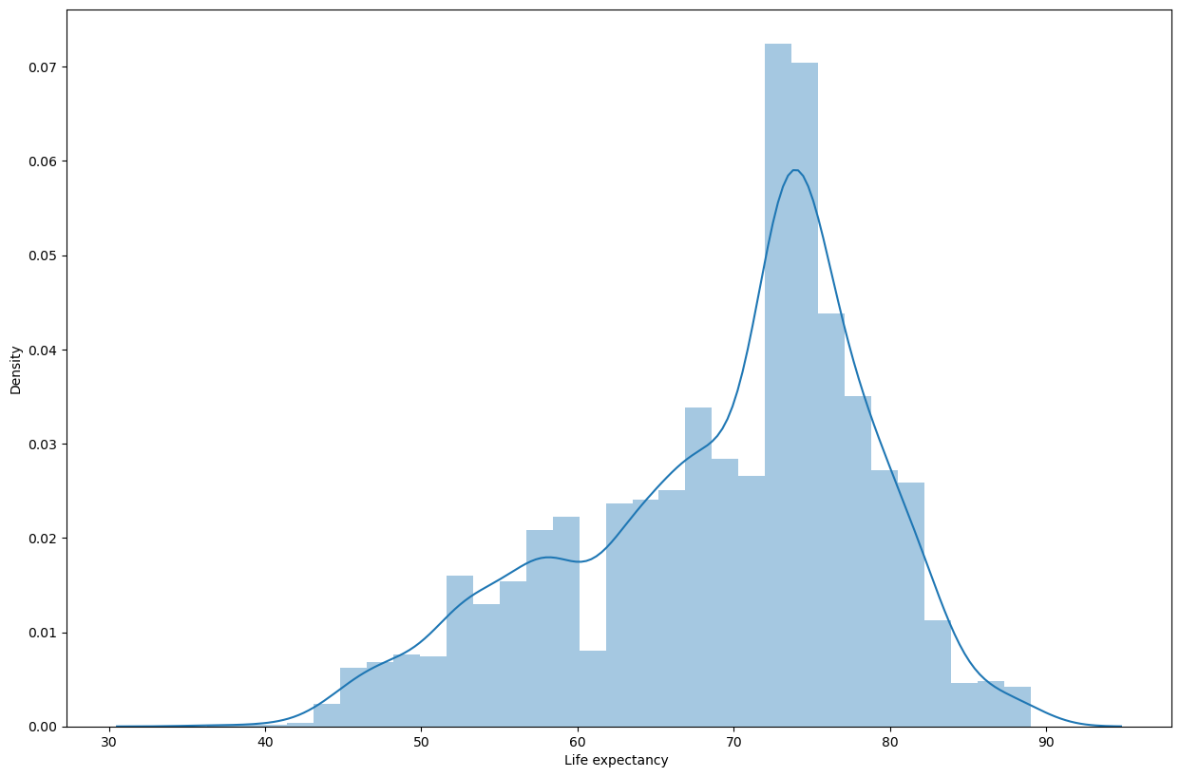

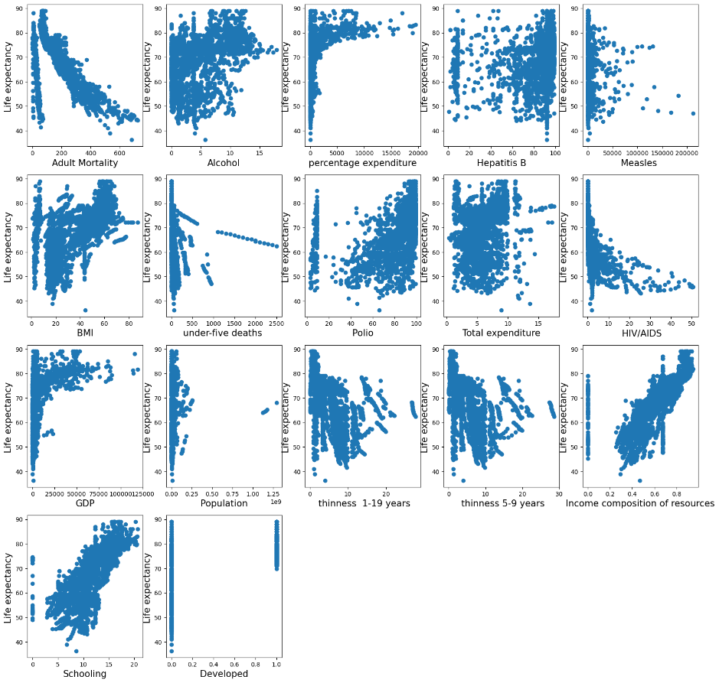

1. **Requirements Gathering:**

* Window 10 Operating system
* Visual studio software
* 2 Team members for the research part
* Project integration idea from IEEE website
* Few Github Non copyrighted source codes

1. **Analysis:**

The Life Expectancy Prediction project aims to create a machine learning-based system that predicts life expectancy based on various factors, such as healthcare, education, lifestyle, and environmental conditions. The project involves data collection, preprocessing, model training and evaluation, prediction generation, user interface design, visualization, error reporting, and user feedback.

The project has the potential to provide valuable insights into public health and guide policy decisions that can improve the quality of life for populations around the world. The use of machine learning techniques for life expectancy prediction is a novel and promising approach that can provide accurate predictions based on a wide range of factors.

The project is developed using popular tools such as Python, Numpy, HTML, and CSS, which are widely used in the data analysis and web development communities. The use of these tools ensures that the project is highly scalable and can be easily integrated into existing systems.

The project follows an agile development process, which allows for continuous feedback and iteration, ensuring that the final product meets the requirements and expectations of all stakeholders. The inclusion of user feedback and error reporting features also ensures that the user experience is optimized, and any issues can be quickly identified and resolved.

Overall, the Life Expectancy Prediction project is a promising initiative that can provide valuable insights into public health and guide policy decisions that can improve the quality of life for populations around the world.

1. **Final Screenshot of Project Output**



