| **HTTP/1.1** | **HTTP/2** |
| --- | --- |
| It works on the textual format. | It works on the binary protocol. |
| There is head of line blocking that blocks all the requests behind it until it doesn’t get its all resources. | It allows multiplexing so one TCP connection is required for multiple requests. |
| It uses requests resource Inlining for use getting multiple pages | It uses PUSH frame by server that collects all multiple pages |
| It compresses data by itself. | It uses HPACK for data compression. |

1. **Difference between HTTP1.1 vs HTTP2**

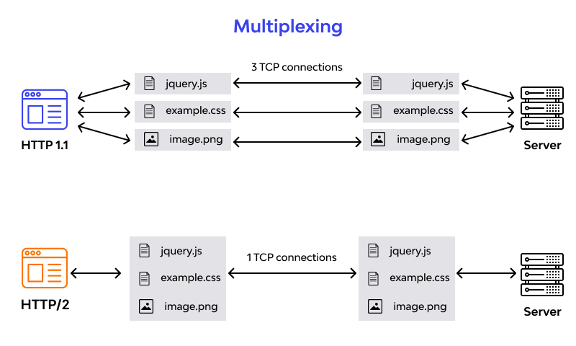

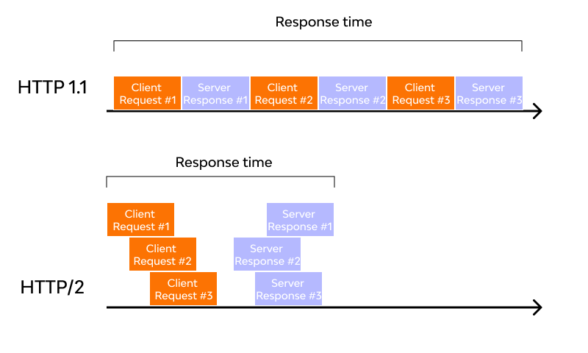

**2.Objects And Its Internal Representation In JavaScript**

**Object:**

* Object is like a container that holds different property.

* object store their element as a key-value pairs, each key value pair is termed as property.

car - colour, material, how many wheels, engine type, mileage.

var car1 = ["white", "fibre", 4, "petrol", 20];

var car2 = ["black", "plastic", 4, "disel", 30];

Array [] / Object {}

var car = {

key value

| |

color: "white",

material: "fibre",

wheels: 4,

milege: 20

}

Objects, in JavaScript, is it’s most important data-type and forms the building blocks for modern JavaScript. These objects are quite different from JavaScript’s primitive data-types(Number, String, Boolean, null, undefined and symbol) in the sense that while these primitive data-types all store a single value each (depending on their types).

Objects are more complex and each object may contain any combination of these primitive data-types as well as reference data-types. An object, is a reference data type. Variables that are assigned a reference value are given a reference or a pointer to that value. That reference or pointer points to the location in memory where the object is stored. The variables don’t actually store the value.

Example:-

1. console.log(" Student Details ");

console.log(" =============== ");

var stu= { name: "VIJAY",

Class: "12 std" ,

section: "A",

Year: 2023,

Bloodgroup : "O+"

}

console.log(stu);

console.log(" Bike Details");

console.log(" ============");

var Bike={ Color: "Blue",

Material: "Fiber" ,

section: "A",

Wheels: 2,

Milege : 30

}

console.log(Bike);

console.log(" Aadhar Details");

console.log(" ==============");

var aadhar={ Name: "NIJANTH",

Age: 22,

Gender: "MALE",

Address: "Arakkonam",

State : "TamilNadu"

}

console.log(aadhar);

Property : The property name must be double-quoted and the values can only be strings, numbers,boolean, null, arrays.

[In above eg:”Blue” is an property]

Method : An object in JavaScript may also have a function as a member, in which case it will be known as a **method** of that object.

[In above eg :Color is an method]