**Java Memory Model**

Understanding **JVM Memory Model**, **Java Memory Management** are very important if you want to understand the working of **Java Garbage Collection**. Today we will look into memory management in java, different parts of JVM memory and how to monitor and perform garbage collection tuning.

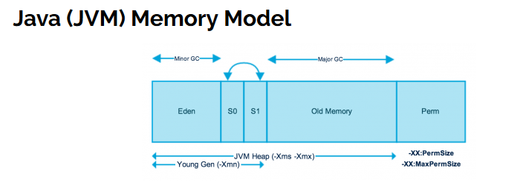

As you can see in the above image, JVM memory is divided into separate parts. At broad level, JVM Heap memory is physically divided into two parts – **Young Generation** and **Old Generation**.

## Memory Management in Java – Young Generation

Young generation is the place where all the new objects are created. When young generation is filled, garbage collection is performed. This garbage collection is called **Minor GC**. Young Generation is divided into three parts – **Eden Memory** and two **Survivor Memory** spaces.

Important Points about Young Generation Spaces:

* Most of the newly created objects are located in the Eden memory space.
* When Eden space is filled with objects, Minor GC is performed and all the survivor objects are moved to one of the survivor spaces.
* Minor GC also checks the survivor objects and move them to the other survivor space. So at a time, one of the survivor space is always empty.
* Objects that are survived after many cycles of GC, are moved to the Old generation memory space. Usually it’s done by setting a threshold for the age of the young generation objects before they become eligible to promote to Old generation.

## Memory Management in Java – Old Generation

Old Generation memory contains the objects that are long lived and survived after many rounds of Minor GC. Usually garbage collection is performed in Old Generation memory when it’s full. Old Generation Garbage Collection is called **Major GC** and usually takes longer time.

### Stop the World Event

All the Garbage Collections are “Stop the World” events because all application threads are stopped until the operation completes.

Since Young generation keeps short-lived objects, Minor GC is very fast and the application doesn’t get affected by this.

However Major GC takes longer time because it checks all the live objects. Major GC should be minimized because it will make your application unresponsive for the garbage collection duration. So if you have a responsive application and there are a lot of Major Garbage Collection happening, you will notice timeout errors.

The duration taken by garbage collector depends on the strategy used for garbage collection. That’s why it’s necessary to monitor and tune the garbage collector to avoid timeouts in the highly responsive applications.

### Java Memory Model – Permanent Generation

Permanent Generation or “Perm Gen” contains the application metadata required by the JVM to describe the classes and methods used in the application. Note that Perm Gen is not part of Java Heap memory.

Perm Gen is populated by JVM at runtime based on the classes used by the application. Perm Gen also contains Java SE library classes and methods. Perm Gen objects are garbage collected in a full garbage collection.

### Java Memory Model – Method Area

Method Area is part of space in the Perm Gen and used to store class structure (runtime constants and static variables) and code for methods and constructors.

### Java Memory Model – Memory Pool

Memory Pools are created by JVM memory managers to create a pool of immutable objects, if implementation supports it. String Pool is a good example of this kind of memory pool. Memory Pool can belong to Heap or Perm Gen, depending on the JVM memory manager implementation.

### Java Memory Model – Runtime Constant Pool

Runtime constant pool is per-class runtime representation of constant pool in a class. It contains class runtime constants and static methods. Runtime constant pool is the part of method area.

### Java Memory Model – Java Stack Memory

Java Stack memory is used for execution of a thread. They contain method specific values that are short-lived and references to other objects in the heap that are getting referred from the method. You should read [Difference between Stack and Heap Memory](https://www.journaldev.com/4098/java-heap-space-vs-stack-memory).

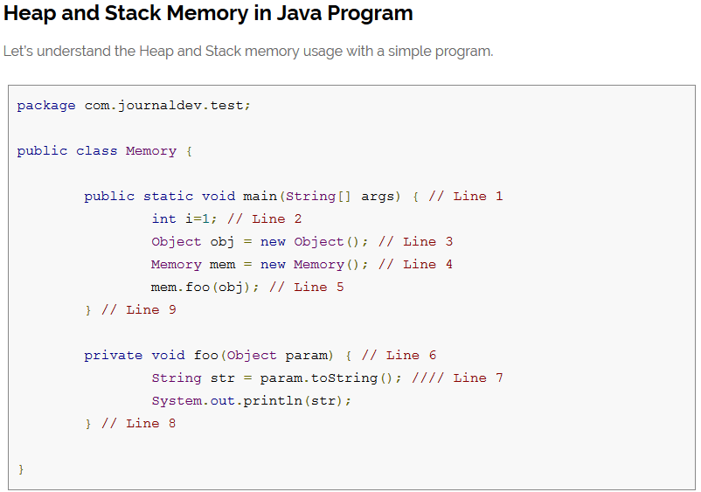

Below image shows the Stack and Heap memory with reference to above program and how they are being used to store primitive, Objects and reference variables.

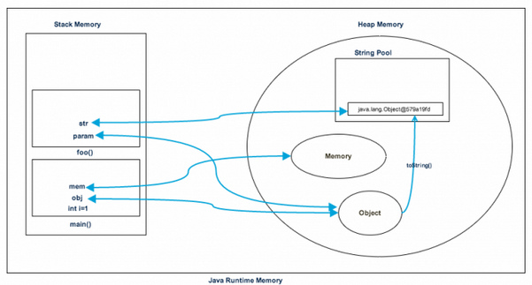

Let’s go through the steps of execution of the program.

* As soon as we run the program, it loads all the Runtime classes into the Heap space. When main() method is found at line 1, Java Runtime creates stack memory to be used by main() method thread.
* We are creating primitive local variable at line 2, so it’s created and stored in the stack memory of main() method.
* Since we are creating an Object in line 3, it’s created in Heap memory and stack memory contains the reference for it. Similar process occurs when we create Memory object in line 4.
* Now when we call foo() method in line 5, a block in the top of the stack is created to be used by foo() method. Since Java is pass by value, a new reference to Object is created in the foo() stack block in line 6.
* A string is created in line 7, it goes in the [String Pool](https://www.journaldev.com/797/what-is-java-string-pool) in the heap space and a reference is created in the foo() stack space for it.
* foo() method is terminated in line 8, at this time memory block allocated for foo() in stack becomes free.
* In line 9, main() method terminates and the stack memory created for main() method is destroyed. Also the program ends at this line, hence Java Runtime frees all the memory and end the execution of the program.

## Difference between Java Heap Space and Stack Memory

Based on the above explanations, we can easily conclude following differences between Heap and Stack memory.

1. Heap memory is used by all the parts of the application whereas stack memory is used only by one thread of execution.
2. Whenever an object is created, it’s always stored in the Heap space and stack memory contains the reference to it. Stack memory only contains local primitive variables and reference variables to objects in heap space.
3. Objects stored in the heap are globally accessible whereas stack memory can’t be accessed by other threads.
4. Memory management in stack is done in LIFO manner whereas it’s more complex in Heap memory because it’s used globally. Heap memory is divided into Young-Generation, Old-Generation etc, more details at [Java Garbage Collection](https://www.journaldev.com/2856/java-jvm-memory-model-memory-management-in-java).
5. Stack memory is short-lived whereas heap memory lives from the start till the end of application execution.
6. We can use **-Xms** and **-Xmx** JVM option to define the startup size and maximum size of heap memory. We can use **-Xss** to define the stack memory size.
7. When stack memory is full, Java runtime throws java.lang.StackOverFlowError whereas if heap memory is full, it throws java.lang.OutOfMemoryError: Java Heap Space error.
8. Stack memory size is very less when compared to Heap memory. Because of simplicity in memory allocation (LIFO), stack memory is very fast when compared to heap memory.

That’s all for **Java Heap Space vs Stack Memory** in terms of java application, I hope it will clear your doubts regarding memory allocation when any java program is executed.

### Memory Management in Java – Java Heap Memory Switches

Java provides a lot of memory switches that we can use to set the memory sizes and their ratios. Some of the commonly used memory switches are:

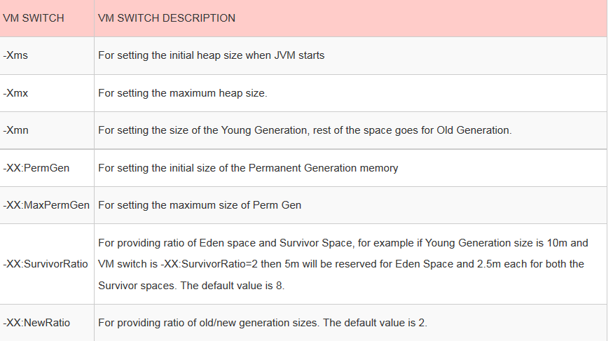

### Memory Management in Java – Java Garbage Collection

Java Garbage Collection is the process to identify and remove the unused objects from the memory and free space to be allocated to objects created in the future processing. One of the best feature of java programming language is the **automatic garbage collection**, unlike other programming languages such as C where memory allocation and deallocation is a manual process.

**Garbage Collector** is the program running in the background that looks into all the objects in the memory and find out objects that are not referenced by any part of the program. All these unreferenced objects are deleted and space is reclaimed for allocation to other objects.

One of the basic way of garbage collection involves three steps:

1. **Marking**: This is the first step where garbage collector identifies which objects are in use and which ones are not in use.
2. **Normal Deletion**: Garbage Collector removes the unused objects and reclaim the free space to be allocated to other objects.
3. **Deletion with Compacting**: For better performance, after deleting unused objects, all the survived objects can be moved to be together. This will increase the performance of allocation of memory to newer objects.

There are two problems with simple mark and delete approach.

1. First one is that it’s not efficient because most of the newly created objects will become unused
2. Secondly objects that are in-use for multiple garbage collection cycle are most likely to be in-use for future cycles too.

The above shortcomings with the simple approach is the reason that **Java Garbage Collection is Generational** and we have **Young Generation** and **Old Generation** spaces in the heap memory. I have already explained above how objects are scanned and moved from one generational space to another based on the Minor GC and Major GC.

### Memory Management in Java – Java Garbage Collection Types

There are five types of garbage collection types that we can use in our applications. We just need to use JVM switch to enable the garbage collection strategy for the application. Let’s look at each of them one by one.

1. **Serial GC (-XX:+UseSerialGC)**: Serial GC uses the simple **mark-sweep-compact** approach for young and old generations garbage collection i.e Minor and Major GC.

Serial GC is useful in client-machines such as our simple stand alone applications and machines with smaller CPU. It is good for small applications with low memory footprint.

1. **Parallel GC (-XX:+UseParallelGC)**: Parallel GC is same as Serial GC except that is spawns N threads for young generation garbage collection where N is the number of CPU cores in the system. We can control the number of threads using -XX:ParallelGCThreads=n JVM option.

Parallel Garbage Collector is also called throughput collector because it uses multiple CPUs to speed up the GC performance. Parallel GC uses single thread for Old Generation garbage collection.

1. **Parallel Old GC (-XX:+UseParallelOldGC)**: This is same as Parallel GC except that it uses multiple threads for both Young Generation and Old Generation garbage collection.
2. **Concurrent Mark Sweep (CMS) Collector (-XX:+UseConcMarkSweepGC)**: CMS Collector is also referred as concurrent low pause collector. It does the garbage collection for Old generation. CMS collector tries to minimize the pauses due to garbage collection by doing most of the garbage collection work concurrently with the application threads.

CMS collector on young generation uses the same algorithm as that of the parallel collector. This garbage collector is suitable for responsive applications where we can’t afford longer pause times. We can limit the number of threads in CMS collector using -XX:ParallelCMSThreads=n JVM option.

1. **G1 Garbage Collector (-XX:+UseG1GC)**: The Garbage First or G1 garbage collector is available from Java 7 and it’s long term goal is to replace the CMS collector. The G1 collector is a parallel, concurrent, and incrementally compacting low-pause garbage collector.

Garbage First Collector doesn’t work like other collectors and there is no concept of Young and Old generation space. It divides the heap space into multiple equal-sized heap regions. When a garbage collection is invoked, it first collects the region with lesser live data, hence “Garbage First”. You can find more details about it at [Garbage-First Collector Oracle Documentation](http://docs.oracle.com/javase/7/docs/technotes/guides/vm/G1.html).

### Memory Management in Java – Java Garbage Collection Monitoring

We can use Java command line as well as UI tools for monitoring garbage collection activities of an application. For my example, I am using one of the demo application provided by Java SE downloads.

If you want to use the same application, go to [Java SE Downloads](http://www.oracle.com/technetwork/java/javase/downloads/index.html) page and download **JDK 7 and JavaFX Demos and Samples**. The sample application I am using is **Java2Demo.jar** and it’s present in jdk1.7.0_55/demo/jfc/Java2D directory. However this is an optional step and you can run the GC monitoring commands for any java application.

Command used by me to start the demo application is:

pankaj@Pankaj:~/Downloads/jdk1.7.0_55/demo/jfc/Java2D$ java -Xmx120m -Xms30m -Xmn10m -XX:PermSize=20m -XX:MaxPermSize=20m -XX:+UseSerialGC -jar Java2Demo.jar

#### jstat

We can use jstat command line tool to monitor the JVM memory and garbage collection activities. It ships with standard JDK, so you don’t need to do anything else to get it.

For executing jstat you need to know the process id of the application, you can get it easily using ps -eaf | grep java command.

