**REPORT**

PART 1:

* Method used for Data pre-processing –
  + Understood the overview of the dataset.
  + Dropped columns which were irrelevant for prediction.
  + Check for columns with Nan (empty) values or mismatching data types.
  + Replace them with mean and mode and refactored invalid data
  + Checked for outliers and removed them.
  + Converted Objects-data types to categorical values using one-hot encoding, label encoding and frequency encoding.
* Data Set –
  + **Breeding Bird Atlas** 
    - Domain - Breeding bird observations based on geographical locations
    - Type of Data - The dataset consists of categorical and numerical data
    - Features – 15 features
    - Number of Samples – 361582
    - Mean for each numerical column:
      * Fed. Region – 5.85
      * Month – 49.77
      * Day – 49.5
      * Year – 1964.18
      * Temperature – 49.46
      * Average UB Student – 2.85
    - Standard Deviation for each numerical column:
      * Fed. Region – 5.83
      * Month – 28.65
      * Day – 28.79
      * Year – 190.06
      * Temperature – 17.32
      * Average UB Student – 0.49
    - Missing Values for each column:
      * Fed. Region – 5795
      * Block ID – 2718
      * Map Link – 4717
      * County – 10602
      * Common Name - 10530
      * Scientific Name – 7485
      * NYS Protection Status – 8470
      * Family Name – 2456
      * Family Description -4733
      * Breeding Behavior -5183
      * Month – 358156
      * Day – 352244
      * Year – 10480
    - Graph-
      * Box Plot are used for detecting outliers, for column ‘Year’, we could see there are few values which lies beyond the first and third quartiles

* + - * For Fed. Region we do not have any outliers

* + - * Bar Plot for County, here the data is linearly reducing and the most frequent value being Parulidae

* + - * Comparing the feature ‘NYC protection status’ with ‘Breeding status’ column we see the most repeating Status is ‘Protected’

* + - * When comparing ‘year’ with ‘Breeding Status’, we could see at year 1984 there were lot of breeding with ‘confirmed’ status occurred

* + - * Correlation matrix here gives us the relation of each feature with the target column ‘Breeding Status’, the breeding behavior column had the most relation with the target column and the least being Temperature which provides just 0.1% relation

* + Dataset 2 –
    - Domain: Biological and ecological observations of penguins in Palmer Archipelago
    - Type of Data : Structured, tabular with numerical and categorical columns
    - Number of Samples: 344
    - Key Statistics:

|  |  |  |  |  |  |  |  |
| --- | --- | --- | --- | --- | --- | --- | --- |
|  | calorie requirement | average sleep duration | bill_length_mm | bill_depth_mm | flipper_length_mm | body_mass_g | year |
| count | 344 | 344 | 337 | 333 | 336 | 339 | 342 |
| mean | 5270.002907 | 10.447674 | 45.494214 | 18.018318 | 197.764881 | 4175.463127 | 2008.035 |
| std | 1067.959116 | 2.265895 | 10.815787 | 9.241384 | 27.764491 | 858.713267 | 0.816938 |

* Missing Values :

|  |  |
| --- | --- |
| Column Name | Is Null sum |
| species | 11 |
| island | 10 |
| calorie_requirement | 0 |
| average_sleep_duration | 0 |
| bill_length_mm | 7 |
| bill_depth_mm | 11 |
| flipper_length_mm | 8 |
| body_mass_g | 5 |
| gender | 17 |
| year | 2 |

Graphs:

Box plots to detect the outliers in the data, so that further processing could be done. The majority of the numerical datasets showed outliers when box plot was constructed. Therefore, in order to zero in, Z -score was calculated and Z-score > 3 were classified as outliers.

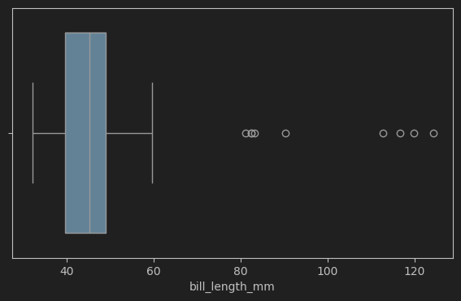

Z-score statistics: few outliers were found in bill_length_mm and bill_depth_mm using z-score. All were removed for further processing.

* Number of outliers in bill length: 9
* Number of outliers in bill depth: 3

Correlation Matrix:

Bar plots: The plot is self-evident and show cases that the greatest number of penguins are Adelie and the least is Chinstrap.

Average Sleep Duration between species: We observe that the average sleep durations are similar between species, which indicates that certain characteristics are common across the species.

Pie Chart: It show cases the distribution of penguins by island, with maximum residing in Biscoe at 51.2% and the least in Torgersen at 14.5%

Scatter plot

Bill length and depth relationship: There appears to be clustering of data points into 3 groups. This is in line with our observation that there exist 3 distinct groups. Here we are drilling down to the data to corroborate the fact that the three groups might have different biological features/ characteristics.

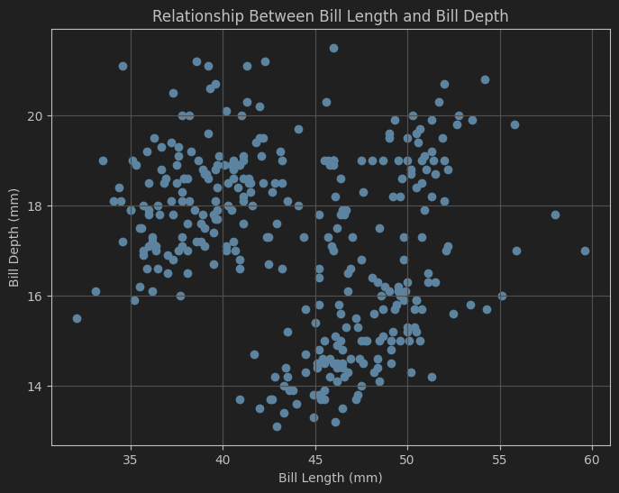

* + Dataset 3 –
    - Domain: Impact of Minerals on Temperature per Country, scaled over time.
    - Type of Data: Structured, tabular with Categorical and numerical columns
    - Sample size: 63104, 12
    - Key Statistics:

|  |  |  |  |  |  |  |  |  |  |  |
| --- | --- | --- | --- | --- | --- | --- | --- | --- | --- | --- |
|  | Year | Total | Temperature | GDP Per Capita (USD) | Coal | Oil | Gas | Cement | Flaring | Per Capita |
| count | 62307.000000 | 62381.000000 | 63104.000000 | 63104.000000 | 21797.000000 | 21774.000000 | 21717.000000 | 20488.000000 | 21338.000000 | 19392.000000 |
| mean | 1888.267097 | 73.683456 | 49.497813 | 39026.539015 | 127.387271 | 153.480038 | 125.162671 | 62.599364 | 56.074327 | 121.565443 |
| std | 122.651184 | 843.930381 | 17.292092 | 10975.539432 | 677.951392 | 670.830891 | 514.391435 | 353.918064 | 337.629062 | 489.339877 |

* Missing Values:

|  |  |
| --- | --- |
| Column | Null Count |
| Country | 2017 |
| ISO 3166-1 alpha-3 | 3621 |
| Year | 797 |
| Total | 723 |
| Temperature | 0 |
| GDP Per Capita (USD) | 0 |
| Coal | 41307 |
| Oil | 41330 |
| Gas | 41387 |
| Cement | 42616 |
| Flaring | 41766 |
| Other | 60419 |
| Per Capita | 43712 |

* Graph:

Correlation matrix: This showcases the correlation between all the features in the dataset. We can see that there exists a huge correlation between coal, gas, oil and cement data. With temperatures it is having less correlation. We will need to drill down to find the cause for this.

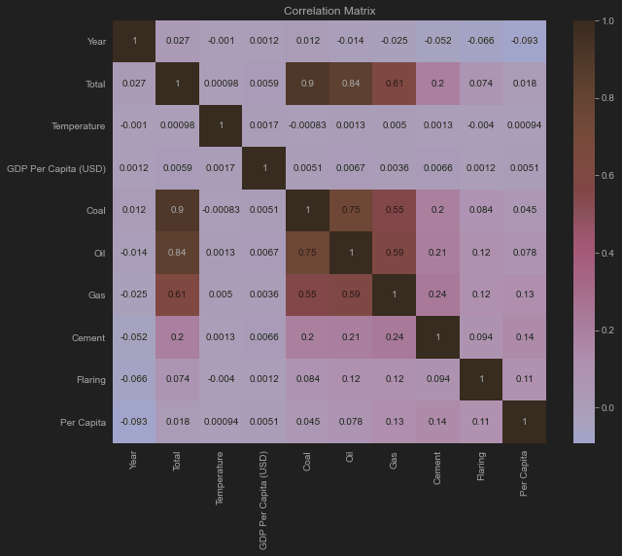

Line Chart: We plot the temperature to year graph for USA and find that their exist outliers, as in future data. We will remove this.

Scatter plot: next we plot a scatter plot between year and per capita, only to find that them exist an anomaly, that is at year 0, there is a peak of these values. So we effectively delete those, since we also see that there is a huge gap from year 0 till around year 1000.

Box plot: We plot all numerical columns in this and try to find the outliers. The distribution of coal, gas, oil etc. is wide, so we take the next step, that is to calculate the z score to find and eliminate outliers more than 3 standard deviations away.

Outliers count (Z Score > 3):

* + - * Number of outliers in Total: 235
      * Number of outliers in Coal: 215
      * Number of outliers in Oil: 227
      * Number of outliers in Cement: 186
      * Number of outliers in Flaring: 167
      * Number of outliers in Per Capita: 246
      * Number of outliers in Gas: 256

We eliminate these values.

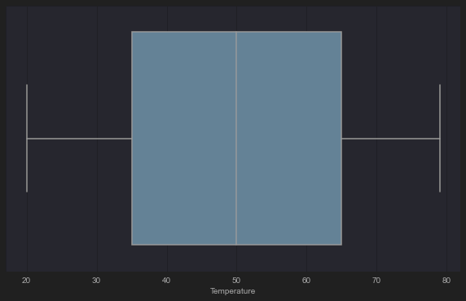

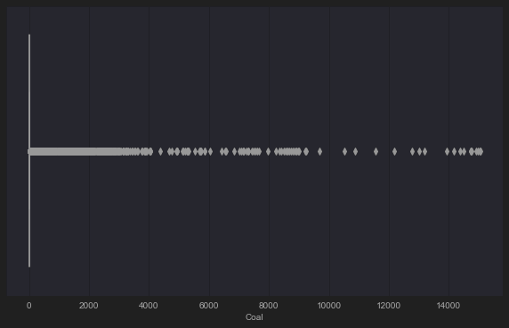

Bar chart: We plot the mean chart for all numerical for coal, gas, oil, cement and flaring and only showcase the top 10 values out of it.

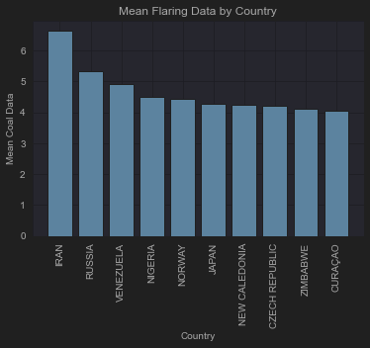

PART 2: Penguin Dataset

Best Accuracy – 89.55 %

Loss Graph -

Analysis – The loss graph for the model with a learning rate of 0.005 and 100,000 iterations shows that the model started with an initial loss of approximately 1.2 After a few iterations, the loss dropped significantly to 0.7, indicating rapid initial learning. The subsequent result suggests the model has reached a point where further training yields minimal improvements

Graphs for various Learning Rate and Iterations –

* Learning Rate – 0.001, Iterations – 100000, Accuracy – 85.07%

* Learning Rate – 0.02 and Iterations – 200000, Accuracy – 89.55%

* Learning Rate - 0.01 and Iterations – 250000, Accuracy – 88.06%

* Learning Rate - 0.4 and Iterations – 300000, Accuracy – 88.06%

* + A lower learning rate of 0.001 results in gradual convergence, which can prevent overshooting the minimum but may require more iterations
  + A medium learning rate of 0.005 often provides a good balance, leading to quicker convergence and improved accuracy
  + A high learning rate of 0.4 can lead to rapid learning but risks overshooting the optimal solution, causing fluctuations in loss and potentially lowering accuracy.
  + Increasing the number of iterations allows the model to refine its weights further, leading to lower loss. However, after a certain point, the benefits diminish, especially if the learning rate is not set appropriately.

Benefits / Drawbacks of Linear Regression –

* + Linear Regression performs requires less computational power and memory, making it suitable for smaller datasets or when computational resources are limited.
  + It performs well for linearly separable features making it an effective choice for binary classification tasks
  + Logistic regression is primarily used for binary classification problems
  + They are very sensitive to outliers which will affect the model’s accuracy

PART 3:

* Dataset Used – Diamonds
* Number of Samples – 53940
* Number of Features – 12
* Characteristics –
  + The dataset had 2 numerical columns and 10 categorical columns
  + “average us salary” and “number of diamonds mined (millions)” had no null values whereas rest columns had some null values
  + Number of outliers in each column A screenshot of a computer code

    Description automatically generated
  + After pre-processing I was left with 42190 samples and 16 features.
* Model Evaluation
  + Mean Squared Error
    - Linear Regression – 0.0037062
    - Ridge Regression – 0.0037061
  + Prediction v/s Actual Graphs
    - Linear Regression A graph with red and blue dots

      Description automatically generated
    - Ridge Regression – A graph with green and red lines

      Description automatically generated
  + Discussion
    - **Benefits and drawbacks of using OLS for weight computation** –
      * It is straightforward to implement and understand and it is very optimized for smaller datasets.
      * It is sensitive to outliers
      * If variables are highly correlated it can lead to very high standard errors and unstable coefficient estimates
      * It can overfit the model to the training data and ideally it is designed for linear relationships
    - **Evaluate the strengths and weaknesses of linear regression in general**
      * The computations involved in linear regression is efficient and simple
      * It can handle multiple independent variables
      * If the relationship is nonlinear, the model may be inadequate, and it is highly sensitive to outliers
      * With many predictors relative to the number of observations, linear regression can easily overfit the model
    - **Explain the motivation for using L2 regularization and how ridge regression improves upon linear regression. Discuss its benefits and limitations compared to linear regression**
      * L2 regularization can prevent overfitting as it adds a penalty for larger co-efficient
      * It can easily handle multicollinearity by shrinking co-efficient to zero
      * L2 regression improves upon linear regression as it adds penalty term this makes L2 better than linear
      * Limitations of L2 –
        + It introduces bias to model
        + It is more complex to implement
        + It is computationally more intensive than linear regression