HOMEWORK 7: DEEP LEARNING

Collaboration Questions

Did you receive any help whatsoever from anyone in solving this assignment?
No.

Did you give any help whatsoever to anyone in solving this assignment?
No.

How many hours did this assignment take?
8 hours.

Q8 [5 points] Visualize the output of the second and third layers. Show 20 images from each layer on a single figure file.
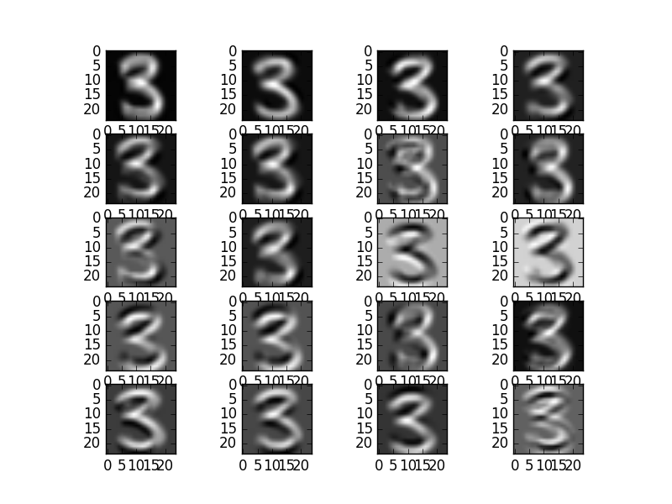
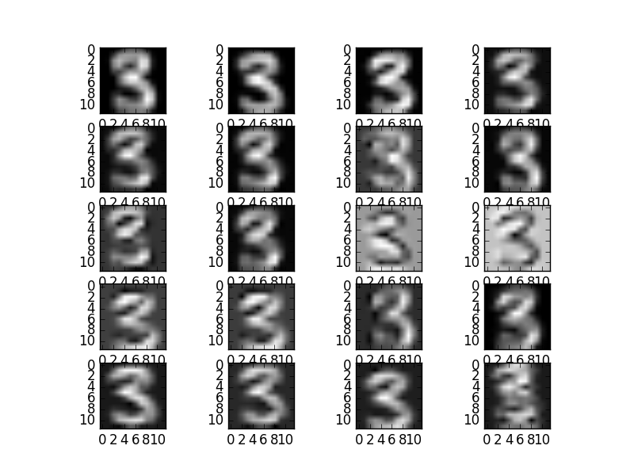
Figure1: 2nd Layer output (Left Image) and 3rd Layer output (Right Image)

Q9
(a) [2 points] Compare the output of the second layer and the original image (output of the first layer), what changes do you find?
Vertical Edge

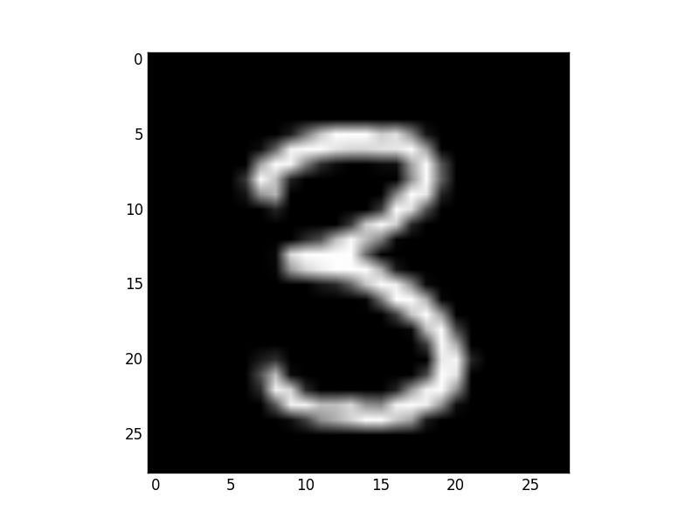

Horizontal Edge

Figure2: Input Image (Left Image) and 2nd Layer output (Right Image)

We find that the 2nd layer highlights 20 different features from the original image. For example the top left image feature picks out vertical edges while the 11th image (at (3,3) position) picks out horizontal edges. In our example the input image is the number “3”. It has almost no vertical edges but very distinct horizontal edges, therefore the second figure image is lot more sharper.

(b) [2 points] Compare the output of the third layer and the output of the second layer, what changes do you find?

Figure3: 2nd Layer output (Left Image) and 3rd Layer output (Right Image)

The 3rd layer is essentially a low dimensional version of the higher dimensional 2nd layer output. It essentially keeps brightest pixels in an 2x2 moving filter area. Overall the 3rd layer images look blurry compared to 2nd layer.

(c) [3 points] Explain your observation.

As shown in the figure below; the convolution layer picks out 20 different features from the original image. As an example the first filter is picking out vertical edges; the 11th filter picks out horizontal edge.
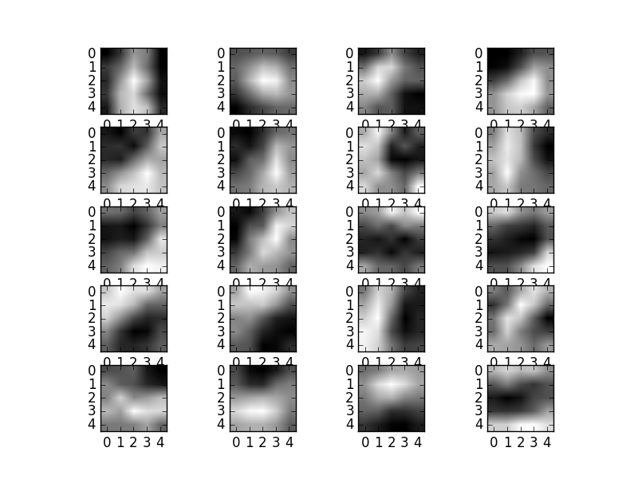
.

.

.

Figure4: Convolution Layer Filter Weights

The three filters at the bottom also pick out relatively horizontal edges. As can be seen in the corresponding outputs (17,18,19) of the Layer 3 output the resultant is a sharper low dimensional version of the input = “3”. While the top 4 (1,2,3,4) of the Layer 3 is a blurred version.

Q10 [3 points] Run your final code on the entire MNIST dataset by setting fullset to true in testLeNet. Report the final test accuracy and time taken by testLeNet to run the training procedure for 10,000 iterations.
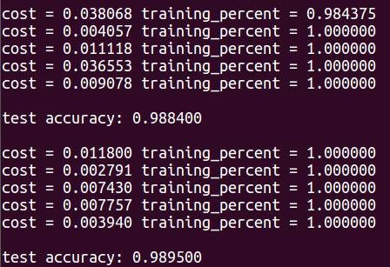
Final Test Accuracy: 98.95%
Time Taken: 6.5 Hours

