11-641 Home Work 3

Name: NIKHIL MALIK
AndrewID:nmalik1

Statement of Assurance
All the material submitted for this assignment is my own work.

Experiments

(a) Describe the custom weighing scheme that you have implemented. Explain your motivation
for creating this weighting scheme.

The custom weighting scheme: 0.9*log(Page Rank Value) + 0.1*(Search Relevance Score)
The distribution of the the raw values of the Page Rank and Search Relevance score suggest that the page rank value are exponentially decreasing. Therefore a more equitable weighting between the two requires a log of the Page Rank Value.

See Table2, highlighted values. These indicate improved mean average precision at 0,10 and 20% recall values as a result. However the precision remains the same or worse at higher recall levels when compared to the original linear weighting scheme.

(b) Report the performance of the 9 approaches as described above.

Table1: For each of the 9 methods – map score, wall clock time, dampening factor

Table2: For each of the 3 GPR methods: comparison of 11 point map scores averaged over all the queries

Table3: For each of the remaining 6 methods: comparison of 11 point map scores averaged over all the queries

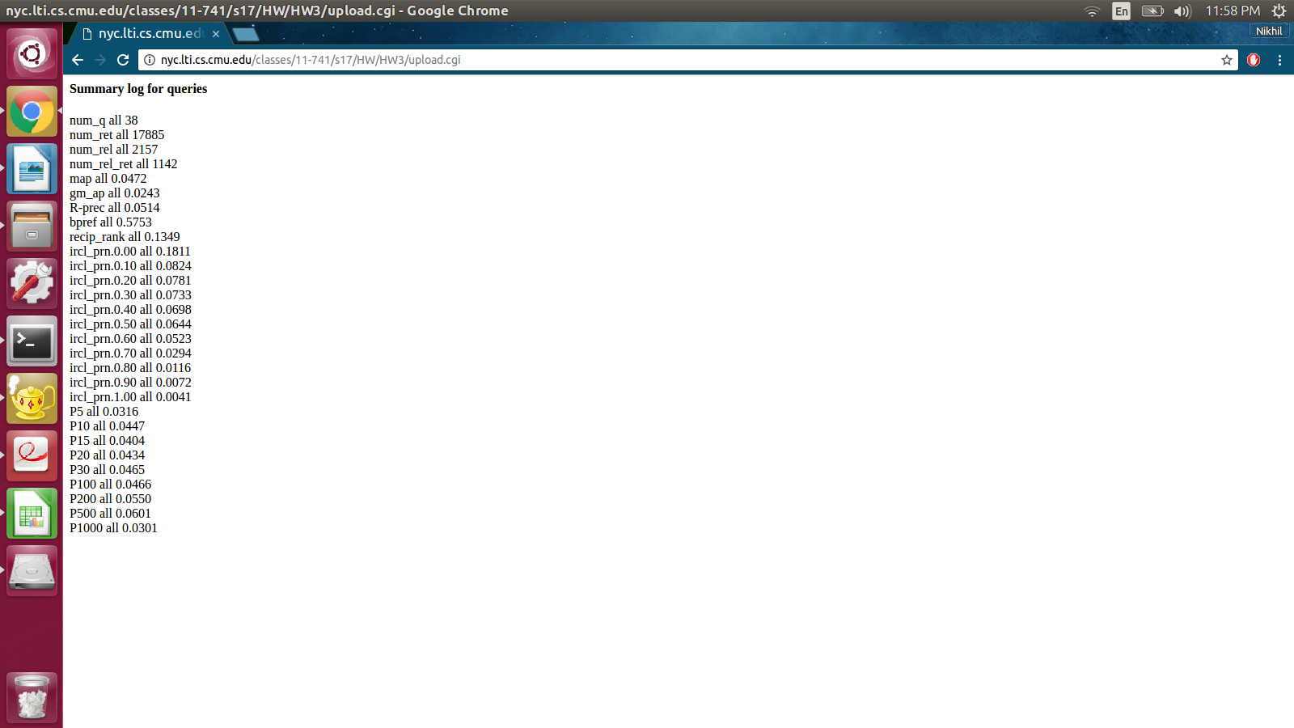

Figure1: A sample screenshot of the trec-eval summary output.

(c) Compare these 9 approaches based on the various metrics described above.

Wall Clock time: The majority of the time is spent in Page Rank calculations, while the combination of search relevance and page rank step is extremely small.
The GPR method requires a single Page Rank calculation and takes ~0.16 seconds.
However QTSPR and PTSPR both reuse the same topic sensitive page rank module needs to run the Page rank algorithm 12 times i.e. once for each topic. Resulting in 0.16*12 ~ 2.2 seconds.

Additionally the time to generate the evaluation files has not been reported. This amounts to an additional ~15-20 seconds.

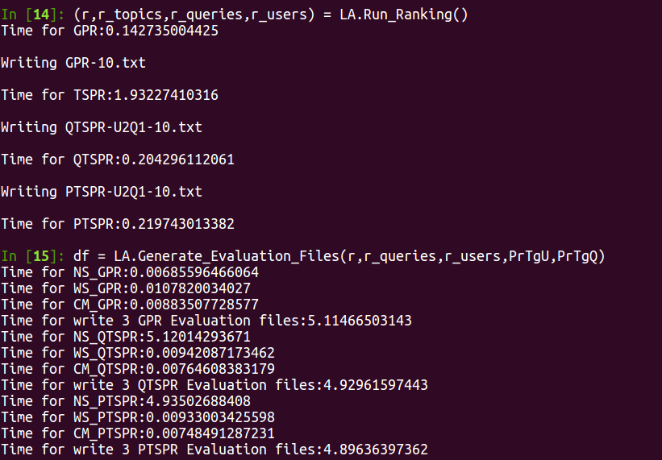
Figure2: Show a snapshot of the output with the wall clock times printed out.

Custom Method: Shows significant precision improvement at low recall levels, given the log scale usage.

Dampening Factor: Has been kept at 0.8 across all 9 methods

Mean Average Precision: The map for original and custom weighting scheme are significantly more than the no weighting scheme. Showing the significance of search relevance scores.

(d) Analyze these various algorithms, parameters, and discuss your general observations about
using PageRank algorithms

The Page Rank Algorithm stopping criteria is based on convergence of page rank values across iterations. However a simple euclidean distance (or an absolute L1 norm) may lead to early convergence. Measuring the difference between the page rank values across iterations as a ratio of the L2 (or L1) norm of the page rank vector itself is likely to be a better criteria. The attached code was sense-checked for this new criteria, however this calculation has temporarily been commented out.

The initial values of page ranks r = 1/N for all documents does not necessarily change the final convergence of the ranks. An initial value of zeros or 1’s also results in the exact same final ranks.

The higher the dampening factor (1-alpha) the higher the weight given to the document linkages.

(e) Discuss some general remarks about
• What could be some novel ways for search engines to estimate whether a query can benefit
from personalization?

Query could be classified into “specific” or “non-specific” query based on the sentence construction of the query. A “non-specific” query could benefit from greater personalization to the general topics of interests for the user. However the same personalization might be a nuisance for a “specific” query.
This classification can be achieved using a supervised historical query data, tagged based on whether the user subsequently chose from the recommended search results or browsed to find a very specific result of interest.
Examples: “Buy HP Laptop model abc.xyz from Amazon” [Specific]
“What laptops are hot?” [Non-Specific]

Another mechanism could utilize information on: time-of-day, platform(mobile or pc) etc for the user. To differentiate for each user what combination of these features indicate the users interest in personalized results.

• What could be some novel ways of identifying the user’s interests (e.g. the user’s topical
interest distribution Pr(t|u) ) in general?

- Utilizing past queries by the user.
- Subsequent search results clicked and topics of those pages.
- Collaborative Filtering to identify topics of interest based on similar other users.
- Utilizing information on time-of-day, platform.

Details of the software implementation

(a) Describe your design decisions and high-level software architecture;

Key High level design decisions
- All input files are read in a single go at first.
- The transition matrix is stored as a sparse matrix to avoid memory issues.
- Vector and matrix algebra has been used instead of for loops to improve performance.
- A topic sensitive page rank (1 for each of 12 topics) has been calculated and reused for both the QTSPR and PTSPR methods.

Software Architecture
- Read_Data: Read the 4 files for Page Rank calculation
- Read_indri_files: Read the 5th file for search relevance scores
- PageRank: Runs the core page rank algorithm given a Matrix M and vector p
- TS_PageRank: Runs 12 page ranks for 12 topics
- Online_TS_PageRank: Wrapper Function for QTSPR and PTSPR
- Run_Ranking: Return all three ranks GPR, QTSPR, PTSPR
- Read_PageRank_Output: Converts page rank output to a pandas dataframe
- Write_PageRank_file: Write the 10th iteration files
- Write_treceval_file: Write the trec-eval files
- Generate_Evaluation_Files: Wrapper function that generates all the output files one by one.

(b) Describe major data structures and any other data structures you used for speeding up the
computation of PageRank;

- scipy lil_matrix: For sparse matrix storage
- pandas dataframe: For tabular data, before writing the evaluation text files.

(c) Describe any programming tools or libraries that you used;

- scipy: For sparse matrix
- pandas dataframe: For tabular data, before writing the evaluation text files.
- Numpy
- sklearn preprocession: For L1 normalisation of the M matrix
- zipfile: For unzipping the search relevance score files
- time: for calculating wall clock time

(d) Describe strengths and weaknesses of your design, and any problems that your system en-
countered

Strength
- The entire code including the creation of the evaluation files runs in <1 minute.
- Sparse data structures allow for ~50 iterations of Page rank to complete under 1 second.

Weaknesses
- Naming of the function modules and reusability is lacking at some points.
- Hard coded parameters like alpha and weights.

