Specifications

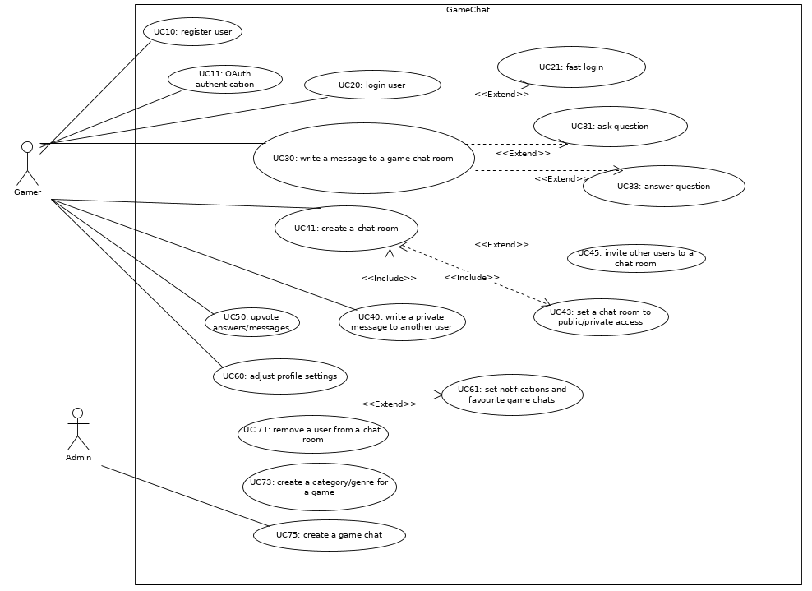
Illustration 1: use case diagram of game chat

UC10(MUST): register user
User types in: firstname, lastname, email, password, on the register page to register.

UC11(CAN): OAuth authentication
Optional OAuth is available as an alternative way to register/login.

UC20(MUST): login user
User type in email and password for authentication to get into the application.

UC21(CAN): fast login
If the user has saved his login credentials, it is possible to log in via touching the login sphere on the login page.

UC30(MUST): write a message to a game chat room
Once logged in, the user is able to choose a game chat. In the game chat page the user is able to directly add a comment in the discussion section.

UC31(MUST): ask question
In the game chat page, the user is able to ask a question by clicking on the question button, a pop up page will appear to let the user write the question.

UC33(MUST): answer question
In the game chat page, the user is able to answer a question by selecting it after clicking a button. The user will be redirected to a new page where it is possible to add an answer to the question.

UC40(CAN): write a private message to another user
The user is able to write a private message to an another user.

UC41(CAN): create a chat room
The user is able to create a chat room.

UC43(CAN): set a chat room to public/private access
The user is able to set a chat room to a public or a private access mode.

UC45(CAN): invite other users to a chat room
The user is able to invite other users to a chat room.

UC50(MUST): upvote answers/messages
The user is able to press a like button on the message. The like counter on the message increments by 1. User can also un-like which will have the opposite effect. The number of upvotes are used to order the messages within the Q&A section.

UC60(MUST): adjust profile settings
The user is able to change his avatar, password, email, billing information.

UC61(CAN): set notifications and favourite game chats
The user is able to set notification to get notified in case someone sent a message or an invitation to a discussion to the user. Also it is possible have a favourite list of game chats. To add a game chat to the favourite list, the user is able to press a button inside a game chat.

UC71(MUST): remove a user from a chat room
If some user is rude, or is insulting other gamer, either the system or an admin user is able to abandon the mentioned user. This could be done with a warning/explanation message and a timeframe, e.g. 1 day.

UC73(MUST): create a category/genre for a game
The admin user is able to create categories/genres for a game. In addition it is possible to create tags for different genres, e.g. action & rpg. Then game chats are inside those categories/genres.

UC75(MUST): create a game chat
The admin user is able to create a chat for a specific game and add it to a category/genre. The game chat is accessible via the dashboard panel inside a category. It has a title, image, and short description of the game.

Wireframe specifications

Fast Login


Profile
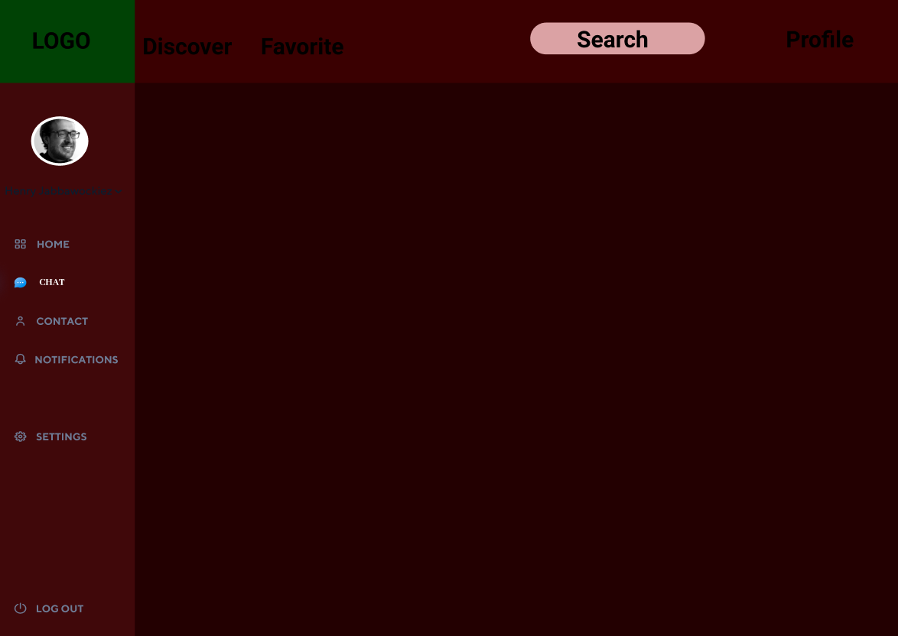
Home
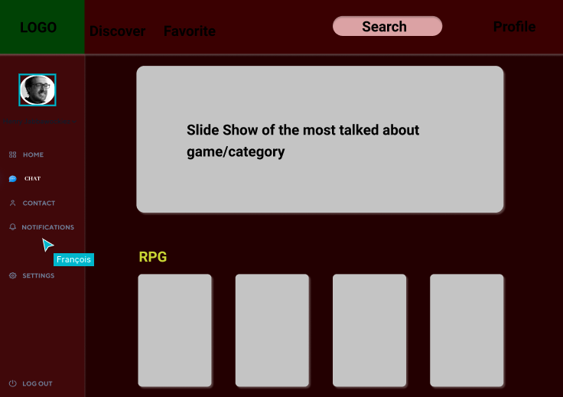
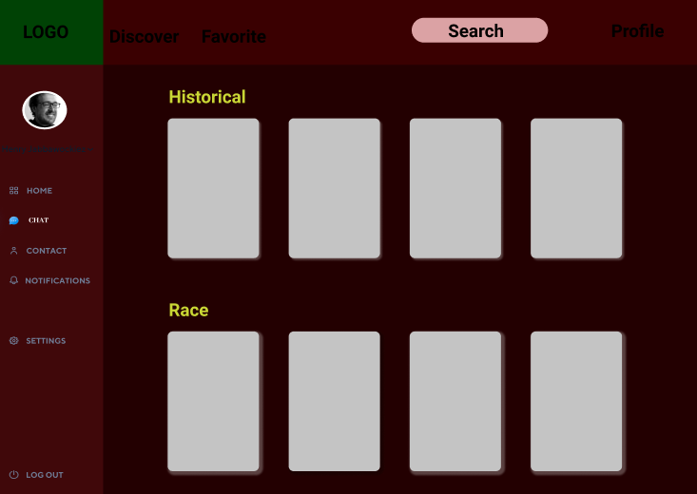

Game
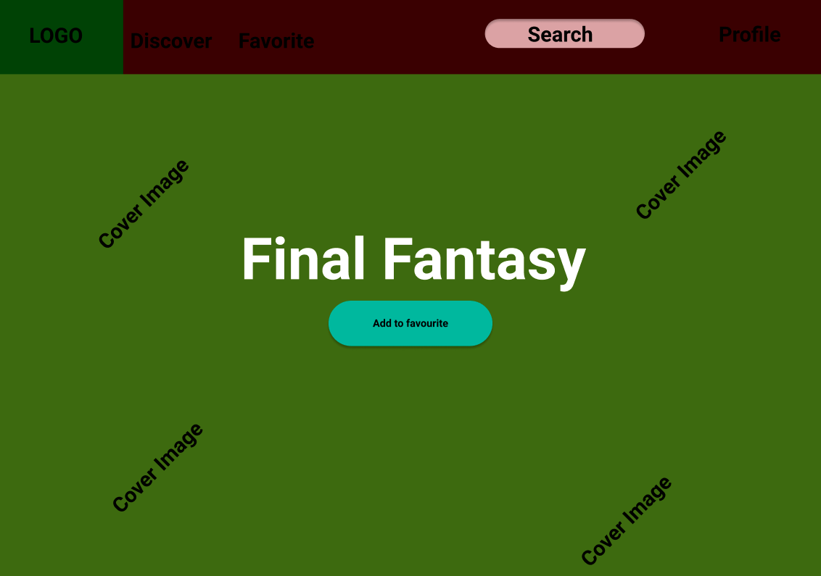
Chat
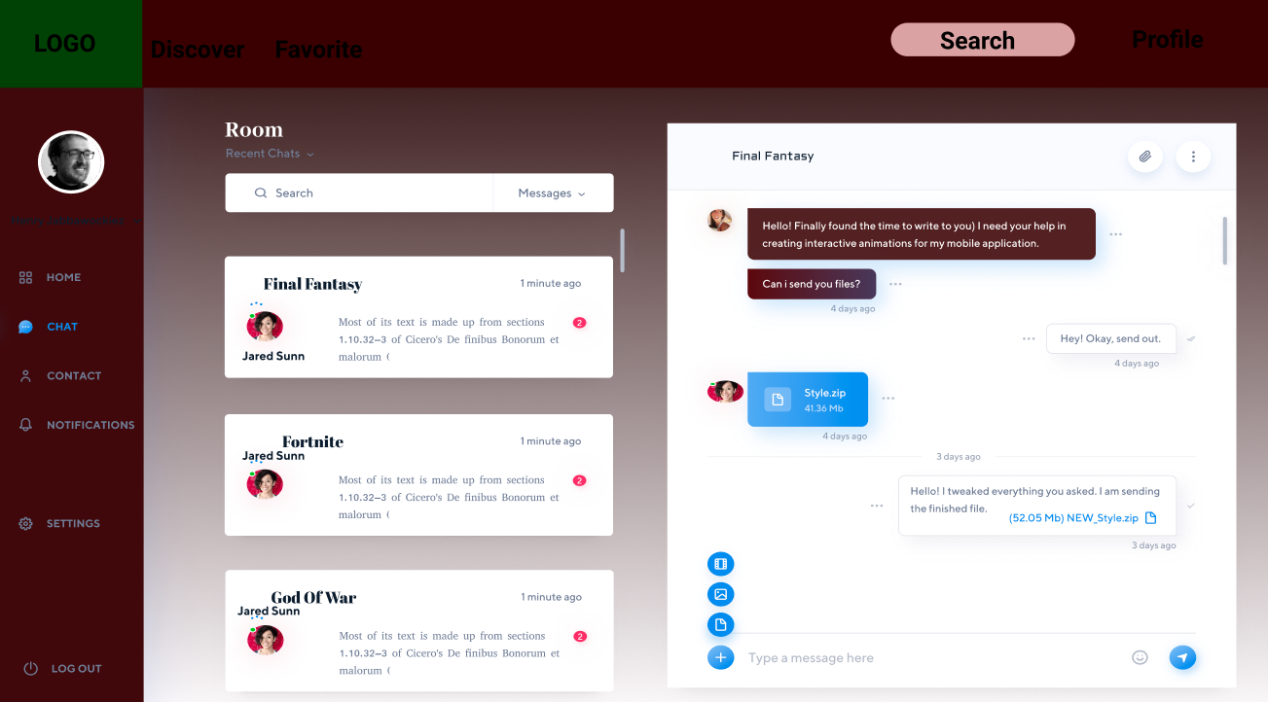

UML Class Diagram

