Intro to game design

William Webb, Nik Sloop

Joston Chan, Andre Kerlin

Luke Meads, Zac Stephen

**Shrek Adventures**

**Goals:** This game is a sidescroller game like Super Mario Bros. The characters that are in the game will be Donkey and Shrek. Shrek will have to travel from one end of the map to the other end. The game will have obstacles along the way, allowing players to have a more entertaining time in playing the game. The goal of the game is to reach the final point of map, which will be a door, and the game is finish.

**Feed back:**  The feedback we got from play testers was that we needed to make the collision between the players and the obstacles on the map smoother. In our playtest version there were multiple bugs that made the game difficult to play.

**Final Product:** Our final game has three levels. In these levels the player can switch between Donkey and Shrek. Donkey can jump higher than Shrek and fit into smaller spaces than Shrek. These two mechanics give players multiple ways to progress through out the game. It is broken up into several different files and .png images for the sprites used through-out the levels. The main code file is Shrek_Adventure.

**About the Game:**

*Setting Up*

* We use minim for the audio that is played, to install it follow these simple steps.

1. Open up processing and click on “Sketch” in the top right corner
2. Hover over “Import Library…”
3. Select “Add…”

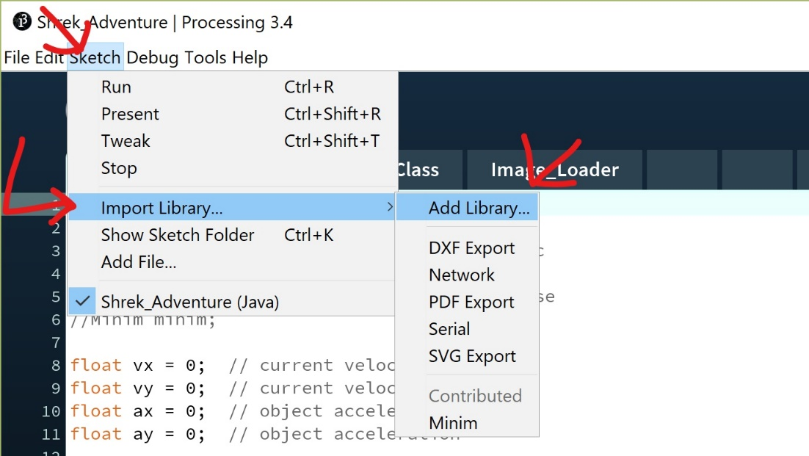

1. A window will pop up, search for Minim, it should appear about half way down the list.
2. Select Minim and install!

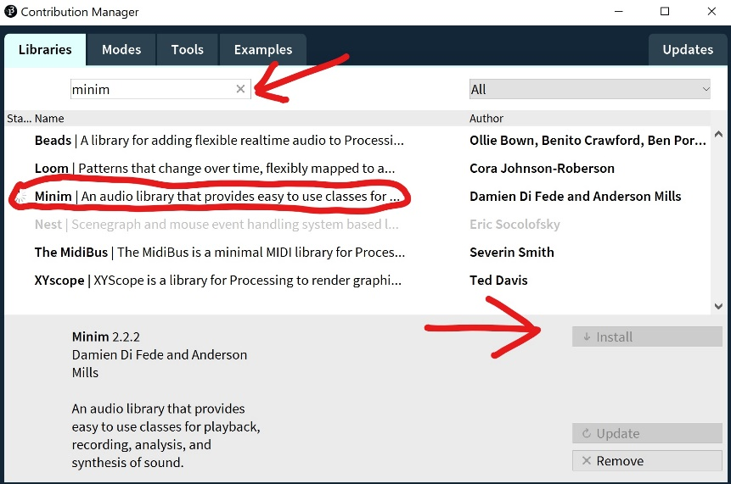

*Characters*

* Donkey is agile and quick! He can jump higher than Shrek and also fit into those tight spaces!
* Shrek is not as fast as whit, this means he has to get rid of his obstacles by crushing them, instead of jumping over them or squeezing around them.

*Controls*

* **E** Toggles between characters
* **A** Moves the character left
* **D** Moves the character Right
* **Space** Jump

*Tips*

* Have a long jump? Getting a running start to build up momentum to help you go farther.
* Remember to switch between characters to solve different problems

*Highlights*

We are very proud of the engine that drives our game, especially the part the controls collision detection, we create a system that allows us to easily add different obstacles easily without having to add multiple lines of logic. We are also happy with the sprites we were able to create to make our game feel a bit more unique.

*Places to improve*

There is really no one place that we wish we did better. We only wish we had more time to apply a better finish to the game, such as making collision slightly smoother, levels a bit more challenging and an overall smoother experience for the player. However, we believe we will be able to achieve this in part two.