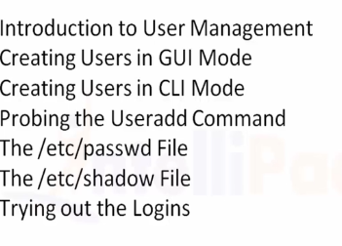

Adding Users:

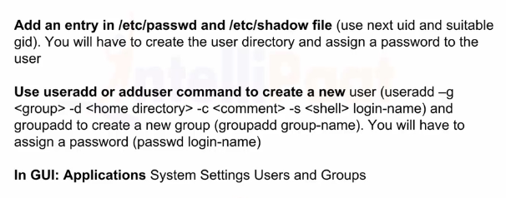

For help command use useradd -h

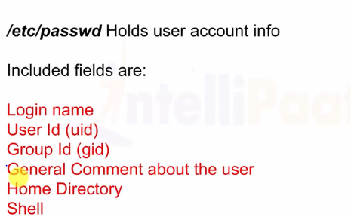

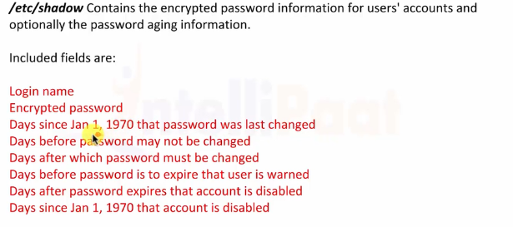

/etc/passwd explanation:

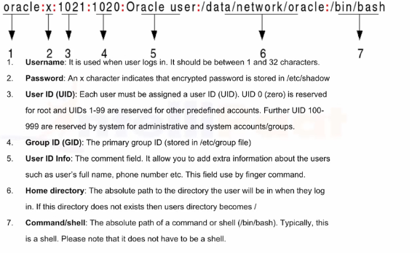

/etc/shadow explanation:

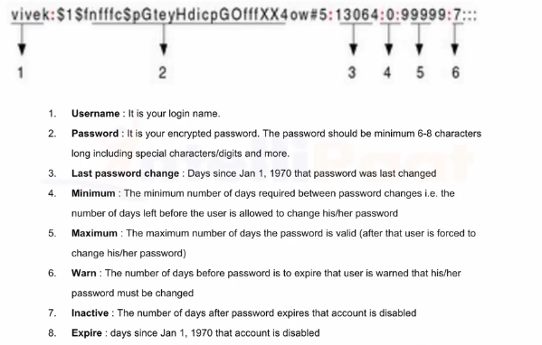

Usermod command:

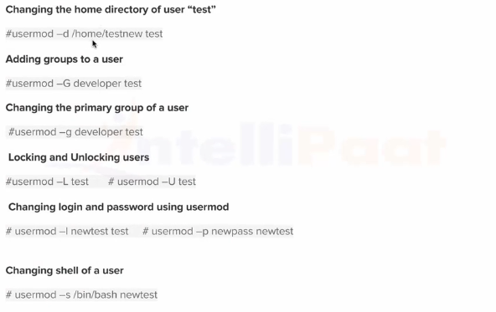

Example:

Existing path is /var/tester change to /home/tester

Usermod -d /home/tester tester

Mkdir /home/tester

Creating group:

Groupadd<groupname>

Userdel command:

