Fast GPU Material-Removal Simulation for 3-Axis Milling
Fused swept-segment subtraction on a single-axis dexel field, with tube pruning

7 August 2026

Abstract
Simulating material removal (the “carving” of a stock by a rotating tool along a G-code toolpath) is the forward model at the heart of learned and search-based toolpath generation: it must be fast, because it is evaluated inside an optimization loop, and accurate, because its output is the training signal. We present the GPU carving pipeline of autocam, a 3-axis milling simulator built on OpenGL compute shaders. Stock and tool are stored as a single-axis dexel field - per-column sorted lists of Z-transitions - on which a Boolean difference is an embarrassingly parallel per-column merge. On top of a fused swept-segment subtraction (one Boolean difference per linear toolpath segment, whose swept-tool column is computed on the fly as a Z-envelope and subtracted in place, without ever materializing the swept volume), we introduce tube pruning: because the GPU dispatch covers the axis-aligned bounding box of a segment’s endpoints - far larger than the actual swept band on diagonal moves and in-air rapids - we skip the per-column write-back for columns the tool never touches. This attacks memory-write traffic, which we show is the true bottleneck, rather than compute. The optimization is bit-exact (byte-identical output) and delivers, on an Intel Lunar Lake iGPU, ~2.6–2.9× on a 45° raster, ~5× on long diagonal cuts and ~7.6× on in-air rapids, while leaving axis-aligned programs unchanged. We also report two documented negative results - a range-query envelope acceleration and an oriented tiled dispatch - that together localize the bottleneck precisely: on this pipeline the lever that pays is the one that removes memory traffic, not the ones that remove compute or launched threads.
Keywords: NC machining simulation, material removal, dexel, swept volume, GPU compute, memory bandwidth, 3-axis milling.

1. Introduction

1.1 Motivation
CNC toolpath data is scarce in public datasets because it is proprietary. Our long-term goal is to synthesize training data for a learned toolpath generator: given a stock block and a cutting tool, produce the G-code that machines a target part. Learning this map requires many (G-code → resulting geometry) pairs, which in turn requires a fast, accurate forward model - a simulator that, given a toolpath, a tool and a stock, computes the machined geometry. That forward model sits inside an optimization loop (a genetic algorithm searches toolpaths and scores each against a target), so it may be evaluated millions of times. Raw simulation speed at fixed accuracy is therefore the central engineering requirement. We restrict the scope to 3-axis milling (tool translation only; the tool axis is fixed to Z).

1.2 Related work
Column-based material-removal simulation begins with the dexel model of Van Hook (1986) [1], which renders NC milling in real time as an image-space Boolean subtraction: the workpiece is a grid of Z-direction “depth elements” (dexels), and the tool lowers their heights. The model was extended to multi-/tri-dexel representations (three orthogonal dexel bundles) to improve sampling on steep walls: Müller & Surmann (2003) [2] present online sculpting on multi-dexel volumes, and GPU variants were developed by Tukora & Szalay (2012) [3] and Inui, Kobayashi & Umezu (2019) [4]. In parallel, the solid-modeling community proposed sparse, per-axis implicit representations with GPU Booleans, notably Layered Depth-Normal Images (LDNI, Wang, Leung & Chen 2010 [5]). Swept-volume computation has its own line, from the sweep-envelope differential equation of Blackmore, Leu & Wang (1997) [6] to the survey of Abdel-Malek et al. (2006) [7]. Surface reconstruction uses Marching Cubes (Lorensen & Cline 1987 [8]; on the GPU, Dyken et al. 2008 [9]).
Two observations frame our contribution. First, subtracting a tool’s swept volume per move from a dexel model is not new - it is exactly what [2,3,4] do. Second, once the obvious per-step overheads are removed, such a simulator is limited not by geometry but by memory bandwidth on the working-set buffer. Our contribution is therefore not a new representation, but (i) an efficient materialization-free, single-axis GPU realization of swept-segment subtraction, and (ii) tube pruning, an optimization that targets memory-write traffic - the actual bottleneck - which the prior GPU-dexel line does not address.

1.3 Contributions
- A fused swept-segment subtraction on a single-axis (Z) dexel field: one Boolean difference per linear toolpath segment, whose swept-tool column is computed on the fly as a Z-envelope and subtracted in place, with no intermediate swept-volume buffer (§3.3).
- Tube pruning (§3.6): skipping the per-column write-back for columns outside the swept band (diagonal over-dispatch) or outside the stock’s Z-range (in-air rapids). Bit-exact; 2.6–7.6× in its regime (§6).
- A bit-exact validation methodology (order-independence + Chebyshev sampling + a residual-volume invariant) and a runtime A/B toggle so baseline and optimized run from one binary (§5).
- Two documented negative results (range-query envelopes; oriented tiled dispatch) that localize the bottleneck to memory-write bandwidth (§7).

2. Volume representation: single-axis dexel field
Both stock and tool are stored not as a dense 3D occupancy grid but as a single-axis dexel field along Z. For a grid of W × H × D voxels, each (x, y) column of D voxels is encoded as the sorted list of Z heights at which occupancy flips (empty→solid or solid→empty). Because milling parts are mostly solid with a few bounding surfaces, a column typically has only 2–4 transitions; a plain stock column is just [0, T].
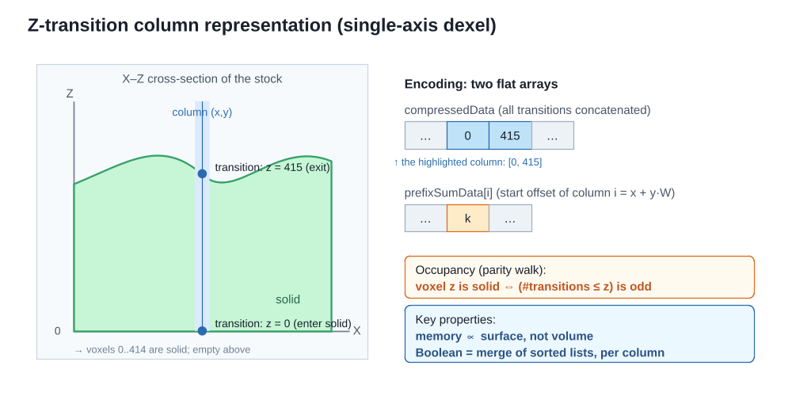
Figure 1. The single-axis dexel (Z-transition column) representation. Each column stores the sorted heights where occupancy flips; two flat arrays encode the whole object, and occupancy is recovered by a parity walk. Storage is proportional to surface complexity, not volume, and any Boolean operation is a merge of sorted lists, independent per column.
The whole object (struct VoxelObject) is two flat arrays:
- compressedData - all columns’ transition lists, sorted ascending, concatenated.
- prefixSumData - for each column i = x + y·W, the start offset of its list in compressedData.
Occupancy at (x, y, z) is recovered by a parity walk: voxel z is solid iff an odd number of transitions are ≤ z. Three properties are exploited throughout: (i) compactness (storage grows with surface area, not volume: a 1000×1000×500 stock is ≈2·10⁶ transitions, a few MB, versus 500 M dense voxels); (ii) Boolean = per-column merge, independent across the W·H columns, hence massively parallel on the GPU; (iii) a free bounding interval - a column’s lowest and highest transitions are exactly its solid extent [bottom, top], a single interval for tools whose columns are single Z-intervals (§4.5).

3. From naive stamping to the final solution
We build the method as a sequence of steps, each validated bit-exactly (§4.6). A running example is used throughout: a stock 1000×1000×500; a ball-end mill (a cylinder with a hemispherical tip) of radius R; and a linear move of the tool centre from p0 to p1.

3.1 Naive stamping (baseline)
The naive simulator advances the tool in small fixed jog steps (e.g. s = 2 voxels) and stamps the whole tool - one Boolean-difference dispatch - at every step. For a segment of length L this is ≈ L/s subtractions; consecutive stamps re-process columns already carved, and, when s > 1, leave scallops between samples.
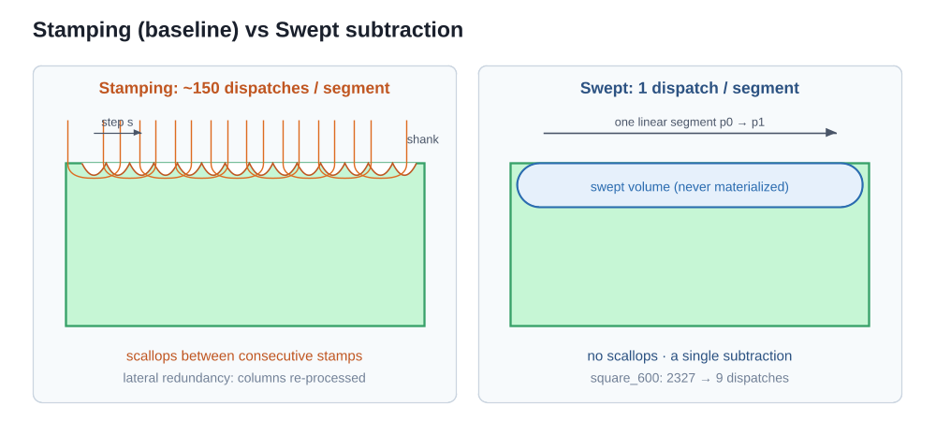
Figure 2. Stamping versus swept subtraction. Left: many overlapping stamps along the path, with residual scallops and lateral redundancy (the tool is a ball-end mill - hemisphere tip plus shank). Right: a single subtraction of the swept volume, with a clean floor. On the square_600 benchmark the dispatches drop from 2327 to 9.

3.2 Swept-segment subtraction
Instead of L/s stamps we perform one subtraction per linear segment, of the tool’s swept volume (the Minkowski sum tool ⊕ p0p1). Set difference is order-independent and distributes over unions, so subtracting the swept volume once equals stamping at every sampled position along the segment (§4.6). Effect: on square_600 the dispatches drop from 2327 to 9.

3.3 On-the-fly Z-envelope, fused in one kernel (core contribution)
The subtlety is that “subtract the swept volume” would seem to require building it in a separate buffer and then subtracting it. We never do. Because the tool’s XY columns are single solid intervals, moving it by ≤1 voxel per sub-step makes the intervals a given stock column “sees” overlap; the union of overlapping intervals is still one interval [min bottom, max top] - the Z-envelope. A single fused compute shader computes this envelope on the fly, per column, and subtracts it in place in the same pass.
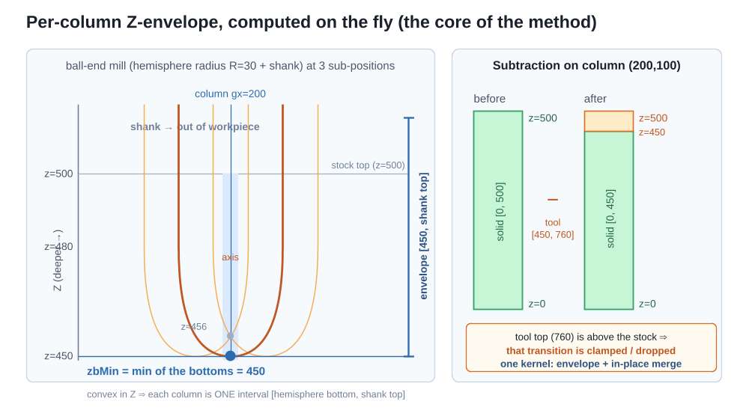
Figure 3. The per-column Z-envelope. Left: the ball-end mill (hemisphere tip + shank) at three sub-positions; the shank rises out of the workpiece. For a given column the deepest bottom is reached when the tool axis passes over it; the envelope is [zbMin, shank top]. Right: its subtraction from the column, done in place in the same kernel - the tool’s top transition, above the stock, is clamped.
Worked example. A stock column starts as [0, 500]. As the tool centre slides in X, the column is covered for a contiguous sub-range of positions; for each, the hemisphere bottom at that lateral offset is computed. The envelope takes the minimum bottom (deepest, on-axis) and the maximum top (the shank top, above the stock). Subtracting [450, shankTop] from [0, 500] - with the shank-top transition clamped to the stock range - yields [0, 450]: exactly what the 150 stamps would produce, via a short loop and one merge, with no buffer for the swept volume.

3.4 Sub-step bounding
A column is covered by the tool only for a contiguous range of sub-steps [k0, k1], obtainable in closed form from the tool centre’s linear motion. Iterating only that range (with ±1 safety margins) drops the per-column work from segment length to ≈ tool extent on axis-aligned moves.

3.5 GPU compaction for read-back
After carving, the result must be returned in the compact column format. Reading back the unpacked working buffer would be W·H·32·4 B ≈ 128 MB. Instead we compact on the GPU first (§4.2), so only ~8 MB of dense transitions cross the bus; read-back drops from ~72 ms to ~8 ms.

3.6 Tube pruning (the new optimization)
The dispatch (§4.3) covers the axis-aligned bounding box (AABB) of the two tool-centre endpoints, dilated by the tool footprint. For an axis-aligned move that AABB already equals the swept band, but for a diagonal move of length L and tool footprint D it is ≈ (0.7L + D)² columns while the tool sweeps only ≈ L·D - and every over-covered column still rewrote all 32 slots for a no-op, because the shader had no early-out before its write-back. In-air rapid (G0) moves are the same: the tool is above the stock, so every column is a no-op that still rewrites 32 slots.
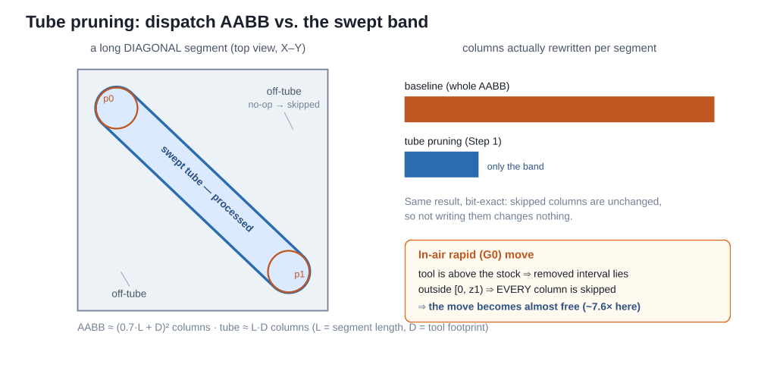
Figure 7. Tube pruning. On a long diagonal segment the dispatch AABB (dashed) is far larger than the swept band it contains; the off-band columns are no-ops that were still being rewritten. Skipping their write-back leaves them untouched (bit-exact) and removes that memory traffic. In-air rapids are the extreme case: the removed interval is entirely outside the stock’s Z-range, so every column is skipped.
The fix is a single early-out in the shader (§4.4): before the merge and write-back, return when the tool never covers the column (hasMat == false) or the removed interval lies entirely outside the stock’s Z-range (zbMin ≥ z1 || ztMax ≤ 0). The column is left untouched - correct, because it is unchanged - and its 128 bytes of write traffic vanish. This is what makes over-dispatched diagonals and in-air rapids cheap; axis-aligned dispatches are fully covered and unaffected.

4. Algorithm and GPU implementation

4.1 A short GPU-compute primer
The pipeline uses compute shaders - programs that run on the GPU outside the graphics pipeline. A program is launched by a dispatch that creates a grid of workgroups; each workgroup contains a fixed block of threads (here local_size = 8 × 8 × 1, so 64 threads) that execute the shader in parallel. Each thread reads its gl_GlobalInvocationID, a 3-D index identifying it within the whole grid. Data lives in Shader Storage Buffer Objects (SSBOs) - large GPU-resident arrays the shader reads and writes. Ordering between dependent dispatches is enforced by a memory barrier. In our carver one thread processes one workpiece column; this is what makes the per-column-merge property of the dexel representation (§2) map directly onto the hardware.

4.2 Data layout: the flat working buffer
During a carving session the stock is held GPU-resident in a fixed-stride flat buffer, obj1_flat, of W·H·MAX_TRANSITIONS uints (MAX_TRANSITIONS = 32), plus a per-column count buffer obj1_dataNum. Column (x,y) owns the 32-slot slice obj1_flat[idx·32 … idx·32+32), idx = x + y·W. Subtractions write results in place into the same slots, so no per-operation reallocation is needed. This buffer is 1000·1000·32·4 B = 128 MB for the reference stock - the working set whose bandwidth dominates the cost (§7). The tool is uploaded once as a compact (compressedData, prefixSumData) pair and never mutates.

4.3 Dispatch: mapping threads onto the XY grid
For each segment the host computes the swept bounding box - the AABB of the two tool-centre endpoints, dilated by the tool half-footprint (w2/2, h2/2) and clamped to the grid - giving an origin (baseX, baseY) and a size (bboxW, bboxH). It then dispatches ⌈bboxW/8⌉ × ⌈bboxH/8⌉ workgroups. Inside the shader each thread recovers its column as gx = baseX + gl_GlobalInvocationID.x, gy = baseY + gl_GlobalInvocationID.y, and returns immediately if gx ≥ W or gy ≥ H (the ragged edge of the last workgroups).
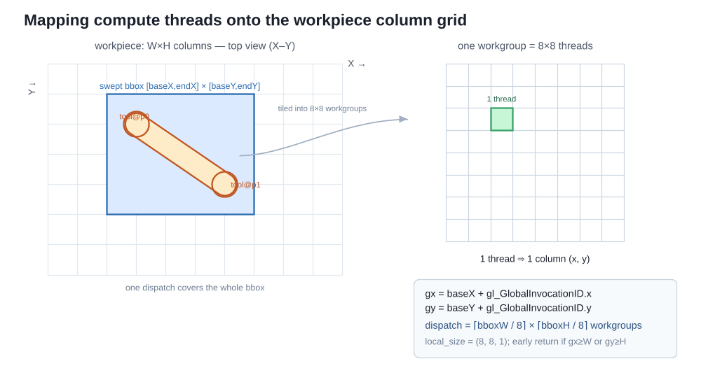
Figure 5. Mapping compute threads onto the workpiece column grid. The host restricts the dispatch to the swept bounding box; the GPU tiles it into 8×8 workgroups, and each thread handles one column (x,y) recovered from its global invocation ID. The number of workgroups is ⌈bboxW/8⌉ × ⌈bboxH/8⌉.

4.4 The subtract_swept shader, step by step
Each thread runs the following (Figure 6). It is deliberately branch-light and reads the tool from cached buffers while touching the large obj1_flat buffer exactly once per column.
- Identify the column and bounds-check it against W, H.
- Read the stock column - its transition count count1 from obj1_dataNum, its transitions from obj1_flat.
- Bound the sub-step range [k0, k1] - the sub-positions of the tool centre for which the tool could cover this column (from the linear motion tr ≈ start + k·Δ/K).
- Accumulate the Z-envelope - loop k over [k0, k1]; for each, find the tool’s column under (gx, gy) and update zbMin = min(zbMin, bottom), ztMax = max(ztMax, top).
- Tube-pruning early-out - if enableSkip and (the tool never covered the column, or the interval [zbMin, ztMax] lies entirely outside [0, z1)), return without writing (§3.6).
- Subtract - a two-pointer merge of the stock column with the single interval [zbMin, ztMax], emitting a transition whenever the result occupancy (stockInside AND NOT toolInside) changes.
- Write back the result transitions in place, zero the unused slots, and store the new count.
- Optional counter - when material-removal tracking is on (used by the fitness evaluator), atomicAdd(removed[segment], oldSolid − newSolid).
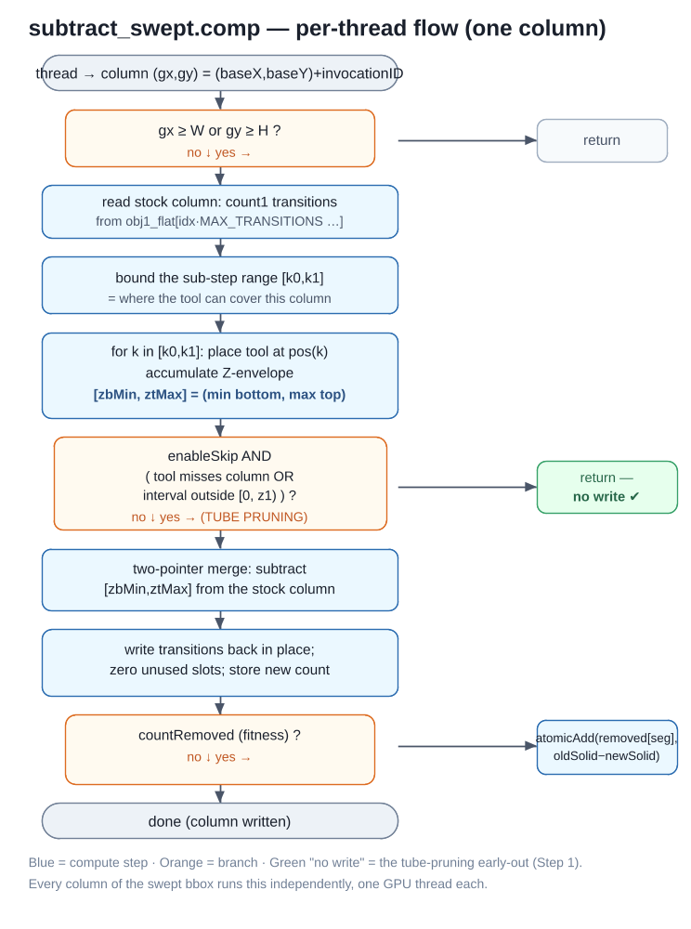
Figure 6. Per-thread control flow of subtract_swept.comp. Blue boxes are compute steps, orange are branches; the green “no write” return is the tube-pruning early-out. Every column of the swept bounding box runs this independently, one GPU thread each.
Two design points matter for performance. The merge is in place and touches the 32-slot column once; and the envelope reuses the column’s lowest/highest transition rather than an intermediate swept solid. The tube-pruning early-out (step 5) is the only change of §3.6, and it removes the write of step 7 - the expensive part - for no-op columns.

4.5 Tool geometry
A ball-end mill is not a sphere but a cylinder with a hemispherical tip; its shank rises above the stock and, in normal 3-axis milling, is out of the workpiece at every instant. This is compatible with the single-interval property: the hemisphere-plus-shank solid is convex in Z, so each of its XY columns is one interval [hemisphere bottom, shank top]. The shank top is a genuine transition in the tool’s representation, but because it lies above the stock it is clamped away by the [0, z1) bound during subtraction. The method is exact for tools whose columns are single Z-intervals (ball, flat, conical, bull-nose) and over-removes gracefully for non-convex tools - the same behaviour as the discrete stamper.

4.6 Correctness: bit-exact against the stamper
The swept result equals discrete stamping to the byte, for two reasons. Order-independence: set difference distributes over unions and is order-independent, so A \ (B₁ ∪ … ∪ Bₙ) = (…((A\B₁)\B₂)…\Bₙ); the swept volume is the union of the tool at the sampled positions, so subtracting it once equals stamping them all. Chebyshev sampling: sub-positions are sampled at step K = max(|Δx|,|Δy|,|Δz|) (the Chebyshev/L∞ length), guaranteeing ≤1-voxel motion per sub-step, so the envelope touches every integer position the stamper would. Tube pruning only skips writes to unchanged columns, so it is bit-exact by construction. The invariant used to check this is the residual solid volume - the sum, over all columns and their solid intervals, of (top − bottom) - a deterministic, render-independent quantity.

5. Numerical experiments

5.1 Hardware, software, and the A/B toggle
Measurements are on an Intel Lunar Lake integrated GPU (Mesa iris driver), OpenGL 4.6 compute, which autocam reaches via an EGL/Wayland context. (Note: the X11 glxinfo utility reports llvmpipe on this system, but that is the GLX path, not the context autocam uses; the real driver is confirmed from the EGL log.) The tube-pruning early-out is gated by an enableSkip uniform driven by the environment variable AUTOCAM_SWEPT_SKIP (default on), so baseline and optimized run from the same binary - essential for a fair A/B. All runs are headless (--no-view).

5.2 Benchmarks and the G-code generator
Because the optimization targets segments whose length L exceeds the tool footprint D, the benchmark set must exercise that regime - long, non-axis-aligned segments and air travel - which the project’s original programs (a square perimeter, star pocket, rectangular pocket) do not when run with the wide 256-voxel hemispheric_mill_10. We therefore use:
- square_600 with hemispheric_mill_10 (256 wide) - an axis-aligned control (AABB already equals the tube; expected ~1×).
- bench_complex with hemispheric_mill_3 (32 wide) - a 45° raster with 13 long diagonal cutting passes interleaved with long diagonal air repositions, generated programmatically.
- Two stress micro-benchmarks with the 32-wide tool: diag_cut (repeated long diagonal cuts) and air_moves (repeated long diagonal G0 rapids).
The 45° raster is emitted by a small parametric generator that walks lanes in a rotated basis (cutting direction û = (1,1)/√2, step direction v̂ = (1,−1)/√2), converting each (u,v) to (x,y); each lane is a long diagonal G1 cut followed by a retract and a long diagonal G0 reposition to the next lane. This mirrors a real finishing raster while maximizing both effects the optimization targets.

5.3 Validation
For every configuration we save the carved .bin and confirm it is byte-identical across baseline, skip, and tube modes, and that its residual solid volume matches the project’s reference numbers (square_600 = 281 165 072, star_pocket = 462 722 118). The residual volume is computed offline by an independent pure-Python reader (no dependency on the GPU path).

5.4 Methodology
Each configuration is run several times; the first run is discarded as compute-pipeline warm-up and the minimum net-carving time is reported. Crucially, the modes are interleaved per round (one run of each mode per round) rather than measured in separate batches, so that GPU clock/thermal drift cancels in the ratio - without this, the never-taken branch of the axis-aligned control spuriously appears 30% slower. Timing uses the simulator’s internal “net carving” timer (a glFinish around the per-segment loop, excluding read-back).

6. Results
Table 1 gives net carving time (ms) for the three modes and the resulting speedups; Figure 8 shows the same, normalized to baseline.
Table 1 - Net carving time (ms), Intel LNL / iris, interleaved min-of-N, all bit-exact.
benchmark (tool) | baseline | skip (Step 1) | tube (Step 2) | skip speedup | tube speedup
square_600 (mill_10, control) | 23.7 | 24.5 | 28.0 | 0.97× | 0.85×
bench_complex (mill_3) | 42.7 | 14.8 | 23.6 | 2.89× | 1.81×
diag_cut (mill_3) | 31.7 | 6.2 | 12.4 | 5.08× | 2.56×
air_moves (mill_3) | 29.6 | 3.9 | 7.5 | 7.64× | 3.93×
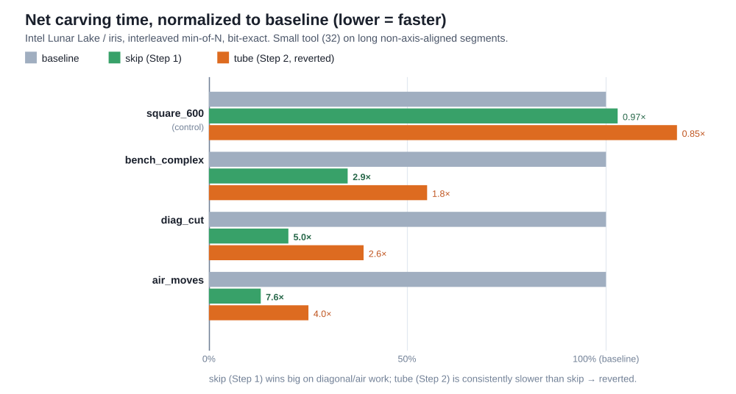
Figure 8. Net carving time normalized to baseline (lower is faster). Tube pruning (skip, Step 1) wins large on diagonal and air-heavy work and is neutral on the axis-aligned control; the oriented tiled dispatch (tube, Step 2) is consistently slower than skip and was reverted.
For historical context, Table 2 recalls how the swept baseline itself was reached from the naive stamper (the pre-tube optimization history on the same class of GPU): baseline stamping ~1232 ms → per-step overhead removal → swept subtraction → GPU compaction → sub-step bounding ≈ 40 ms total (≈33×), all bit-exact. Tube pruning of §3.6 is applied on top of that swept baseline.

7. Discussion
The bottleneck is memory-write bandwidth. Three follow-up experiments, read together, localize it:
- Range-query envelopes (negative). Precomputing per-tool directional Z-envelopes as range-minimum/maximum sparse tables makes the per-column envelope an O(1) query instead of an O(sub-steps) loop. Implemented exactly, it gave only ~25–30% - because it optimized compute, which is not the bottleneck - and was reverted.
- Tube pruning (positive, §3.6). Skipping the write-back of off-band and out-of-Z-range columns attacks memory-write traffic and gives 2.6–7.6× in its regime. This is the complement of the previous result: the lever that pays removes memory traffic, not compute.
- Oriented tiled dispatch (negative). Tempted to also avoid launching the off-band threads (each still does a counter read plus the early-out), we tiled the dispatch along the motion so it follows the band. Each tile reuses the full-segment envelope uniforms (so every column is computed identically); adjacent tiles overlap idempotently, separated by a barrier - keeping it bit-exact. The result was ~2× slower than tube pruning alone: the per-tile barriers serialize the tiles and the joins double-process columns, and that synchronization cost exceeds the thread-launch saving, because tube pruning already made the off-band threads cheap (a read, no write). Reverted.
The pattern is consistent: once per-step overhead is gone, the simulator is bandwidth-bound on the 128 MB working buffer; optimizations that cut compute or launched-thread count hit diminishing or negative returns, while the one that cuts bytes written wins. A dispatch-enqueue cost that stays ~0.4 ms whether a program has 9 or 202 segments corroborates that per-segment host overhead is not the limit.
When tube pruning helps. The gain requires segment length L ≫ D. Axis-aligned programs, or diagonal programs machined with a tool nearly as wide as the segments are long, see little - their AABB already equals the tube. Real 3-axis programs, however, contain substantial air travel (rapids between features, retract/reposition links) and non-axis-aligned finishing passes, all of which this optimization accelerates; the in-air pruning in particular applies to every rapid.
Limitations. The pipeline runs in voxel units; a calibrated millimetre mapping is future work. The envelope over-removes for non-convex-in-Z tools, and the flat-buffer stride MAX_TRANSITIONS = 32 is not overflow-guarded. The tool is axis-fixed (3-axis only). The largest remaining lever for the optimization loop is a GPU-side objective (comparing carved-vs-target on the GPU) to remove the per-iteration read-back entirely.

8. Conclusions
We presented a GPU material-removal simulator for 3-axis milling built on a single-axis dexel field, in which Boolean difference is a per-column merge that maps one workpiece column to one GPU thread. On top of a fused, materialization-free swept-segment subtraction, we introduced tube pruning - skipping the write-back for columns the swept tool never touches - which is bit-exact and yields 2.6–7.6× on the diagonal and air-heavy work that dominates real toolpaths, while leaving axis-aligned programs unchanged. The optimization, and two documented negative results bracketing it, together show that on this pipeline the decisive resource is memory-write bandwidth: the successful lever removes bytes written, not arithmetic or launched threads. The simulator is fast enough and accurate enough (bit-exact) to serve as the forward model of a search- or learning-based toolpath generator, which is the subject of ongoing work.

Appendix A. Terminology
Term | Meaning in this paper
Voxel | A cell of the regular 3-D grid; solid or empty.
Dexel | “Depth element”: the run of solid voxels along one axis in a column.
Single-axis dexel field | The stock/tool stored as per-(x,y)-column Z-runs (our representation).
Column | One (x, y) stack of D voxels along Z.
Transition | A Z height where a column’s occupancy flips (empty↔solid).
Parity walk | Recovering occupancy by counting transitions ≤ z: odd ⇒ solid.
Stock / workpiece | The block being machined (obj1).
Tool | The cutter (obj2); here a ball-end mill (hemisphere + shank).
Footprint (D) | The tool’s XY extent in voxels (w2 × h2).
Segment | One straight toolpath move p0 → p1.
Swept volume | The region the tool sweeps over a segment (tool ⊕ p0p1).
Z-envelope | Per stock column, the single interval [min bottom, max top] of the swept tool.
Sub-step | One sampled tool-centre position along a segment.
Chebyshev length (K) | max(|Δx|,|Δy|,|Δz|); number of ≤1-voxel sub-steps.
AABB | Axis-aligned bounding box (of a segment’s endpoints, dilated by the footprint).
Swept band / tube | The columns the tool actually sweeps - a band along the motion.
Tube pruning | Skipping the write-back for columns outside the tube / stock Z-range.
Thread | One GPU work-item; here it processes one column.
Workgroup | A block of threads executed together (8×8 here).
Dispatch | A launch of a compute shader over a grid of workgroups.
gl_GlobalInvocationID | A thread’s global index within the dispatch grid.
SSBO | Shader Storage Buffer Object: a large GPU-resident array.
Memory barrier | A synchronization that orders dependent GPU memory accesses.
MAX_TRANSITIONS | Fixed per-column slot count (32) of the flat working buffer.
Bit-exact | Byte-identical output; verified via the residual-volume invariant.
Residual solid volume | Σ (top − bottom) over all columns’ solid intervals.
Net carving time | GPU carving-loop time, excluding read-back (measured with a glFinish).

References
- T. Van Hook. Real-time shaded NC milling display. Computer Graphics (Proc. SIGGRAPH ’86), 20(4):15–20, 1986.
- H. Müller, T. Surmann, M. Stautner, F. Albersmann, K. Weinert. Online sculpting and visualization of multi-dexel volumes. Proc. 8th ACM Symposium on Solid Modeling and Applications (SM ’03), 258–261, 2003.
- B. Tukora, T. Szalay. Multi-dexel based material removal simulation and cutting force prediction with the use of general-purpose graphics processing units. Advances in Engineering Software, 43(1):65–70, 2012.
- M. Inui, M. Kobayashi, N. Umezu. Cutter engagement feature extraction using triple-dexel representation workpiece model and GPU parallel processing. Computer-Aided Design and Applications, 16(1):89–102, 2019.
- C. C. L. Wang, Y.-S. Leung, Y. Chen. Solid modeling of polyhedral objects by Layered Depth-Normal Images on the GPU. Computer-Aided Design, 42(6):535–544, 2010.
- D. Blackmore, M. C. Leu, L. P. Wang. The sweep-envelope differential equation algorithm and its application to NC machining verification. Computer-Aided Design, 29(9):629–637, 1997.
- K. Abdel-Malek, J. Yang, D. Blackmore, K. Joy. Swept volumes: foundation, perspectives, and applications. International Journal of Shape Modeling, 12(1):87–127, 2006.
- W. E. Lorensen, H. E. Cline. Marching cubes: a high resolution 3D surface construction algorithm. Computer Graphics (Proc. SIGGRAPH ’87), 21(4):163–169, 1987.
- C. Dyken, G. Ziegler, C. Theobalt, H.-P. Seidel. High-speed marching cubes using HistoPyramids. Computer Graphics Forum, 27(8):2028–2039, 2008.

