A Fast GPU Algorithm for Carving Simulation
Nicola Scuor¹*, Paolo Gallina¹, Philip Long², Stefano Seriani¹
¹ Department of Engineering and Architecture, University of Trieste, Via Alfonso Valerio 6/1, 34127 Trieste, Italy
² Department of Electronic, Software and Advanced Manufacturing Engineering, Atlantic Technological University, Galway, Ireland
* Corresponding author: Nicola Scuor, nscuor@units.it
ORCID
Nicola Scuor: 0000-0002-5073-637X
Paolo Gallina: [to be inserted]
Philip Long: 0000-0002-0784-8720
Stefano Seriani: 0000-0002-5563-9595

Abstract
Material-removal (carving) simulation - computing the workpiece geometry that a milling program actually produces - is a core primitive of computer-aided manufacturing: toolpath verification, cutting-force and cutter-workpiece engagement estimation, machining digital twins, and process- or toolpath-optimization and learning loops all rely on it, and call it repeatedly, from many times in an interactive check to millions inside a search, so its throughput sets the scale of study that is feasible at all [10-15]. We present a GPU algorithm for this simulation that is, to the best of our knowledge, the fastest reported for dexel-based milling material removal. It is built on a single-axis dexel field - a grid of columns storing sorted height transitions - in which Boolean subtraction becomes an independent per-column merge that maps one workpiece column to one GPU thread. Against two established baselines, per-step stamping and swept-volume subtraction through a separate buffer, we contribute two optimizations. Fused swept-segment subtraction computes each move's swept extent on the fly as a per-column envelope and subtracts it in place, never materializing the swept volume; it is 1.85 times faster than the external-buffer baseline and halves resident memory. Tube pruning skips the write-back for dispatched columns the tool never touches, giving 3.2 to 7.4 times on diagonal and air-heavy programs, at up to 8% cost on dense axis-aligned rasters. Two negative results and one positive one support a single diagnosis: the levers that pay remove memory-write traffic, not arithmetic or launched threads - the simulation is bound by write bandwidth to the working-set buffer. Every optimization level is byte-identical, and exact against an analytic reference on axis-aligned moves. The method is a drop-in accelerator for the many CAM workflows bottlenecked by repeated carving simulation.

Keywords: Material-removal simulation, GPU compute, Dexel model, Swept volume, Machining simulation, CAM

1. Introduction

1.1 Motivation
Material-removal simulation predicts the workpiece geometry a milling program produces by repeatedly subtracting the cutting tool's swept volume from a stock model. It is a workhorse of computer-aided manufacturing: it underlies toolpath verification and gouge or collision checking [15], cutting-force and cutter-workpiece engagement estimation [10, 11], machining digital twins [12], and - increasingly - optimization [13] and learning [14] loops that search over candidate toolpaths and score each against a target. In all of these the simulator is called repeatedly, from many times in an interactive verifier to millions inside a search or a training run, so its raw throughput at a fixed, adequate accuracy sets the scale of study that is feasible at all. A fast and accurate forward model - one that, given a toolpath, tool and stock, computes the resulting workpiece - is therefore the enabling primitive, and it is the object of this paper.
Raw simulation speed at a fixed, adequate accuracy is thus the central requirement and the primary driver of the design choices below; the method's geometric error against the continuously-swept cut is zero on axis-aligned moves and 0.08 % on diagonals, measured against an analytic reference in §4.6, so accuracy here is a constraint to hold, not the quantity we optimize. We restrict the scope to milling in which the tool translates with its axis fixed to Z - three-axis machining - and to programs of linear moves, G00 and G01; circular interpolation is handled upstream by rendering arcs as polylines, and each resulting segment is the input the method takes.

1.2 Related work
Column-based material-removal simulation begins with the dexel model [1], which renders NC milling in real time as an image-space Boolean subtraction: the workpiece is a grid of Z-direction “depth elements” (dexels), and the tool lowers their heights. The model was extended to multi-/tri-dexel representations (three orthogonal dexel bundles) to improve sampling on steep walls: [2] present online sculpting on multi-dexel volumes, and GPU variants were developed [3, 4]. In parallel, the solid-modeling community proposed sparse, per-axis implicit representations with GPU Booleans, notably Layered Depth-Normal Images, LDNI [5]. Swept-volume computation has its own line, from the sweep-envelope differential equation [6] to the survey [7]. Surface reconstruction uses Marching Cubes [8], and its corresponding GPU version [9].
Two observations frame what follows. First, subtracting a tool's swept volume per move from a dexel model is not new; it is exactly what [2, 3, 4] do, and we treat it as a baseline rather than a contribution. Second, that line of work optimizes the geometry of the subtraction, while the cost we measure is dominated by the traffic to the working-set buffer, a resource none of it addresses. Our contribution is therefore not a new representation but a different target.

1.3 Contributions
We present two optimizations, both implemented entirely on the GPU and each isolated by A/B comparison against the best available baseline from the literature. We label the four levels S0 to S3 throughout: per-step stamping (S0), swept subtraction through an external buffer (S1), the fused in-place swept kernel (S2), and the fused kernel with tube pruning (S3); the first two are the established baselines and the last two are this work, and §6.1 anchors each to the literature it represents. Each of ours is byte-identical to the swept baseline it builds on, S0 being a timing and behavioural reference rather than a geometric ground truth (§4.6).
Contribution 1: Fused swept-segment subtraction. For each linear toolpath segment, the swept-tool column is computed on the fly as a Z-envelope and subtracted in place, never materializing the swept volume. Because columns are independent, the operation maps directly to one GPU thread per column. Compared to an external-buffer swept baseline (which writes the swept volume to a separate buffer and subtracts it in a second pass), fusion is ≈1.2–2.5× faster (geomean ≈1.85×) and halves resident memory: the external buffer requires a full-size twin of the working set that the fused kernel eliminates (§6.1, §6.3). This is a consistent win across all workloads.
Contribution 2: Tube pruning with in-air skip. The GPU dispatch covers the axis-aligned bounding box of each segment's endpoints, which on diagonal moves and in-air rapids is far larger than the actual swept band. We skip the per-column write-back for columns the tool never touches, leaving them untouched and the result byte-identical. Tube pruning delivers 3.2–7.4× on the stress benchmarks (Table 1), while staying neutral-to-modest-cost on axis-aligned programs (at most ≈8 % on the densest raster, where the dispatch already matches the swept band, §6).
Beyond these two main contributions, we introduce three additional refinements that improve specific aspects of the method. First, we perform GPU-side result compaction, which reduces read-back traffic by approximately an order of magnitude by returning only the compact transition lists rather than the full unpacked buffer (§3.5). Second, we implement a sparse tiled backend that materializes only the tiles actually touched during carving. This is a memory/scale lever rather than a speed optimization: for localized programs, it shrinks the resident footprint to a small fraction of the full buffer; for whole-stock machining, however, it offers no saving. The backend is runtime-selectable and byte-identical to the flat buffer version (§6.2). Third, we eliminate the dead trailing zero-fill of each column’s write-back: byte-identical, it removes write traffic on the active columns for 8–22% on the fused kernel, reaching the axis-aligned case where tube pruning does not (§6.4).
We also report two attempted optimizations that we implemented in full and then discarded because they did not pay off. The first was a range-query envelope acceleration: we precomputed per-tool directional Z-envelopes as sparse tables, turning the per-column envelope computation from an O(sub-steps) loop into an O(1) query. This gave only modest improvement, because it optimized compute, which is not the bottleneck, and was reverted. The second was an oriented tiled dispatch: we attempted to tile the launch along the swept band itself, so that off-band threads would not even be launched. This required barriers between tiles to preserve byte-identity, and the resulting synchronization overhead, together with overlapping joins between adjacent tiles, made the approach slower than tube pruning alone. We reverted it as well. Together, these negative results corroborate our central diagnosis: on this pipeline, the lever that pays is the one that removes memory-write traffic, not the ones that reduce compute or launched threads (§7).

2. Volume representation: single-axis dexel field
Both the stock and the tool are discretised on a common voxel lattice of W × H × D cells, but that lattice is never materialised: it only fixes the sampling resolution and the integer coordinates in which every quantity is expressed. What is actually stored is a single-axis dexel field along Z. Each (x, y) column of the lattice is a one-dimensional occupancy function of z, encoded as the sorted list of the heights at which occupancy flips: empty to solid or solid to empty. Because occupancy alternates, transitions come in pairs, one entering and one leaving the solid (Fig. 1).
Milling parts are massive bodies bounded by a few surfaces, so a column crosses the boundary only a handful of times: two to four transitions is typical, and two is the minimum, since transitions come in pairs. An uncarved column of a prismatic stock is exactly that minimum, the single pair [0, z_top], where z_top is the height of the stock's top face: solid from the base up to that face, empty above. For a stock that fills the lattice, z_top coincides with the grid depth z1 used as the clamping bound in §3.6 and §4.4.
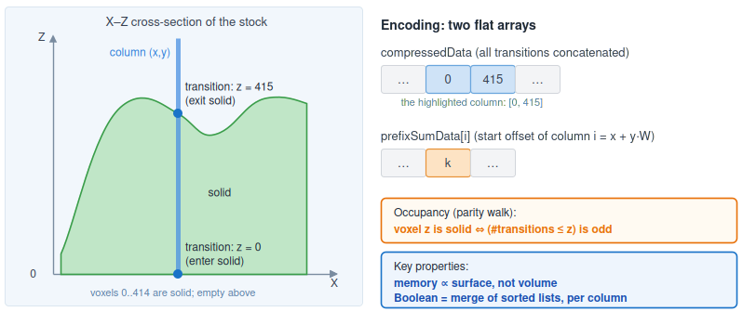
Fig. 1 The single-axis dexel (Z-transition column) representation. A column stores the sorted heights at which occupancy flips; two flat arrays encode the whole object, and occupancy at any voxel is recovered by a parity walk. Storage scales with the complexity of the boundary rather than with the enclosed volume, and any Boolean operation becomes a merge of sorted lists, independent per column
The whole object is a struct VoxelObject, used for both stock and tool, consisting of two flat arrays. Columns are addressed by the linear index i=x+y*W, i.e. row-major with X varying fastest, and both arrays follow that order:
- compressedData: the transition lists of all columns, each sorted ascending, concatenated in order of i.
- prefixSumData: for each column i, the offset at which its list begins in compressedData. The array has one entry per column, so the length of column i’s list is prefixSumData[i+1] − prefixSumData[i], with the last column running to the end of compressedData. During a carving session the resident stock keeps its per-column counts in a separate array instead (§4.2).
The name is historical: the struct stores transitions, not voxels.
Occupancy at (x, y, z) is recovered by a parity walk: the voxel is solid iff the number of transitions of its column that are ≤ z is odd. No dense buffer is ever allocated, read or written.
Three properties are exploited throughout.
- Compactness: storage is proportional to the number of transitions, that is, to how often the columns cross the boundary, and not to the enclosed volume. A field averaging c transitions per column costs c*W*H integers where a dense grid would cost W*H*D occupancy values, a saving of a factor D/c. For c ≈ 2 to 4 and the depths typical of a milling stock this is two to three orders of magnitude, and it does not grow as the part becomes more massive, only as its surface becomes more intricate (absolute figures for the reference stock of §5.2 are given in §6.3).
- Boolean = per-column merge. Any Boolean between two fields on the same lattice is a two-pointer merge of their sorted transition lists, performed independently for each of the W*H columns: the traversal is the same in every case, only the predicate on the two occupancy states differs (AND for intersection, OR for union, AND-NOT for difference), and a transition is emitted wherever the predicate changes value. The carver uses difference alone (subtracting the tool from the stock) and it is the only operation implemented on the GPU (§4.4). Columns never interact, so the merge is embarrassingly parallel and maps to one GPU thread per column (§4.1).
- A free bounding interval. The lowest and highest transitions of a column are exactly its solid extent [bottom, top], available without a search. For tools whose columns are a single Z-interval (§4.5) that interval is not a bound on the column: it is the column; this makes the on-the-fly Z-envelope of §3.3 possible.

3. From naive stamping to the final solution
We build the method as a sequence of refinement levels, each validated against the previous one (byte-identical among the swept levels; §4.6). To make the transformations concrete we follow one setting throughout: a prismatic stock, a ball-end mill, that is, a cylinder closed by a hemispherical tip of the same radius, and a single linear segment carrying the tool from p0 to p1. No dimensions are needed here, since none of the steps depends on them; the measured configurations are those of §5.
The tool is positioned by the centre of its own bounding box: the G-code coordinate, converted to voxel units, places that centre, with no compensation for the tip radius or the shank length. This is a calibration convention rather than a modelling choice, and it applies identically to every refinement level, so it affects none of the comparisons below. It does mean that a real G-code program in millimetres cannot yet be consumed without an external calibration step (§7).

3.1 Naive stamping (baseline)
The naive simulator advances the tool along the segment in fixed jog steps and stamps the whole tool at each of them, one Boolean-difference dispatch per step, subtracting the tool at that position from the stock. The step s is a fixed distance in voxel units along the segment, independent of the segment's direction and length. A segment of length L thus costs approximately L/s dispatches. This approach has two sources of inefficiency. First, the dispatches overlap: consecutive positions differ by s while the tool footprint is many voxels wide, so every column under the tool is read, merged and rewritten several times over, even though only the first of those passes typically removes material. Second, the sampling is visible in the result: between two stamps the tool is never evaluated, so for s>1 the carved floor exhibits a stepped profile (Fig. 2a). Because the stamper is a union of stamps, refining the step can only add positions to that union, never remove any; its removed volume grows monotonically as s shrinks, approaching the continuous cut from below in removed volume. §4.6 discusses how the single-pass swept subtraction relates to that limit and to the stamper.
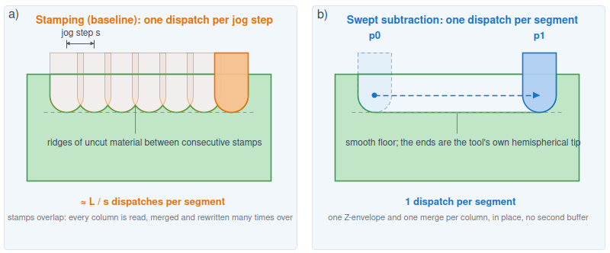
Fig. 2 Stamping versus swept subtraction. Left: many overlapping stamps along the path: a coarse step leaves a stepped floor and re-processes each column many times (the tool is a ball-end mill: hemisphere tip plus shank). Right: a single subtraction of the swept volume, one pass with a step-free floor

3.2 Swept-segment subtraction
Instead of L/s stamps we perform one subtraction per linear segment, of the tool's swept volume, i.e., the union of all tool positions along the segment (Fig. 2b; formally, the Minkowski sum of the tool geometry and the line segment; see [7] for a comprehensive treatment). Set difference is order-independent and distributes over unions, so subtracting the swept volume once equals stamping at every sampled sub-position along the segment. This drastically reduces the number of dispatches (quantified in §6, Table 2).

3.3 On-the-fly Z-envelope, fused in one kernel (core contribution)
The subtlety is that "subtract the swept volume" appears to require building that volume in a separate buffer and then subtracting it. We never build it. The property that makes this possible is that each XY column of the tool is a single solid interval in Z, from its lowest point to its top. This holds for the standard 3-axis tool shapes: ball-end, flat-end, conical and bull-nose cutters are all convex in Z, and the shank that closes them from above does not break the property. For the ball-end mill of our running example, the interval runs from the hemisphere bottom up to the shank top. Tools that violate it are discussed in §4.5.
Consider a fixed stock column. Only a contiguous range of sub-positions along the segment actually overlaps that column; outside this range the tool never covers it and the column stays unchanged. Within the range, each sub-position contributes one interval, whose bottom depends on the lateral offset between the tool axis and the column at that instant (Fig. 3a). Since the tool advances by at most one voxel per sub-step, the intervals contributed by consecutive sub-positions overlap; their union is therefore again a single interval, [min bottom, max top], which we call the Z-envelope (Fig. 3b). For a ball-end mill the deepest bottom occurs at the sub-position where the tool axis passes closest to the column, reaching the tip depth for a column that lies directly under the path; for a flat-end cutter the bottom is the same at every covering sub-position. The maximum top is the shank top, which lies above the stock at every instant.
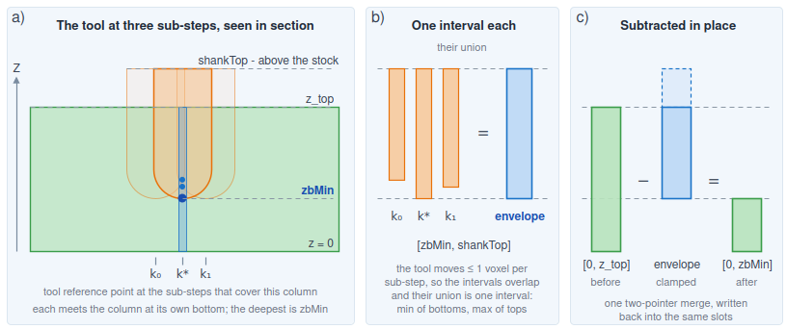
Fig. 3 The per-column Z-envelope. The three panels share one vertical Z scale. (a) Vertical section through the tool axis: the ball-end mill at three sub-steps over one fixed stock column, with the shank rising out of the workpiece. Each sub-step meets the column at its own hemisphere bottom; the deepest occurs at the sub-step where the tool passes closest to the column. (b) Each column of the tool is a single interval in Z, so every sub-step contributes [bottom(k), shankTop]. Because the tool moves by at most one voxel per sub-step, consecutive intervals overlap and their union is again one interval: the envelope [zbMin, shankTop]. (c) The envelope is subtracted from the column in place, the shank-top transition being clamped away because it lies above z_top, leaving [0, zbMin]
A single fused compute shader accumulates this envelope in registers as it walks only the sub-positions that overlap the column, then subtracts it from the column in place, in the same pass (Fig. 3c): a two-pointer merge of the stock column against one interval, with the shank-top transition clamped away, since it lies above the stock surface. A column that starts as [0, z_top] ends as [0, zbMin], exactly what stamping at every sub-position of that range would produce (§4.6), from a short loop and one merge, with no buffer for the swept volume. The range of covering sub-positions is computed in closed form, as described in §3.4.
§6.1 and §6.3 measure what this fusion buys against the external-buffer version, which needs a second full buffer and an extra pass.

3.4 Sub-step bounding
The range of sub-positions that actually cover a given column, [k0, k1], can be computed directly from the segment geometry without iterating over all sub-steps. For a linear toolpath segment from p0 to p1, the tool centre moves along a straight line in the XY plane. The tool is a solid of revolution about Z, so its XY footprint is a square of side F voxels and its radius is F/2. The lateral distance between the tool axis and a fixed column (x, y) is a convex quadratic function of the interpolation parameter t ∈ [0, 1]; the times at which this distance equals F/2 define the boundaries of the covering interval. The enclosing range [k0, k1] in sub-step indices is then obtained by projecting the column onto the segment, clamping to the segment endpoints, and dilating by F/2. A small safety margin (±1 voxel) is added to account for numerical rounding and to ensure that no covering sub-position is missed. Iterating only this range per column reduces the per-column work from the full segment length to approximately the tool extent on axis-aligned moves, and to a similarly reduced band on diagonal moves.

3.5 GPU compaction for read-back
After carving, the result must be returned to the host in the compact column format. Reading back the unpacked working buffer would transfer the entire fixed-stride flat buffer, including all unused slots, which is wasteful. Instead, we compact the result on the GPU first (§4.2), producing a densely packed transition list that contains only the actual transitions of each column. This reduces the read-back traffic by approximately an order of magnitude, since the compact representation transfers only the transitions that are actually present, rather than the full allocated buffer. Quantitative figures for the reference benchmark are given in §6.3.

3.6 Tube pruning (the new optimization)
The dispatch (§4.3) covers the axis-aligned bounding box (AABB) of the two tool-centre endpoints, dilated by the tool footprint (Fig. 4a). For an axis-aligned move, that AABB already equals the swept band, but for a diagonal move of length L it is approximately (0.7L+F)^2 columns while the tool sweeps only approximately L*F, so most of the dispatch falls outside the band. Every over-covered column still rewrites its entire allocated slot count for a no-op, because the shader had no early-out before its write-back (Fig. 4b). In-air rapid (G0) moves are the same: the tool is above the stock, so every column is a no-op that still rewrites its slots (Fig. 4c).
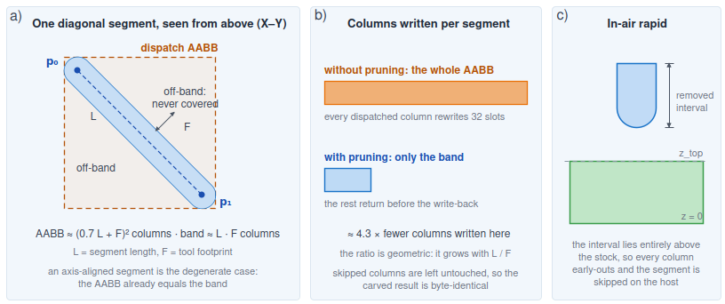
Fig. 4 Tube pruning. (a) A long diagonal segment seen from above: the dispatch AABB (dashed) is far larger than the swept band it contains, and the off-band columns are no-ops that the baseline still rewrites. (b) Columns written per segment, with and without pruning, in the ratio given by the geometry drawn in (a); skipping the write-back leaves the off-band columns untouched, so the result is byte-identical. (c) In-air rapids are the extreme case: the removed interval lies entirely outside the stock's Z-range, so every column is skipped and the whole segment is dropped on the host. Panels (a) and (c) correspond to the two branches of the same early-out
The solution is a single early-out in the shader (§4.4): before the merge and write-back, the shader returns when the tool never covers the column, which is the case of Fig. 4a, or when the removed interval lies entirely outside the stock's Z-range, the case of Fig. 4c. The column is left untouched, which is correct because it is unchanged, and its write traffic vanishes. This is what makes over-dispatched diagonals and in-air rapids cheap; axis-aligned dispatches are fully covered, so the test never pays there and costs up to 11% (§6.1).
The same pruning applies one level up, on the host, at segment granularity: when the tool's Z-extent over a whole segment cannot reach the stock's [0, z1) range (the common case for an in-air G0 rapid, which maps below the stock under the inverted-Z convention), the segment removes nothing and its entire dispatch is skipped, not merely pruned per column. Rapids become much cheaper (quantified in §6, Table 1), and every program with repositioning moves speeds up; this optimization is host-side, byte-identical, and gated by the same toggle.

4. Algorithm and GPU implementation

4.1 A short GPU-compute primer
The pipeline uses compute shaders: programs that run on the GPU outside the graphics pipeline. A program is launched by a dispatch that creates a grid of workgroups; each workgroup contains a fixed block of threads that execute the shader in parallel (in our case, local_size = 8×8×1, so 64 threads per workgroup). Each thread reads its gl_GlobalInvocationID, a three-dimensional index identifying it within the whole grid. Data is stored in Shader Storage Buffer Objects (SSBOs): large GPU-resident arrays that the shader reads and writes. Ordering between dependent dispatches is enforced by a memory barrier. In our carver, one thread processes one workpiece column; this is how the per-column-merge property of the dexel representation (§2) maps directly onto the hardware.

4.2 Data layout: the flat working buffer
During a carving session the stock is held GPU-resident in a fixed-stride flat buffer, obj1_flat, of W*H*MAX_TRANSITIONS unsigned integers, plus a per-column count buffer obj1_dataNum. Column (x, y) owns the slice of MAX_TRANSITIONS slots at offset (x+y*W)*MAX_TRANSITIONS. Subtractions write results in place into the same slots, so no per-operation reallocation is needed. This buffer is the working set whose bandwidth dominates the cost of a carve (§7); its size for the reference stock of §5.2 is given in §6.3.
The value MAX_TRANSITIONS = 32 is chosen as a safe upper bound. A column crosses the boundary only a handful of times (§2), and even complex parts rarely exceed a few dozen transitions, so a fixed stride of 32 slots covers the vast majority of practical cases while keeping memory access patterns regular and predictable. Occupancy queries read only the first obj1_dataNum[i] slots of a column, but the write-back covers the whole stride: the merge writes the new transitions and then zeroes the remaining slots. Every column the shader does not skip therefore costs a full stride of write traffic, which is what the early-out of §3.6 avoids and what §6.4 measures directly.
The stride is not overflow-guarded. If a column would produce more than MAX_TRANSITIONS transitions the merge stops there, the surplus is dropped, and the truncated list is written back with its count; the failure is a localised loss of geometry in that column, silent and non-propagating, with the rest of the carve unaffected (§7). The margin is generous, but a column needing more than MAX_TRANSITIONS transitions would be clipped rather than detected. We did not implement detection because none of the geometries we target approaches the bound, and inputs at that extreme are outside the scope of this work; it would be near-free to add, since the merge loop already tests the stride bound at every iteration and a flag would cost one atomic write on a branch that is never taken in normal operation.
The tool is uploaded once as a compact (compressedData, prefixSumData) pair and never mutates.

4.3 Dispatch: mapping threads onto the XY grid
For each segment the host computes the swept bounding box, i.e. the AABB of the two tool-centre endpoints dilated by the tool half-footprint F/2, then clamps it so that it addresses only columns in [0, W) × [0, H), since a segment near an edge of the stock, or one passing outside it altogether, would otherwise dilate past the grid. This gives an origin (baseX, baseY) and a size (bboxW, bboxH) that address existing columns only (Fig. 5a). The implementation reads the two tool extents (w2/2, h2/2) separately only because the same structure also holds the non-square stock. It then dispatches ⌈bboxW/8⌉ × ⌈bboxH/8⌉ workgroups (Fig. 5b), and inside the shader each thread recovers its column as gx = baseX+gl_GlobalInvocationID.x, gy = baseY+gl_GlobalInvocationID.y (Fig. 5c).
Rounding up to whole workgroups overshoots the bounding box by up to seven columns per edge, and what those surplus threads do depends on where the box sits. When the box was clamped to the far edge of the grid they fall outside the workpiece, and the shader's gx ≥ W or gy ≥ H test returns them immediately. When the box ends before that edge, they address real columns just past the swept footprint and run to completion, finding nothing to remove: no-ops that the early-out of §3.6 stops before the write-back. Because both corners are clamped, that test can never fire on a column inside the bounding box; it is purely a guard against the workgroup rounding.
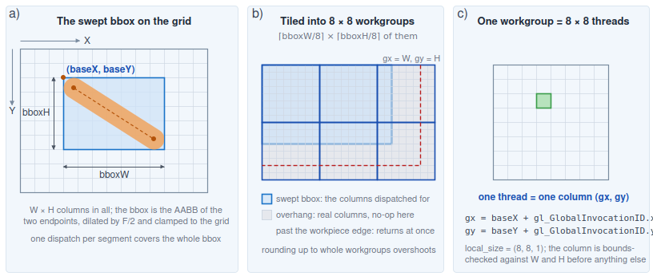
Fig. 5 Mapping compute threads onto the workpiece column grid. (a) The host restricts the dispatch to the swept bounding box, the AABB of the segment endpoints dilated by F/2 and clamped to the grid, giving the origin (baseX, baseY) and the size bboxW × bboxH. (b) The box is tiled into ⌈bboxW/8⌉ × ⌈bboxH/8⌉ workgroups of 8×8 threads; rounding up overshoots, so the last workgroups cover columns outside the box, and those past the edge of the workpiece return immediately. (c) Each thread handles one column, recovered from its global invocation ID

4.4 The subtract_swept shader, step by step
Each thread runs the following steps (Fig. 6). The shader is deliberately branch-light and reads the tool from cached buffers, while the large obj1_flat buffer is read once and written once per column.
- Identify the column: recover gx = baseX+gl_GlobalInvocationID.x and gy = baseY+gl_GlobalInvocationID.y from the thread's position in the dispatch (§4.3), and return immediately if gx ≥ W or gy ≥ H.
- Read the stock column: its transition count count1 from obj1_dataNum, and its transitions from obj1_flat.
- Bound the sub-step range [k0, k1]: the sub-positions of the tool centre for which the tool could cover this column (the sub-positions being tr = start + round(k*Δ/K), component-wise nearest integer, for k = 0…K).
- Accumulate the Z-envelope: loop k over [k0, k1]; for each, find the tool's column under (gx, gy) and update zbMin = min(zbMin, bottom), ztMax = max(ztMax, top).
- Tube-pruning early-out: if enableSkip and (the envelope accumulated no coverage over the whole sub-step range, hasMat == false, or the interval [zbMin, ztMax] lies entirely outside [0, z1)), return without writing (§3.6).
- Subtract: perform a two-pointer merge of the stock column with the single interval [zbMin, ztMax], emitting a transition whenever the result occupancy (stockInside AND NOT toolInside) changes.
- Write back the result transitions in place, zero the unused slots (optional; §6.4), and store the new count.
- Optional counter: when material-removal tracking is enabled, the shader measures the column's solid extent before and after the merge and performs atomicAdd(removed[segment], oldSolid - newSolid). This gives the volume removed by each segment, which the optimization loop of §1.1 uses to score candidate toolpaths.
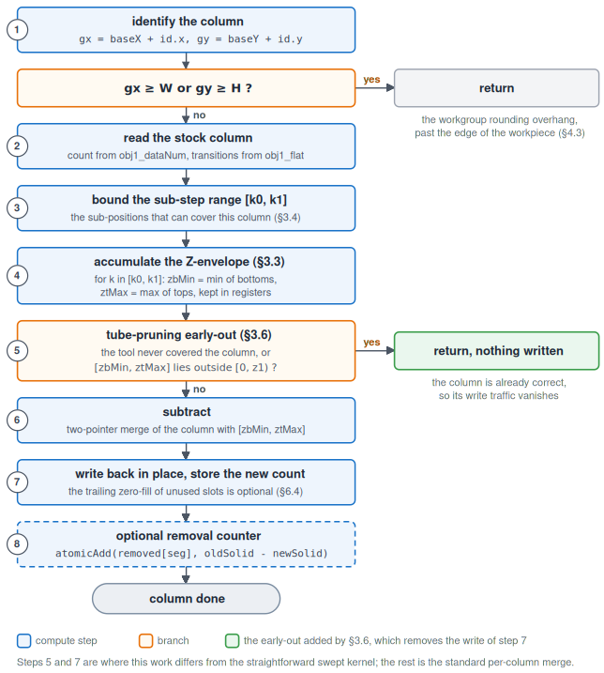
Fig. 6 Per-thread control flow of subtract_swept.comp, with the step numbers of §4.4. One GPU thread handles one column, and every column of the swept bounding box runs this independently. The two exits leave without writing: the first on the workgroup rounding overhang past the edge of the workpiece (§4.3), the second on the tube-pruning early-out of step 5 (§3.6), which is what removes the write-back of step 7 for columns the tool never touches
Two design points matter for performance. The merge is in place: the column is read once and written once, with no round-trip through an intermediate swept solid, and the envelope is built from the tool column's lowest and highest transitions rather than from a materialized volume. The write of step 7 covers the whole MAX_TRANSITIONS stride, which is what makes it the expensive part of the thread and why removing it matters twice over: the early-out of step 5, the only change that §3.6 makes to the shader, skips it entirely for columns the tool never touches, and dropping the trailing zero-fill (§6.4) shortens it for the columns it does touch. The optional counter of step 8 is gated by a uniform and off in every run reported here, so neither the atomic nor the two extra column scans that feed it appear in the timings.

4.5 Tool geometry
A ball-end mill is not a sphere but a cylinder with a hemispherical tip, and its shank rises above the stock: in normal 3-axis milling it is out of the workpiece at every instant, so the shank top, though a genuine transition in the tool's representation, always falls outside the stock's [0, z1) range and is dropped when the removed interval is clamped to that range (§3.3, §4.4).
The method is exact for the tools of §3.3, whose columns are single Z-intervals. It is worth being precise about where the approximation would arise. At a single tool position, for a convex-in-Z tool, each column has exactly two transitions, so representing it as [bottom, top] loses nothing: a per-step stamper merging the tool's full transition list reads exactly those two values and no others. The reduction is real only because [zbMin, ztMax] is the union over all the sub-positions of a segment, and convexity in Z is what guarantees that union is again a single interval.
For a tool that is not convex in Z the guarantee fails, and the envelope treats any internal gap along Z as solid. The error is one-sided: an over-removal equal to the volume of those gaps swept along the path. It is a property of the tool rather than of the toolpath: a tool with no internal gaps is exact; one with them is wrong by the same amount on every segment that engages the material. A per-step stamper does not share this artefact, since it never forms the union, though it differs from the swept result for the separate reason given in §4.6. Undercut geometries are outside the scope of a single-axis dexel field, since a column stores only Z-transitions.

4.6 Correctness: byte-identity, exactness, and the gap to the continuum
Three claims hold, of decreasing strength, and it is worth separating them.
(i) The swept optimizations are byte-identical to one another. The external-buffer (S1), fused (S2) and tube-pruned (S3) kernels produce byte-identical carved output, since pruning only skips writes to columns it leaves unchanged. This is the load-bearing correctness claim: it shows that the fusion and the pruning change nothing geometric. We verify it by a direct diff of the saved .bin files (§5.3).
(ii) The envelope is exact with respect to stamping on the same sample grid. Set difference distributes over unions and is order-independent, so A\(B₁∪…∪Bₙ) = (…((A\B₁)\B₂)…\Bₙ), and the swept volume is the union of the tool at the sub-positions sampled along the segment. Those are taken at Chebyshev step K = max(|Δx|,|Δy|,|Δz|), the L∞ length, giving tr = start+round(k*Δ/K) for k = 0…K, consecutive positions differing by at most one voxel per axis. Collapsing the tool column to a single interval therefore loses nothing: at each sub-position a convex-in-Z column already has exactly two transitions (§4.5), and their union over the segment is again one interval. The argument is verified directly: stamping the tool's full transition list at exactly those positions produces output byte-identical to the envelope, on an axis-aligned and on a 45° segment.
(iii) Against the continuous sweep the envelope is exact on axis-aligned moves and under-removes slightly on diagonals. The reference here is analytic, not a finer stamper: for a linear segment the squared lateral distance from a column to the tool axis is a quadratic in the interpolation parameter, so the deepest coverage of every column has a closed form, and the exactly swept solid can be computed without sampling. Measured against it, on a 600-voxel segment, the kernel removes 248,432 voxels against 248,432 exact on the axis-aligned move, a gap of zero, and 349,574 against 349,855 at 45°, an under-removal of 0.080 %. The axis-aligned result is structural rather than fortuitous: there the integer sub-steps fall on every position the continuum's deepest coverage requires. On a diagonal the true closest approach lies at a fractional centre between two integer samples, so the column is cut a fraction of a voxel shallower. The gap is a discretisation artefact and vanishes with the voxel: on the same segment it is 0.450 % at twice the voxel size, 0.080 % at the native one, 0.027 % at half and 0.010 % at a third. The trend is computed on an emulation of the kernel that is byte-exact against the GPU at the native resolution: the comparison cannot be repeated on hardware at other resolutions, because the tool must be re-voxelised at each one, and the resulting change in its discretised profile is two orders of magnitude larger than the sampling term it would be measuring.
Two quantities must be kept out of this figure. The first is the voxelised tool itself, which differs from the ideal hemisphere it approximates by an amount that depends on the tool file and its radius, about 1.4% for the tool used here; that is a property of the tool model, it cancels in any comparison between two carvers using the same tool, and it is not an algorithm error, so the reference above holds the depth profile fixed and compares only the sampling in t. The second is the --legacy stamper, which is a coarser reference on a different lattice: it advances by Euclidean arc length and truncates towards zero, where the swept path rounds to nearest on the Chebyshev grid. That is why the two are not byte-identical at any step we tested, and why a stray comparison between them mixes lattice geometry with the sampling gap.
One implementation artefact in that path has also been corrected: its drive loop advanced before stamping and so skipped each segment's first sample. The fix stamps the start once, up front, and changes no timing figure. We therefore use S0 as a timing and behavioural reference, not a geometric ground truth.
All volume comparisons use one invariant, the residual solid volume, the sum over all columns and their solid intervals of (top - bottom), a deterministic and render-independent quantity; the byte comparisons are direct diffs of the saved files.

5. Numerical experiments

5.1 Hardware, software, and the A/B toggle
Measurements are on an Intel Lunar Lake integrated GPU (Mesa iris driver), OpenGL 4.6 compute, which the simulator reaches via an EGL/Wayland context. Every level runs from the same binary and is selected at runtime, which is essential for a fair A/B: --legacy gives S0, --legacy-external-buffer gives S1, and the fused kernel gives S2 with SWEPT_SKIP=0 or S3 with =1, the default. All runs are headless (--no-view), and timings are the interleaved mean-of-N described in §5.4.

5.2 Benchmarks and the G-code generator
The optimization targets segments whose length L exceeds the tool footprint F, and its effect depends on the orientation of those segments, so the benchmark programs are synthetic: each isolates one point in that space rather than averaging over the mixture a production part would contain. Two ball-end tool models are used, distinguished by their footprint in voxels, one 256 wide and one 32 wide. With the wide tool a segment of a few hundred voxels is comparable to the footprint, so the dispatch bounding box already coincides with the swept band; with the narrow one the same geometry gives L >> F. All programs run on the same stock, a prismatic block of 1000×1000×500 voxels, which we refer to as the reference stock throughout. Everything below is expressed in voxels, and deliberately so: the cost of a carve is set by the number of columns touched and by the ratio L/F, not by the physical size of the part, so a millimetre scale would add a constant without changing any of the comparisons. The tools are likewise described by their footprint in voxels.
- Axis-aligned perimeter (square_600), with the 256-voxel tool (mill_10): a closed square perimeter of side 600 voxels, cut along the axes. This is the control, chosen because its cutting segments are axis-aligned and short relative to the footprint, so per-column pruning has little off-band material to skip. The same perimeter cut with the 32-voxel tool (mill_3) is contour in Table 3; the pair isolates the L/F ratio on one fixed geometry.
- Diagonal cuts (diag_cut) and air-heavy travel (air_moves), with the 32-voxel tool: two micro-benchmarks that isolate the two effects. diag_cut is a boustrophedon of long diagonal cuts, where the endpoint bounding box (≈ L²/2) dwarfs the swept band (≈ L*F) and per-column pruning skips the off-band columns. air_moves is an air-heavy program (short diagonal cuts reached by long diagonal in-air rapids), where the whole dispatch of each rapid is skipped. The mixed 45° raster that combines cutting and air travel in one program is raster45 in Table 3 (§6.1); its S2→S3 gain there is the same lever measured on the same diagonal geometry, not independent evidence.
The carved result of every program is rendered in Appendix B. The diagonal programs are emitted by a small parametric generator that walks lanes in a rotated basis (cutting direction û = [1/√2, 1/√2], step direction v̂ = [1/√2, -1/√2]), converting each [u, v] to [x, y]; every generated file records its exact regeneration command in its header. The programs, tool models and benchmark scripts are available with the code (see the data availability statement).

5.3 Validation
For every configuration we save the carved .bin. Across the three swept levels - external-buffer S1, fused S2, pruned S3, the file is byte-identical, which is what certifies that the fusion and the pruning leave the geometry untouched; the comparison is a direct diff of the files. The stamper S0 is a coarser reference, not a ground truth: it is not byte-identical to the swept output at any step we tested (2, 1, 0.5, 0.25 voxels), because it samples a different lattice (§4.6). Against the analytic continuum reference of that section the swept result is exact on an axis-aligned segment and under-removes by 0.08 % on a 45° one. As a second, independent check, the residual solid volume of the carved result is recomputed offline by a pure-Python reader with no dependency on the GPU path, and agrees on both a perimeter program (281,165,072 voxels) and a star-shaped pocket (462,722,118). The latter is not one of the benchmark programs of §5.2; it is a concave pocket kept as a regression case.

5.4 Methodology
Each configuration is run eleven times; the first run is discarded as compute-pipeline warm-up and the arithmetic mean of the remaining ten net-carving times is reported (the GPU timings fluctuate run-to-run, so the mean is more representative than a single minimum). Crucially, the modes are interleaved per round (one run of each mode per round) rather than measured in separate batches, so that GPU clock and thermal drift cancel in the ratio: without this, measuring the modes in separate batches made the never-taken branch of the axis-aligned control appear about 30 % slower. Timing uses the simulator's internal net-carving timer, a glFinish around the per-segment loop, excluding read-back.
To turn these per-campaign means into publishable figures with error bars, the entire suite was run as ten independent campaigns on an otherwise idle machine (load average below one), and every number reported in §6 is the mean over the ten campaigns, quoted with the population standard deviation across them - so each figure is a mean of ten × ten = one hundred carves, and the stated spread is run-to-run reproducibility rather than within-run jitter. Across the ten campaigns the coefficient of variation of every reported mean stays below about six percent. Ratios are formed within each campaign and then averaged, so they do not exactly equal the ratio of the rounded means shown in the tables.
One measurement effect must be kept in view when reading the absolute times. The net time of a given swept level depends on the mix of modes interleaved with it, not only on the kernel: the same S2 kernel on square_600 reads about 17.6 ms inside the four-level sweep of Table 2, where each round is dominated by the roughly 520 ms legacy stamp that lets the integrated GPU recover between swept runs, but about 32 ms when only S2 and S3 are interleaved back-to-back and the GPU stays in a hotter clock state. The cross-campaign spread of each of those figures is under two percent, so this is a clock/thermal (DVFS) effect of the integrated GPU, not load noise. Ratios cancel it; we therefore state every speed claim as a ratio and compare absolute times only within a single table. The pruning ratio on the axis-aligned control is additionally reported from a standalone high-N run (thirty measurements per campaign) that isolates it from that recovery.

6. Results
The four levels of §1.3 are measured in two groups. Table 1 isolates the pruning lever, S2→S3, on the two generated diagonal stress programs; the axis-aligned control spans that L/F regime as the four-level ablation of Table 2. Table 3 then measures all four levels on the same six machining workloads, which separates what the literature already delivers, the per-move swept formulation (S0→S1), from this work's fusion of the subtraction (S1→S2) and its pruning (S2→S3); that matrix is the primary comparison. Table 2 is the four-level end-to-end ablation on the axis-aligned control, from the naive stamper (S0) to this work's pruned kernel (S3). The memory side is consolidated in §6.3 and the sparse tiled working set in §6.2.
Table 1 Tube pruning on the two diagonal stress benchmarks: net carving time (ms), Intel Lunar Lake / iris, mean of ten interleaved campaigns ± population sd (§5.4), S2 and S3 byte-identical. "S2 swept" is the fused baseline of §3.3; "S3 +pruning" is this work. diag_cut isolates the per-column pruning of off-band columns; air_moves isolates the whole-dispatch air-skip of in-air rapids. The axis-aligned control, whose dispatch bounding box already nearly matches the swept band with the 256-voxel tool, is the four-level ablation of Table 2; with the 32-voxel tool the same per-column skip test costs at most ≈8 % on dense rasters (Table 3).
Benchmark (tool) | S2 swept (baseline) | S3 +pruning (ours) | S2→S3
diag_cut (mill_3, diagonal cuts) | 32.8 ± 1.5 | 10.1 ± 0.3 | 3.23×
air_moves (mill_3, air-heavy) | 39.0 ± 1.9 | 5.3 ± 0.4 | 7.45×

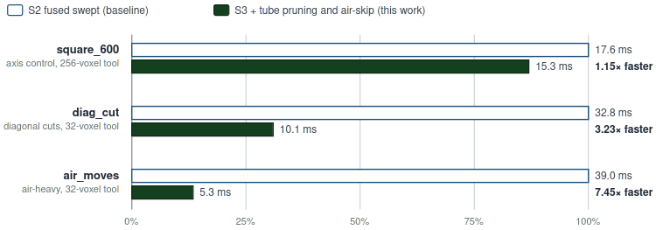
Fig. 7 Tube pruning on the stress benchmarks, normalized to the fused S2 baseline; shorter is faster. Net carving time, Intel Lunar Lake / iris, mean of ten campaigns (§5.4), byte-identical output. S3 wins large on diagonal cutting (diag_cut) and in-air work (air_moves); the axis-aligned control (square_600) barely moves - 1.15× here (Table 2), because with the 256-voxel tool the dispatch bounding box already nearly matches the swept band. Mean of ten campaigns ± sd (§5.4)
Table 2 gives the four-level end-to-end ablation on the axis-aligned control, from the naive stamper (S0) through the two established swept baselines (S1, S2) to this work's pruned kernel (S3), in net carving and in total wall time including read-back.
Table 2 Four-level ablation on the control (square_600, mill_10): net carving and total time including read-back, mean of ten interleaved campaigns ± population sd (§5.4). S1–S3 are byte-identical; S0 is a coarse, differently-sampled reference, not a geometric ground truth (§4.6). Overall S0→S3 is 34.2 ± 0.7× in net carving (17.1 ± 0.3× including read-back), and the fusion step S1→S2 is 1.54 ± 0.03×. Pruning on this axis-aligned control (S2→S3) is a modest 1.15 ± 0.02× as measured inside the sweep, rising to 1.25 ± 0.01× in a standalone high-N run (N = 30 per campaign) that removes the clock recovery the long S0 stage affords between swept runs (§5.4).
Level | Net carving (ms) | Total incl. read-back (ms)
S0 - per-step stamping [1] | 522.3 ± 2.6 | 549.5 ± 2.0
S1 - swept, external buffer [2–4] | 27.1 ± 0.6 | 46.4 ± 1.1
S2 - swept, fused in place (this work) | 17.6 ± 0.4 | 34.4 ± 0.7
S3 - + tube pruning + air-skip (this work) | 15.3 ± 0.3 | 32.2 ± 0.6

Overall S0→S3 is 34.2× in net carving (17.1× with read-back). The pruning of §3.6 is applied on top of the S2 swept baseline. Because Table 2 uses square_600 with the larger mill_10 tool, its absolute milliseconds differ from the mill_3 net-carving figures in Tables 1 and 3; the comparison of interest is always within a table, on one binary and hardware.

6.1 Cross-workload matrix: established methods vs. this work
Table 1 isolates the pruning lever on two diagonal stress programs; to separate what a known method already buys from this work’s contributions across realistic work, we ran a suite of machining workloads that stress different axes at four refinement levels, all on the same binary, representation and GPU - apples-to-apples. We deliberately do not quote other authors’ absolute timings (meaningless across hardware, representation, tool and resolution); each level is our fair, optimized implementation of the corresponding algorithm class, anchored to the literature it represents:
- S0, per-step stamping: the classic z-map/dexel display method (Van Hook 1986 [1]); the tool is stamped at fixed jog steps along each segment (--legacy, default step 2 voxels - the setting a display-oriented stamper would realistically use). S0 is a timing and behavioural reference, not a geometric ground truth (§4.6).
- S1, swept, external buffer: the straightforward per-move swept implementation (the multi-/tri-dexel class; Müller & Surmann 2003 [2]; Tukora & Szalay 2012 [3]; Inui et al. 2019 [4]) - the swept volume is materialized in a separate full-size buffer and then subtracted (--legacy-external-buffer).
- S2, swept, fused in-place: this work’s fusion - the swept-tool column is computed on the fly as a Z-envelope and subtracted in place in the resident buffer, with no intermediate swept-volume buffer (§3.3; SWEPT_SKIP=0).
- S3, + tube pruning + in-air skip: this work's traffic pruning on top of S2 (§3.6).
The design decision the paper claims - fuse the subtraction rather than materialize the swept volume - is thus isolated as a single measured step, S1→S2. The three swept levels (S1–S3) are byte-identical to one another; S0 is a timing and behavioural reference, not a geometric ground truth (§4.6).
Table 3 Net carving time (ms) per machining workload and refinement level (32-voxel tool; mean of ten interleaved campaigns ± population sd, cross-campaign CV ≤ 6% (§5.4), Intel iris; swept levels byte-identical, S0 a coarse reference not a ground truth). S1→S2 is the fusion / no-external-buffer gain (this work); S2→S3 is pruning (this work); S0→S3 is overall.
Workload (what it stresses) | S0 | S1 | S2 | S3 | S1→S2 | S2→S3 | S0→S3
what the level is | stamping | swept, ext. buffer | swept, fused | + prune + air-skip | (fusion) | (prune)
attribution | Van Hook [1] | straightforward swept [2–4] | this work | this work
contour - axis-aligned perimeter | 51.47 | 10.00 | 4.01 | 4.08 | 2.49× | 0.99× | 12.6×
pocket_axis - axis-aligned raster | 151.22 | 17.81 | 8.76 | 9.25 | 2.03× | 0.95× | 16.4×
raster45 - 45° diagonal raster | 264.75 | 43.88 | 35.59 | 14.79 | 1.23× | 2.41× | 17.9×
rapids - scattered cuts, long air moves | 81.00 | 17.41 | 12.76 | 6.63 | 1.37× | 1.93× | 12.2×
localized - small corner feature | 39.00 | 13.46 | 5.77 | 4.92 | 2.34× | 1.18× | 7.9×
finishing - fine-stepover axis-aligned raster | 111.57 | 15.36 | 7.60 | 8.18 | 2.02× | 0.93× | 13.7×

Two of the levels are established, two are ours. S0→S1 (≈2.9-8.5×) is the per-move swept formulation over per-step stamping - what the known methods already deliver. S1→S2 (≈1.2–2.5×, geomean ≈1.85×) is this work’s fusion: computing the swept envelope on the fly and subtracting it in place, rather than writing it to a separate buffer and subtracting in a second pass, is a consistent speed win and removes a full-size resident buffer (§6.3) - the gain is largest where the carve is otherwise cheap (the fixed cost of the extra pass and buffer round-trip dominates) and smallest on the big diagonal raster. S2→S3 is this work’s tube pruning, workload-dependent by construction: it removes the over-dispatch of non-axis-aligned segments (45° raster 2.41×) and in-air rapids (1.93×), and on axis-aligned programs it costs at most ≈8 % (contour 0.99×, pocket_axis 0.95×, finishing 0.93×) - the price of the per-column branch on dense rasters where every column is active and the AABB already equals the swept band. Fusion (S1→S2) and pruning (S2→S3) are complementary - the first always pays, the second pays where the dispatch over-covers. Reproducible via tools/bench_matrix.sh.
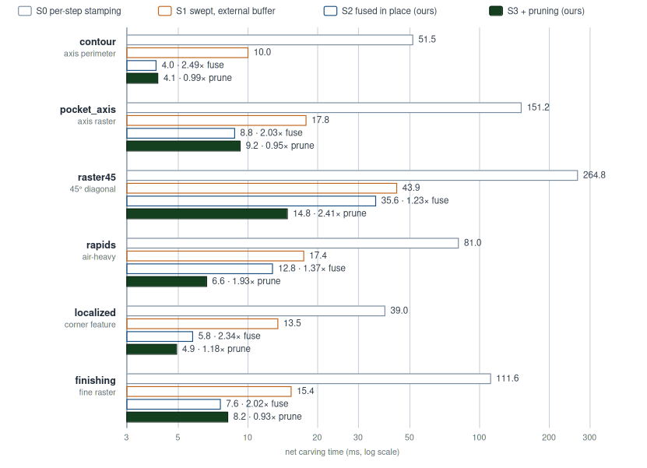
Fig. 8 Net carving time per machining workload and refinement level (log scale). S0→S1 is the established per-move swept method; S1→S2 is this work’s fusion - the swept volume computed on the fly and subtracted in place instead of via a separate buffer (≈1.2-2.5×, and it halves resident memory); S2→S3 is this work’s tube-pruning + in-air skip, which pays where the dispatch over-covers (45° raster 2.41×, air-heavy 1.93×)

6.2 Working-set: a sparse tiled study
The 128 MB flat buffer is ~16× padding (MAX_TRANSITIONS = 32 vs. 2 to 4 real transitions per column). A full alternative backend (CARVE_BACKEND=sparse) stores the stock in 32×32-column tiles, keeping untouched tiles UNIFORM (O(1)) and materializing a tile only when a segment’s bounding box first touches it - byte-identical to the flat backend, runtime-selectable. It isolates two effects. (i) Per-carve bandwidth is bounded by the swept bounding box, not the buffer size (both backends touch only the bbox columns), so tiling does not reduce the carve’s traffic volume; it only improves access locality (the strided-access problem) → ~1.1× (square_600 1.09×, raster45 1.11×, pocket_axis 1.15×). (ii) Footprint is a conditional win tied to locality - a localized program materializes 49-56 / 1024 tiles (8 MB vs. 122 MB, ~15×), whereas whole-stock machining touches most tiles (raster45 736 / 1024, no saving). So sparse tiling is a memory/scale lever (finer resolutions, larger stocks, smaller read-back for localized work), not a carve-speed lever; host-side materialization even makes whole-stock programs slower.

6.3 Memory and data movement across the four levels
Speed is only half the story: each step also shrinks what the GPU must hold and move. Table 4 consolidates the footprint and data-movement figures introduced piecemeal above (§3.3, §3.5, §6.2) for the reference stock.
Table 4 Resident footprint and data movement, per level (reference stock)
 | Naive stamping | Swept, external buffer (S1) | Fused in place (S2) | + pruning (S3)
Material-to-remove | tool stamped every jog step | materialized - swept volume written to a buffer | none - O(1) Z-envelope per column, on the fly | same as S2
Resident working set | 128 MB flat | 256 MB - 128 MB stock + a 128 MB swept twin | 128 MB (no twin) | 8 MB sparse for localized work (~15×), else 128 MB
Result assembly | separate output + per-step 12 MB stock copy | second pass reads the twin, subtracts | in place in the one working buffer | same as S2
Read-back transfer | 128 MB unpacked | 8 MB GPU-compacted | 8 MB GPU-compacted (~16×) | same as S2
Per-carve write traffic | whole grid, full footprint | swept-AABB columns, twice (write twin + subtract) | swept-AABB columns, once | swept tube only - off-band / off-Z columns skipped

The fusion (S1→S2) is a memory decision as much as a speed one: the external-buffer baseline needs a full-size 128 MB twin of the working buffer to hold the materialized swept volume (2× resident), and round-trips the envelope through it, whereas the fused kernel keeps only an O(1) per-column envelope in registers - so it halves resident memory while also running 1.2–2.5× faster across the matrix, geomean ≈1.85× (§6.1), and 1.54× on the control (Table 2). The memory wins up to S2 are unconditional (in-place single buffer, no per-step 12 MB stock copy, 8 MB compacted read-back); S3 adds a conditional footprint win tied to spatial locality (§6.2) and a write-traffic reduction tied to non-axis-aligned and in-air motion (§6.1). No step trades memory for speed: the two move together, because the simulator is bandwidth-bound (§7).

6.4 Dead write-back on active columns
Every processed column writes its full MAX_TRANSITIONS-slot stride: writeCount real transitions, then zeros to the end (§4.4). Occupancy reads only the first obj1_dataNum[col] slots, so those zeros are dead - a typical active column has 2–4 transitions, i.e. ~8 useful bytes of the 128 written. Dropping the zero-fill (SWEPT_ZEROFILL=0) is byte-identical (verified by a .bin diff over the whole suite) and removes that dead traffic on active columns, the complement of tube pruning, which removes traffic on inactive ones.
On the fused kernel (pruning off) it removes real write traffic. Table 5 gives one interleaved session with three configurations side by side, so every comparison below can be checked against it directly.
Table 5 The zero-fill lever and the best available configuration, from one interleaved loop within the campaign (32-voxel tool, net carving ms, mean of ten campaigns ± sd, §5.4). Absolute times differ from Tables 2–3 because this loop interleaves only cheap swept configs, so the GPU stays in a hotter clock state (§5.4); the comparisons of interest are within this table. The two S2 columns are byte-identical (verified by a .bin diff). The pruned kernel without zero-fill was measured in the same campaign and is discussed in the text.
Workload | S2 (zero-fill) | S2 (no fill) | S3 (default)
contour | 7.32 ± 0.18 | 6.76 ± 0.22 | 6.57 ± 0.21
pocket_axis | 18.30 ± 0.50 | 15.68 ± 0.53 | 17.63 ± 0.35
finishing | 15.38 ± 0.42 | 13.04 ± 0.25 | 14.94 ± 0.37
raster45 | 43.86 ± 1.05 | 34.05 ± 0.87 | 18.70 ± 0.54
rapids | 27.09 ± 0.79 | 24.16 ± 0.73 | 15.72 ± 0.51
localized | 6.99 ± 0.21 | 6.46 ± 0.14 | 5.40 ± 0.25

Dropping the zero-fill (columns one to two) is faster on every workload, from 7.6 % on the small localized program to 22 % on the 45° raster; the reduction is largest and most stable on the dense rasters (finishing and raster45, 15–22%), where the active columns, and so the dead-write traffic, are most numerous. It is byte-identical, and it acts on active columns - the complement of tube pruning’s inactive-column saving (§7). It is the active-column lever the paper otherwise lacked, and it reaches the axis-aligned case (finishing) where pruning is neutral-to-negative (§6.1).
Columns two and three weigh the no-fill fused kernel against the shipped pruned default. On axis-aligned work the two are close: finishing is 15% faster without pruning, while contour and pocket_axis fall within about 12% either way (contour favours the pruned default, pocket_axis the no-fill kernel). On non-axis-aligned and air-heavy work the default is far ahead (1.8× on the 45° raster, 1.5× on the rapids). So the pruned default is the right all-rounder, the no-fill fused kernel is competitive only on dense axial work, and both are runtime-selectable.
Removing the zero-fill on the pruned kernel itself splits by workload, exactly as the complementarity of §7 predicts. Where pruning has already removed the off-band columns, on the diagonal and air-heavy programs, little dead-write traffic remains and dropping the zero-fill is now slightly counterproductive: raster45 and rapids both slow by about 3.5 %, a small but reproducible regression consistent with the partial-stride read-modify-write of §7. Where pruning finds nothing to skip, on the dense axis-aligned rasters, the active columns and their dead writes persist and removing the zero-fill still pays about 15 % (pocket_axis and finishing). We keep the zero-fill on by default and expose its removal as a toggle.

7. Discussion
The bottleneck is memory-write bandwidth. A design A/B and a series of experiments, read together, localize it:
- Fusion vs. an external buffer (positive, §6.1). Materializing the swept volume in a separate full-size buffer and subtracting it in a second pass round-trips the envelope through memory (write the twin, read it back) and doubles the resident set. Fusing the two - envelope on the fly, subtracted in place - removes that traffic and the twin, for a geomean ≈1.85× and half the memory. Removing memory traffic pays; the swept-envelope compute is identical in both, and it is not where the time goes.
- Range-query envelopes (negative). Precomputing per-tool directional Z-envelopes as range-minimum/maximum sparse tables makes the per-column envelope an O(1) query instead of an O(sub-steps) loop. Implemented exactly, it gave a modest gain that did not justify the added structure, because it optimized compute, which is not the bottleneck, and was reverted.
- Tube pruning (positive, §3.6). Skipping the write-back of off-band and out-of-Z-range columns attacks memory-write traffic and gives 3.2–7.4× in its regime (stress benchmarks, Table 1). This is the complement of the previous result: the lever that pays removes memory traffic, not compute.
- Dead-write elimination (positive on the fused kernel, §6.4). The trailing zero-fill of unused column slots is dead write traffic (~30 of 32 slots on a typical column). Dropping it is byte-identical and gives 8–22% on the fused kernel - the active-column counterpart to tube pruning’s inactive-column saving, and the one lever that reaches the axis-aligned case where pruning does nothing. It confirms the write-traffic diagnosis from the opposite side. The two do not add: they reduce traffic to the same buffer on complementary column sets, so once pruning has thinned the active set the remaining dead-write traffic is small and its removal drops into the noise (§6.4).
- Oriented tiled dispatch (negative). Tempted to also avoid launching the off-band threads (each still does a counter read plus the early-out), we tiled the dispatch along the motion so it follows the band. Each tile reuses the full-segment envelope uniforms (so every column is computed identically); adjacent tiles overlap idempotently, separated by a barrier - keeping it byte-identical. The result was measurably slower than tube pruning alone: the per-tile barriers serialize the tiles and the joins double-process columns, and that synchronization cost exceeds the thread-launch saving, because tube pruning already made the off-band threads cheap (a read, no write). Reverted. Neither branch survives in the current build, so neither is measured on the benchmark set of §5.2 and neither appears in the tables; we report the direction of both results, which is what the diagnosis rests on, rather than figures from a configuration a reader could not reproduce.
- Sparse tiled working-set (footprint, not speed; §6.2). A tiled backend that keeps untouched tiles UNIFORM shrinks the working set to the touched fraction, but the per-carve traffic is bounded by the swept bounding box in either layout, so it only improves access locality (~1.1×) and reduces footprint conditionally on locality (~15× localized, nothing whole-stock). Working-set size is a memory/scale lever, not a bandwidth one.
The pattern is consistent - a map of the bottleneck. Attacking compute (RMQ), launched-thread count (tiled dispatch) or working-set size (sparse tiling) yields diminishing, negative or footprint-only returns; the levers that pay all remove memory-write traffic on the over-dispatched bounding box - fusing away the swept-volume round-trip (S1→S2, always), tube pruning the off-band/off-Z write-back on inactive columns (S2→S3, where the dispatch over-covers), and dropping the dead zero-fill on active columns (§6.4, the fused kernel). The granularity that matters is the cache line: a column’s 128-byte stride is two 64-byte lines, and a full-stride store writes both with no read, so the payoff is in not touching a line - pruning skips both, the dead-write removal skips the second. That is also why pruning and dead-write removal overlap rather than add (same buffer, complementary columns), and why a partial store that still touches the first line by read-modify-write can fail to pay. The simulator is bbox-bandwidth-bound, at cache-line granularity: the productive optimization removes bbox lines touched. A dispatch-enqueue cost that stays ~0.4 ms whether a program has 9 or 202 segments corroborates that per-segment host overhead is not the limit.
Portability and the roofline argument. All measurements here are on one integrated GPU, which invites the question of whether the findings are hardware-specific. They are not, and the reason is structural rather than empirical. The per-column merge moves on the order of 128-256 bytes per active column - it rewrites all MAX_TRANSITIONS = 32 slots and reads a comparable number - while performing only a few integer comparisons per 4-byte transition: an arithmetic intensity well below 1 op/byte, one to three orders of magnitude under the ridge point of any modern GPU roofline. A kernel this far into the memory-bound regime is memory-bound on every GPU; and because discrete NVIDIA parts carry a higher compute-to-bandwidth ratio than an integrated Intel GPU, the diagnosis becomes more true there, not less. The load-bearing claims are therefore architecture-invariant: the representation, the exactness argument, the “carving is a memory-movement problem” thesis, and the geometric workload dependence of tube pruning (a function of the AABB-to-swept-band ratio, not the silicon) all transfer unchanged. The pipeline also uses only portable compute primitives (SSBOs, std430, dispatch, a storage barrier) - no subgroup intrinsics, tensor or ray-tracing cores - so a Vulkan or CUDA port is a direct transliteration of the same kernel.
A faster or discrete GPU changes magnitudes, not directions. Absolute carve times fall with bandwidth while the kernel stays bandwidth-bound; the fusion and pruning ratios shift because their fixed components (an extra pass and a barrier for fusion; a per-column branch for pruning) scale differently from the traffic they save - the fusion win is already largest where the carve is cheapest, and that fixed-cost fraction only grows as traffic gets faster. One optimization would become more valuable off the iGPU: the GPU-side read-back compaction (128 MB → 8 MB), because on a discrete card the read-back crosses PCIe (~16-32 GB/s), where the full unpacked buffer alone would cost several milliseconds.
Three caveats are genuinely API-, occupancy- or driver-specific and would warrant re-measurement. First, the oriented tiled dispatch negative result is partly a statement about OpenGL's coarse glMemoryBarrier and dispatch model: CUDA and Vulkan expose finer synchronization (timeline semaphores, cooperative groups, persistent kernels, dynamic parallelism) that could avoid the barrier serialization that sank it, so that reverted idea may be worth revisiting on those APIs. Second, the per-thread localOut[64] scratch (256 B) and the branchy sub-step loop interact with the register file and 32-wide warps: register spilling or warp divergence could move the fine ratios, and the large L2 caches of recent discrete GPUs (tens of MB) might hold more of the active bounding box, plausibly increasing the sparse-tiling locality benefit. Third, the sub-positions are computed in single precision and rounded to nearest, and GLSL leaves the tie-break at exact half-integers unspecified; a sample landing on or within an ulp of such a boundary can resolve to either neighbour on a different driver. This never moves a sample by more than one voxel and does not affect the byte-identity of S1, S2 and S3 on one machine, which is what §5.3 verifies, but byte-identity across drivers is not guaranteed. None of the three changes which lever breaks the ceiling; together they set the agenda for a cross-hardware study.
When tube pruning helps. The gain requires segment length L ≫ F. Axis-aligned programs, or diagonal programs machined with a tool nearly as wide as the segments are long, see little - their AABB already equals the tube. Real 3-axis programs, however, contain substantial air travel (rapids between features, retract/reposition links) and non-axis-aligned finishing toolpaths, all of which this optimization accelerates; the in-air pruning in particular applies to every rapid.
Limitations. The pipeline runs in voxel units. That is deliberate for the results reported here (§5.2), but it does mean that a real G-code program in millimetres is not yet consumed directly: the tool datum is the centre of the tool's bounding box, so the Z origin shifts with the modelled shank length and neither the tip radius nor the tool length is compensated. A calibrated millimetre mapping with an explicit tool datum is future work. The envelope over-removes for non-convex-in-Z tools, and the flat-buffer stride MAX_TRANSITIONS = 32 is not overflow-guarded, though detection would be near-free to add (§4.2). The tool is axis-fixed (3-axis only). Arcs are handled only as polylines, so a segment count that grows with the chord tolerance is the price of curved paths; a native circular-swept envelope would be a natural extension. Against the continuously-swept cut the single-pass envelope is exact on axis-aligned moves and under-removes by 0.08 % on a 45° one, a gap that shrinks with the voxel size (§4.6). The path used when scoring a candidate toolpath is not itself optimized: the per-segment removal counter is an unreduced global atomic per active column on a single counter, plus two extra column scans, where a per-workgroup shared-memory reduction would be the obvious fix; it is disabled in all measurements reported here. That path is also where the largest remaining lever lies: a GPU-side objective, comparing carved-vs-target on the GPU, would remove the per-iteration read-back entirely.

8. Conclusions
We presented a GPU material-removal simulator for 3-axis milling built on a single-axis dexel field, in which Boolean difference is a per-column merge that maps one workpiece column to one GPU thread. On top of a fused, materialization-free swept-segment subtraction, we introduced tube pruning - skipping the write-back for columns the swept tool never touches - which is byte-identical and yields 3.2–7.4× (stress benchmarks, Table 1) on the diagonal and air-heavy work that dominates real toolpaths, with an axis-aligned effect that depends on the program and tool (a gain when whole rapids are air-skipped or a large-tool AABB overhangs the band, a modest cost on dense rasters where every column is active). The optimization, two documented negative results bracketing it, and a third positive one that removes the dead per-column write-back on active columns, together show that in this setting the decisive resource is memory-write bandwidth: the successful levers remove bytes written, not arithmetic or launched threads. The simulator is fast enough, and accurate against the continuously-swept cut - exactly so on axis-aligned moves and to within 0.08 % on diagonals (§4.6) - to serve as a drop-in accelerator wherever repeated carving simulation is the bottleneck, from interactive toolpath verification to cutting-force models and search- or learning-based toolpath optimization.

Appendix A. Terminology
Term | Meaning in this paper
Voxel | A cell of the regular 3-D grid; solid or empty.
Dexel | “Depth element”: the run of solid voxels along one axis in a column.
Single-axis dexel field | The stock/tool stored as per-(x,y)-column Z-runs (our representation).
Column | One (x, y) stack of D voxels along Z.
Lattice (W × H × D) | The voxel grid: W×H columns, each D voxels deep (D = lattice depth, distinct from the footprint F).
Transition | A Z height where a column’s occupancy flips (empty↔solid).
Parity walk | Recovering occupancy by counting transitions ≤ z: odd ⇒ solid.
Stock / workpiece | The block being machined (obj1).
Tool | The cutter (obj2); here a ball-end mill (hemisphere + shank).
Footprint (F) | The tool's XY extent in voxels: a square of side F, since the tool is a solid of revolution about Z.
Segment | One straight toolpath move p0 → p1.
Swept volume | The region the tool sweeps over a segment (tool ⊕ p0p1).
Z-envelope | Per stock column, the single interval [min bottom, max top] of the swept tool.
Sub-step | One sampled tool-centre position along a segment.
Chebyshev length (K) | max(|Δx|,|Δy|,|Δz|); number of ≤1-voxel sub-steps.
AABB | Axis-aligned bounding box (of a segment’s endpoints, dilated by the footprint).
Swept band / tube | The columns the tool actually sweeps - a band along the motion.
Tube pruning | Skipping the write-back for columns outside the tube / stock Z-range.
Thread | One GPU work-item; here it processes one column.
Workgroup | A block of threads executed together (8×8 here).
Dispatch | A launch of a compute shader over a grid of workgroups.
gl_GlobalInvocationID | A thread’s global index within the dispatch grid.
SSBO | Shader Storage Buffer Object: a large GPU-resident array.
Memory barrier | A synchronization that orders dependent GPU memory accesses.
MAX_TRANSITIONS | Fixed per-column slot count (32) of the flat working buffer.
Byte-identical | Identical saved .bin files across the swept levels (S1–S3); a direct file diff. (We avoid “bit-exact”.)
Exact | Equal to stamping on the same Chebyshev sampling grid (§4.6) - a mathematical identity, not a file comparison.
Residual solid volume | Σ (top - bottom) over all columns’ solid intervals.
Net carving time | GPU carving-loop time, excluding read-back (measured with a glFinish).

Appendix B. Machining operation renders
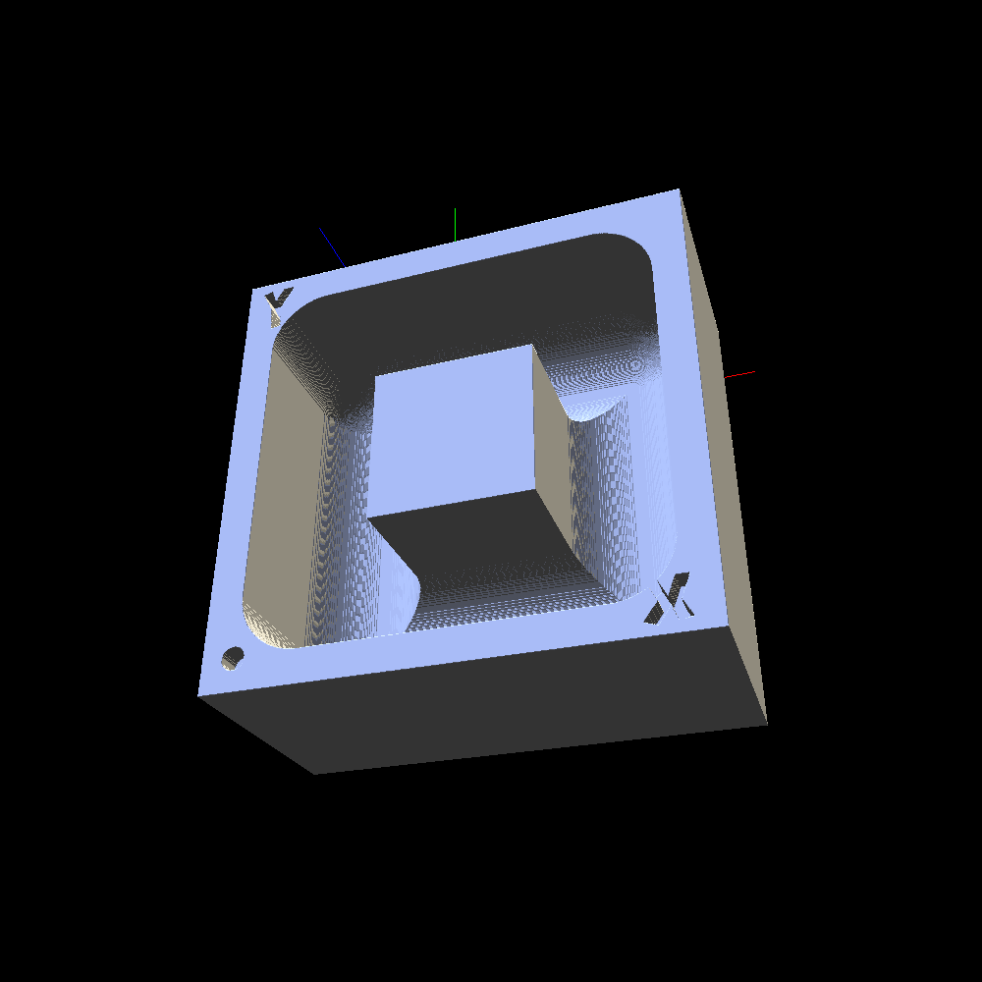 | 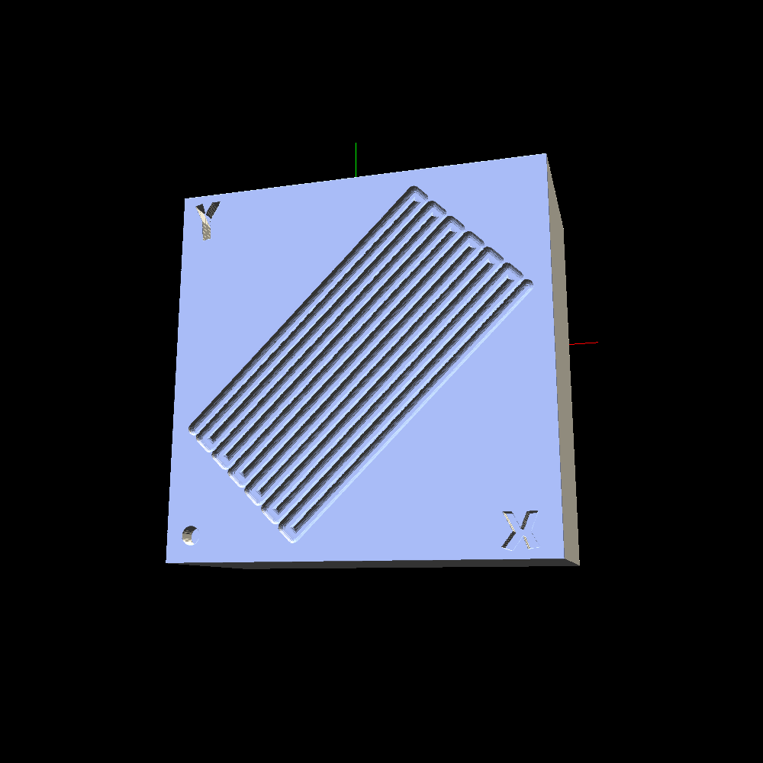 | 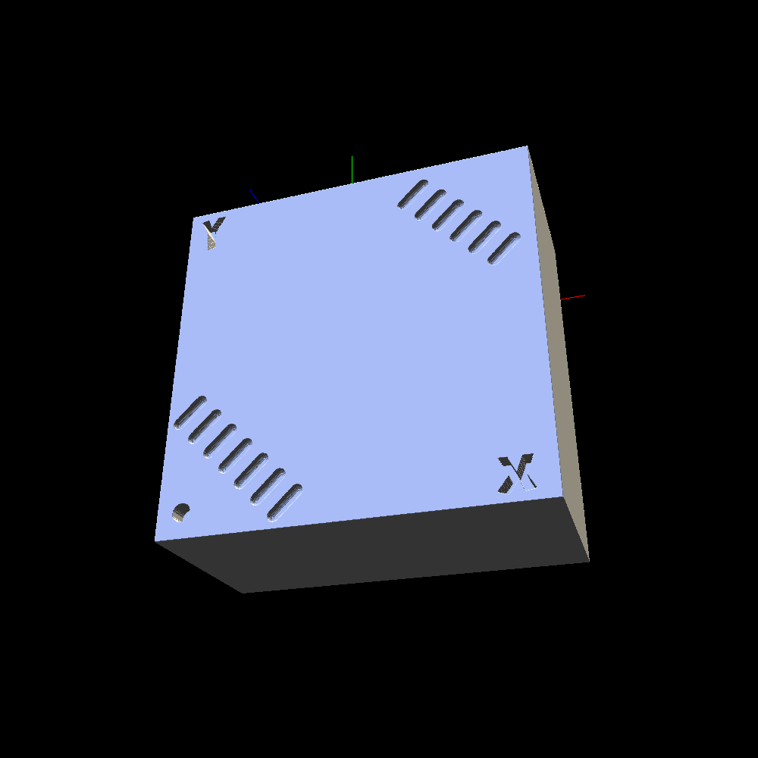
square_600.gcode | diagonal_cut.gcode | air_moves.gcode
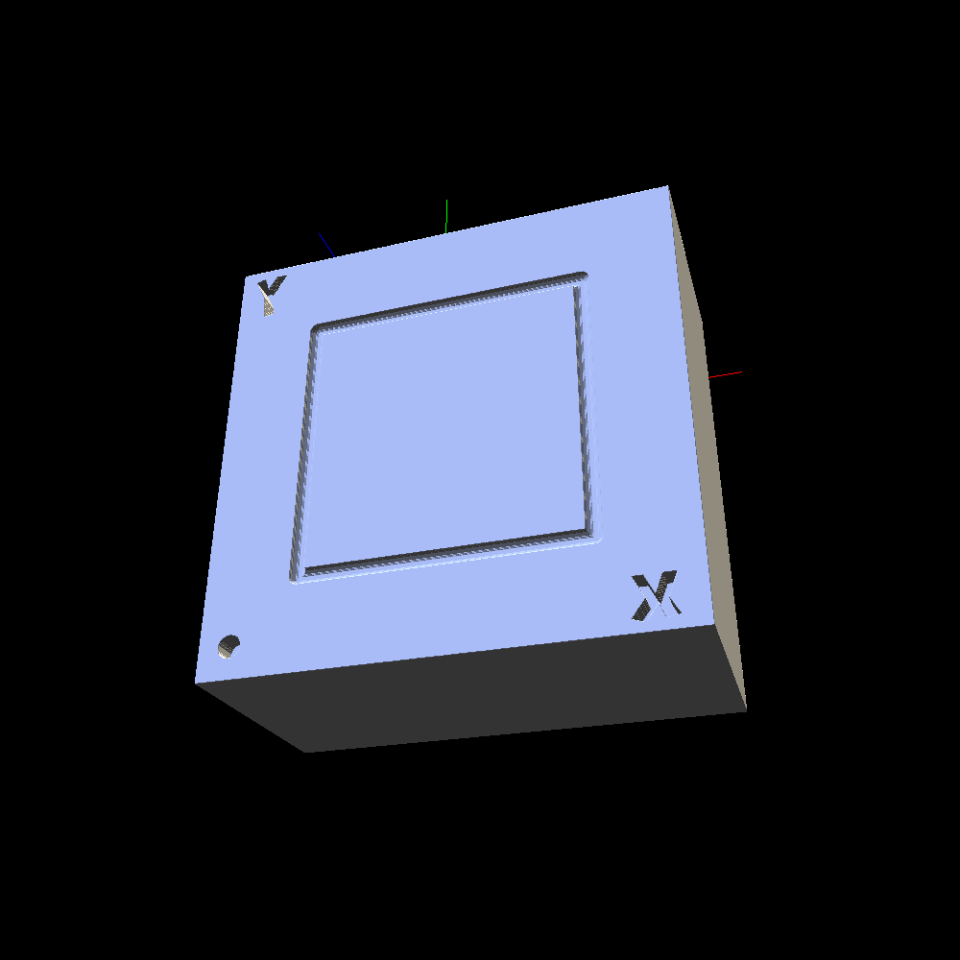 | 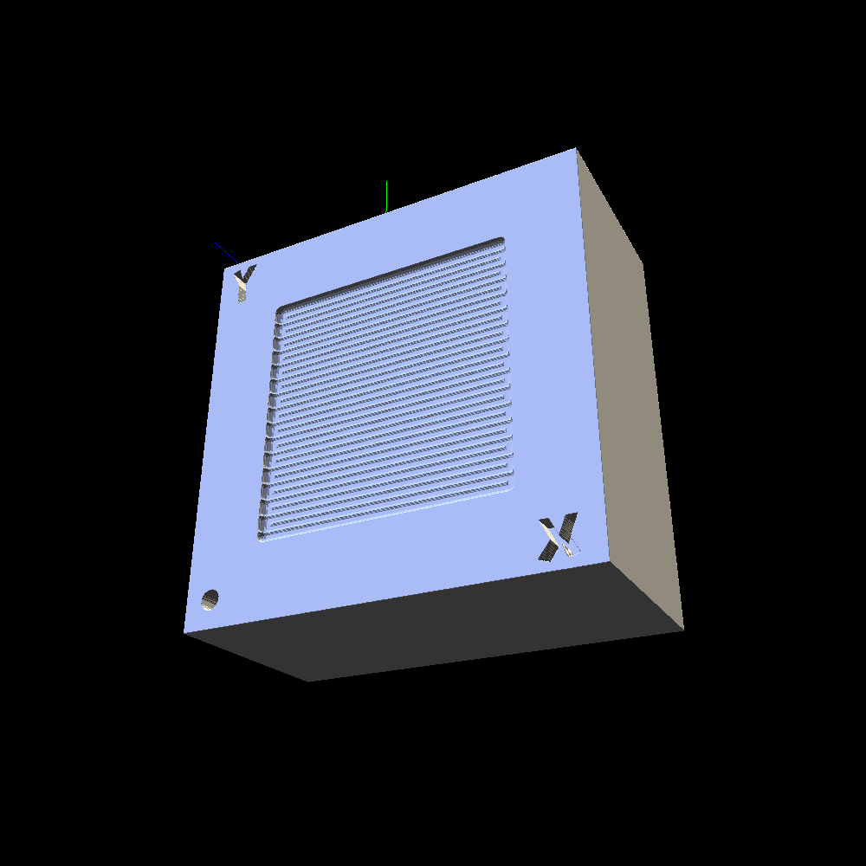 | 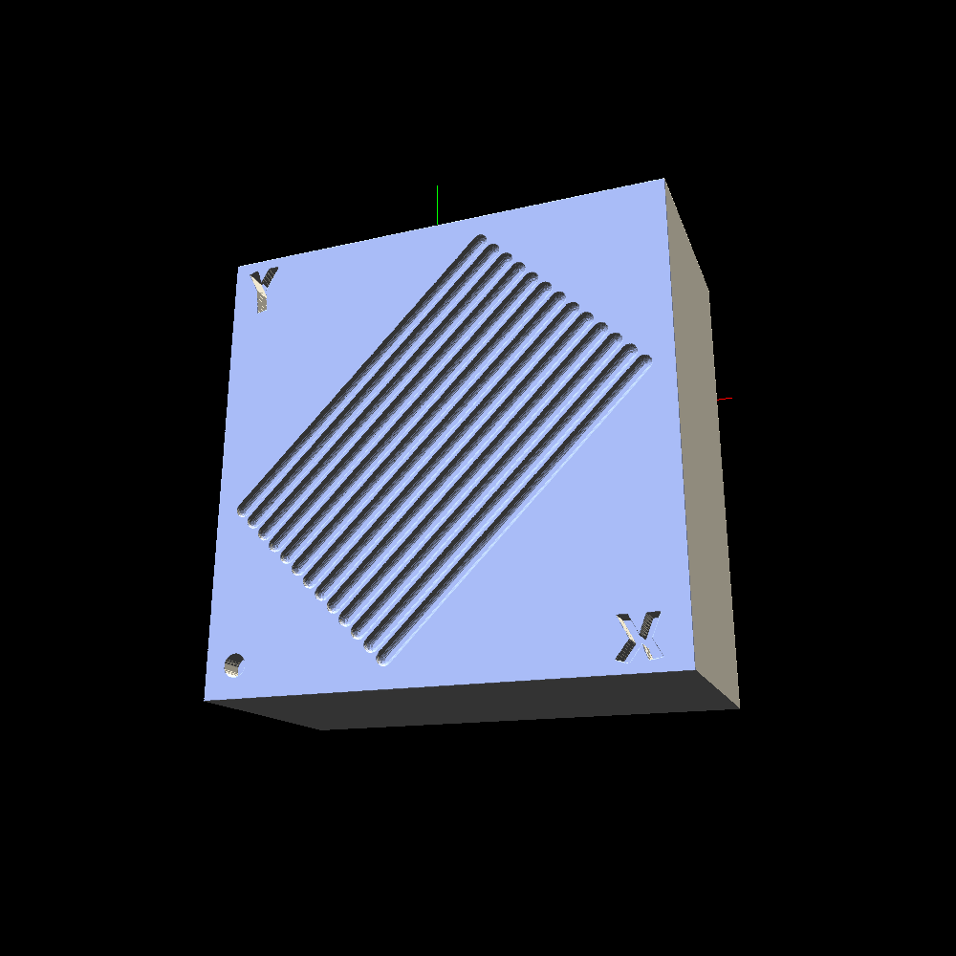
contour.gcode | pocket_axis.gcode | raster_45.gcode
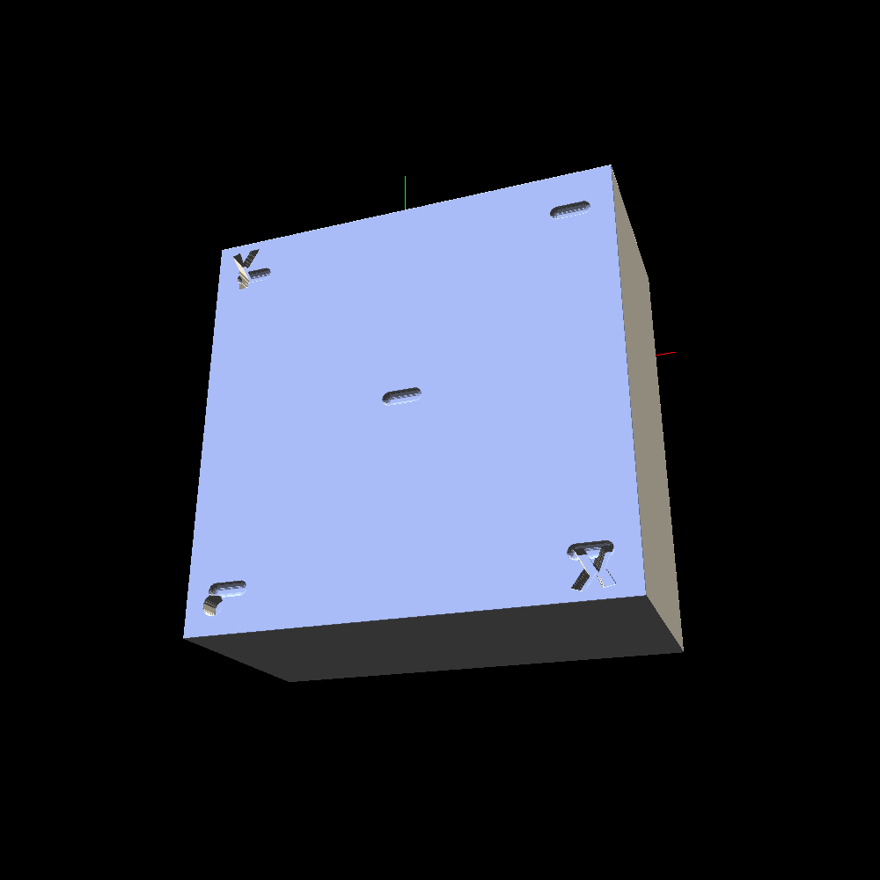 | 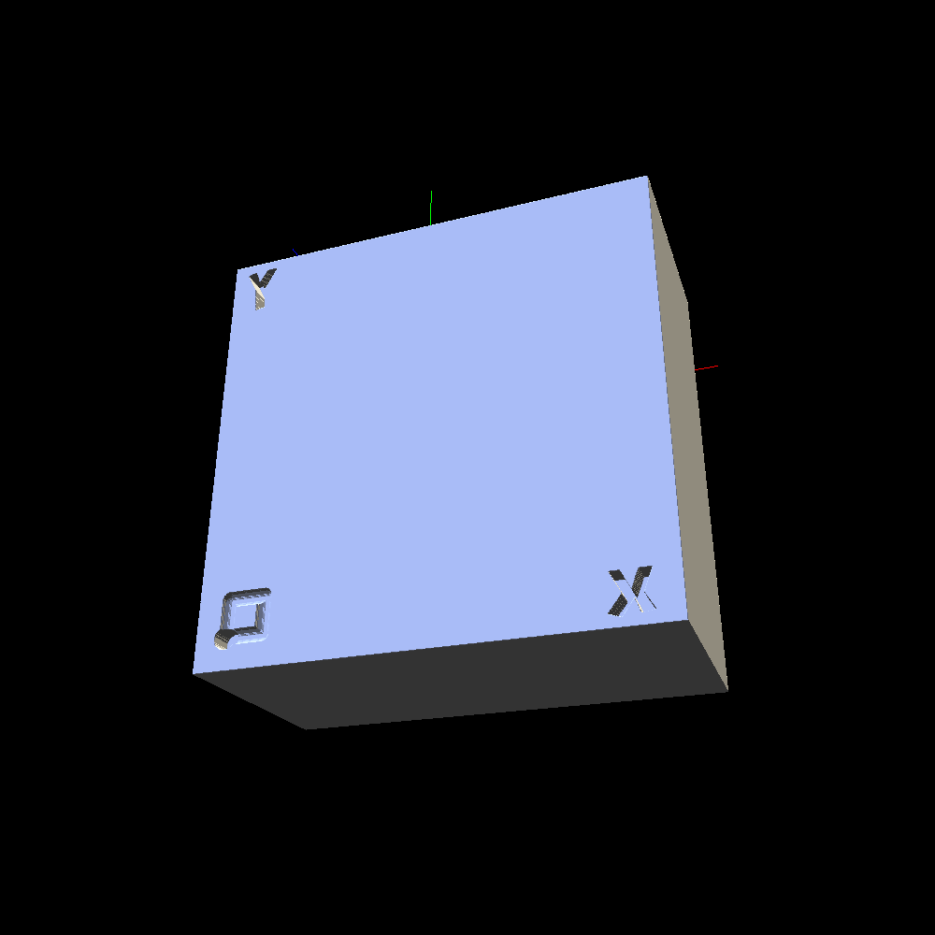 | 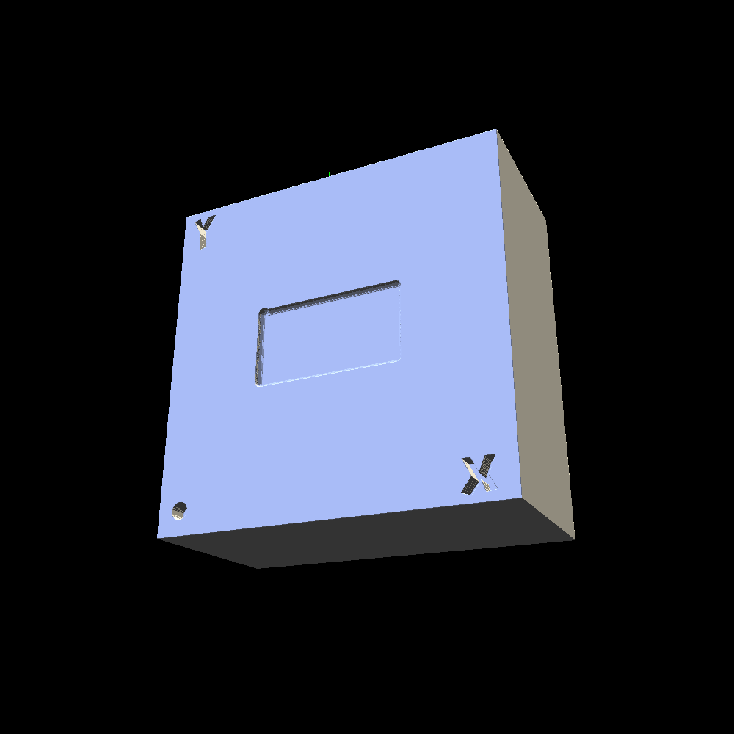
Rapids.gcode | localized.gcode | finishing.gcode

References
1. T. Van Hook. Real-time shaded NC milling display. Computer Graphics (Proc. SIGGRAPH ’86), 20(4):15-20, 1986.
2. H. Müller, T. Surmann, M. Stautner, F. Albersmann, K. Weinert. Online sculpting and visualization of multi-dexel volumes. Proc. 8th ACM Symposium on Solid Modeling and Applications (SM ’03), 258-261, 2003.
3. B. Tukora, T. Szalay. Multi-dexel based material removal simulation and cutting force prediction with the use of general-purpose graphics processing units. Advances in Engineering Software, 43(1):65-70, 2012.
4. M. Inui, M. Kobayashi, N. Umezu. Cutter engagement feature extraction using triple-dexel representation workpiece model and GPU parallel processing. Computer-Aided Design and Applications, 16(1):89-102, 2019.
5. C. C. L. Wang, Y.-S. Leung, Y. Chen. Solid modeling of polyhedral objects by Layered Depth-Normal Images on the GPU. Computer-Aided Design, 42(6):535-544, 2010.
6. D. Blackmore, M. C. Leu, L. P. Wang. The sweep-envelope differential equation algorithm and its application to NC machining verification. Computer-Aided Design, 29(9):629-637, 1997.
7. K. Abdel-Malek, J. Yang, D. Blackmore, K. Joy. Swept volumes: foundation, perspectives, and applications. International Journal of Shape Modeling, 12(1):87-127, 2006.
8. W. E. Lorensen, H. E. Cline. Marching cubes: a high resolution 3D surface construction algorithm. Computer Graphics (Proc. SIGGRAPH ’87), 21(4):163-169, 1987.
9. C. Dyken, G. Ziegler, C. Theobalt, H.-P. Seidel. High-speed marching cubes using HistoPyramids. Computer Graphics Forum, 27(8):2028-2039, 2008.
10. Y. Boz, H. Erdim, I. Lazoglu. A comparison of solid model and three-orthogonal dexelfield methods for cutter-workpiece engagement calculations in three- and five-axis virtual milling. The International Journal of Advanced Manufacturing Technology, 81(5-8):811-823, 2015. https://doi.org/10.1007/s00170-015-7251-7
11. Y. Altintas, P. Kersting, D. Biermann, E. Budak, B. Denkena, I. Lazoglu. Virtual process systems for part machining operations. CIRP Annals, 63(2):585-605, 2014. https://doi.org/10.1016/j.cirp.2014.05.007
12. X. Cao, G. Zhao, W. Xiao. Digital Twin-oriented real-time cutting simulation for intelligent computer numerical control machining. Proceedings of the Institution of Mechanical Engineers, Part B: Journal of Engineering Manufacture, 236(1-2):5-15, 2022. https://doi.org/10.1177/0954405420937869
13. H. Erdim, I. Lazoglu, B. Ozturk. Feedrate scheduling strategies for free-form surfaces. International Journal of Machine Tools and Manufacture, 46(7-8):747-757, 2006. https://doi.org/10.1016/j.ijmachtools.2005.07.036
14. W. Li, B. Li, S. He, X. Mao, C. Qiu, Y. Qiu, X. Tan. A novel milling parameter optimization method based on improved deep reinforcement learning considering machining cost. Journal of Manufacturing Processes, 84:1362-1375, 2022. https://doi.org/10.1016/j.jmapro.2022.11.015
15. Y. Zhang, X. Xu, Y. Liu. Numerical control machining simulation: a comprehensive survey. International Journal of Computer Integrated Manufacturing, 24(7):593-609, 2011. https://doi.org/10.1080/0951192X.2011.566283

Declarations
Funding
The authors declare that no funds, grants, or other support were received during the preparation of this manuscript.
Competing interests
The authors have no relevant financial or non-financial interests to disclose.
Code and data availability
The simulator, the benchmark G-code programs, the voxelised tool models and the scripts that reproduce every table in this paper are openly available at https://github.com/nik71b14/autocam. The analytic continuum reference of §4.6 is included as a standalone script with no dependency on the GPU code path.
Author contributions
[to be completed]

