Water Droplets Simulation using Metaballs and Lennard-Jones force field

Blender 2.77a Tutorials

Author | Nik Mohamad Aizuddin Nik Azmi
Email | nik-mohamad-aizuddin@yandex.com
Date Created | 22. Aug. 2016
Last Modified | 23. Aug. 2016

Document Revision History
Rev# | Date | Comments
2 | 23. Aug. 2016 | Completed draft.

Table of Contents
1)Start with an empty scene 4
2)Create two metaballs 5
2.1)Create Mball 5
2.2)Create Mball.001 6
3)Create Plane 7
3.1)Set Plane rotation and scale 7
3.2)Create wdrop_small_static particle system 8
3.3)Set the wdrop_small_static particle system 9
3.4)Create particle collision on the Plane 12
4)Create DynamicWdrop_Emitter Plane 13
4.1)Set DynamicWdrop_Emitter location and scale 13
4.2)Create wdrop_large_dynamic particle system 14
4.3)Set the wdrop_large_dynamic particle system 14
5)Assign materials to Plane and DynamicWdrop_Emitter (optional) 18
5.1)Material properties for Plane 18
5.2)Material properties for DynamicWdrop_Large_Emitter 18
5.3)Material properties for Mball 18
6)Simulate the water droplets 19
6.1)Bake All Dynamics 19

List of Figures
Figure 1: Empty scene 4
Figure 2: Start Frame, End Frame, and FPS settings 4
Figure 3: How to Create Metaballs 5
Figure 4: Mball 5
Figure 5: Mball.001 6
Figure 6: How to Create Plane 7
Figure 7: Plane 7
Figure 8: Plane Attribute 7
Figure 9: Create and name the particle system for the Plane 8
Figure 10: wdrop_small_static Particle Emission settings 9
Figure 11: wdrop_small_static Particle Cache settings 9
Figure 12: wdrop_small_static Particle Velocity settings 10
Figure 13: wdrop_small_static Particle Rotation settings 10
Figure 14: wdrop_small_static Particle Physics settings 10
Figure 15: wdrop_small_static Particle Render settings 11
Figure 16: wdrop_small_static Particle Field Weights settings 11
Figure 17: wdrop_small_static Particle Force Field Settings 11
Figure 18: Plane Particle Collision settings 12
Figure 19: The DynamicWdrop_Emitter Plane 13
Figure 20: DynamicWdrop_Emitter's Location and Scale 13
Figure 21: DynamicWdrop_Emitter's particle system name 14
Figure 22: wdrop_large_dynamic Particle Emission settings 14
Figure 23: wdrop_large_dynamic Particle Cache settings 15
Figure 24: wdrop_large_dynamic Particle Velocity Settings 15
Figure 25: wdrop_large_dynamic Particle Rotation settings 15
Figure 26: wdrop_large_dynamic Particle Physics settings 16
Figure 27: wdrop_large_dynamic Particle Render settings 16
Figure 28: wdrop_large_dynamic Particle Field Weights settings 17
Figure 29: wdrop_large_dynamic Particle Force Field settings 17
Figure 30: Assign Materials 18
Figure 31: Bake All Dynamics 19
Figure 32: The final result 19

Start with an empty scene
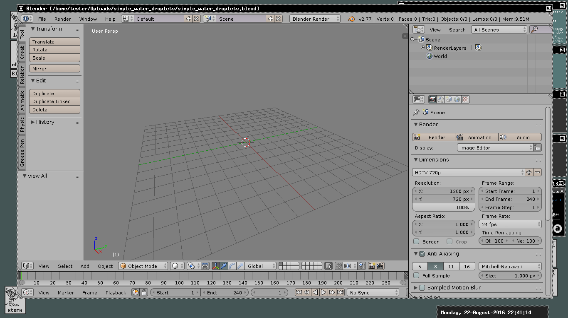Figure 1: Empty scene
We are going to create a 10 seconds water droplets simulation. However, this is just a trick, not a realistic simulation, so the simulation will not stable and will not always work as expected.
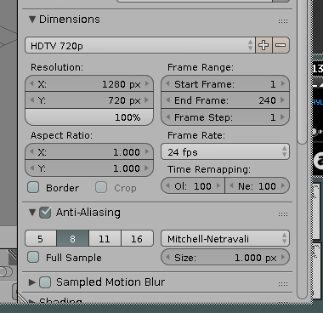Figure 2: Start Frame, End Frame, and FPS settings

Blender startup scene has a Cube, a Camera, and a Lamp. Delete those objects, they are not the required for this tutorial.

Set the Start Frame = 1, End Frame = 240, and Frame Rate = 24 FPS.

Create two metaballs
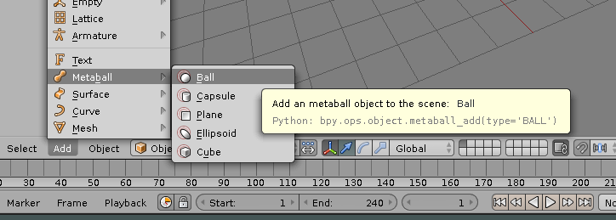Figure 3: How to Create Metaballs

Create Mball
- Click Add > Metaball > Ball
- Set Location to [10, 0, 0]
- Set Scale to [0.010, 0.010, 0.008]
- Set Mball View Resolution and Render Resolution to 0.6
- Set Mball Threshold to 1.4

CAUTION: Be careful when adjusting its Resolution and Threshold. Having a low Resolution value and at the same time low Threshold value will cause your system to crash. Because, for example, when Resolution to 0.6 and Threshold to 0.6, there will be 1 millions of polygons!
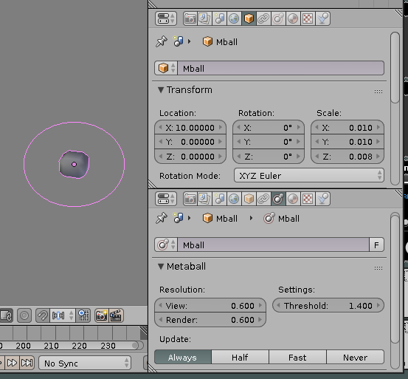Figure 4: Mball

Create Mball.001
- Click Add > Metaball > Ball
- Set Location = [11, 0, 0]
- Set Scale = [0.012, 0.030, 0.030]
- Set Mball View Resolution and Render Resolution = 0.6
- Set Mball Threshold = 1.4

NOTES: If you want to rename Mball to another name, make sure its partner has ".001" postfix. For example, MballA and MballA.001. If you renamed the Metaballs different with its partner name, for example MballA and MballB, they will not merge.

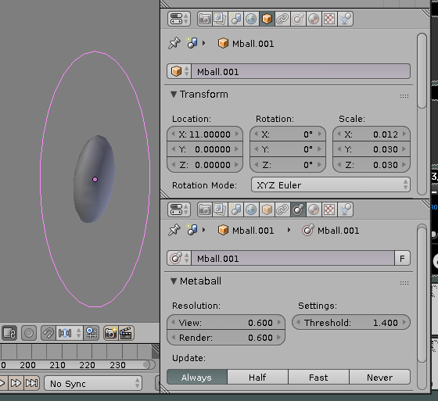Figure 5: Mball.001

Create Plane
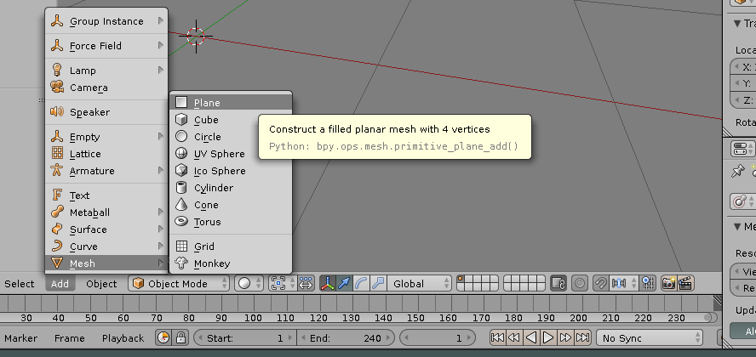Figure 6: How to Create Plane

Set Plane rotation and scale
- Add > Mesh > Plane
- Set Rotation to [45, 0, 0]
- Set Scale to [0.5, 1.0, 1.0]
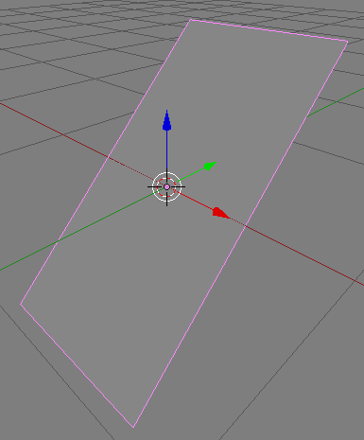Figure 7: Plane
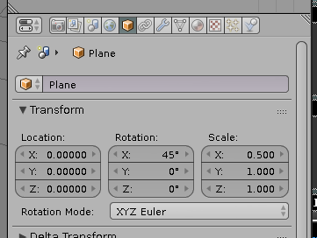Figure 8: Plane Attribute

Create wdrop_small_static particle system
- Goto Plane's Particle tab, and click New button. A particle system named "ParticleSystem" will appear.
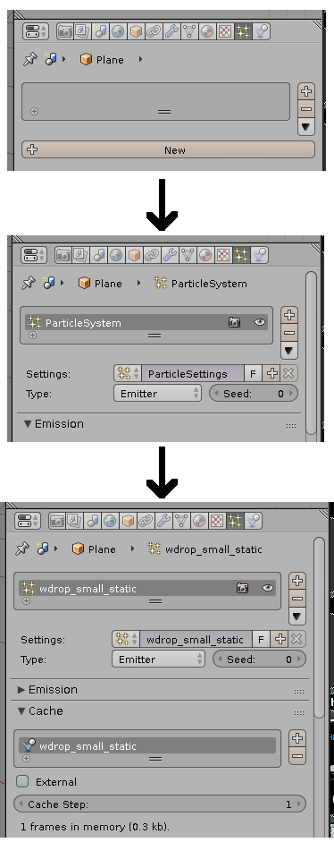Figure 9: Create and name the particle system for the Plane
- Rename the "ParticleSystem" and "ParticleSettings" to "wdrop_small_static". Also name the Cache name as "wdrop_small_static".

NOTES: The "wdrop_small_static" is stand for water droplets small and static. Static here means that these water droplets are not affected by the Gravity force.

Set the wdrop_small_static particle system
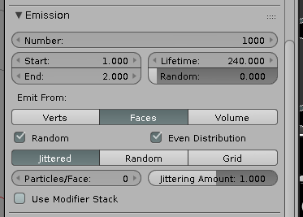Figure 10: wdrop_small_static Particle Emission settings
- Emission
  - Number = 1000
  - Start = 1
  - End = 2
  - Lifetime = 240
  - Random = 0

- Cache
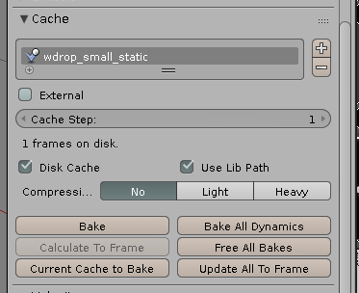Figure 11: wdrop_small_static Particle Cache settings
  - Disk Cache = Enabled

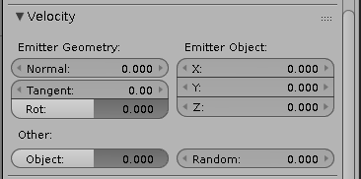Figure 12: wdrop_small_static Particle Velocity settings
- Velocity
  - Normal = 0

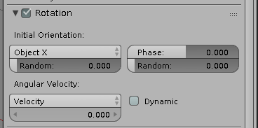Figure 13: wdrop_small_static Particle Rotation settings
- Rotation
  - Initial Orientation = Object X

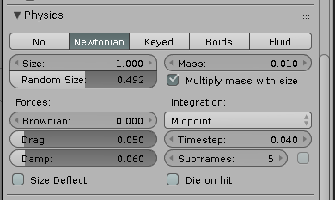Figure 14: wdrop_small_static Particle Physics settings
- Physics
  - Physics Type = Newtonian
  - Size = 1
  - Random Size = 0.492
  - Mass = 0.010
  - Multiply mass with size
  - Drag = 0.050
  - Damp = 0.060
  - Subframes = 5

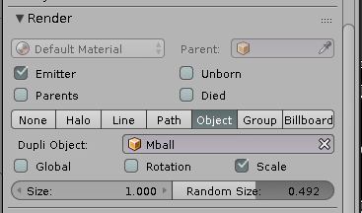Figure 15: wdrop_small_static Particle Render settings
- Render
  - Render Type = Object
  - Duplicate Object = Mball

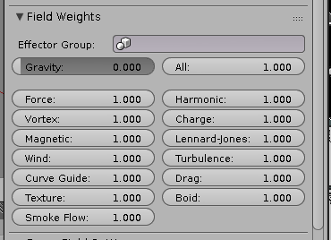Figure 16: wdrop_small_static Particle Field Weights settings
- Field Weights
  - Gravity = 0

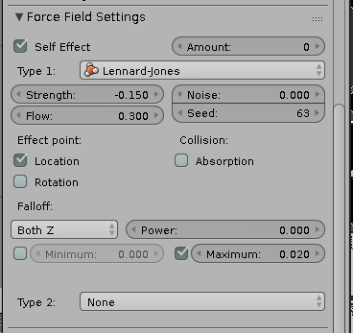Figure 17: wdrop_small_static Particle Force Field Settings
- Force Field Settings
  - Type 1 = Lennard-Jones
  - Self Effect
  - Strength = -0.150
  - Flow = 0.300
  - Effect point = Location only
  - Maximum Distance = 0.020

Create particle collision on the Plane

- Goto the Plane's Physics tab, and click the Collision button. The settings for the collision will appear.
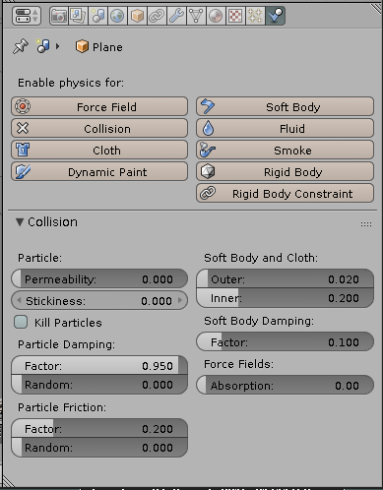Figure 18: Plane Particle Collision settings
- Set Particle Damping Factor to 0.95
- Set Particle Friction Factor to 0.20

Create DynamicWdrop_Emitter Plane
"DynamicWdrop_Emitter" is stands for dynamic water droplets emitter. This plane will emit dynamic water droplets particle. The term dynamic here means the particle will be influenced by Gravity force.
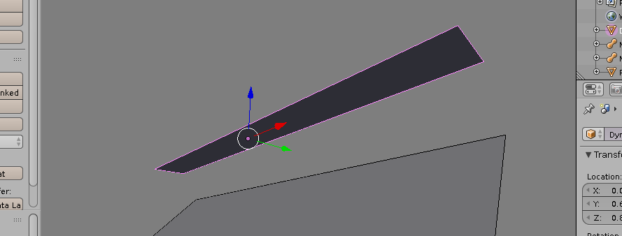Figure 19: The DynamicWdrop_Emitter Plane
- Add > Mesh > Plane
- Rename it to DynamicWdrop_Emitter

Set DynamicWdrop_Emitter location and scale
- Set Location to [0.0, 0.6, 0.8]
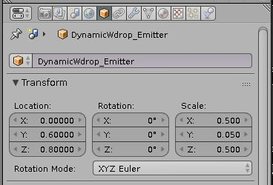Figure 20: DynamicWdrop_Emitter's Location and Scale
- Set Scale to [0.50, 0.05, 0.50]

Create wdrop_large_dynamic particle system
- Goto the Particle tab, and create a new particle system for DynamicWdrop_Emitter plane.
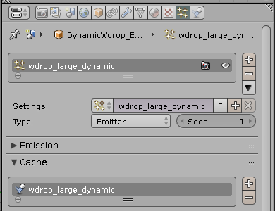Figure 21: DynamicWdrop_Emitter's particle system name
- Rename the particle system including its Cache name to "wdrop_large_dynamic".
- Set Seed value to 1 or any value as long as it is different from wdrop_small_static's Seed value.

Set the wdrop_large_dynamic particle system
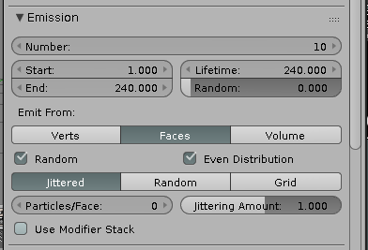Figure 22: wdrop_large_dynamic Particle Emission settings
- Emission
  - Number = 10
  - Start = 1
  - End = 240
  - Lifetime = 240

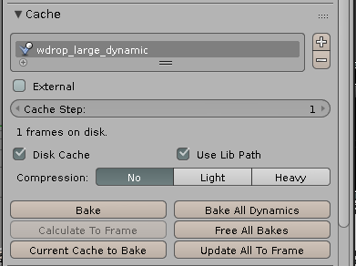Figure 23: wdrop_large_dynamic Particle Cache settings
- Cache
  - Disk Cache = Enabled

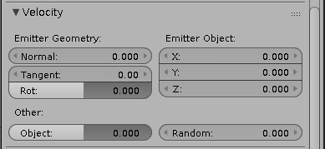Figure 24: wdrop_large_dynamic Particle Velocity Settings
- Velocity
  - Normal = 0

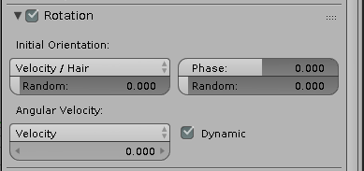Figure 25: wdrop_large_dynamic Particle Rotation settings
- Rotation
  - Initial Rotation = Velocity/Hair
  - Angular Velocity = Velocity
  - Dynamic Angular Velocity

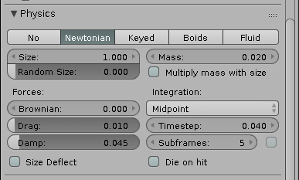Figure 26: wdrop_large_dynamic Particle Physics settings
- Physics
  - Physics Type = Newtonian
  - Size = 1
  - Mass = 0.020
  - Drag = 0.010
  - Damp = 0.045
  - Subframes = 5

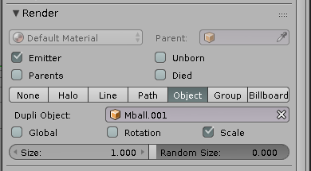Figure 27: wdrop_large_dynamic Particle Render settings
- Render
  - Render Type = Object
  - Duplicate Object = Mball.001

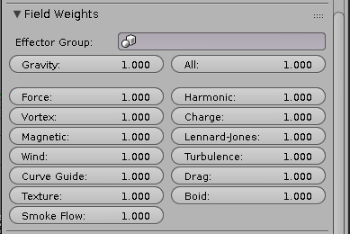Figure 28: wdrop_large_dynamic Particle Field Weights settings
- Field Weights
  - Enable all field weights

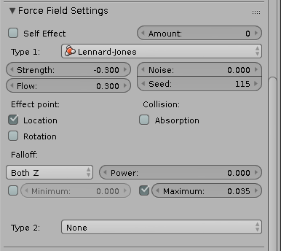Figure 29: wdrop_large_dynamic Particle Force Field settings
- Force Field Settings
  - Type 1 = Lennard-Jones
  - Strength = -0.3
  - Flow = 0.3
  - Effect point = Location only
  - Falloff Max Distance = 0.035

Assign materials to Plane and DynamicWdrop_Emitter (optional)
For convenient purposes, assign some materials to the objects.
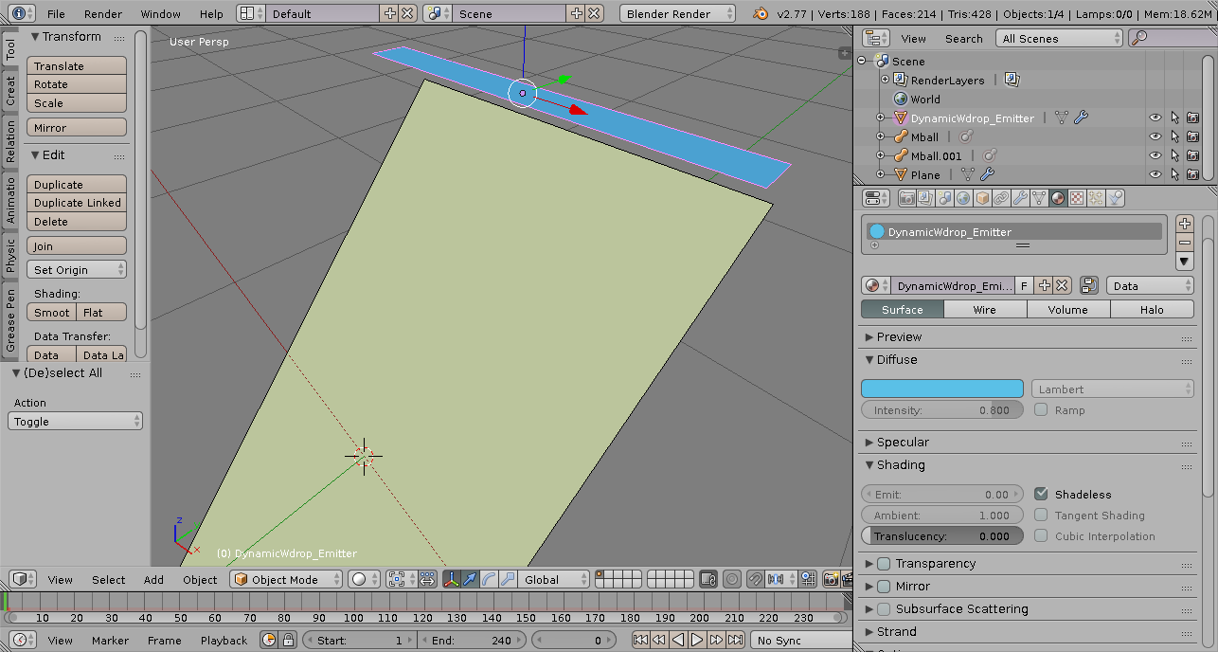Figure 30: Assign Materials

Material properties for Plane
- Diffuse color = F2FFCA
- Shading = Shadeless

Material properties for DynamicWdrop_Large_Emitter
- Diffuse Color = 5AC0E7
- Shading = Shadeless

Material properties for Mball
- Diffuse Color = 0079CF
- Shading = Shadeless

Simulate the water droplets
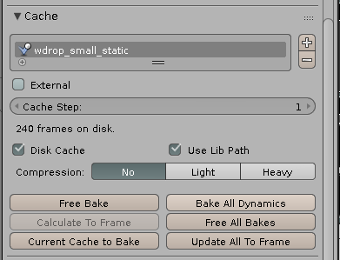Figure 31: Bake All Dynamics

Bake All Dynamics
Select either Plane or DynamicWdrop_Emitter, goto the Particle tab, under section Cache, click the button Bake All Dynamics.
It took 4 minutes and 10 seconds on my Acer Aspire 4741 laptop.

Now you can play to see the water droplet simulation.
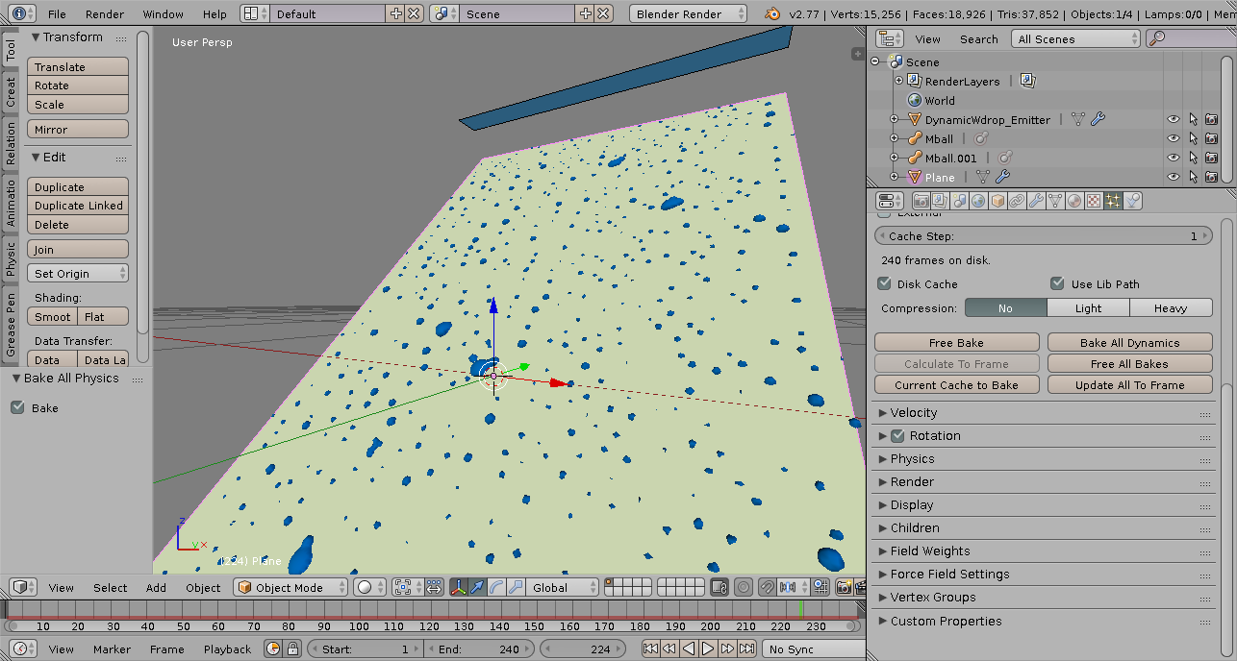Figure 32: The final result

