-------INSTANCES-------

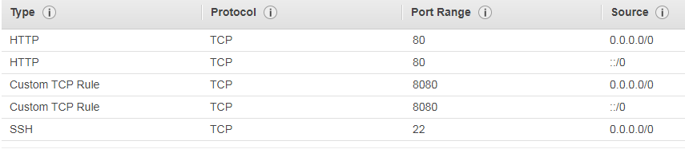

-------ANSIBLE-------

1. sudo apt-add-repository ppa:ansible/ansible

2. sudo apt update

3. sudo apt install ansible

4. **Доп.модули**

sudo apt-get install python-yaml python-jinja2 python-paramiko python-crypto

5. **Настроить хосты**

[servers]

server1 ansible_host=IP_of_server ansible_user=ubuntu ansible_ssh_private_key_file=/home/ubuntu/.ssh/MyKeyPair.pem

server2 ansible_host= IP_of_server ansible_user=ec2-user ansible_ssh_private_key_file=/home/ubuntu/.ssh/MyKeyPair.pem

6. **Добавить MyKeyPair.pem в нужную директорию**

7. **Проверка соединения (*поменять права доступа на 600*)**

chmod 600 /home/ubuntu/.ssh/MyKeyPair.pem

ansible all -m ping -u root

8. **Настройка конфигурации**

[defaults]

host_key_checking=false

inventory=hosts

9. **Создание playbook**

---

- hosts: servers

become: true

tasks:

- name: install apache2

apt: name=apache2 update_cache=yes state=latest

- name: enabled mod_rewrite

apache2_module: name=rewrite state=present

notify:

- restart apache2

- name: Clean artifact path

file:

state: absent

path: "/var/www/html/index.html"

- name: Changed permissions

file:

dest=/var/www/html mode=777 recurse=yes

- name: install php modules

apt: name={{ item }} update_cache=yes state=latest

loop: [ 'php', 'libapache2-mod-php', 'php-mysql' ]

**Альтернатива**

---

- hosts: servers

become: true

tasks:

- name: install apache2

apt: name=apache2 update_cache=yes state=latest

when: ansible_os_family == "Debian"

- name: install apache

package: name=httpd update_cache=yes state=latest

when: ansible_os_family == "RedHat"

- name: enabled mod_rewrite

apache2_module: name=rewrite state=present

notify:

- restart apache2

when: ansible_os_family == "Debian"

- name: Restart service httpd, in all cases

service:

name: httpd

state: restarted

when: ansible_os_family == "RedHat"

- name: Clean artifact path

file:

state: absent

path: "/var/www/html/index.html"

- name: Changed permissions

file:

dest=/var/www/html mode=777 recurse=yes

- name: install php

package: name=php update_cache=yes state=latest

-------

loop: [ 'php', 'libapache2-mod-php', 'php-mysql' ]

when: ansible_os_family == "Debian"

- name: install php

package: name={{ item }} update_cache=yes state=latest

loop: [ 'php' ]

when: ansible_os_family == "RedHat"

10. **Запуск playbook**

ansible-playbook ApachePB.yml

-------JENKINS-------

1. **Установка Java 8**

sudo apt update

sudo apt install openjdk-8-jre

**2. Установка Jenkins**

wget -q -O - https://pkg.jenkins.io/debian-stable/jenkins.io.key | sudo apt-key add -

sudo sh -c 'echo deb https://pkg.jenkins.io/debian-stable binary/ > \

/etc/apt/sources.list.d/jenkins.list'

sudo apt-get update

sudo apt-get install jenkins

**3. Установка плагина Publish over ssh**

**4. Credentials для GIT**

**5. Webhook для GIT**

**6. В Publish Over SSH сделать */** для настроек**

-------SERVER-------

1. sudo apt install php libapache2-mod-php php-mysql