## **Queue-it Project**

1. Create contents.
2. Call contentful (CMS) API(Post)
3. Svelte App call Svelte App
4. Host Svelte App
5. Load Svelte app using iFrame

**Overview**

**Prototype**

**Code Standard:**

* Camel case for source code
* Kebab case for Html file
* Have a full name of variables

**Domain Model**

Noun & Verb List

Noun: marketing team, contentful, goPlatform, Svelte app, customer

Verb: create, upload, use, store, communicate, call, retrieve, analyse

SWOT

|  |  |
| --- | --- |
| Strengths | Weaknesses |
| * Blue ocean * Unique product | * High prices |
| Opportunities | Threats |
|  |  |

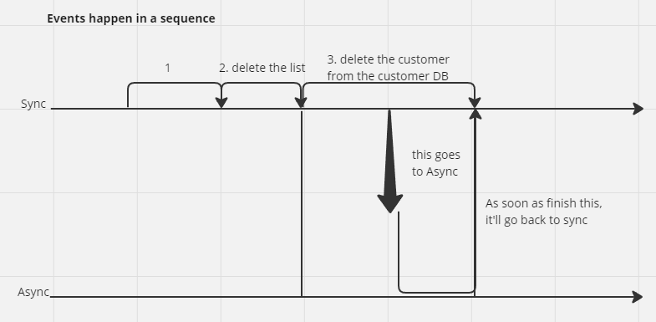

Figure 1: Async

Figure 2: Prop Drilling using Store

Figure 3: Routing