Changes:

1. Decrease font Size of h1

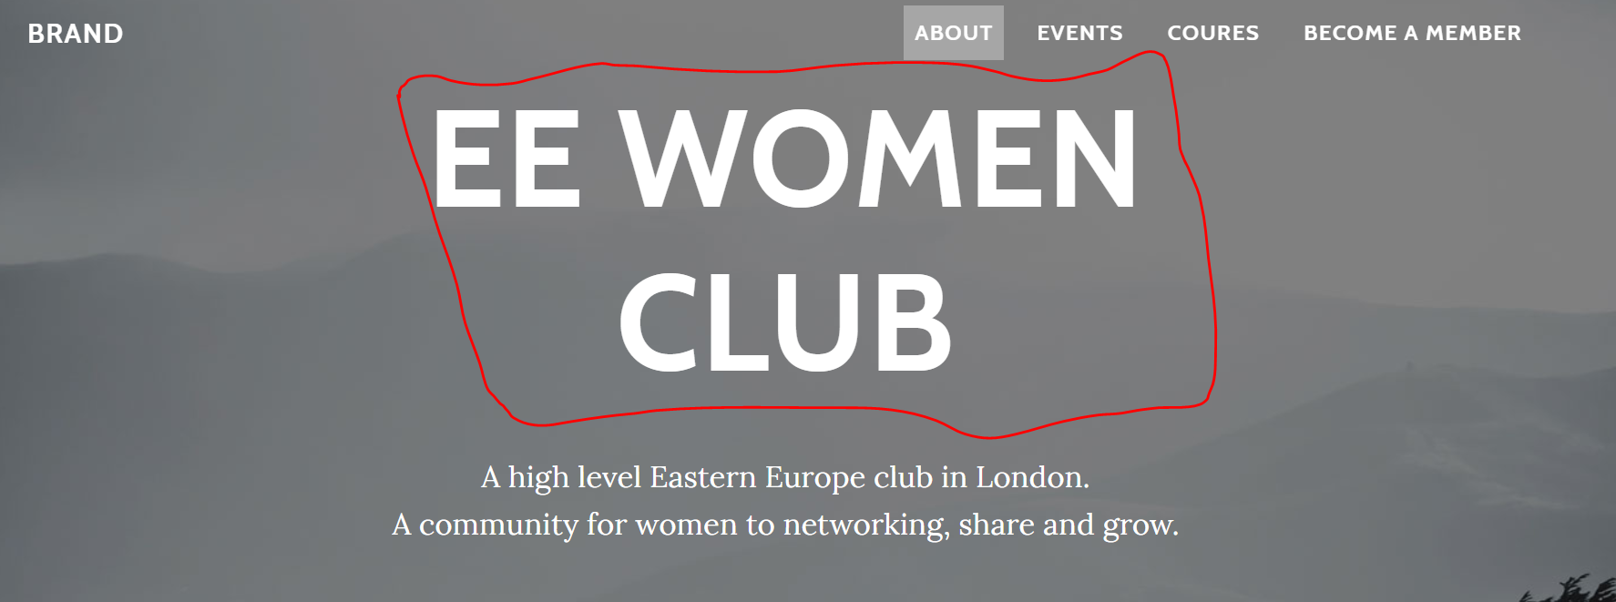

1. <body id="page-top">

ABOUT

When we click info is not centralized:

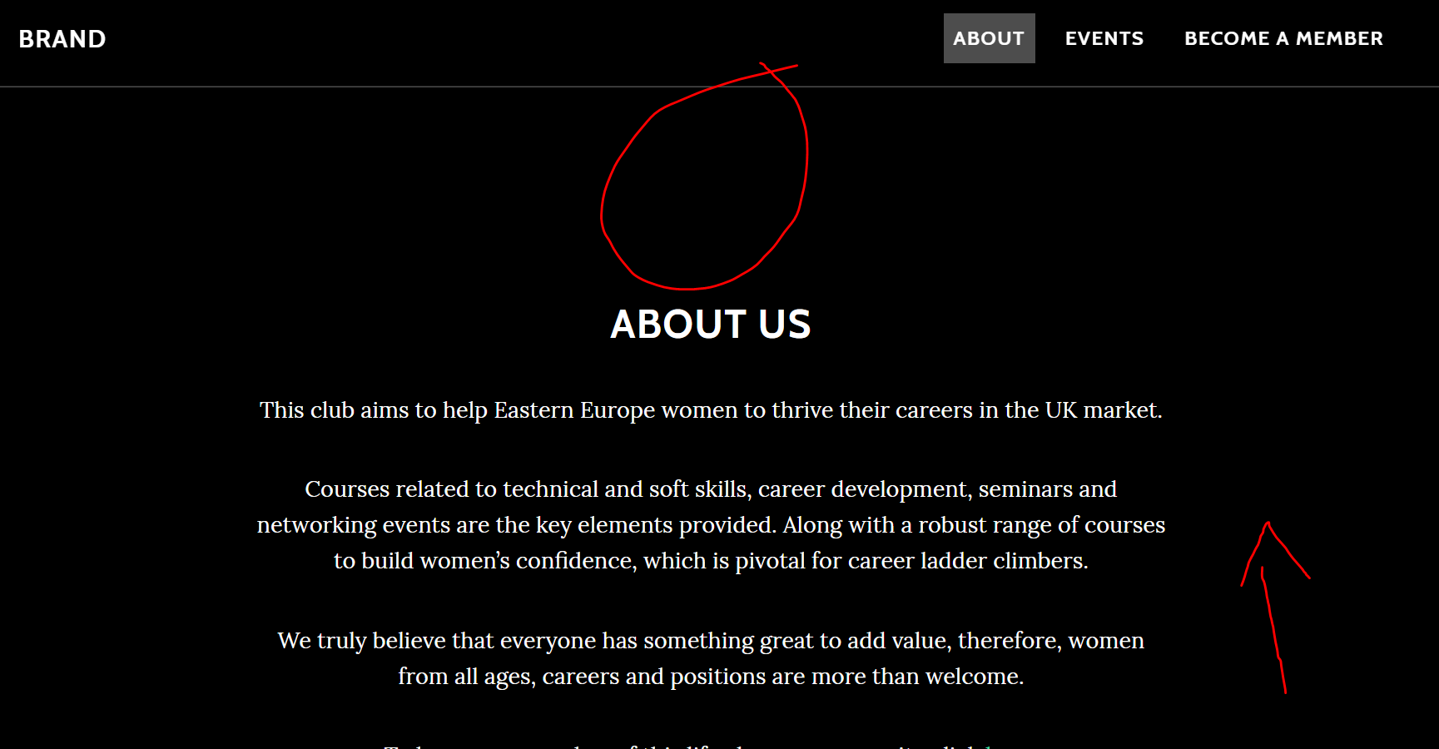

1. Become a member is not directing to email box.
2. I have added COURSES and it has changed info below:

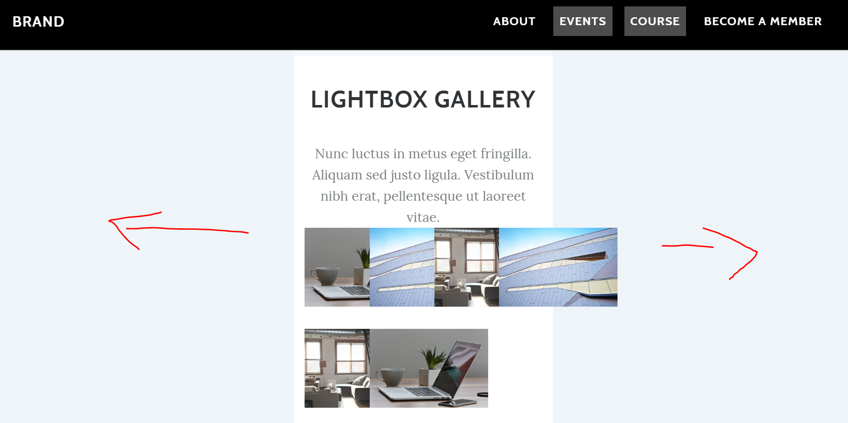

* The same here:

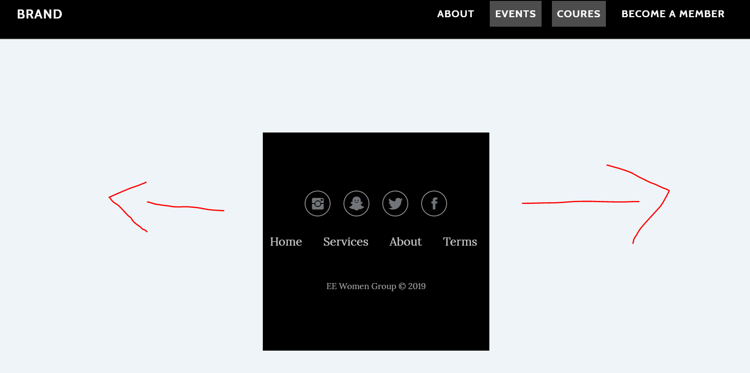

Notes:

I have added an option click here as it is mandatory. Also it needs to open another page. We cannot use just a single page.