1. Add period.

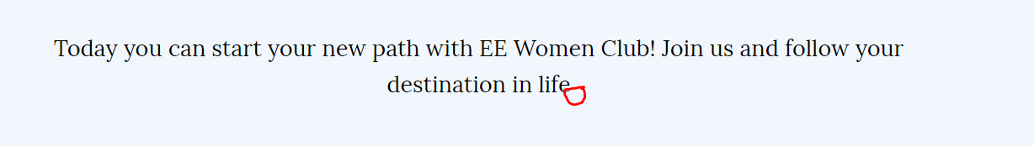

1. Change text to: UK based recruiters will prepare yourself to stand out in the application process. CV review, portfolio analysis and interview process. Don miss out!

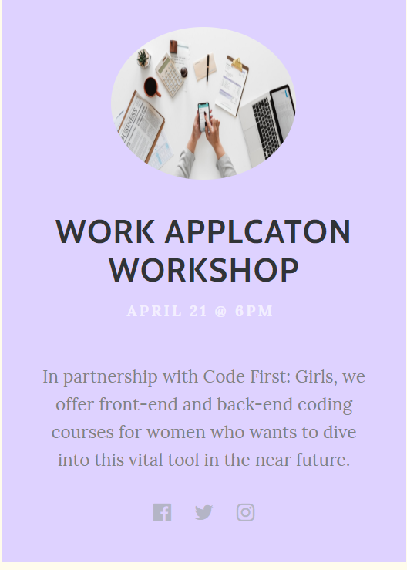

1. Our courses are totally free and provided by experts from Eastern Europe.

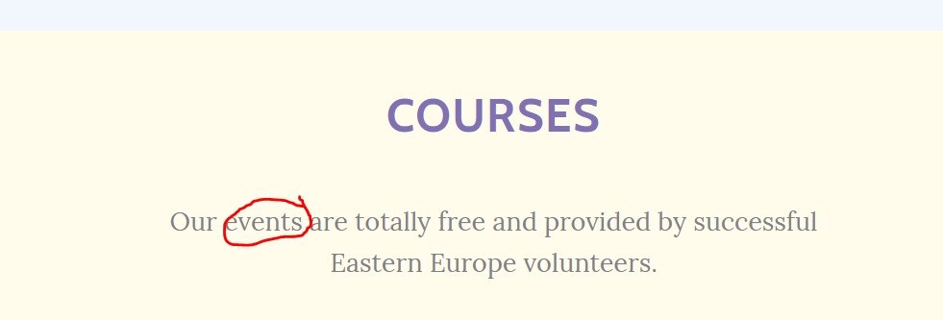

1. Helping women to build their best version. A panel driven by coaching experts will discuss the process of commitment to self-development.

