Nika Arts Studio
Admin and End-User Guide
Visual operating handbook for admin workflows, customer flow, product uploads, orders, CMS, deployment, and production checks.
Prepared from the current production codebase.

1. Quick Admin Reference
Need to do this | Go here | Action
Add product | /admin -> Inventory Management | Add Product, then Edit to upload image
Bulk upload products | /admin -> Inventory Management | Upload images, copy URLs, upload CSV
Remove duplicate | /admin -> Inventory Management | Search product, click Remove
Update order status | /admin -> Dashboard & Sales | Change fulfillment/logistics, click Save
Change homepage text | /admin -> Site Content CMS | Edit fields, Save Content
Change logo/artist image | /admin -> Site Content CMS | Choose file and upload image
Change admin password | /admin -> Settings | Enter current and new password

2. Architecture
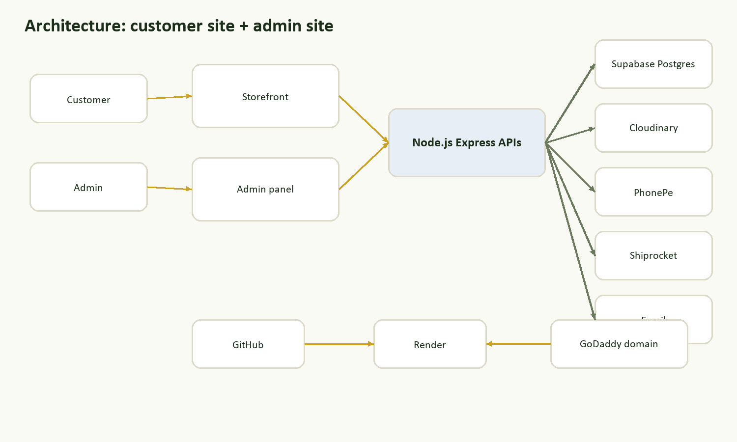
Customer site and admin site both use the same Express backend, with data in Supabase and images in Cloudinary.
Layer | Technology | Purpose
Frontend | HTML/CSS/JavaScript | Storefront and admin screens
Backend | Node.js + Express | APIs, auth, products, orders, payments, logistics
Database | Supabase Postgres | Products, orders, customers, sessions, settings
Images | Cloudinary | Product images, logo, artist image
Hosting | Render | Runs the live application
Code | GitHub | Source control and deploy trigger

3. Admin Panel Map
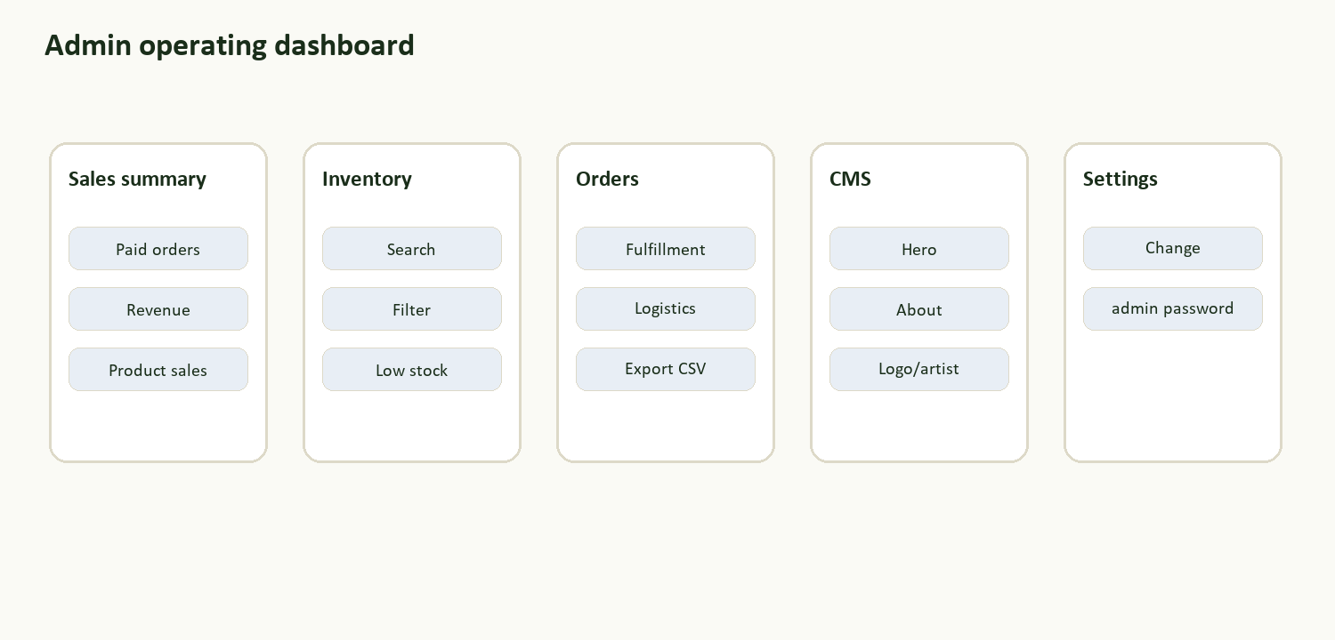
Main admin areas and the kind of work performed in each tab.
Admin area | Capabilities
Dashboard & Sales | Sales summary, top products, low stock, orders, order CSV export
Inventory Management | Search/filter/sort products, add/edit/hide/remove, image upload, CSV upload/export
Site Content CMS | Homepage hero/about/contact text, logo image, artist image
Settings | Admin password change

4. Product Workflows
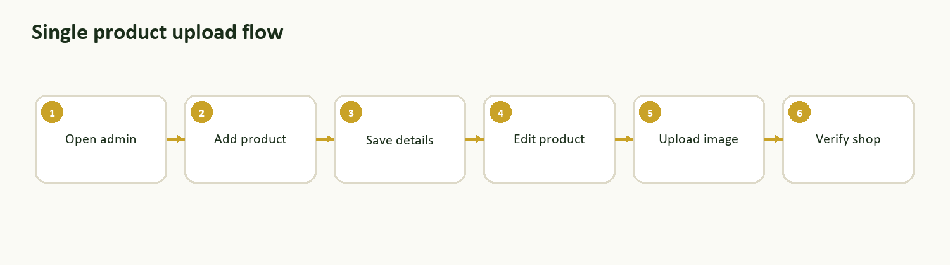
Recommended flow for adding a single product with image.
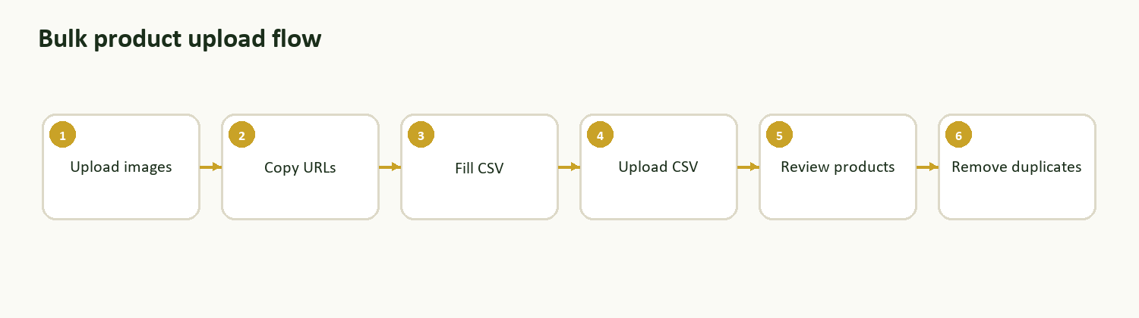
Recommended flow for adding many products with Cloudinary URLs and CSV.
Product field | Rule
Name | Clear customer-facing product name
Category | Reuse an existing category where possible
Price | Number only, in INR
Stock | Current sellable quantity
Description | Short and customer friendly
Image | JPEG, PNG, or WEBP; max 4 MB

5. Hide, Remove, or Edit?
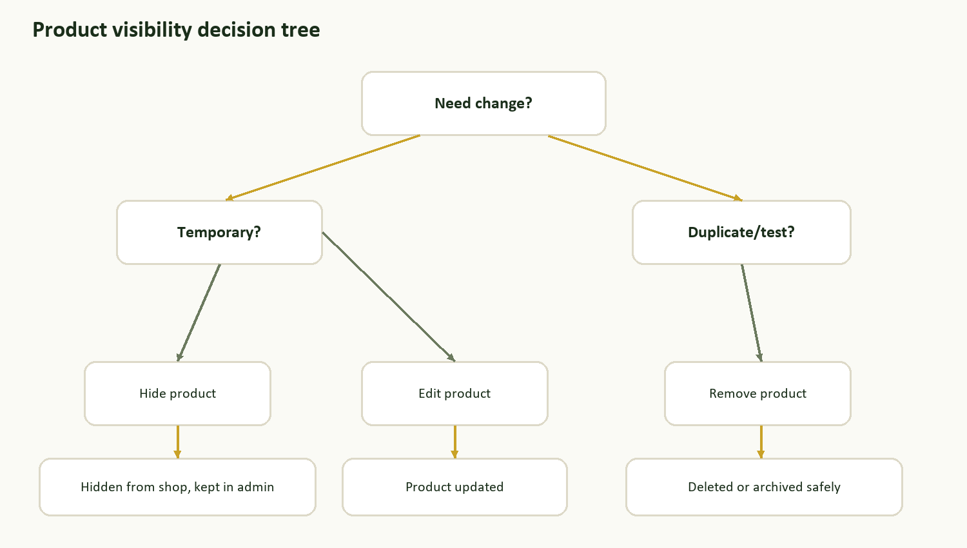
Use Hide for temporary removal, Remove for duplicates/test products, and Edit for corrections.
Action | Use when | Result
Edit | Correct product information | Product details update in Supabase
Hide | Temporarily stop selling | Product is hidden from storefront but remains in admin
Remove | Duplicate/test/wrong product | Deleted if safe, archived if order history exists

6. Orders, Customer Accounts, and Shipping
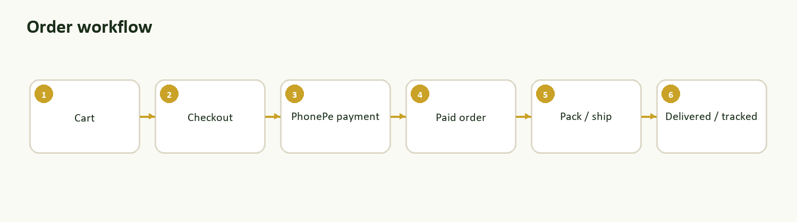
Customer order lifecycle from cart through delivery/tracking.
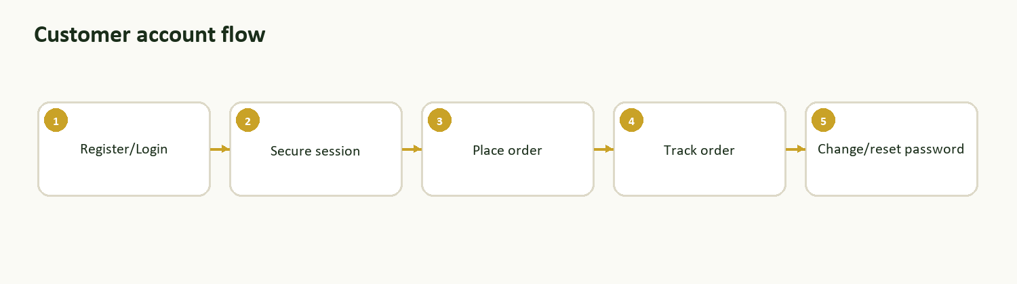
Customer account and password-management flow.
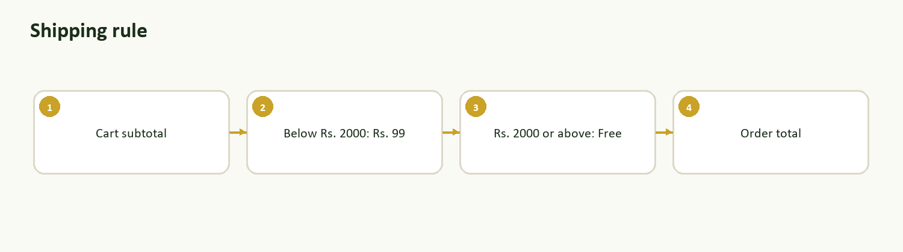
Shipping is calculated centrally by backend configuration.
Rule/config | Current value
Shipping fee | Rs. 99
Free shipping threshold | Rs. 2,000
Customer account URL | /account
Order tracking URL | /track-order

7. CMS and Deployment
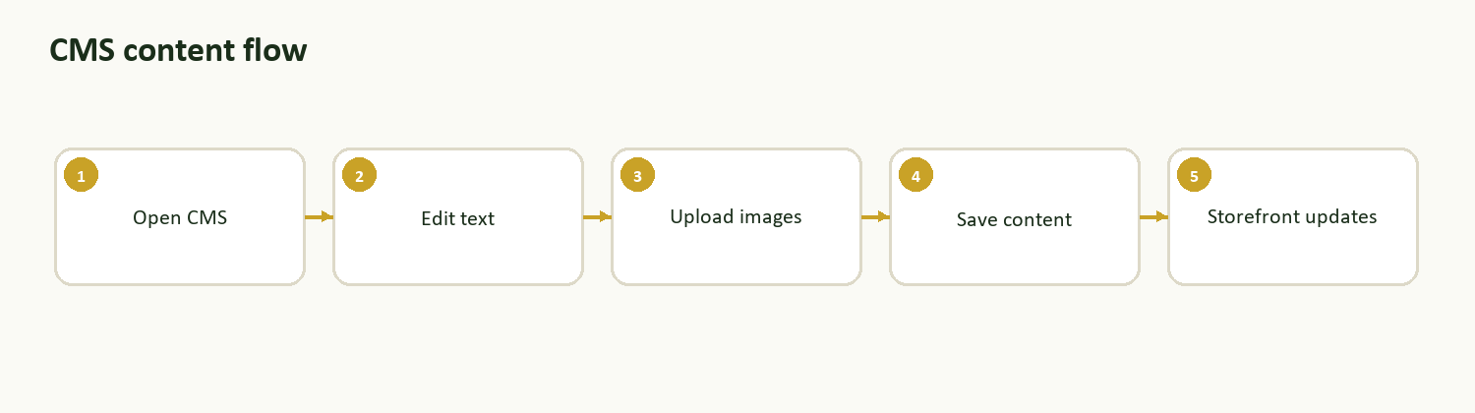
CMS updates store text and site images without code changes.
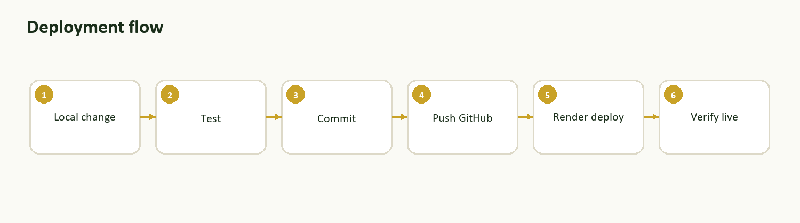
Production deployment flow through GitHub and Render.
CMS section | Admin can update
Hero | Eyebrow, title, subtitle
Images | Logo image, artist image
About | Eyebrow, title, paragraph 1, paragraph 2
Contact | Email, display phone, phone link

8. Production Environment Checklist
Group | Required values
Core | BASE_URL, DATABASE_URL, PGSSLMODE, JWT_SECRET
Admin | ADMIN_USERNAME, ADMIN_PASSWORD, ADMIN_SESSION_HOURS
Email | EMAIL_USER, EMAIL_PASS
Cloudinary | CLOUDINARY_CLOUD_NAME, CLOUDINARY_API_KEY, CLOUDINARY_API_SECRET
PhonePe | PHONEPE_MERCHANT_ID, PHONEPE_SALT_KEY, PHONEPE_SALT_INDEX, PHONEPE_ENV
Shiprocket | SHIPROCKET_EMAIL, SHIPROCKET_PASSWORD, SHIPROCKET_PICKUP_LOCATION, SHIPROCKET_PICKUP_PINCODE

9. Production Smoke Test
- Home page loads at /
- Shop page loads at /shop
- Cloudinary product images load
- Add to cart and quantity update work
- Checkout shows correct shipping rule
- Admin login works
- Inventory and dashboard load
- CMS logo/artist upload works
- Customer login/logout works
- Password reset email works after BASE_URL is configured
- Order tracking works
- PhonePe payment test is completed
- Shiprocket serviceability test is completed

10. Pending Work
Priority | Item | Reason
High | PhonePe production verification | Real payments must be tested after onboarding
High | Shiprocket live order verification | Pickup/order creation must be confirmed live
High | Final domain + BASE_URL | Needed for reset links and callbacks
High | Password reset live test | Confirms email and domain setup
Medium | Policy page final wording | Business/legal clarity
Medium | Supabase backup/export routine | Recovery safety
Later | Multi-admin roles/audit log | Useful when more operators join

11. Troubleshooting Matrix
Problem | Check first | Likely fix
Product image missing | Image URL opens directly? | Re-upload image or update product image
Product duplicated | CSV uploaded twice? | Use Remove on duplicate
Product not on shop | Hidden? Category filter active? | Edit status to Live
Admin login fails | Password, Supabase, env vars | Reset/seed admin or check DB
Reset email missing | EMAIL_USER, EMAIL_PASS, BASE_URL | Fix env and redeploy
Cloudinary not active | CLOUDINARY_* env vars | Add vars and redeploy
Supabase connection fails | Pooler URL and SSL | Use pooler host and PGSSLMODE=require

