**TortoiseSVN Version Control**

TortoiseSVN is a version control software for Microsoft Windows and is implemented as a Windows shell extension to allow easy integration into Windows Explorer. Since it is not an integration for a specific IDE you can use it with whatever development tools you like.

1. Download Tortoise SVN from [http://tortoisesvn.net](http://tortoisesvn.net/) and Install the software.

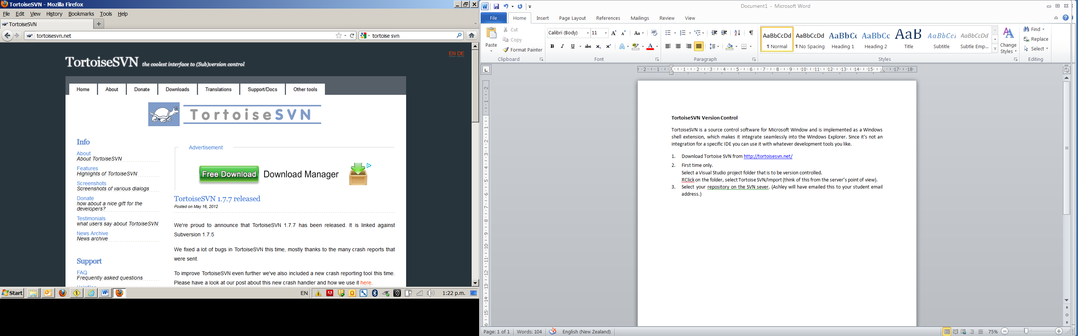

Note the Support section on this web site, FAQ, Helpfiles, UsefulTips etc.

1. **To Import a Project (first time only)**

Select a folder that is to be version controlled.

RClick on the folder, select Tortoise SVN/Import (think of this from the server’s point of view).

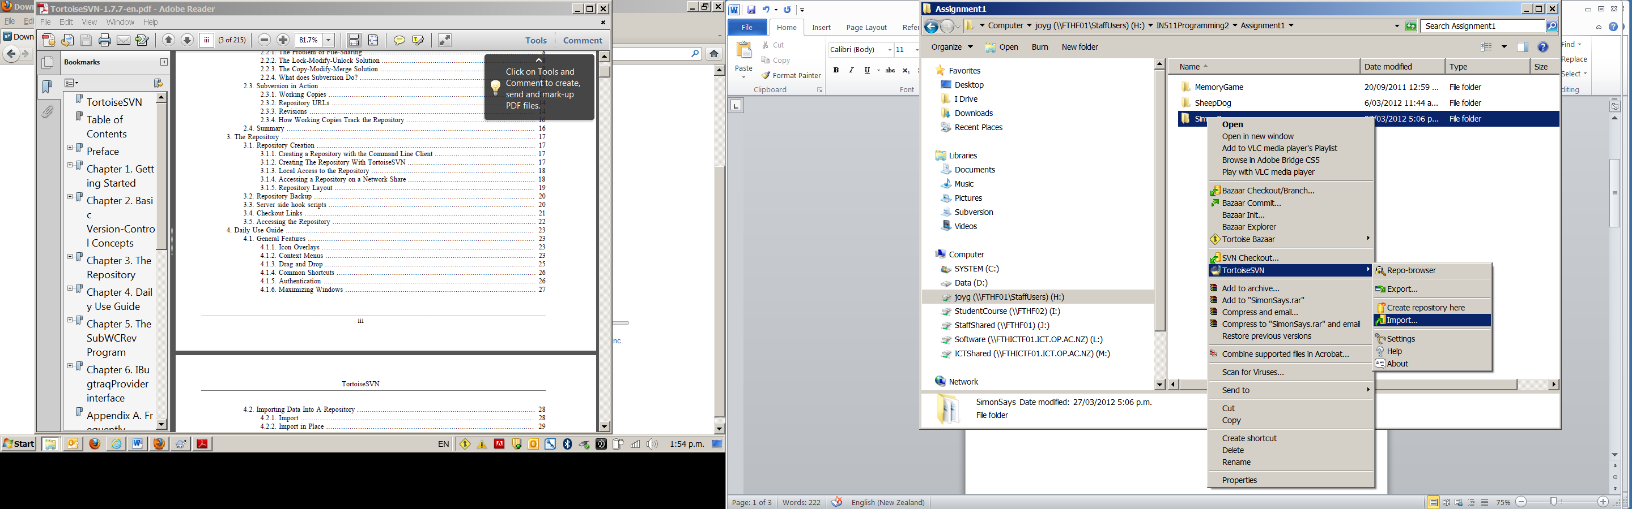

Select your repository on the SVN server. It should be:

*https://svn.ict.op.ac.nz/svn/<yourusername>*

Add a message that explains what you are doing/OK.

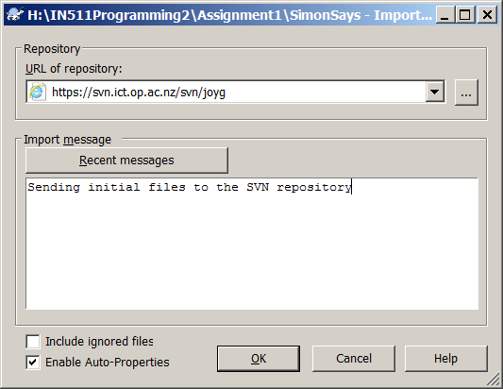

Accept the validation certificate permanently

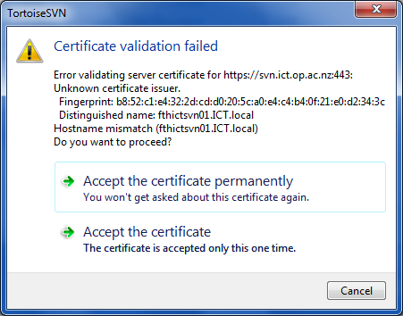

Fill in your normal username and password and tick the save authentication box

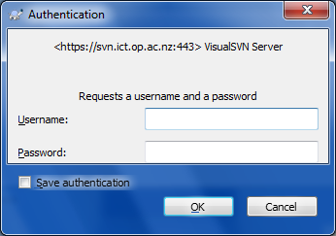

You should see confirmation of your import

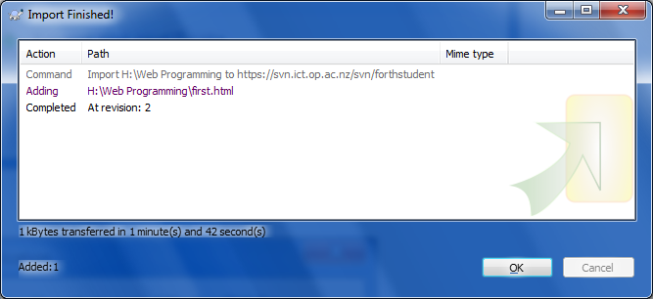

Go back to your folder and delete (to the recycle bin for safety) all files in that folder.

RClick on the now empty folder and select SVNCheckout/OK. This will access all the project files that were sent to the server.

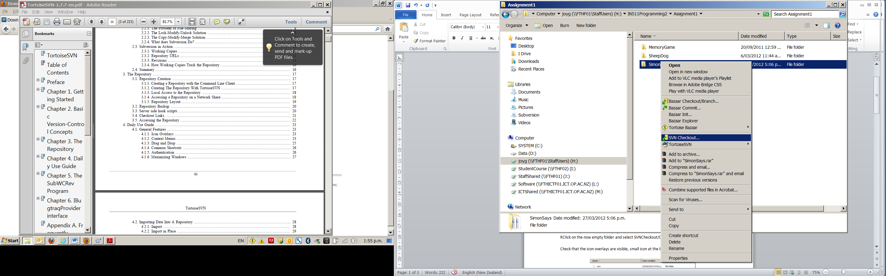

**Check that the icon overlays are visible**, small icon at the bottom left of the file icon.

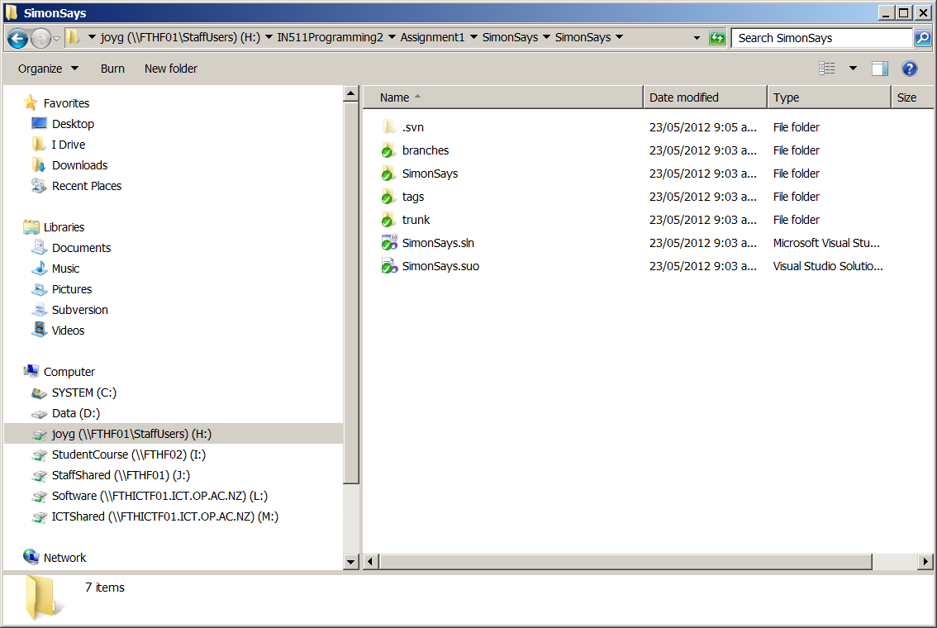

If the icons are not showing, RClick on your folder/TortoiseSVN/Settings

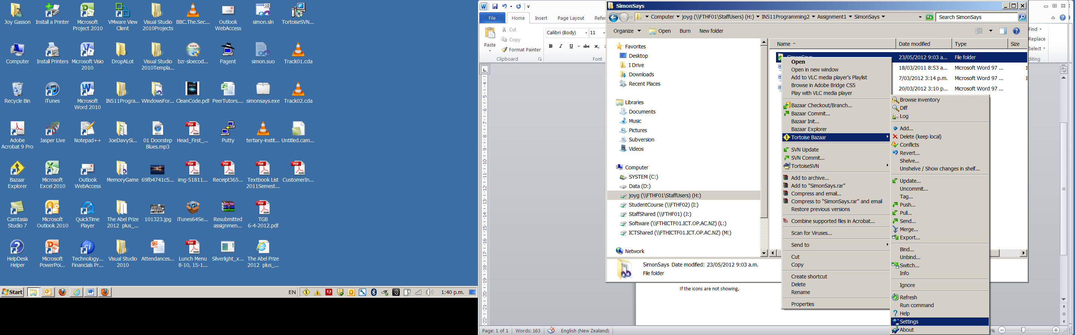

Choose Icon Overlays from the left hand window, tick the Network drives checkbox under Drive Types and OK.

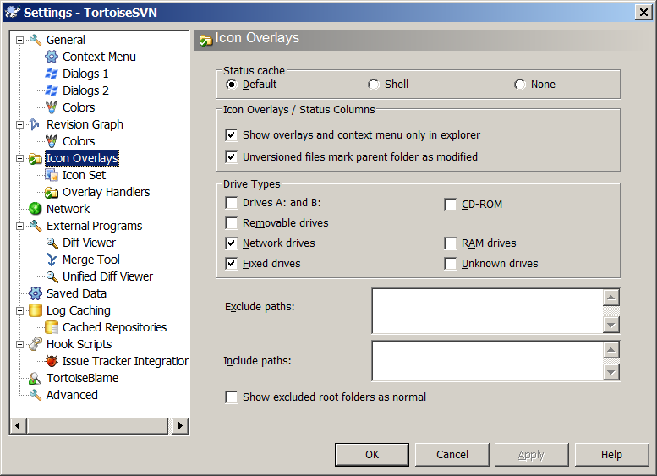

1. **Accessing the latest version of the project (Every time you want to work on these files)**

Select your Visual Studio project folder, RClick/SVN Update

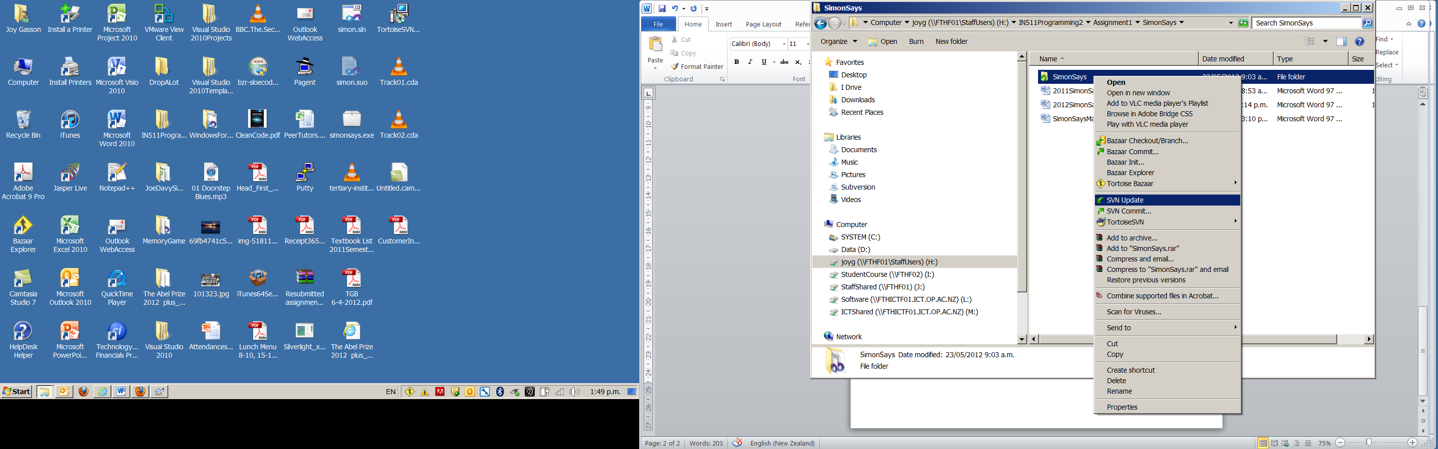

This will access/pop the latest version of your project in the repository and copy them to your working folder.

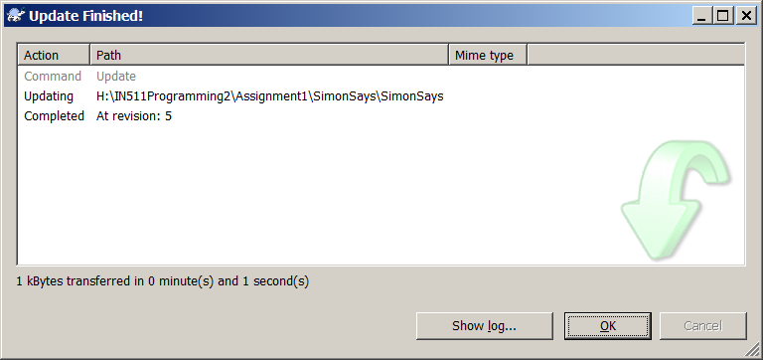

Check the Show log… button and ShowAll to see the log of all the interactions with the repository. This is why messages are so important. Note they are date and time stamped.

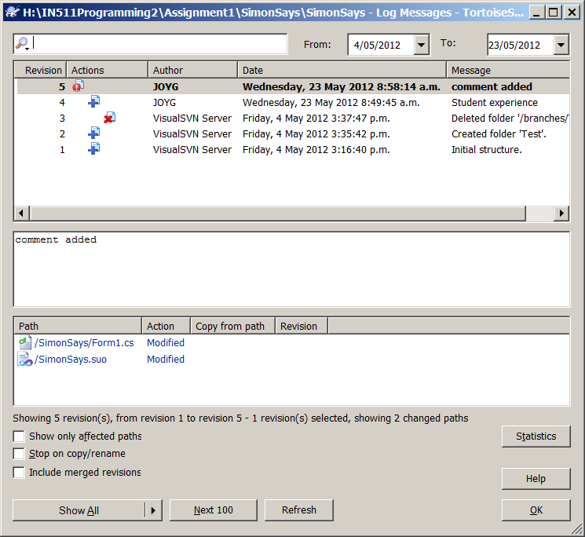

1. **Committing your files (saving your work to the repository)**

When you want to save/push your files to the repository, RClick on your folder/SVNCommit.

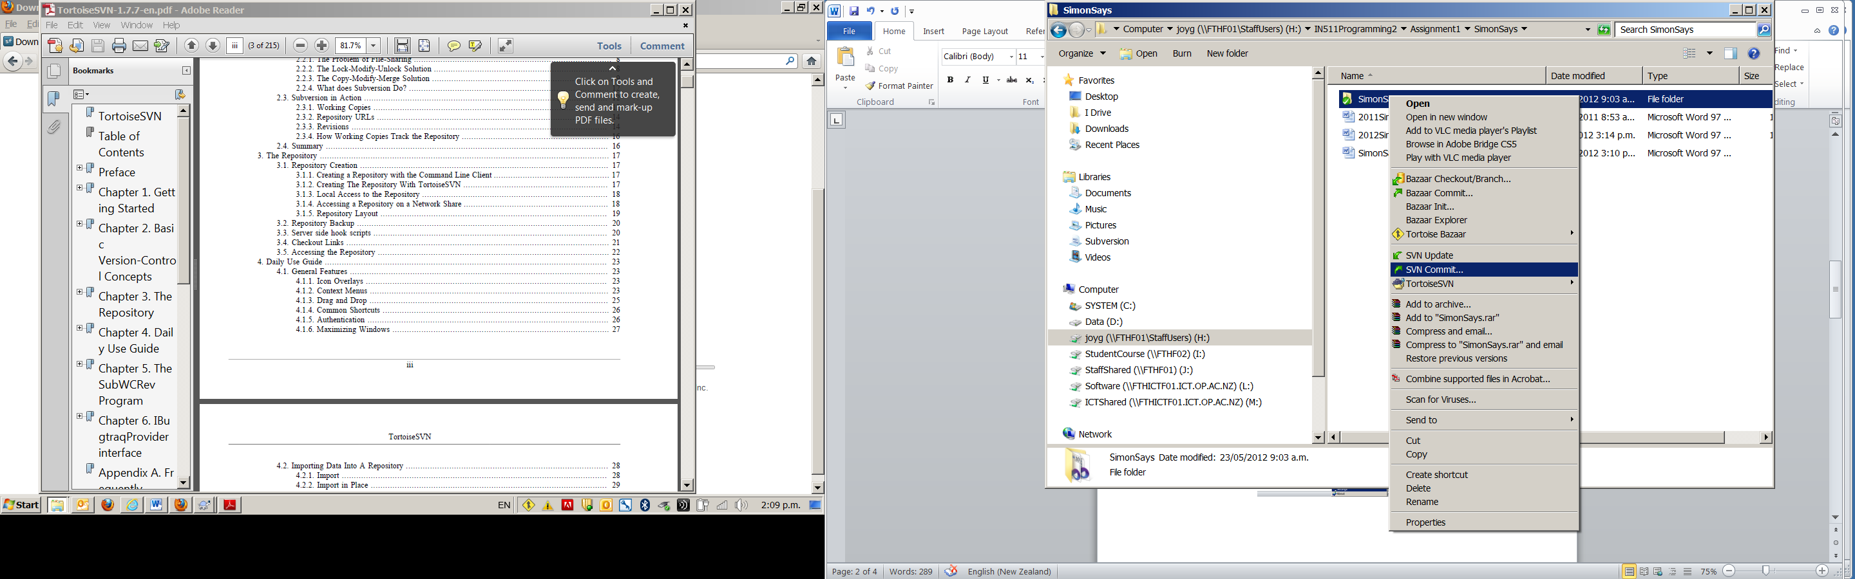

A message must be added here, it will then show in the log.

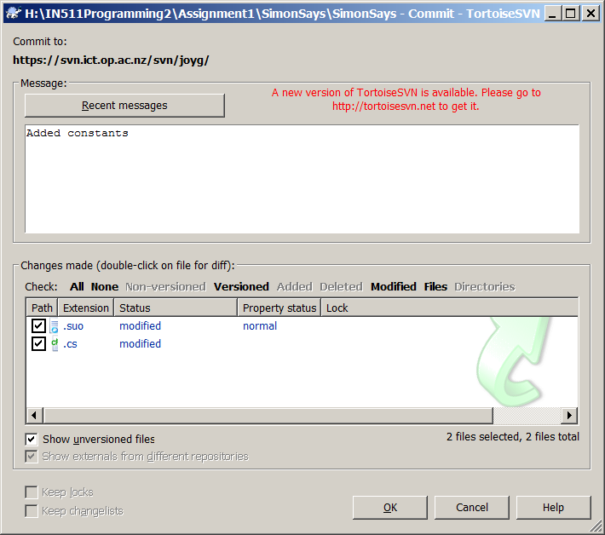

A commit Finished! Window will show that the commit has been accepted (or if a conflict has arisen).

