**This BDD framework is helping us to achieve Smoke tests for placing order**.

Project is structured using POM approach

**Note:-**

* **Currently I am using data from feature file.**
* **If required we can use Excel.**
* **We require unique user email address so each time when we run we have to give unique email id in our feature file for new user registration**
* **We can handle this in 2 ways**
* **1.We can generate random email id and can consume in your test script. —currently using this approach**
* **2.We can write in @before(we can connect to DB and delete the user) to delete user before running our new customer**
* **This Framework takes screenshot whether test failed or pass once scenario is completed.(screenshot attached at the end)**
* **We can control this behavior when we want to take screenshot either on pass or fail.**
* **We can run our Test runner file via TestNG xml by using cucumber-testng dependency(This I have not done in this Framework, but yes there is option to do and will help in CICD flow)**
* **Currently verification/validation is paced on the last page, but we can put it on the pages where we need**

**Project Structure**

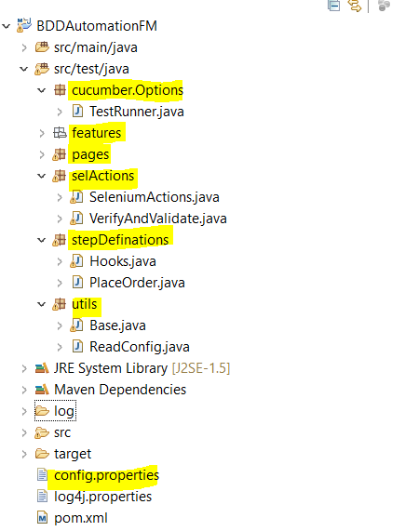

Cucumber.options package has TestRunner

Features package has all feature files

selActions has all selenium actions

setpDefinations has all stepdefination

utils has all helping things

config.properties has all configurable items.

**It has one feature file which contains 4 scenarios.**

**1.Existing Customer using search functionality and placing order by adding 2 products.**

*@existingUserPlaceOrderBySearchingProduct*

**Scenario:** Place Order by Existing Logon and searching product by search bar

*Given* Customer Launches Application

*When* Customer search "Summer Dresses > Printed Summer Dress" to buy

*And* Customer Add selected product to cart

*And* Customer Continue to Shopping

*When* Customer search "Blouses > Blouse" to buy

*And* Customer Add selected product to cart

*And* Customer proceeds for checkout

*And* Customer Proceeds to checkout on Summary Page

*And* Customer SingIn by giving his "prajapati.pravesh@gmail.com" and "Pravesh@123"

*And* Custome selects "My address"

*And* Customer Proceeds to checkout on Address Page

*And* Customer Agrees terms on Shipping Page

*And* Customer Proceeds to checkout on Shipping Page

*And* Customer select payment option "Pay by bank wire"

*And* Customer confirm his order

*Then* Customer should get success message "Your order on My Store is complete."

**2. Existing Customer using popular products and placing order by adding 2 products.**

*@existingUserPlaceOrderBySearchingPopularProducts*

**Scenario:** Place Order by Existing Logon and searching by popular products

*Given* Customer Launches Application

*When* Customer click on popular products

*Then* Customer Add popular product "Faded Short Sleeve T-shirts"

*And* Customer Continue to Shopping

*Then* Customer Add popular product "Blouse"

*And* Customer proceeds for checkout

*And* Customer Proceeds to checkout on Summary Page

*And* Customer SingIn by giving his "prajapati.pravesh@gmail.com" and "Pravesh@123"

*And* Custome selects "My address"

*And* Customer Proceeds to checkout on Address Page

*And* Customer Agrees terms on Shipping Page

*And* Customer Proceeds to checkout on Shipping Page

*And* Customer select payment option "Pay by bank wire"

*And* Customer confirm his order

*Then* Customer should get success message "Your order on My Store is complete."

**3. Existing Customer using Best Sellers and placing order by adding 2 products.**

*@existingUserPlaceOrderBySearchingBestSellers*

**Scenario:** Place Order by Existing Logon and searching by Best Sellers

*Given* Customer Launches Application

*When* Customer click on Best Sellers

*Then* Customer Add his preferred product "Printed Chiffon Dress"

*And* Customer Continue to Shopping

*Then* Customer Add his preferred product "Blouse"

*And* Customer proceeds for checkout

*And* Customer Proceeds to checkout on Summary Page

*And* Customer SingIn by giving his "prajapati.pravesh@gmail.com" and "Pravesh@123"

*And* Custome selects "My address"

*And* Customer Proceeds to checkout on Address Page

*And* Customer Agrees terms on Shipping Page

*And* Customer Proceeds to checkout on Shipping Page

*And* Customer select payment option "Pay by bank wire"

*And* Customer confirm his order

*Then* Customer should get success message "Your order on My Store is complete."

**4.New customer using category and register’s himself and places order by adding 2 products**

*@newUserPlaceOrderBySearchingCategoryProduct*

**Scenario:** Place Order by new SignIn and searching product by category

*Given* Customer Launches Application

*Then* Customer select product by Women Category

*Then* Customer Add his preferred product "Printed Dress" Category

*And* Customer Add selected product to cart

*And* Customer Continue to Shopping

*Then* Customer select product by Dresses Category

*Then* Customer Add his preferred product "Printed Summer Dress" Category

*And* Customer Add selected product to cart

*And* Customer proceeds for checkout

*And* Customer Proceeds to checkout on Summary Page

*And* Customer enter email "pravesh.prajapati@abc8.com" for creating account

*And* Customer Create his account

*And* Customer select his gender "Male"

*And* Customer enter his firstname "pravesh"

*And* Customer enter his lastname "prajapati"

*And* Customer enter his password "XXXXX@123"

*And* Customer enter his DateOfBirth "12 5 1990"

*And* Customer enter his company "WooliesX"

*And* Customer enter his address "10 Rex street"

*And* Customer enter his city "Sydney"

*And* Customer enter his state "Maine"

*And* Customer enter his postcode "00000"

*And* Customer select his country "United States"

*And* Customer enter additional information "Register me"

*And* Customer enter mobile no "0469872035"

*And* Customer registered himself

*And* Custome selects "My address"

*And* Customer Proceeds to checkout on Address Page

*And* Customer Agrees terms on Shipping Page

*And* Customer Proceeds to checkout on Shipping Page

*And* Customer select payment option "Pay by bank wire"

*And* Customer confirm his order

*Then* Customer should get success message "Your order on My Store is complete."

**To generate report run project from maven**

Mvn test verify

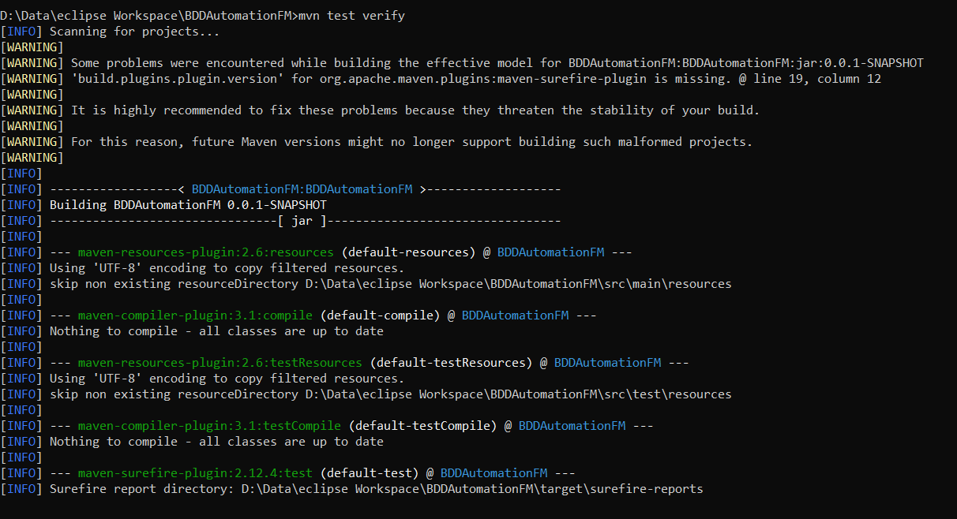

Below is the html report generated

Report folder is /target/cucumber-html-reports

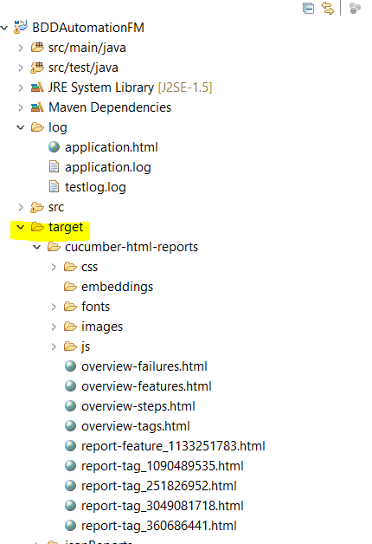

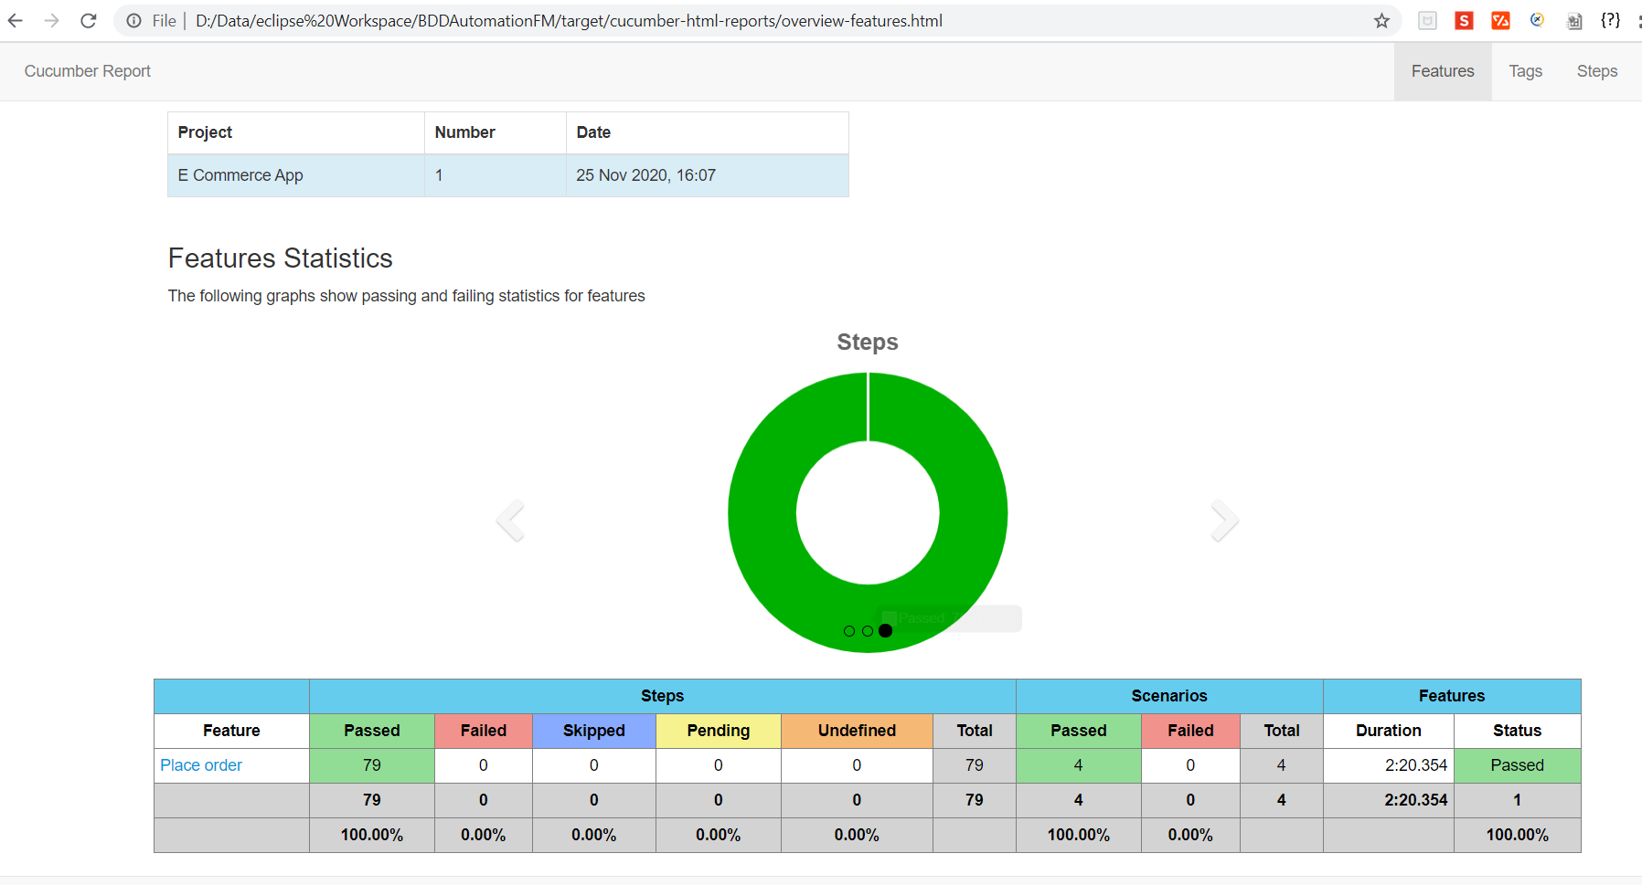

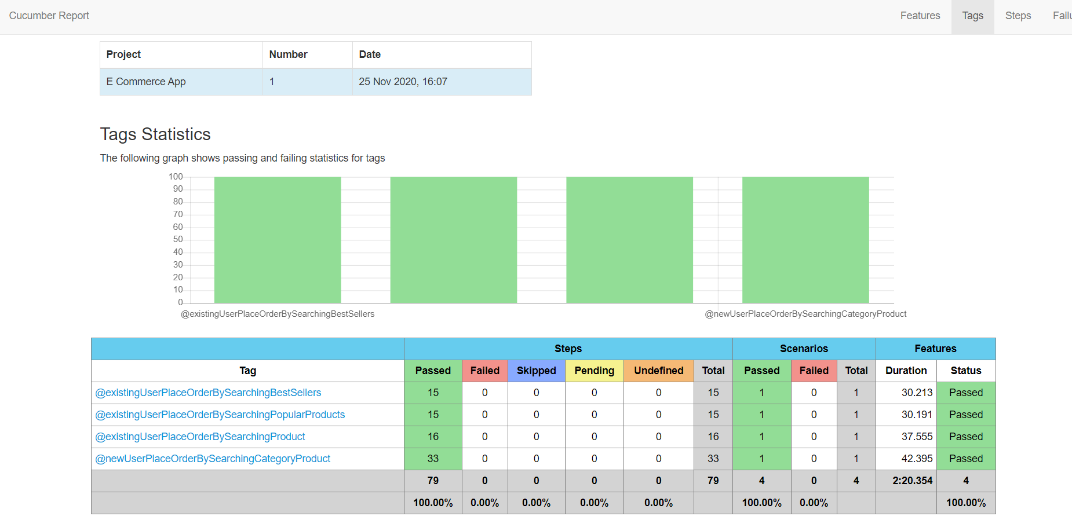

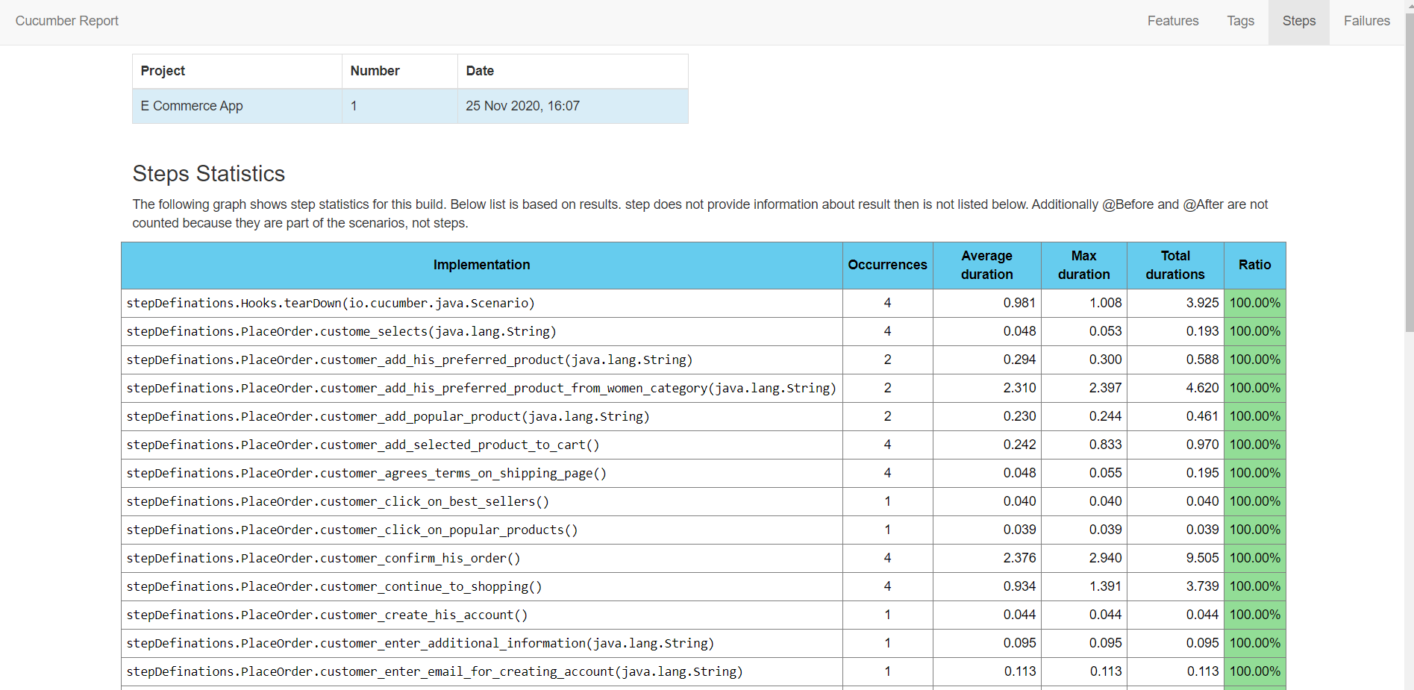

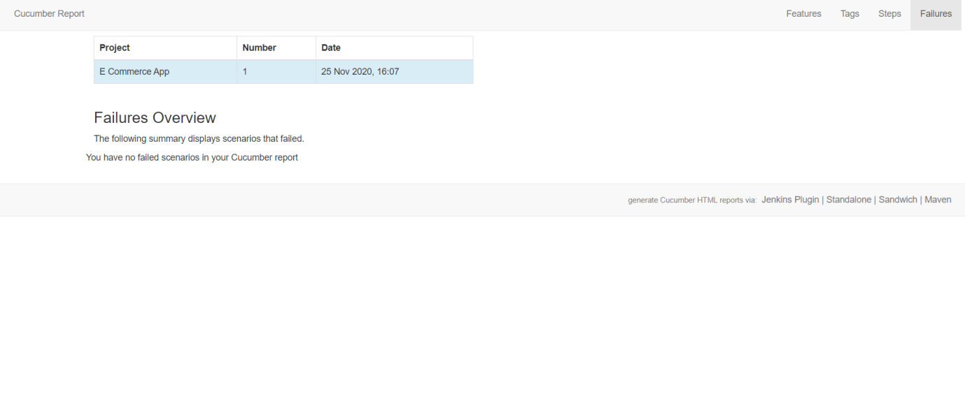

**Logs are generated to below folder**

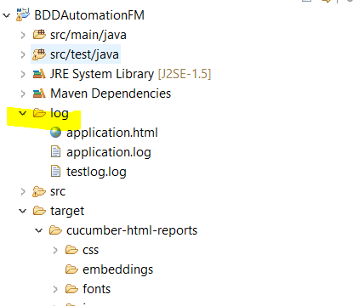

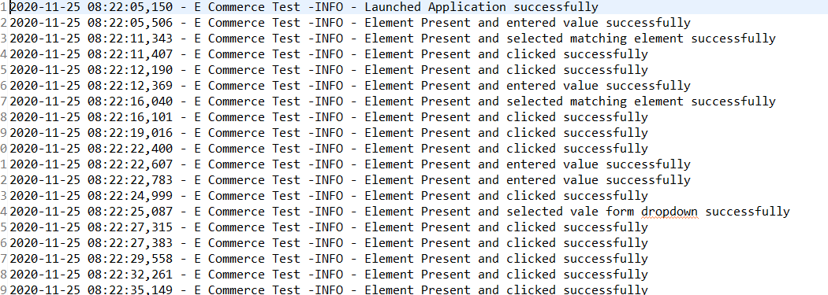

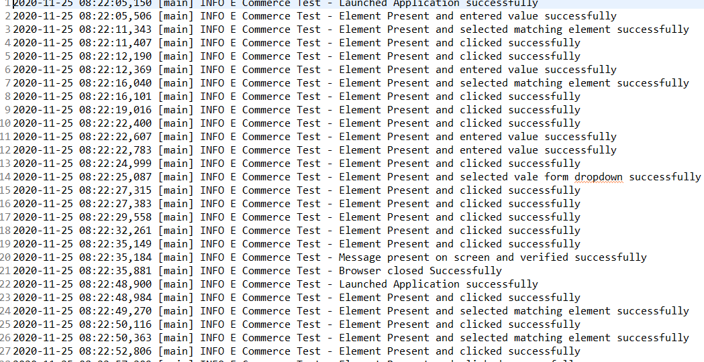

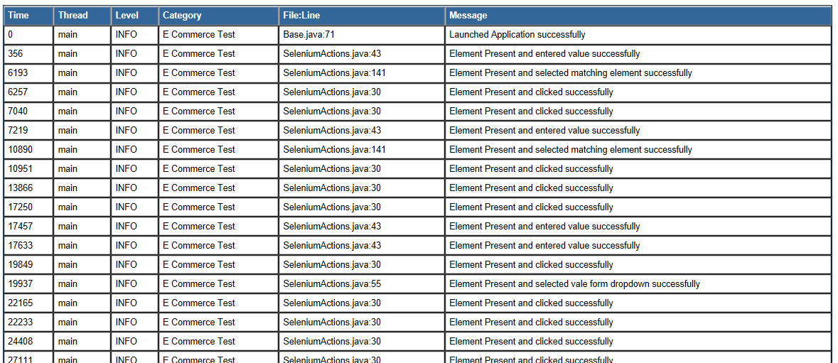

Test results

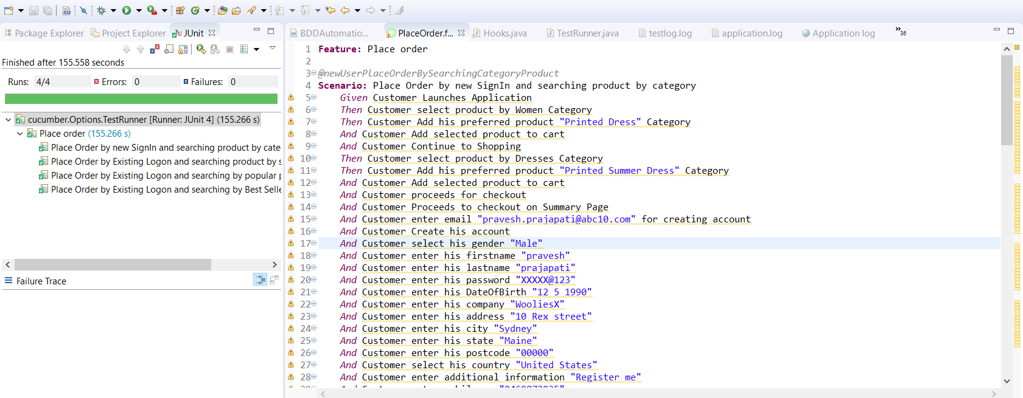

Cucumber html reports

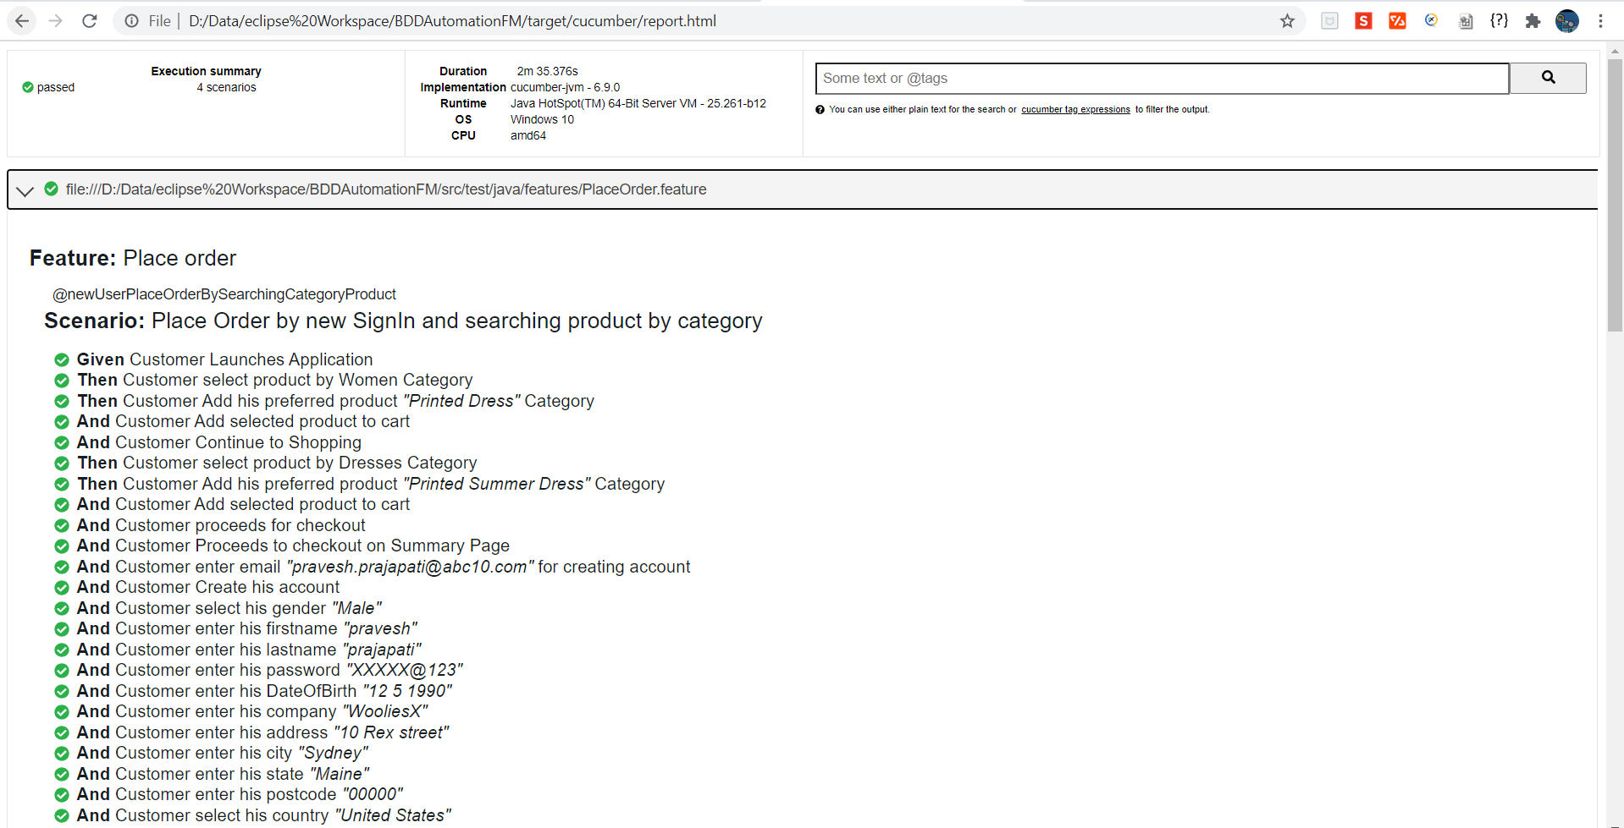

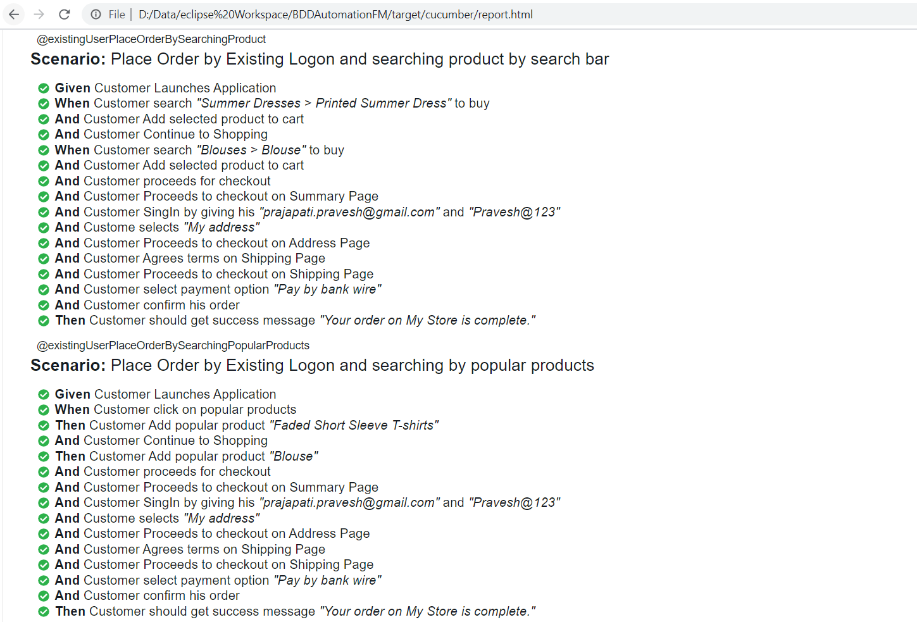

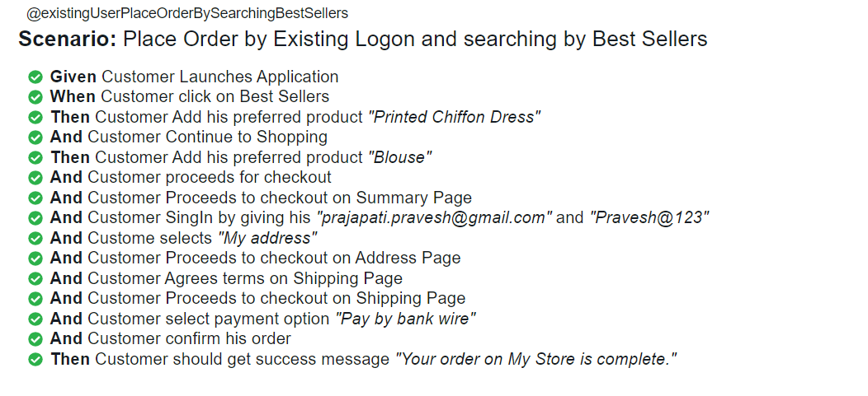

Test results With screenshots

