**What is S3 Lifecycle?**

an S3 Lifecycle configuration is an XML file that consists of a set of rules with predefined actions that we want Amazon S3 to perform on objects during their lifetime.

We can also configure the lifecycle by using the Amazon S3 console, REST API, AWS SDK.

After creation of S3 bucket we need to follow the steps which I have mentioned below.

1.Bucket -> Management -> Lifecycle policy -> Create Lifecycle rule

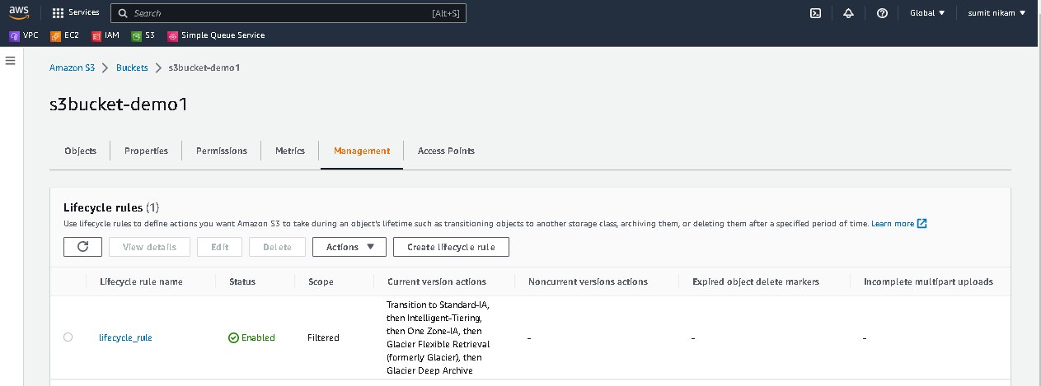

2. Provide all the necessary details like name for lifecycle rule, Prefix for Bucket, and Lifecycle rule actions  
  
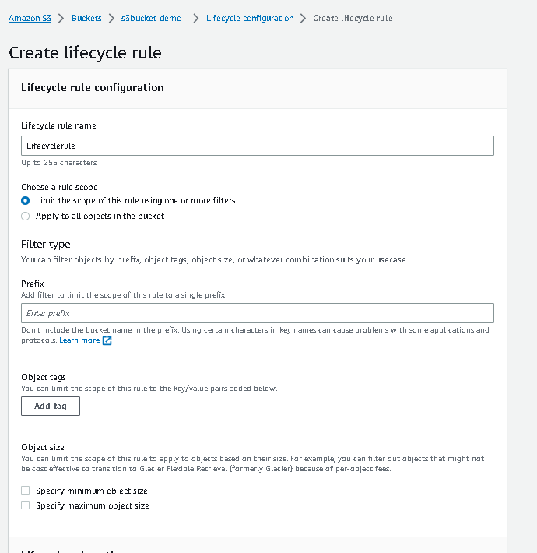

3.We have to provide storage classes with number of days.  
  
Types of classes:  
  
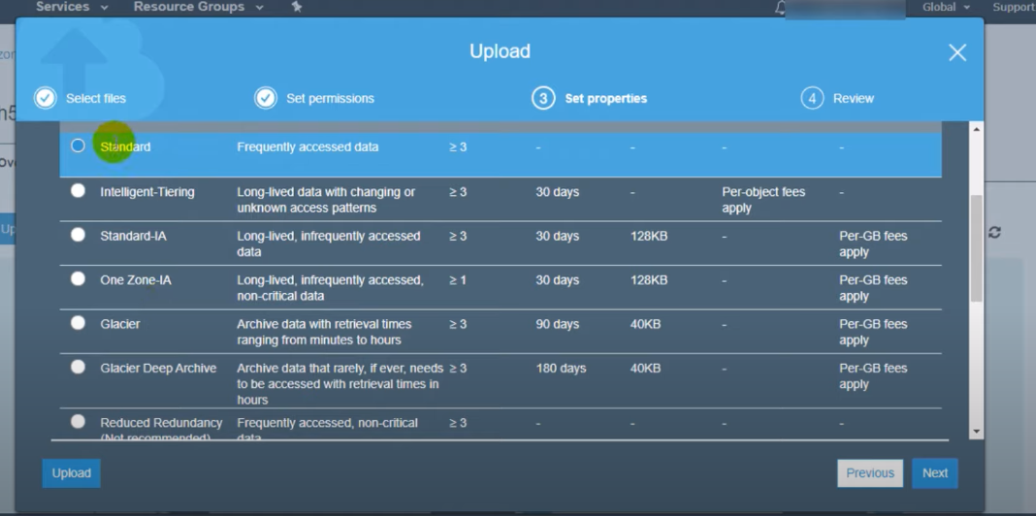

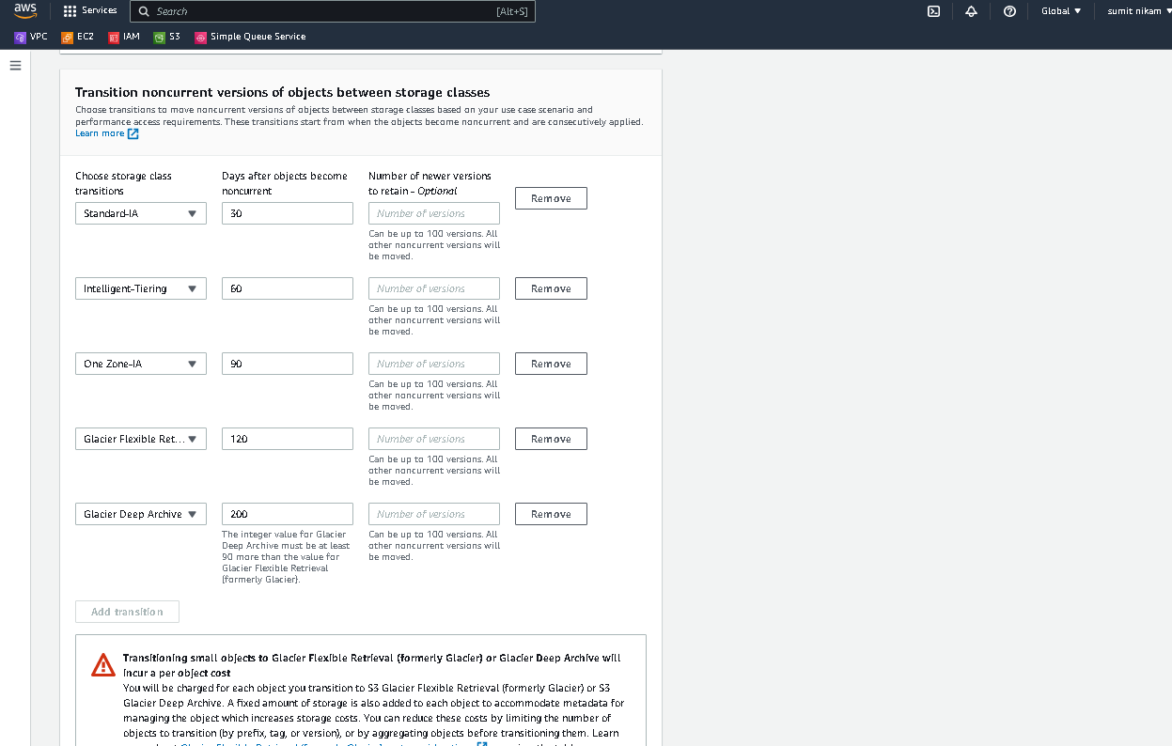  
  
  
1. S3 Standard

S3 Standard offers high durability, availability, and performance object storage for frequently accessed data. Because it delivers low latency and high throughput, S3 Standard is appropriate for a wide variety of use cases, including cloud applications, dynamic websites, content distribution, mobile and gaming applications, and big data analytics. S3 Storage Classes can be configured at the object level and a single bucket can contain objects stored across S3 Standard, S3 Intelligent-Tiring, S3 Standard-IA, and S3 One Zone-IA. You can also use S3 Lifecycle policies to automatically transition objects between storage classes without any application changes.

2.  S3 Intelligent-Tiering

[Amazon S3 Intelligent-Tiering (S3 Intelligent-Tiering)](https://aws.amazon.com/s3/storage-classes/intelligent-tiering/) is the first cloud storage that automatically reduces your storage costs on a granular object level by automatically moving data to the most cost-effective access tier based on access frequency, without performance impact, retrieval fees, or operational overhead. S3 Intelligent-Tiering delivers milliseconds latency and high throughput performance for frequently, infrequently, and rarely accessed data in the Frequent, Infrequent, and Archive Instant Access tiers. You can use S3 Intelligent-Tiering as the default storage class for virtually any workload, especially data lakes, data analytics, new applications, and user-generated content.

For a small monthly object monitoring and automation charge, S3 Intelligent-Tiering monitors access patterns and automatically moves objects that have not been accessed to lower-cost access tiers. S3 Intelligent-Tiering automatically stores objects in three access tiers: one tier that is optimized for frequent access, a 40% lower-cost tier that is optimized for infrequent access, and a 68% lower-cost tier optimized for rarely accessed data. S3 Intelligent-Tiering monitors access patterns and moves objects that have not been accessed for 30 consecutive days to the Infrequent Access tier and after 90 days of no access to the Archive Instant Access tier. For data that does not require immediate retrieval, you can set up S3 Intelligent-Tiering to monitor and automatically move objects that aren’t accessed for 180 days or more to the Deep Archive Access tier to realize up to 95% in storage cost savings.

3.  S3 Standard-Infrequent Access

S3 Standard-IA is for data that is accessed less frequently, but requires rapid access when needed. S3 Standard-IA offers the high durability, high throughput, and low latency of S3 Standard, with a low per GB storage price and per GB retrieval charge. This combination of low cost and high performance make S3 Standard-IA ideal for long-term storage, backups, and as a data store for disaster recovery files. S3 Storage Classes can be configured at the object level and a single bucket can contain objects stored across S3 Standard, S3 Intelligent-Tiering, S3 Standard-IA, and S3 One Zone-IA. You can also use S3 Lifecycle policies to automatically transition objects between storage classes without any application changes.

4. S3 One Zone-Infrequent Access

S3 One Zone-IA is for data that is accessed less frequently, but requires rapid access when needed. Unlike other S3 Storage Classes which store data in a minimum of three Availability Zones (AZs), S3 One Zone-IA stores data in a single AZ and costs 20% less than S3 Standard-IA. S3 One Zone-IA is ideal for customers who want a lower-cost option for infrequently accessed data but do not require the availability and resilience of S3 Standard or S3 Standard-IA. It’s a good choice for storing secondary backup copies of on-premises data or easily re-creatable data. You can also use it as cost-effective storage for data that is replicated from another AWS Region using S3 Cross-Region Replication.

S3 One Zone-IA offers the same high durability†, high throughput, and low latency of S3 Standard, with a low per GB storage price and per GB retrieval charge. S3 Storage Classes can be configured at the object level, and a single bucket can contain objects stored across S3 Standard, S3 Intelligent-Tiering, S3 Standard-IA, and S3 One Zone-IA. You can also use S3 Lifecycle policies to automatically transition objects between storage classes without any application changes.

5. S3 Glacier Instant Retrieval

Amazon S3 Glacier Instant Retrieval is an archive storage class that delivers the lowest-cost storage for long-lived data that is rarely accessed and requires retrieval in milliseconds. With S3 Glacier Instant Retrieval, you can save up to 68% on storage costs compared to using the S3 Standard-Infrequent Access (S3 Standard-IA) storage class, when your data is accessed once per quarter. S3 Glacier Instant Retrieval delivers the fastest access to archive storage, with the same throughput and milliseconds access as the S3 Standard and S3 Standard-IA storage classes. S3 Glacier Instant Retrieval is ideal for archive data that needs immediate access, such as medical images, news media assets, or user-generated content archives. You can upload objects directly to S3 Glacier Instant Retrieval, or use S3 Lifecycle policies to transfer data from the S3 storage classes.

6. S3 Glacier Flexible Retrieval

S3 Glacier Flexible Retrieval delivers low-cost storage, up to 10% lower cost (than S3 Glacier Instant Retrieval), for archive data that is accessed 1—2 times per year and is retrieved asynchronously. For archive data that does not require immediate access but needs the flexibility to retrieve large sets of data at no cost, such as backup or disaster recovery use cases, S3 Glacier Flexible Retrieval (formerly S3 Glacier) is the ideal storage class. S3 Glacier Flexible Retrieval delivers the most flexible retrieval options that balance cost with access times ranging from minutes to hours and with free bulk retrievals. It is an ideal solution for backup, disaster recovery, offsite data storage needs, and for when some data occasionally need to be retrieved in minutes, and you don’t want to worry about costs. S3 Glacier Flexible Retrieval is designed for 99.999999999% (11 9s) of data durability and 99.99% availability by redundantly storing data across multiple physically separated AWS Availability Zones in a given year.

7.  S3 Glacier Deep Archive

S3 Glacier Deep Archive is Amazon S3’s lowest-cost storage class and supports long-term retention and digital preservation for data that may be accessed once or twice in a year. It is designed for customers—particularly those in highly-regulated industries, such as financial services, healthcare, and public sectors—that retain data sets for 7—10 years or longer to meet regulatory compliance requirements. S3 Glacier Deep Archive can also be used for backup and disaster recovery use cases, and is a cost-effective and easy-to-manage alternative to magnetic tape systems, whether they are on-premises libraries or off-premises services. S3 Glacier Deep Archive complements Amazon S3 Glacier, which is ideal for archives where data is regularly retrieved and some of the data may be needed in minutes. All objects stored in S3 Glacier Deep Archive are replicated and stored across at least three geographically-dispersed Availability Zones, protected by 99.999999999% of durability, and can be restored within 12 hours.