# Big Mountain *Revisiting its pricing strategy*

## Brief overview

Big Mountain Resort recently invested in an additional chair lift, increasing its operating cost base by $1.54m this season. A significant investment as such is driving Management to revisit its pricing strategy to determine whether its ticket prices can be adjusted to reflect a more valuable offering from increased facilities provision.

Given competitor data, how much can Big Mountain Resort charge for the services and facilities it provides?

Analyzing the ticket prices of more than 250 competitors in the US and the various facilities and services they provide, we developed a pricing model inferring the relationship between the individual facilities/services and the prices fixed by each resort. Extrapolating this to Big Mountain’s offering, **the model suggests a higher ticket price than the current $81 adult weekend ticket.**

The ultimate aim of the business is to generate higher profits, which in turn, can accelerate the return on investment (ROI) from the chair lift or other initiatives in the future. By uncovering insights as to sensitive pricing is to the various facilities provided, the model can also be used to provide direction for 1) identifying better opportunities to increase prices (and thereby revenue) through certain investments or 2) reducing cost base efficiently with controlled or minimal effect on pricing.

What is the potential impact of specific initiatives on pricing?

Using the model, we explored the potential price impact of the following scenarios:

1. Permanently closing down up to 10 of the least used runs
2. Increase the vertical drop by adding a run to a point 150 feet lower down but requiring the installation of an additional chair lift to bring skiers back up, without additional snow making coverage
3. Same as number 2, but adding 2 acres of snow making
4. Increase the longest run by 0.2 mile to boast 3.5 miles length, requiring an additional snow making coverage of 4 acres

The results of which will be discussed in more detail.

## Findings

Exploratory data analysis uncovered some notable trends as described below.

**General trends per state** *(refer to Figure 1 & 2)*

* Most prices appear to lie in a broad band from around $25 to over $100.
* Resorts in certain states such as Utah, Colorado, Vermont, Arizona, New Jersey, California and Nevada have a much higher average ticket price. Whilst analysis has shown that this can be partially influenced by competition (resorts per capita, resorts per area), it would be interesting to confer with Management on other possible reasons for this.
* New York seems to have more but smaller resorts whereas Montana is the opposite with fewer but larger resorts. Meanwhile, Colorado ranks high in both the number of resorts and the total amount of skiable area, suggesting this is a popular spot for skiing. The top area for both resorts and amount of skiable area tend to be more northerly states.

**Correlation between features** *(refer to Figure 3)*

* Data shows some positive correlation between the ratio of night skiing area and the number of resorts per capita. In other words, it seems that when resorts are more densely located with population, more night skiing is provided.
* In states where resorts per capita is low, ticket prices tend to be quite variable. Prices may drop a little before then climbing upwards as the number of resorts per capita increases. A plausible explanation for the pattern could be that states with fewer resorts per capita are less popular for skiing (less demand), hence, lower ticket prices. On the other hand, there may also be states where there are less resorts compared to the population size, allowing the few resorts to have monopoly effect and thereby, support the higher prices charged. Ticket prices which increase with the resorts per capita could be indicative of popular areas for skiing. To confirm this hypothesis and understand the trend further requires information on *demand for skiing* *in various geographies*, which is currently not in the model.

**Modelling**

* The model confirmed initial findings from the exploratory data analysis, which confirms certain resort parameters are more significant in determining ticket prices.
  + Linear regression model ranks the following characteristics in order of importance: vertical_drop, Snow Making_ac, total_chairs, fastQuads, Runs, LongestRun_mi, trams and SkiableTerrain_ac.
  + This overlaps with findings from the random forest model, where fastQuads, Runs, and Snow Making_ac as the most predictive features of the model. *(refer to Figure 4)*
  + One surprising result, though, is the negative relationship between skiable terrain and prices. There may be other reasons for this which is not accounted for by the current model. Potentially, including proxies for demand (such as the number of visitors or number of tickets sold) can explain the trend.
* In terms of predictive accuracy on the test set, random forest accuracy has a lower-cross validation mean absolute error (MAE) by almost $1 (Linear Regression MAE: $11.79; Random Forest MAE: $9.54) and a lower variance for the MAE (1.35 compared to 1.62 for the Linear Regression model). Hence, this was the preferred model between the two.

## Conclusion

* Big Mountain Resort’s modelled price is $95.87, 18% higher than actual price of $81.00. Even with the expected MAE of $10.39, this suggests that the resort is currently underpricing and that there is room for an increase.
  + The premium pricing is supported by the superior offering of Big Mountain. Big Mountain ranks higher than peers in both the US and in Montana for most of the important features mentioned.
* Of the four scenarios, the first two are predicted to impact pricing:

|  |  |  |
| --- | --- | --- |
| Scenario | Results | Comment |
| Permanently closing down up to 10 of the least used runs | Closing one run makes no difference. However, closing 2 and 3 successively reduces support for ticket price.  If Big Mountain closes down 3 runs, it seems they may as well close down 4 or 5 as there's no further loss in ticket price.  Increasing the closures down to 6 or more leads to a large drop. | Depending on the cost savings from closing a run, the business can consider closing either 2,5,8,9 or 10 runs. |
| Increase the vertical drop by adding a run to 150ft lower, requiring additional chair lift | Supports a price increase of $1.99, resulting into approximately £3.5m over the season | Can be considered depending on costs of implementation |
| Same as above but adding 2 acres of snow making | Same as above; hence adding the two acres of snow does not support a higher price | Not recommended |
| Increase longest run by 0.2 mile to 3.5mi and requiring additional 4-acre snow | No price difference | Not recommended |
|  |  |  |

However, to determine whether the investment will be profitable requires more information about the costs of implementation.

**Limitation**

* With respect to the constraints and scope of the project, the findings should be interpreted considering the methodology and the particular dataset that has been used to make such predictions. The approach also assumed that all other resorts are largely setting prices based on how much people value certain facilities. Essentially this assumes prices are set by a free market.
* The current analysis can be supplemented with other data (i.e. number of tickets sold, location, income distribution in local area) or qualitative analysis (i.e. anticipated competitive reaction) to make findings more robust.

## Appendix

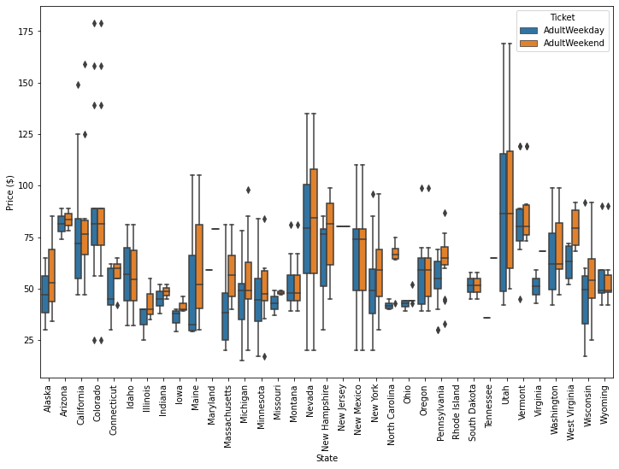

**Figure 1: Weekend vs. Weekday Ticket Prices**

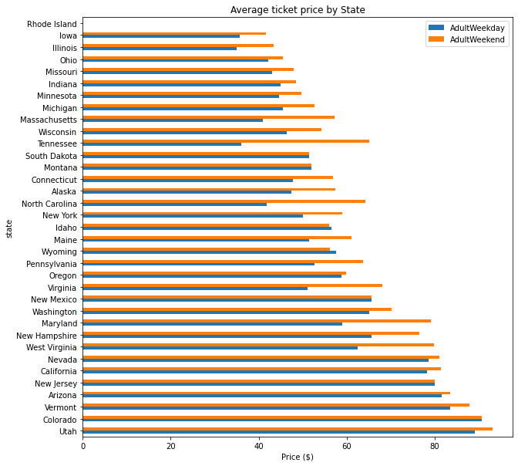

**Figure 2: Average Ticket Price by State**

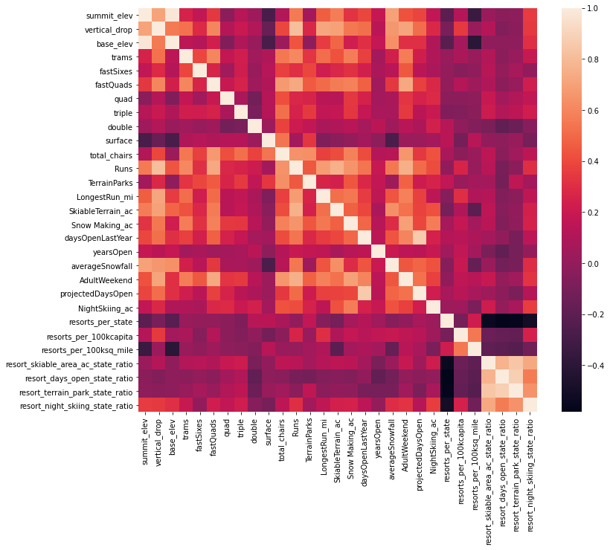

**Figure 3: Feature Correlation Matrix**

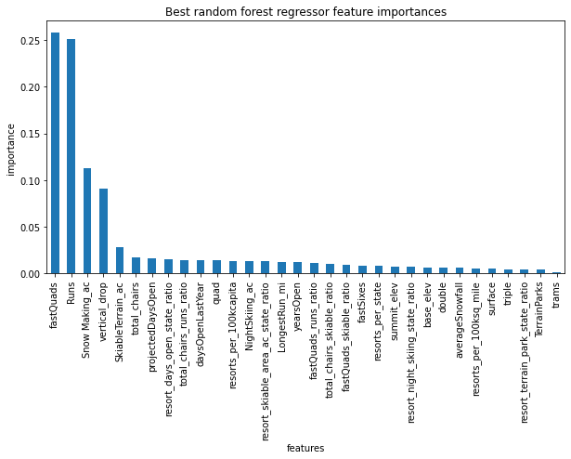

**Figure 4: Feature Importance**