



**ITT 450**

**INFORMATION AND NETWORK SECURITY**

PREPARED BY:

**NIK MOHD ASYRAF BIN MOHAMMED (2017373657)**

CLASS:

**M3CS2453A**

PREPARED FOR:

**MOHD ALI BIN MOHD ISA**

***FAKULTI SAINS KOMPUTER DAN MATEMATIK***

UITM MELAKA, KAMPUS JASIN, MELAKA

2017 / 2018

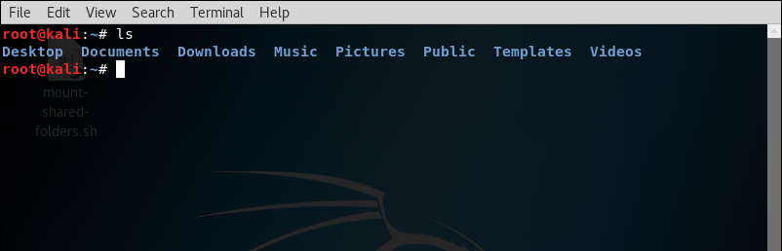**1) ls -** Stands for (List Directory Contents). List the contents of the folder, be it files or folder from which it runs.

**2) cd -** Stands for (change directory). It change the working directory to execute, copy, move write and read from terminal itself.

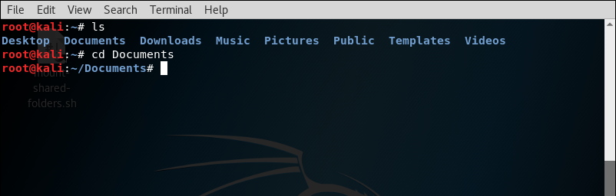 Syntax -

**3) mv -** Moves a file from one location to another location

4) **rm -** Removes files and directory

**5) mkdir -** Creates empty folder

6) **rmdir** - Remove folders

7) **touch** - Create new empty files and also used to change the timestamps

8) **cat** - Allows us to create single or multiple files, view contain of file, concatenate files and redirect output in terminal or files

9) **pwd** - Print working directory

10) **file** - To determine a file’s type

11) **ln** - To create either soft or hard links

12) **chmod** - Used to change file access permissions such as read, write and access

13) **chown** - Used to change file owner and group information

14) **more / less** - To view a text file one page at a time

15) **grep** - To search a word in a single file

16) **wc** - To find out the number of newline count, word count, byte and characters count in a files specified by the files arguments

17) **kill** - Terminate a process

18) **ps** - View the processes running on the system

19) **top** - Shows the top processes based on certain criteria like cpu usage or memory usage

20) **uname**  - Display detailed information about the machine name, Operating System and Kernel

21) **uptime** - To check how long your system is running

22) **ping** - To test the connection and latency between two network connections

23) **netstat** - Monitoring network connections both incoming and outgoing as well as viewing routing tables and interface statistics