ImportData using Transform Maps (Spreadsheet)

Phase-4 -- Project Planning Phase

Date | 28/9/2026
Team Id | SWT ID -2026-5783
Project Name | Import Data using Transform Maps (Spreadsheet)

TeamMembers:

Name | Roll.no
K.Tharanika | U24CSE1450
E.Vijitha | U24CSE1455
K.Kiruthiga | U24CSE1420
N. Suhaila begum | U24CSE1447
K.Thilagapathi | U24CSE1452

ProjectObjectivesPlanning

Defineclearobjectivestoguidetheimplementationandverificationsteps:

- ImportemployeedatafromaspreadsheetintoServiceNowreliably.
- UseanImportSetasastagingarea(u_employee_import).
- UseaTransformMaptomapandmovedataintotheEmployeeTesttable(u_employee_test).
- MaintainEmployeeIDasthe primaryidentifierandCoalescekeytopreventduplicates.
- Supportbothinsert(newrecords)andupdate(existingrecords)operations.
- Validatetransformedrecordsandproducethreereportsandacentralizeddashboard.

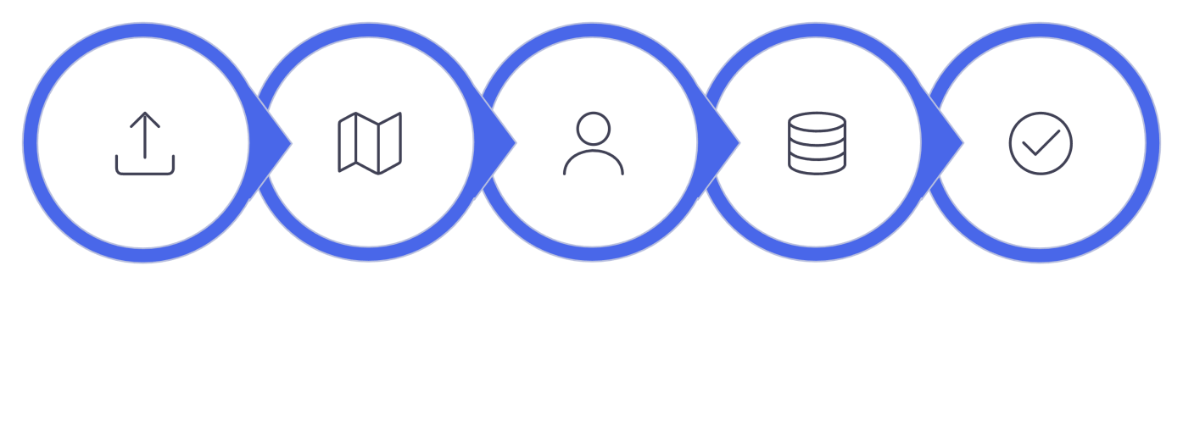
Import
Transform
Match
Upsert
Validate

- PreparethespreadsheetdatabeforeloadingitintotheServiceNowImportSet.
- CreatetheEmployeeImportstagingtable to receive spreadsheetrecords.
- CreatetheEmployeeTesttargettabletostoretransformedemployeerecords.
- ConfiguretheTransformMapbetweentheEmployee ImportandEmployeeTesttables.
- Mapallfiveemployeefieldscorrectlyduringthetransformationprocess.
- UseAutoMapMatchingFieldswherethesourceandtargetfieldnamesmatch.
- UseMappingAssistforfieldsthatrequiremanualmapping.
- Testthetransformationusingnew andexistingEmployeeIDs.
- VerifythetransformationresultsthroughTransformHistoryandtheEmployeeTesttable.
- Provideemployeedatavisibilitythroughdepartment,location,andemployee-listreportsonthe
EmployeeAnalyticsDashboardsdashboard.

DataPlanning

Planthesourceandtargetdatastructureandpreparationrulesbeforeimporting.

- Requiredfieldsinsourceandtarget:EmployeeID,EmployeeName,Email,Department,Location.
- UseconsistentfieldnamesandformatsacrossspreadsheetandServiceNowtables.
- PlacedatainSheet1witha headerrow(row1)describing eachcolumn.
- EnsureEmployeeID ispopulatedforeveryrowtoenableCoalescematching.
- CreateasamplefilenamedSampleSpreadsheet.xlsxforiterativetesting.


Create
Spreadsheet
AddRequired
Fields
Enter
Records
Review
SourceData
Download
Sample

- DefinetheEmployeeIDasthekeyemployeeidentificationfield.
- Prepareemployeedatainastructuredspreadsheetformatbeforeimporting.
- EnsureeachspreadsheetcolumncorrespondstoafieldintheEmployeeImportandEmployeeTest
tables.
- KeepEmployeeNamevaluesreadyforinsertionorupdateduringtransformation.
- PreparevalidEmailvaluesforeachemployeerecord.
- IncludeDepartmentinformationfordepartment-wisereporting.
- IncludeLocationinformationforlocation-wisereporting.
- Planthedatastructuresothesameemployeecanbeidentifiedduringrepeatedimports.
- Preparebothnewemployeerecordsandexistingemployeerecordswithchangedvaluesfor testing.
- Usethe preparedsampledatato verifythe import, transformation,update,andduplicate- prevention process.

TableandStagingPlanning

Definethestagingandtargettables,theirpurpose,andtherationaleforseparation.

- Employee Import (staging): Label = Employee Import, Table = u_employee_import — receives raw spreadsheetrows.
- Employee Test (target): Label = Employee Test, Table = u_employee_test — final store for transformed, validated records.
- Keepstagingandtargetseparatetoallowreviewandcorrectiveactionpriortotransformation.
- Maintainidenticalfieldsetbetweenstagingandtargettosimplifymapping.


Spreadsheet
EmployeeImport
TransformMap
EmployeeTest

- DefineEmployeeImportasthestagingtableforuploadedspreadsheetdata.
- DefineEmployeeTestasthetargettablefortransformedemployeerecords.
- Useu_employee_importasthesourcetablefortheTransformMap.
- Useu_employee_testas thetargettablefortheTransform Map.
- Planthestagingtabletoholdtheimportedspreadsheetrowsbeforetransformation.
- Planthetargettabletocontaintheresultingemployeerecordsaftertransformation.
- Create the target table with fields for Employee ID,Employee Name, Email, Department,and Location.
- Verifythattherequiredfieldsareavailableinthetargettablebeforetransformation.
- Planthetablestructuresosourcefieldscanbemappedtocorrespondingtargetfields.
- Verify the targetEmployee Testrecords aftertransformation to confirm that the planned table structure works correctly.

ImportSetPlanning

PlantheImportSetconfigurationandstandardoperatingstepsforloadingspreadsheetdata.

- ImportSetlabel:EmployeeImport;Table:u_employee_import.
- Sourcefile:SampleSpreadsheet.xlsx,Sheetnumber:1,Headerrow: 1.
- Loadspreadsheetdataintothestagingtableandperformaninitialreviewpriortorunning transforms.
- ReusetheEmployeeImporttableforiterativetestimports;clearorarchivestagingrowsasneeded.
- PlantheImportSetasthestagingareaforspreadsheetemployeedata.
- ConfirmthattheImportSettableiscreatedwiththelabelEmployeeImport.
- Verifythatthetablenameisu_employee_import.
- PlanthespreadsheetuploadusingSampleSpreadsheet.xlsx.
- SelectSheet1duringthefileuploadprocess.
- Userow1 astheheaderrowsothecolumnnamesareidentifiedcorrectly.
- VerifythattheuploadeddataisavailableintheEmployeeImportstagingtable.
- ReviewtheimportedrowsbeforestartingtheTransformoperation.
- ChecktheImportSetstatusandconfirmthatthefileisprocessedsuccessfullybeforetransforming thedata.
- PlantousethesameImportSettableforsubsequenttestuploadsandtransformationactivities.


SourceFile
Sample
Spreadsheet.xlsx
HeaderRow
SetHeaderRow1
Review
Checkimported
records
SelectSheet
ChooseSheet1
LoadData
Importto EmployeeImport

TransformMapPlanning

DesigntheTransformMaptomapsourcefieldstotargetfieldsandpreparemappingsforexecution.

- TransformMapName:SampleSpreadsheetImport.
- SourceTable:u_employee_import;TargetTable:u_employee_test.
- Plansource-to-targetmappingsforallfivefields;enableAutoMapwherecolumnnamesmatch.
- UseMappingAssistforremainingfieldsandreview eachmappingfortypecompatibility.
- PlantheTransformoperationanddocumenttheexpected Insert/Update behavior.
- PlantheTransformMapaftercreatingtheEmployeeImportandEmployeeTesttables.
- Confirmthatthesourcetablecontainstherequiredemployeefieldsbeforetransformation.
- Verifythat thetargettablecontainsmatchingfieldsfor theimportedemployeedata.
- PlanthemappingforEmployeeIDasthekeyfieldforidentifyingemployeerecords.
- PlanmappingsforEmployee Name,Email,Department,andLocation.
- Reviewthefieldnamesandensurethesourceandtargetfieldsarecorrectlyconnected.
- UseAutoMapMatchingFieldswhensourceandtargetcolumnnamesarethesame.
- UseMappingAssisttomanuallyconnectfieldsthatarenotautomaticallymatched.
- Reviewallfield mappingsbeforerunningtheTransformoperation.
- Recordtheexpectedtransformationresult:newEmployeeIDsareinserted,whileexisting Employee IDs are updated when Coalesce is enabled.

Employee
Import
Preparesource spreadsheet
SelectTarget
ChooseEmployee Testtable
Review&Save
Adjustmappings and save map
Create
Transform
Map
Definenewmap forimport
AutoMap
Fields
Runautomatic fieldmatching

CoalesceandDuplicateManagement Planning

Establishduplicatepreventionlogicanddecisionsattransformationtime.

- Assumerepeatedimportsofsimilardata;useCoalescetopreventduplicates.
- SetEmployeeIDastheCoalescefieldtoidentifyexistingrecords.
- Behavior:existingEmployeeID→Updateexistingrecord;newEmployeeID→Insertnewrecord.
- PlantoreviewtransformationhistoryandsamplerecordstoverifyCoalesceresults.

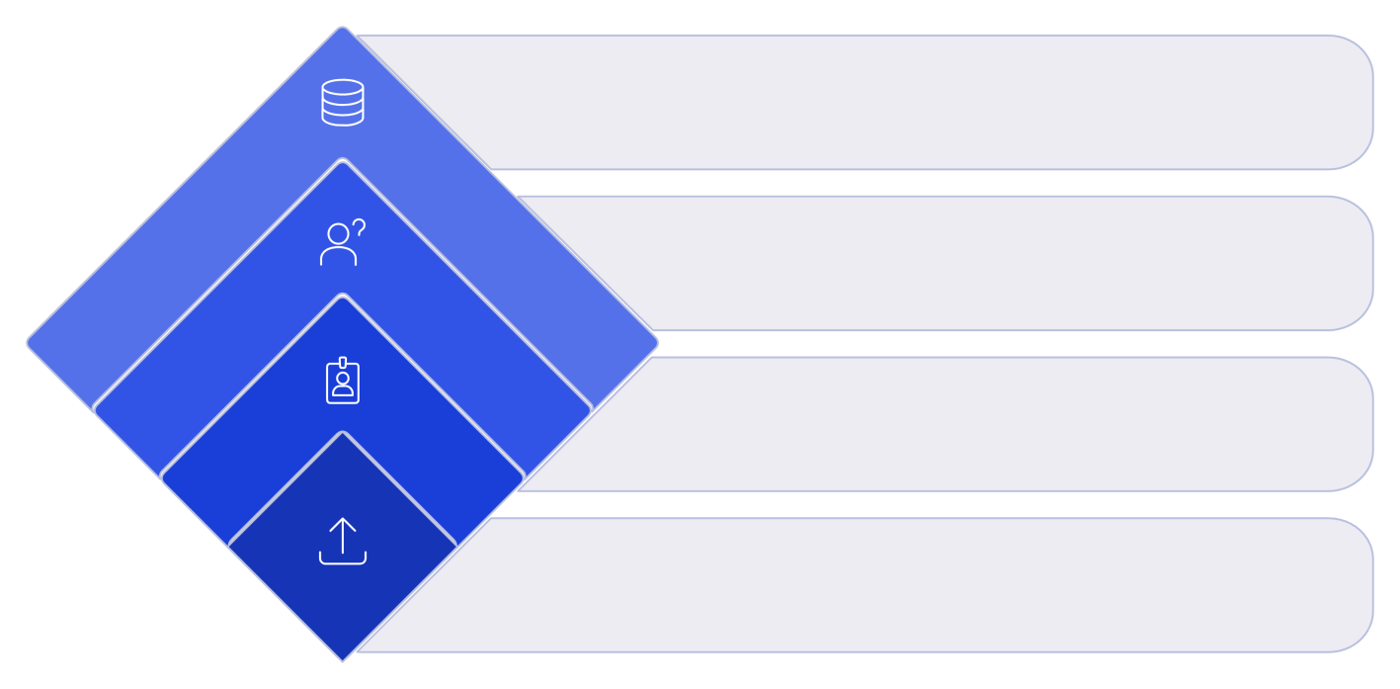
ApplyOutcome
Insert,update,orignore
IDExists?
Decision:updateor insert
CheckID
LookupEmployeeID
ImportRecord
Receiveemployeedata

TestingandValidationPlanning

Definetestscenarios,expectedoutcomes,andthevalidationchecklisttoconfirmcorrectness.

- TesttheinitialimportandverifyrecordsinEmployeeTest.
- Scenariodocumented:upload4rows—2newEmployeeIDs,2existingIDswithchangeddata.
- Expectedfirstrun:2Inserted,2Updated.Repeatingsamespreadsheet:0Inserted,0Updated,4 Ignored.
- Validateinsertedandupdatedresults,reviewtransformationhistory,andconfirmnoduplicates
existinEmployeeTest.
- Verifythattheuploadedspreadsheetcontainstherequiredfivefieldsbeforestartingtheimport.
- ConfirmthattheEmployeeImporttablereceivestheuploadedspreadsheetdatacorrectly.
- CheckthattheTransformMapusesthecorrectsourcetableandtargettable.
- Verifythateachsourcefieldismappedtothecorrespondingtargetfield.
- TestwhethernewEmployeeIDscreatenewrecordsintheEmployeeTesttable.
- TestwhetherexistingEmployeeIDsupdatetheexistingemployeerecordsinsteadofcreating duplicates.
- VerifythatchangedEmployeeNameandEmailvaluesareupdatedcorrectlyforexistingIDs.
- ReviewtheTransformHistorytoconfirmthenumberofinserted,updated,andignoredrecords.
- Re-importthesamespreadsheetandverifythatpreviouslyprocessedrecordsareignored.
- Perform afinalvalidationof the Employee Testtableto confirm the imported dataandduplicate- preventionbehaviorarecorrect.

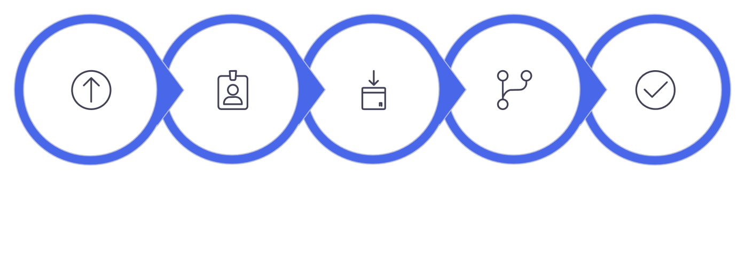
InitialImport
Verify
Employee Test
ImportNew+
Existing
Run
Transform
Check
Results

ReportingandDashboardPlanning

PlanthereportsanddashboardthatwillprovideinsightsfromtheEmployeeTesttable.

- Report1—EmployeesbyDepartment:Source=EmployeeTest,Type=PieChart,Groupby Department, Aggregation = Count.
- Report2—EmployeesbyLocation:Source=EmployeeTest,Type=BarChart,GroupbyLocation, Aggregation = Count.
- Report3—EmployeeListReport:Source=EmployeeTest,Type=ListwithcolumnsEmployeeID,
Name,Email,Department,Location.
- Dashboard: Employee Analytics Dashboards — include the three reports and configure sharing by Users, Groups, and Roles.
- PlanallreportsusingtheEmployeeTesttableasthereportsource.
- Ensurethereportsusetheimported employeerecordsforanalysis.
- PlantheDepartmentreporttoshowthedistributionofemployeesacrossdepartments.
- PlantheLocationreporttoshowthedistribution ofemployeesacrossdifferentlocations.
- UseCountaggregationto determinethenumberofemployeerecordsineachgroup.
- Configureappropriatereportformatssothegroupedemployeedataiseasytounderstand.
- IncludeimportantemployeefieldsintheEmployeeListReportfordetailedrecordviewing.
- VerifythatthethreereportsdisplaytheexpectedEmployeeTestdataafterimportand transformation.
- AddthecompletedreportstotheEmployeeAnalyticsDashboardsdashboard.
- PlandashboardaccessbyconfiguringappropriateUsers,Groups,andRolesforsharing.

Validated
Data
Employee Test table validated
By
Department
GenerateEmployeesby Department
Review&Save
Finalizeandstore reports
CreateReports

Setupreport
templates
ByLocation
Generate Employeesby Location

Activity Sequence and Planning Summary

Presenttheorderedactivitiesrequiredtocompleteimplementationandaconciseacademicsummary of the planning phase.

- Sequencehighlights:preparespreadsheet→createstagingandtargettables→createandsave
TransformMap→configureCoalesce→executetransforms→validateandtest→createreports
→ assembledashboard→ configureaccess→final review.
- Planningestablishesthestructure andsequenceneededtoimplementarepeatable,auditable employee dataimport processusingServiceNowImport Sets andTransformMaps.
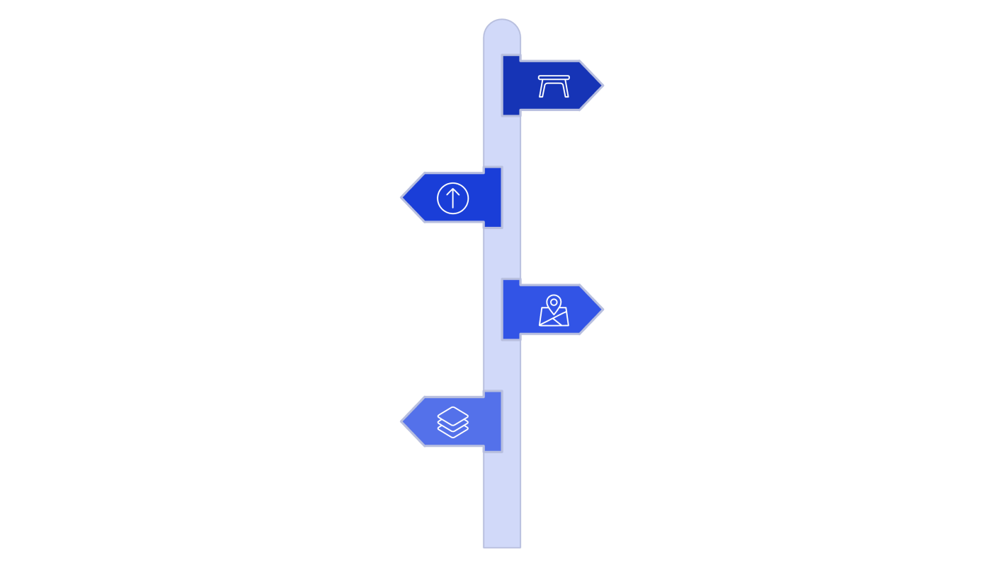
PrepareData
Prepare spreadsheetand staging
Map&
Transform
Createtransform map and field mapping
Report&
Review
Createdashboards and final review
Validate&
Test
BuildTables
Createtestand importtables
Execute
transformation andvalidate records
SpreadsheetPrep
Organizeandvalidatesource data.
ImportSetPlanning
Designstagingandimportworkflows.
TransformMapPlanning
Definemappingsandtransformation rules.
CoalescePlanning
Specifydeduplicationandmergelogic.

