Лабораторная работа №3

Описательные статистики

Данные в таблице содержат метеопараметры и показания по энергопотреблению в нескольких зонах.
В таблице 1 приведены основные статистики, характеризующие случайные величины (количество наблюдений, среднее, доверит., медиана, минимум, максимум, нижняя и верхняя квартиль, размах, квартильн. размах, ст. откл., коэф. вар., станд. ошибки, асимметрия и эксцесс)

Таблица 1
Variable | Descriptive Statistics (Worksheet in power-consumptionLAB3)
Variable | Valid N | Mean | Confidence  -95,000% | Confidence  95,000% | Median | Minimum
Temperature | 300 | 11,1125 | 10,68469 | 11,5403 | 11,82000 | 4,21200
Humidity | 300 | 70,1503 | 69,12637 | 71,1742 | 71,05000 | 52,45000
general diffuse flows | 300 | 116,0644 | 96,04008 | 136,0888 | 0,08400 | 0,01800
diffuse flows | 300 | 25,5521 | 19,85303 | 31,2511 | 0,15400 | 0,06300

Variable | Descriptive Statistics (Worksheet in power-consumptionLAB3)
Variable | Maximum | Lower  Quartile | Upper  Quartile | Range | Quartile  Range | Std.Dev.
Temperature | 15,8300 | 9,04000 | 14,6150 | 11,6180 | 5,5750 | 3,7651
Humidity | 87,0000 | 61,77500 | 77,1000 | 34,5500 | 15,3250 | 9,0120
general diffuse flows | 498,8000 | 0,06200 | 218,6500 | 498,7820 | 218,5880 | 176,2421
diffuse flows | 253,4000 | 0,11900 | 39,9450 | 253,3370 | 39,8260 | 50,1595

Variable | Descriptive Statistics (Worksheet in power-consumptionLAB3)
Variable | Coef.Var. | Standard  Error | Skewness | Kurtosis
Temperature | 33,8822 | 0,21738 | -0,532534 | -0,99118
Humidity | 12,8467 | 0,52031 | -0,126618 | -1,02469
general diffuse flows | 151,8485 | 10,17534 | 1,150332 | -0,34117
diffuse flows | 196,3032 | 2,89596 | 2,970913 | 9,04776

В таблицах 2.1-2.4 приведены основные статистики для различных временных промежутков (ночь 0:00-6:00, утро 6:00-12:00, день 12:00-18:00 и вечер 18:00-0:00)
Таблица 2.1
Variable | Descriptive Statistics (Worksheet in Workbook1_(Recovered))Include condition: "Day Time" = 0
Variable | Valid N | Mean | Confidence  -95,000% | Confidence  95,000% | Median | Minimum
Temperature | 84 | 8,46919 | 7,84679 | 9,09159 | 10,00500 | 4,21200
Humidity | 84 | 77,46429 | 76,78827 | 78,14030 | 77,50000 | 71,00000
general diffuse flows | 84 | 0,06610 | 0,06231 | 0,06988 | 0,06600 | 0,01800
diffuse flows | 84 | 0,13386 | 0,12804 | 0,13967 | 0,13400 | 0,08200

Variable | Descriptive Statistics (Worksheet in Workbook1_(Recovered))Include condition: "Day Time" = 0
Variable | Maximum | Lower  Quartile | Upper  Quartile | Range | Quartile  Range | Std.Dev.
Temperature | 12,42000 | 5,29850 | 10,85000 | 8,20800 | 5,551500 | 2,868044
Humidity | 84,10000 | 75,05000 | 79,25000 | 13,10000 | 4,200000 | 3,115087
general diffuse flows | 0,11700 | 0,05500 | 0,07300 | 0,09900 | 0,018000 | 0,017462
diffuse flows | 0,23000 | 0,11500 | 0,15200 | 0,14800 | 0,037000 | 0,026800

Variable | Descriptive Statistics (Worksheet in Workbook1_(Recovered))Include condition: "Day Time" = 0
Variable | Coef.Var. | Standard  Error | Skewness | Kurtosis
Temperature | 33,86444 | 0,312929 | -0,203272 | -1,75735
Humidity | 4,02132 | 0,339884 | 0,177433 | -0,38269
general diffuse flows | 26,41985 | 0,001905 | 0,403697 | 1,29860
diffuse flows | 20,02141 | 0,002924 | 0,341621 | 0,83863

Таблица 2.2
Variable | Descriptive Statistics (Worksheet in Workbook1_(Recovered))Include condition: "Day Time" = 1
Variable | Valid N | Mean | Confidence  -95,000% | Confidence  95,000% | Median | Minimum
Temperature | 72 | 8,2904 | 7,4861 | 9,0948 | 8,70000 | 4,29000
Humidity | 72 | 74,7028 | 72,4734 | 76,9322 | 74,55000 | 53,26000
general diffuse flows | 72 | 140,0191 | 102,3915 | 177,6466 | 61,54000 | 0,03300
diffuse flows | 72 | 18,4507 | 14,3986 | 22,5027 | 19,82000 | 0,06300

Variable | Descriptive Statistics (Worksheet in Workbook1_(Recovered))Include condition: "Day Time" = 1
Variable | Maximum | Lower  Quartile | Upper  Quartile | Range | Quartile  Range | Std.Dev.
Temperature | 15,2800 | 4,72650 | 9,7700 | 10,9900 | 5,0435 | 3,4230
Humidity | 87,0000 | 70,60000 | 83,9000 | 33,7400 | 13,3000 | 9,4874
general diffuse flows | 440,2000 | 0,07500 | 285,5000 | 440,1670 | 285,4250 | 160,1250
diffuse flows | 43,7400 | 0,14500 | 34,1450 | 43,6770 | 34,0000 | 17,2436

Variable | Descriptive Statistics (Worksheet in Workbook1_(Recovered))Include condition: "Day Time" = 1
Variable | Coef.Var. | Standard  Error | Skewness | Kurtosis
Temperature | 41,2880 | 0,40340 | 0,481798 | -0,77909
Humidity | 12,7002 | 1,11810 | -0,639219 | -0,36487
general diffuse flows | 114,3595 | 18,87092 | 0,646857 | -1,18725
diffuse flows | 93,4580 | 2,03218 | 0,108366 | -1,74852

Таблица 2.3
Variable | Descriptive Statistics (Worksheet in Workbook1_(Recovered))Include condition: "Day Time" = 2
Variable | Valid N | Mean | Confidence  -95,000% | Confidence  95,000% | Median | Minimum
Temperature | 72 | 15,3490 | 15,2562 | 15,4419 | 15,4200 | 13,08000
Humidity | 72 | 58,2743 | 57,7594 | 58,7892 | 58,3150 | 52,45000
general diffuse flows | 72 | 342,7515 | 307,0640 | 378,4390 | 411,4500 | 22,40000
diffuse flows | 72 | 87,0608 | 70,4160 | 103,7057 | 44,2750 | 25,24000

Variable | Descriptive Statistics (Worksheet in Workbook1_(Recovered))Include condition: "Day Time" = 2
Variable | Maximum | Lower  Quartile | Upper  Quartile | Range | Quartile  Range | Std.Dev.
Temperature | 15,8300 | 15,2150 | 15,5850 | 2,7500 | 0,3700 | 0,3952
Humidity | 62,3200 | 56,6750 | 59,4300 | 9,8700 | 2,7550 | 2,1910
general diffuse flows | 498,8000 | 202,4000 | 476,7000 | 476,4000 | 274,3000 | 151,8692
diffuse flows | 253,4000 | 42,0100 | 122,5000 | 228,1600 | 80,4900 | 70,8326

Variable | Descriptive Statistics (Worksheet in Workbook1_(Recovered))Include condition: "Day Time" = 2
Variable | Coef.Var. | Standard  Error | Skewness | Kurtosis
Temperature | 2,57450 | 0,04657 | -2,97789 | 14,65750
Humidity | 3,75983 | 0,25821 | -0,13291 | -0,28723
general diffuse flows | 44,30882 | 17,89795 | -0,64307 | -1,08247

Таблица 2.4
Variable | Descriptive Statistics (Worksheet in Workbook1_(Recovered))Include condition: "Day Time" = 3
Variable | Valid N | Mean | Confidence  -95,000% | Confidence  95,000% | Median | Minimum
Temperature | 72 | 12,78181 | 12,56616 | 12,99746 | 12,87500 | 11,29000
Humidity | 72 | 68,94083 | 68,31677 | 69,56489 | 68,96000 | 63,27000
general diffuse flows | 72 | 0,75410 | 0,12100 | 1,38719 | 0,06600 | 0,02900
diffuse flows | 72 | 0,79933 | 0,16007 | 1,43860 | 0,10600 | 0,06300

Variable | Descriptive Statistics (Worksheet in Workbook1_(Recovered))Include condition: "Day Time" = 3
Variable | Maximum | Lower  Quartile | Upper  Quartile | Range | Quartile  Range | Std.Dev.
Temperature | 14,54000 | 12,05500 | 13,44000 | 3,25000 | 1,385000 | 0,917704
Humidity | 74,80000 | 66,99000 | 70,70000 | 11,53000 | 3,710000 | 2,655710
general diffuse flows | 18,00000 | 0,05100 | 0,08100 | 17,97100 | 0,030000 | 2,694150
diffuse flows | 18,29000 | 0,09300 | 0,13000 | 18,22700 | 0,037000 | 2,720402

Variable | Descriptive Statistics (Worksheet in Workbook1_(Recovered))Include condition: "Day Time" = 3
Variable | Coef.Var. | Standard  Error | Skewness | Kurtosis
Temperature | 7,1798 | 0,108152 | 0,025323 | -1,04287
Humidity | 3,8522 | 0,312978 | -0,084044 | -0,27884
general diffuse flows | 357,2682 | 0,317509 | 4,927015 | 26,63619
diffuse flows | 340,3338 | 0,320602 | 4,966828 | 27,06965

Корреляционная матрица

Таблица 3.1
Variable | Correlations (Worksheet in Workbook1_(Recovered))  Marked correlations are significant at p < ,05000  N=300 (Casewise deletion of missing data)
Variable | Means | Std.Dev. | Temperature | Humidity | diffuse flows
Temperature | 11,1125 | 3,7651 | 1,000000 | -0,683590 | 0,446813
Humidity | 70,1503 | 9,0120 | -0,683590 | 1,000000 | -0,522489
diffuse flows | 25,5521 | 50,1595 | 0,446813 | -0,522489 | 1,000000
general diffuse flows | 116,0644 | 176,2421 | 0,503460 | -0,728481 | 0,439784

Variable | Correlations (Worksheet in Workbook1_(Recovered))  Marked correlations are significant at p < ,05000  N=300 (Casewise deletion of missing data)
Variable | general diffuse flows
Temperature | 0,503460
Humidity | -0,728481
diffuse flows | 0,439784
general diffuse flows | 1,000000

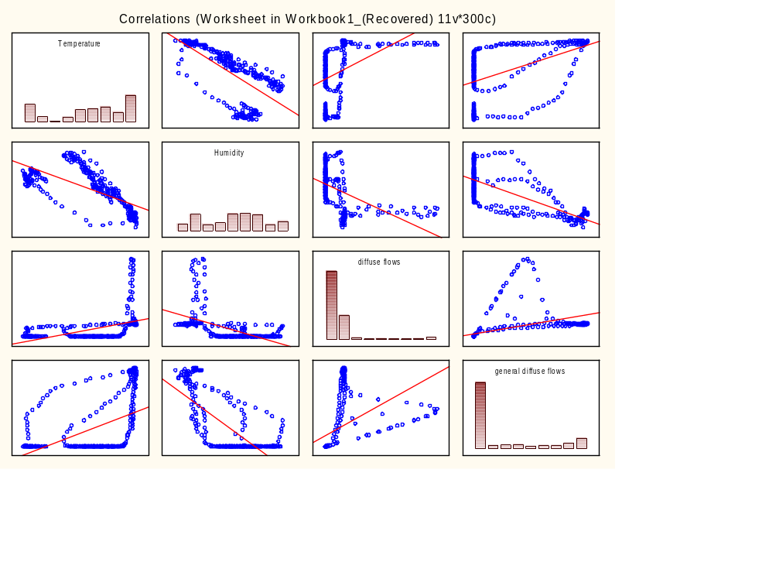
Рис. 1

Таблица 4
Variable | Correlations (Worksheet in Workbook1_(Recovered))  N=300 (Casewise deletion of missing data)
Variable | Temperature | Humidity | diffuse flows | general diffuse flows
Temperature | 1,000000 | -0,683590 | 0,446813 | 0,503460
Humidity | -0,683590 | 1,000000 | -0,522489 | -0,728481
diffuse flows | 0,446813 | -0,522489 | 1,000000 | 0,439784
general diffuse flows | 0,503460 | -0,728481 | 0,439784 | 1,000000

Критерий Стьюдента

В таблице 5.1 p больше 0,05, поэтому гипотезу о равенстве средней разности 0 не отвергаем, т.е. отличие среднего потребления энергии в двух зонах статистически не значимо.

Таблица 5.1
Variable | T-test for Dependent Samples (Worksheet in power-consumptionLAB3)  Marked differences are significant at p < ,05000
Variable | Mean | Std.Dv. | N | Diff. | Std.Dv.  Diff. | t | df | p
Zone 1 | 28478,81 | 6864,907
NewZone | 29337,67 | 6788,496 | 300 | -858,866 | 9891,002 | -1,50399 | 299 | 0,133639

Variable | T-test for Dependent Samples (Worksheet in power-consumptionLAB3)  Marked differences are significant at p < ,05000
Variable | Confidence  -95,000% | Confidence  +95,000%
Zone 1
NewZone | -1982,67 | 264,9342

Рассмотрим реализацию первого метода: t-test, independent, by groups задачи и при интерпретации результатов воспользуемся исследование корреляционных связей пробегов с категориальными переменными Время суток и Сила ветра:

Таблица 6.1
Variable | T-tests; Grouping: Day Time: =iif(DTHour("DateTime")<6;0;(iif(DTHour("D (Worksheet in power-consumptionLAB3)  Group 1: Night  Group 2: Morning
Variable | Mean  Night | Mean  Morning | t-value | df | p | Valid N  Night | Valid N  Morning | Std.Dev.  Night
Zone 1 | 22550,24 | 24029,96 | -3,11520 | 154 | 0,002193 | 84 | 72 | 2713,226
Zone 2 | 14758,10 | 15920,57 | -3,07693 | 154 | 0,002476 | 84 | 72 | 1753,520
Zone 3 | 15383,68 | 13833,17 | 5,67494 | 154 | 0,000000 | 84 | 72 | 1625,784
NewZone | 29088,38 | 29336,25 | -0,22964 | 154 | 0,818673 | 84 | 72 | 6866,487

Variable | T-tests; Grouping: Day Time: =iif(DTHour("DateTime")<6;0;(iif(DTHour("D (Worksheet in power-consumptionLAB3)  Group 1: Night  Group 2: Morning
Variable | Std.Dev.  Morning | F-ratio  Variances | p  Variances
Zone 1 | 3219,824 | 1,408291 | 0,133175
Zone 2 | 2899,681 | 2,734506 | 0,000013
Zone 3 | 1785,342 | 1,205915 | 0,410116
NewZone | 6546,446 | 1,100166 | 0,682056

Диаграммы размаха:

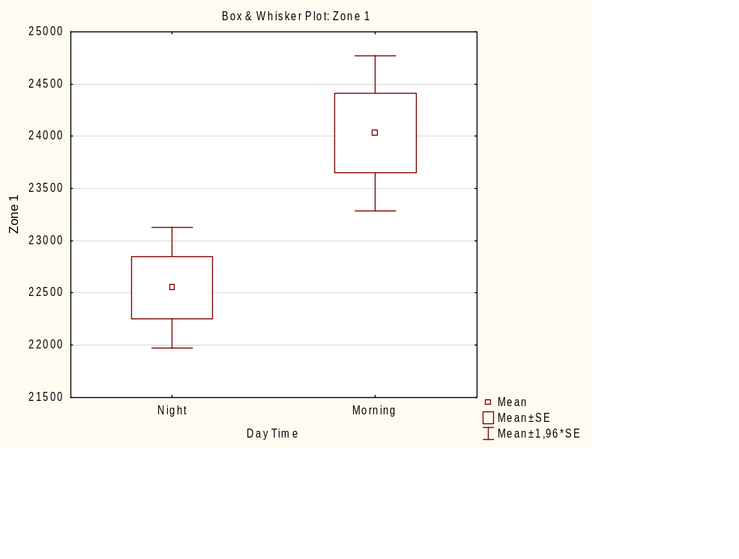
Рис. 2.1
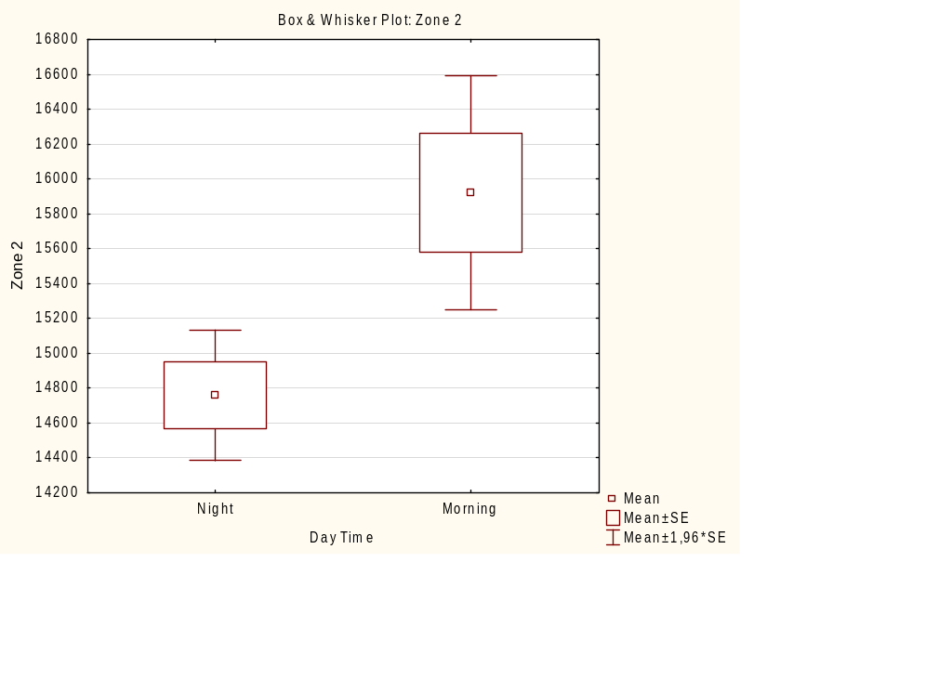
Рис. 2.2

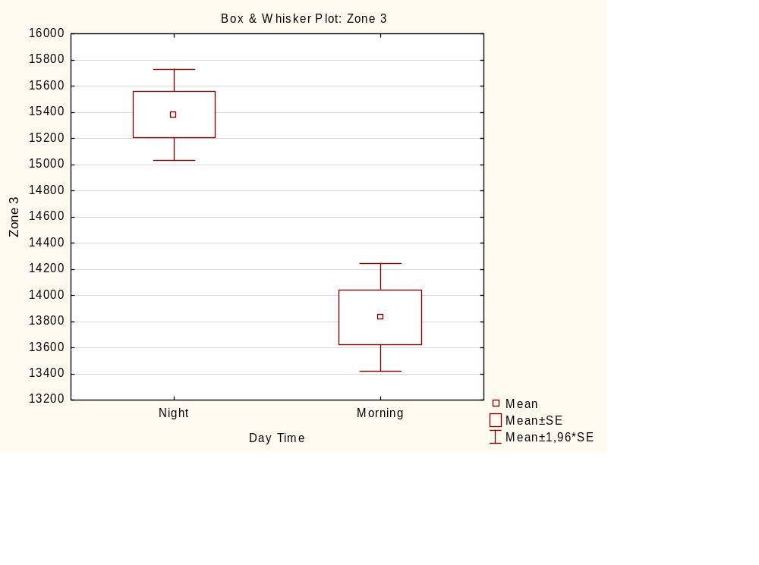
Рис. 2.3

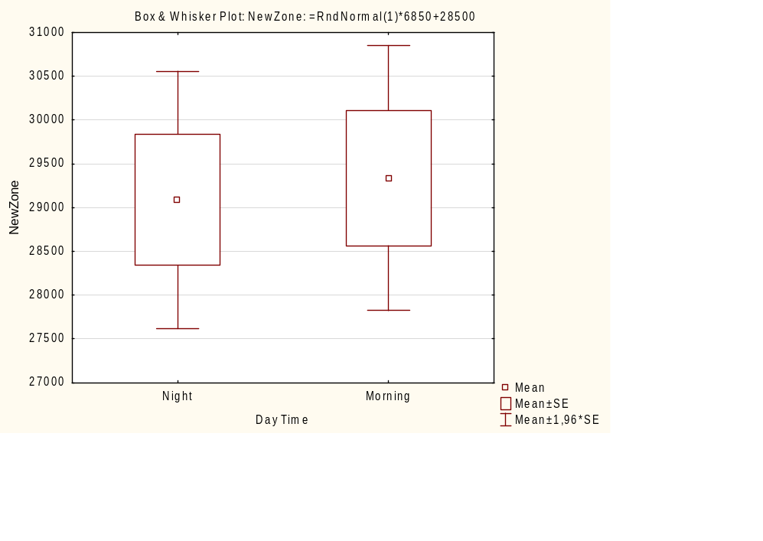
Рис. 2.4

Таблица 6.2
Variable | T-tests; Grouping: Wind: =iif( 'Wind Speed'<1; 0; 1) (Worksheet in power-consumptionLAB3)  Group 1: Calm  Group 2: Strong
Variable | Mean  Calm | Mean  Strong | t-value | df | p | Valid N  Calm | Valid N  Strong | Std.Dev.  Calm
Zone 1 | 28499,26 | 27732,15 | 0,311345 | 298 | 0,755756 | 292 | 8 | 6954,762
Zone 2 | 18599,79 | 16867,02 | 1,094095 | 298 | 0,274797 | 292 | 8 | 4470,774
Zone 3 | 17844,67 | 15248,67 | 1,644540 | 298 | 0,101119 | 292 | 8 | 4456,798
NewZone | 29314,16 | 30195,93 | -0,361932 | 298 | 0,717660 | 292 | 8 | 6819,359

Variable | T-tests; Grouping: Wind: =iif( 'Wind Speed'<1; 0; 1) (Worksheet in power-consumptionLAB3)  Group 1: Calm  Group 2: Strong
Variable | Std.Dev.  Strong | F-ratio  Variances | p  Variances
Zone 1 | 1258,079 | 30,55968 | 0,000082
Zone 2 | 731,603 | 37,34341 | 0,000041
Zone 3 | 528,912 | 71,00349 | 0,000005
NewZone | 5860,312 | 1,35408 | 0,721063

Диаграммы размаха:

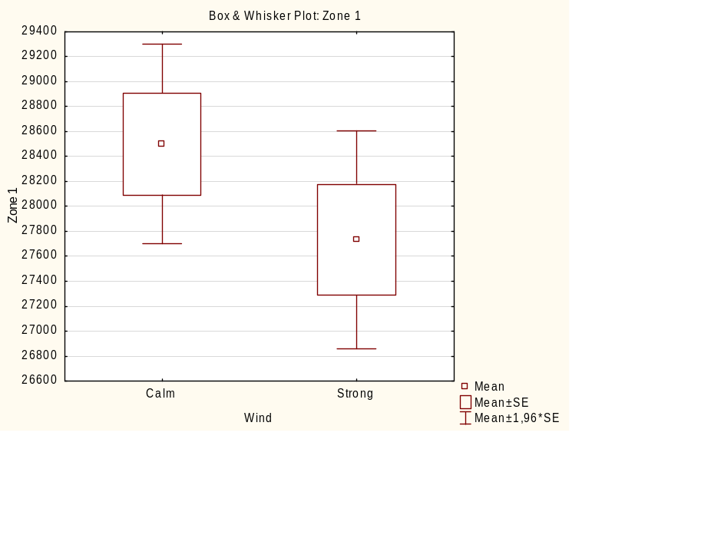
Рис. 3.1

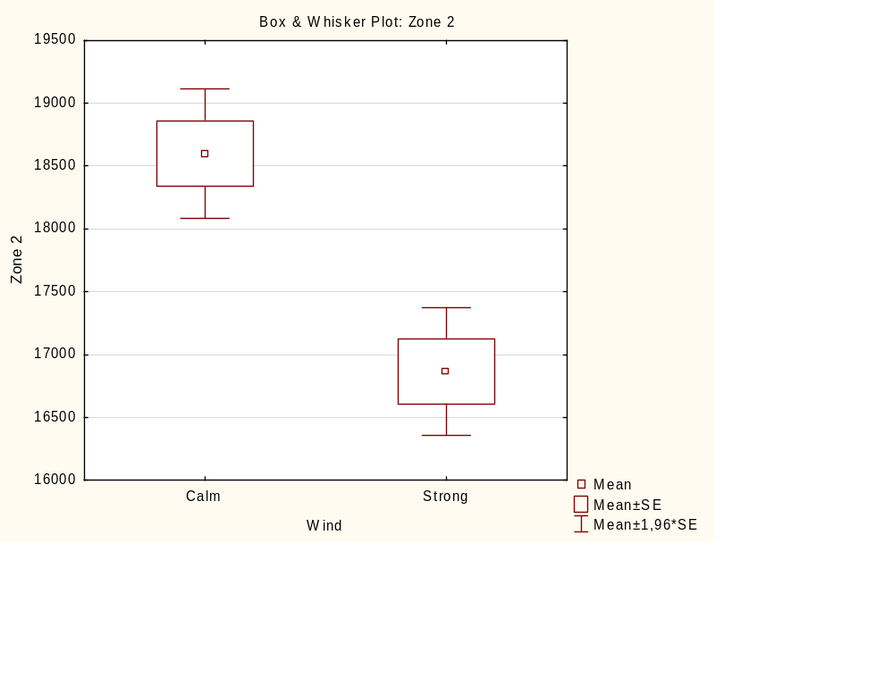
Рис. 3.2

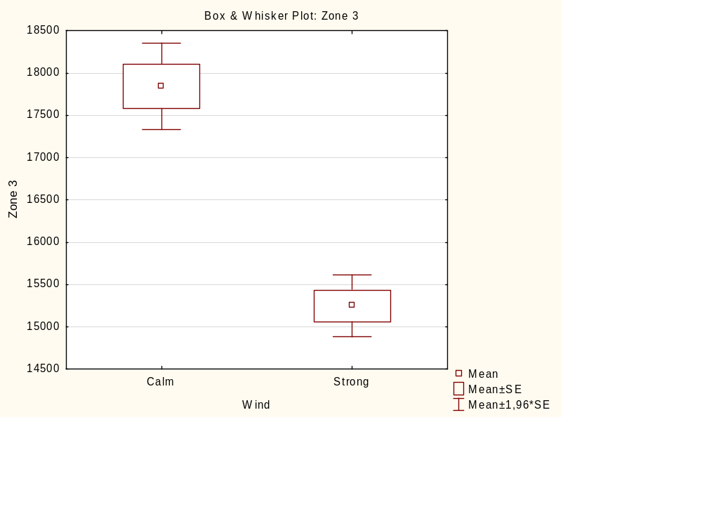
Рис. 3.3

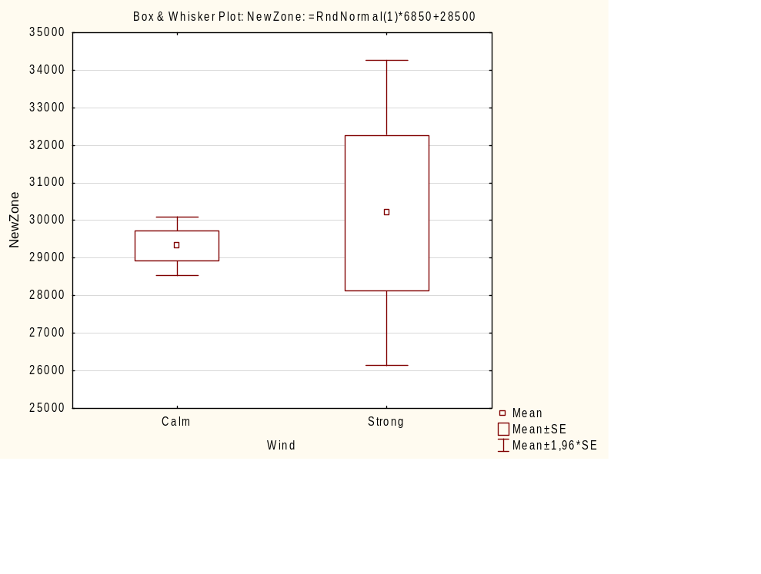
Рис. 3.4

Рассмотрим реализацию второго метода: t-test, independent, by variables. По данным таблицы результатов можно сделать вывод, что верна гипотеза о равенстве средних, при этом также верна гипотеза о равенстве дисперсий.

Таблица 7.1
Group 1 vs. Group 2 | T-test for Independent Samples (Worksheet in power-consumptionLAB3)  Note: Variables were treated as independent samples
Group 1 vs. Group 2 | Mean  Group 1 | Mean  Group 2 | t-value | df | p | Valid N  Group 1 | Valid N  Group 2
Zone 1 vs. NewZone | 28478,81 | 29337,67 | -1,54083 | 598 | 0,123888 | 300 | 300

Group 1 vs. Group 2 | T-test for Independent Samples (Worksheet in power-consumptionLAB3)  Note: Variables were treated as independent samples
Group 1 vs. Group 2 | Std.Dev.  Group 1 | Std.Dev.  Group 2 | F-ratio  Variances | p  Variances
Zone 1 vs. NewZone | 6864,907 | 6788,496 | 1,022639 | 0,846660

Запишем столбец Zone 1 в виде двух столбцов: Zone1 Night и Zone1 Morning отдельно для двух периодов измерения. Они полностью совпали с данными первой строки таблицы 6.1.

Таблица 7.2
Group 1 vs. Group 2 | T-test for Independent Samples (Worksheet in power-consumptionLAB3)  Note: Variables were treated as independent samples
Group 1 vs. Group 2 | Mean  Group 1 | Mean  Group 2 | t-value | df | p | Valid N  Group 1
Zone1 Night vs. Zone1 Morning | 22550,24 | 24029,96 | -3,11520 | 154 | 0,002193 | 84

Group 1 vs. Group 2 | T-test for Independent Samples (Worksheet in power-consumptionLAB3)  Note: Variables were treated as independent samples
Group 1 vs. Group 2 | Valid N  Group 2 | Std.Dev.  Group 1 | Std.Dev.  Group 2 | F-ratio  Variances | p  Variances
Zone1 Night vs. Zone1 Morning | 72 | 2713,226 | 3219,824 | 1,408291 | 0,133175

Рассмотрим реализацию четвертого метода – процедуру t-test, single samples (простые выборки). Предположим известно, что в среднем потребление энергии в зоне 1 в ночное время суток составляет 22500.
Проверим гипотезу, что среднее из выборки не отличается статистически значимо от указанного среднего. Из таблицы 8 следует, что отличие статистически не значимо, а именно, среднее нашей выборки (22550,24) статистически не значимо больше, чем среднее (22500) в генеральной совокупности.

Таблица 8
Variable | Test of means against reference constant (value) (Worksheet in power-consumptionLAB3)Include condition: "Day Time"=0
Variable | Mean | Std.Dv. | N | Std.Err. | Reference  Constant | t-value | df | p
Zone 1 | 22550,24 | 2713,226 | 84 | 296,0372 | 22500,00 | 0,169692 | 83 | 0,865665

