CSYE 7270

Building Virtual Environments

Reinforcement Learning

Professor: Nik Bear Brown

TA: Rohan Bharti <bharti.r@husky.neu.edu>

Reinforcement Learning

Counts towards assignment score

Implement goal oriented behavior using ML-Agents <https://github.com/Unity-Technologies/ml-agents> and see <https://github.com/Unity-Technologies/ml-agents/blob/master/docs/Readme.md>

# (10 Points) Complete Getting Started with the 3D Balance Ball Environment

<https://github.com/Unity-Technologies/ml-agents/blob/master/docs/Getting-Started-with-Balance-Ball.md>

# You MUST change the look of the scene so it is obviously visually different from the out of the box the 3D Balance Ball Environment

Show that you got it working.

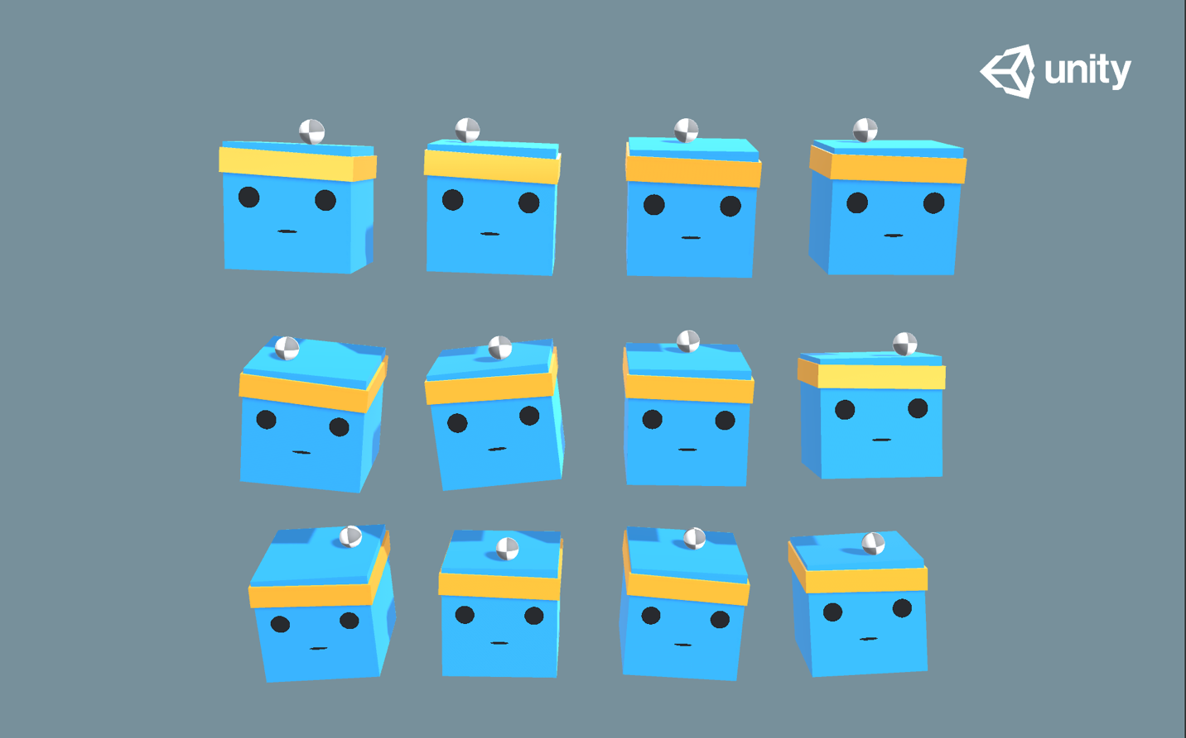

Part 2. Pick An example environment and extend it.

<https://github.com/Unity-Technologies/ml-agents/blob/master/docs/Learning-Environment-Examples.md>

(10 Points) Establish a baseline performance.

(10 Points) You must add at least two more states that improve the performance by at least 5%. 5 point for some improvement one more point for each percent improvement.

(10 Points) Change the  AgentAction() function that improve the performance by at least 5%. 5 point for some improvement one more point for each percent improvement.

(10 Points) Change the rewards, how does it effect the performance?

## (10 Points) Train with mlagents-learn, how does it effect the performance?

# (10 Points) Train with Proximal Policy Optimization, how does it effect the performance?

# (10 Points) Training with Soft-Actor Critic, how does it effect the performance?

(10 Points) Did I explain my evaluation clearly?

Clearly explain the code and testing.

(10 Points) Video

Create a video that explains what you did.

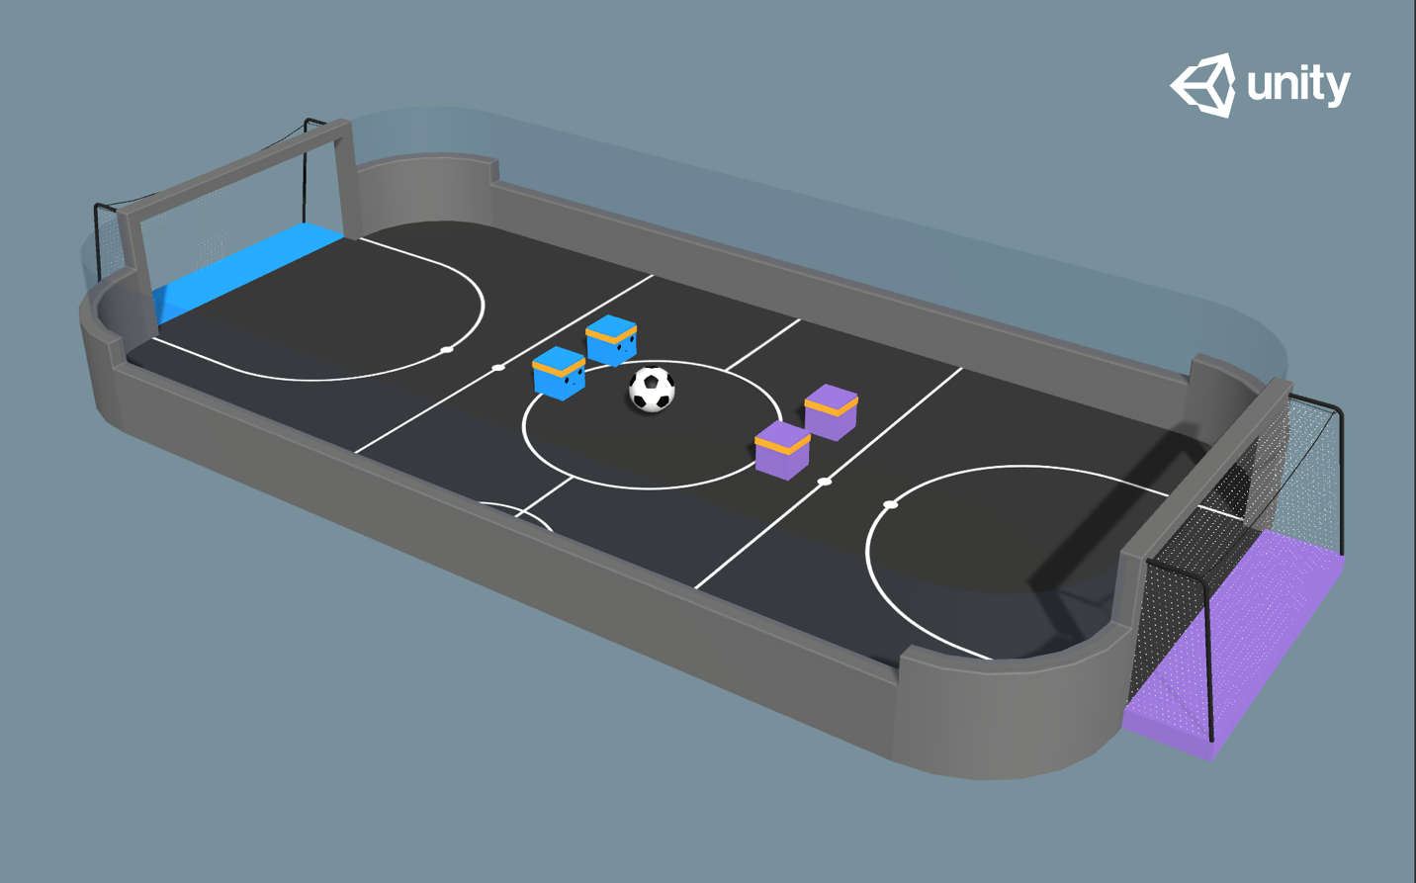

More information on Unity Machine Learning Agents

[**Using Machine Learning Agents in a real game: a beginner’s guide**](https://blogs.unity3d.com/2017/12/11/using-machine-learning-agents-in-a-real-game-a-beginners-guide/) <https://blogs.unity3d.com/2017/12/11/using-machine-learning-agents-in-a-real-game-a-beginners-guide/?>

[**Introducing ML-Agents v0.2: Curriculum Learning, new environments, and more**](https://blogs.unity3d.com/2017/12/08/introducing-ml-agents-v0-2-curriculum-learning-new-environments-and-more/)

<https://blogs.unity3d.com/2017/12/08/introducing-ml-agents-v0-2-curriculum-learning-new-environments-and-more/>

[**Introducing: Unity Machine Learning Agents**](https://blogs.unity3d.com/2017/09/19/introducing-unity-machine-learning-agents/)

<https://blogs.unity3d.com/2017/09/19/introducing-unity-machine-learning-agents>

[**Unity Machine Learning home page**](https://unity3d.ai/)

<https://unity3d.com/machine-learning/>

**Download the latest release on** [**the ML GitHub page.**](https://github.com/Unity-Technologies/ml-agents)

<https://github.com/Unity-Technologies/ml-agents>