CSYE 7374

Autonomous Learning in Games

Assignment 4 – Deep Reinforcement Learning

Unity ML Agents

Professor: Nik Bear Brown

Due: **Sunday, April 5, 2020**

TAs

Dikshant Rathi [rathi.d@husky.neu.edu](mailto:rathi.d@husky.neu.edu)

Note: There is a third option related to learning about GANS for Assignment 4 if you would rather that than some form of RL.

Implement deep reinforcement learning using ML-Agents <https://github.com/Unity-Technologies/ml-agents> and see <https://github.com/Unity-Technologies/ml-agents/blob/master/docs/Readme.md>

Pick an ML-Agent environment or find a YouTube tutorial that uses deep reinforcement learning.

<https://github.com/Unity-Technologies/ml-agents/blob/master/docs/Learning-Environment-Examples.md>

(10 Points) Establish a baseline performance with some default deep learning hyperparameters.

(20 Points) You must explain the CNN hyperparameters you used and show the effect on the performance of at least one important hyperparameter.

(10 Points) Change the  AgentAction() function that improve the performance by at least 5%. 5 point for some improvement one more point for each percent improvement.

(10 Points) Change the rewards, how does it effect the performance?

# (15 Points) Train with Proximal Policy Optimization, how does it effect the performance?

# (15 Points) Training with Soft-Actor Critic, how does it effect the performance?

(10 Points) Did I explain my evaluation clearly?

Clearly explain the code and testing.

(10 Points) Video

Create a video that explains what you did.

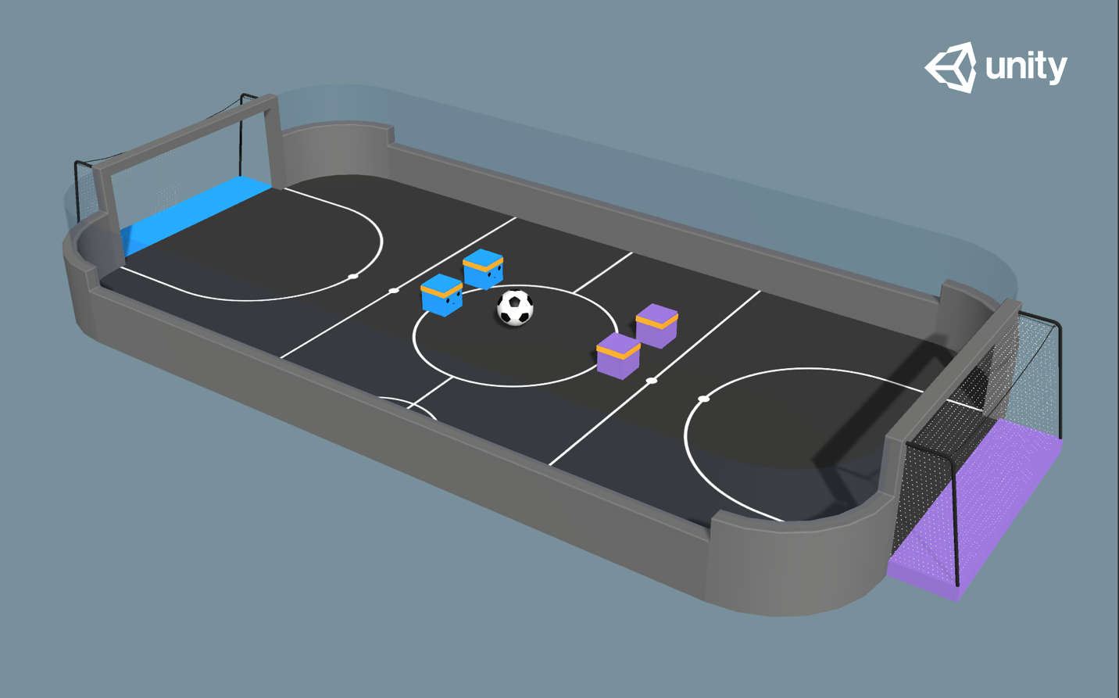

More information on Unity Machine Learning Agents

[**Using Machine Learning Agents in a real game: a beginner’s guide**](https://blogs.unity3d.com/2017/12/11/using-machine-learning-agents-in-a-real-game-a-beginners-guide/) <https://blogs.unity3d.com/2017/12/11/using-machine-learning-agents-in-a-real-game-a-beginners-guide/?>

[**Introducing ML-Agents v0.2: Curriculum Learning, new environments, and more**](https://blogs.unity3d.com/2017/12/08/introducing-ml-agents-v0-2-curriculum-learning-new-environments-and-more/)

<https://blogs.unity3d.com/2017/12/08/introducing-ml-agents-v0-2-curriculum-learning-new-environments-and-more/>

[**Introducing: Unity Machine Learning Agents**](https://blogs.unity3d.com/2017/09/19/introducing-unity-machine-learning-agents/)

<https://blogs.unity3d.com/2017/09/19/introducing-unity-machine-learning-agents>

[**Unity Machine Learning home page**](https://unity3d.ai/)

<https://unity3d.com/machine-learning/>

**Download the latest release on** [**the ML GitHub page.**](https://github.com/Unity-Technologies/ml-agents)

<https://github.com/Unity-Technologies/ml-agents>