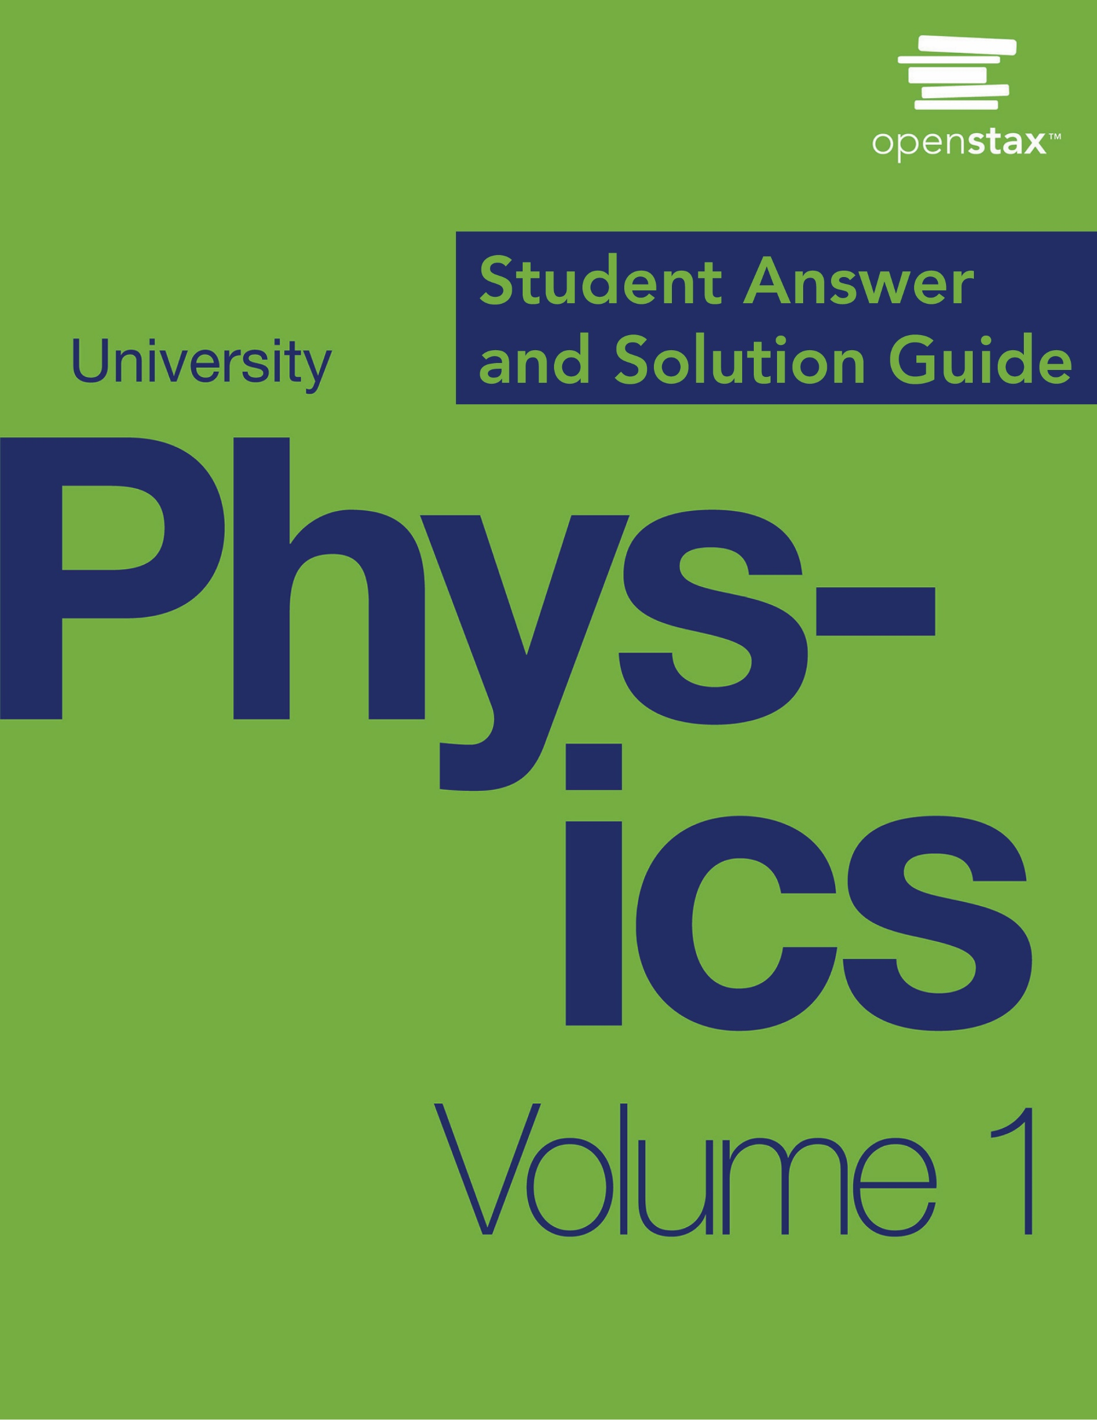

***University Physics Volume I***

**Unit 1: Mechanics**

**Chapter 1: Units and Measurement**

**Conceptual Questions**

1. What is physics?

Solution

Physics is the science concerned with describing the interactions of energy, matter, space, and time to uncover the fundamental mechanisms that underlie every phenomenon.

3. If two different theories describe experimental observations equally well, can one be said to be more valid than the other (assuming both use accepted rules of logic)?

Solution

No, neither of these two theories is more valid than the other. Experimentation is the ultimate decider. If experimental evidence does not suggest one theory over the other, then both are equally valid. A given physicist might prefer one theory over another on the grounds that one seems more simple, more natural, or more beautiful than the other, but that physicist would quickly acknowledge that he or she cannot say the other theory is invalid. Rather, he or she would be honest about the fact that more experimental evidence is needed to determine which theory is a better description of nature.

5. Certain criteria must be satisfied if a measurement or observation is to be believed. Will the criteria necessarily be as strict for an expected result as for an unexpected result?

Solution

Probably not. As the saying goes, “Extraordinary claims require extraordinary evidence.”

7. Identify some advantages of metric units.

Solution

Conversions between units require factors of 10 only, which simplifies calculations. Also, the same basic units can be scaled up or down using metric prefixes to sizes appropriate for the problem at hand.

9. What is the difference between a base unit and a derived unit? (b) What is the difference between a base quantity and a derived quantity? (c) What is the difference between a base quantity and a base unit?

Solution

a. Base units are defined by a particular process of measuring a base quantity whereas derived units are defined as algebraic combinations of base units. b. A base quantity is chosen by convention and practical considerations. Derived quantities are expressed as algebraic combinations of base quantities. c. A base unit is a standard for expressing the measurement of a base quantity within a particular system of units. So, a measurement of a base quantity could be expressed in terms of a base unit in any system of units using the same base quantities. For example, length is a base quantity in both SI and the English system, but the meter is a base unit in the SI system only.

11. (a) What is the relationship between the precision and the uncertainty of a measurement? (b) What is the relationship between the accuracy and the discrepancy of a measurement?

Solution

a. Uncertainty is a quantitative measure of precision. b. Discrepancy is a quantitative measure of accuracy.

13. What should you do after obtaining a numerical answer when solving a problem?

Solution

Check to make sure it makes sense and assess its significance.

**Problems**

15. Use the orders of magnitude you found in the previous problem to answer the following questions to within an order of magnitude. (a)How many electrons would it take to equal the mass of a proton? (b)How many Earths would it take to equal the mass of the Sun? (c) How many Earth–Moon distances would it take to cover the distance from Earth to the Sun? (d) How many Moon atmospheres would it take to equal the mass of Earth’s atmosphere? (e) How many moons would it take to equal the mass of Earth? (f)How many protons would it take to equal the mass of the Sun?

Solution

a. 10–27/10–30 = 103; b. 1030/1025 = 105; c. 1011/109 = 102;d. 1019/104 = 1015;e. 1025/1023 = 102; f. 1030/10–27 = 1057

For the remaining questions, you need to use the following figure to obtain the necessary orders of magnitude of lengths, masses, and times.

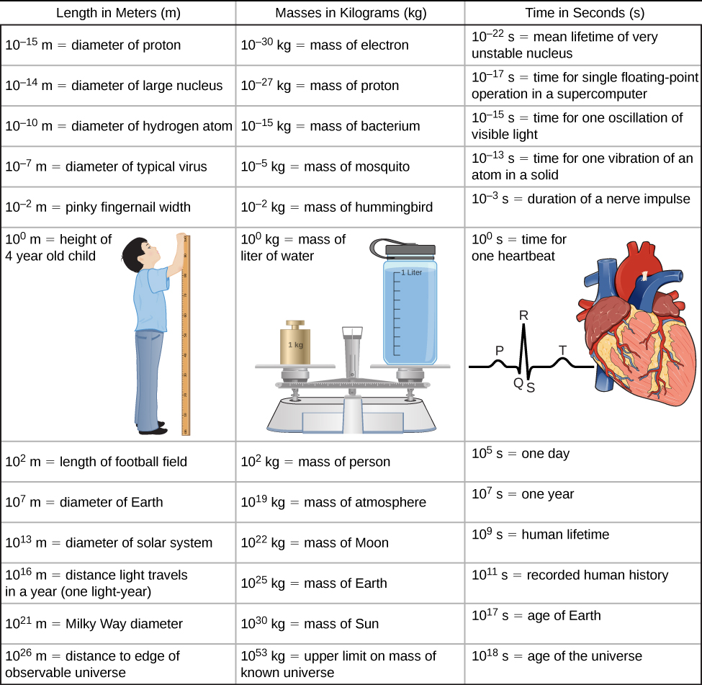

17. A generation is about one-third of a lifetime. Approximately how many generations have passed since the year 0?

Solution

102 generations

19. Calculate the approximate number of atoms in a bacterium. Assume the average mass of an atom in the bacterium is 10 times the mass of a proton.

Solution

1011 atoms

21. Assuming one nerve impulse must end before another can begin, what is the maximum firing rate of a nerve in impulses per second?

Solution

103 nerve impulses/s

23. Roughly how many floating-point operations can a supercomputer perform in a human lifetime?

Solution

109/10–17 = 1026 floating-point operations per human lifetime

25. The following times are given in seconds. Use metric prefixes to rewrite them so the numerical value is greater than one but less than 1000. For example, s could be written as either 7.9 cs or 79 ms. (a) s; (b) 0.045 s; (c) s; (d)  s.

Solution

a. 957 ks; b. 4.5 cs or 45 ms; c. 550 ns; d. 31.6 Ms

27. The following lengths are given in meters. Use metric prefixes to rewrite them so the numerical value is bigger than one but less than 1000. For example,  m could be written either as 7.9 cm or 79 mm. (a) m; (b) 0.0074 m; (c)  m; (d)  m.

Solution

a. 75.9 Mm; b. 7.4 mm; c. 88 pm; d. 16.3 Tm

29. The following masses are given in kilograms. Use metric prefixes on the gram to rewrite them so the numerical value is bigger than one but less than 1000. For example,  kg could be written as 70 cg or 700 mg. (a) kg; (b) kg; (c) kg; (d) kg; (e) kg.

Solution

a. 3.8 cg or 38 mg; b. 230 Eg; c. 24 ng; d. 8 Eg e. 4.2 g

31. The speed limit on some interstate highways is roughly 100 km/h. (a) What is this in meters per second? (b) How many miles per hour is this?

Solution

a. 27.8 m/s; b. 62 mi/h

33. In SI units, speeds are measured in meters per second (m/s). But, depending on where you live, you’re probably more comfortable of thinking of speeds in terms of either kilometers per hour (km/h) or miles per hour (mi/h). In this problem, you will see that 1 m/s is roughly 4 km/h or 2 mi/h, which is handy to use when developing your physical intuition. More precisely, show that (a) and (b).

Solution

a.  km/h; b.  mi/h

35. Soccer fields vary in size. A large soccer field is 115 m long and 85.0 m wide. What is its area in square feet? (Assume that 1 m = 3.281 ft.)

Solution



37. Mount Everest, at 29,028 ft, is the tallest mountain on Earth. What is its height in kilometers? (Assume that 1 m = 3.281 ft.)

Solution

39. Tectonic plates are large segments of Earth’s crust that move slowly. Suppose one such plate has an average speed of 4.0 cm/yr. (a) What distance does it move in 1.0 s at this speed? (b) What is its speed in kilometers per million years?

Solution

a. ; b. 40 km/My

41. The density of nuclear matter is about 1018 kg/m3. Given that 1 mL is equal in volume to cm3, what is the density of nuclear matter in megagrams per microliter (that is,)?

Solution



43. A commonly used unit of mass in the English system is the pound-mass, abbreviated lbm, where 1 lbm = 0.454 kg. What is the density of water in pound-mass per cubic foot?

Solution

* 1. lbm/ft3

45. It takes  radians (rad) to get around a circle, which is the same as 360°. How many radians are in 1°?

Solution

* 1. d

47. A light-nanosecond is the distance light travels in 1 ns. Convert 1 ft to light-nanoseconds.

Solution

1 light-nanosecond

49. A fluid ounce is about 30 mL. What is the volume of a 12 fl-oz can of soda pop in cubic meters?

Solution

 m3

51. Consider the physical quantities *s*, *v, a,* and *t* with dimensions , , , and . Determine whether each of the following equations is dimensionally consistent. (a) ; (b) ; (c) ; (d) .

Solution

a. Yes, both terms have dimension L2T-2 b. No. c. Yes, both terms have dimension LT-1 d. Yes, both terms have dimension LT-2

53. Suppose quantity  is a length and quantity  is a time. Suppose the quantities  and  are defined by *v* = *ds*/*dt* and *a* = *dv*/*dt*. (a) What is the dimension of *v*? (b) What is the dimension of the quantity *a*? What are the dimensions of (c), (d) , and (e) *da*/*dt*?

Solution

a. [v] = LT–1; b. [a] = LT–2; c.  = L; d. LT–1; e. LT–3

55. The arc length formula says the length  of arc subtended by angle  in a circle of radius  is given by the equation . What are the dimensions of (a) *s*, (b) *r*, and (c) ?

Solution

a. L; b. L; c. L0 = 1 (that is, it is dimensionless)

57. Assuming the human body is primarily made of water, estimate the number of molecules in it. (Note that water has a molecular mass of 18 g/mol and there are roughly 1024 atoms in a mole.)

Solution

(102 kg/(10–2 kg/mol))(1024 atoms/mol) = 1028 atoms

59. Estimate the number of molecules that make up Earth, assuming an average molecular mass of 30 g/mol. (Note there are on the order of 1024 objects per mole.)

Solution

[1025 kg/(10–2 kg/mol)](1024 molecules/mol) = 1051 molecules

61. Roughly how many solar systems would it take to tile the disk of the Milky Way?

Solution

(1021 m/1013 m)2 = 1016 solar systems

63. The average density of the Sun is on the order 103 kg/m3. (a) Estimate the diameter of the Sun. (b) Given that the Sun subtends at an angle of about half a degree in the sky, estimate its distance from Earth.

Solution

a. Volume is 1030 kg/(103 kg/m3) = 1027 m3, so diameter is 109 m.; b. 109 m/10–2 = 1011 m

65. A floating-point operation is a single arithmetic operation such as addition, subtraction, multiplication, or division. (a) Estimate the maximum number of floating-point operations a human being could possibly perform in a lifetime. (b) How long would it take a supercomputer to perform that many floating-point operations?

Solution

a. A reasonable estimate might be one operation per second for a total of 109 in a lifetime.; b. about (109)(10–17 s) = 10–8 s, or about 10 ns

67. Suppose your bathroom scale reads your mass as 65 kg with a 3% uncertainty. What is the uncertainty in your mass (in kilograms)?

Solution

2 kg

69. An infant’s pulse rate is measured to be 130 ± 5 beats/min. What is the percent uncertainty in this measurement?

Solution

4%

71. A can contains 375 mL of soda. How much is left after 308 mL is removed?

Solution

67 mL

73. (a) How many significant figures are in the numbers 99 and 100.? (b) If the uncertainty in each number is 1, what is the percent uncertainty in each? (c) Which is a more meaningful way to express the accuracy of these two numbers: significant figures or percent uncertainties?

Solution

a. The number 99 has 2 significant figures; 100. has 3 significant figures. b. 1.00%; c. percent uncertainties

75. (a) A person’s blood pressure is measured to be  What is its percent uncertainty? (b) Assuming the same percent uncertainty, what is the uncertainty in a blood pressure measurement of 80 mm Hg?

Solution

a. 2%; b. 1 mm Hg

77. What is the area of a circle 3.102 cm in diameter?

Solution

* 1. 2

79. Perform the following calculations and express your answer using the correct number of significant digits. (a) A woman has two bags weighing 13.5 lb and one bag with a weight of 10.2 lb. What is the total weight of the bags? (b) The force *F* on an object is equal to its mass *m* multiplied by its acceleration *a*. If a wagon with mass 55 kg accelerates at a rate of 0.0255 m/s2, what is the force on the wagon? (The unit of force is called the *newton* and it is expressed with the symbol N.)

Solution

a. 37.2 lb; because the number of bags is an exact value, it is not considered in the significant figures; b. 1.4 N; because the value 55 kg has only two significant figures, the final value must also contain two significant figures

**Additional Problems**

81. Consider the equation  where *s* is a length and *t* is a time. What are the dimensions and SI units of (a) , (b) , (c) , (d) , (e) , and (f) *c*?

Solution

a.  and units are meters (m); b.  and units are meters per second (m/s); c.  and units are meters per second squared (m/s2); d.  and units are meters per second cubed (m/s3); e.  and units are m/s4; f. and units are m/s5.

83. A marathon runner completes a 42.188-km course in 2 h, 30 min, and 12 s. There is an uncertainty of 25 m in the distance traveled and an uncertainty of 1 s in the elapsed time. (a) Calculate the percent uncertainty in the distance. (b) Calculate the percent uncertainty in the elapsed time. (c) What is the average speed in meters per second? (d) What is the uncertainty in the average speed?

Solution

a. 0.059%; b. 0.01%; c. 4.681 m/s; d. 0.07%, 0.003 m/s

85. When nonmetric units were used in the United Kingdom, a unit of mass called the pound-mass (lbm) was used, where 1 lbm = 0.4539 kg. (a) If there is an uncertainty of 0.0001 kg in the pound-mass unit, what is its percent uncertainty? (b) Based on that percent uncertainty, what mass in pound-mass has an uncertainty of 1 kg when converted to kilograms?

Solution

a. 0.02%; b. 1×104 lbm

87. A car engine moves a piston with a circular cross-section of 7.500 ± 0.002 cm in diameter a distance of 3.250 ± 0.001 cm to compress the gas in the cylinder. (a) By what amount is the gas decreased in volume in cubic centimeters? (b) Find the uncertainty in this volume.

Solution

a. 143.6 cm3; b. 0.1 cm3 or 0.84%

**Challenge Problems**

89. The purpose of this problem is to show the entire concept of dimensional consistency can be summarized by the old saying “You can’t add apples and oranges.” If you have studied power series expansions in a calculus course, you know the standard mathematical functions such as trigonometric functions, logarithms, and exponential functions can be expressed as infinite sums of the form  where the  are dimensionless constants for all  and *x* is the argument of the function. (If you have not studied power series in calculus yet, just trust us.) Use this fact to explain why the requirement that all terms in an equation have the same dimensions is sufficient as a definition of dimensional consistency. That is, it actually implies the arguments of standard mathematical functions must be dimensionless, so it is not really necessary to make this latter condition a separate requirement of the definition of dimensional consistency as we have done in this section.

Solution

Since each term in the power series involves the argument raised to a different power, the only way that every term in the power series can have the same dimension is if the argument is dimensionless. To see this explicitly, suppose [x] = LaMbTc. Then, [xn] = [x]n = LanMbnTcn. If we want [x] = [xn], then an = a, bn = b, and cn = c for all n. The only way this can happen is if a = b = c = 0.

This file is copyright 2016, Rice University. All Rights Reserved.