***University Physics Volume I***

**Unit 1: Mechanics**

**Chapter 2: Vectors**

**Conceptual Questions**

1. A weather forecast states the temperature is predicted to be  the following day. Is this temperature a vector or a scalar quantity? Explain.

Solution

scalar

3. Give a specific example of a vector, stating its magnitude, units, and direction.

Solution

answers may vary

5. Suppose you add two vectors  and What relative direction between them produces the resultant with the greatest magnitude? What is the maximum magnitude? What relative direction between them produces the resultant with the smallest magnitude? What is the minimum magnitude?

Solution

parallel, sum of magnitudes, antiparallel, zero

7. Is it possible for two vectors of different magnitudes to add to zero? Is it possible for three vectors of different magnitudes to add to zero? Explain.

Solution

no, yes

9. When a 10,000-m runner competing on a 400-m track crosses the finish line, what is the runner’s net displacement? Can this displacement be zero? Explain.

Solution

zero, yes

11. Can a magnitude of a vector be negative?

Solution

no

13. If two vectors are equal, what can you say about their components? What can you say about their magnitudes? What can you say about their directions?

Solution

equal, equal, the same

15. Give an example of a nonzero vector that has a component of zero.

Solution

a unit vector of the *x*-axis

17. If two vectors are equal, what can you say about their components?

Solution

They are equal.

19. If one of the two components of a vector is not zero, can the magnitude of the other vector component of this vector be zero?

Solution

yes

21. What is wrong with the following expressions? How can you correct them? (a)  (b)  (c)  (d)  (e)  (f)  (g)  (h ) (i)  and (j)

Solution

a. , b.  or , c. , d. , e. , f.  g. left side is a scalar and right side is a vector, h. , i. , j. 

23. If the dot product of two vectors vanishes, what can you say about their directions?

Solution

They are orthogonal.

**Problems**

25. A scuba diver makes a slow descent into the depths of the ocean. His vertical position with respect to a boat on the surface changes several times. He makes the first stop 9.0 m from the boat but has a problem with equalizing the pressure, so he ascends 3.0 m and then continues descending for another 12.0 m to the second stop. From there, he ascends 4 m and then descends for 18.0 m, ascends again for 7 m and descends again for 24.0 m, where he makes a stop, waiting for his buddy. Assuming the positive direction up to the surface, express his net vertical displacement vector in terms of the unit vector. What is his distance to the boat?

Solution

, 49 m

27. Suppose you walk 18.0 m straight west and then 25.0 m straight north. How far are you from your starting point and what is the compass direction of a line connecting your starting point to your final position? Use a graphical method.

Solution

30.8 m,  west of north (equivalently,  north of west or  from east)

29. A delivery man starts at the post office, drives 40 km north, then 20 km west, then 60 km northeast, and finally 50 km north to stop for lunch. Use a graphical method to find his net displacement vector.

Solution

134 km, 

31. In an attempt to escape a desert island, a castaway builds a raft and sets out to sea. The wind shifts a great deal during the day and he is blown along the following directions: 2.50 km and  north of west, then 4.70 km and south of east, then 1.30 km and  south of west, then 5.10 km straight east, then 1.70 km and  east of north, then 7.20 km and  south of west, and finally 2.80 km and  north of east. Use a graphical method to find the castaway’s final position relative to the island.

Solution

7.34 km,  south of east

33. A trapper walks a 5.0-km straight-line distance from his cabin to the lake, as shown in the following figure. Use a graphical method (the parallelogram rule) to determine the trapper’s displacement directly to the east and displacement directly to the north that sum up to his resultant displacement vector. If the trapper walked only in directions east and north, zigzagging his way to the lake, how many kilometers would he have to walk to get to the lake?

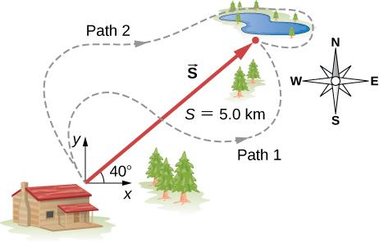

Solution

3.8 km east, 3.2 km north, 7.0 km

35. A pedestrian walks 6.0 km east and then 13.0 km north. Use a graphical method to find the pedestrian’s resultant displacement and geographic direction.

Solution

14.3 km, 

37. Assuming the +*x*-axis is horizontal and points to the right, resolve the vectors given in the following figure to their scalar components and express them in vector component form.

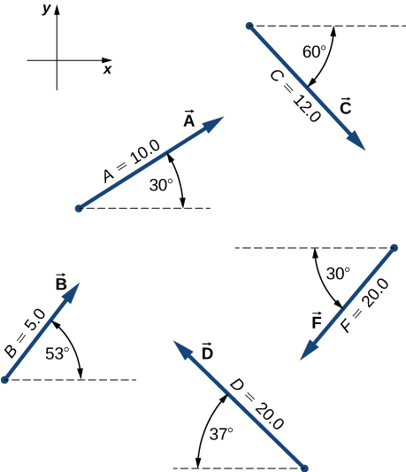

Solution

a. , b. , c. , d. , f. 

39. You drive 7.50 km in a straight line in a direction  east of north. (a) Find the distances you would have to drive straight east and then straight north to arrive at the same point. (b) Show that you still arrive at the same point if the east and north legs are reversed in order. Assume the +*x*-axis is to the east.

Solution

a. 1.94 km, 7.24 km; b. proof

41. A trapper walks a 5.0-km straight-line distance from her cabin to the lake, as shown in the following figure. Determine the east and north components of her displacement vector. How many more kilometers would she have to walk if she walked along the component displacements? What is her displacement vector?



Solution

3.8 km east, 3.2 km north, 2.0 km, 

43. Two points in a plane have polar coordinates  and  Determine their Cartesian coordinates and the distance between them in the Cartesian coordinate system. Round the distance to a nearest centimeter.

Solution

, , 4.55 m

45. Two points in the Cartesian plane are *A*(2.00 m, –4.00 m) and *B*(–3.00 m, 3.00 m). Find the distance between them and their polar coordinates.

Solution

8.60 m, , 

47. For vectors  and  calculate (a)  and its magnitude and direction angle, and (b)  and its magnitude and direction angle.

Solution

a.  ; b. , 

49. Given two displacement vectors  and  find the displacements and their magnitudes for (a)  and (b) 

Solution

a. ;

b. 

51. In an attempt to escape a desert island, a castaway builds a raft and sets out to sea. The wind shifts a great deal during the day, and she is blown along the following straight lines: 2.50 km and  north of west, then 4.70 km and  south of east, then 1.30 km and south of west, then 5.10 km due east, then 1.70 km and  east of north, then 7.20 km and  south of west, and finally 2.80 km and  north of east. Use the analytical method to find the resultant vector of all her displacement vectors. What is its magnitude and direction?

Solution

 is to the east, 7.34 km, 

53. Given the vectors in the preceding figure, find vector  that solves equations (a)  and (b)  Assume the +*x*-axis is horizontal to the right.



Solution

a. , b. 

55. An adventurous dog strays from home, runs three blocks east, two blocks north, and one block east, one block north, and two blocks west. Assuming that each block is about a 100 yd, use the analytical method to find the dog’s net displacement vector, its magnitude, and its direction. Assume the +*x*-axis is to the east. How would your answer be affected if each block was about 100 m?

Solution

 *D* = 360.5 yd,  north of east; The numerical answers would stay the same but the physical unit would be meters. The physical meaning and distances would be about the same because 1 yd is comparable with 1 m.

57. Given the displacement vector  find the displacement vector  so that 

Solution



59. At one point in space, the direction of the electric field vector is given in the Cartesian system by the unit vector  If the magnitude of the electric field vector is *E* = 400.0 V/m, what are the scalar components   and  of the electric field vector  at this point? What is the direction angle  of the electric field vector at this point?

Solution

    

61. In the control tower at a regional airport, an air traffic controller monitors two aircraft that travel in straight paths directly away from the control tower. One plane is a cargo carrier Boeing 747 climbing at above the horizontal, and moving  north of west. The other plane is a Douglas DC-3 climbing at above the horizontal, and cruising directly west.  At some moment in time, the controller notes that the Boeing is at an altitude of 2500 m and the DC-3 is at an altitude of 3000 m. (a) Find the position vectors of the planes relative to the control tower at this time. (b) What is the distance between the planes at this time?

Solution

a. , ;

b. 

63. Assuming the +*x*-axis is horizontal to the right for the vectors in the preceding figure, find (a) the component of vector  along vector  (b) the component of vector  along vector  (c) the component of vector  along vector and (d) the component of vector  along vector 

Solution

a. 0, b. 0, c. –0.866, d. –17.32

65. Find the angles that vector  makes with the *x*-, *y*-, and *z*- axes.

Solution



67. Assuming the +*x*-axis is horizontal to the right for the vectors in the previous figure, find the following vector products: (a)  (b)  (c)  (d)  (e)  (f)  (g)  and (h) 

Solution

a. , b. , c. , d. , e. , f. , g. , h. 0

69. For the vectors in the earlier figure, find (a)  (b)  and (c) 

Solution

a. 0, b. 0, c. 

**Additional Problems**

71. You fly  in a straight line in still air in the direction  south of west. (a) Find the distances you would have to fly due south and then due west to arrive at the same point. (b) Find the distances you would have to fly first in a direction  south of west and then in a direction  west of north. Note these are the components of the displacement along a different set of axes—namely, the one rotated by  with respect to the axes in (a).

Solution

a. 18.4 km and 26.2 km, b. 31.5 km and 5.56 km

73. If the polar coordinates of a point are  and its rectangular coordinates are  determine the polar coordinates of the following points: (a) (–*x*, *y*), (b) (–2*x*, –2*y*), and (c) (3*x*, –3*y*).

Solution

a. , b. , (c) 

75. Starting at the island of Moi in an unknown archipelago, a fishing boat makes a round trip with two stops at the islands of Noi and Poi. It sails from Moi for 4.76 nautical miles (nmi) in a direction  north of east to Noi. From Noi, it sails  west of north to Poi. On its return leg from Poi, it sails  east of south. What distance does the boat sail between Noi and Poi? What distance does it sail between Moi and Poi? Express your answer both in nautical miles and in kilometers. Note: 1 nmi = 1852 m.

Solution



77. Show that when  then  where  is the angle between vectors  and 

Solution

proof

79. A skater glides along a circular path of radius 5.00 m in clockwise direction. When he coasts around one-half of the circle, starting from the west point, find (a) the magnitude of his displacement vector and (b) how far he actually skated. (c) What is the magnitude of his displacement vector when he skates all the way around the circle and comes back to the west point?

Solution

a. 10.00 m, b.  c. 0

81. If the velocity vector of a polar bear is  how fast and in what geographic direction is it heading? Here,  and  are directions to geographic east and north, respectively.

Solution

22.2 km/h,  south of west

83. A diver explores a shallow reef off the coast of Belize. She initially swims 90.0 m north, makes a turn to the east and continues for 200.0 m, then follows a big grouper for 80.0 m in the direction  north of east. In the meantime, a local current displaces her by 150.0 m south. Assuming the current is no longer present, in what direction and how far should she now swim to come back to the point where she started?

Solution

270 m,  north of west

85. Vectors  and  are two orthogonal vectors in the *xy*-plane and they have identical magnitudes. If  find

Solution

 or 

87. Show that  is the volume of the parallelepiped, with edges formed by the three vectors in the following figure.

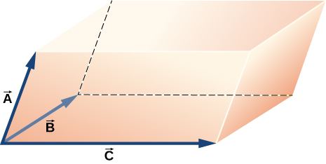

Solution

proof

**Challenge Problems**

89. What is the component of the force vector  along the force vector 

Solution



91. Distances between points in a plane do not change when a coordinate system is rotated. In other words, the magnitude of a vector is *invariant* under rotations of the coordinate system. Suppose a coordinate system S is rotated about its origin by angle  to become a new coordinate system  as shown in the following figure. A point in a plane has coordinates (*x*, *y*) in S and coordinates  in 

1. Show that, during the transformation of rotation, the coordinates in  are expressed in terms of the coordinates in S by the following relations:



1. Show that the distance of point *P* to the origin is invariant under rotations of the coordinate system. Here, you have to show that



1. Show that the distance between points *P* and *Q* is invariant under rotations of the coordinate system. Here, you have to show that



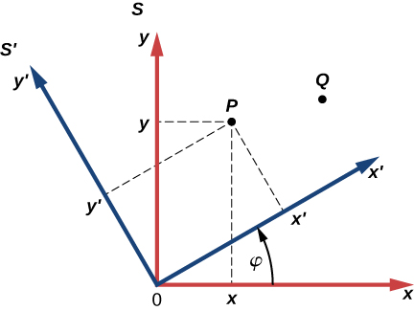

Solution

proof

This file is copyright 2016, Rice University. All Rights Reserved.