***University Physics Volume I***

**Unit 1: Mechanics**

**Chapter 3: Motion Along a Straight Line**

**Conceptual Questions**

1. Give an example in which there are clear distinctions among distance traveled, displacement, and magnitude of displacement. Identify each quantity in your example specifically.

Solution

You drive your car into town and return to drive past your house to a friend’s house.

3. Bacteria move back and forth using their flagella (structures that look like little tails). Speeds of up to 50 μm/s (50 × 10−6 m/s) have been observed. The total distance traveled by a bacterium is large for its size, whereas its displacement is small. Why is this?

Solution

If the bacteria are moving back and forth, then the displacements are canceling each other and the final displacement is small.

5. Does a car’s odometer measure distance traveled or displacement?

Solution

Distance traveled

7. There is a distinction between average speed and the magnitude of average velocity. Give an example that illustrates the difference between these two quantities.

Solution

Average speed is the total distance traveled divided by the elapsed time. If you go for a walk, leaving and returning to your home, your average speed is a positive number. Since Average velocity = Displacement/Elapsed time, your average velocity is zero.

9. If you divide the total distance traveled on a car trip (as determined by the odometer) by the elapsed time of the trip, are you calculating average speed or magnitude of average velocity? Under what circumstances are these two quantities the same?

Solution

Average speed. They are the same if the car doesn’t reverse direction.

11. Is it possible for speed to be constant while acceleration is not zero?

Solution

No, in one dimension constant speed requires zero acceleration.

13. Give an example in which velocity is zero yet acceleration is not.

Solution

A ball is thrown into the air and its velocity is zero at the apex of the throw, but acceleration is not zero.

15. Plus and minus signs are used in one-dimensional motion to indicate direction. What is the sign of an acceleration that reduces the magnitude of a negative velocity? Of a positive velocity?

Solution

Plus, minus

17. State two scenarios of the kinematics of single object where three known quantities require two kinematic equations to solve for the unknowns.

Solution

If the acceleration, time, and displacement are the knowns, and the initial and final velocities are the unknowns, then two kinematic equations must be solved simultaneously. Also if the final velocity, time, and displacement are the knowns then two kinematic equations must be solved for the initial velocity and acceleration.

19. An object that is thrown straight up falls back to Earth. This is one-dimensional motion. (a) When is its velocity zero? (b) Does its velocity change direction? (c) Does the acceleration have the same sign on the way up as on the way down?

Solution

a. at the top of its trajectory; b. yes, at the top of its trajectory; c. yes

21. The severity of a fall depends on your speed when you strike the ground. All factors but the acceleration from gravity being the same, how many times higher could a safe fall occur on the Moon than on Earth (gravitational acceleration on the Moon is about one-sixth that of the Earth)?

Solution

Earth ; Moon ; Earth  Moon 

23. When given the acceleration function, what additional information is needed to find the velocity function and position function?

Solution

We must know the initial conditions on the velocity and position at *t* = 0 to solve for the constants of integration.

**Problems**

25. A car is 2.0 km west of a traffic light at *t* = 0 and 5.0 km east of the light at *t* = 6.0 min. Assume the origin of the coordinate system is the light and the positive *x* direction is eastward. (a) What are the car’s position vectors at these two times? (b) What is the car’s displacement between 0 min and 6.0 min?

Solution

a. , ; b.  east

27. The position of a particle moving along the *x*-axis is given by m. (a) At what time does the particle cross the origin? (b) What is the displacement of the particle between  and 

Solution

a.  s; b. 

29. On February 15, 2013, a superbolide meteor (brighter than the Sun) entered Earth’s atmosphere over Chelyabinsk, Russia, and exploded at an altitude of 23.5 km. Eyewitnesses could feel the intense heat from the fireball, and the blast wave from the explosion blew out windows in buildings. The blast wave took approximately 2 minutes 30 seconds to reach ground level. The blast wave traveled at 10above the horizon. (a) What was the average velocity of the blast wave? (b) Compare this with the speed of sound, which is 343 m/s at sea level.

Solution

a.   b. 263% the speed of sound at sea level or about Mach 2.

31. Sketch the velocity-versus-time graph from the following position-versus-time graph.

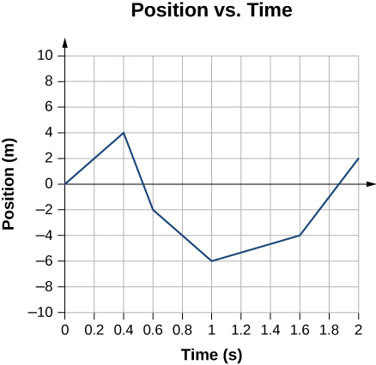

Solution

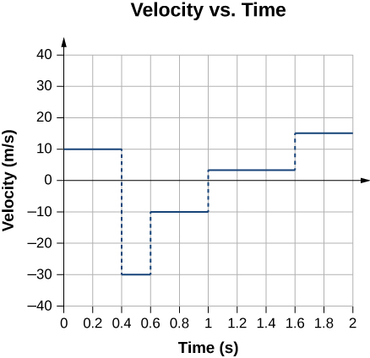

33. Given the following velocity-versus-time graph, sketch the position-versus-time graph.

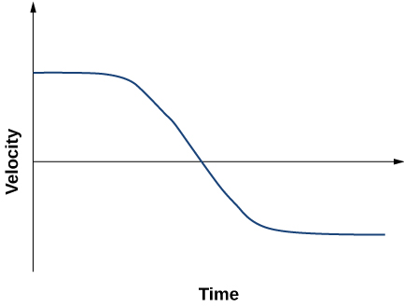

Solution

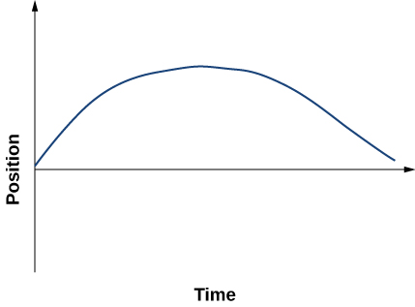

35. A particle moves along the *x-*axis according to  (a) What is the instantaneous velocity at *t* = 2 s and *t* = 3 s? (b) What is the instantaneous speed at these times? (c) What is the average velocity between *t* = 2 s and *t* = 3 s?

Solution

a.  *v*(2 s) = 2 m/s, *v*(3 s) = –2 m/s; b.  (c) 

37. A cheetah can accelerate from rest to a speed of 30.0 m/s in 7.00 s. What is its acceleration?

Solution



39. Sketch the acceleration-versus-time graph from the following velocity-versus-time graph.

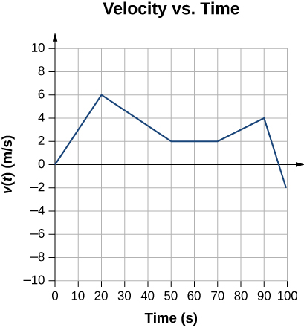

Solution

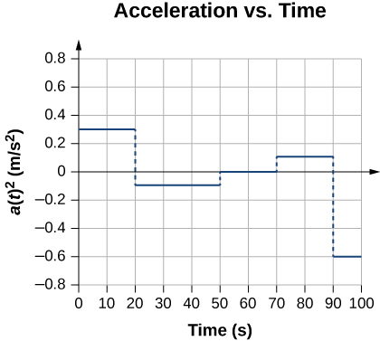

41. Assume an intercontinental ballistic missile goes from rest to a suborbital speed of 6.50 km/s in 60.0 s (the actual speed and time are classified). What is its average acceleration in meters per second squared and in multiples of *g* (9.80 m/s2)?

Solution



43. A particle moves in a straight line at a constant velocity of 30 m/s. What is its displacement between t = 0 and t = 5.0 s?

Solution

150 m

45. A particle moves in a straight line with an initial velocity of 30 m/s and constant acceleration 30 m/s2. (a) What is its displacement at *t* = 5 s? (b) What is its velocity at this same time?

Solution

a. 

b. 

47. (a) Sketch a graph of acceleration versus time corresponding to the graph of velocity versus time given in the following figure. (b) Identify the time or times (*t*a, *t*b, *t*c, etc.) at which the acceleration has the greatest positive value. (c) At which times is it zero? (d) At which times is it negative?

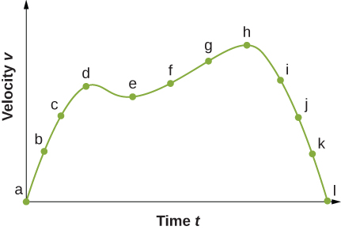

Solution

a.

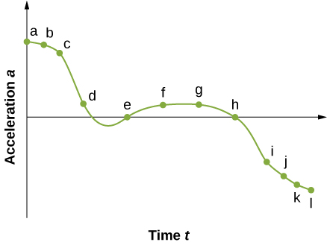

b. The acceleration has the greatest positive value at 

c. The acceleration is zero at 

d. The acceleration is negative at 

49. At *t* = 10 s, a particle is moving from left to right with a speed of 5.0 m/s. At *t* = 20 s, the particle is moving right to left with a speed of 8.0 m/s. Assuming the particle’s acceleration is constant, determine (a) its acceleration, (b) its initial velocity, and (c) the instant when its velocity is zero.

Solution

a. 

b.  or 

c. 

51. A bullet in a gun is accelerated from the firing chamber to the end of the barrel at an average rate of  for  What is its muzzle velocity (that is, its final velocity)?

Solution



53. While entering a freeway, a car accelerates from rest at a rate of 2.40 m/s2 for 12.0 s. (a) Draw a sketch of the situation. (b) List the knowns in this problem. (c) How far does the car travel in those 12.0 s? To solve this part, first identify the unknown, then indicate how you chose the appropriate equation to solve for it. After choosing the equation, show your steps in solving for the unknown, check your units, and discuss whether the answer is reasonable. (d) What is the car’s final velocity? Solve for this unknown in the same manner as in (c), showing all steps explicitly.

Solution

a.

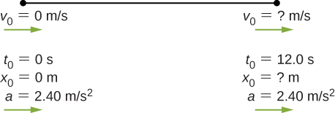

b. Knowns: 

c. the answer seems reasonable at about 172.8 m; d. 

55. Blood is accelerated from rest to 30.0 cm/s in a distance of 1.80 cm by the left ventricle of the heart. (a) Make a sketch of the situation. (b) List the knowns in this problem. (c) How long does the acceleration take? To solve this part, first identify the unknown, then discuss how you chose the appropriate equation to solve for it. After choosing the equation, show your steps in solving for the unknown, checking your units. (d) Is the answer reasonable when compared with the time for a heartbeat?

Solution

a.

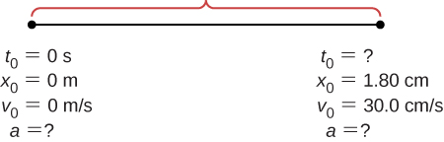

b. Knowns: 

c. 

d. yes

57. A powerful motorcycle can accelerate from rest to 26.8 m/s (100 km/h) in only 3.90 s. (a) What is its average acceleration? (b) Assuming constant acceleration, how far does it travel in that time?

Solution

a.  b. 

59. A fireworks shell is accelerated from rest to a velocity of 65.0 m/s over a distance of 0.250 m. (a) Calculate the acceleration. (b) How long did the acceleration last?

Solution

a. 

b. 

61. A woodpecker’s brain is specially protected from large accelerations by tendon-like attachments inside the skull. While pecking on a tree, the woodpecker’s head comes to a stop from an initial velocity of 0.600 m/s in a distance of only 2.00 mm. (a) Find the acceleration in meters per second squaredand in multiples of *g*, where *g* = 9.80 m/s2. (b) Calculate the stopping time. (c) The tendons cradling the brain stretch, making its stopping distance 4.50 mm (greater than the head and, hence, less acceleration of the brain). What is the brain’s acceleration, expressed in multiples of *g*?

Solution

a. 

b. 

c. 

63. A care package is dropped out of a cargo plane and lands in the forest. If we assume the care package speed on impact is 54 m/s (123 mph), then what is its acceleration? Assume the trees and snow stops it over a distance of 3.0 m.

Solution

Knowns:  We want *a*, so we can use this equation: .

65. **Unreasonable results** Dragsters can actually reach a top speed of 145.0 m/s in only 4.45 s. (a) Calculate the average acceleration for such a dragster. (b) Find the final velocity of this dragster starting from rest and accelerating at the rate found in (a) for 402.0 m (a quarter mile) without using any information on time. (c) Why is the final velocity greater than that used to find the average acceleration? (*Hint*: Consider whether the assumption of constant acceleration is valid for a dragster. If not, discuss whether the acceleration would be greater at the beginning or end of the run and what effect that would have on the final velocity.)

Solution

a. 

b. 

c.  because the assumption of constant acceleration is not valid for a dragster. A dragster changes gears and would have a greater acceleration in first gear than second gear than third gear, and so on. The acceleration would be greatest at the beginning, so it would not be accelerating at  during the last few meters, but substantially less, and the final velocity would be less than 

67. Calculate the displacement and velocity at times of (a) 0.500 s, (b) 1.00 s, (c) 1.50 s, (d) 2.00 s, and (e) 2.50 s for a rock thrown straight down with an initial velocity of 14.0 m/s from the Verrazano Narrows Bridge in New York City. The roadway of this bridge is 70.0 m above the water.

Solution

a. ****;

b. ****;

c. ****;

d. ****;

e. 

69. A rescue helicopter is hovering over a person whose boat has sunk. One of the rescuers throws a life preserver straight down to the victim with an initial velocity of 1.40 m/s and observes that it takes 1.8 s to reach the water. (a) List the knowns in this problem. (b) How high above the water was the preserver released? Note that the downdraft of the helicopter reduces the effects of air resistance on the falling life preserver, so that an acceleration equal to that of gravity is reasonable.

Solution

a. Knowns: ;

b. and the origin is at the rescuers, who are 18.4 m above the water.

71. A diver bounces straight up from a diving board, avoiding the diving board on the way down, and falls feet first into a pool. She starts with a velocity of 4.00 m/s and her takeoff point is 1.80 m above the pool. (a) What is her highest point above the board? (b) How long a time are her feet in the air? (c) What is her velocity when her feet hit the water?

Solution

a. ; b. to the apex  times 2 to the board = 0.82 s from the board to the water  , solution to quadratic equation gives 1.13 s; c. 

73. A very strong, but inept, shot putter puts the shot straight up vertically with an initial velocity of 11.0 m/s. How long a time does he have to get out of the way if the shot was released at a height of 2.20 m and he is 1.80 m tall?

Solution

Time to the apex:  times 2 equals 2.24 s to a height of 2.20 m. To 1.80 m in height is an additional 0.40 m. .

Take the positive root, so the time to go the additional 0.4 m is 0.04 s. Total time is .]

75. A kangaroo can jump over an object 2.50 m high. (a) Considering just its vertical motion, calculate its vertical speed when it leaves the ground. (b) How long a time is it in the air?

Solution

a. ; b.  times 2 gives 1.44 s in the air

77. There is a 250-m-high cliff at Half Dome in Yosemite National Park in California. Suppose a boulder breaks loose from the top of this cliff. (a) How fast will it be going when it strikes the ground? (b) Assuming a reaction time of 0.300 s, how long a time will a tourist at the bottom have to get out of the way after hearing the sound of the rock breaking loose (neglecting the height of the tourist, which would become negligible anyway if hit)? The speed of sound is 335.0 m/s on this day.

Solution

a. ; b. time heard after rock begins to fall: , time to reach the ground: , 

79. Between *t* = 0 and *t* = *t*0, a rocket moves straight upward with an acceleration given by , where *A* and *B* are constants. (a) If *x* is in meters and *t* is in seconds, what are the units of *A* and *B*? (b) If the rocket starts from rest, how does the velocity vary between *t* = 0 and *t* = *t*0? (c) If its initial position is zero, what is the rocket’s position as a function of time during this same time interval?

Solution

a. ;

b. ;

c. 

81. A particle at rest leaves the origin with its velocity increasing with time according to *v*(*t*) = 3.2*t* m/s. At 5.0 s, the particle’s velocity starts decreasing according to [16.0 – 1.5(*t* – 5.0)] m/s. This decrease continues until *t* = 11.0 s, after which the particle’s velocity remains constant at 7.0 m/s. (a) What is the acceleration of the particle as a function of time? (b) What is the position of the particle at *t* = 2.0 s, *t* = 7.0 s, and *t* = 12.0 s?

Solution

a. ;

b. 

**Additional Problems**

83. An airplane leaves Chicago and makes the 3000-km trip to Los Angeles in 5.0 h. A second plane leaves Chicago one-half hour later and arrives in Los Angeles at the same time. Compare the average velocities of the two planes. Ignore the curvature of Earth and the difference in altitude between the two cities.

Solution

Take west to be the positive direction.

1st plane: 

2nd plane 

85. An object has an acceleration of  At its velocity is  Determine the object’s velocities at  and 

Solution

 ,  ; 

87. A particle moving at constant acceleration has velocities of 2.0 m/s at *t* =2.0 s and –7.6 m/s at *t* = 5.2 s. What is the acceleration of the particle?

Solution



89. An electron is moving in a straight line with a velocity of  m/s. It enters a region 5.0 cm long where it undergoes an acceleration of  along the same straight line. (a) What is the electron’s velocity when it emerges from this region? b) How long does the electron take to cross the region?

Solution

a. 

b. 

91. A motorcycle that is slowing down uniformly covers 2.0 successive km in 80 s and 120 s, respectively. Calculate (a) the acceleration of the motorcycle and (b) its velocity at the beginning and end of the 2-km trip.

Solution

;  solve simultaneously to get  and  which is  Velocity at the end of the trip is 

93. Two trains are moving at 30 m/s in opposite directions on the same track. The engineers see simultaneously that they are on a collision course and apply the brakes when they are 1000 m apart. Assuming both trains have the same acceleration, what must this acceleration be if the trains are to stop just short of colliding?

Solution



95. A police car waits in hiding slightly off the highway. A speeding car is spotted by the police car doing 40 m/s. At the instant the speeding car passes the police car, the police car accelerates from rest at 4 m/s2 to catch the speeding car. How long does it take the police car to catch the speeding car?

Solution

Equation for the speeding car: This car has a constant velocity, which is the average velocity, and is not accelerating, so use the equation for displacement with :; Equation for the police car: This car is accelerating, so use the equation for displacement with  and , since the police car starts from rest: ; Now we have an equation of motion for each car with a common parameter, which can be eliminated to find the solution. In this case, we solve for . Step 1, eliminating : ; Step 2, solving for : . The speeding car has a constant velocity of 40 m/s, which is its average velocity. The acceleration of the police car is 4 m/s2. Evaluating *t*, the time for the police car to reach the speeding car, we have 

97. **Unreasonable results** A runner approaches the finish line and is 75 m away; her speed at this position is 8 m/s. She accelerates opposite to the motion at this point at 0.5 m/s2. How long does it take her to cross the finish line from 75 m away? Is this reasonable?

Solution

At this acceleration she comes to a full stop in  but the distance covered is  which is less than the distance she is away from the finish line, so she never finishes the race.

99. Compare the distance traveled of an object that undergoes a change in velocity that is twice its initial velocity with an object that changes its velocity by four times its initial velocity over the same time period. The accelerations of both objects are constant.

Solution



 

101. A ball is thrown straight up. It passes a 2.00-m-high window 7.50 m off the ground on its path up and takes 1.30 s to go past the window. What was the ball’s initial velocity?

Solution

  
 velocity at the bottom of the window.





103. A soft tennis ball is dropped onto a hard floor from a height of 1.50 m and rebounds to a height of 1.10 m. (a) Calculate its velocity just before it strikes the floor. (b) Calculate its velocity just after it leaves the floor on its way back up. (c) Calculate its acceleration during contact with the floor if that contact lasts 3.50 ms  (d) How much did the ball compress during its collision with the floor, assuming the floor is absolutely rigid?

Solution

a. ;

b. ;

c. ;

d. 

105. Compare the time in the air of a basketball player who jumps 1.0 m vertically off the floor with that of a player who jumps 0.3 m vertically.

Solution

Consider the players fall from rest at the height 1.0 m and 0.3 m.

s times 2 = 0.9 s

 s times 2 = 0.5 s

107. A hot-air balloon rises from ground level at a constant velocity of 3.0 m/s. One minute after liftoff, a sandbag is dropped accidentally from the balloon. Calculate (a) the time it takes for the sandbag to reach the ground and (b) the velocity of the sandbag when it hits the ground.

Solution

a. The altitude of the balloon when the sandbag is released is 180 m. Take the origin at the location of the balloon at 180 m high; *y* is positive upward, so the ground is at –180 m. m



 

 taking the positive root;

b. 

109. An object is dropped from a height of 75.0 m above ground level. (a) Determine the distance traveled during the first second. (b) Determine the final velocity at which the object hits the ground. (c) Determine the distance traveled during the last second of motion before hitting the ground.

Solution

a. ;

b. ;

c.  initial velocity 1 s before impact 

111. An object is dropped from a roof of a building of height *h*. During the last second of its descent, it drops a distance *h*/3. Calculate the height of the building.

Solution

 , *h* = total height and time to drop to ground

 in *t* – 1 seconds it drops 2/3*h*

 or 

 

*t* = 5.45 s and *h* = 145.5 m. Other root is less than 1 s. Check for *t* = 4.45 s  m 

**Challenge Problems**

113. The position of a particle moving along the *x*-axis varies with time according to  m. Find (a) the velocity and acceleration of the particle as functions of time, (b) the velocity and acceleration at *t* = 2.0 s, (c) the time at which the position is a maximum, (d) the time at which the velocity is zero, and (e) the maximum position.

Solution

a. ;

b. ; c. The slope of the position function is zero or the velocity is zero. There are two possible solutions: *t* = 0, which gives *x* = 0, or *t* = 10.0/12.0 = 0.83 s, which gives *x* = 1.16 m. The second answer is the correct choice; d. 0.83 s (e) 1.16 m

115. In 1967, New Zealander Burt Munro set the world record for an Indian motorcycle, on the Bonneville Salt Flats in Utah, of 295.38 km/h. The one-way course was 8.00 km long. Acceleration rates are often described by the time it takes to reach 96.0 km/h from rest. If this time was 4.00 s and Burt accelerated at this rate until he reached his maximum speed, how long did it take Burt to complete the course?

Solution

 , 295.38 km/h = 82.05 m/s,  time to accelerate to maximum speed

 distance covered during acceleration

 at a constant speed

 so total time is 

This file is copyright 2016, Rice University. All Rights Reserved.