***University Physics Volume I***

**Unit 1: Mechanics**

**Chapter 4: Motion in Two and Three Dimensions**

**Conceptual Questions**

1. What form does the trajectory of a particle have if the distance from any point *A* to point *B* is equal to the magnitude of the displacement from *A* to *B*?

Solution

straight line

3. If the instantaneous velocity is zero, what can be said about the slope of the position function?

Solution

The slope must be zero because the velocity vector is tangent to the graph of the position function.

5. If an object has a constant *x*-component of the velocity and suddenly experiences an acceleration in the *y* direction, does the *x-*component of its velocity change?

Solution

No, motions in perpendicular directions are independent.

7. Answer the following questions for projectile motion on level ground assuming negligible air resistance, with the initial angle being neither  nor  (a) Is the velocity ever zero? (b) When is the velocity a minimum? A maximum? (c) Can the velocity ever be the same as the initial velocity at a time other than at *t* = 0? (d) Can the speed ever be the same as the initial speed at a time other than at *t* = 0?

Solution

a. no; b. minimum at apex of trajectory and maximum at launch and impact; c. no, velocity is a vector; d. yes, where it lands

9. A dime is placed at the edge of a table so it hangs over slightly. A quarter is slid horizontally on the table surface perpendicular to the edge and hits the dime head on. Which coin hits the ground first?

Solution

They both hit the ground at the same time.

11. Can tangential acceleration change the speed of a particle undergoing circular motion?

Solution

yes

13. A basketball player dribbling down the court usually keeps his eyes fixed on the players around him. He is moving fast. Why doesn’t he need to keep his eyes on the ball?

Solution

If he is going to pass the ball to another player, he needs to keep his eyes on the reference frame in which the other players on the team are located.

15. The hat of a jogger running at constant velocity falls off the back of his head. Draw a sketch showing the path of the hat in the jogger’s frame of reference. Draw its path as viewed by a stationary observer. Neglect air resistance.

Solution

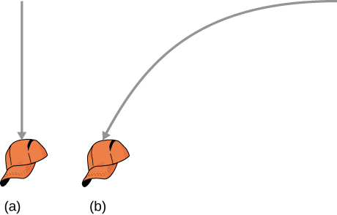

**Problems**

17. The coordinates of a particle in a rectangular coordinate system are (1.0, –4.0, 6.0). What is the position vector of the particle?

Solution



19. The 18th hole at Pebble Beach Golf Course is a dogleg to the left of length 496.0 m. The fairway off the tee is taken to be the *x* direction. A golfer hits his tee shot a distance of 300.0 m, corresponding to a displacement  and hits his second shot 189.0 m with a displacement  What is the final displacement of the golf ball from where it started?

Solution



21. A cyclist rides 5.0 km due east, then 10.0 km  west of north. From this point she rides 8.0 km due west. What is the final displacement from where the cyclist started?

Solution

Sum of displacements = 



23. The position of a particle is  (a) What is the velocity of the particle at 0 s and at  s? (b) What is the average velocity between 0 s and  s?

Solution

a. , b. 

25. The F-35B Lighting II is a short-takeoff and vertical landing fighter jet. If it does a vertical takeoff to 20.00-m height above the ground and then follows a flight path angled at with respect to the ground for 20.00 km, what is the final displacement?

Solution







27. A particle’s acceleration is  At *t* = 0, its position and velocity are zero. (a) What are the particle’s position and velocity as functions of time? (b) Find the equation of the path of the particle. Draw the *x-* and *y-*axes and sketch the trajectory of the particle.

Solution

a.  , b. 

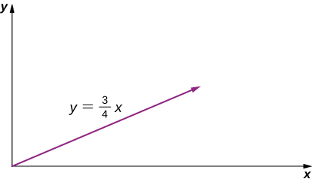

29. The position of a particle for *t* > 0 is given by  (a) What is the velocity as a function of time? (b) What is the acceleration as a function of time? (c) What is the particle’s velocity at *t* = 2.0 s? (d) What is its speed at *t* = 1.0 s and *t* = 3.0 s? (e) What is the average velocity between *t* = 1.0 s and *t* = 2.0 s?

Solution

a.  ,

b. , c. ,

d. 

 ,

e. 



31. A particle has a position function , where the arguments of the cosine and sine functions are in radians. (a) What is the velocity vector? (b) What is the acceleration vector?

Solution

a. , b. 

33. A bullet is shot horizontally from shoulder height (1.5 m) with an initial speed 200 m/s. (a) How much time elapses before the bullet hits the ground? (b) How far does the bullet travel horizontally?

Solution

a. , b. 

35. A dart is thrown horizontally at a speed of 10 m/s at the bull’s-eye of a dartboard 2.4 m away, as in the following figure. (a) How far below the intended target does the dart hit? (b) What does your answer tell you about how proficient dart players throw their darts?

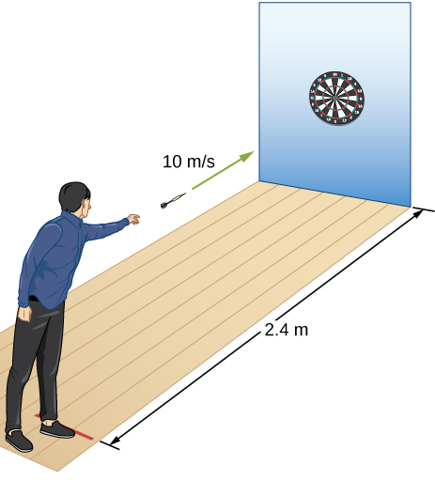

Solution

a. , b. They aim high.

37. Suppose the airplane in the preceding problem fires a projectile horizontally in its direction of motion at a speed of 300 m/s relative to the plane. )a) How far in front of the release point does the projectile hit the ground? (b) What is its speed when it hits the ground?

Solution

a., 

b. 

39. A projectile is launched at an angle of  and lands 20 s later at the same height as it was launched. (a) What is the initial speed of the projectile? (b) What is the maximum altitude? (c) What is the range? (d) Calculate the displacement from the point of launch to the position on its trajectory at 15 s.

Solution

a.  ,

b. ,

c. 

d. 

41. At a particular instant, a hot air balloon is 100 m in the air and descending at a constant speed of 2.0 m/s. At this exact instant, a girl throws a ball horizontally, relative to herself, with an initial speed of 20 m/s. When she lands, where will she find the ball? Ignore air resistance.

Solution

  

43. An athlete can jump a distance of 8.0 m in the broad jump. What is the maximum distance the athlete can jump on the Moon, where the gravitational acceleration is one-sixth that of Earth?

Solution



45. A rock is thrown off a cliff at an angle of with respect to the horizontal. The cliff is 100 m high. The initial speed of the rock is 30 m/s. (a) How high above the edge of the cliff does the rock rise? (b) How far has it moved horizontally when it is at maximum altitude? (c) How long after the release does it hit the ground? (d) What is the range of the rock? (e) What are the horizontal and vertical positions of the rock relative to the edge of the cliff at *t* = 2.0 s, *t* = 4.0 s, and *t* = 6.0 s?

Solution

a. ,

b., c.  , d. ,

e. 





47. A golfer on a fairway is 70 m away from the green, which sits below the level of the fairway by 20 m. If the golfer hits the ball at an angle of  with an initial speed of 20 m/s, how close to the green does she come?

Solution





So the golfer’s shot lands 13.3 m short of the green.

49. An astronaut on Mars kicks a soccer ball at an angle of  with an initial velocity of 15 m/s. If the acceleration of gravity on Mars is 3.7 m/s2, (a) what is the range of the soccer kick on a flat surface? (b) What would be the range of the same kick on the Moon, where gravity is one-sixth that of Earth?

Solution

a. ,

b. 

51. MIT’s robot cheetah can jump over obstacles 46 cm high and has speed of 12.0 km/h. (a) If the robot launches itself at an angle of  at this speed, what is its maximum height? (b) What would the launch angle have to be to reach a height of 46 cm?

Solution

a. 

,

b. 



53. Drew Brees of the New Orleans Saints can throw a football 23.0 m/s (50 mph). If he angles the throw at  from the horizontal, what distance does it go if it is to be caught at the same elevation as it was thrown?

Solution



55. A soccer goal is 2.44 m high. A player kicks the ball at a distance 10 m from the goal at an angle of  The ball hits the crossbar at the top of the goal. What is the initial speed of the soccer ball?

Solution





57. In 1999, Robbie Knievel was the first to jump the Grand Canyon on a motorcycle. At a narrow part of the canyon (69.0 m wide) and traveling 35.8 m/s off the takeoff ramp, he reached the other side. What was his launch angle?

Solution

or 

59. Aaron Rodgers throws a football at 20.0 m/s to his wide receiver, who is running straight down the field at 9.4 m/s. If Aaron throws the football when the wide receiver is 10.0 m in front of him, (a) at what angle does Aaron have to launch the ball so the ball will be at the same height as the receiver when the receiver makes it to 20.0 m in front of Aaron? (b) Will the receiver be able to catch the ball?

Solution

(a) It takes the wide receiver 1.1 s to cover the last 10 m of his run. 

(b) 

Therefore, the ball will be overthrown, and the receiver will not be able to catch it.

61. A particle travels in a circle of radius 10 m at a constant speed of 20 m/s. What is the magnitude of the acceleration?

Solution



63. A fairground ride spins its occupants inside a flying saucer-shaped container. If the horizontal circular path the riders follow has an 8.00-m radius, at how many revolutions per minute are the riders subjected to a centripetal acceleration equal to that of gravity?

Solution

 

 which is 

65. What is the acceleration of Venus toward the Sun, assuming a circular orbit?

Solution

Venus is 108.2 million km from the Sun and has an orbital period of 0.6152 y.





67. A fan is rotating at a constant 360.0 rev/min. What is the magnitude of the acceleration of a point on one of its blades 10.0 cm from the axis of rotation?

Solution



 

69. The coordinate axes of the reference frame  remain parallel to those of *S*, asmoves away from *S* at a constant velocity  (a) If at time *t* = 0 the origins coincide, what is the position of the origin  in the *S* frame as a function of time? (b) How is particle position for  and  as measured in *S* and  respectively, related? (c) What is the relationship between particle velocities  (d) How are accelerations  related?

Solution

a. ,

b.  ,

c. , d. The accelerations are the same.

71. The velocity of a particle in reference frame *A* is  The velocity of reference frame *A* with respect to reference frame *B* is  and the velocity of reference frame *B* with respect to *C* is  What is the velocity of the particle in reference frame *C*?

Solution



73. A seagull can fly at a velocity of 9.00 m/s in still air. (a) If it takes the bird 20.0 min to travel 6.00 km straight into an oncoming wind, what is the velocity of the wind? (b) If the bird turns around and flies with the wind, how long will it take the bird to return 6.00 km?

Solution

a. A = air, S = seagull, G = ground   
 velocity of seagull with respect to still air

 



b. 



75. A boat can be rowed at 8.0 km/h in still water. (a) How much time is required to row 1.5 km downstream in a river moving 3.0 km/h relative to the shore? (b) How much time is required for the return trip? (c) In what direction must the boat be aimed to row straight across the river? (d) Suppose the river is 0.8 km wide. What is the velocity of the boat with respect to Earth and how much time is required to get to the opposite shore? (e) Suppose, instead, the boat is aimed straight across the river. How much time is required to get across and how far downstream is the boat when it reaches the opposite shore?

Solution

Take the positive direction to be the same direction that the river is flowing, which is east. S = shore/Earth, W = water, and B = boat.

a.  



b.  



c.   west of north

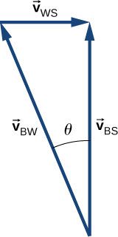

d.  

e.   but only the component of the velocity straight across the river is used to get the time

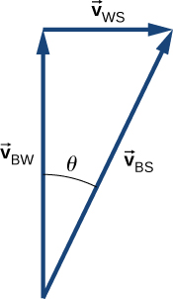



Downstream = 

77. A cyclist traveling southeast along a road at 15 km/h feels a wind blowing from the southwest at 25 km/h. To a stationary observer, what are the speed and direction of the wind?

Solution



 

The angle between  and  is  so the direction of the wind is  north of east.

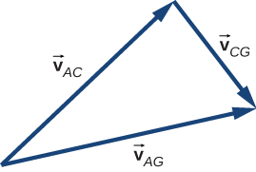

**Additional Problems**

79. A Formula One race car is traveling at 89.0 m/s along a straight track enters a turn on the race track with radius of curvature of 200.0 m. What centripetal acceleration must the car have to stay on the track?

Solution



81. The driver of a car moving at 90.0 km/h presses down on the brake as the car enters a circular curve of radius 150.0 m. If the speed of the car is decreasing at a rate of 9.0 km/h each second, what is the magnitude of the acceleration of the car at the instant its speed is 60.0 km/h?

Solution

 



83. An elephant is located on Earth’s surface at a latitude  Calculate the centripetal acceleration of the elephant resulting from the rotation of Earth around its polar axis. Express your answer in terms of  the radius  of Earth, and time *T* for one rotation of Earth. Compare your answer with *g* for 

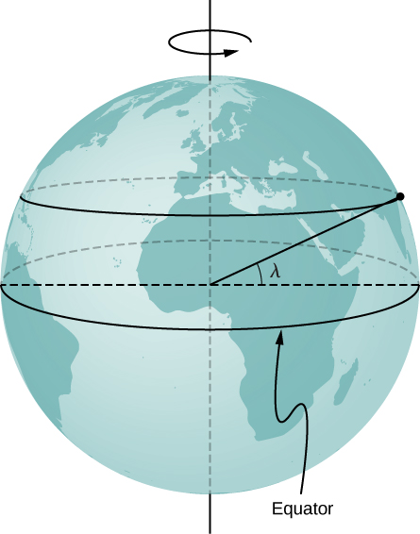

Solution

The radius of the circle of revolution at latitude  is  The velocity of the body is  for 

85. A propeller blade at rest starts to rotate from *t* = 0 s to *t* = 5.0 s with a tangential acceleration of the tip of the blade at  The tip of the blade is 1.5 m from the axis of rotation. At *t* = 5.0 s, what is the total acceleration of the tip of the blade?

Solution



 with respect to the tangent to the circle of revolution directed inward. 

87. A particle’s centripetal acceleration is at *t* = 0 s where it is on the *x*-axis and moving counterclockwise in the *xy* plane. It is executing uniform circular motion about an axis at a distance of 5.0 m. What is its velocity at *t* = 10 s?

Solution







89. A particle located initially at  undergoes a displacement of  What is the final position of the particle?

Solution



91. A spaceship is traveling at a constant velocity of  when its rockets fire, giving it an acceleration of  What is its velocity  s after the rockets fire?

Solution







93. A long jumper can jump a distance of 8.0 m when he takes off at an angle of  with respect to the horizontal. Assuming he can jump with the same initial speed at all angles, how much distance does he lose by taking off at 

Solution



95. A mountain biker encounters a jump on a race course that sends him into the air at  to the horizontal. If he lands at a horizontal distance of 45.0 m and 20 m below his launch point, what is his initial speed?

Solution



97. A geosynchronous satellite orbits Earth at a distance of 42,250.0 km and has a period of 1 day. What is the centripetal acceleration of the satellite?

Solution





**Challenge Problems**

99. World’s Longest Par 3. The tee of the world’s longest par 3 sits atop South Africa’s Hanglip Mountain at 400.0 m above the green and can only be reached by helicopter. The horizontal distance to the green is 359.0 m. Neglect air resistance and answer the following questions. (a) If a golfer launches a shot that is with respect to the horizontal, what initial velocity must she give the ball? (b) What is the time to reach the green?

Solution

a. 



, b. 

101. A truck is traveling east at 80 km/h. At an intersection 32 km ahead, a car is traveling north at 50 km/h. (a) How long after this moment will the vehicles be closest to each other? (b) How far apart will they be at that point?

Solution

a. 



,

b. 

This file is copyright 2016, Rice University. All Rights Reserved.