***University Physics Volume I***

**Unit 1: Mechanics**

**Chapter 6: Applications of Newton’s Laws**

**Conceptual Questions**

1. To simulate the apparent weightlessness of space orbit, astronauts are trained in the hold of a cargo aircraft that is accelerating downward at *g*. Why do they appear to be weightless, as measured by standing on a bathroom scale, in this accelerated frame of reference? Is there any difference between their apparent weightlessness in orbit and in the aircraft?

Solution

The scale is in free fall along with the astronauts, so the reading on the scale would be 0. There is no difference in the apparent weightlessness; in the aircraft and in orbit, free fall is occurring.

3. When you learn to drive, you discover that you need to let up slightly on the brake pedal as you come to a stop or the car will stop with a jerk. Explain this in terms of the relationship between static and kinetic friction.

Solution

If you do not let up on the brake pedal, the car’s wheels will lock so that they are not rolling; sliding friction is now involved and the sudden change (due to the larger force of static friction) causes the jerk.

5. A physics major is cooking breakfast when she notices that the frictional force between her steel spatula and Teflon frying pan is only 0.200 N. Knowing the coefficient of kinetic friction between the two materials, she quickly calculates the normal force. What is it?

Solution

5.00 N

7. Define centripetal force. Can any type of force (for example, tension, gravitational force, friction, and so on) be a centripetal force? Can any combination of forces be a centripetal force?

Solution

Centripetal force is defined as any net force causing uniform circular motion. The centripetal force is not a new kind of force. The label “centripetal” refers to any force that keeps something turning in a circle. That force could be tension, gravity, friction, electrical attraction, the normal force, or any other force. Any combination of these could be the source of centripetal force, for example, the centripetal force at the top of the path of a tetherball swung through a vertical circle is the result of both tension and gravity.

9. Race car drivers routinely cut corners, as shown below (Path 2). Explain how this allows the curve to be taken at the greatest speed.

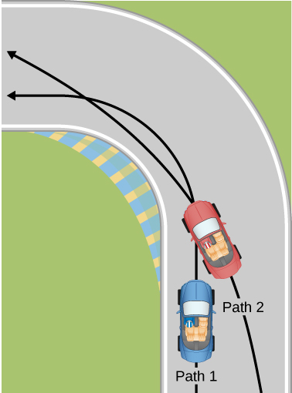

Solution

The driver who cuts the corner (on Path 2) has a more gradual curve, with a larger radius. That one will be the better racing line. If the driver goes too fast around a corner using a racing line, he will still slide off the track; the key is to stay at the maximum value of static friction. So, the driver wants maximum possible speed and maximum friction.   
Consider the equation for centripetal force:  where *v* is speed and *r* is the radius of curvature. So by decreasing the curvature (1/*r*) of the path that the car takes, we reduce the amount of force the tires have to exert on the road, meaning we can now increase the speed, *v*. Looking at this from the point of view of the driver on Path 1, we can reason this way: the sharper the turn, the smaller the turning circle; the smaller the turning circle, the larger is the required centripetal force. If this centripetal force is not exerted, the result is a skid.

11. What causes water to be removed from clothes in a spin-dryer?

Solution

The barrel of the dryer provides a centripetal force on the clothes (including the water droplets) to keep them moving in a circular path. As a water droplet comes to one of the holes in the barrel, it will move in a path tangent to the circle.

13. Suppose a child is riding on a merry-go-round at a distance about halfway between its center and edge. She has a lunch box resting on wax paper, so that there is very little friction between it and the merry-go-round. (a) Which path shown below, as viewed from the ground, will the lunch box take when she lets go? (b) The lunch box leaves a trail in the dust on the merry-go-round. What is the shape of the dust trail? Explain your answers.

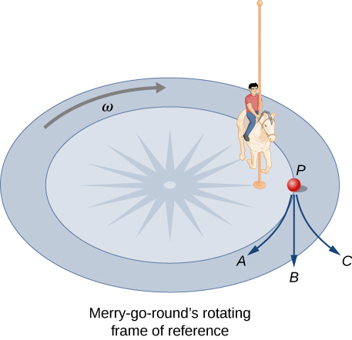

Solution

(a) If there is no friction, then there is no centripetal force. This means that, in the inertial frame of the ground, the lunch box will move along a path tangent to the circle, and thus follows path *B*. This is a result of Newton’s first law of motion. (b) The dust trail traces the motion of the box relative to the merry-go-round and will be radially out.

15. Suppose a mass is moving in a circular path on a frictionless table as shown below. In Earth’s frame of reference, there is no centrifugal force pulling the mass away from the center of rotation, yet there is a force stretching the string attaching the mass to the nail. Using concepts related to centripetal force and Newton’s third law, explain what force stretches the string, identifying its physical origin.

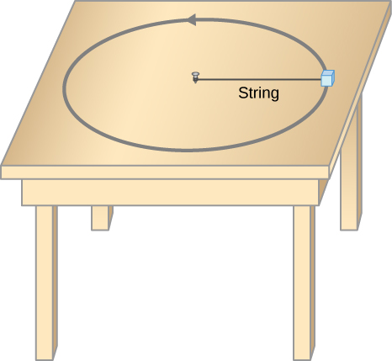

Solution

There must be a centripetal force to maintain the circular motion; this is provided by the nail at the center. Newton’s third law explains the phenomenon. The action force is the force of the string on the mass; the reaction force is the force of the mass on the string. This reaction force causes the string to stretch.

17. A car rounds a curve and encounters a patch of ice with a very low coefficient of kinetic fiction. The car slides off the road. Describe the path of the car as it leaves the road.

Solution

Since the radial friction with the tires supplies the centripetal force, and friction is nearly 0 when the car encounters the ice, the car will obey Newton’s first law and go off the road in a straight line path, tangent to the curve. A common misconception is that the car will follow a curved path off the road.

19. Two friends are having a conversation. Anna says a satellite in orbit is in free fall because the satellite keeps falling toward Earth. Tom says a satellite in orbit is not in free fall because the acceleration due to gravity is not . Who do you agree with and why?

Solution

Anna is correct. The satellite is freely falling toward Earth due to gravity, even though gravity is weaker at the altitude of the satellite, and *g* is not . Free fall does not depend on the value of *g*; that is, you could experience free fall on Mars if you jumped off Olympus Mons (the tallest volcano in the solar system).

21. Athletes such as swimmers and bicyclists wear body suits in competition. Formulate a list of pros and cons of such suits.

Solution

The pros of wearing body suits include: (1) the body suit reduces the drag force on the swimmer and the athlete can move more easily; (2) the tightness of the suit reduces the surface area of the athlete, and even though this is a small amount, it can make a difference in performance time. The cons of wearing body suits are: (1) The tightness of the suits can induce cramping and breathing problems. (2) Heat will be retained and thus the athlete could overheat during a long period of use.

23. As cars travel, oil and gasoline leaks onto the road surface. If a light rain falls, what does this do to the control of the car? Does a heavy rain make any difference?

Solution

The oil is less dense than the water and so rises to the top when a light rain falls and collects on the road. This creates a dangerous situation in which friction is greatly lowered, and so a car can lose control. In a heavy rain, the oil is dispersed and does not affect the motion of cars as much.

**Problems**

25. A 30.0-kg girl in a swing is pushed to one side and held at rest by a horizontal force  so that the swing ropes are  with respect to the vertical. (a) Calculate the tension in each of the two ropes supporting the swing under these conditions. (b) Calculate the magnitude of 

Solution

a. 170 N; b. 170 N

27. Three forces act on an object, considered to be a particle, which moves with constant velocity  Two of the forces are  and  Find the third force.

Solution



29. Two muscles in the back of the leg pull upward on the Achilles tendon, as shown below. (These muscles are called the medial and lateral heads of the gastrocnemius muscle.) Find the magnitude and direction of the total force on the Achilles tendon. What type of movement could be caused by this force?

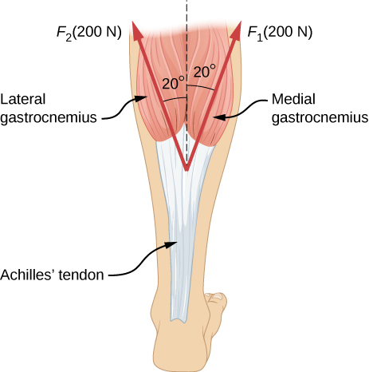

Solution

376 N

31. A 35.0-kg dolphin accelerates opposite to the motion from 12.0 to 7.50 m/s in 2.30 s to join another dolphin in play. What average force was exerted to slow the first dolphin if it was moving horizontally? (The gravitational force is balanced by the buoyant force of the water.)

Solution

–68.5 N

33. A large rocket has a mass of  at takeoff, and its engines produce a thrust of . (a) Find its initial acceleration if it takes off vertically. (b) How long does it take to reach a velocity of 120 km/h straight up, assuming constant mass and thrust?

Solution

a. ; b. 4.33 s

35. A 2.50-kg fireworks shell is fired straight up from a mortar and reaches a height of 110.0 m. (a) Neglecting air resistance (a poor assumption, but we will make it for this example), calculate the shell’s velocity when it leaves the mortar. (b) The mortar itself is a tube 0.450 m long. Calculate the average acceleration of the shell in the tube as it goes from zero to the velocity found in (a). (c) What is the average force on the shell in the mortar? Express your answer in newtons and as a ratio to the weight of the shell.

Solution

a. 46.4 m/s; b.  c. 245

37. An elevator filled with passengers has a mass of . (a) The elevator accelerates upward from rest at a rate of  for 1.50 s. Calculate the tension in the cable supporting the elevator. (b) The elevator continues upward at constant velocity for 8.50 s. What is the tension in the cable during this time? (c) The elevator accelerates opposite to the motion at a rate of  for 3.00 s. What is the tension in the cable during acceleration opposite to the motion? (d) How high has the elevator moved above its original starting point, and what is its final velocity?

Solution

a.  b.  c.  d. 19.4 m, 0 m/s

39. A student’s backpack, full of textbooks, is hung from a spring scale attached to the ceiling of an elevator. When the elevator is accelerating downward at , the scale reads 60 N. (a) What is the mass of the backpack? (b) What does the scale read if the elevator moves upward while speeding up at a rate ? (c) What does the scale read if the elevator moves upward at constant velocity? (d) If the elevator had no brakes and the cable supporting it were to break loose so that the elevator could fall freely, what would the spring scale read?

Solution

a. 10 kg; b. 140 N; c. 98 N; d. 0

41. A roller coaster car starts from rest at the top of a track 30.0 m long and inclined at  to the horizontal. Assume that friction can be ignored. (a) What is the acceleration of the car? (b) How much time elapses before it reaches the bottom of the track?

Solution

a. ; b. 4.2 s

43. Two blocks are connected by a massless rope as shown below. The mass of the block on the table is 4.0 kg and the hanging mass is 1.0 kg. The table and the pulley are frictionless. (a) Find the acceleration of the system. (b) Find the tension in the rope. (c) Find the speed with which the hanging mass hits the floor if it starts from rest and is initially located 1.0 m from the floor.

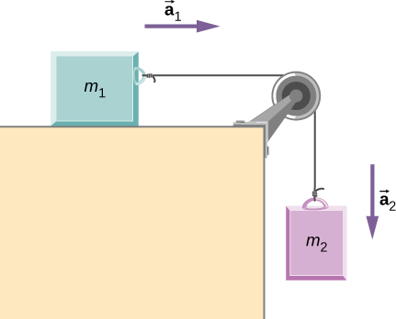

Solution

a. b. 7.8 N; c. 2.0 m/s

45. A 2.00 kg block (mass 1) and a 4.00 kg block (mass 2) are connected by a light string as shown; the inclination of the ramp is . Friction is negligible. What is (a) the acceleration of each block and (b) the tension in the string?

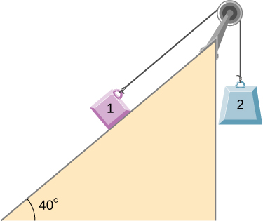

Solution

a.  (mass 1 accelerates up the ramp as mass 2 falls with the same acceleration); b. 21.5 N

47. (a) What is the maximum frictional force in the knee joint of a person who supports 66.0 kg of her mass on that knee? (b) During strenuous exercise, it is possible to exert forces to the joints that are easily 10 times greater than the weight being supported. What is the maximum force of friction under such conditions? The frictional forces in joints are relatively small in all circumstances except when the joints deteriorate, such as from injury or arthritis. Increased frictional forces can cause further damage and pain.

Solution

a. 10.0 N; b. 97.0 N

49. (a) If half of the weight of a small  utility truck is supported by its two drive wheels, what is the maximum acceleration it can achieve on dry concrete? (b) Will a metal cabinet lying on the wooden bed of the truck slip if it accelerates at this rate? (c) Solve both problems assuming the truck has four-wheel drive.

Solution

a. ; b. The cabinet will not slip. c. The cabinet will slip.

51. Consider the 65.0-kg ice skater being pushed by two others shown below. (a) Find the direction and magnitude of  the total force exerted on her by the others, given that the magnitudes  and  are 26.4 N and 18.6 N, respectively. (b) What is her initial acceleration if she is initially stationary and wearing steel-bladed skates that point in the direction of  (c) What is her acceleration assuming she is already moving in the direction of  (Remember that friction always acts in the direction opposite that of motion or attempted motion between surfaces in contact.)

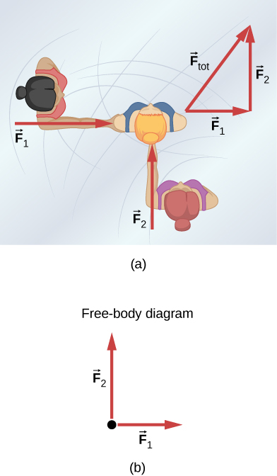

Solution

a. 32.3 N,  b. 0; c.  in the direction of 

53. Show that the acceleration of any object down an incline where friction behaves simply (that is, where  is  Note that the acceleration is independent of mass and reduces to the expression found in the previous problem when friction becomes negligibly small 

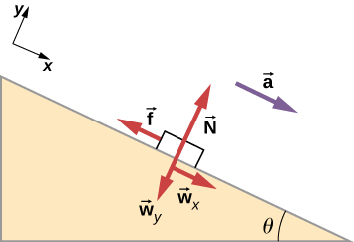

Solution



55. A machine at a post office sends packages out a chute and down a ramp to be loaded into delivery vehicles. (a) Calculate the acceleration of a box heading down a  slope, assuming the coefficient of friction for a parcel on waxed wood is 0.100. (b) Find the angle of the slope down which this box could move at a constant velocity. You can neglect air resistance in both parts.

Solution

a. b. 

57. Calculate the maximum acceleration of a car that is heading down a  slope (one that makes an angle of  with the horizontal) under the following road conditions. You may assume that the weight of the car is evenly distributed on all four tires and that the coefficient of static friction is involved—that is, the tires are not allowed to slip during the acceleration opposite to the motion. (Ignore rolling.) Calculate for a car: (a) On dry concrete. (b) On wet concrete. (c) On ice, assuming that , the same as for shoes on ice.

Solution

a.  b. c.

59. Repeat the preceding problem for a car with four-wheel drive.

Solution

a.  b.  c. 

61. Consider the 52.0-kg mountain climber shown below. (a) Find the tension in the rope and the force that the mountain climber must exert with her feet on the vertical rock face to remain stationary. Assume that the force is exerted parallel to her legs. Also, assume negligible force exerted by her arms. (b) What is the minimum coefficient of friction between her shoes and the cliff?

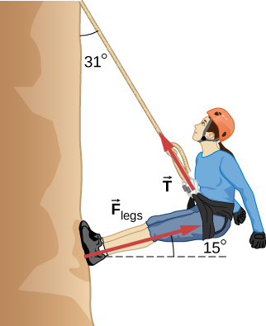

Solution

a. 272 N, 512 N; b. 0.268

63. The contestant now pulls the block of ice with a rope over his shoulder at the same angle above the horizontal as shown below. The coefficient of friction of ice can be found in Table 6.1. Calculate the minimum force *F* he must exert to get the block moving. (b) What is its acceleration once it starts to move, if that force is maintained?

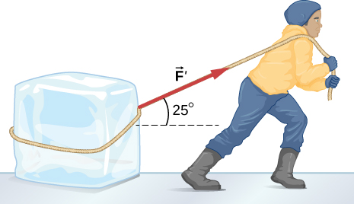

Solution

a. 46.5 N; b. 

65. (a) A 22.0-kg child is riding a playground merry-go-round that is rotating at 40.0 rev/min. What centripetal force is exerted if he is 1.25 m from its center? (b) What centripetal force is exerted if the merry-go-round rotates at 3.00 rev/min and he is 8.00 m from its center? (c) Compare each force with his weight.

Solution

a. 483 N; b. 17.4 N; c. 2.24, 0.0807

67. What is the ideal banking angle for a gentle turn of 1.20-km radius on a highway with a 105 km/h speed limit (about 65 mi/h), assuming everyone travels at the limit?

Solution



69. (a) What is the radius of a bobsled turn banked at  and taken at 30.0 m/s, assuming it is ideally banked? (b) Calculate the centripetal acceleration. (c) Does this acceleration seem large to you?

Solution

a. 24.6 m; b.  c. 3.73 times *g*

71. If a car takes a banked curve at less than the ideal speed, friction is needed to keep it from sliding toward the inside of the curve (a problem on icy mountain roads). (a) Calculate the ideal speed to take a 100.0 m radius curve banked at . (b) What is the minimum coefficient of friction needed for a frightened driver to take the same curve at 20.0 km/h?

Solution

a. 16.2 m/s; b. 0.234

73. A child of mass 40.0 kg is in a roller coaster car that travels in a loop of radius 7.00 m. At point A the speed of the car is 10.0 m/s, and at point B, the speed is 10.5 m/s. Assume the child is not holding on and does not wear a seat belt. (a) What is the force of the car seat on the child at point A? (b) What is the force of the car seat on the child at point B? (c) What minimum speed is required to keep the child in his seat at point A?

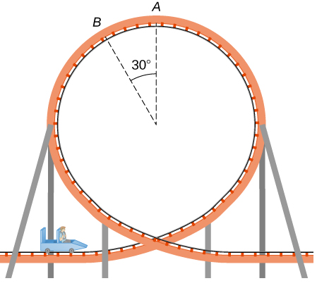

Solution

a. 179 N; b. 290 N; c. 8.3 m/s

75. Railroad tracks follow a circular curve of radius 500.0 m and are banked at an angle of . For trains of what speed are these tracks designed?

Solution

20.7 m/s

77. A car rounds an unbanked curve of radius 65 m. If the coefficient of static friction between the road and car is 0.70, what is the maximum speed at which the car can traverse the curve without slipping?

Solution

21 m/s

79. The terminal velocity of a person falling in air depends upon the weight and the area of the person facing the fluid. Find the terminal velocity (in meters per second and kilometers per hour) of an 80.0-kg skydiver falling in a pike (headfirst) position with a surface area of .

Solution

115 m/s or 414 km/h

81. A 560-g squirrel with a surface area of  falls from a 5.0-m tree to the ground. Estimate its terminal velocity. (Use a drag coefficient for a skydiver falling feet first.) What will be the velocity of a 56-kg person hitting the ground, assuming no drag contribution in such a short distance?

Solution



83. By what factor does the drag force on a car increase as it goes from 65 to 110 km/h?

Solution

 times

85. Using Stokes’ law, verify that the units for viscosity are kilograms per meter per second.

Solution

Stokes’ law is  Solving for the viscosity,  Considering only the units, this becomes 

87. Stokes’ law describes sedimentation of particles in liquids and can be used to measure viscosity. Particles in liquids achieve terminal velocity quickly. One can measure the time it takes for a particle to fall a certain distance and then use Stokes’ law to calculate the viscosity of the liquid. Suppose a steel ball bearing (density , diameter 3.0 mm) is dropped in a container of motor oil. It takes 12 s to fall a distance of 0.60 m. Calculate the viscosity of the oil.

Solution



89. A small diamond of mass 10.0 g drops from a swimmer’s earring and falls through the water, reaching a terminal velocity of 2.0 m/s. (a) Assuming the frictional force on the diamond obeys  what is *b*? (b) How far does the diamond fall before it reaches 90 percent of its terminal speed?

Solution

a. 0.049 kg/s; b. 0.57 m

91. A 75.0-kg woman stands on a bathroom scale in an elevator that accelerates from rest to 30.0 m/s in 2.00 s. (a) Calculate the scale reading in newtons and compare it with her weight. (The scale exerts an upward force on her equal to its reading.) (b) What is unreasonable about the result? (c) Which premise is unreasonable, or which premises are inconsistent?

Solution

a. 1860 N, 2.53; b. The value (1860 N) is more force than you expect to experience on an elevator. The force of 1860 N is 418 pounds, compared to the force on a typical elevator of 904 N (which is about 203 pounds); this is calculated for a speed from 0 to 10 miles per hour, which is about 4.5 m/s, in 2.00 s). c. The acceleration  is much higher than any standard elevator. The final speed is too large (30.0 m/s is VERY fast)! The time of 2.00 s is not unreasonable for an elevator.

93. As shown below, if  what is the tension in string 1?

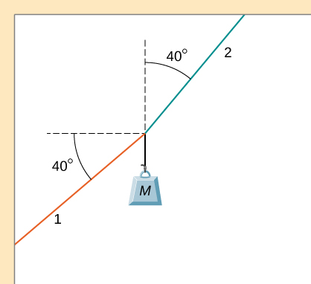

Solution

199 N

95. As shown below, if  what is the tension in the connecting string? The pulley and all surfaces are frictionless.

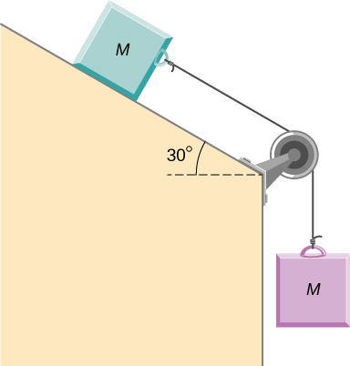

Solution

15 N

97. A half-full recycling bin has mass 3.0 kg and is pushed up a  incline with constant speed under the action of a 26-N force acting up and parallel to the incline. The incline has friction. What magnitude force must act up and parallel to the incline for the bin to move down the incline at constant velocity?

Solution

12 N

**Additional Problems**

99. The two barges shown here are coupled by a cable of negligible mass. The mass of the front barge is  and the mass of the rear barge is  A tugboat pulls the front barge with a horizontal force of magnitude  and the frictional forces of the water on the front and rear barges are  and  respectively. Find the horizontal acceleration of the barges and the tension in the connecting cable.

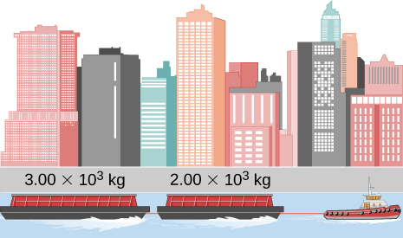

Solution

 and 

101. An object with mass *m* moves along the *x*-axis. Its position at any time is given by  where *p* and *q* are constants. Find the net force on this object for any time *t*.

Solution

*m*(6*pt* + 2*q*)

103. Located at the origin, an electric car of mass *m* is at rest and in equilibrium. A time dependent force of  is applied at time , and its components are  and  where *p*, *q*, and *n* are constants. Find the position  and velocity  as functions of time *t*.

Solution

 and 

105. A 2.0-kg object has a velocity of  at  A constant resultant force of  then acts on the object for 3.0 s. What is the magnitude of the object's velocity at the end of the 3.0-s interval?

Solution

9.2 m/s

107. A box is dropped onto a conveyor belt moving at 3.4 m/s. If the coefficient of friction between the box and the belt is 0.27, how long will it take before the box moves without slipping?

Solution

1.3 s

109. As shown below, the mass of block 1 is  while the mass of block 2 is  The coefficient of friction between  and the inclined surface is  What is the acceleration of the system?

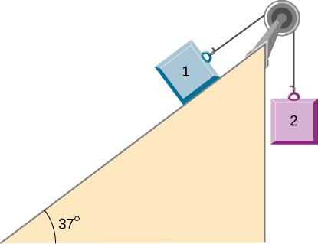

Solution



111. A crate of mass 100.0 kg rests on a rough surface inclined at an angle of  with the horizontal. A massless rope to which a force can be applied parallel to the surface is attached to the crate and leads to the top of the incline. In its present state, the crate is just ready to slip and start to move down the plane. The coefficient of friction is  of that for the static case. (a) What is the coefficient of static friction? (b) What is the maximum force that can be applied upward along the plane on the rope and not move the block? (c) With a slightly greater applied force, the block will slide up the plane. Once it begins to move, what is its acceleration and what reduced force is necessary to keep it moving upward at constant speed? (d) If the block is given a slight nudge to get it started down the plane, what will be its acceleration in that direction? (e) Once the block begins to slide downward, what upward force on the rope is required to keep the block from accelerating downward?

Solution

a. 0.75; b. 1200 N; c.  and 1080 N; d. –  e. 120 N

113. A crate having mass 50.0 kg falls horizontally off the back of the flatbed truck, which is traveling at 100 km/h. Find the value of the coefficient of kinetic friction between the road and crate if the crate slides 50 m on the road in coming to rest. The initial speed of the crate is the same as the truck, 100 km/h.

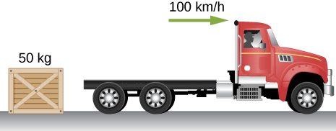

Solution

0.789

115. A 30.0-g ball at the end of a string is swung in a vertical circle with a radius of 25.0 cm. The tangential velocity is 200.0 cm/s. Find the tension in the string: (a) at the top of the circle, (b) at the bottom of the circle, and (c) at a distance of 12.5 cm from the center of the circle ().

Solution

a. 0.186 N; b. 0.774 N; c. 0.48 N

117. A stunt cyclist rides on the interior of a cylinder 12 m in radius. The coefficient of static friction between the tires and the wall is 0.68. Find the value of the minimum speed for the cyclist to perform the stunt.

Solution

13 m/s

119. A piece of bacon starts to slide down the pan when one side of a pan is raised up 5.0 cm. If the length of the pan from pivot to the raising point is 23.5 cm, what is the coefficient of static friction between the pan and the bacon?

Solution

0.21

121. An airplane flies at 120.0 m/s and banks at a  angle. If its mass is  (a) what is the magnitude of the lift force? (b) what is the radius of the turn?

Solution

a. 28,300 N; b. 2540 m

123. Two blocks connected by a string are pulled across a horizontal surface by a force applied to one of the blocks, as shown below. The coefficient of kinetic friction between the blocks and the surface is 0.25. If each block has an acceleration of  to the right, what is the magnitude *F* of the applied force?

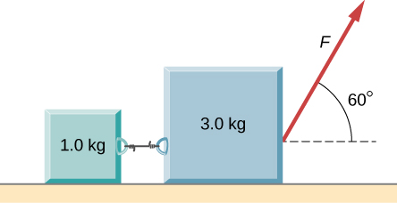

Solution

25 N

125. In the figure, the coefficient of kinetic friction between the surface and the blocks is  If  find an expression for the magnitude of the acceleration of either block (in terms of *F*,  and *g*).

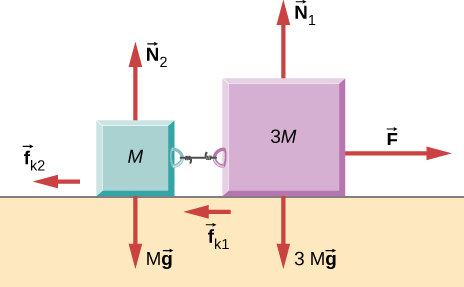

Solution



127. A box rests on the (horizontal) back of a truck. The coefficient of static friction between the box and the surface on which it rests is 0.24. What maximum distance can the truck travel (starting from rest and moving horizontally with constant acceleration) in 3.0 s without having the box slide?

Solution

11 m

**Challenge Problems**

129. In a later chapter, you will find that the weight of a particle varies with altitude such that  where  is the radius of Earth and *r* is the distance from Earth’s center. If the particle is fired vertically with velocity  from Earth’s surface, determine its velocity as a function of position *r*. (*Hint:* use  the rearrangement mentioned in the text.)

Solution



131. A car of mass 1000.0 kg is traveling along a level road at 100.0 km/h when its brakes are applied. Calculate the stopping distance if the coefficient of kinetic friction of the tires is 0.500. Neglect air resistance. (*Hint:* since the distance traveled is of interest rather than the time, *x* is the desired independent variable and not *t*. Use the Chain Rule to change the variable: 

Solution

78.7 m

133. A skydiver is at an altitude of 1520 m. After 10.0 seconds of free fall, he opens his parachute and finds that the air resistance, , is given by the formula , where *b* is a constant and *v* is the velocity. If , and the mass of the skydiver is 82.0 kg, first set up differential equations for the velocity and the position, and then find: (a) the speed of the skydiver when the parachute opens, (b) the distance fallen before the parachute opens, (c) the terminal velocity after the parachute opens (find the limiting velocity), and (d) the time the skydiver is in the air after the parachute opens.

Solution

a. 98 m/s; b. 490 m; c. 107 m/s; d. 10.1 s

135. A boater and motor boat are at rest on a lake. Together, they have mass 200.0 kg. If the thrust of the motor is a constant force of 40.0 N in the direction of motion, and if the resistive force of the water is numerically equivalent to 2 times the speed *v* of the boat, set up and solve the differential equation to find: (a) the velocity of the boat at time *t*; (b) the limiting velocity (the velocity after a long time has passed).

Solution

a.  b. 

This file is copyright 2016, Rice University. All Rights Reserved.