***University Physics Volume I***

**Unit 1: Mechanics**

**Chapter 9: Linear Momentum and Collisions**

**Conceptual Questions**

1. An object that has a small mass and an object that has a large mass have the same momentum. Which object has the largest kinetic energy?

Solution

Since  then if the momentum is fixed, the object with smaller mass has more kinetic energy.

3. Is it possible for a small force to produce a larger impulse on a given object than a large force? Explain.

Solution

Yes; impulse is the force applied multiplied by the time during which it is applied (), so if a small force acts for a long time, it may result in a larger impulse than a large force acting for a small time.

5. What external force is responsible for changing the momentum of a car moving along a horizontal road?

Solution

By friction, the road exerts a horizontal force on the tires of the car, which changes the momentum of the car.

7. Under what circumstances is momentum conserved?

Solution

Momentum is conserved when the mass of the system of interest remains constant during the interaction in question and when no *net* external force acts on the system during the interaction.

9. Explain in terms of momentum and Newton’s laws how a car’s air resistance is due in part to the fact that it pushes air in its direction of motion.

Solution

To accelerate air molecules in the direction of motion of the car, the car must exert a force on these molecules by Newton’s second law . By Newton’s third law, the air molecules exert a force of equal magnitude but in the opposite direction on the car. This force acts in the direction opposite the motion of the car and constitutes the force due to air resistance.

11. A sprinter accelerates out of the starting blocks. Can you consider him as a closed system? Explain.

Solution

No, he is not a closed system because a net nonzero external force acts on him in the form of the starting blocks pushing on his feet.

13. Two objects of equal mass are moving with equal and opposite velocities when they collide. Can all the kinetic energy be lost in the collision?

Solution

Yes, all the kinetic energy can be lost if the two masses come to rest due to the collision (i.e., they stick together).

15. Momentum for a system can be conserved in one direction while not being conserved in another. What is the angle between the directions? Give an example.

Solution

The angle between the directions must be 90°. Any system that has zero net external force in one direction and nonzero net external force in a perpendicular direction will satisfy these conditions.

17. It is possible for the velocity of a rocket to be greater than the exhaust velocity of the gases it ejects. When that is the case, the gas velocity and gas momentum are in the same direction as that of the rocket. How is the rocket still able to obtain thrust by ejecting the gases?

Solution

Yes, the rocket speed can exceed the exhaust speed of the gases it ejects. The thrust of the rocket does not depend on the relative speeds of the gases and rocket, it simply depends on conservation of momentum.

**Problems**

19. A skater of mass 40 kg is carrying a box of mass 5 kg. The skater has a speed of 5 m/s with respect to the floor and is gliding without any friction on a smooth surface.

1. Find the momentum of the box with respect to the floor.
2. Find the momentum of the box with respect to the floor after she puts the box down on the frictionless skating surface.

Solution

a. magnitude:  b. same as a.

21. The mass of Earth is  and its orbital radius is an average of . Calculate the magnitude of its linear momentum at the location in this diagram.

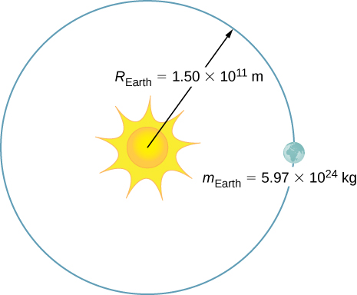

Solution



23. What is the average momentum of an avalanche that moves a 40-cm-thick layer of snow over an area of 100 m by 500 m over a distance of 1 km down a hill in 5.5 s? Assume a density of 350 kg/m3 for the snow.

Solution



25. A 75.0-kg person is riding in a car moving at 20.0 m/s when the car runs into a bridge abutment (see the following figure).

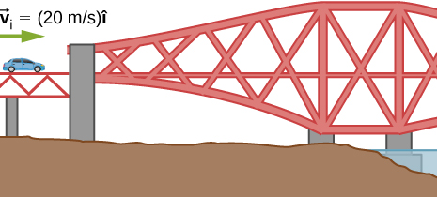

* 1. Calculate the average force on the person if he is stopped by a padded dashboard that compresses an average of 1.00 cm.
  2. Calculate the average force on the person if he is stopped by an air bag that compresses an average of 15.0 cm.

Solution

a. ; b. 

27. A cruise ship with a mass of  strikes a pier at a speed of 0.750 m/s. It comes to rest after traveling 6.00 m, damaging the ship, the pier, and the tugboat captain’s finances. Calculate the average force exerted on the pier using the concept of impulse. (*Hint*: First calculate the time it took to bring the ship to rest, assuming a constant force.)

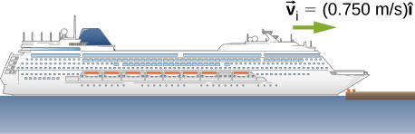

Solution



29. Water from a fire hose is directed horizontally against a wall at a rate of 50.0 kg/s and a speed of 42.0 m/s. Calculate the force exerted on the wall, assuming the water’s horizontal momentum is reduced to zero.

Solution



31. What is the momentum (as a function of time) of a 5.0-kg particle moving with a velocity  What is the net force acting on this particle?

Solution

;

33. A hockey puck of mass 150 g is sliding due east on a frictionless table with a speed of 10 m/s. Suddenly, a constant force of magnitude 5 N and direction due north is applied to the puck for 1.5 s. Find the north and east components of the momentum at the end of the 1.5-s interval.

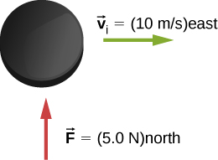

Solution

Let the positive x-axis be in the direction of the original momentum. Then  and 

35. Train cars are coupled together by being bumped into one another. Suppose two loaded train cars are moving toward one another, the first having a mass of  and a velocity of and the second having a mass of  and a velocity of . What is their final velocity?

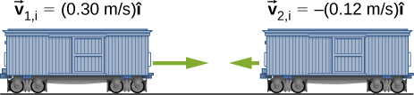

Solution



37. The figure below shows a bullet of mass 200 g traveling horizontally towards the east with speed 400 m/s, which strikes a block of mass 1.5 kg that is initially at rest on a frictionless table.

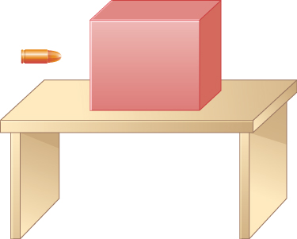

After striking the block, the bullet is embedded in the block and the block and the bullet move together as one unit.

* 1. What is the magnitude and direction of the velocity of the block/bullet combination immediately after the impact?
  2. What is the magnitude and direction of the impulse by the block on the bullet?
  3. What is the magnitude and direction of the impulse from the bullet on the block?
  4. If it took 3 ms for the bullet to change the speed from 400 m/s to the final speed after impact, what is the average force between the block and the bullet during this time?

Solution

a. 47 m/s in the bullet to block direction; b., toward the bullet; c., toward the block; d. magnitude is 

39. A 4.5 kg puffer fish expands to 40% of its mass by taking in water. When the puffer fish is threatened, it releases the water toward the threat to move quickly forward. What is the ratio of the speed of the puffer fish forward to the speed of the expelled water backwards?

Solution

2:5

41. Two figure skaters are coasting in the same direction, with the leading skater moving at 5.5 m/s and the trailing skating moving at 6.2 m/s. When the trailing skater catches up with the leading skater, he picks her up without applying any horizontal forces on his skates. If the trailing skater is 50% heavier than the 50-kg leading skater, what is their speed after he picks her up?

Solution

5.9 m/s

43. A 5.50-kg bowling ball moving at 9.00 m/s collides with a 0.850-kg bowling pin, which is scattered at an angle of 15.8 to the initial direction of the bowling ball and with a speed of 15.0 m/s.

* 1. Calculate the final velocity (magnitude and direction) of the bowling ball.
  2. Is the collision elastic?

Solution

a. 6.80 m/s, 5.33°; b. yes (calculate the ratio of the initial and final kinetic energies)

45. A 90.0-kg ice hockey player hits a 0.150-kg puck, giving the puck a velocity of 45.0 m/s. If both are initially at rest and if the ice is frictionless, how far does the player recoil in the time it takes the puck to reach the goal 15.0 m away?

Solution

2.5 cm

47. In an elastic collision, a 400-kg bumper car collides directly from behind with a second, identical bumper car that is traveling in the same direction. The initial speed of the leading bumper car is 5.60 m/s and that of the trailing car is 6.00 m/s. Assuming that the mass of the drivers is much, much less than that of the bumper cars, what are their final speeds?

Solution

the speed of the leading bumper car is 6.00 m/s and that of the trailing bumper car is 5.60 m/s

49. An alpha particle (4He) undergoes an elastic collision with a stationary uranium nucleus (235U). What percent of the kinetic energy of the alpha particle is transferred to the uranium nucleus? Assume the collision is one-dimensional.

Solution

6.6%

51. A 35-kg child rides a relatively massless sled down a hill and then coasts along the flat section at the bottom, where a second 35-kg child jumps on the sled as it passes by her. If the speed of the sled is 3.5 m/s before the second child jumps on, what is its speed after she jumps on?

Solution

1.8 m/s

53. A 0.90-kg falcon is diving at 28.0 m/s at a downward angle of . It catches a 0.325-kg pigeon from behind in midair. What is their combined velocity after impact if the pigeon’s initial velocity was 7.00 m/s directed horizontally? Note that  is a unit vector pointing in the direction in which the falcon is initially flying.

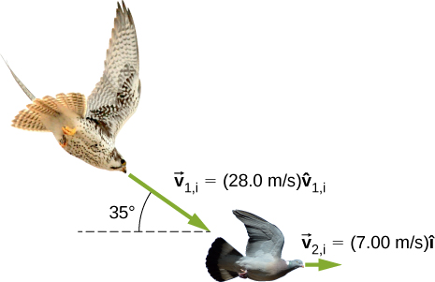

Solution

22.1 m/s at  below the horizontal

55. A projectile of mass 2.0 kg is ﬁred in the air at an angle of 40.0 to the horizon at a speed of 50.0 m/s. At the highest point in its flight, the projectile breaks into three parts of mass 1.0 kg, 0.7 kg, and 0.3 kg. The 1.0-kg part falls straight down after breakup with an initial speed of 10.0 m/s, the 0.7-kg part moves in the original forward direction, and the 0.3-kg part goes straight up.

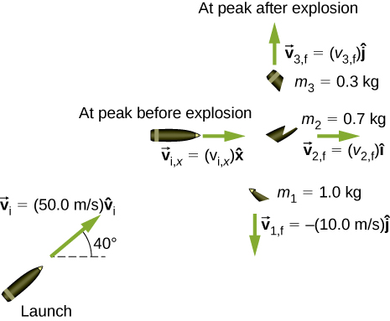

* 1. Find the speeds of the 0.3-kg and 0.7-kg pieces immediately after the break-up.
  2. How high from the break-up point does the 0.3-kg piece go before coming to rest?
  3. Where does the 0.7-kg piece land relative to where it was ﬁred from?

Solution

a. 33 m/s and 110 m/s; b. 57 m; c. 480 m

57. A 200-kg rocket in deep space moves with a velocity of . Suddenly, it explodes into three pieces, with the first (78 kg) moving at  and the second (56 kg) moving at . Find the velocity of the third piece.

Solution



59. Three 70-kg deer are standing on a flat 200-kg rock that is on an ice-covered pond. A gunshot goes off and the dear scatter, with deer A running at , deer B running at , and deer C running at . What is the velocity of the rock on which they were standing?

Solution



61. An oxygen atom (mass 16 u) moving at 733 m/s at 15.0° with respect to the  direction collides and sticks to an oxygen molecule (mass 32 u) moving at 528 m/s at 128° with respect to the  direction. The two stick together to form ozone. What is the final velocity of the ozone molecule?

Solution

341 m/s at 86.8° with respect to the  axis.

63. Three point masses are placed at the corners of a triangle as shown in the figure below.

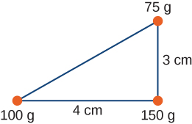

Find the center of mass of the three-mass system.

Solution

With the origin defined to be at the position of the 150-g mass,  and 

65. Two particles of equal masses  and  separated by a horizontal distance *D* are let go from the same height *h* at different times. Particle 1 starts at , and particle 2 is let go at . Find the vertical position of the center of mass at a time before the first particle strikes the ground. Assume no air resistance.

Solution



67. Two particles of masses  and  move uniformly in different circles of radii  and about the origin in the *x*,*y*-plane. The coordinates of the two particles in meters are given as follows ( for both). Here *t* is in seconds:



1. Find the radii of the circles of motion of both particles.
2. Find the *x*- and *y*-coordinates of the center of mass.
3. Decide if the center of mass moves in a circle by plotting its trajectory.

Solution

a.  , ; b. ; c. yes, with 

69. Find the center of mass of a rod of length *L* whose mass density changes from one end to the other quadratically. That is, if the rod is laid out along the *x*-axis with one end at the origin and the other end at , the density is given by , where  and  are constant values.

Solution



71. Find the center of mass of a rectangular material of length *a* and width *b* made up of a material of nonuniform density. The density is such that when the rectangle is placed in the *xy*-plane, the density is given by 

Solution



73. Find the center of mass of cone of uniform density that has a radius *R* at the base, height *h*, and mass *M*. Let the origin be at the center of the base of the cone and have +*z* going through the cone vertex.

Solution



75. Find the center of mass of a uniform thin semicircular plate of radius *R*. Let the origin be at the center of the semicircle, the plate arc from the +*x* axis to the −x axis, and the *z* axis be perpendicular to the plate.

Solution



77. (a) A 5.00-kg squid initially at rest ejects 0.250 kg of fluid with a velocity of 10.0 m/s. What is the recoil velocity of the squid if the ejection is done in 0.100 s and there is a 5.00-*N* frictional force opposing the squid’s movement?

(b) How much energy is lost to work done against friction?

Solution

(a) 0.413 m/s, (b) about 0.2 J

79. Repeat the preceding problem but for a rocket that takes off from a space station, where there is no gravity other than the negligible gravity due to the space station.

Solution

1551 kg

81. What exhaust speed is required to accelerate a rocket in deep space from 800 m/s to 1000 m/s in 5.0 s if the total rocket mass is 1200 kg and the rocket only has 50 kg of fuel left?

Solution

4.9 km/s

**Additional Problems**

84. Which has a larger magnitude of momentum: a 3000-kg elephant moving at 40 km/h or a 60-kg cheetah moving at 112 km/h?

Solution

the elephant has a higher momentum

86. Your friend claims that momentum is mass multiplied by velocity, so things with more mass have more momentum. Do you agree? Explain.

Solution

Answers may vary. The first clause is true, but the second clause is not true in general because the velocity of an object with small mass may be large enough so that the momentum of the object is greater than that of a larger-mass object with a smaller velocity.

88. Your 1500-kg sports car accelerates from 0 to 30 m/s in 10 s. What average force is exerted on it during this acceleration?

Solution



90. Repeat the preceding problem, but including a drag force due to air of

Solution



92. A car crashes into a large tree that does not move. The car goes from 30 m/s to 0 in 1.3 m. (a) What impulse is applied to the 70 kg driver by the seatbelt, assuming he follows the same motion as the car? (b) What is the average force applied to the driver by the seatbelt?

Solution

a.  , b. 

94. You are coasting on your 10-kg bicycle at 15 m/s and a 5.0-g bug splatters on your helmet. The bug was initially moving at 2.0 m/s in the same direction as you. If your mass is 60 kg, (a) what is the initial momentum of you plus your bicycle? (b) What is the initial momentum of the bug? (c) What is your change in velocity due to the collision with the bug? (d) What would the change in velocity have been if the bug were traveling in the opposite direction?

Solution

a.  , b. , c. , d. 

96. Two carts on a straight track collide head on. The first cart was moving at 3.6 m/s in the positive *x* direction and the second was moving at 2.4 m/s in the opposite direction. After the collision, the second car continues moving in its initial direction of motion at 0.24 m/s. If the mass of the second car is 5.0 times that of the first, what is the mass and final velocity of the first car?

Solution

0.10 kg, 

98. Derive the equations giving the final speeds for two objects that collide elastically, with the mass of the objects being  and  and the initial speeds being  and  (i.e., second object is initially stationary).

Solution



100. A child sleds down a hill and collides at 5.6 m/s into a stationary sled that is identical to his. The child is launched forward at the same speed, leaving behind the two sleds that lock together and slide forward more slowly. What is the speed of the two sleds after this collision?

Solution

* 1. m/s

102. A 90-kg football player jumps vertically into the air to catch a 0.50-kg football that is thrown essentially horizontally at him at 17 m/s. What is his horizontal speed after catching the ball?

Solution

0.094 m/s

104. Two billiard balls are at rest and touching each other on a pool table. The cue ball travels at 3.8 m/s along the line of symmetry between these balls and strikes them simultaneously. If the collision is elastic, what is the velocity of the three balls after the collision?

Solution

final velocity of cue ball is  , final velocities of the other two balls are 2.6 m/s at ±30° with respect to the initial velocity of the cue ball

106. Two identical billiard balls collide. The first one is initially traveling at  and the second one at . Suppose they collide when the center of ball 1 is at the origin and the center of ball 2 is at the point  where *R* is the radius of the balls. What is the final velocity of each ball?

Solution

ball 1: , ball 2: 

108. Repeat the preceding problem if the balls collide when the center of ball 1 is at the origin and the center of ball 2 is at the point 

Solution

ball 1: , ball 2: 

110. Where is the center of mass of a slice of pizza that was cut into eight equal slices? Assume the origin is at the apex of the slice and measure angles with respect to an edge of the slice. The radius of the pizza is *R*.

Solution



112. Your friend wonders how a rocket continues to climb into the sky once it is sufficiently high above the surface of Earth so that its expelled gasses no longer push on the surface. How do you respond?

Solution

Answers may vary. The rocket is propelled forward not by the gasses pushing against the surface of Earth, but by conservation of momentum. The momentum of the gas being expelled out the back of the rocket must be compensated by an increase in the forward momentum of the rocket.

**Challenge Problems**

114. A 65-kg person jumps from the first floor window of a burning building and lands almost vertically on the ground with a horizontal velocity of 3 m/s and vertical velocity of . Upon impact with the ground he is brought to rest in a short time. The force experienced by his feet depends on whether he keeps his knees stiff or bends them. Find the force on his feet in each case.

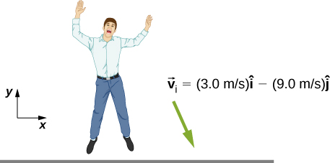

1. First find the impulse on the person from the impact on the ground. Calculate both its magnitude and direction.
2. Find the average force on the feet if the person keeps his leg stiff and straight and his center of mass drops by only 1 cm vertically and 1 cm horizontally during the impact.
3. Find the average force on the feet if the person bends his legs throughout the impact so that his center of mass drops by 50 cm vertically and 5 cm horizontally during the impact.
4. Compare the results of part (b) and (c), and draw conclusions about which way is better.

You will need to find the time the impact lasts by making reasonable assumptions about the acceleration opposite to the motion. Although the force is not constant during the impact, working with constant average force for this problem is acceptable.

Solution

a. , 108° ; b. , ; c. , 

116. Two identical objects (such as billiard balls) have a one-dimensional collision in which one is initially motionless. After the collision, the moving object is stationary and the other moves with the same speed as the other originally had. Show that both momentum and kinetic energy are conserved.

Solution

Conservation of momentum demands . We are given that , , and . Combining these equations with the equation given by conservation of momentum gives, which is true, so conservation of momentum is satisfied. Conservation of energy demands . Again combining this equation with the conditions given above give , so conservation of energy is satisfied.

118. Find the center of mass of the structure given in the figure below. Assume a uniform thickness of 20 cm, and a uniform density of 

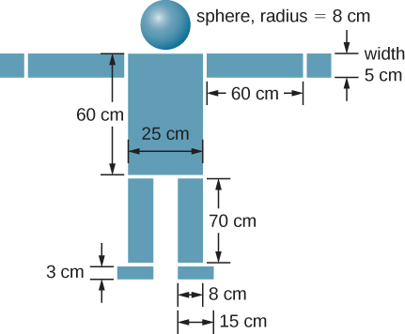

Solution

Assume origin on centerline and at floor, then 

This file is copyright 2016, Rice University. All Rights Reserved.