***University Physics Volume I***

**Unit 1: Mechanics**

**Chapter 10: Fixed-Axis Rotation**

**Conceptual Questions**

1. A clock is mounted on the wall. As you look at it, what is the direction of the angular velocity vector of the second hand?

Solution

The second hand rotates clockwise, so by the right-hand rule, the angular velocity vector is into the wall.

3. A baseball bat is swung. Do all points on the bat have the same angular velocity? The same tangential speed?

Solution

They have the same angular velocity. Points further out on the bat have greater tangential speeds.

5. If a rigid body has a constant angular acceleration, what is the functional form of the angular velocity in terms of the time variable?

Solution

straight line, linear in time variable

7. If the angular acceleration of a rigid body is zero, what is the functional form of the angular velocity?

Solution

constant

9. Explain why centripetal acceleration changes the direction of velocity in circular motion but not its magnitude.

Solution

The centripetal acceleration vector is perpendicular to the velocity vector.

11. Suppose a piece of food is on the edge of a rotating microwave oven plate. Does it experience nonzero tangential acceleration, centripetal acceleration, or both when: (a) the plate starts to spin faster? (b) The plate rotates at constant angular velocity? (c) The plate slows to a halt?

Solution

a. both; b. nonzero centripetal acceleration; c. both

13. A solid sphere is rotating about an axis through its center at a constant rotation rate. Another hollow sphere of the same mass and radius is rotating about its axis through the center at the same rotation rate. Which sphere has a greater rotational kinetic energy?

Solution

The hollow sphere, since the mass is distributed further away from the rotation axis.

15. A discus thrower rotates with a discus in his hand before letting it go. (a) How does his moment of inertia change after releasing the discus? (b) What would be a good approximation to use in calculating the moment of inertia of the discus thrower and discus?

Solution

a. It decreases. b. The arms could be approximated with rods and the discus with a disk. The torso is near the axis of rotation so it doesn’t contribute much to the moment of inertia.

17. The moment of inertia of a long rod spun around an axis through one end perpendicular to its length is  Why is this moment of inertia greater than it would be if you spun a point mass *m* at the location of the center of mass of the rod (at *L*/2) (that would be )?

Solution

Because the moment of inertia varies as the square of the distance to the axis of rotation. The mass of the rod located at distances greater than *L*/2 would provide the larger contribution to make its moment of inertia greater than the point mass at *L*/2.

19. What three factors affect the torque created by a force relative to a specific pivot point?

Solution

magnitude of the force, length of the lever arm, and angle of the lever arm and force vector

21. When reducing the mass of a racing bike, the greatest benefit is realized from reducing the mass of the tires and wheel rims. Why does this allow a racer to achieve greater accelerations than would an identical reduction in the mass of the bicycle’s frame?

Solution

The moment of inertia of the wheels is reduced, so a smaller torque is needed to accelerate them.

23. Can a set of forces have a net torque that is zero and a net force that is not zero?

Solution

yes

25. In the expression  can  ever be less than the lever arm? Can it be equal to the lever arm?

Solution

 can be equal to the lever arm but never less than the lever arm

27. A rod is pivoted about one end. Two forces  are applied to it. Under what circumstances will the rod not rotate?

Solution

If the forces are along the axis of rotation, or if they have the same lever arm and are applied at a point on the rod.

**Problems**

29. A track star runs a 400-m race on a 400-m circular track in 45 s. What is his angular velocity assuming a constant speed?

Solution



31. A particle moves 3.0 m along a circle of radius 1.5 m. (a) Through what angle does it rotate? (b) If the particle makes this trip in 1.0 s at a constant speed, what is its angular velocity? (c) What is its acceleration?

Solution

a. ; b. ; c. Since the angular acceleration is a constant, the only acceleration the particle experiences is its centripetal acceleration: .

33. **Unreasonable results.** The propeller of an aircraft is spinning at 10 rev/s when the pilot shuts off the engine. The propeller reduces its angular velocity at a constant  for a time period of 40 s. What is the rotation rate of the propeller in 40 s? Is this a reasonable situation?

Solution

The propeller takes only  to come to rest, when the propeller is at 0 rad/s, it would start rotating in the opposite direction. This would be impossible due to the magnitude of forces involved in getting the propeller to stop and start rotating in the opposite direction.

35. On takeoff, the propellers on a UAV (unmanned aerial vehicle) increase their angular velocity for 3.0 s from rest at a rate of  where *t* is measured in seconds. (a) What is the instantaneous angular velocity of the propellers at ? (b) What is the angular acceleration?

Solution

a. ; b. 

37. A wheel has a constant angular acceleration of  Starting from rest, it turns through 300 rad. (a) What is its final angular velocity? (b) How much time elapses while it turns through the 300 radians?

Solution

a. ;

b. 

39. The angular velocity of a rotating rigid body increases from 500 to 1500 rev/min in 120 s. (a) What is the angular acceleration of the body? (b) Through what angle does it turn in this 120 s?

Solution

a. ;

b. 

41. A wheel 1.0 m in radius rotates with an angular acceleration of  (a) If the wheel’s initial angular velocity is 2.0 rad/s, what is its angular velocity after 10 s? (b) Through what angle does it rotate in the 10-s interval? (c) What are the tangential speed and acceleration of a point on the rim of the wheel at the end of the 10-s interval?

Solution

a. ;

b. ;

c. 

43. A circular disk of radius 10 cm has a constant angular acceleration of  at  its angular velocity is 2.0 rad/s. (a) Determine the disk’s angular velocity at  (b) What is the angle it has rotated through during this time? (c) What is the tangential acceleration of a point on the disk at 

Solution

a. ;

b.  ;

c. 

45. A rod of length 20 cm has two bead attached its ends. The rod with beads starts rotating from rest. If the bead are to have a tangential speed of 20 m/s in 7 s, what is the angular acceleration of the rod to achieve this?

Solution

The angular velocity to achieve the tangential speed is :

.

47. A man stands on a merry-go-round that is rotating at 2.5 rad/s. If the coefficient of static friction between the man’s shoes and the merry-go-round is  how far from the axis of rotation can he stand without sliding?

Solution

The merry-go-round is rotating at a constant angular velocity, so the angular acceleration is zero, leaving only the centripetal acceleration. For the man not to slide off, the force of friction must equal the centripetal acceleration times his mass.

 

49. A wind turbine is rotating counterclockwise at 0.5 rev/s and slows to a stop in 10 s. Its blades are 20 m in length. (a) What is the angular acceleration of the turbine? (b) What is the centripetal acceleration of the tip of the blades at  (c) What is the magnitude and direction of the total linear acceleration of the tip of the blade that lies along the positive *x*-axis at 

Solution

a. ,

b. ; c. 

 in the counterclockwise direction from the centripetal acceleration vector

51. A child with mass 40 kg sits on the edge of a merry-go-round at a distance of 3.0 m from its axis of rotation. The merry-go-round accelerates from rest up to 0.4 rev/s in 10 s. If the coefficient of static friction between the child and the surface of the merry-go-round is 0.6, does the child fall off before 5 s?

Solution

 At  the angular velocity is





The maximum friction force is  so the child does not fall of yet.

53. The angular velocity of a flywheel with radius 1.0 m varies according to  Plot  from  for  Analyze these results to explain when  and when  for a point on the flywheel at a radius of 1.0 m.

Solution



Plotting both accelerations gives

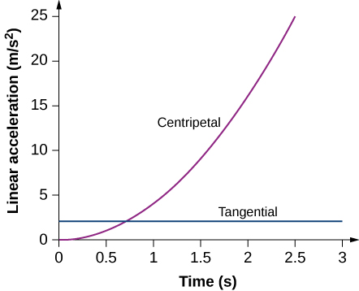

The tangential acceleration is constant, while the centripetal acceleration is time dependent, and increases with time to values much greater than the tangential acceleration after *t* = 1s. For times less than 0.7 s and approaching zero the centripetal acceleration is much less than the tangential acceleration.

55. (a) Calculate the rotational kinetic energy of Earth on its axis. (b) What is the rotational kinetic energy of Earth in its orbit around the Sun?

Solution

a. 

b. 

57. A baseball pitcher throws the ball in a motion where there is rotation of the forearm about the elbow joint as well as other movements. If the linear velocity of the ball relative to the elbow joint is 20.0 m/s at a distance of 0.480 m from the joint and the moment of inertia of the forearm is , what is the rotational kinetic energy of the forearm?

Solution



59. An aircraft is coming in for a landing at 300 meters height when the propeller falls off. The aircraft is flying at 40.0 m/s horizontally. The propeller has a rotation rate of 20 rev/s, a moment of inertia of 70.0 kg-m2, and a mass of 200 kg. Neglect air resistance, so the rotation rate does not change as the propeller falls. (a) With what translational velocity does the propeller hit the ground? (b) What is the rotation rate of the propeller at impact?

Solution

a. The initial energy in the system is 

The gravitational potential energy is converted into translational energy:



Since  the rotational terms cancel,



and we have 

;

b. The rotational rate of the propeller stays the same at 20 rev/s.

61. A neutron star of mass 2 × 1030 kg and radius 10 km rotates with a period of 0.02 seconds. What is its rotational kinetic energy?

Solution



63. A system consists of a disk of mass 2.0 kg and radius 50 cm upon which is mounted an annular cylinder of mass 1.0 kg with inner radius 20 cm and outer radius 30 cm (see below). The system rotates about an axis through the center of the disk and annular cylinder at 10 rev/s. (a) What is the moment of inertia of the system? (b) What is its rotational kinetic energy?

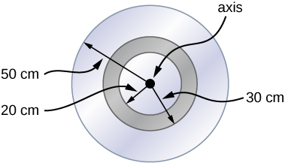

Solution

a. 

;

b. 

65. Using the parallel axis theorem, what is the moment of inertia of the rod of mass *m* about the axis shown below?

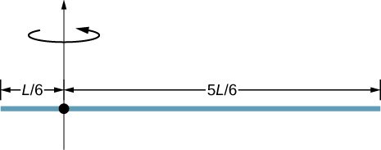

Solution

by the parallel-axis theorem



67. A uniform rod of mass 1.0 kg and length 2.0 m is free to rotate about one end (see the following figure). If the rod is released from rest at an angle of  with respect to the horizontal, what is the speed of the tip of the rod as it passes the horizontal position?

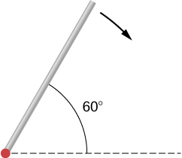

Solution

The center of mass of the rod is located  above the horizontal. By conservation of energy, ,

, and



69. A solid sphere of radius 10 cm is allowed to rotate freely about an axis. The sphere is given a sharp blow so that its center of mass starts from the position shown in the following figure with speed 15 cm/s. What is the maximum angle that the diameter makes with the vertical?

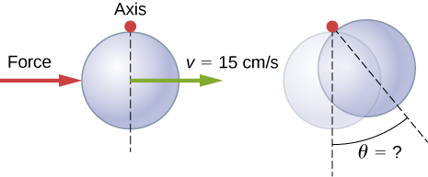

Solution



,



71. Two flywheels of negligible mass and different radii are bonded together and rotate about a common axis (see below). The smaller flywheel of radius 30 cm has a cord that has a pulling force of 50 N on it. What pulling force needs to be applied to the cord connecting the larger flywheel of radius 50 cm such that the combination does not rotate?

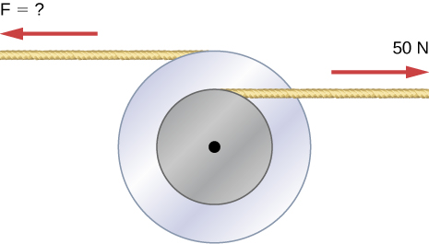

Solution

The torques must balance. 

73. (a) When opening a door, you push on it perpendicularly with a force of 55.0 N at a distance of 0.850 m from the hinges. What torque are you exerting relative to the hinges? (b) Does it matter if you push at the same height as the hinges? There is only one pair of hinges.

Solution

a. ; b. It does not matter at what height you push. The torque depends on only the magnitude of the force applied and the perpendicular distance of the force’s application from the hinges.

75. What hanging mass must be placed on the cord to keep the pulley from rotating (see the following figure)? The mass on the frictionless plane is 5.0 kg. The mass on the plane is connected to a cord that wraps around the pulley’s inner radius of 20 cm. The hanging mass is connected to a cord that wraps around the pulley’s outer radius of 30 cm.

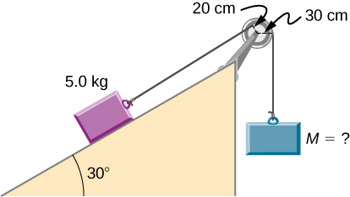

Solution

the mass on the plane provides a torque of 



77. Calculate the torque about the z-axis that is out of the page at the origin in the following figure, given that 

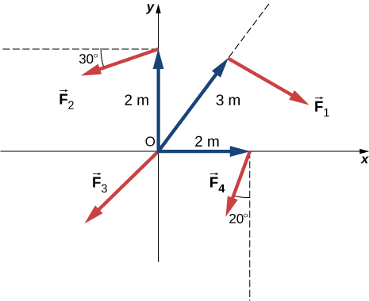

Solution



79. A pendulum consists of a rod of mass 1 kg and length 1 m connected to a pivot with a solid sphere attached at the other end with mass 0.5 kg and radius 30 cm. What is the torque about the pivot when the pendulum makes an angle of  with respect to the vertical?

Solution

the center of mass of the system is located at  from the axis of rotation;



81. A horizontal beam of length 3 m and mass 2.0 kg has a mass of 1.0 kg and width 0.2 m sitting at the end of the beam (see the following figure). What is the torque of the system about the support at the wall?

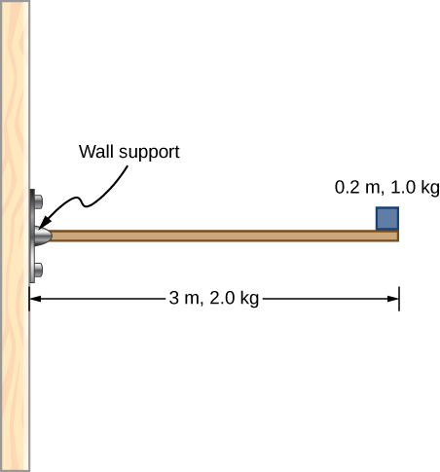

Solution



83. What is the torque about the origin of the force  if it is applied at the point whose position is: 

Solution



85. Suppose you exert a force of 180 N tangential to a 0.280-m-radius, 75.0-kg grindstone (a solid disk). (a)What torque is exerted? (b) What is the angular acceleration assuming negligible opposing friction? (c) What is the angular acceleration if there is an opposing frictional force of 20.0 N exerted 1.50 cm from the axis?

Solution

a. ;

b. ;

c. 

87. A constant torque is applied to a rigid body whose moment of inertia is  around the axis of rotation. If the wheel starts from rest and attains an angular velocity of 20.0 rad/s in 10.0 s, what is the applied torque?

Solution



89. A flywheel  rotating at 500.0 rev/min is brought to rest by friction in 2.0 min. What is the frictional torque on the flywheel?

Solution



91. Suppose when Earth was created, it was not rotating. However, after the application of a uniform torque for 6 days according to the current length of a day, it was rotating at 1 rev/day. (a) What was the angular acceleration during the 6 days? (b) What torque was applied to Earth during this period? (c) What force tangent to Earth at its equator would produce this torque?

Solution

a. ;

b. ; c. 

93. A block of mass 3 kg slides down an inclined plane at an angle of  with a massless tether attached to a pulley with mass 1 kg and radius 0.5 m at the top of the incline (see the following figure). The pulley can be approximated as a disk. The coefficient of kinetic friction on the plane is 0.4. What is the acceleration of the block?

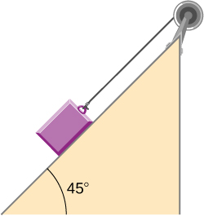

Solution

 from forces on the block, Newton’s second law  
 torque on the pulley =  since    
   


95. A uniform rod of mass and length is held vertically by two strings of negligible mass, as shown below. (a) Immediately after the string is cut, what is the linear acceleration of the free end of the stick? (b) Of the middle of the stick?

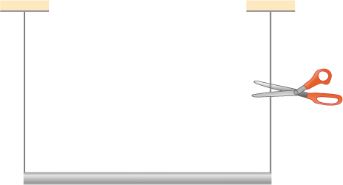

Solution

Torque is mg (distance to center of mass) from pivot at left string; a.

; b. 

97. A wind turbine rotates at 20 rev/min. If its power output is 2.0 MW, what is the torque produced on the turbine from the wind?

Solution



99. A uniform cylindrical grindstone has a mass of 10 kg and a radius of 12 cm. (a) What is the rotational kinetic energy of the grindstone when it is rotating at  (b) After the grindstone’s motor is turned off, a knife blade is pressed against the outer edge of the grindstone with a perpendicular force of 5.0 N. The coefficient of kinetic friction between the grindstone and the blade is 0.80. Use the work energy theorem to determine how many turns the grindstone makes before it stops.

Solution

;

a. ;

b. 

101. A propeller is accelerated from rest to an angular velocity of 1000 rev/min over a period of 6.0 seconds by a constant torque of  (a) What is the moment of inertia of the propeller? (b) What power is being provided to the propeller 3.0 s after it starts rotating?

Solution

a. ;

b.

103. A uniform rod of length *L* and mass *M* is held vertically with one end resting on the floor as shown below. When the rod is released, it rotates around its lower end until it hits the floor. Assuming the lower end of the rod does not slip, what is the linear velocity of the upper end when it hits the floor?

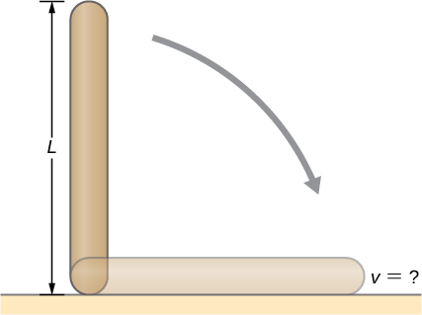

Solution

 is measured from the vertical. The torque is taken from the center of mass,  ;



105. A 2-kg block on a frictionless inclined plane at  has a cord attached to a pulley of mass 1 kg and radius 20 cm (see the following figure). The block slides a distance of 0.50 m. (a) What is the acceleration of the block down the plane? (b) What is the work done by the cord on the pulley?

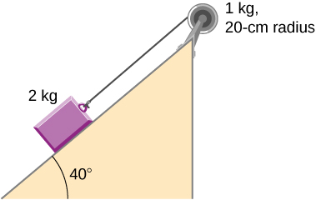

Solution

a. ,

,

,  that of a disk,

;

b. The net torque on the pulley: ,

,   


**Additional Problems**

107. A cyclist is riding such that the wheels of the bicycle have a rotation rate of 3.0 rev/s. If the cyclist brakes such that the rotation rate of the wheels decrease at a rate of  how long does it take for the cyclist to come to a complete stop?

Solution



109. A phonograph turntable rotating at 33 1/3 rev/min slows down and stops in 1.0 min. (a) What is the turntable’s angular acceleration, in radians/s2, assuming it is constant? (b) How many revolutions does the turntable make while stopping?

Solution

a.  ;

b. 

111. Suppose a piece of dust has fallen on a CD. If the spin rate of the CD is 500 rpm, and the piece of dust is 4.3 cm from the center, what is the total distance traveled by the dust in 3 minutes? (Ignore accelerations due to getting the CD rotating.)

Solution





113. Calculate the moment of inertia of a skater given the following information. (a) The 60.0-kg skater is approximated as a cylinder that has a 0.110-m radius. (b) The skater with arms extended is approximated by a cylinder that is 52.5 kg, has a 0.110-m radius, and has two 0.900-m-long arms which are 3.75 kg each and extend straight out from the cylinder like rods rotated about their ends.

Solution

a. ;

b. 

115. A pendulum consists of a rod of length 2 m and mass 3 kg with a solid sphere of mass 1 kg and radius 0.3 m attached at one end. The axis of rotation is as shown below. What is the angular velocity of the pendulum at its lowest point if it is released from rest at an angle of 

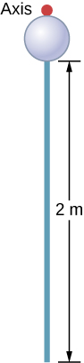

Solution

the center of mass of the system is located at  from the axis of rotation.







117. Two children push on opposite sides of a door during play. Both push horizontally and perpendicular to the door. One child pushes with a force of 17.5 N at a distance of 0.600 m from the hinges, and the second child pushes at a distance of 0.450 m. What force must the second child exert to keep the door from moving? Assume friction is negligible.

Solution



119. An automobile engine can produce 200 Nm of torque. Calculate the angular acceleration produced if 95.0% of this torque is applied to the drive shaft, axle, and rear wheels of a car, given the following information. The car is suspended so that the wheels can turn freely. Each wheel acts like a 15.0-kg disk that has a 0.180-m radius. The walls of each tire act like a 2.00-kg annular ring that has inside radius of 0.180 m and outside radius of 0.320 m. The tread of each tire acts like a 10.0-kg hoop of radius 0.330 m. The 14.0-kg axle acts like a rod that has a 2.00-cm radius. The 30.0-kg drive shaft acts like a rod that has a 3.20-cm radius.

Solution



**Challenge Problems**

121. The angular acceleration of a rotating rigid body is given by  If the body starts rotating from rest at  (a) what is the angular velocity? (b) Angular position? (c) What angle does it rotate through in 10 s? (d) Where does the vector perpendicular to the axis of rotation indicating  at  lie at ?

Solution

a. ;

b. ;

c. ;

d.  the vector is at 

123. A disk of mass *m*, radius *R*, and area *A* has a surface mass density  (see the following figure). What is the moment of inertia of the disk about an axis through the center?

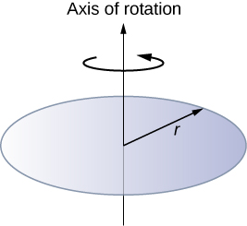

Solution



125. A cord is wrapped around the rim of a solid cylinder of radius 0.25 m, and a constant force of 40 N is exerted on the cord shown, as shown in the following figure. The cylinder is mounted on frictionless bearings, and its moment of inertia is . (a) Use the work energy theorem to calculate the angular velocity of the cylinder after 5.0 m of cord have been removed. (b) If the 40-N force is replaced by a 40-N weight, what is the angular velocity of the cylinder after 5.0 m of cord have unwound?

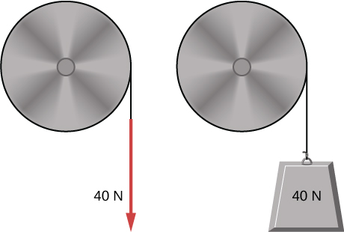

Solution

a. 



;

b. Use conservation of mechanical energy







This file is copyright 2016, Rice University. All Rights Reserved.