***University Physics Volume I***

**Unit 1: Mechanics**

**Chapter 11: Angular Momentum**

**Conceptual Questions**

1. Can a round object released from rest at the top of a frictionless incline undergo rolling motion?

Solution

No, the static friction force is zero.

3. A wheel is released from the top on an incline. Is the wheel most likely to slip if the incline is steep or gently sloped?

Solution

The wheel is more likely to slip on a steep incline since the coefficient of static friction must increase with the angle to keep rolling motion without slipping.

5. A hollow sphere and a hollow cylinder of the same radius and mass roll up an incline without slipping and have the same initial center of mass velocity. Which object reaches a greater height before stopping?

Solution

The cylinder reaches a greater height. By , its acceleration in the direction down the incline would be less.

7. For a particle traveling in a straight line, are there any points about which the angular momentum is zero? Assume the line intersects the origin.

Solution

All points on the straight line will give zero angular momentum, because a vector crossed into a parallel vector is zero.

9. If a particle is moving with respect to a chosen origin it has linear momentum. What conditions must exist for this particle’s angular momentum to be zero about the chosen origin?

Solution

The particle must be moving on a straight line that passes through the chosen origin.

11. What is the purpose of the small propeller at the back of a helicopter that rotates in the plane perpendicular to the large propeller?

Solution

Without the small propeller, the body of the helicopter would rotate in the opposite sense to the large propeller in order to conserve angular momentum. The small propeller exerts a thrust at a distance *R* from the center of mass of the aircraft to prevent this from happening.

13. As the rope of a tethered ball winds around a pole, what happens to the angular velocity of the ball?

Solution

The angular velocity increases because the moment of inertia is decreasing.

15. Explain why stars spin faster when they collapse.

Solution

More mass is concentrated near the rotational axis, which decreases the moment of inertia causing the star to increase its angular velocity.

17. Gyroscopes used in guidance systems to indicate directions in space must have an angular momentum that does not change in direction. When placed in the vehicle, they are put in a compartment that is separated from the main fuselage, such that changes in the orientation of the fuselage does not affect the orientation of the gyroscope. If the space vehicle is subjected to large forces and accelerations how can the direction of the gyroscopes angular momentum be constant at all times?

Solution

A torque is needed in the direction perpendicular to the angular momentum vector in order to change its direction. These forces on the space vehicle are external to the container in which the gyroscope is mounted and do not impart torques to the gyroscope’s rotating disk.

**Problems**

19. What is the angular velocity of a 75.0-cm-diameter tire on an automobile traveling at 90.0 km/h?

Solution



21. If the boy on the bicycle in the preceding problem accelerates from rest to a speed of 10.0 m/s in 10.0 s, what is the angular acceleration of the tires?

Solution



23. A marble rolls down an incline at  from rest. (a) What is its acceleration? (b) How far does it go in 3.0 s?

Solution

 ;



25. A rigid body with a cylindrical cross-section is released from the top of a  incline. It rolls 10.0 m to the bottom in 2.60 s. Find the moment of inertia of the body in terms of its mass *m* and radius *r.*

Solution

positive is down the incline plane;

,





27. A solid cylinder of radius 10.0 cm rolls down an incline with slipping. The angle of the incline is  The coefficient of kinetic friction on the surface is 0.400. What is the angular acceleration of the solid cylinder? What is the linear acceleration

Solution





29. A 40.0-kg solid cylinder is rolling across a horizontal surface at a speed of 6.0 m/s. How much work is required to stop it?

Solution

,



31. A solid cylinder rolls up an incline at an angle of  If it starts at the bottom with a speed of 10 m/s, how far up the incline does it travel?

Solution

Mechanical energy at the bottom equals mechanical energy at the top;

,

 so the distance up the incline is 

33. A hollow cylinder that is rolling without slipping is given an initial velocity and rolls up an incline to a vertical height of 1.0 m. If a hollow sphere of the same mass and radius is given the same initial velocity, how high vertically does it roll up the incline?

Solution

Use energy conservation

,

.

Subtracting the two equations, eliminating the initial translational energy, we have



The ratio of the height reached by the sphere to the height reached by the cylinder is 

So the sphere reaches a lower height of 

35. A bird flies overhead from where you stand at an altitude of 300.0 m and at a speed horizontal to the ground of 20.0 m/s. The bird has a mass of 2.0 kg. The radius vector to the bird makes an angle with respect to the ground. The radius vector to the bird and its momentum vector lie in the *xy*-plane. What is the bird’s angular momentum about the point where you are standing?

Solution

The magnitude of the cross product of the radius to the bird and its momentum vector yields , which gives  as the altitude of the bird *h*. The direction of the angular momentum is perpendicular to the radius and momentum vectors, which we choose arbitrarily as , which is in the plane of the ground:



37. A particle of mass 5.0 kg has position vector  at a particular instant of time when its velocity is  with respect to the origin. (a) What is the angular momentum of the particle? (b) If a force  acts on the particle at this instant, what is the torque about the origin?

Solution

a. ;

b. 

39. Suppose the particles in the preceding problem have masses  The velocities of the particles are , , ,  (a) Calculate the angular momentum of each particle about the origin. (b) What is the total angular momentum of the four-particle system about the origin?

Solution

a. , ,

;

b. 

41. An airplane of mass 4.0 × 104 kg flies horizontally at an altitude of 10 km with a constant speed of 250 m/s relative to Earth. (a) What is the magnitude of the airplane’s angular momentum relative to a ground observer directly below the plane? (b) Does the angular momentum change as the airplane flies along a constant altitude?

Solution

a. 

b. No, the angular momentum stays the same since the cross-product involves only the perpendicular distance from the plane to the ground no matter where it is along its path.

43. A particle of mass *m* is dropped at the point (–*d*, 0) and falls vertically in Earth’s gravitational field  (a) What is the expression for the angular momentum of the particle around the *z*-axis, which points directly out of the page as shown below? (b) Calculate the torque on the particle around the *z*-axis. (c) Is the torque equal to the time rate of change of the angular momentum?

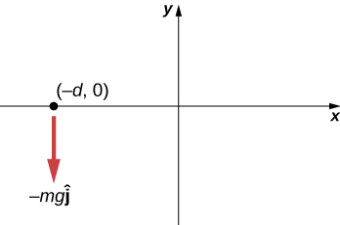

Solution

a. ;

b. ;

c. yes

45. A boulder of mass 20 kg and radius 20 cm rolls down a hill 15 m high from rest. What is its angular momentum when it is half way down the hill? (b) At the bottom?

Solution

a. ;

;

;

b. ;



47. A propeller consists of two blades each 3.0 m in length and mass 120 kg each. The propeller can be approximated by a single rod rotating about its center of mass. The propeller starts from rest and rotates up to 1200 rpm in 30 seconds at a constant rate. (a) What is the angular momentum of the propeller at  (b) What is the torque on the propeller?

Solution

a.  ;  ;

; ;

;

b. 

49. The blades of a wind turbine are 30 m in length and rotate at a maximum rotation rate of 20 rev/min. (a) If the blades are 6000 kg each and the rotor assembly has three blades, calculate the angular momentum of the turbine at this rotation rate. (b) What is the torque require to rotate the blades up to the maximum rotation rate in 5 minutes?

Solution

a. ;

b. 

51. A mountain biker takes a jump in a race and goes airborne. The mountain bike is travelling at 10.0 m/s before it goes airborne. If the mass of the front wheel on the bike is 750 g and has radius 35 cm, what is the angular momentum of the spinning wheel in the air the moment the bike leaves the ground?

Solution



53. The Sun’s mass is 2.0 × 1030 kg, its radius is 7.0 × 105 km, and it has a rotational period of approximately 28 days. If the Sun should collapse into a white dwarf of radius 3.5 × 103 km, what would its period be if no mass were ejected and a sphere of uniform density can model the Sun both before and after?

Solution

,



55. A diver off the high board imparts an initial rotation with his body fully extended before going into a tuck and executing three back somersaults before hitting the water. If his moment of inertia before the tuck is  and after the tuck during the somersaults is , what rotation rate must he impart to his body directly off the board and before the tuck if he takes 1.4 s to execute the somersaults before hitting the water?

Solution



57. A Molniya orbit is a highly eccentric orbit of a communication satellite so as to provide continuous communications coverage for Scandinavian countries and adjacent Russia. The orbit is positioned so that these countries have the satellite in view for extended periods in time (see below). If a satellite in such an orbit has an apogee at 40,000.0 km as measured from the center of Earth and a velocity of 3.0 km/s, what would be its velocity at perigee measured at 200.0 km altitude?

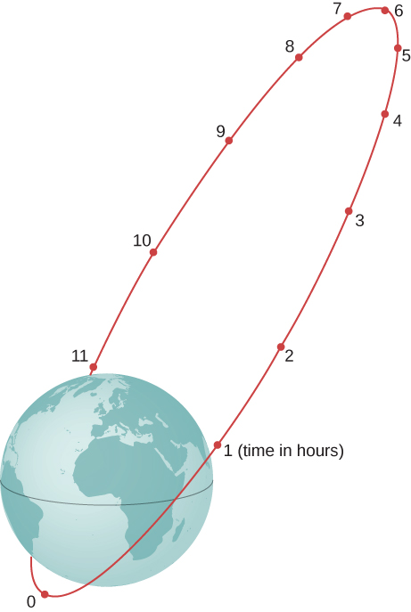

Solution



59. A bug of mass 0.020 kg is at rest on the edge of a solid cylindrical disk  rotating in a horizontal plane around the vertical axis through its center. The disk is rotating at 10.0 rad/s. The bug crawls to the center of the disk. (a) What is the new angular velocity of the disk? (b) What is the change in the kinetic energy of the system? (c) If the bug crawls back to the outer edge of the disk, what is the angular velocity of the disk then? (d) What is the new kinetic energy of the system? (e) What is the cause of the increase and decrease of kinetic energy?

Solution

a. ,

,



b. ;

c.  back to the original value;

d.  back to the original value;

e. work of the bug crawling on the disk

61. A merry-go-round has a radius of 2.0 m and a moment of inertia  A boy of mass 50 kg runs tangent to the rim at a speed of 4.0 m/s and jumps on. If the merry-go-round is initially at rest, what is the angular velocity after the boy jumps on?

Solution







63. Three children are riding on the edge of a merry-go-round that is 100 kg, has a 1.60-m radius, and is spinning at 20.0 rpm. The children have masses of 22.0, 28.0, and 33.0 kg. If the child who has a mass of 28.0 kg moves to the center of the merry-go-round, what is the new angular velocity in rpm?

Solution







65. Twin skaters approach one another as shown below and lock hands. (a) Calculate their final angular velocity, given each had an initial speed of 2.50 m/s relative to the ice. Each has a mass of 70.0 kg, and each has a center of mass located 0.800 m from their locked hands. You may approximate their moments of inertia to be that of point masses at this radius. (b) Compare the initial kinetic energy and final kinetic energy.

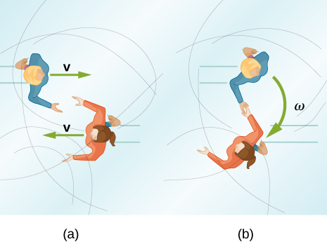

Solution

a. ,

,

;

b. ,



67. In 2015, in Warsaw, Poland, Olivia Oliver of Nova Scotia broke the world record for being the fastest spinner on ice skates. She achieved a record 342 rev/min, beating the existing Guinness World Record by 34 rotations. If an ice skater extends her arms at that rotation rate, what would be her new rotation rate? Assume she can be approximated by a 45-kg rod that is 1.7 m tall with a radius of 15 cm in the record spin. With her arms stretched take the approximation of a rod of length 130 cm with  of her body mass aligned perpendicular to the spin axis. Neglect frictional forces.

Solution

Moment of inertia in the record spin: ,

****,

****,



69. A gymnast does cartwheels along the floor and then launches herself into the air and executes several flips in a tuck while she is airborne. If her moment of inertia when executing the cartwheels is  and her spin rate is 0.5 rev/s, how many revolutions does she do in the air if her moment of inertia in the tuck is  and she has 2.0 s to do the flips in the air?

Solution

Her spin rate in the air is: ;

She can do four flips in the air.

71. A ride at a carnival has four spokes to which pods are attached that can hold two people. The spokes are each 15 m long and are attached to a central axis. Each spoke has mass 200.0 kg, and the pods each have mass 100.0 kg. If the ride spins at 0.2 rev/s with each pod containing two 50.0-kg children, what is the new spin rate if all the children move in their pods to halfway along the spoke?

Solution

Moment of inertia with all children aboard:

;

;



73. A space station consists of a giant rotating hollow cylinder. It is rotating in space at 3.30 rev/min in order to produce artificial gravity. If the inertia of the station were to decrease by 10% of the original value by a rearrangement of mass, what is the new rotation rate?

Solution



75. A gyroscope has a 0.5-kg disk that spins at 40 rev/s. The center of mass of the disk is 15 cm from a pivot with a radius of the disk of 10 cm. What is the precession angular velocity?

Solution

,



77. The axis of Earth makes a 23.5° angle with a direction perpendicular to the plane of Earth’s orbit. As shown below, this axis precesses, making one complete rotation in 25,780 y.

(a) Calculate the change in angular momentum in half this time.

(b) What is the average torque producing this change in angular momentum?

(c) If this torque were created by a pair of forces acting at the most effective point on the equator, what would the magnitude of each force be?

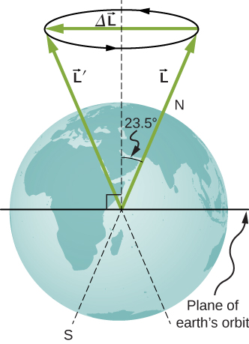

Solution

a. ,

;

b.;

c. The two forces at the equator would have the same magnitude but different directions, one in the north direction and the other in the south direction on the opposite side of Earth. The angle between the forces and the lever arms to the center of Earth is , so a given torque would have magnitude . Both would provide a torque in the same direction: 

**Additional Problems**

79. Repeat the preceding problem replacing the marble with a hollow sphere. Explain the new results.

Solution

,



b.  ;

The hollow sphere has a larger moment of inertia, and therefore is harder to bring to a rest than the marble, or solid sphere. The distance travelled is larger and the time elapsed is longer.

81. Repeat the preceding problem for a hollow sphere of the same radius and mass and initial speed. Explain the differences in the results.

Solution

a.,

;

b. ,

,

;

The moment of inertia is less for the hollow sphere, therefore less work is required to stop it. Likewise it rolls up the incline a shorter distance than the hoop.

83. A 4.0-kg particle moves in a circle of radius 2.0 m. The angular momentum of the particle varies in time according to *l* = 5.0*t*2. (a) What is the torque on the particle about the center of the circle at ? (b) What is the angular velocity of the particle at ?

Solution

a. ;

b. 

85. (a) What is the angular momentum of the Moon in its orbit around Earth? (b) How does this angular momentum compare with the angular momentum of the Moon on its axis? Remember that the Moon keeps one side toward Earth at all times.

Solution

a.  average distance to the Moon; orbital period ; speed of the Moon ; mass of the Moon ,

;

b. radius of the Moon ; the orbital period is the same as (a): ,

;

The orbital angular momentum is  times larger than the rotational angular momentum for the Moon.

87. A potter’s disk spins from rest up to 10 rev/s in 15 s. The disk has a mass 3.0 kg and radius 30.0 cm. What is the angular momentum of the disk at ?

Solution

,

 ,

 ,

 

89. A solid cylinder of mass 2.0 kg and radius 20 cm is rotating counterclockwise around a vertical axis through its center at 600 rev/min. A second solid cylinder of the same mass and radius is rotating clockwise around the same vertical axis at 900 rev/min. If the cylinders couple so that they rotate about the same vertical axis, what is the angular velocity of the combination?

Solution

In the conservation of angular momentum equation, the rotation rate appears on both sides so we keep the (rev/min) notation as the angular velocity can be multiplied by a constant to get (rev/min):



 clockwise

91. Eight children, each of mass 40 kg, climb on a small merry-go-round. They position themselves evenly on the outer edge and join hands. The merry-go-round has a radius of 4.0 m and a moment of inertia  After the merry-go-round is given an angular velocity of 6.0 rev/min, the children walk inward and stop when they are 0.75 m from the axis of rotation. What is the new angular velocity of the merry-go-round? Assume there is negligible frictional torque on the structure.

Solution

,







93. A satellite in the shape of a sphere of mass 20,000 kg and radius 5.0 m is spinning about an axis through its center of mass. It has a rotation rate of 8.0 rev/s. Two antennas deploy in the plane of rotation extending from the center of mass of the satellite. Each antenna can be approximated as a rod has mass 200.0 kg and length 7.0 m. What is the new rotation rate of the satellite?

Solution

,

,



**Challenge Problems**

95. The truck shown below is initially at rest with solid cylindrical roll of paper sitting on its bed. If the truck moves forward with a uniform acceleration *a*,what distance *s* does it move before the paper rolls off its back end? (*Hint*: If the roll accelerates forward with , then is accelerates backward relative to the truck with an acceleration . Also, .)

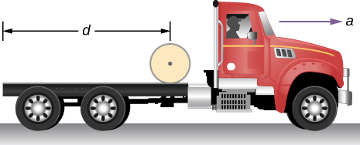

Solution

Assume the roll accelerates forward with respect to the ground with an acceleration **.Then it accelerates backwards relative to the truck with an acceleration .

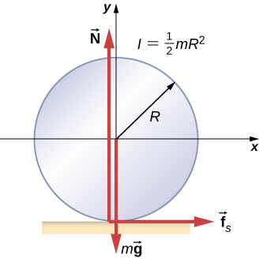

Also, ,

,

Solving for : ; ,



therefore, 

97. A small ball of mass 0.50 kg is attached by a massless string to a vertical rod that is spinning as shown below. When the rod has an angular velocity of 6.0 rad/s, the string makes an angle of  with respect to the vertical. (a) If the angular velocity is increased to 10.0 rad/s, what is the new angle of the string? (b) Calculate the initial and final angular momenta of the ball. (c) Can the rod spin fast enough so that the ball is horizontal?

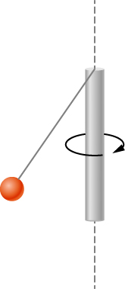

Solution

a. The tension in the string provides the centripetal force such that . The component of the tension that is vertical opposes the gravitational force such that . This gives . We solve for . This gives the length of the string as .

At , there is a new angle, tension, and perpendicular radius to the rod. Dividing the two equations involving the tension to eliminate it, we have ;

;

b.,

;

c. No, the cosine of the angle is inversely proportional to the square of the angular velocity, therefore in order for . The rod would have to spin infinitely fast.

This file is copyright 2016, Rice University. All Rights Reserved.