***University Physics Volume I***

**Unit 1: Mechanics**

**Chapter 12: Static Equilibrium and Elasticity**

**Conceptual Questions**

1. What can you say about the velocity of a moving body that is in dynamic equilibrium?

Solution

constant

3. What three factors affect the torque created by a force relative to a specific pivot point?

Solution

magnitude and direction of the force, and its lever arm

For the next four problems, evaluate the statement as either true or false and explain your answer.

5. If there is only one external force (or torque) acting on an object, it cannot be in equilibrium.

Solution

True, as the sum of forces cannot be zero in this case unless the force itself is zero.

7. If an odd number of forces act on an object, the object cannot be in equilibrium.

Solution

False, provided forces add to zero as vectors then equilibrium can be achieved.

9. What purpose is served by a long and flexible pole carried by wire-walkers?

Solution

It helps a wire-walker to maintain equilibrium.

11. Show how a spring scale and a simple fulcrum can be used to weigh an object whose weight is larger than the maximum reading on the scale.

Solution

proof

*Note:* Unless stated otherwise, the weights of the wires, rods, and other elements are assumed to be negligible. Elastic moduli of selected materials are given in the following table.

|  |  |  |  |
| --- | --- | --- | --- |
| Material | Young’s modulus | Bulk modulus | Shear modulus |
| Aluminum | 7.0 | 7.5 | 2.5 |
| Bone (tension) | 1.6 | 0.8 | 8.0 |
| Bone (compression) | 0.9 |  |  |
| Brass | 9.0 | 6.0 | 3.5 |
| Brick | 1.5 |  |  |
| Concrete | 2.0 |  |  |
| Copper | 11.0 | 14.0 | 4.4 |
| Crown glass | 6.0 | 5.0 | 2.5 |
| Granite | 4.5 | 4.5 | 2.0 |
| Hair (human) | 1.0 |  |  |
| Hardwood | 1.5 |  | 1.0 |
| Iron | 21.0 | 16.0 | 7.7 |
| Lead | 1.6 | 4.1 | 0.6 |
| Marble | 6.0 | 7.0 | 2.0 |
| Nickel | 21.0 | 17.0 | 7.8 |
| Polystyrene | 3.0 |  |  |
| Silk | 6.0 |  |  |
| Spider thread | 3.0 |  |  |
| Steel | 20.0 | 16.0 | 7.5 |
| Acetone |  | 0.07 |  |
| Ethanol |  | 0.09 |  |
| Glycerin |  | 0.45 |  |
| Mercury |  | 2.5 |  |
| Water |  | 0.22 |  |

13. Why can a squirrel jump from a tree branch to the ground and run away undamaged, while a human could break a bone in such a fall?

Solution

In contact with the ground, stress in squirrel’s limbs is smaller than stress in human’s limbs.

15. A thin wire strung between two nails in the wall is used to support a large picture. Is the wire likely to snap if it is strung tightly or if it is strung so that it sags considerably?

Solution

tightly

17. What type of stress are you applying when you press on the ends of a wooden rod? When you pull on its ends?

Solution

compressive; tensile

19. Can Young’s modulus have a negative value? What about the bulk modulus?

Solution

no

21. Discuss how you might measure the bulk modulus of a liquid.

Solution

Answers will vary.

*Note:* Unless stated otherwise, in the following two exercises, the weights of the wires, rods, and other elements are assumed to be negligible. Elastic moduli of selected materials are given in the table shown above.

23. Steel rods are commonly placed in concrete before it sets. What is the purpose of these rods?

Solution

It acts as “reinforcement,” increasing a range of strain values before the structure reaches its breaking point.

**Problems**

25. When opening a door, you push on it perpendicularly with a force of 55.0 N at a distance of 0.850 m from the hinges. What torque are you exerting relative to the hinges?

Solution

46.8 Nm

27. What force must be applied at point *P* to keep the structure shown in equilibrium? The weight of the structure is negligible.

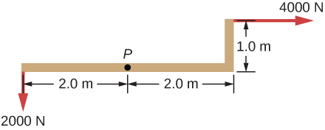

Solution

 in direction 

29. Two children push on opposite sides of a door during play. Both push horizontally and perpendicular to the door. One child pushes with a force of 17.5 N at a distance of 0.600 m from the hinges, and the second child pushes at a distance of 0.450 m. What force must the second child exert to keep the door from moving? Assume friction is negligible.

Solution

23.3 N

31. The uniform seesaw is balanced at its center of mass, as seen below. The smaller boy on the right has a mass of 40.0 kg. What is the mass of his friend?

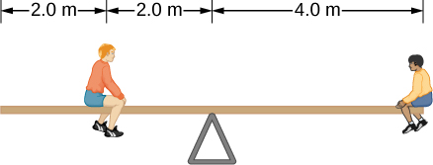

Solution

80.0 kg

33. The uniform seesaw shown below is balanced on a fulcrum located 3.0 m from the left end. The smaller boy on the right has a mass of 40 kg and the bigger boy on the left has a mass 80 kg. What is the mass of the board?

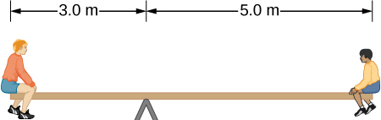

Solution

40 kg

35. A uniform 40.0-kg scaffold of length 6.0 m is supported by two light cables, as shown below. An 80.0-kg painter stands 1.0 m from the left end of the scaffold, and his painting equipment is 1.5 m from the right end. If the tension in the left cable is twice that in the right cable, find the tensions in the cables and the mass of the equipment.

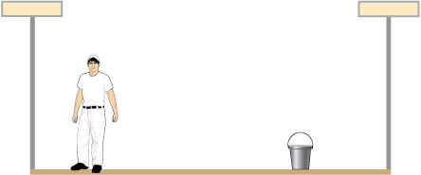

Solution

right cable, 444.3 N; left cable, 888.5 N; weight of equipment 156.8 N; 16.0 kg

37. To get up on the roof, a person (mass 70.0 kg) places a 6.00-m aluminum ladder (mass 10.0 kg) against the house on a concrete pad with the base of the ladder 2.00 m from the house. The ladder rests against a plastic rain gutter, which we can assume to be frictionless. The center of mass of the ladder is 2.00 m from the bottom. The person is standing 3.00 m from the bottom. Find the normal reaction and friction forces on the ladder at its base.

Solution

784 N, 132.8 N

39. The forearm shown below is positioned at an angle with respect to the upper arm, and a 5.0-kg mass is held in the hand. The total mass of the forearm and hand is 3.0 kg, and their center of mass is 15.0 cm from the elbow. (a) What is the magnitude of the force that the biceps muscle exerts on the forearm for  (b) What is the magnitude of the force on the elbow joint for the same angle? (c) How do these forces depend on the angle ?

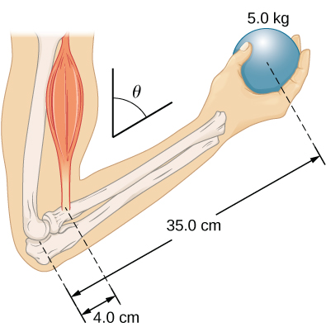

Solution

a. 539 N; b. 461 N; c. do not depend on the angle

41. The uniform boom shown below weighs 700 N, and the object hanging from its right end weighs 400 N. The boom is supported by a light cable and by a hinge at the wall. Calculate the tension in the cable and the force on the hinge on the boom. Does the force on the hinge act along the boom?

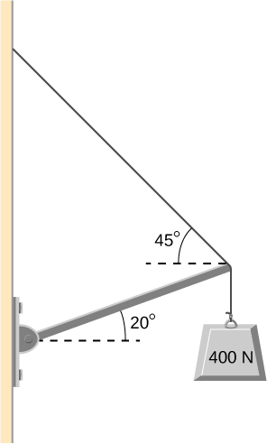

Solution

tension 778 N; at hinge 778 N at above the horizontal; no

43. A uniform trapdoor shown below is 1.0 m by 1.5 m and weighs 300 N. It is supported by a single hinge (H), and by a light rope tied between the middle of the door and the floor. The door is held at the position shown, where its slab makes a  angle with the horizontal floor and the rope makes a  angle with the floor. Find the tension in the rope and the force at the hinge.

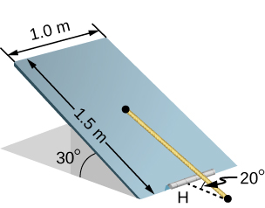

Solution

1500 N; 1620 N at 

45. The “lead” in pencils is a graphite composition with a Young’s modulus of approximately . Calculate the change in length of the lead in an automatic pencil if you tap it straight into the pencil with a force of 4.0 N. The lead is 0.50 mm in diameter and 60 mm long.

Solution

1.2 mm

47. By how much does a 65.0-kg mountain climber stretch her 0.800-cm diameter nylon rope when she hangs 35.0 m below a rock outcropping? (For nylon, 

Solution

32.9 cm

49. A farmer making grape juice fills a glass bottle to the brim and caps it tightly. The juice expands more than the glass when it warms up, in such a way that the volume increases by 0.20%. Calculate the force exerted by the juice per square centimeter if its bulk modulus is , assuming the bottle does not break.

Solution



51. A vertebra is subjected to a shearing force of 500.0 N. Find the shear deformation, taking the vertebra to be a cylinder 3.00 cm high and 4.00 cm in diameter.

Solution



53. A 20.0-m-tall hollow aluminum flagpole is equivalent in strength to a solid cylinder 4.00 cm in diameter. A strong wind bends the pole as much as a horizontal 900.0-N force on the top would do. How far to the side does the top of the pole flex?

Solution

0.57 mm

55. As an oil well is drilled, each new section of drill pipe supports its own weight and the weight of the pipe and the drill bit beneath it. Calculate the stretch in a new 6.00-m-long steel pipe that supports a 100-kg drill bit and a 3.00-km length of pipe with a linear mass density of 20.0 kg/m. Treat the pipe as a solid cylinder with a 5.00-cm diameter.

Solution

8.59 mm

57. A 90-kg mountain climber hangs from a nylon rope and stretches it by 25.0 cm. If the rope was originally 30.0 m long and its diameter is 1.0 cm, what is Young’s modulus for the nylon?

Solution



59. A copper wire is 1.0 m long and its diameter is 1.0 mm. If the wire hangs vertically, how much weight must be added to its free end in order to stretch it 3.0 mm?

Solution

259.0 N

61. The bulk modulus of a material is . What fractional change in volume does a piece of this material undergo when it is subjected to a bulk stress increase of ? Assume that the force is applied uniformly over the surface.

Solution

0.01%

63. During a walk on a rope, a tightrope walker creates a tension of  in a wire that is stretched between two supporting poles that are 15.0 m apart. The wire has a diameter of 0.50 cm when it is not stretched. When the walker is on the wire in the middle between the poles the wire makes an angle of  below the horizontal. How much does this tension stretch the steel wire when the walker is this position?

Solution

1.44 cm

65. Normal forces are applied uniformly over the surface of a spherical volume of water whose radius is 20.0 cm. If the pressure on the surface is increased by 200 MPa, by how much does the radius of the sphere decrease?

Solution

0.63 cm

67. One end of a vertical metallic wire of length 2.0 m and diameter 1.0 mm is attached to a ceiling, and the other end is attached to a 5.0-N weight pan, as shown below. The position of the pointer before the pan is 4.000 cm. Different weights are then added to the pan area, and the position of the pointer is recorded in the table shown. Plot stress versus strain for this wire, then use the resulting curve to determine Young’s modulus and the proportionality limit of the metal. What metal is this most likely to be?

|  |  |
| --- | --- |
| Added load (including pan) (N) | Scale reading (cm) |
| 0 | 4.000 |
| 15 | 4.036 |
| 25 | 4.073 |
| 35 | 4.109 |
| 45 | 4.146 |
| 55 | 4.181 |
| 65 | 4.221 |
| 75 | 4.266 |
| 85 | 4.316 |

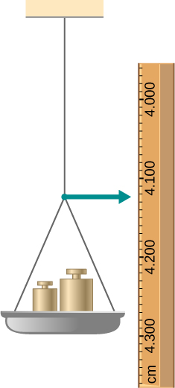

**Additional Problems**

69. The coefficient of static friction between the rubber eraser of the pencil and the tabletop is. If the force  is applied along the axis of the pencil, as shown below, what is the minimum angle at which the pencil can stand without slipping? Ignore the weight of the pencil.

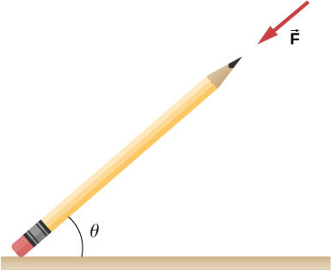

Solution



71. A uniform 4.0-m plank weighing 200.0 N rests against the corner of a wall, as shown below. There is no friction at the point where the plank meets the corner. (a) Find the forces that the corner and the floor exert on the plank. (b) What is the minimum coefficient of static friction between the floor and the plank to prevent the plank from slipping?

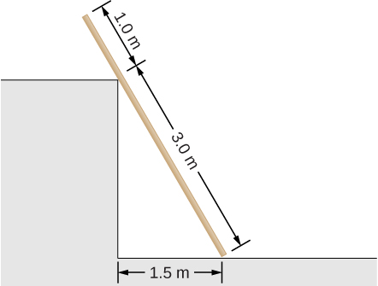

Solution

a. at corner 66.7 N at  with the horizontal; at floor 177 N at  with the horizontal; b. 

73. Two thin rods, one made of steel and the other of aluminum, are joined end to end. Each rod is 2.0 m long and has cross-sectional area . If a 10,000-N tensile force is applied at each end of the combination, find: (a) stress in each rod; (b) strain in each rod; and, (c) elongation of each rod.

Solution

a.; b. ; c. 11.0 mm, 31.4 mm

**Challenge Problems**

75. A horizontal force  is applied to a uniform sphere in direction exact toward the center of the sphere, as shown below. Find the magnitude of this force so that the sphere remains in static equilibrium. What is the frictional force of the incline on the sphere?

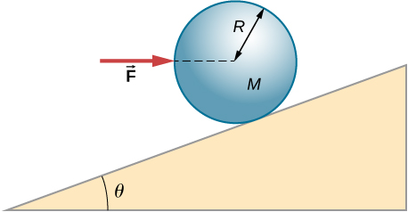

Solution



77. Two wheels *A* and *B* with weights *w* and 2*w*, respectively, are connected by a uniform rod with weight *w*/2, as shown below. The wheels are free to roll on the sloped surfaces. Determine the angle that the rod forms with the horizontal when the system is in equilibrium. *Hint:* There are five forces acting on the rod, which is two weights of the wheels, two normal reaction forces at points where the wheels make contacts with the wedge, and the weight of the rod.

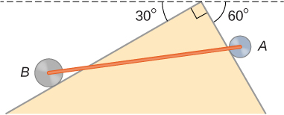

Solution

with the horizontal, ;  with the steeper side of the wedge

79. In order to lift a shovelful of dirt, a gardener pushes downward on the end of the shovel and pulls upward at distance  from the end, as shown below. The weight of the shovel is  and acts at the point of application of . Calculate the magnitudes of the forces  and  as functions of , , *mg*, and the weight *W* of the load. Why do your answers not depend on the angle that the shovel makes with the horizontal?

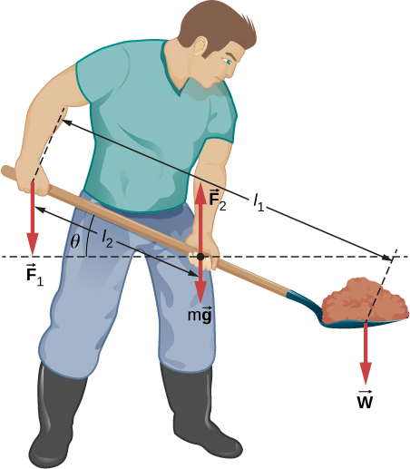

Solution



81. The pole shown below is at a  bend in a power line and is therefore subjected to more shear force than poles in straight parts of the line. The tension in each line is , at the angles shown. The pole is 15.0 m tall, has an 18.0 cm diameter, and can be considered to have half the strength of hardwood. (a) Calculate the compression of the pole. (b) Find how much it bends and in what direction. (c) Find the tension in a guy wire used to keep the pole straight if it is attached to the top of the pole at an angle of  with the vertical. The guy wire is in the opposite direction of the bend.

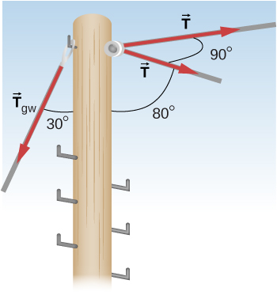

Solution

a. 1.1 mm; b. 6.6 mm to the right; c. 

This file is copyright 2016, Rice University. All Rights Reserved.