***University Physics Volume I***

**Unit 2: Waves and Acoustics**

**Chapter 16: Waves**

**Conceptual Questions**

1. Give one example of a transverse wave and one example of a longitudinal wave, being careful to note the relative directions of the disturbance and wave propagation in each.

Solution

A wave on a guitar string is an example of a transverse wave. The disturbance of the string moves perpendicular to the propagation of the wave. The sound produced by the string is a longitudinal wave where the disturbance of the air moves parallel to the propagation of the wave.

3. What is the difference between propagation speed and the frequency of a mechanical wave? Does one or both affect wavelength? If so, how?

Solution

Propagation speed is the speed of the wave propagating through the medium. If the wave speed is constant, the speed can be found by  The frequency is the number of wave that pass a point per unit time. The wavelength is directly proportional to the wave speed and inversely proportional to the frequency.

5. Consider a wave produced on a stretched spring by holding one end and shaking it up and down. Does the wavelength depend on the distance you move your hand up and down?

Solution

No, the distance you move your hand up and down will determine the amplitude of the wave. The wavelength will depend on the frequency you move your hand up and down, and the speed of the wave through the spring.

7. An electromagnetic wave, such as light, does not require a medium. Can you think of an example that would support this claim?

Solution

Light from the Sun and stars reach Earth through empty space where there is no medium present.

9. If you shake the end of a stretched spring up and down with a frequency *f*, you can produce a sinusoidal, transverse wave propagating down the spring. Does the wave number depend on the frequency you are shaking the spring?

Solution

The wavelength is equal to the velocity of the wave times the frequency and the wave number is equal to  so yes, the wave number will depend on the frequency and also depend on the velocity of the wave propagating through the spring.

11. In this section, we have considered waves that move at a constant wave speed. Does the medium accelerate?

Solution

The medium moves in simple harmonic motion as the wave propagates through the medium, continuously changing speed, therefore it accelerates. The acceleration of the medium is due to the restoring force of the medium, which acts in the opposite direction of the displacement.

13. If the tension in a string were increased by a factor of four, by what factor would the wave speed of a wave on the string increase?

Solution

The wave speed is proportional to the square root of the tension, so the speed is doubled.

15. Guitars have strings of different linear mass density. If the lowest density string and the highest density string are under the same tension, which string would support waves with the higher wave speed?

Solution

Since the speed of a wave on a string is inversely proportional to the square root of the linear mass density, the speed would be higher in the low linear mass density of the string.

17. Electrical power lines connected by two utility poles are sometimes heard to hum when driven into oscillation by the wind. The speed of the waves on the power lines depend on the tension. What provides the tension in the power lines?

Solution

The tension in the wire is due to the weight of the electrical power cable.

19. Consider a string with under tension with a constant linear mass density. A sinusoidal wave is produced by some external driving force. If the frequency, keeping the wave amplitude as it was originally, how is the time-averaged power of the wave affected? If the amplitude of the wave is decreased by half, keeping the wave frequency as it was originally, how is the time-averaged power affected? Explain your answer.

Solution

The time averaged power is  If the frequency or amplitude is halved, the power decreases by a factor of 4.

21. In a transverse wave on a string, the motion of the string is perpendicular to the motion of the wave. If this is so, how is possible to move energy along the length of the string?

Solution

As a portion on the string moves vertically, it exerts a force on the neighboring portion of the string, doing work on the portion and transferring the energy.

23. The intensity of a spherical waves decreases as the wave moves away from the source. If the intensity of the wave at the source is  how far from the source will the intensity decrease by a factor of nine?

Solution

The intensity of a spherical wave is  if no energy is dissipated the intensity will decrease by a factor of nine at three meters.

25. A string of a length of 2.00 m with a linear mass density of  is attached to the end of a 2.00-m-long string with a linear mass density of  The free end of the higher-density string is fixed to the wall, and a student holds the free end of the low-density string, keeping the tension constant in both strings. The student sends a pulse down the string. Describe what happens at the interface between the two strings.

Solution

At the interface, the incident pulse produces a reflected pulse and a transmitted pulse. The reflected pulse would be out of phase with respect to the incident pulse, and would move at the same propagation speed as the incident pulse, but would move in the opposite direction. The transmitted pulse would travel in the same direction as the incident pulse, but at half the speed. The transmitted pulse would be in phase with the incident pulse. Both the reflected pulse and the transmitted pulse would have amplitudes less than the amplitude of the incident pulse.

27. Many of the topics discussed in this chapter are useful beyond the topics of mechanical waves. It is hard to conceive of a mechanical wave with sharp corners, but you could encounter such a wave form in your digital electronics class, as shown below. This could be a signal from a device known as an analog to digital converter, in which a continuous voltage signal is converted into a discrete signal or a digital recording of sound. What is the result of the superposition of the two signals?

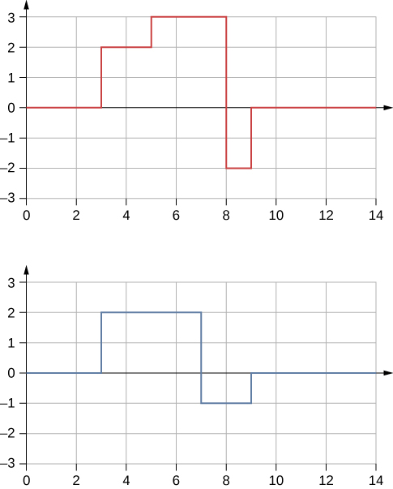

Solution

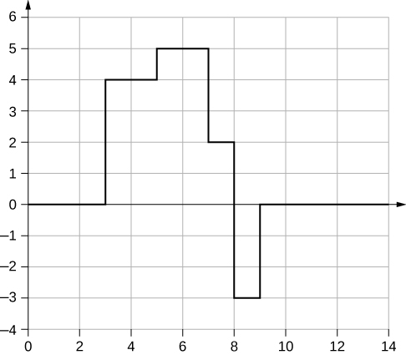

29. A truck manufacturer finds that a strut in the engine is failing prematurely. A sound engineer determines that the strut resonates at the frequency of the engine and suspects that this could be the problem. What are two possible characteristics of the strut can be modified to correct the problem?

Solution

It may be as easy as changing the length and/or the density a small amount so that the parts do not resonate at the frequency of the motor.

31. Wine glasses can be set into resonance by moistening your finger and rubbing it around the rim of the glass. Why?

Solution

Energy is supplied to the glass by the work done by the force of your finger on the glass. When supplied at the right frequency, standing waves form. The glass resonates and the vibrations produce sound.

33. Consider a standing wave modeled as  Is there a node or an antinode at  What about a standing wave modeled as  Is there a node or an antinode at the  position?

Solution

For the equation  there is a node because when ,  so  for all time. For the equation  there is an antinode because when , , so  oscillates between +*A* and –*A* as the cosine term oscillates between +1 and -1.

**Problems**

35. Waves on a swimming pool propagate at 0.75 m/s. You splash the water at one end of the pool and observe the wave go to the opposite end, reflect, and return in 30.00 s. How far away is the other end of the pool?

Solution



37. How many times a minute does a boat bob up and down on ocean waves that have a wavelength of 40.0 m and a propagation speed of 5.00 m/s?

Solution



39. What is the wavelength of the waves you create in a swimming pool if you splash your hand at a rate of 2.00 Hz and the waves propagate at a wave speed of 0.800 m/s?

Solution



41. Radio waves transmitted through empty space at the speed of light  by the *Voyager* spacecraft have a wavelength of 0.120 m. What is their frequency?

Solution



43. (a) Seismographs measure the arrival times of earthquakes with a precision of 0.100 s. To get the distance to the epicenter of the quake, geologists compare the arrival times of S- and P-waves, which travel at different speeds. If S- and P-waves arrive at 4.00 and 7.20 km/s, respectively, in the region considered, how precisely can the distance to the source of the earthquake be determined? (b) Seismic waves from underground detonations of nuclear bombs can be used to locate the test site and detect violations of test bans. Discuss whether your answer to (a) implies a serious limit to such detection. (Note also that the uncertainty is greater if there is an uncertainty in the propagation speeds of the S- and P-waves.)

Solution

a. The P-waves outrun the S-waves by a speed of  therefore,  b. Since the uncertainty in the distance is less than a kilometer, our answer to part (a) does not seem to limit the detection of nuclear bomb detonations. However, if the velocities are uncertain, then the uncertainty in the distance would increase and could then make it difficult to identify the source of the seismic waves.

45. A quality assurance engineer at a frying pan company is asked to qualify a new line of nonstick-coated frying pans. The coating needs to be 1.00 mm thick. One method to test the thickness is for the engineer to pick a percentage of the pans manufactured, strip off the coating, and measure the thickness using a micrometer. This method is a destructive testing method. Instead, the engineer decides that every frying pan will be tested using a nondestructive method. An ultrasonic transducer is used that produces sound waves with a frequency of  The sound waves are sent through the coating and are reflected by the interface between the coating and the metal pan, and the time is recorded. The wavelength of the ultrasonic waves in the coating is 0.076 m. What should be the time recorded if the coating is the correct thickness (1.00 mm)?

Solution



47. A transverse wave on a string is modeled with the wave function  What is the height of the string with respect to the equilibrium position at a position  and a time 

Solution



49. A pulse is defined as  Use a spreadsheet, or other computer program, to plot the pulse as the height of medium *y* as a function of position *x*. Plot the pulse at times  and  on the same graph. Where is the pulse centered at time ? Use your spreadsheet to check your answer.

Solution

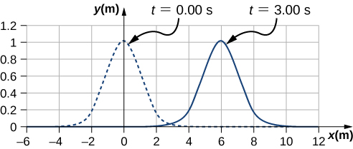

The pulse will move .

51. A wave is modeled with the function  Find the (a) amplitude, (b) wave number, (c) angular frequency, (d) wave speed, (e) initial phase shift, (f) wavelength, and (g) period of the wave.

Solution

a.  b. ; c.  d.  e.  f. ; g. 

53. A wave is modeled by the wave function  What are the amplitude, wavelength, wave speed, period, and frequency of the wave?

Solution



55. A swimmer in the ocean observes one day that the ocean surface waves are periodic and resemble a sine wave. The swimmer estimates that the vertical distance between the crest and the trough of each wave is approximately 0.45 m, and the distance between each crest is approximately 1.8 m. The swimmer counts that 12 waves pass every two minutes. Determine the simple harmonic wave function that would describes these waves.

Solution



57. Consider two waves defined by the wave functions  and  What are the similarities and differences between the two waves?

Solution

They have the same angular frequency, frequency, and period. They are traveling in opposite directions and  has twice the wavelength as  and is moving at half the wave speed.

59. The speed of a transverse wave on a string is 300.00 m/s, its wavelength is 0.50 m, and the amplitude is 20.00 cm. How much time is required for a particle on the string to move through a distance of 5.00 km?

Solution

Each particle of the medium moves a distance of 4*A* each period. The period can be found by dividing the velocity by the wavelength: 

61. A copper wire has a density of  a radius of 1.20 mm, and a length *L*. The wire is held under a tension of 10.00 N. Transverse waves are sent down the wire. (a) What is the linear mass density of the wire? (b) What is the speed of the waves through the wire?

Solution

a. 

b. 

63. A string with a linear mass density of  is tied to the ceiling. A 20-kg mass is tied to the free end of the string. The string is plucked, sending a pulse down the string. Estimate the speed of the pulse as it moves down the string.

Solution



65. A string is 3.00 m long with a mass of 5.00 g. The string is held taut with a tension of 500.00 N applied to the string. A pulse is sent down the string. How long does it take the pulse to travel the 3.00 m of the string?

Solution



67. Two strings are attached to poles, however the first string is twice the linear mass density  of the second. If both strings have the same tension, what is the ratio of the speed of the pulse of the wave from the first string to the second string?

Solution

0.707

69. Two strings are attached between two poles separated by a distance of 2.00 m as shown below, both under the same tension of 600.00 N. String 1 has a linear density of  and string 2 has a linear mass density of  Transverse wave pulses are generated simultaneously at opposite ends of the strings. How much time passes before the pulses pass one another?

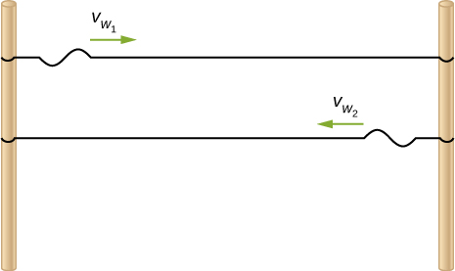

Solution



71. The note  is played on a piano and has a frequency of  If the linear mass density of this string of the piano is  and the string is under a tension of 1000.00 N, what is the speed of the wave on the string and the wavelength of the wave?

Solution



73. A sinusoidal wave travels down a taut, horizontal string with a linear mass density of . The maximum vertical speed of the wave is  The wave is modeled with the wave equation  (a) What is the amplitude of the wave? (b) What is the tension in the string?

Solution

a. 

b. 

75. A string of length 5 m and a mass of 90 g is held under a tension of 100 N. A wave travels down the string that is modeled as  What is the power over one wavelength?

Solution





77. The low-frequency speaker of a stereo set has a surface area of  and produces 1 W of acoustical power. (a) What is the intensity at the speaker? (b) If the speaker projects sound uniformly in all directions, at what distance from the speaker is the intensity ?

Solution

a. 

b. 

79. A device called an insolation meter is used to measure the intensity of sunlight. It has an area of  and registers 6.50 W. What is the intensity in ?

Solution



81. Suppose you have a device that extracts energy from ocean breakers in direct proportion to their intensity. If the device produces 10.0 kW of power on a day when the breakers are 1.20 m high, how much will it produce when they are 0.600 m high?

Solution



83. A microphone receiving a pure sound tone feeds an oscilloscope, producing a wave on its screen. If the sound intensity is originally , but is turned up until the amplitude increases by , what is the new intensity?

Solution



85. The power versus time for a point on a string  in which a sinusoidal traveling wave is induced. The wave is modeled with the wave equation . What is the frequency and amplitude of the wave?

Solution



87. A 250-Hz tuning fork is struck and the intensity at the source is  at a distance of one meter from the source. (a) What is the intensity at a distance of 4.00 m from the source? (b) How far from the tuning fork is the intensity a tenth of the intensity at the source?

Solution

a.  ; b. 

89. The energy of a ripple on a pond is proportional to the amplitude squared. If the amplitude of the ripple is 0.1 cm at a distance from the source of 6.00 meters, what was the amplitude at a distance of 2.00 meters from the source?

Solution



91. Consider two sinusoidal sine waves traveling along a string, modeled as  and  What is the height of the resultant wave formed by the interference of the two waves at the position  at time 

Solution



93. Two sinusoidal waves are moving through a medium in the same direction, both having amplitudes of 3.00 cm, a wavelength of 5.20 m, and a period of 6.52 s, but one has a phase shift of an angle . What is the phase shift if the resultant wave has an amplitude of 5.00 cm? [*Hint:* Use the trig identity ]

Solution



95. Two sinusoidal waves are moving through a medium in the positive *x*-direction, both having amplitudes of 7.00 cm, a wave number of  an angular frequency of  and a period of 6.00 s, but one has a phase shift of an angle  What is the height of the resultant wave at a time  and a position 

Solution



97. Two sinusoidal waves, which are identical except for a phase shift, travel along in the same direction. The wave equation of the resultant wave is . What are the angular frequency, wave number, amplitude, and phase shift of the individual waves?

Solution



99. Consider two wave functions,  and  (a) Using a spreadsheet, plot the two wave functions and the wave that results from the superposition of the two wave functions as a function of position  for the time  (b)What are the wavelength and amplitude of the two original waves? (c) What are the wavelength and amplitude of the resulting wave?

Solution

a. 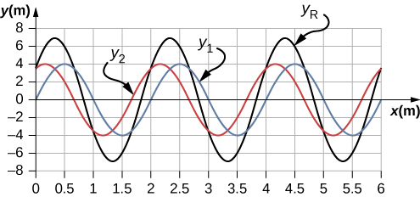

b. ;

c. 

101. Consider two wave functions that differ only by a phase shift, and  Use the trigonometric identities  and  to find a wave equation for the wave resulting from the superposition of the two waves. Does the resulting wave function come as a surprise to you?

Solution

 The result is not surprising because

103. A 2-m long string is stretched between two supports with a tension that produces a wave speed equal to  What are the wavelength and frequency of the first three modes that resonate on the string?

Solution



105. A cable with a linear density of  is hung from telephone poles. The tension in the cable is 500.00 N. The distance between poles is 20 meters. The wind blows across the line, causing the cable resonate. A standing waves pattern is produced that has 4.5 wavelengths between the two poles. The speed of sound at the current temperature is 343.00 m/s. What are the frequency and wavelength of the hum?

Solution



107. Consider two wave functions  and . Write a wave function for the resulting standing wave.

Solution



109. A string with a linear mass density of 0.0062 kg/m and a length of 3.00 m is set into the  mode of resonance. The tension in the string is 20.00 N. What is the wavelength and frequency of the wave?

Solution





111. Two sinusoidal waves with identical wavelengths and amplitudes travel in opposite directions along a string producing a standing wave. The linear mass density of the string is  and the tension in the string is  The time interval between instances of total destructive interference is  What is the wavelength of the waves?

Solution



113. A string is fixed at both end. The mass of the string is 0.0090 kg and the length is 3.00 m. The string is under a tension of 200.00 N. The string is driven by a variable frequency source to produce standing waves on the string. Find the wavelengths and frequency of the first four modes of standing waves.

Solution



115. A string is fixed at both ends to supports 3.50 m apart and has a linear mass density of The string is under a tension of 90.00 N. A standing wave is produced on the string with six nodes and five antinodes. What are the wave speed, wavelength, frequency, and period of the standing wave?

Solution



**Additional Problems**

117. Ultrasound equipment used in the medical profession uses sound waves of a frequency above the range of human hearing. If the frequency of the sound produced by the ultrasound machine is  what is the wavelength of the ultrasound in bone, if the speed of sound in bone is 

Solution



119. The speed of light in air is approximately  and the speed of light in glass is . A red laser with a wavelength of  shines light incident of the glass, and some of the red light is transmitted to the glass. The frequency of the light is the same for the air and the glass. (a) What is the frequency of the light? (b) What is the wavelength of the light in the glass?

Solution

a.  b. 

121. A sunbather stands waist deep in the ocean and observes that six crests of periodic surface waves pass each minute. The crests are 16.00 meters apart. What is the wavelength, frequency, period, and speed of the waves?

Solution



123. A motorboat is traveling across a lake at a speed of . The boat bounces up and down every 0.50 s as it travels in the same direction as a wave. It bounces up and down every 0.30 s as it travels in a direction opposite the direction of the waves. What is the speed and wavelength of the wave?

Solution



125. Given the wave functions  and  with  , show that  is a solution to the linear wave equation with a wave velocity of 

Solution



127. A sinusoidal wave travels down a taut, horizontal string with a linear mass density of  The magnitude of maximum vertical acceleration of the wave is  and the amplitude of the wave is 0.40 m. The string is under a tension of . The wave moves in the negative *x*-direction. Write an equation to model the wave.

Solution



129. A transverse wave on a horizontal string  is described with the equation  The string is under a tension of 300.00 N. What are the wave speed, wave number, and angular frequency of the wave?

Solution



131. A wave on a string is driven by a string vibrator, which oscillates at a frequency of 100.00 Hz and an amplitude of 1.00 cm. The string vibrator operates at a voltage of 12.00 V and a current of 0.20 A. The power consumed by the string vibrator is . Assume that the string vibrator is  efficient at converting electrical energy into the energy associated with the vibrations of the string. The string is 3.00 m long, and is under a tension of 60.00 N. What is the linear mass density of the string?

Solution



133. A transverse wave on a string has a wavelength of 5.0 m, a period of 0.02 s, and an amplitude of 1.5 cm. The average power transferred by the wave is 5.00 W. What is the tension in the string?

Solution



135. Consider two periodic wave functions,  and  (a) For what values of  will the wave that results from a superposition of the wave functions have an amplitude of 2*A*? (b) For what values of  will the wave that results from a superposition of the wave functions have an amplitude of zero?

Solution

a. ;

b. 

137. A trough with dimensions 10.00 meters by 0.10 meters by 0.10 meters is partially filled with water. Small-amplitude surface water waves are produced from both ends of the trough by paddles oscillating in simple harmonic motion. The height of the water waves are modeled with two sinusoidal wave equations,  and  What is the wave function of the resulting wave after the waves reach one another and before they reach the end of the trough (i.e., assume that there are only two waves in the trough and ignore reflections)? Use a spreadsheet to check your results. [*Hint:* Use the trig identities and ]

Solution



139. Consider what is shown below. A 20.00-kg mass rests on a frictionless ramp inclined at 45°. A string with a linear mass density of  is attached to the 20.00-kg mass. The string passes over a frictionless pulley of negligible mass and is attached to a hanging mass (*m*). The system is in static equilibrium. A wave is induced on the string and travels up the ramp. (a) What is the mass of the hanging mass (*m*)? (b) At what wave speed does the wave travel up the string?

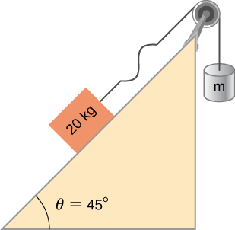

Solution

a.  ; b. 

141. A string has a mass of 150 g and a length of 3.4 m. One end of the string is fixed to a lab stand and the other is attached to a spring with a spring constant of  The free end of the spring is attached to another lab pole. The tension in the string is maintained by the spring. The lab poles are separated by a distance that stretches the spring 2.00 cm. The string is plucked and a pulse travels along the string. What is the propagation speed of the pulse?

Solution



143. A string with a length of 4 m is held under a constant tension. The string has a linear mass density of  Two resonant frequencies of the string are 400 Hz and 480 Hz. There are no resonant frequencies between the two frequencies. (a) What are the wavelengths of the two resonant modes? (b) What is the tension in the string?

Solution

a. ;

b. 

**Challenge Problems**

145. A pulse moving along the *x* axis can be modeled as the wave function (a)What are the direction and propagation speed of the pulse? (b) How far has the wave moved in 3.00 s? (c) Plot the pulse using a spreadsheet at time  and  to verify your answer in part (b).

Solution

a. Moves in the negative *x* direction at a propagation speed of . b. 

c.

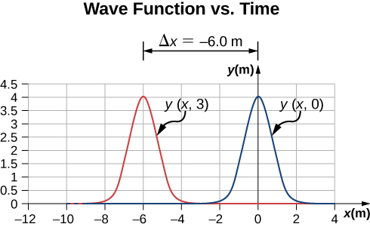

147. Consider two wave functions  and . What is the wave function resulting from the interference of the two wave? (*Hint:*  and .)

Solution



149. Consider two wave functions  and . The resultant wave form when you add the two functions is  Consider the case where  , and . (a) Where are the first three nodes of the standing wave function starting at zero and moving in the positive *x* direction? (b) Using a spreadsheet, plot the two wave functions and the resulting function at time  to verify your answer.

Solution



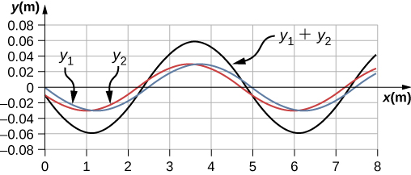

This file is copyright 2016, Rice University. All Rights Reserved.