***University Physics Volume I***

**Unit 2: Waves and Acoustics**

**Chapter 17: Sound**

**Conceptual Questions**

1. What is the difference between sound and hearing?

Solution

Sound is a disturbance of matter (a pressure wave) that is transmitted from its source outward. Hearing is the human perception of sound.

3. Sound waves can be modeled as a change in pressure. Why is the change in pressure used and not the actual pressure?

Solution

Consider a sound wave moving through air. The pressure of the air is the equilibrium condition, it is the change in pressure that produces the sound wave.

5. When sound passes from one medium to another where its propagation speed is different, does its frequency or wavelength change? Explain your answer briefly.

Solution

The frequency does not change as the sound wave moves from one medium to another. Since the speed changes and the frequency does not, the wavelength must change. This is similar to the driving force of a harmonic oscillator or a wave on the string.

7. You may have used a sonic range finder in lab to measure the distance of an object using a clicking sound from a sound transducer. What is the principle used in this device?

Solution

The transducer sends out a sound wave, which reflects off the object in question and measures the time it takes for the sound wave to return. Since the speed of sound is constant, the distance to the object can found by multiplying the velocity of sound by half the time interval measured.

9. Six members of a synchronized swim team wear earplugs to protect themselves against water pressure at depths, but they can still hear the music and perform the combinations in the water perfectly. One day, they were asked to leave the pool so the dive team could practice a few dives, and they tried to practice on a mat, but seemed to have a lot more difficulty. Why might this be?

Solution

The ear plugs reduce the intensity of the sound both in water and on land, but Navy researchers have found that sound under water is heard through vibrations mastoid, which is the bone behind the ear.

11. You are given two wind instruments of identical length. One is open at both ends, whereas the other is closed at one end. Which is able to produce the lowest frequency?

Solution

The fundamental wavelength of a tube open at each end is 2*L*, where the wavelength of a tube open at one end and closed at one end is 4*L*. The tube open at one end has the lower fundamental frequency, assuming the speed of sound is the same in both tubes.

13. Two identical columns, open at both ends, are in separate rooms. In room *A*, the temperature is *T* = 20 °C and in room *B*, the temperature is *T* = 25 °C. A speaker is attached to the end of each tube, causing the tubes to resonate at the fundamental frequency. Is the frequency the same for both tubes? Which has the higher frequency?

Solution

The wavelength in each is twice the length of the tube. The frequency depends on the wavelength and the speed of the sound waves. The frequency in room *B* is higher because the speed of sound is higher where the temperature is higher.

15. Consider three pipes of the same length (*L*). Pipe *A* is open at both ends, pipe *B* is closed at both ends, and pipe *C* has one open end and one closed end. If the velocity of sound is the same in each of the three tubes, in which of the tubes could the lowest fundamental frequency be produced? In which of the tubes could the highest fundamental frequency be produced?

Solution

When resonating at the fundamental frequency, the wavelength for pipe *C* is 4*L*, and for pipes *A* and *B* is 2*L*. The frequency is equal to  Pipe *C* has the lowest frequency and pipes *A* and *B* have equal frequencies, higher than the one in pipe *C*.

17. A string is tied between two lab posts a distance *L* apart. The tension in the string and the linear mass density is such that the speed of a wave on the string is  A tube with symmetric boundary conditions has a length *L* and the speed of sound in the tube is  What could be said about the frequencies of the harmonics in the string and the tube? What if the velocity in the string were ?

Solution

Since the boundary conditions are both symmetric, the frequencies are Since the speed is the same in each, the frequencies are the same. If the wave speed were doubled in the string, the frequencies in the string would be twice the frequencies in the tube.

19. The label has been scratched off a tuning fork and you need to know its frequency. From its size, you suspect that it is somewhere around 250 Hz. You find a 250-Hz tuning fork and a 270-Hz tuning fork. When you strike the 250-Hz fork and the fork of unknown frequency, a beat frequency of 5 Hz is produced. When you strike the unknown with the 270-Hz fork, the beat frequency is 15 Hz. What is the unknown frequency? Could you have deduced the frequency using just the 250-Hz fork?

Solution

The frequency of the unknown fork is 255 Hz. No, if only the 250 Hz fork is used, listening to the beat frequency could only limit the possible frequencies to 245 Hz or 255 Hz.

21. A “showy” custom-built car has two brass horns that are supposed to produce the same frequency but actually emit 263.8 and 264.5 Hz. What beat frequency is produced?

Solution

The beat frequency is 0.7 Hz.

23. Three stationary observers observe the Doppler shift from a source moving at a constant velocity. The observers are stationed as shown below. Which observer will observe the highest frequency? Which observer will observe the lowest frequency? What can be said about the frequency observed by observer 3?

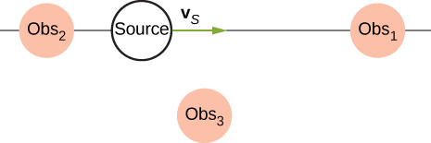

Solution

Observer 1 will observe the highest frequency. Observer 2 will observe the lowest frequency. Observer 3 will hear a higher frequency than the source frequency, but lower than the frequency observed by observer 1, as the source approaches and a lower frequency than the source frequency, but higher than the frequency observed by observer 1, as the source moves away from observer 3.

25. Prior to 1980, conventional radar was used by weather forecasters. In the 1960s, weather forecasters began to experiment with Doppler radar. What do you think is the advantage of using Doppler radar?

Solution

Doppler radar can not only detect the distance to a storm, but also the speed and direction at which the storm is traveling.

27. Due to efficiency considerations related to its bow wake, the supersonic transport aircraft must maintain a cruising speed that is a constant ratio to the speed of sound (a constant Mach number). If the aircraft flies from warm air into colder air, should it increase or decrease its speed? Explain your answer.

Solution

The speed of sound decreases as the temperature decreases. The Mach number is equal to  so the plane should slow down.

**Problems**

29. Consider a sound wave modeled with the equation What is the maximum displacement, the wavelength, the frequency, and the speed of the sound wave?

Solution



31. Consider a diagnostic ultrasound of frequency 5.00 MHz that is used to examine an irregularity in soft tissue. (a) What is the wavelength in air of such a sound wave if the speed of sound is 343 m/s? (b) If the speed of sound in tissue is 1800 m/s, what is the wavelength of this wave in tissue?

Solution

a.  b. 

33. A sound wave is modeled with the wave function and the sound wave travels in air at a speed of  (a) What is the wave number of the sound wave? (b) What is the value for ?

Solution

a. 

b. 

35. A speaker is placed at the opening of a long horizontal tube. The speaker oscillates at a frequency *f*, creating a sound wave that moves down the tube. The wave moves through the tube at a speed of  The sound wave is modeled with the wave function . At time , an air molecule at  is at the maximum displacement of 7.00 nm. At the same time, another molecule at  has a displacement of 3.00 nm. What is the frequency at which the speaker is oscillating?

Solution



37. A sound wave produced by an ultrasonic transducer, moving in air, is modeled with the wave equation . The transducer is to be used in nondestructive testing to test for fractures in steel beams. The speed of sound in the steel beam is  Find the wave function for the sound wave in the steel beam.

Solution



39. Bats use sound waves to catch insects. Bats can detect frequencies up to 100 kHz. If the sound waves travel through air at a speed of *v* = 343 m/s, what is the wavelength of the sound waves?

Solution



41. Consider the graph shown below of a compression wave. Shown are snapshots of the wave function for  (blue) and  (orange). What are the wavelength, maximum displacement, velocity, and period of the compression wave?

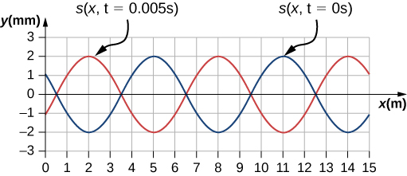

Solution



43. A guitar string oscillates at a frequency of 100 Hz and produces a sound wave. (a) What do you think the frequency of the sound wave is that the vibrating string produces? (b) If the speed of the sound wave is  , what is the wavelength of the sound wave?

Solution

(a)  (b) 

45. What frequency sound has a 0.10-m wavelength when the speed of sound is 340 m/s?

Solution



47. (a) What is the speed of sound in a medium where a 100-kHz frequency produces a 5.96-cm wavelength? (b) Which substance in the following table is this likely to be?

|  |  |
| --- | --- |
| Medium | *v* (m/s) |
| *Gases at* | |
| Air | 331 |
| Carbon dioxide | 259 |
| Oxygen | 316 |
| Helium | 965 |
| Hydrogen | 1290 |
| *Liquids at* | |
| Ethanol | 1160 |
| Mercury | 1450 |
| Water, fresh | 1480 |
| Sea Water | 1540 |
| Human tissue | 1540 |
| *Solids (longitudinal or bulk)* | |
| Vulcanized rubber | 54 |
| Polyethylene | 920 |
| Marble | 3810 |
| Glass, Pyrex | 5640 |
| Lead | 1960 |
| Aluminum | 5120 |
| Steel | 5960 |

Solution

a. ; b. steel (from the preceding table)

49. Air temperature in the Sahara Desert can reach 56.0 °C (about ). What is the speed of sound in air at that temperature?

Solution



51. A sonar echo returns to a submarine 1.20 s after being emitted. What is the distance to the object creating the echo? (Assume that the submarine is in the ocean, not in fresh water.)

Solution



53. Ultrasonic sound waves are often used in methods of nondestructive testing. For example, this method can be used to find structural faults in a steel I-beams used in building. Consider a 10.00 meter long, steel I-beam with a cross-section shown below. The weight of the I-beam is 3846.50 N. What would be the speed of sound through in the I-beam? .

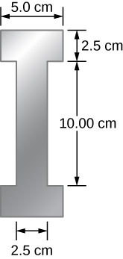

Solution



55. During a 4th of July celebration, an M80 firework explodes on the ground, producing a bright flash and a loud bang. The air temperature of the night air is . Two observers see the flash and hear the bang. The first observer notes the time between the flash and the bang as 0.10 second. The second observer notes the difference as 0.15 seconds. The line of sight between the two observers meet at a right angle as shown below. What is the distance  between the two observers?

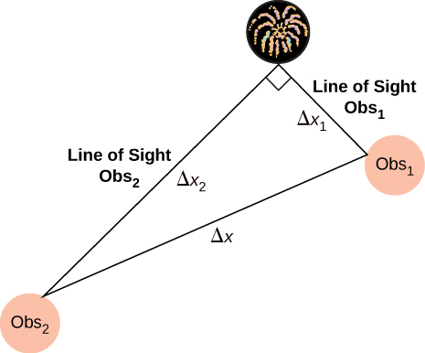

Solution



57. Suppose a bat uses sound echoes to locate its insect prey, 3.00 m away. (See the following figure.) (a) Calculate the echo times for temperatures of 5.00 °C and 35.0 °C. (b) What percent uncertainty does this cause for the bat in locating the insect? (c) Discuss the significance of this uncertainty and whether it could cause difficulties for the bat. (In practice, the bat continues to use sound as it closes in, eliminating most of any difficulties imposed by this and other effects, such as motion of the prey.)

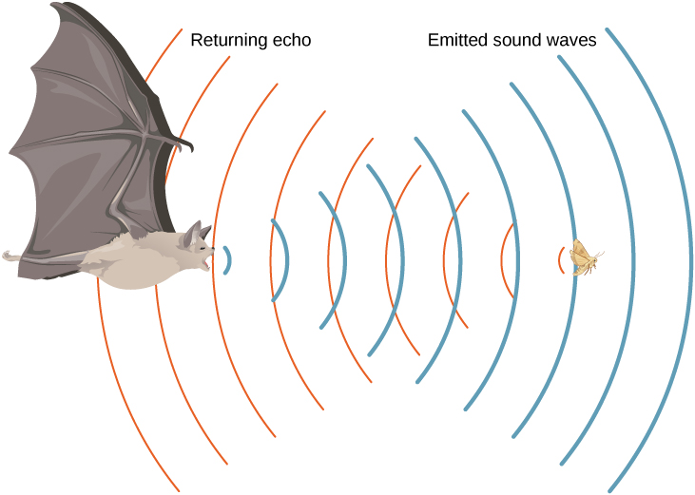

Solution

a. ; b. % uncertainty =; c. This uncertainty could definitely cause difficulties for the bat, if it didn’t continue to use sound as it closed in on its prey. A 5% uncertainty could be the difference between catching the prey around the neck or around the chest, which means that it could miss grabbing its prey.

59. The warning tag on a lawn mower states that it produces noise at a level of 91.0 dB. What is the intensity of this sound in watts per meter squared?

Solution



61. What intensity level does the sound in the preceding problem correspond to?

Solution

85 dB

63. What is the decibel level of a sound that is twice as intense as a 90.0-dB sound? (b) What is the decibel level of a sound that is one-fifth as intense as a 90.0-dB sound?

Solution

a. 93 dB; b. 83 dB

65. People with good hearing can perceive sounds as low as –8.00 dB at a frequency of 3000 Hz. What is the intensity of this sound in watts per meter squared?

Solution



67. Ten cars in a circle at a boom box competition produce a 120-dB sound intensity level at the center of the circle. What is the average sound intensity level produced there by each stereo, assuming interference effects can be neglected?

Solution

A decrease of a factor of 10 in intensity corresponds to a reduction of 10 dB in sound level: 

69. If a sound intensity level of 0 dB at 1000 Hz corresponds to a maximum gauge pressure (sound amplitude) of , what is the maximum gauge pressure in a 60-dB sound? What is the maximum gauge pressure in a 120-dB sound?

Solution

We know that 60 dB corresponds to a factor of  increase in intensity. Therefore,



120 dB corresponds to a factor of  increase

71. Sound is more effectively transmitted into a stethoscope by direct contact rather than through the air, and it is further intensified by being concentrated on the smaller area of the eardrum. It is reasonable to assume that sound is transmitted into a stethoscope 100 times as effectively compared with transmission though the air. What, then, is the gain in decibels produced by a stethoscope that has a sound gathering area of , and concentrates the sound onto two eardrums with a total area of  with an efficiency of ?

Solution

28.2 dB

73. The factor of 10–12 in the range of intensities to which the ear can respond, from threshold to that causing damage after brief exposure, is truly remarkable. If you could measure distances over the same range with a single instrument and the smallest distance you could measure was 1 mm, what would the largest be?

Solution



75. Can you tell that your roommate turned up the sound on the TV if its average sound intensity level goes from 70 to 73 dB?

Solution

 Such a change in sound level is easily noticed.

77. A person has a hearing threshold 10 dB above normal at 100 Hz and 50 dB above normal at 4000 Hz. How much more intense must a 100-Hz tone be than a 4000-Hz tone if they are both barely audible to this person?

Solution

2.5; The 100-Hz tone must be 2.5 times more intense than the 4000-Hz sound to be audible by this person.

79. What is the length of a tube that has a fundamental frequency of 176 Hz and a first overtone of 352 Hz if the speed of sound is 343 m/s?

Solution

0.974 m

81. Calculate the first overtone in an ear canal, which resonates like a 2.40-cm-long tube closed at one end, by taking air temperature to be 37.0 °C. Is the ear particularly sensitive to such a frequency? (The resonances of the ear canal are complicated by its nonuniform shape, which we shall ignore.)

Solution

11.0 kHz; The ear is not particularly sensitive to this frequency, so we don’t hear overtones due to the ear canal.

83. A 4.0-m-long pipe, open at one end and closed at one end, is in a room where the temperature is *T* = 22 °C. A speaker capable of producing variable frequencies is placed at the open end and is used to cause the tube to resonate. (a) What is the wavelength and the frequency of the fundamental frequency? (b) What is the frequency and wavelength of the first overtone?

Solution

a. 

b. 

85. A nylon guitar string is fixed between two lab posts 2.00 m apart. The string has a linear mass density of  and is placed under a tension of 160.00 N. The string is placed next to a tube, open at both ends, of length *L*. The string is plucked and resonate at the fundamental frequency while the tube resonates at the  mode. The speed of sound is 343 m/s. What is the length of the tube?

Solution



87. Students in a physics lab are asked to find the length of an air column that has a fundamental frequency of 256 Hz. They obtain a long tube that is closed at one end. They hold the tube vertically and fill it with water to the top, then lower the water while a 256-Hz tuning fork is rung and listen for the first resonance. (a) What is the air temperature if the resonance occurs for a length of 0.336 m? (b) At what length will they observe the second resonance (first overtone)?

Solution

a. ; b. 1.01 m

89. What are the first three overtones of a bassoon that has a fundamental frequency of 90.0 Hz? It is open at both ends. (The overtones of a real bassoon are more complex than this example, because its double reed makes it act more like a tube closed at one end.)

Solution



91. What length should an oboe have to produce a fundamental frequency of 110 Hz on a day when the speed of sound is 343 m/s? It is open at both ends.

Solution

1.56 m

93. An organ pipe  is closed at both ends. Compute the wavelengths and frequencies of the first three modes of resonance. Assume the speed of sound is

Solution

The pipe has symmetrical boundary conditions;



95. A sound wave of a frequency of 2.00 kHz is produced by a string oscillating in the  mode. The linear mass density of the string is  and the length of the string is 1.50 m. What is the tension in the string?

Solution



97. A student holds an 80.00-cm lab pole one quarter of the length from the end of the pole. The lab pole is made of aluminum. The student strikes the lab pole with a hammer. The pole resonates at the lowest possible frequency. What is that frequency?

Solution



99. By what fraction will the frequencies produced by a wind instrument change when air temperature goes from 10.0 °C to 30.0 °C? That is, find the ratio of the frequencies at those temperatures.

Solution

1.03 or 

101. What beat frequencies result if a piano hammer hits three strings that emit frequencies of 127.8, 128.1, and 128.3 Hz?

Solution



103. Two identical strings, of identical lengths of 2.00 m and linear mass density of  are fixed on both ends. String *A* is under a tension of 120.00 N. String *B* is under a tension of 130.00 N. They are each plucked and produce sound at the  mode. What is the beat frequency?

Solution



105. A string with a linear mass density of  is stretched between two posts 1.30 m apart. The tension in the string is 150.00 N. The string oscillates and produces a sound wave. A 1024-Hz tuning fork is struck and the beat frequency between the two sources is 52.83 Hz. What are the possible frequency and wavelength of the wave on the string?

Solution



The frequency is 1076.83 Hz and the wavelength is 0.14 m.

107. The middle C hammer of a piano hits two strings, producing beats of 1.50 Hz. One of the strings is tuned to 260.00 Hz. What frequencies could the other string have?

Solution



109. Twin jet engines on an airplane are producing an average sound frequency of 4100 Hz with a beat frequency of 0.500 Hz. What are their individual frequencies?

Solution



111. (a) What frequency is received by a person watching an oncoming ambulance moving at 110 km/h and emitting a steady 800-Hz sound from its siren? The speed of sound on this day is 345 m/s. (b) What frequency does she receive after the ambulance has passed?

Solution

a. 878 Hz; b. 735 Hz

113. What frequency is received by a mouse just before being dispatched by a hawk flying at it at 25.0 m/s and emitting a screech of frequency 3500 Hz? Take the speed of sound to be 331 m/s.

Solution



115. A commuter train blows its 200-Hz horn as it approaches a crossing. The speed of sound is 335 m/s. (a) An observer waiting at the crossing receives a frequency of 208 Hz. What is the speed of the train? (b) What frequency does the observer receive as the train moves away?

Solution

a. 12.9 m/s; b. 193 Hz

117. Two eagles fly directly toward one another, the first at 15.0 m/s and the second at 20.0 m/s. Both screech, the first one emitting a frequency of 3200 Hz and the second one emitting a frequency of 3800 Hz. What frequencies do they receive if the speed of sound is 330 m/s?

Solution

The first eagle hears  The second eagle hears

119. An ambulance with a siren  blaring is approaching an accident scene. The ambulance is moving at 70.00 mph. A nurse is approaching the scene from the opposite direction, running at  What frequency does the nurse observe? Assume the speed of sound is 

Solution



121. What is the minimum speed at which a source must travel toward you for you to be able to hear that its frequency is Doppler shifted? That is, what speed produces a shift of  on a day when the speed of sound is 331 m/s?

Solution

An audible shift occurs when ; 

123. A jet flying at an altitude of 8.50 km has a speed of Mach 2.00, where the speed of sound is  How long after the jet is directly overhead, will a stationary observer hear a sonic boom?

Solution



125. A plane is flying at Mach 1.2, and an observer on the ground hears the sonic boom 15.00 seconds after the plane is directly overhead. What is the altitude of the plane? Assume the speed of sound is 

Solution



127. A speaker is placed at the opening of a long horizontal tube. The speaker oscillates at a frequency of *f*, creating a sound wave that moves down the tube. The wave moves through the tube at a speed of  The sound wave is modeled with the wave function . At time , an air molecule at  is at the maximum displacement of 6.34 nm. At the same time, another molecule at  has a displacement of 2.30 nm. What is the wave function of the sound wave, that is, find the wave number, angular frequency, and the initial phase shift?

Solution



**Additional Problems**

129. A 0.80-m-long tube is opened at both ends. The air temperature is 26 °C. The air in the tube is oscillated using a speaker attached to a signal generator. What are the wavelengths and frequencies of first two modes of sound waves that resonate in the tube?

Solution

;



131. Consider the following figure. The length of the string between the string vibrator and the pulley is  The linear density of the string is  The string vibrator can oscillate at any frequency. The hanging mass is 2.00 kg. (a)What are the wavelength and frequency of  mode? (b) The string oscillates the air around the string. What is the wavelength of the sound if the speed of the sound is ?

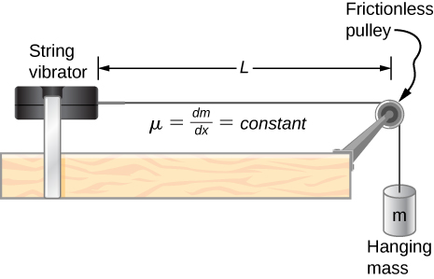

Solution

a. ; b. 

133. Two cars move toward one another, both sounding their horns . Car A is moving at 65 mph and Car B is at 75 mph. What is the beat frequency heard by each driver? The air temperature is .

Solution



135. Suppose that the sound level from a source is 75 dB and then drops to 52 dB, with a frequency of 600 Hz. Determine the (a) initial and (b) final sound intensities and the (c) initial and (d) final sound wave amplitudes. The air temperature is  and the air density is 

Solution

;

a. ; b. ; c. ; d. 

137. A stationary observer hears a frequency of 1000.00 Hz as a source approaches and a frequency of 850.00 Hz as a source departs. The source moves at a constant velocity of 75 mph. What is the temperature of the air?

Solution



**Challenge Problems**

139. Two sound speakers are separated by a distance *d*, each sounding a frequency *f*. An observer stands at one speaker and walks in a straight line a distance *x*, perpendicular to the the two speakers, until he comes to the first maximum intensity of sound. The speed of sound is *v*. How far is he from the speaker? Assume the distance, *d*, between the slits is larger than the wavelength of the sound.

Solution



141. Two speakers producing the same frequency of sound are a distance of *d* apart. Consider an arc along a circle of radius *R*, centered at the midpoint of the speakers, as shown below. (a) At what angles will there be maxima? (b) At what angle will there be minima?

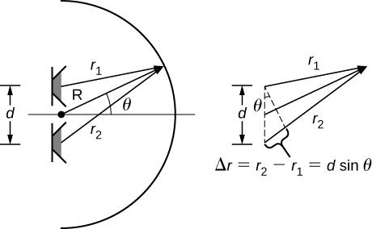

Solution

a. For maxima 

b. For minima, 

143. A string  is fixed at both ends and is under a tension of 155 N. It oscillates in the  mode and produces sound. A tuning fork is ringing nearby, producing a beat frequency of 23.76 Hz. (a) What is the frequency of the sound from the string? (b) What is the frequency of the tuning fork if the tuning fork frequency is lower? (c) What should be the tension of the string for the beat frequency to be zero?

Solution

a. ;

b. ;

c. 

145. A string has a linear mass density  a length  a tension of  and oscillates in a mode . (a) What is the frequency of the oscillations? (b) Use the result in the preceding problem to find the change in the frequency when the tension is increased by .

Solution

a. ; b. 

147. A string on the violin has a length of 23.00 cm and a mass of 0.900 grams. The tension in the string 850.00 N. The temperature in the room is  The string is plucked and oscillates in the  mode. (a) What is the speed of the wave on the string? (b) What is the wavelength of the sounding wave produced? (c) What is the frequency of the oscillating string? (d) What is the frequency of the sound produced? (e) What is the wavelength of the sound produced?

Solution

a. ; b. ; c. ;

d. ; e. 

This file is copyright 2016, Rice University. All Rights Reserved.