Homework 1

1. Find the impulse response of the following system, where , and .
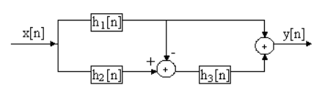

2. Consider the following system:

- Find the system function and specify if the system is stable or not
- Find the zero-state response to the input signal
- Find the response to the input signal if the initial conditions

