**Introduction to Programming**

**Week 1**

**Program_01**

**Python**

Name: Nikita Sah

Level 4 Section: A

British Id: 10011

LBU Id: c7576150

Level 4 BSc. Hons Computing

Subject: Fundamental Of Computer Programming (FOCP)

The British College (TBC)

**Questions:**

1. Write a program that prints a cheery message (such as "Hello World") on the screen. Run it, and note that you have taken the first step to becoming a programmer!

**Answer:**

**Source Code of Question No. 1:**

**Output of Question No. 1:**

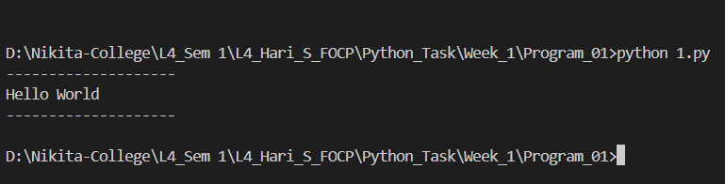

1. Make a copy of the previous program, and modify it so that it displays your name. So if your name is Herbert the message should become: Hello, Herbert! Note: Very few programs are written from scratch. It is usually best to start with a program that you know works, and ideally does something similar to the new program.

**Answer:**

**Source Code of Question No. 2:**

**Output of Question No. 2:**

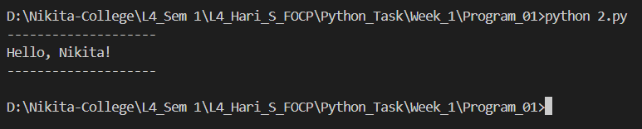

1. Over the summer, temperatures in Yorkshire reached 38.4C. Write a program that converts this value in Celsius to the equivalent temperature in Fahrenheit, and then displays both.

**Answer:**

**Source Code of Question No. 3:**

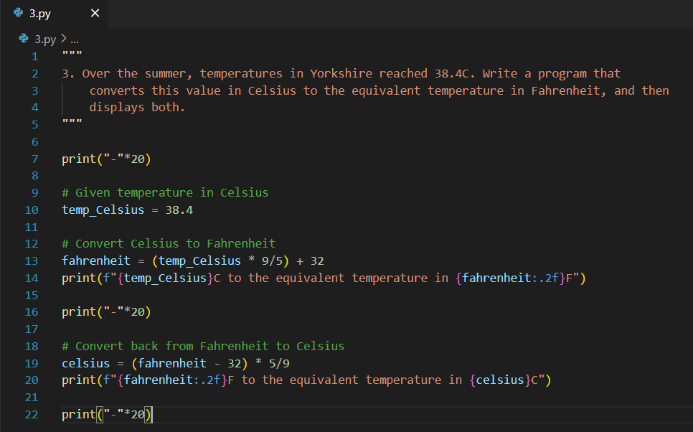

**Output of Question No. 3:**

1. In a long career for Yorkshire, Geoffrey Boycott played 609 matches, batted 1014 times, was not out 162 times, and scored 48426 runs. Write a program to calculate and display Boycott's batting average.

Note: A batting average is the number of runs scored divided by the number of completed innings (i.e. the total times batted minus the times not out).

**Answer:**

**Source Code of Question No. 4:**

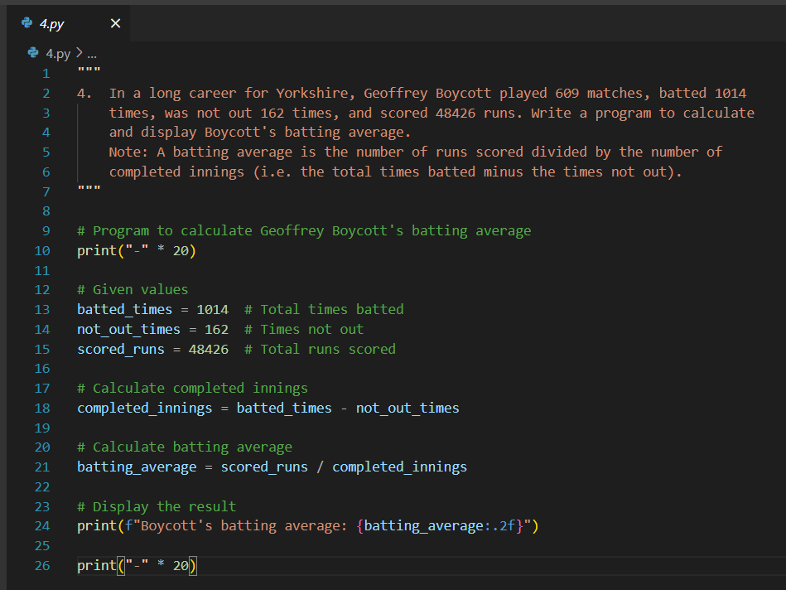

**Output of Question No. 4:**

1. The Head of Computing at the University of Poppleton is tasked with dividing a group of students into lab groups. A lab group is 24 students, since this is the number of PCs in a lab. Write a program that calculates how many groups are needed for the following number of students: 113, 175, 12. Display how many full groups there will be, and how many students will be in the smaller "le over" group.

**Answer:**

**Source code of Question No. 5:**

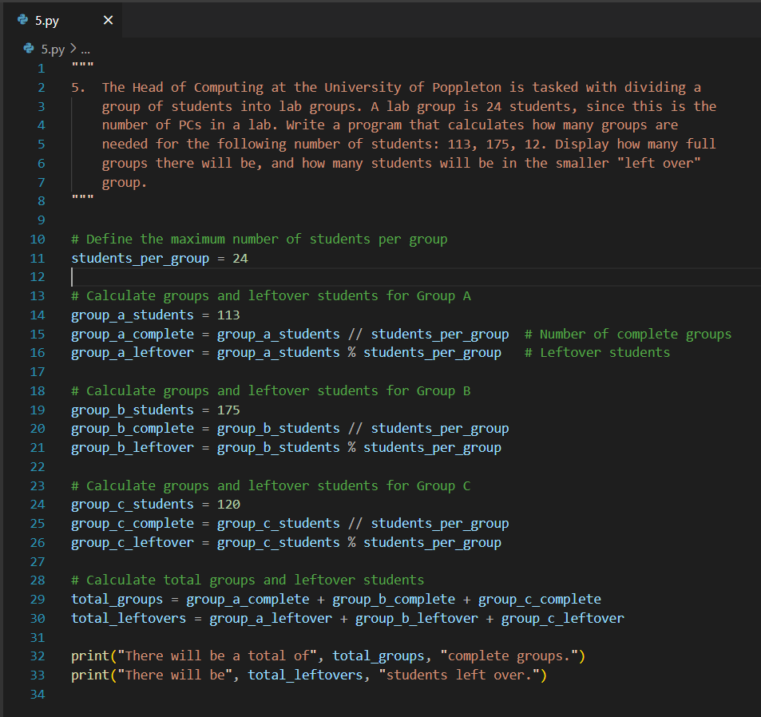

**Output of Question No. 5:**

