**Introduction to Programming**

**Lab Worksheet**

**Week 3**

**Python**

Name: Nikita Sah

Level 4 Section: A

British Id: 10011

LBU Id: c7576150

Level 4 BSc. Hons Computing

Subject: Fundamental of Computer Programming

(FOCP)

The British College (TBC)

**Task:**

**#Week 3 practical**

1. Start the Python Interpreter and input the following expressions, noting each result.

10 < 100

100 != 100

50 >= 50

**Output of Question No. 1:**

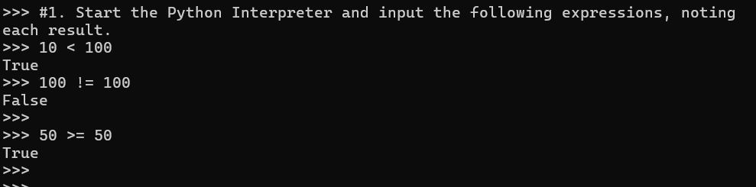

1. Input a program that defines a variable called ‘age’ that is initialised to your own age. Then type several Boolean expressions that compare the variable to see whether it is less than ‘18’, ‘21’ then ‘31’.

**Answer:**

age = 20

age < 18

age < 21

age < 31

**Output of Question No. 2:**

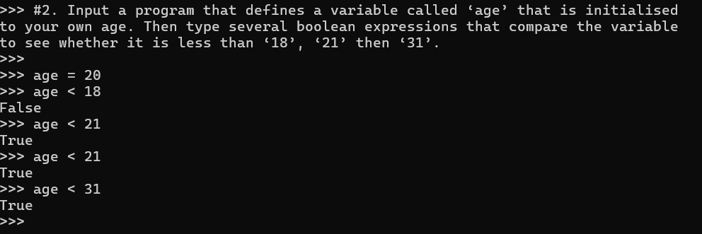

1. Try inputting the following code and note the results.

“a” < “b”

“b” < “a”

“John” < “Terry”

**Output of Question No. 3:**

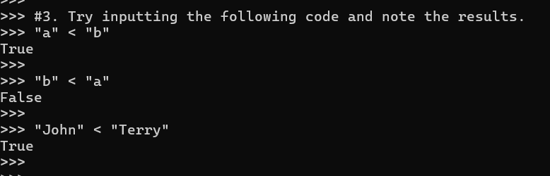

1. Try inputting the following code and note the result. Try to work out why the answer is different from the previous expression (look carefully, it *is* different).

“John” < “Terry”

**Answer:**

Because ASCII value of j is 106 and T is 84. So, 106 < 84 is false.

**Output of Question No. 4:**

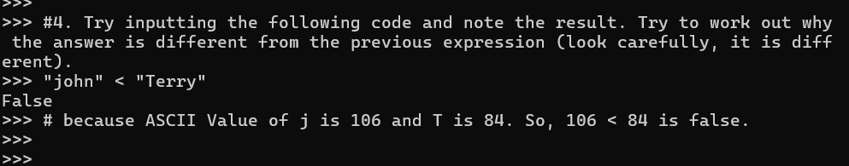

1. Try inputting the following code and note the results.

5 < 10.2

5 < "Monty"

5 < "5"

**Answer:**

Because an integer is compared to an integer or a string is compared to a string, an error occurs when different types are compared.

**Output of Question No. 5:**

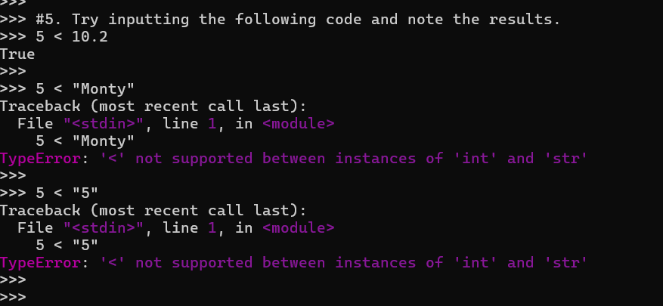

1. Try inputting the following code and examine the results.

age = 30

age >=18 and age <=65

age <18 or age >65

not age > 18

**Output of Question No. 6:**

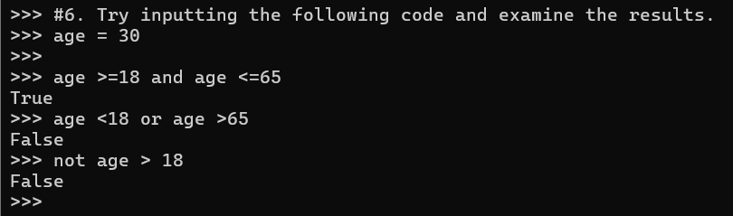

1. Try inputting the following code and examine the result.

age = 30

(age >=18 and age <=65) and (not age==30)

**Output of Question No. 7:**

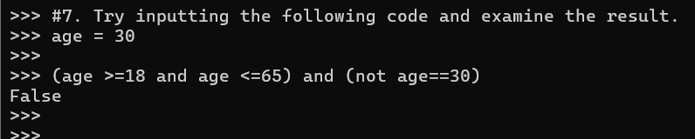

1. Try inputting two expressions that use operator chaining and are equivalent to the two expressions shown below. (note: you may first want to first assign values to the ‘weight’ and ‘height’ variables for testing purposes)

100 < weight and weight < 200

height > 131 and height < 160

**Answer:**

height = int(input("Enter your height: "))

weight = int(input("Enter your weight: "))

100 < weight and weight < 200

height > 131 and height < 160

**Output of Question No. 8:**

1. Input the given examples but with alternative operand values, that result in both True and False results.

names = ["Terry", "John", "Michael", "Eric", "Terry", "Graham"]

**Answer:**

"Mark" not in names

"Eric" not in names

"Eric" in names

**Output of Question No. 9:**

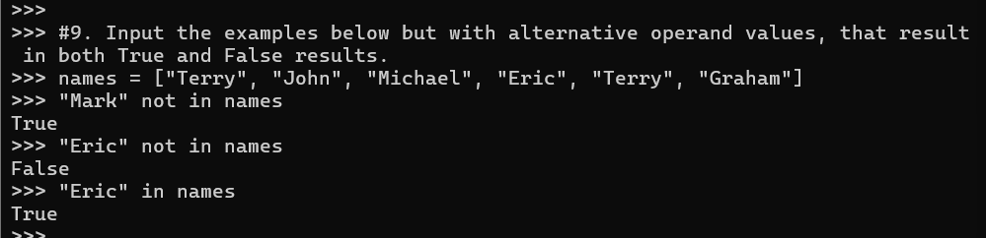

1. Try writing an if statement that checks if someone is between the ages of 18 and 30 inclusive. If they are, then print a message saying, "you are still young!"

**Answer:**

age = int(input("Enter your age: "))

if 18 <= age <= 21:

print("You are still young")

**Output of Question No. 10:**

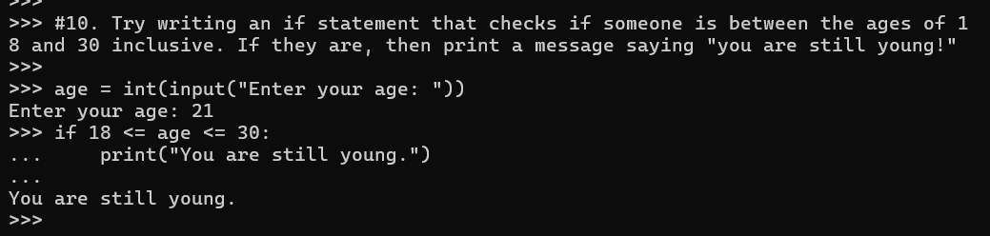

1. Try writing an if statement similar to the last example that includes an extra elif clause to check ages between 30-40. Print a suitable message in the associated code block.

**Answer:**

age = int(input("Enter your age: "))

if 18 <= age <= 30:

print("You are an adult, but not in yours 30s yet. ")

elif 30 <= age <= 40:

print("You are in yours 30s. ")

else:

print("You are either under 18 or above 40. ")

**Output of Question No. 11:**

1. Write the code that inputs a name then prints a message but change the condition so it explicitly uses a Boolean expression. Use the example below to help.

if total != 0:

print(“Total is non-zero”)

else:

print(“Total is zero”)

**Answer:**

name = input("Enter your name: ")

if name != "":

print("Your name is ", name)

else:

print("Name not entered")

**Output of Question No. 12:**

1. Write the code shown below as a single line Ternary expression.

if age >= 18:

print(“you are an adult”)

else:

print(“you are not an adult, yet”)

**Answer:**

age = int(input("Enter your age: "))

print("you are an adult" if age >= 18 else "you are not an adult, yet")

**Output of Question No. 13:**

1. Input and execute a for loop that iterates over a list of four names, printing each of them to the screen.

**Answer:**

for name in ["Nikita", "Rani", "Neha", "Nikki"]:

print(name)

**Output of Question No. 14:**

1. Input and execute a for loop that uses a range() function to generate the following output:
2. for n in range(5):

print(n, "doubled is", n * 2)

**Output of Question No. 15 (a):**

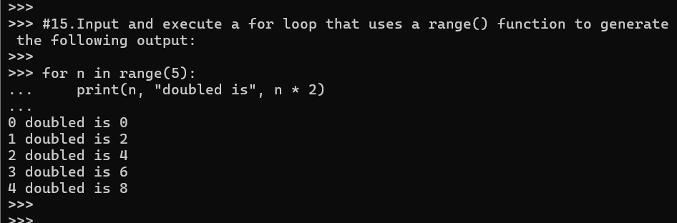

1. for n in range(10,20):

print(n, "doubled is", n * 2)

**Output of Question No. 15 (b):**

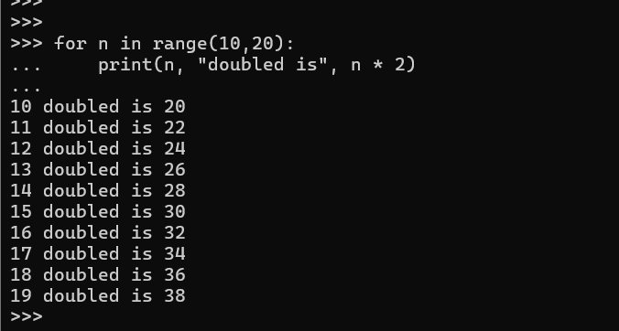

1. for n in range(20, 0, -1):

print(n, "doubled is", n * 2)

**Output of Question No. 15 (c):**

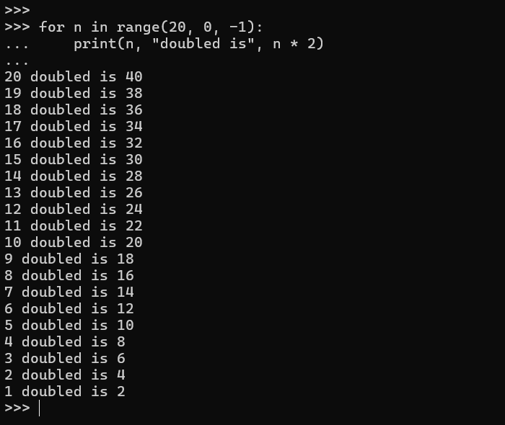

1. print in this format

2 to the power of 2 = 4

4 to the power of 4 = 256

6 to the power of 6 = 46656

8 to the power of 8 = 16777216

1. o the power of 10 = 10000000000

**Answer:**

for n in range(2, 11, 2):

print(f" {n} to the power of {n} = {n ** n}")

**Output of Question No. 15 (d):**

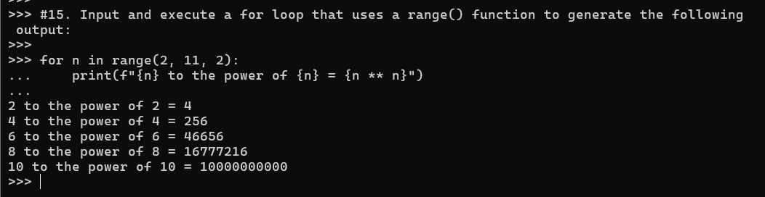

1. Input code containing a for loop that iterates over a list of numbers, printing a running total during each iteration. You may wish to first define the numbers list as follows:

numbers = [10, 20 , 30, 90, 200, 30, 22, 11]

**Answer:**

numbers = [10, 20 , 30, 90, 200, 30, 22, 11]

total=0

for number in numbers:

    total +=number

    print(f"Running Total {number} = {total}")

**Output of Question No. 16:**

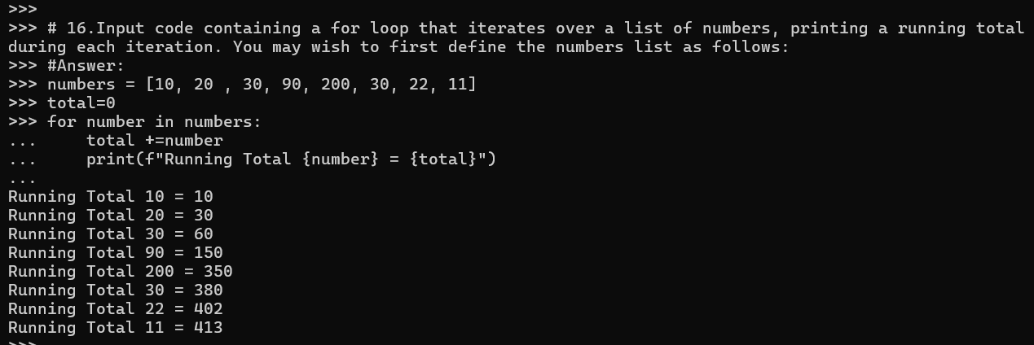

1. Amend your previous solution so that if any value within the list is found to be over 100 then the loop should break immediately.

**Answer:**

numbers = [10, 20 , 30, 90, 200, 30, 22, 11]

total=0

for number in numbers:

    if number >100:

        break

    total +=number

    print(f"Running Total {number} = {total}")

**Output of Question No. 17:**

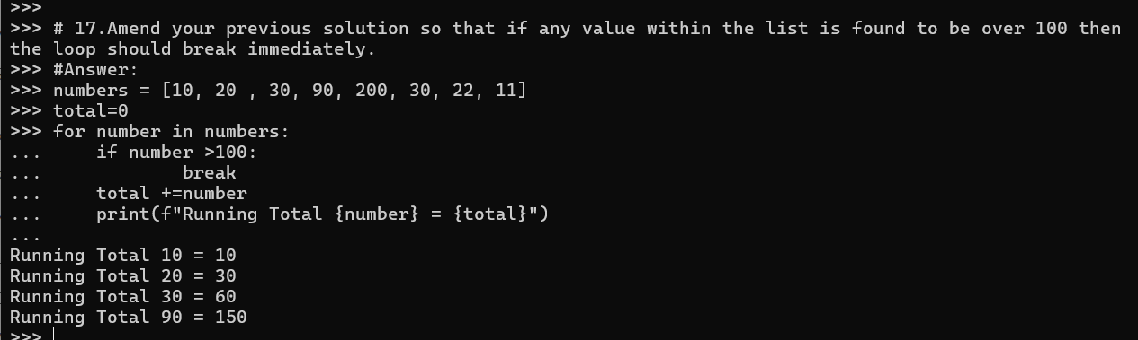

1. Amend your previous solution once again, so that the message “all numbers processed” is printed when the loop completes, but only if all values were less or equal to 100 (i.e. the loop did not break early)

**Answer:**

numbers = [10, 20 , 30, 90, 200, 30, 22, 11]

total=0

for number in numbers:

    if number <=100:

        total +=number

        print(f"Running Total {number} = {total}")

print("all numbers processed")

**Output of Question No. 18:**

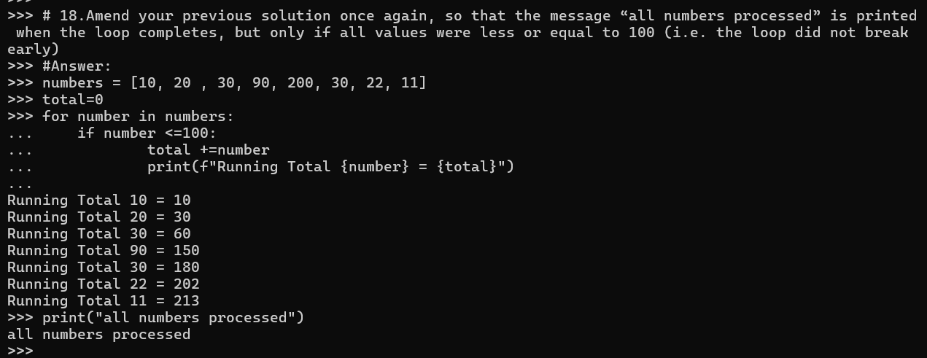

1. Look at each of the phrases below and ensure you understand what each of these means. For any that you do not understand, do a little research to find a definition of each term. This research may involve looking back over these notes, or the associated lecture notes. It may also involve searching for these terms on the Internet.

* Boolean Expression
* Relational Operator
* Logical Operator
* Operator Chaining
* Ternary Operator
* Iteration
* Nested Loop

**Answer:**

* + **Boolean Expression:** A Boolean expression is a logical statement that evaluates a condition and produces a Boolean value, which is either true or false.
  + **Relational Operator:** A relational operator checks the relationship between two operands. If the relation is true, it returns 1 and if the relation is false, it returns value 0.
  + **Logical Operator:** An expression containing logical operator returns either 0 or 1 depending upon whether expression results true or false.
  + **Operator Chaining:** Operator chaining involves using multiple operators in a single expression to create a more complex logical expression.
  + **Ternary Operator:** The ternary operator is a conditional operator that takes three operands: a condition, a value to be returned if the condition is true, and a value to be returned if the condition is false.
  + **Iteration:** Iteration relates to performing actions repeatedly, within some sort of loop.
  + **Nested Loop:** The loop that contains the blocks of code that contain control statements that themselves have blocks of code.