**Introduction to Programming**

**Week 4**

**Program_04**

**Python**

Name: Nikita Sah

Level 4 Section: A

British Id: 10011

LBU Id: c7576150

Level 4 BSc. Hons Computing

Subject: Fundamental Of Computer Programming (FOCP)

The British College (TBC)

**Questions:**

1. Functions are often used to validate input. Write a function that accepts a single integer as a parameter and returns True if the integer is in the range 0 to 100 (inclusive), or False otherwise. Write a short program to test the function.

**Answer:**

**Source Code of Question No. 1:**

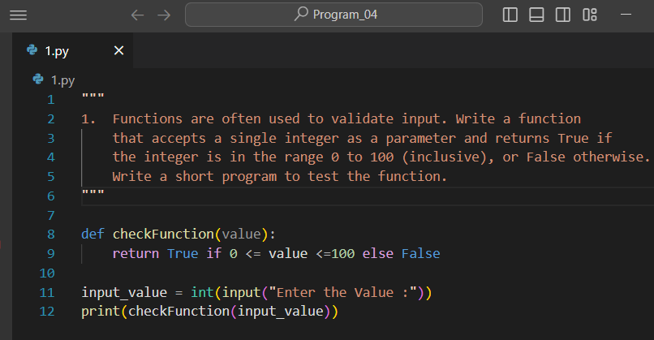

**Output of Question No. 1:**

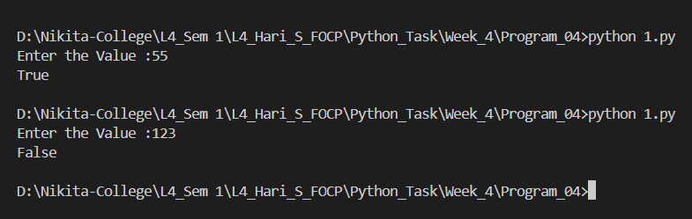

1. Write a function that has a single string as its parameter, and returns the number of uppercase letters, and the number of lowercase letters in the string. Test the function with a short program.

**Answer:**

**Source Code of Question No. 2:**

**Output of Question No. 2:**

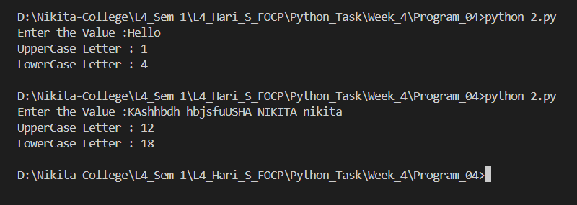

1. Modify your "greetings" program so that the first letter of the name entered is always in uppercase with the rest in lowercase. This should happen even if the user entered their name differently. So if the user entered arthur, ARTHUR, or even arTHur the name should be displayed as Arthur.

**Answer:**

**Source Code of Question No. 3:**

**Output of Question No. 3:**

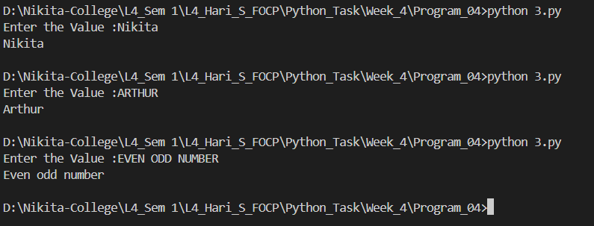

1. When processing data it is often useful to remove the last character from some input (it is often a newline). Write and test a function that takes a string parameter and returns it with the last character removed. (If the string contains one or fewer characters, return it unchanged.)

**Answer:**

**Source Code of Question No. 4:**

**Output of Question No. 4:**

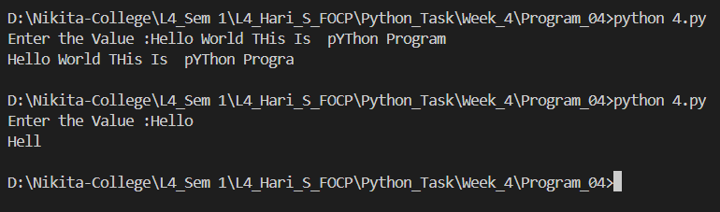

1. Write and test a function that converts a temperature measured in degrees centigrade into the equivalent in Fahrenheit, and another that does the reverse conversion. Test both functions. (Google will find you the formulae).

**Answer:**

**Source Code of Question No. 5:**

**Output of Question No. 5:**

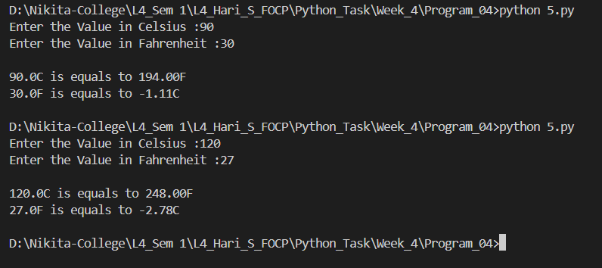

1. Write a program that takes a centigrade temperature and displays the equivalent in Fahrenheit. The input should be a number followed by a letter C. The output should be in the same format.

**Answer:**

**Source Code of Question No. 6:**

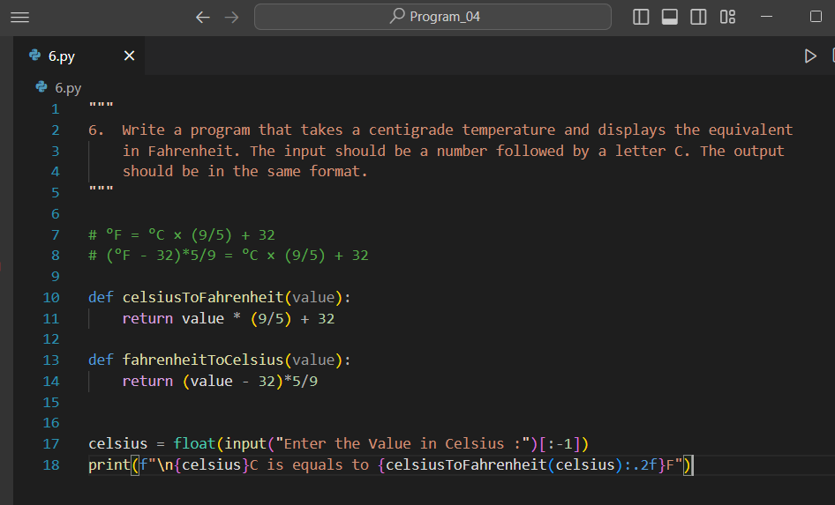

**Output of Question No. 6:**

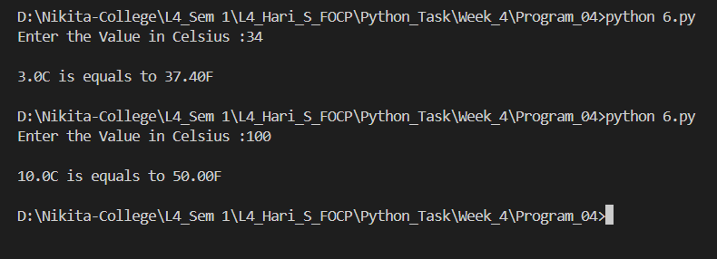

1. Write a program that reads 6 temperatures (in the same format as before), and displays the maximum, minimum, and mean of the values.

*Hint: You should know there are built-in functions for max and min. If you hunt, you might also find one for the mean.*

**Answer:**

**Source Code of Question No. 7:**

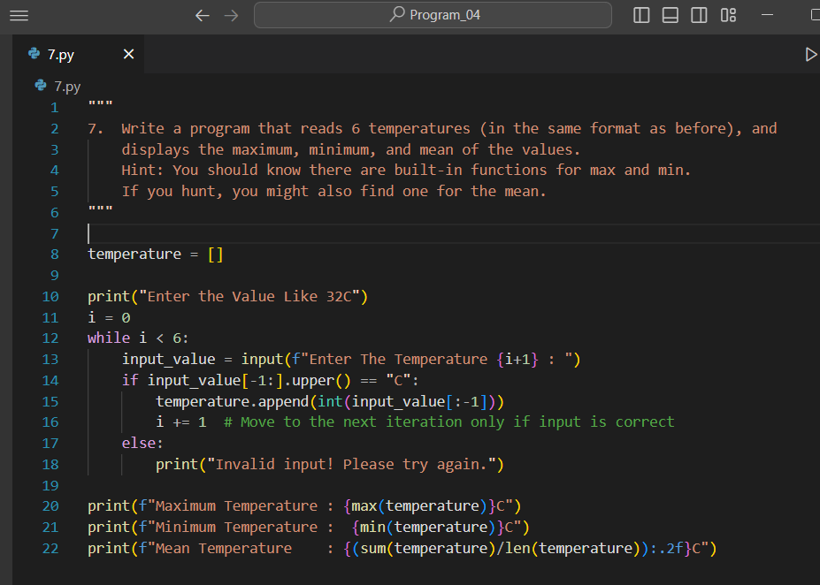

**Output of Question No. 7:**

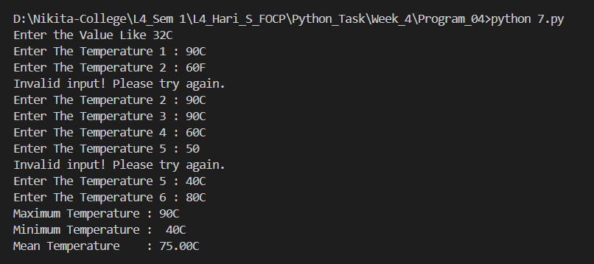

1. Modify the previous program so that it can process any numberof values. The input terminates when the user just pressed "Enter" at the prompt rather than entering a value.

**Answer:**

**Source Code of Question No. 8:**

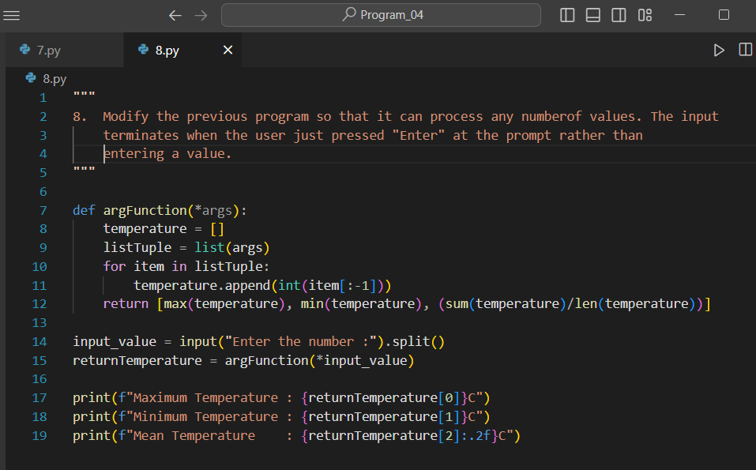

**Output of Question No. 8:**

