**Introduction to Programming**

**Week 5**

**Program_05**

**Python**

Name: Nikita Sah

Level 4 Section: A

British Id: 10011

LBU Id: c7576150

Level 4 BSc. Hons Computing

Subject: Fundamental Of Computer Programming (FOCP)

The British College (TBC)

**Questions:**

1. Using command-line arguments involves the sys module. Review the docs for this module and using the information in there write a short program that when run from the command-line reports what operating system platform is being used.

**Answer:**

**Source Code of Question No. 1:**

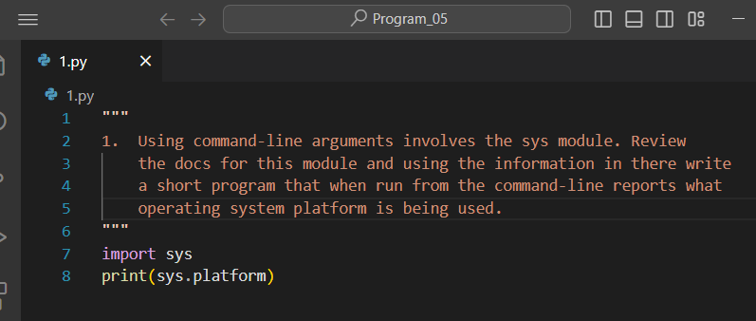

**Output of Question No. 1:**

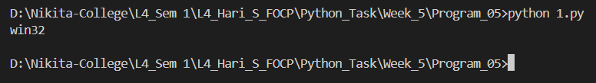

1. Write a program that, when run from the command line, reports how many arguments were provided. (Remember that the program name itself is not an argument).

**Answer:**

**Source Code of Question No. 2:**

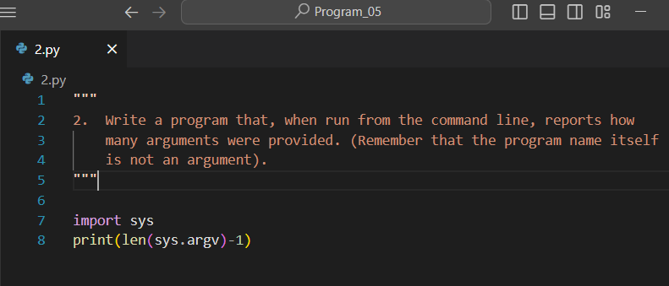

**Output of Question No. 2:**

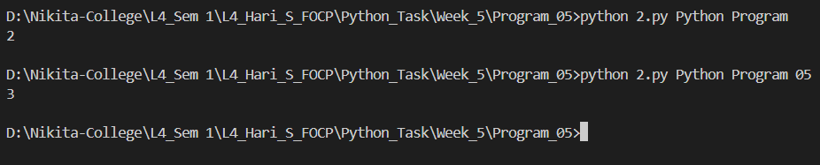

1. Write a program that takes a bunch of command-line arguments, and then prints out the shortest. If there is more than one of the shortest length, any will do. Hint: Don't overthink this. A good way to find the shortest is just to sort them.

**Answer:**

**Source Code of Question No. 3:**

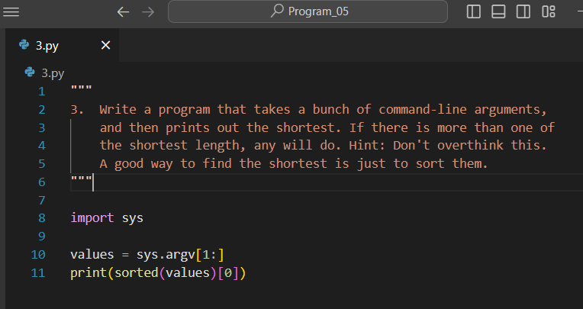

**Output of Question No. 3:**

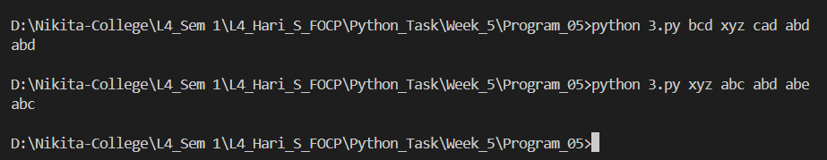

1. Write a program that takes a URL as a command-line argument and reports whether or not there is a working website at that address. Hint: You need to get the HTTP response code. Another Hint: StackOverflow is your friend.

**Answer:**

**Source Code of Question No. 4:**

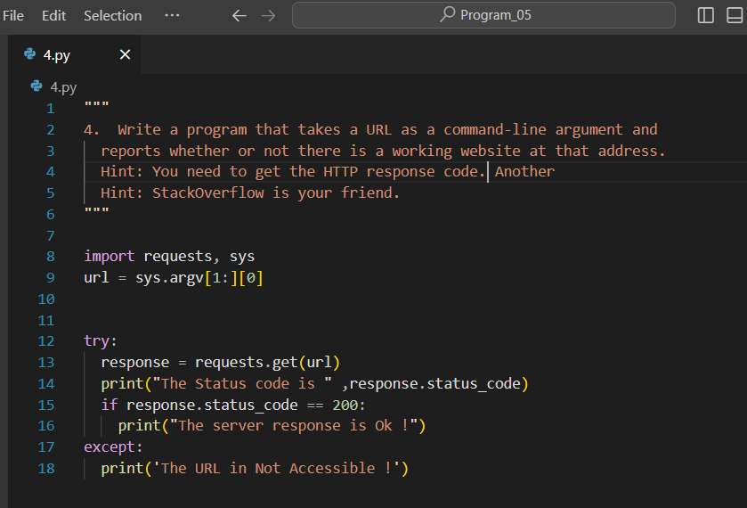

**Output of Question No. 4:**

1. Last week you wrote a program that processed a collection of temperature readings entered by the user and displayed the maximum, minimum, and mean. Create a version of that program that takes the values from the command-line instead. Be sure to handle the case where no arguments are provided!

**Answer:**

**Source Code of Question No. 5:**

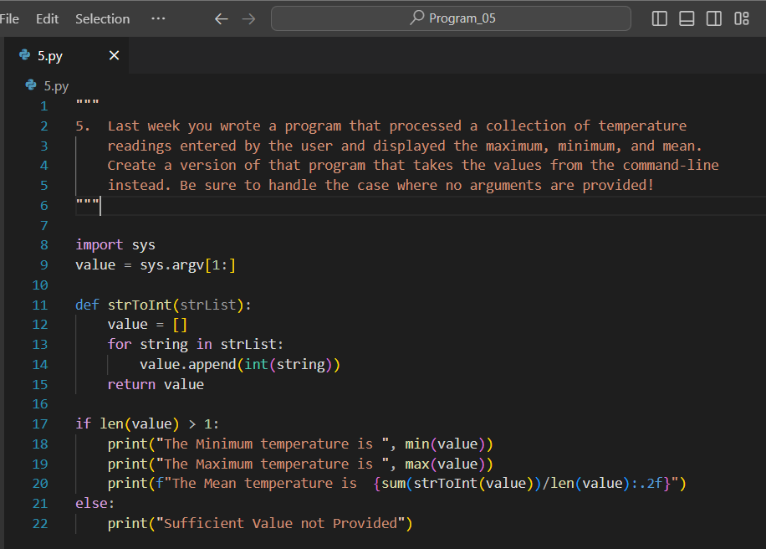

**Output of Question No. 5:**

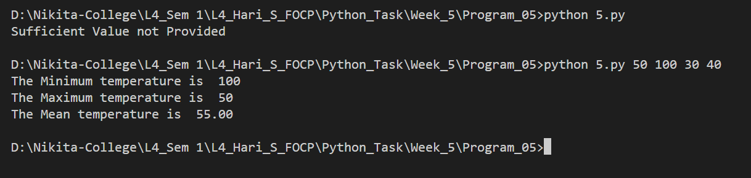

1. Write a program that takes the name of a file as a command-line argument, and creates a backup copy of that file. The backup should contain an exact copy of the contents of the original and should, obviously, have a different name. Hint: By now, you should be getting the idea that there is a built-in way to do the heavy li ing here! Take a look at the "Brief Tour of the Standard Library" in the docs.

**Answer:**

**Source Code of Question No. 6:**

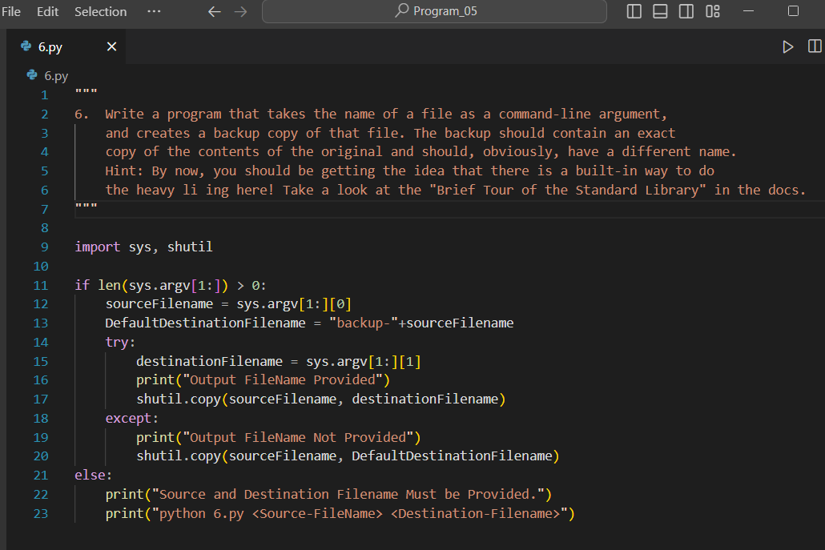

**Output of Question No. 6:**

