

**Introduction to Programming**

Week 2

Program_02(Python)

Name: Nikita Sah

Level 4 Section: A

British Id: 10011

Level 4 BSc. Hons Computing

Subject: Fundamental Of Computer Programming (FOCP)

The British College (TBC)

**Questions:**

1. Last week you wrote a program that printed out a cheery greeting including your name. Take a copy of it, and modify it so that the user enters their name at the keyboard, and then receives a greeting.

For example:

Hello, what is your name? Mr Apricot

Hello, Mr Apricot. Good to meet you!

**Answer:**

**Source Code of Question No. 1:**

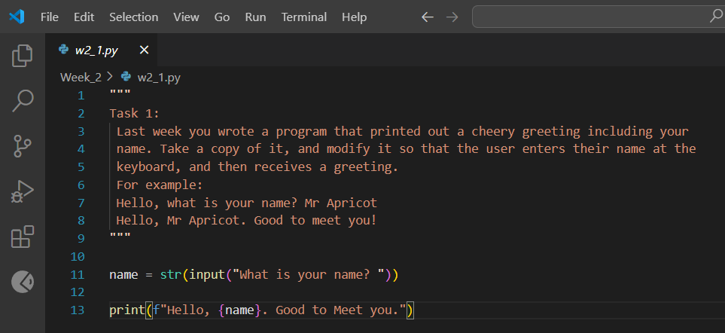

**Output of Question No. 1:**

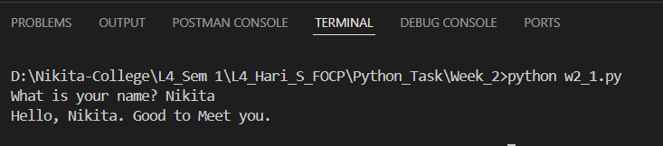

1. Write a program that prompts a user to enter a temperature in Celsius, and then displays the corresponding temperature in Fahrenheit, like so:

Enter a temperature in Celsius: 32.5

32.5C is equivalent to 90.5F.

**Answer:**

**Source Code of Question No. 2:**

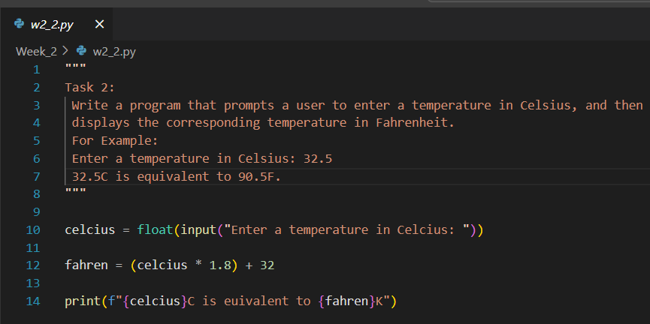

**Output of Question No. 2:**

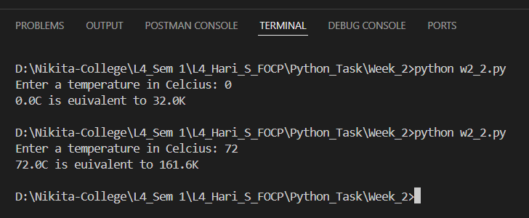

1. The Head of Computing at the University of Poppleton is tasked with dividing a group of students into lab groups. A lab group is usually 24 students, but this is sometimes varied to create groups of similar size. Write a program that prompts for the number of students and group size, and then displays how many groups will be needed and how many will be le over in a smaller group. For Example:

How many students? 113

Required group size? 22

There will be 5 groups with 3 students left over.

For bonus credit, see if you can fix the grammar in the output. So if there were 101 students in groups of 20 the output would be:

There will be 5 groups with 1 student left over.

**Answer:**

**Source Code of Question No. 3:**

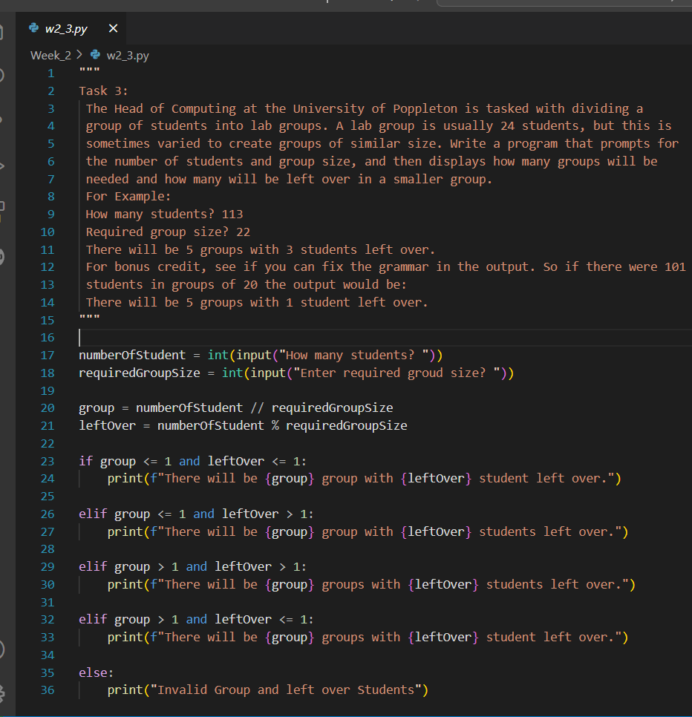

**Output of Question No. 3:**

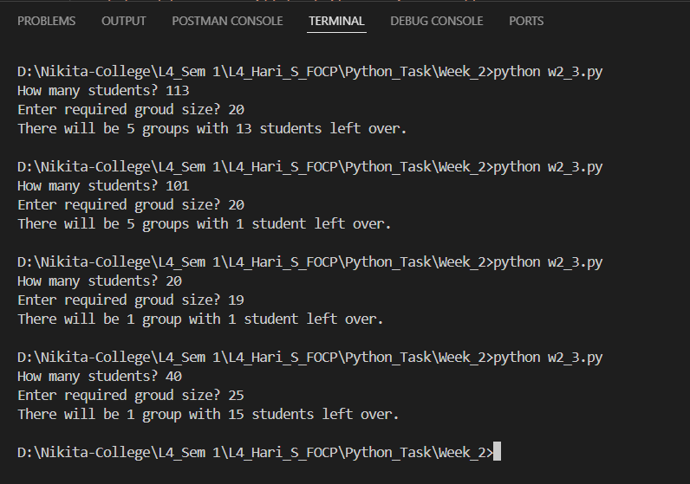

1. A kindly teacher wishes to distribute a tub of sweets between her pupils. She will first count the sweets and then divide them according to how many pupils attend that day. Write a program that will tell the teacher how many sweets to give to each pupil, and how many she will have le over.

**Answer:**

**Source Code of Question No. 4:**

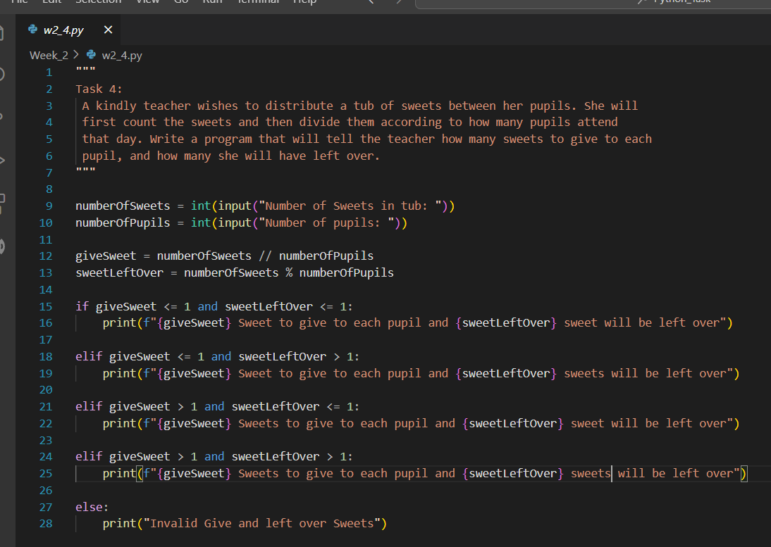

**Output of Question No. 4:**

