

**Introduction to Programming**

Week 3

Program_03(Python)

Name: Nikita Sah

Level 4 Section: A

British Id: 10011

Level 4 BSc. Hons Computing

Subject: Fundamental Of Computer Programming (FOCP)

The British College (TBC)

**Questions:**

1. Modify your greeting program so that if the user does not enter a name (i.e. they just press enter), the program responds "Hello, Stranger!". Otherwise it should print a greeting with their name as before.

**Answer:**

**Source Code of Question No. 1:**

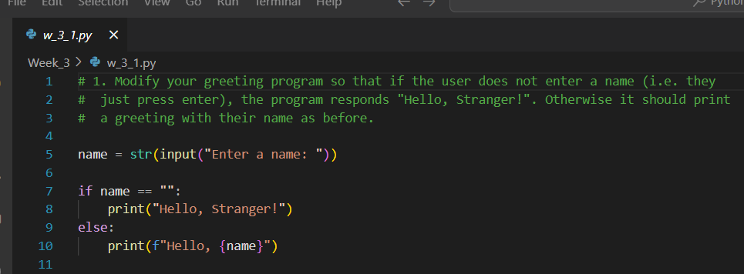

**Output of Question No. 1:**

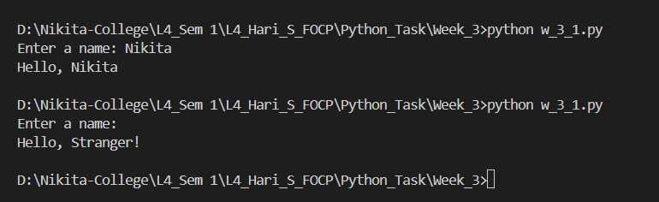

1. Write a program that simulates the way in which a user might choose a password. The program should prompt for a new password, and then prompt again. If the two passwords entered are the same the program should say "Password Set" or similar, otherwise it should report an error.

**Answer:**

**Source Code of Question No. 2:**

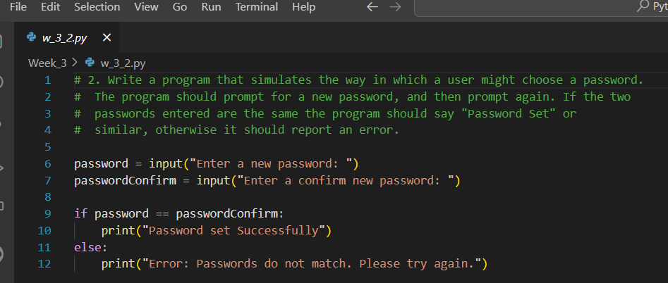

**Output of Question No. 2:**

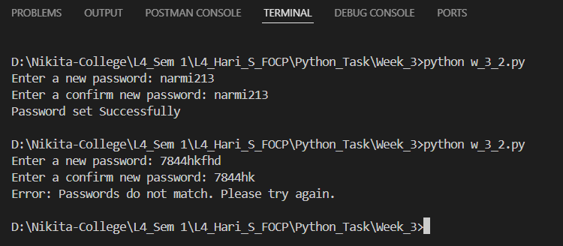

1. Modify your previous program so that the password must be between 8 and 12 characters (inclusive) long.

**Answer:**

**Source Code of Question No. 3:**

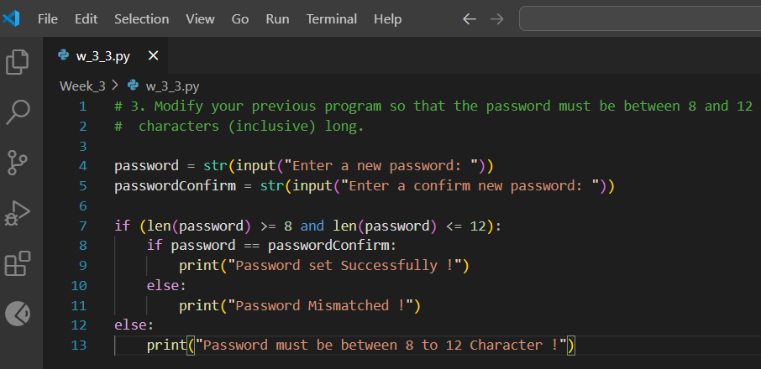

**Output of Question No. 3:**

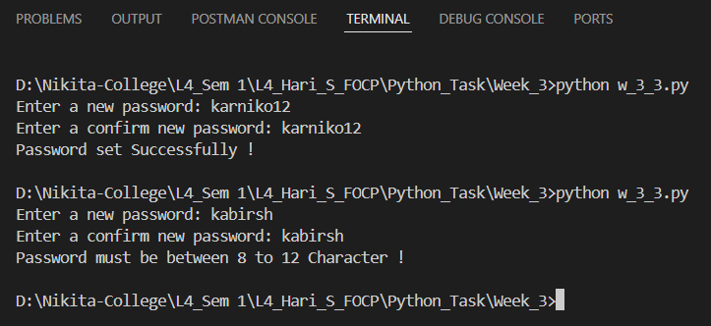

1. Modify your program again so that the chosen password cannot be one of a list of common passwords, defined thus:

BAD_PASSWORDS = ['password', 'letmein', 'sesame', 'hello', 'justinbieber']

**Answer:**

**Source Code of Question No. 4:**

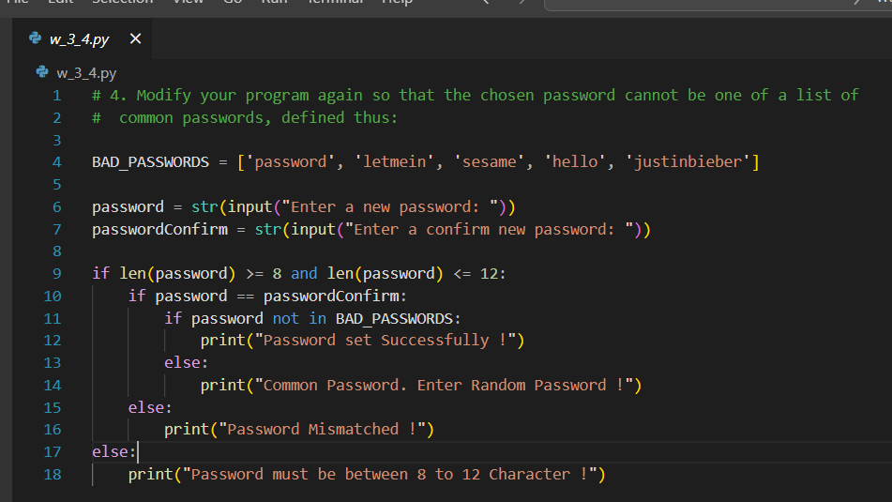

**Output of Question No. 4:**

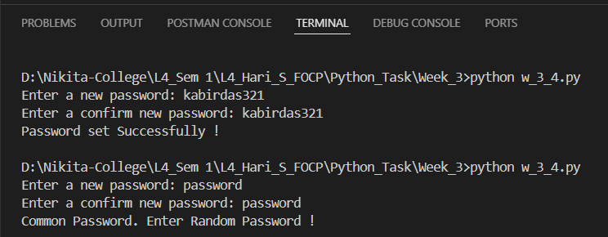

1. Modify your program a final time so that it executes until the user successfully chooses a password. That is, if the password chosen fails any of the checks, the program should return to asking for the password the first time.

**Answer:**

**Source Code of Question No. 5:**

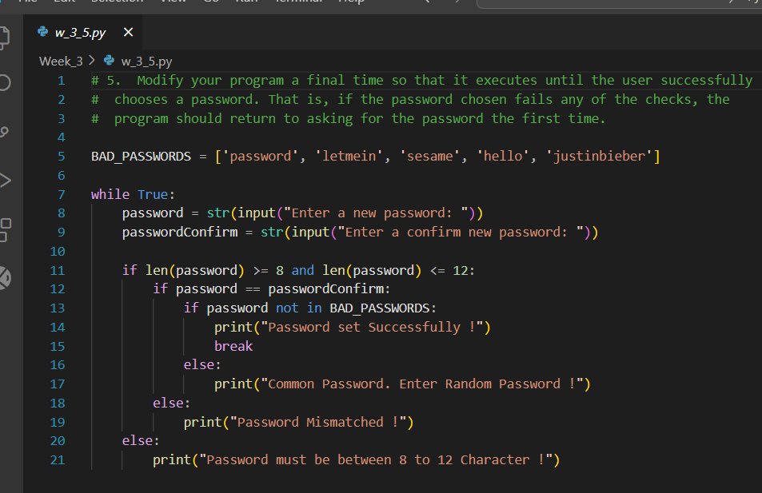

**Output of Question No. 5:**

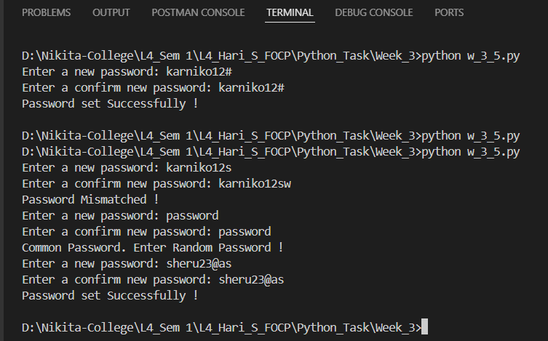

1. Write a program that displays the "Seven Times Table". That is, the result of multiplying 7 by every number from 0 to 12 inclusive. The output might start:

0 x 7 = 0

1 x 7 = 7

2 x 7 = 14 and so on.

**Source Code of Question No. 6:**

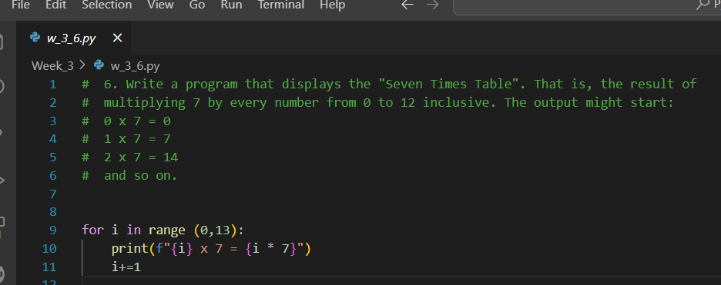

**Output of Question No. 6:**

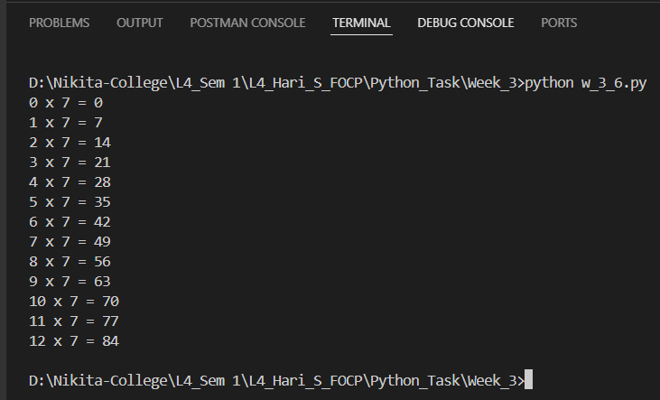

1. Modify your "Times Table" program so that the user enters the number of the table they require. This number should be between 0 and 12 inclusive.

**Answer:**

**Source Code of Question No. 7:**

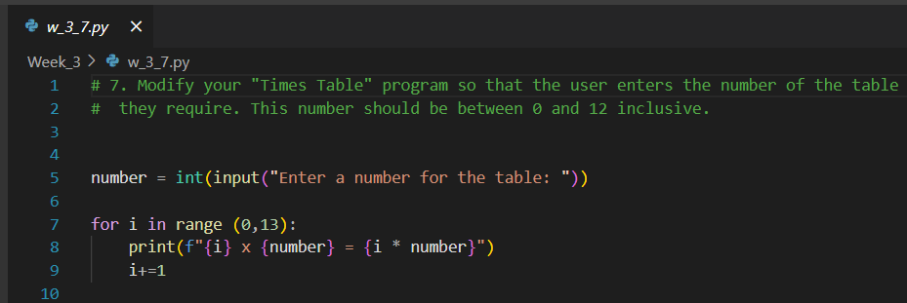

**Output of Question No.7:**

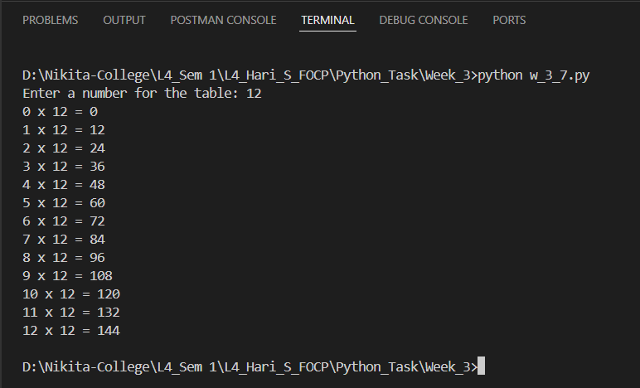

1. Modify the "Times Table" again so that the user still enters the number of the table, but if this number is negative the table is printed backwards. So entering "-7" would produce the Seven Times Table starting at "12 times" down to "0 times".

**Answer:**

**Source Code of Question No. 8:**

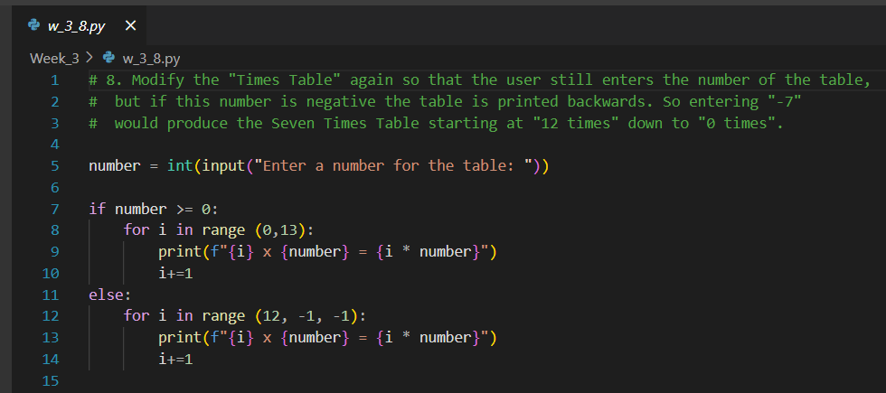

**Output of Question No. 8:**

