1. Creating customers table:

CREATE TABLE customers ( cust_no INT(3) UNSIGNED PRIMARY KEY,
cust_fname VARCHAR(15) NOT NULL,
cust_lname VARCHAR(15) NOT NULL,
cust_company VARCHAR(15),
cust_addr VARCHAR(30) NOT NULL,
city VARCHAR(15) NOT NULL,
cust_phone CHAR(10) NOT NULL);
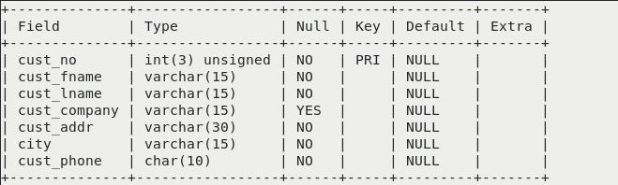

2.Creating author table:

CREATE TABLE author ( author_no INT(3) UNSIGNED PRIMARY KEY,
author-name VARCHAR(20) NOT NULL,
country VARCHAR(15) NOT NULL);
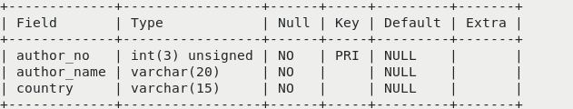

3.Creating publisher table:

CREATE TABLE publisher ( publisher_no INT(3) UNSIGNED PRIMARY KEY,
publisher_name VARCHAR(20) NOT NULL,
publisher_addr VARCHAR(30) ,
year CHAR(4));

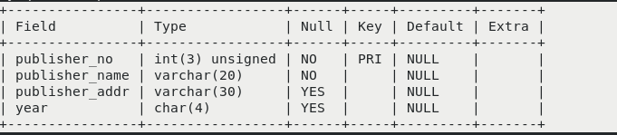

4.Creating book table:

CREATE TABLE book (isbn INT(5) UNSIGNED PRIMARY KEY,
title VARCHAR(20) NOT NULL,
unit_price DECIMAL(6,2) UNSIGNED NOT NULL,
author_no INT(3) UNSIGNED NOT NULL,
publisher_no INT(3) UNSIGNED NOT NULL,
pub_year CHAR(4)
FOREIGN KEY(author_no) REFERENCES author(author_no),
FOREIGN KEY(publisher_no) REFERENCES publisher(publisher_no));

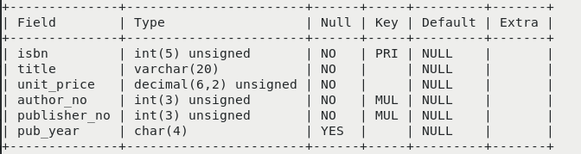

5.Creating table orders:

CREATE TABLE orders (order_no INT(3) UNSIGNED PRIMARY KEY,
cust_no INT(3) UNSIGNED NOT NULL,
isbn INT(5) UNSIGNED NOT NULL,
qty INT(3) UNSIGNED NOT NULL,
odate DATE NOT NULL,
FOREIGN KEY(cust_no) REFERENCES customers(cust_no),
FOREIGN KEY(isbn) REFERENCES book(isbn));
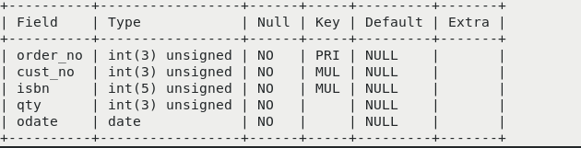

6.Creating simple view

CREATE VIEW simple AS SELECT title,unit_price FROM book;
SELECT * FROM simple;

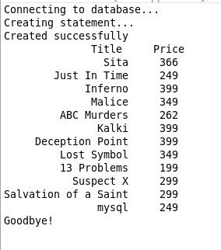

Creating simple index

CREATE INDEX title ON book(title);

SHOW INDEX FROM book WHERE key_name=’title’;

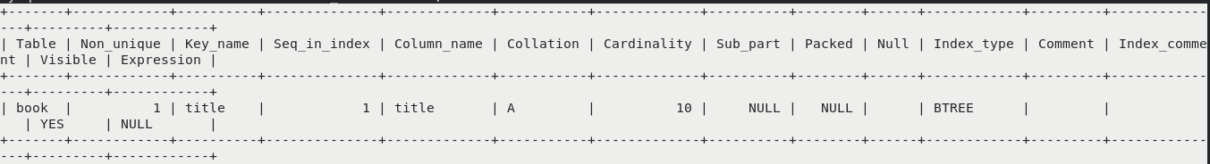

Creating unique index

CREATE UNIQUE IINDEX pub ON publisher(publisher_name);

SHOW INDEX FROM publisher WHERE key_name=’pub’;

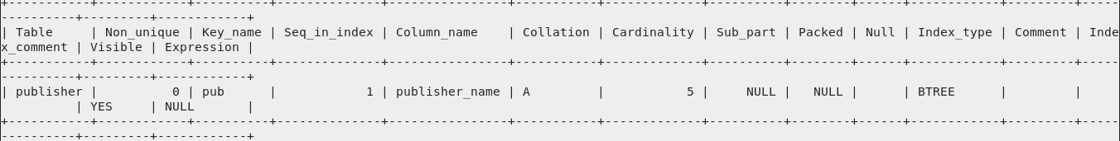

Creating composite index

CREATE INDEX cust ON customers(cust_fname,cust_lname);

SHOW INDEX FROM customers WHERE key_name='cust';

