- Insert at least 10 records in customer table and insert other tables accordingly.

insert into customers values(101,'Rajat','Agarwal','Symantec','4 Shivtara,Katraj','Pune','9765330877');
insert into customers values(202,'Pankaj','Udaas','T-series','3/2 Naintara,Dadar','Mumbai','9823114877');
insert into customers values(303,'Harshada','Yadav','Cognizant','22 Hermes Park,Camp','Pune','9921235346');
insert into customers values(404,'Preeti','Kadam','HP Gas','12 MG Rd,Borivali','Mumbai','9765339877');
insert into customers values(505,'Disha','Sawant','Infosys','23 Dilli Rd','Bangalore','9921435622');
insert into customers values(606,'Sanket','Joshi','LensKart','30 Trump Tower','Bangalore','9634726142');
insert into customers values(707,'Shivang','Sarangi','Gera','A-202 Disha Enclave','Nashik','9476229172');
insert into customers values(808,'Krishna','Bansal','Hyundai','C-302 Raheja Woods','Mumbai','9276449277');
insert into customers values(909,'Shraddha','Joshi','IBM','C-304 Gera Landmark','Nashik','9736229164');
insert into customers values(312,'Vikram','Das','ICICI Bank','4 Konark Kinara','Pune','9123884566');
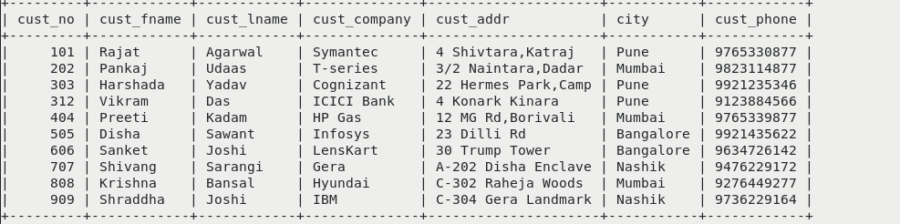

insert into author values(010,'Amish Tripathi','India');
insert into author values(020,'Seema Kaul','India');
insert into author values(030,'Don Brown','Australia');
insert into author values(040,'Higashino Keigo','Japan');
insert into author values(050,'Agatha Christie','UK');

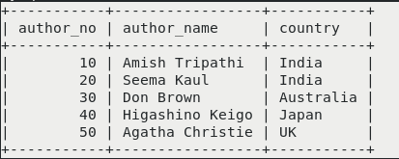

insert into publisher values(001,'Penguin','3 Down Street,England','1984');
insert into publisher values(002,'Pearson','44 Avenue,LA','1990');
insert into publisher values(003,'Hachette','3 MG Rd,Delhi','2015');
insert into publisher values(004,'Wiley','5 Up Street,Sydney','2015');
insert into publisher values(005,'Kodansha','4 Coco,Saitama','2016');

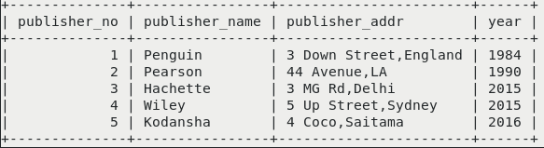

insert into book values(10001,'Sita',349,010,003,'2015');
insert into book values(10011,'Just In Time',249,020,002,'2012');
insert into book values(10021,'Inferno',399,030,004,'2017');
insert into book values(10031,'Malice',349,040,005,'2016');
insert into book values(10041,'ABC Murders',250,050,001,'2015');
insert into book values(10051,'Kalki',399,010,003,'2016');
insert into book values(10061,'Deception Point',399,030,004,'2016');
insert into book values(10071,'Lost Symbol',349,030,002,'2000');
insert into book values(10081,'13 Problems',199,050,001,'2004');
insert into book values(10091,'Suspect X',299,040,002,'2006');
insert into book values(10101,'Salvation of a Saint',299,040,002,'2004');

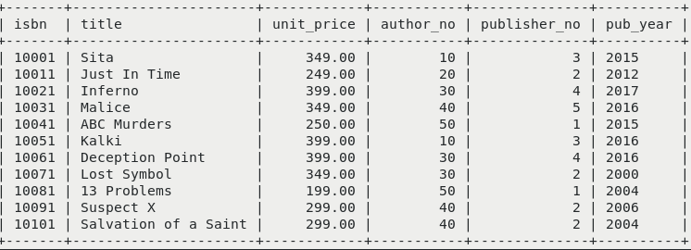

insert into orders values(110,303,10001,1,'2019-07-06');
insert into orders values(120,606,10041,3,'2019-07-20');
insert into orders values(130,808,10031,15,'2019-08-16');
insert into orders values(140,202,10021,20,'2019-08-03');
insert into orders values(150,312,10011,4,'2019-07-08');
insert into orders values(160,404,10031,12,'2019-07-31');

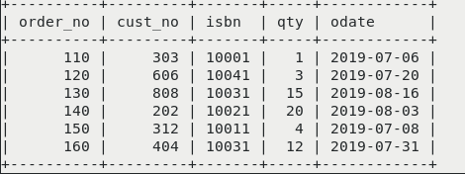

- Display all customer details with city pune and mumbai and customer first name starting with 'p' or 'h'.

SELECT * FROM customers WHERE city IN('Pune','Mumbai') AND (cust_fname LIKE 'P%' OR cust_fname LIKE 'H%');

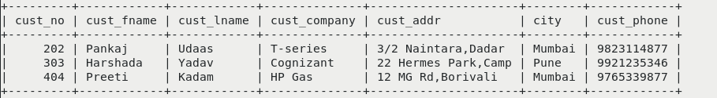
3. lists the number of different customer cities.(use of distinct).

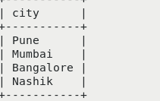
SELECT DISTINCT city FROM customers;

4.Give 5% increase in price of the books with publishing year 2015. ( use of update)

UPDATE book SET unit_price=unit_price*1.05 WHERE pub_year='2015';

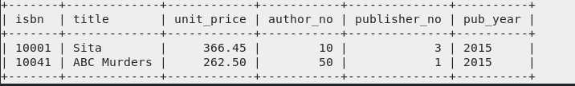

5.Delete customer details living in pune.

DELETE FROM customers WHERE city='Pune';

6. Find the names of authors living in India or Australia (use of UNION).

SELECT author_name FROM author WHERE country='India' UNION SELECT author_name FROM author WHERE country='Australia';

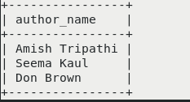

7.Find the publishers who are established in year 2015 as well as in 2016 (use of INTERSECT)

SELECT * FROM publisher where year IN( SELECT pub_year FROM book);

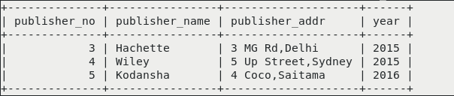

8.Find the book having maximum price and find titles of book having price between 300 and 400. (use of max and between).

SELECT title,unit_price FROM book WHERE unit_price= (SELECT MAX(unit_price) FROM book) ;

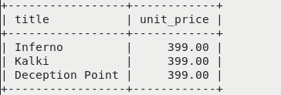

SELECT title,unit_price FROM book WHERE unit_price BETWEEN 300 AND 400;

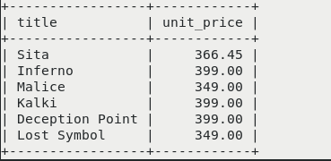

9.Display all titles of books with price and published year in decreasing order of publishing year.

SELECT title,unit_price,pub_year FROM book ORDER BY pub_year DESC;

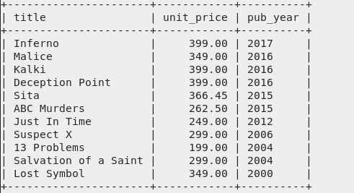

10. Display title,author_no and publisher_no of all books published in 2000,2004,2006. (use of IN)

SELECT title,author_no,publisher_no FROM book WHERE pub_year IN('2000','2004','2006');

