1.Find Customer details and order details using NATURAL JOIN

SELECT * FROM customers NATURAL JOIN orders;
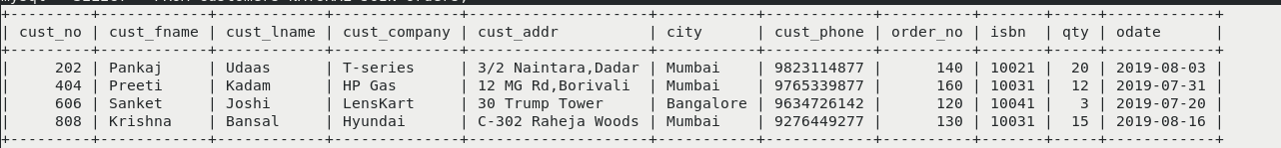

2.Find the book_ title, author_name, country. (INNER JOIN)

SELECT book.title, author.author_name, author.country FROM book INNER JOIN author ON book.author_no = author.author_no;

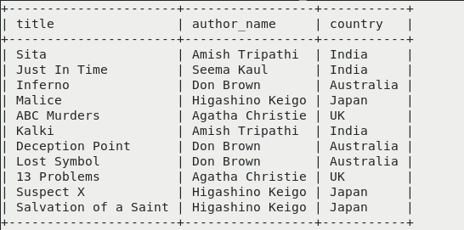

3.Find the customer ID, name and order_no of customers who have never placed an order.

SELECT customers.cust_no,customers.cust_fname,customers.cust_lname,orders.order_no FROM customers LEFT JOIN orders ON customers.cust_no=orders.cust_no WHERE orders.order_no IS NULL;

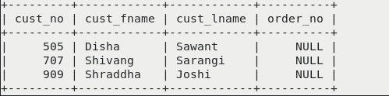

4.Find the Title, ISBN, order_no of the books for which order is not placed. (LEFT/RIGHT)

SELECT book.title,book.isbn,orders.order_no FROM orders RIGHT JOIN book ON orders.isbn=book.isbn WHERE orders.order_no IS NULL;
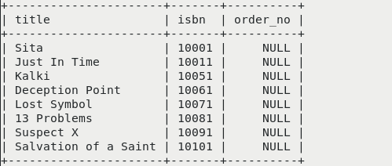

5.Display cust_fname, title,author_no,publisher_year where ISBN=10031. (JOINING more than 2 tables)

SELECT customers.cust_fname,book.title,book.author_no,book.pub_year FROM customers INNER JOIN orders ON customers.cust_no=orders.cust_no INNER JOIN book ON book.isbn=orders.isbn WHERE book.isbn=10031;

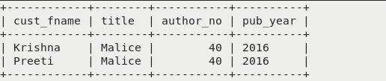

7.List the cust_id, order_no and ISBN with books having title 'mysql'. (sub query- IN)

SELECT cust_no,order_no,isbn FROM orders WHERE orders.isbn=(SELECT isbn FROM book WHERE title IN('mysql'));



8.Find the names of all the companies that ordered books in the year 2015. (sub query, Between)

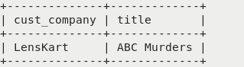
SELECT customers.cust_company,book.title from customers INNER JOIN orders ON customers.cust_no=orders.cust_no INNER JOIN book ON orders.isbn=book.isbn WHERE pub_year='2015';

9.Create view showing author and book details(Complex view)

CREATE VIEW complex AS SELECT b.title,b.unit_price,a.author_name FROM book b INNER JOIN author a ON b.author_no=a.author_no WHERE b.unit_price<300;

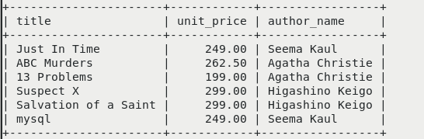

10. Perform manipulation on simple view : Insert,update,delete, drop view

INSERT INTO simple VALUES(10106,50,"Christmas Pudding",355);

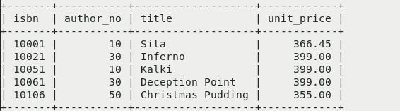

UPDATE simple SET unit_price=350 WHERE isbn=10051;

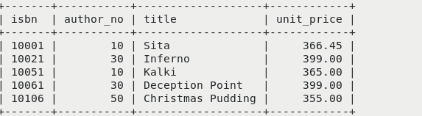

DELETE FROM simple WHERE unit_price<360;

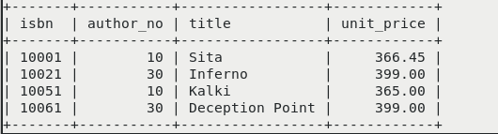

DROP VIEW simple;

