TITLE:

Implement Union, Intersection, Complement and Difference operations on fuzzy sets. Also

create fuzzy relation by Cartesian product of any two fuzzy sets and perform max-min

composition on any two fuzzy relations.

AIM: To write a program for Implementation of Fuzzy set operations.

OBJECTIVES:
- Understand basic concepts of Fuzzy logic
- Practical implementation of Fuzzy set operations.

THEROY:
Common Operations on fuzzy sets: Given two Fuzzy sets A~ and B~
  - Union : Fuzzy set C~ is union of Fuzzy sets A~ and B~ :
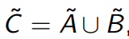
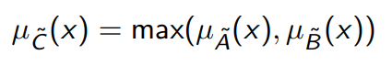
  - Intersection: Fuzzy set D~ is intersection of Fuzzy sets A~ and B~ :
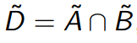
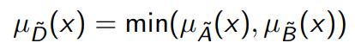
  - Complement: Fuzzy set E~ is complement of Fuzzy set A~ :
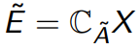
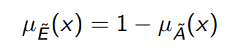
- Some other useful operations on Fuzzy set:
  - Algebraic sum:
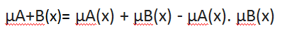
  - Algebraic product:
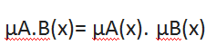
  - Bounded sum:
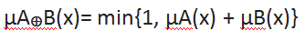
  - Bounded difference:
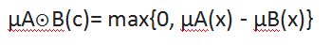

Composition of fuzzy relation
For (x, y) ∈A×B, (y, z) ∈B×C,
μS•R (x, z) = Max y [Min (μR (x, y), μS (y, z))]
= ∨ y [μR (x, y) ∧μS (y, z)]
MS • R =MR•MS

Questions for Review:

- Explain Classical set Vs Fuzzy Set?
- Difference between fuzzification and defuzzfication?
- Consider the two fuzzy sets
B1={1/1.0+0.75/1.5+0.3/2.0+0.15/2.5+0/3.0}
B2={1/1.0+0.6/1.5+0.2/2.0+0.1/2.5+0/3.0}
Find the following
I) 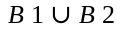2)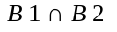3) 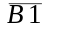4) 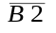5) B1|B2 6) 